Assessment tool-1
33. Customer Purchase Analysis
Files:
• Customers.csv
• Orders.csv
• Orders.json
• Orders.xml
Read customer purchase records from CSV, JSON, and XML. Merge customer and
order datasets, calculate customer spending, identify inactive customers, summarize
city-wise purchases, and export the cleaned dataset.
Customers.csv
CustomerID,CustomerName,Gender,Age,City
101,Varun,Male,22,Hyderabad
102,Rahul,Male,24,Chennai
103,Anjali,Female,23,Bangalore
104,Priya,Female,25,Hyderabad
105,Kiran,Male,21,Vijayawada
106,Divya,Female,27,Chennai
107,Arjun,Male,26,Bangalore
108,Sneha,Female,24,Hyderabad
109,Ramesh,Male,28,Pune
110,Keerthi,Female,23,Visakhapatnam
Orders.csv
OrderID,CustomerID,OrderDate,Amount,PaymentMode
1001,101,2025-01-05,2500,UPI
1002,102,2025-01-08,1800,Card
1003,103,2025-01-12,3200,Cash
1004,101,2025-01-18,1500,UPI
1005,104,2025-01-22,2700,Card
1006,105,2025-01-24,4000,NetBanking
1007,106,2025-02-01,3500,UPI
1008,107,2025-02-05,2800,Card
Orders.json
<?xml version="1.0" encoding="UTF-8"?>
<Orders>
<Order>
<OrderID>1012</OrderID>
<CustomerID>110</CustomerID>
<OrderDate>2025-02-18</OrderDate>
<Amount>2600</Amount>
<PaymentMode>Cash</PaymentMode>
</Order>
<Order>
<OrderID>1013</OrderID>
<CustomerID>101</CustomerID>
<OrderDate>2025-02-20</OrderDate>
<Amount>3400</Amount>
<PaymentMode>UPI</PaymentMode>
</Order>
<Order>
<OrderID>1014</OrderID>
<CustomerID>104</CustomerID>
<OrderDate>2025-02-24</OrderDate>
<Amount>1500</Amount>
<PaymentMode>Card</PaymentMode>
</Order>
</Orders>

Orders.xml
<?xml version="1.0" encoding="UTF-8"?>
<Orders>
<Order>
<OrderID>1012</OrderID>
<CustomerID>110</CustomerID>
<OrderDate>2025-02-18</OrderDate>
<Amount>2600</Amount>
<PaymentMode>Cash</PaymentMode>
</Order>
<Order>
<OrderID>1013</OrderID>
<CustomerID>101</CustomerID>
<OrderDate>2025-02-20</OrderDate>
<Amount>3400</Amount>
<PaymentMode>UPI</PaymentMode>
</Order>
<Order>
<OrderID>1014</OrderID>
<CustomerID>104</CustomerID>
<OrderDate>2025-02-24</OrderDate>
<Amount>1500</Amount>
<PaymentMode>Card</PaymentMode>
</Order>
</Orders>
Python code:
import pandas as pd
import xml.etree.ElementTree as ET
# -----------------------------
# Read CSV Files
# -----------------------------
customers = pd.read_csv("Customers.csv")
orders_csv = pd.read_csv("Orders.csv")
# -----------------------------
# Read JSON File
# -----------------------------
orders_json = pd.read_json("Orders.json")
# -----------------------------
# Read XML File
# -----------------------------
tree = ET.parse("Orders.xml")
root = tree.getroot()
xml_data = []
for order in root.findall("Order"):
xml_data.append({
"OrderID": int(order.find("OrderID").text),
"CustomerID": int(order.find("CustomerID").text),
"Amount": float(order.find("Amount").text)
})
orders_xml = pd.DataFrame(xml_data)
# -----------------------------
# Combine All Orders
# -----------------------------
orders = pd.concat(
[orders_csv, orders_json, orders_xml],
ignore_index=True
)
print("\nAll Orders")
print(orders)
# -----------------------------
# Merge Customers and Orders
# -----------------------------
merged = pd.merge(
customers,
orders,
on="CustomerID",
how="left"
)
print("\nMerged Dataset")
print(merged)
# -----------------------------
# Customer Spending
# -----------------------------
spending = merged.groupby(
["CustomerID", "CustomerName"]
)["Amount"].sum().reset_index()
print("\nCustomer Spending")
print(spending)
# -----------------------------
# Inactive Customers
# -----------------------------
inactive = merged[merged["OrderID"].isnull()]
print("\nInactive Customers")
print(inactive)
# -----------------------------
# City Wise Purchases
# -----------------------------
city_purchase = merged.groupby(
"City"
)["Amount"].sum().reset_index()
print("\nCity Wise Purchases")
print(city_purchase)
# -----------------------------
# Remove Duplicates
# -----------------------------
merged = merged.drop_duplicates()
# -----------------------------
# Fill Missing Values
# -----------------------------
merged["Amount"] = merged["Amount"].fillna(0)
# -----------------------------
# Export Cleaned Dataset
# -----------------------------
merged.to_csv(
"Cleaned_Customer_Purchase.csv",
index=False
)
print("\nCleaned dataset exported successfully.")
output:
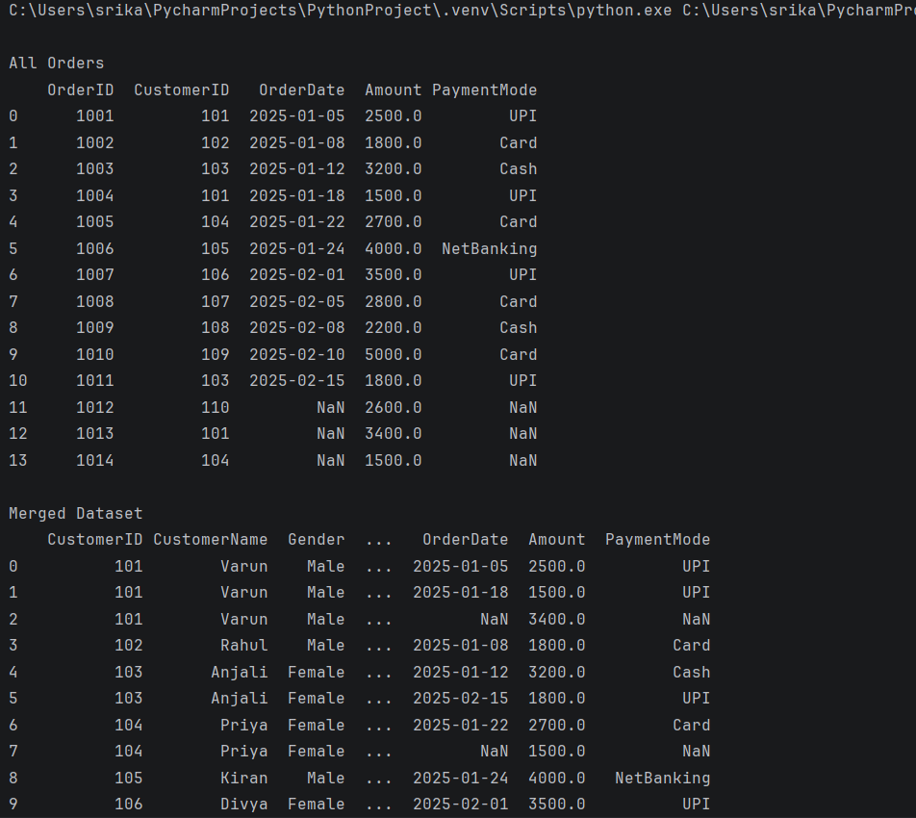
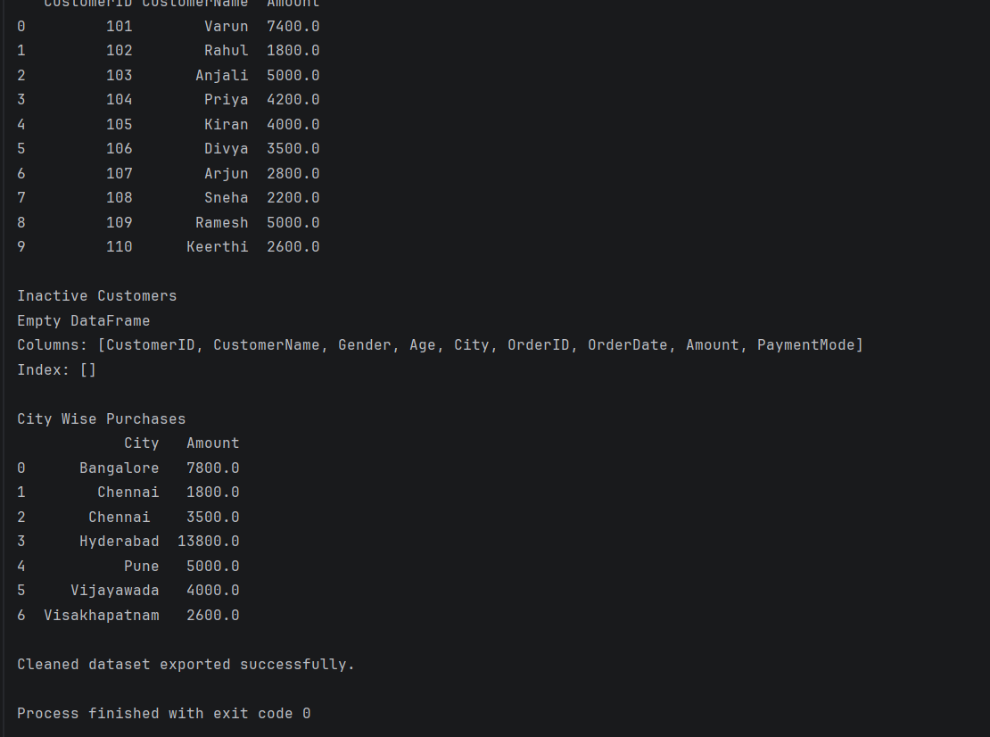
34. Online Shopping Order Analysis
Files:
• Orders.csv
• Products.csv
• Orders.json
• Orders.xml
Read order datasets from multiple formats. Merge product and order data, calculate
order value, identify cancelled orders, summarize category-wise sales, and export the
processed dataset.
Orders.csv
OrderID,ProductID,Quantity,OrderDate,Status
2001,P101,1,2025-03-01,Delivered
2002,P102,2,2025-03-02,Cancelled
2003,P103,3,2025-03-03,Delivered
2004,P104,5,2025-03-04,Delivered
2005,P105,4,2025-03-05,Cancelled
2006,P106,2,2025-03-06,Delivered
2007,P107,1,2025-03-07,Delivered
2008,P108,2,2025-03-08,Delivered

Products.csv
ProductID,ProductName,Category,Price
P101,Laptop,Electronics,65000
P102,Smartphone,Electronics,30000
P103,Shoes,Fashion,2500
P104,T-Shirt,Fashion,900
P105,Book,Education,600
P106,Headphones,Electronics,3500
P107,Backpack,Accessories,1800
P108,Watch,Accessories,4500
P109,Keyboard,Electronics,1200
P110,Water Bottle,Home,700

Orders.json
[
{
"OrderID":2009,
"ProductID":"P109",
"Quantity":3,
"OrderDate":"2025-03-09",
"Status":"Delivered"
},
{
"OrderID":2010,
"ProductID":"P110",
"Quantity":5,
"OrderDate":"2025-03-10",
"Status":"Cancelled"
},
{
"OrderID":2011,
"ProductID":"P102",
"Quantity":1,
"OrderDate":"2025-03-11",
"Status":"Delivered"
}
]

Orders.xml
<?xml version="1.0" encoding="UTF-8"?>
<Orders>
<Order>
<OrderID>2012</OrderID>
<ProductID>P103</ProductID>
<Quantity>2</Quantity>
<OrderDate>2025-03-12</OrderDate>
<Status>Delivered</Status>
</Order>
<Order>
<OrderID>2013</OrderID>
<ProductID>P106</ProductID>
<Quantity>1</Quantity>
<OrderDate>2025-03-13</OrderDate>
<Status>Cancelled</Status>
</Order>
<Order>
<OrderID>2014</OrderID>
<ProductID>P101</ProductID>
<Quantity>1</Quantity>
<OrderDate>2025-03-14</OrderDate>
<Status>Delivered</Status>
</Order>
</Orders>
Python code:
import pandas as pd
import xml.etree.ElementTree as ET
# -----------------------------
# Read CSV Files
# -----------------------------
orders_csv = pd.read_csv("Orders.csv")
products = pd.read_csv("Products.csv")
# -----------------------------
# Read JSON
# -----------------------------
orders_json = pd.read_json("Orders.json")
# -----------------------------
# Read XML
# -----------------------------
tree = ET.parse("Orders.xml")
root = tree.getroot()
xml_orders = []
for order in root.findall("Order"):
xml_orders.append({
"OrderID": int(order.find("OrderID").text),
"ProductID": order.find("ProductID").text,
"Quantity": int(order.find("Quantity").text),
"Status": order.find("Status").text
})
orders_xml = pd.DataFrame(xml_orders)
# -----------------------------
# Combine Orders
# -----------------------------
orders = pd.concat(
[orders_csv, orders_json, orders_xml],
ignore_index=True
)
print("\nCombined Orders")
print(orders)
# -----------------------------
# Merge Orders and Products
# -----------------------------
merged = pd.merge(
orders,
products,
on="ProductID",
how="left"
)
print("\nMerged Dataset")
print(merged)
# -----------------------------
# Calculate Order Value
# -----------------------------
merged["OrderValue"] = (
merged["Quantity"] *
merged["Price"]
)
print("\nOrder Value")
print(merged)
# -----------------------------
# Cancelled Orders
# -----------------------------
cancelled = merged[
merged["Status"] == "Cancelled"
]
print("\nCancelled Orders")
print(cancelled)
# -----------------------------
# Category Wise Sales
# -----------------------------
category_sales = merged.groupby(
"Category"
)["OrderValue"].sum().reset_index()
print("\nCategory Wise Sales")
print(category_sales)
# -----------------------------
# Remove Duplicates
# -----------------------------
merged = merged.drop_duplicates()
# -----------------------------
# Fill Missing Values
# -----------------------------
merged["Price"] = merged["Price"].fillna(0)
# -----------------------------
# Export Dataset
# -----------------------------
merged.to_csv(
"Processed_Orders.csv",
index=False
)
print("\nProcessed dataset exported successfully.")
output:
