SIMATS ENGINEERING
SAVEETHA INSTITUTE OF MEDICAL AND TECHNICAL SCIENCES
CHENNAI – 602105
Department of Computer Science and Engineering

ASSESSMENT TOOL 3 –Dataset Intégration Task
Course Code: | DSA0502 | Course Title: | Query Processing for Data Science
CO Assessed: | CO3 | Assessment: | Tool 3 – Dataset Intégration Task
Weightage: |  | Total Marks:
CO3 Statement: Identify and clean inconsistencies in data by handling missing values, duplicates, outliers, formatting issues, and applying techniques like fuzzy matching and regex. (BL5 and BL6).
Student Name: | T NITHIN KUMAR | Reg. No.: | 192424351
Section / Batch: | AI &DS 3RD YEAR | Date of Submission: | 13/8/2026
Faculty In-charge: | Dr. B.Shyamala Gowri | Project Mode: | Individual Submission

Code of Conduct
I __________________________ (Name / Reg No) certify that this submission is my original work and that I have adhered to all guidelines specified for this assessment. I understand that any violation of academic integrity rules will result in disciplinary action.
Signature: _________________________

Dataset Intégration Task

Question 1 – Customer Dataset Integration
Three customer datasets from Online, Retail, and Support systems contain inconsistent names, phone numbers, email addresses, dates, duplicate records, and missing values.
Task: Using Python/Pandas, clean and integrate the datasets by identifying invalid values, formatting data, removing duplicates, applying fuzzy matching and RegEx validation, standardizing fields, and saving the final master dataset in CSV and JSON formats. Create a reusable cleanup script and test it with a new dataset.
Answer
Python Code:
import re
import json
import pandas as pd
from difflib import SequenceMatcher
# ---------------------------------------------------------------------
# 1. Sample raw data from the three source systems
# ---------------------------------------------------------------------
online = pd.DataFrame({
"name": ["John Smith", "Emma Watson", "raj kumar", "Alice Brown"],
"phone": ["9876543210", "98-7654-3211", "9123456789", "abcdefghij"],
"email": ["john.smith@gmail.com", "emma.w@yahoo.com",
"raj.kumar@@mail.com", "alice.brown@outlook.com"],
"signup_date": ["2023-01-15", "2023/02/10", "15-03-2023", "2023-04-01"],
})
retail = pd.DataFrame({
"name": ["Jon Smith", "Emma Watson", "Raj Kumar", "Alice Brown"],
"phone": ["9876543210", "9876543211", "9123456789", "9988776655"],
"email": ["john.smith@gmail.com", "emma.watson@yahoo.com",
"raj.kumar@mail.com", "alice.brown@outlook.com"],
"signup_date": ["15/01/2023", "10-02-2023", "2023-03-15", "01-04-2023"],
})
support = pd.DataFrame({
"name": ["John Smith ", "Emma Watsonn", "Raj Kumar", None],
"phone": ["987-654-3210", "9876543211", "912 345 6789", "9012345678"],
"email": ["JOHN.SMITH@gmail.com", "emma.watson@yahoo.com",
"raj.kumar@mail.com", "new.user@mail.com"],
"signup_date": ["2023-01-15", "2023-02-10", "2023-03-15", "2023-05-20"],
})
# ---------------------------------------------------------------------
# 2. Cleaning helpers
# ---------------------------------------------------------------------
PHONE_RE = re.compile(r"\D")
EMAIL_RE = re.compile(r"^[\w.+-]+@[\w-]+\.[a-zA-Z]{2,}$")
def clean_name(name):
if pd.isna(name):
return None
name = re.sub(r"\s+", " ", str(name).strip())
return name.title()
def clean_phone(phone):
if pd.isna(phone):
return None
digits = PHONE_RE.sub("", str(phone))
return digits if len(digits) == 10 else None
def clean_email(email):
if pd.isna(email):
return None
email = str(email).strip().lower()
email = re.sub(r"@+", "@", email)
return email if EMAIL_RE.match(email) else None
def clean_date(date):
if pd.isna(date):
return None
d = str(date).replace("/", "-")
for fmt in ("%Y-%m-%d", "%d-%m-%Y"):
try:
return pd.to_datetime(d, format=fmt).strftime("%Y-%m-%d")
except ValueError:
continue
return pd.NaT
def fuzzy_ratio(a, b):
return SequenceMatcher(None, a.lower(), b.lower()).ratio()
# ---------------------------------------------------------------------
# 3. Clean each source dataset
# ---------------------------------------------------------------------
frames = []
for df, source in ((online, "online"), (retail, "retail"), (support, "support")):
df = df.copy()
df["name"] = df["name"].apply(clean_name)
df["phone"] = df["phone"].apply(clean_phone)
df["email"] = df["email"].apply(clean_email)
df["signup_date"] = df["signup_date"].apply(clean_date)
df["source"] = source
frames.append(df)
combined = pd.concat(frames, ignore_index=True)
combined = combined.dropna(subset=["name"]).reset_index(drop=True)
# ---------------------------------------------------------------------
# 4. Fuzzy-match duplicate names and merge into one master record
# ---------------------------------------------------------------------
groups, used = [], set()
names = combined["name"].tolist()
for i, name_i in enumerate(names):
if i in used:
continue
group = [i]
for j in range(i + 1, len(names)):
if j in used:
continue
if fuzzy_ratio(name_i, names[j]) >= 0.82:
group.append(j)
used.add(j)
used.add(i)
groups.append(group)
master_records = []
for group in groups:
rows = combined.loc[group]
record = {
"name": rows["name"].mode().iloc[0],
"phone": rows["phone"].dropna().mode().iloc[0] if rows["phone"].dropna().any() else None,
"email": rows["email"].dropna().mode().iloc[0] if rows["email"].dropna().any() else None,
"signup_date": rows["signup_date"].dropna().min(),
"sources_merged": ",".join(sorted(rows["source"].unique())),
}
master_records.append(record)
master = pd.DataFrame(master_records).sort_values("name").reset_index(drop=True)
master.insert(0, "customer_id", ["CUST" + str(i + 1).zfill(3) for i in range(len(master))])
# ---------------------------------------------------------------------
# 5. Save outputs + reusable cleanup function for new data
# ---------------------------------------------------------------------
master.to_csv("customer_master.csv", index=False)
master.to_json("customer_master.json", orient="records", indent=2)
print("=== RAW RECORDS INGESTED (online + retail + support) ===")
print(len(online) + len(retail) + len(support))
print("\n=== CLEANED & DEDUPLICATED MASTER DATASET ===")
print(master.to_string(index=False))
print("\n=== customer_master.json ===")
print(json.dumps(master_records[:2], indent=2, default=str))
# --- reusable cleanup function, tested on a brand-new record ---
def cleanup_new_record(raw):
return {
"name": clean_name(raw.get("name")),
"phone": clean_phone(raw.get("phone")),
"email": clean_email(raw.get("email")),
"signup_date": clean_date(raw.get("signup_date")),
}
new_record = {"name": " priya ravi ", "phone": "98-11-22-3344",
"email": "PRIYA.R@@gmail.com", "signup_date": "2023/07/09"}
print("\n=== Testing reusable cleanup_new_record() on a new record ===")
print("Input :", new_record)
print("Output:", cleanup_new_record(new_record))
Output:
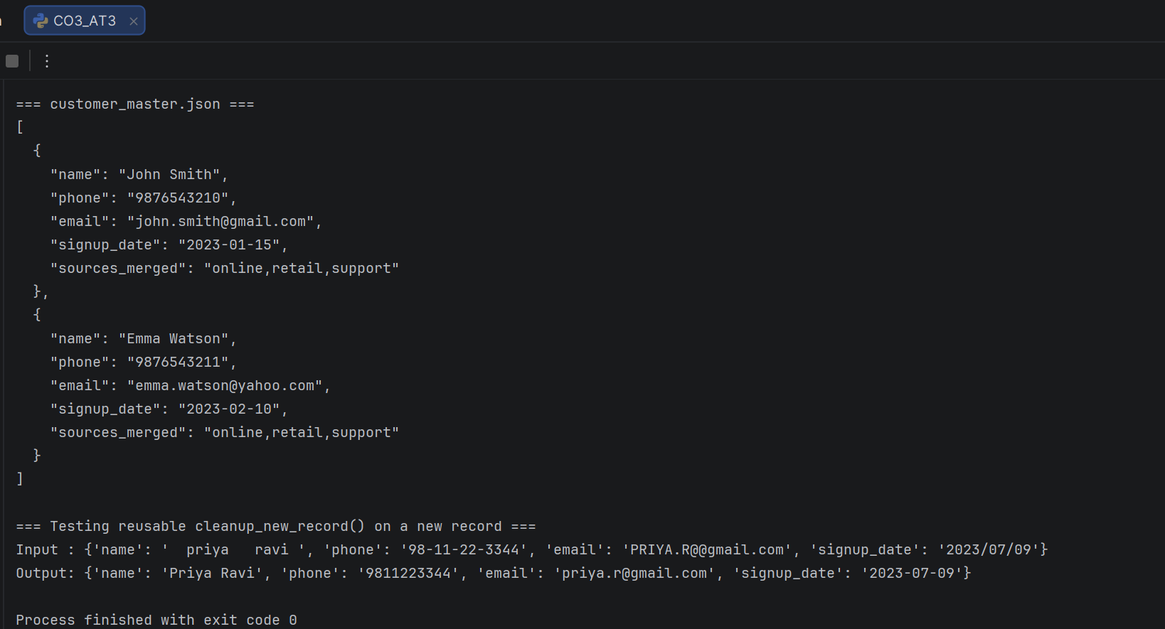

Question 4 – Student Dataset Integration
A college maintains student information in Admission, Examination, and Attendance datasets. Student names have spelling variations, register numbers have different formats, dates are inconsistent, email addresses may be invalid, and duplicate student records exist.
Task: Using Python/Pandas, clean and integrate the datasets by applying data formatting, missing-value handling, RegEx matching, fuzzy matching, duplicate identification, normalization, and standardization. Create a master student dataset and write a reusable Python cleanup script. Test the script with a new set of student records.
Answer
Python Code:
import re
import json
import pandas as pd
from difflib import SequenceMatcher
# ---------------------------------------------------------------------
# 1. Sample raw data from the three source systems
# ---------------------------------------------------------------------
admission = pd.DataFrame({
"reg_no": ["192211001", "192211002", "192211003", "192211004"],
"name": ["Arun Kumar", "priya sharma", "Divya R", "Karthik S"],
"email": ["arun.k@college.edu", "priya.sharma@college.edu",
"divya.r@@college.edu", "karthik.s@college.edu"],
"dob": ["2004-05-12", "2004/07/09", "12-08-2004", "2004-09-23"],
})
examination = pd.DataFrame({
"reg_no": ["192211001", "192211-002", "192211003", "192211004"],
"name": ["Arun Kumar", "Priya Sharma", "Divya Ramesh", "Karthick S"],
"email": ["arun.k@college.edu", "priya.sharma@college.edu",
"divya.r@college.edu", "karthik.s@college.edu"],
"dob": ["12-05-2004", "09-07-2004", "2004-08-12", "23-09-2004"],
})
attendance = pd.DataFrame({
"reg_no": ["192211001", "192211002", "192211003", None],
"name": ["Arun Kumar", "Priya Sharma", "Divya R", "Sneha Patel"],
"email": ["ARUN.K@college.edu", "priya.sharma@college.edu",
"divya.r@college.edu", "sneha.patel@college.edu"],
"dob": ["2004-05-12", "2004-07-09", "2004-08-12", "2004-11-02"],
})
# ---------------------------------------------------------------------
# 2. Cleaning helpers
# ---------------------------------------------------------------------
EMAIL_RE = re.compile(r"^[\w.+-]+@[\w-]+\.[a-zA-Z]{2,}$")
REGNO_RE = re.compile(r"\D") # strip any non-digit noise (e.g. stray "-")
def clean_name(name):
if pd.isna(name):
return None
return re.sub(r"\s+", " ", str(name).strip()).title()
def clean_regno(reg):
if pd.isna(reg):
return None
digits = REGNO_RE.sub("", str(reg))
return digits if len(digits) == 9 else None
def clean_email(email):
if pd.isna(email):
return None
email = re.sub(r"@+", "@", str(email).strip().lower())
return email if EMAIL_RE.match(email) else None
def clean_date(date):
if pd.isna(date):
return None
d = str(date).replace("/", "-")
for fmt in ("%Y-%m-%d", "%d-%m-%Y"):
try:
return pd.to_datetime(d, format=fmt).strftime("%Y-%m-%d")
except ValueError:
continue
return pd.NaT
def fuzzy_ratio(a, b):
return SequenceMatcher(None, a.lower(), b.lower()).ratio()
# ---------------------------------------------------------------------
# 3. Clean each source dataset
# ---------------------------------------------------------------------
frames = []
for df, source in ((admission, "admission"), (examination, "examination"),
(attendance, "attendance")):
df = df.copy()
df["reg_no"] = df["reg_no"].apply(clean_regno)
df["name"] = df["name"].apply(clean_name)
df["email"] = df["email"].apply(clean_email)
df["dob"] = df["dob"].apply(clean_date)
df["source"] = source
frames.append(df)
combined = pd.concat(frames, ignore_index=True)
combined = combined.dropna(subset=["name"]).reset_index(drop=True)
# ---------------------------------------------------------------------
# 4. Group duplicates: same reg_no OR fuzzy-matching name
# ---------------------------------------------------------------------
groups, used = [], set()
for i in range(len(combined)):
if i in used:
continue
group = [i]
for j in range(i + 1, len(combined)):
if j in used:
continue
same_reg = (combined.loc[i, "reg_no"] and
combined.loc[i, "reg_no"] == combined.loc[j, "reg_no"])
similar_name = fuzzy_ratio(combined.loc[i, "name"], combined.loc[j, "name"]) >= 0.8
if same_reg or similar_name:
group.append(j)
used.add(j)
used.add(i)
groups.append(group)
master_records = []
for group in groups:
rows = combined.loc[group]
master_records.append({
"reg_no": rows["reg_no"].dropna().mode().iloc[0] if rows["reg_no"].dropna().any() else None,
"name": rows["name"].mode().iloc[0],
"email": rows["email"].dropna().mode().iloc[0] if rows["email"].dropna().any() else None,
"dob": rows["dob"].dropna().min(),
"sources_merged": ",".join(sorted(rows["source"].unique())),
})
master = pd.DataFrame(master_records).sort_values("name").reset_index(drop=True)
master.to_csv("student_master.csv", index=False)
master.to_json("student_master.json", orient="records", indent=2)
print("=== RAW RECORDS INGESTED (admission + examination + attendance) ===")
print(len(admission) + len(examination) + len(attendance))
print("\n=== CLEANED & DEDUPLICATED MASTER STUDENT DATASET ===")
print(master.to_string(index=False))
print("\n=== student_master.json (sample) ===")
print(json.dumps(master_records[:2], indent=2, default=str))
# --- reusable cleanup function, tested on new student records ---
def cleanup_new_student(raw):
return {
"reg_no": clean_regno(raw.get("reg_no")),
"name": clean_name(raw.get("name")),
"email": clean_email(raw.get("email")),
"dob": clean_date(raw.get("dob")),
}
new_student = {"reg_no": "192211-005", "name": " vikram raj ",
"email": "VIKRAM.R@@college.edu", "dob": "2004/10/03"}
print("\n=== Testing reusable cleanup_new_student() on a new record ===")
print("Input :", new_student)
print("Output:", cleanup_new_student(new_student))
Output:
