SIMATS ENGINEERING (SAVEETHA SCHOOL OF ENGINEERING)
Department of Artificial Intelligence and Data Science
ASSESSMENT TOOL 3 – Mock Interview

Course Code: | DSA03 | Course Title: | Natural Language Processing
CO Assessed: | CO5 – Articulation | Assessment: | Assessment Tool 3 – Mock Interview
Weightage: | 30% of CIA
CO5 Statement: | Implement semantic models using predicate logic, word sense disambiguation and validate information retrieval techniques. (BL-5)
Student Name: | T NITHIN KUMAR | Reg. No.: | 192424351
Section / Batch: | AI & DS 2024 | Date:

Code of Conduct
I T NITHIN KUMAR(192424351) (Name / Reg No) certify that this submission is my original work and that I have adhered to the guidelines specified for this assessment. I understand that any violation of academic integrity rules will result in disciplinary action.
Signature of the Student: _________________________

Instructions
- Start the mock interview by entering the provided ChatGPT prompt exactly as given in the Annexure A in the next page. Enter your Name and Register Number when requested.
- Answer all 10 interview questions independently and in your own words using mobile chatgpt voice. Do not copy content from external sources or use AI-generated responses during the interview.
- Provide detailed and meaningful answers with appropriate technical terminology, examples, and justifications wherever applicable. One-line answers may lead to lower scores.
- Complete the interview in a single session. Ensure that all 10 questions are answered before requesting the final evaluation and assessment report.
- Submit the final ChatGPT-generated report printout, including the interview questions, your responses, question-wise rubric evaluation, and the Student Average Final Mark, as proof of completion.
- Duration: 30 minutes.

Section / Topic | Focus | Question No.
Discourse & Reference Resolution | Understanding discourse, anaphora resolution, reference tracking, and contextual interpretation in text | Q1
Text Coherence & Discourse Structure | Analyzing coherence relations, discourse organization, and maintaining meaningful text flow | Q2
Dialog Acts & Interpretation | Identifying dialog acts, speaker intentions, and conversational meaning | Q3
Dialog and Conversational Agents | Architecture, components, and working of conversational agents/chatbots | Q4
Language Generation Architecture | Stages of Natural Language Generation (NLG), pipeline architecture, and applications | Q5
Surface Realization & Discourse Planning | Transforming semantic representations into grammatically correct sentences and planning discourse | Q6
Machine Translation – Transfer Approach | Translation process using transfer-based methods and practical applications | Q7
Machine Translation – Interlingua Approach | Language-independent representation and multilingual translation framework | Q8
Statistical Approaches in NLP | Statistical language models, probability-based language generation, and machine translation | Q9
Integrated Case Study (Analytical & Problem Solving) | Real-world scenario involving discourse analysis, conversational agents, language generation, and machine translation | Q10

Annexure A – Mock Interview
CHATGPT PROMPT: copy and paste in your chatgpt
MOCK INTERVIEW ASSESSMENT – NLP (Language Generation and Discourse Analysis)
Act as an expert Technical Interview Panel for Computer Science and Engineering students.
Interview Domain:
Language Generation and Discourse Analysis
Topics:
- Discourse
- Reference Resolution
- Text Coherence
- Discourse Structure
- Coherence
- Dialog and Conversational Agents
- Dialog Acts
- Interpretation
- Language Generation
- Architecture
- Surface Realization
- Discourse Planning
- Machine Translation
- Transfer Metaphor
- Interlingua
- Statistical Approaches
Interview Instructions:
Step 1:
Ask the student to enter:
Student Name:
Register Number:
Step 2:
Conduct a technical interview consisting of exactly 10 questions.
Rules:
- Ask only one question at a time.
- Wait for the student's response.
- Ask conceptual, analytical, application-based, and problem-solving questions.
- Include at least:
  - 2 questions on Discourse and Coherence
  - 2 questions on Conversational Agents and Dialog Acts
  - 2 questions on Language Generation
  - 2 questions on Machine Translation
  - 2 analytical or scenario-based questions
Step 3:
Store every question and answer.
Step 4:
After Question 10, evaluate the student using the following rubric.
RUBRIC
Technical Knowledge (25)
Level 4:
Demonstrates strong and accurate subject knowledge with in-depth understanding
Level 3:
Shows good knowledge with minor gaps
Level 2:
Basic knowledge with noticeable errors
Level 1:
Lacks fundamental technical knowledge
Problem Solving (25)
Level 4:
Solves problems logically and applies concepts effectively in real scenarios
Level 3:
Applies concepts with moderate accuracy
Level 2:
Limited problem-solving ability; requires guidance
Level 1:
Unable to solve or apply concepts
Analytical Thinking (20)
Level 4:
Analyzes questions critically and provides well-structured logical answers
Level 3:
Provides reasonable analysis with some structure
Level 2:
Superficial or partially structured responses
Level 1:
No analytical thinking demonstrated
Communication (15)
Level 4:
Communicates clearly, confidently and professionally using appropriate terminology
Level 3:
Communicates well with minor hesitation
Level 2:
Communication lacks clarity or confidence
Level 1:
Unable to communicate effectively
Confidence (15)
Level 4:
Displays high confidence, positive attitude and professional behavior throughout
Level 3:
Shows good confidence with minor issues
Level 2:
Low confidence and inconsistent behavior
Level 1:
Lacks confidence and professionalism
MARK CALCULATION
Level 4 = 100% of weightage
Level 3 = 75% of weightage
Level 2 = 50% of weightage
Level 1 = 25% of weightage
Technical Knowledge = 25 marks
Problem Solving = 25 marks
Analytical Thinking = 20 marks
Communication = 15 marks
Confidence = 15 marks
Calculate:
Final Score = Sum of all rubric scores
Step 5:
Generate the final report in the exact format below.

MOCK INTERVIEW ASSESSMENT REPORT
Student Name:
Register Number:
INTERVIEW QUESTIONS AND RESPONSES
Q1:
Question Asked:
Student Response:
Q2:
Question Asked:
Student Response:
Q3:
Question Asked:
Student Response:
Q4:
Question Asked:
Student Response:
Q5:
Question Asked:
Student Response:
Q6:
Question Asked:
Student Response:
Q7:
Question Asked:
Student Response:
Q8:
Question Asked:
Student Response:
Q9:
Question Asked:
Student Response:
Q10:
Question Asked:
Student Response:
RUBRIC EVALUATION
Criterion | Weightage | Assigned Level | Marks Awarded
Technical Knowledge | 25 | Level X | XX
Problem Solving | 25 | Level X | XX
Analytical Thinking | 20 | Level X | XX
Communication | 15 | Level X | XX
Confidence | 15 | Level X | XX
SUMMARY TABLE
Technical Knowledge (25) | Problem Solving (25) | Analytical Thinking (20) | Communication (15) | Confidence (15) | SubQ Total | Student Avg Final Mark
Level X | Level X | Level X | Level X | Level X | XX.X | XX.X
OVERALL FEEDBACK
Strengths:
- List strengths
Areas for Improvement:
- List improvements
Interview Readiness:
- Excellent / Good / Average / Needs Improvement
End the report after the Interview Readiness section.
After evaluating each answer, do NOT display the marks immediately.
Store the evaluation internally.
After Question 10 is completed:
1. Generate a Question-wise Evaluation Table for all 10 questions.
2. For each question assign:
- Technical Knowledge Level
- Problem Solving Level
- Analytical Thinking Level
- Communication Level
- Confidence Level
- SubQ Total
3. Calculate SubQ Total using:
Level 4 = 100% weightage
Level 3 = 75% weightage
Level 2 = 50% weightage
Level 1 = 25% weightage
4. Calculate Student Avg Final Mark as:

Average of all 10 SubQ Totals
5. Display:
- Complete interview questions
- Student answers
- Question-wise evaluation table
- Student Avg Final Mark
- Overall strengths
- Areas for improvement
- Interview readiness

Student Name: T NITHIN KUMAR
Register Number: 192424351
INTERVIEW QUESTIONS AND RESPONSES
Q1. Discourse & Reference Resolution
Question: What is reference resolution? Why is it difficult?
Response: Reference resolution identifies what a pronoun refers to. It can be difficult when multiple people or objects are possible references. NLP uses grammar, context, and semantic information to select the correct one.

Q2. Text Coherence
Question: What makes a text coherent?
Response: A coherent text has logically connected sentences. Relationships such as cause-effect, contrast, and sequence help maintain meaningful flow.

Q3. Dialog Acts
Question: What are dialog acts?
Response: Dialog acts represent the purpose of an utterance. Examples include Request, Question, Inform, Greeting, and Confirmation. They help a chatbot understand user intention.

Q4. Conversational Agents
Question: How does a conversational agent work?
Response: It understands the user's input, identifies the intent, maintains conversation context, decides an action, and generates a suitable response using NLU and NLG.

Q5. Natural Language Generation
Question: What is Natural Language Generation?
Response: NLG converts structured information into natural language. For example, Student + Buy + Book can become “The student bought a book.”

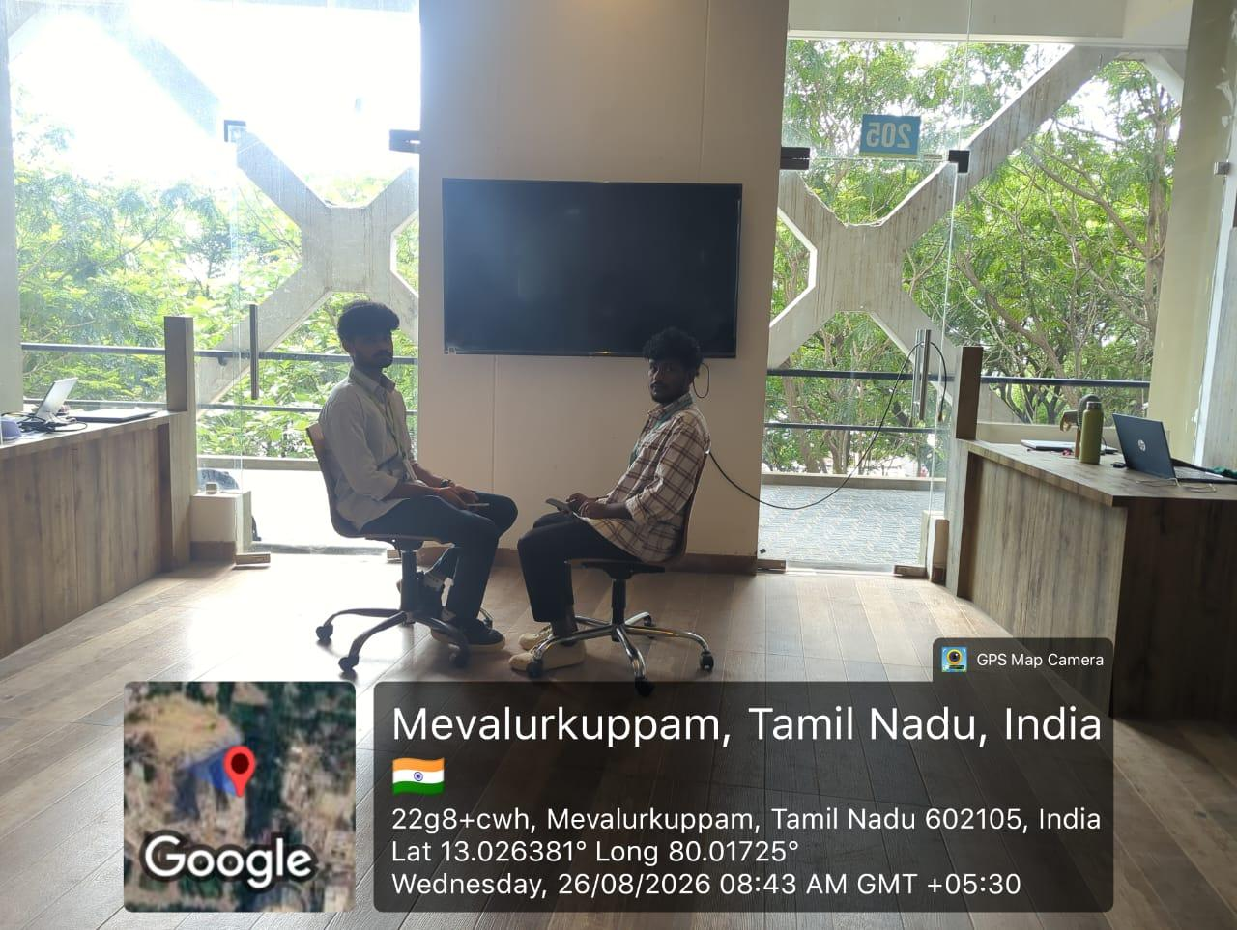

Rubrics for Calculation

Criteria | Weightage | Level 4 (Exemplary) | Level 3 (Proficient) | Level 2 (Developing) | Level 1 (Beginning)
Technical Knowledge | 25 | Demonstrates strong and accurate subject knowledge with in-depth understanding | Shows good knowledge with minor gaps | Basic knowledge with noticeable errors | Lacks fundamental technical knowledge
Problem Solving | 25 | Solves problems logically and applies concepts effectively in real scenarios | Applies concepts with moderate accuracy | Limited problem-solving ability; requires guidance | Unable to solve or apply concepts
Analytical Thinking | 20 | Analyzes questions critically and provides well-structured, logical answers | Provides reasonable analysis with some structure | Superficial or partially structured responses | No analytical thinking demonstrated
Communication | 15 | Communicates clearly, confidently, and professionally with proper terminology | Communicates well with minor hesitation | Communication lacks clarity or confidence | Unable to communicate effectively
Confidence | 15 | Displays high confidence, positive attitude, and professional behavior throughout | Shows good confidence with minor issues | Low confidence; inconsistent behavior | Lacks confidence and professionalism

Q. No. / Criteria Level | Problem Understanding | Algorithm Design | Use of Control Structures | Pseudocode Structure | Completeness | Sub. Total | Total %
1
2
3
4
5
6
7
8
9
10

Faculty In-charge | Course Coordinator | Program Director
Signature: _______________ | Signature: _______________ | Signature: _______________
Date: ___________________ | Date: ___________________ | Date: ___________________

