Quantization Results
MobileNet
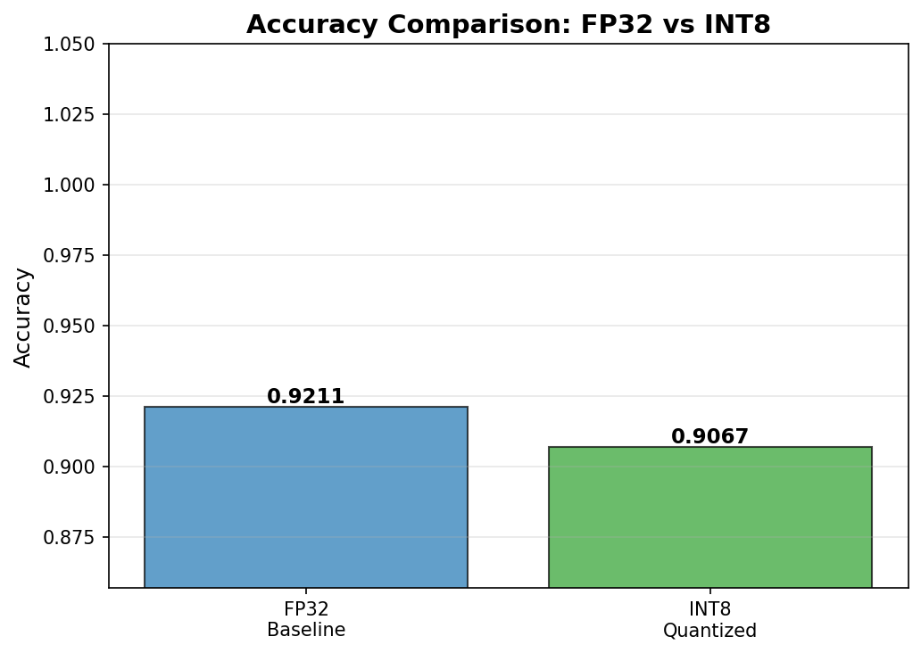
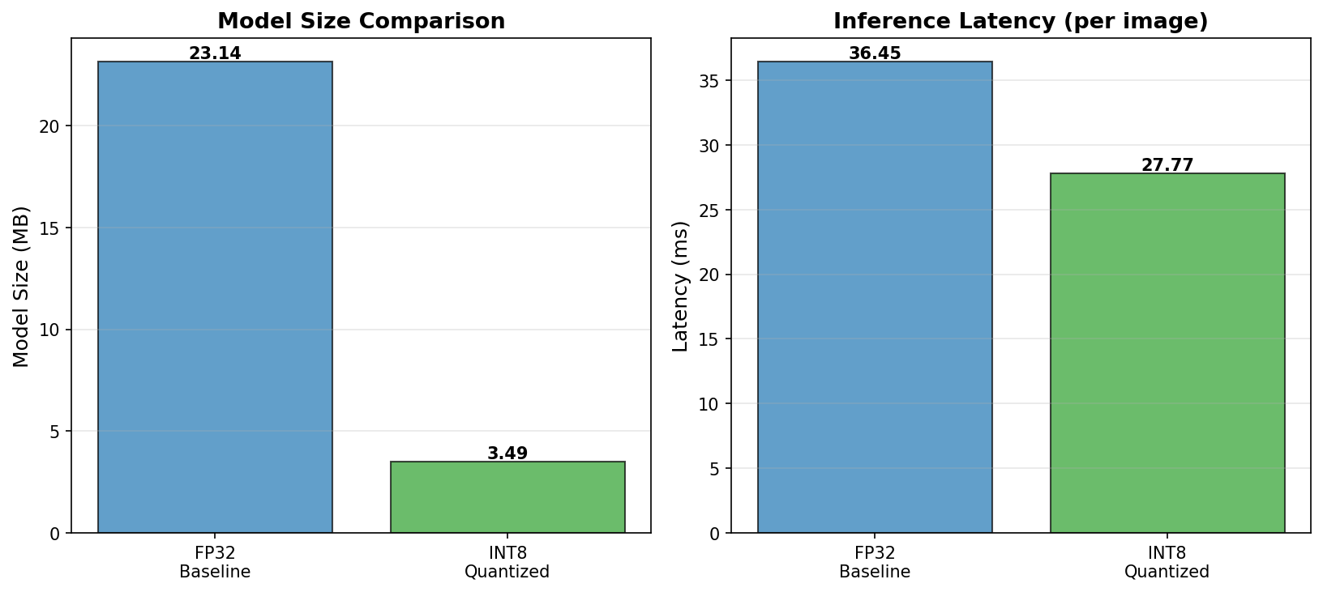
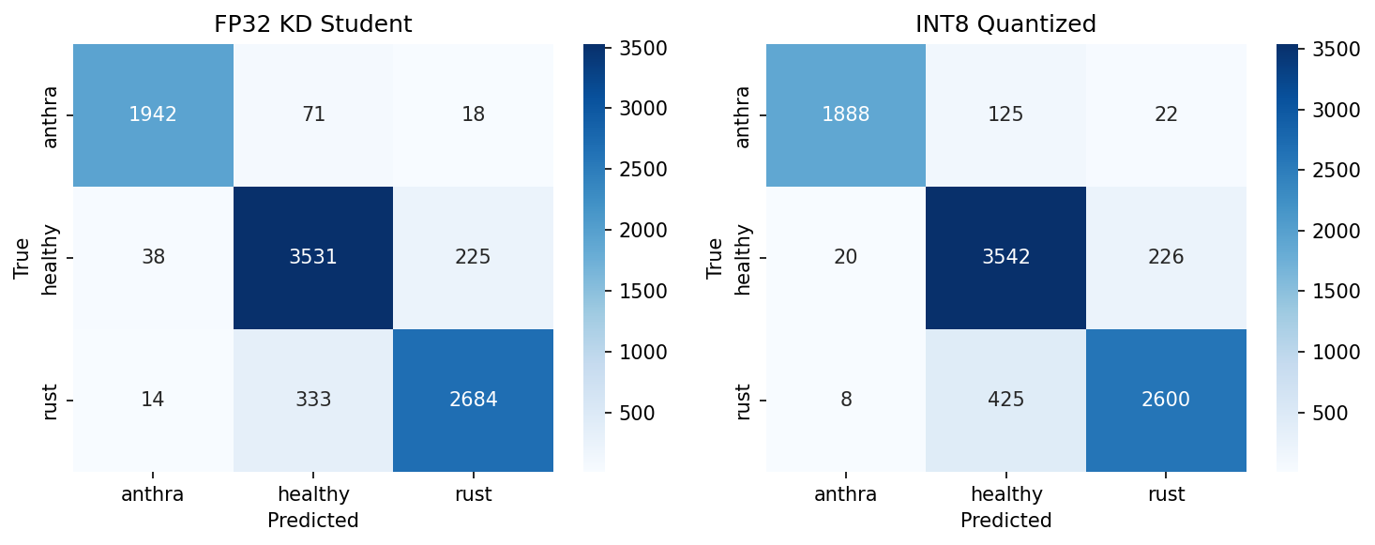

DenseNet121

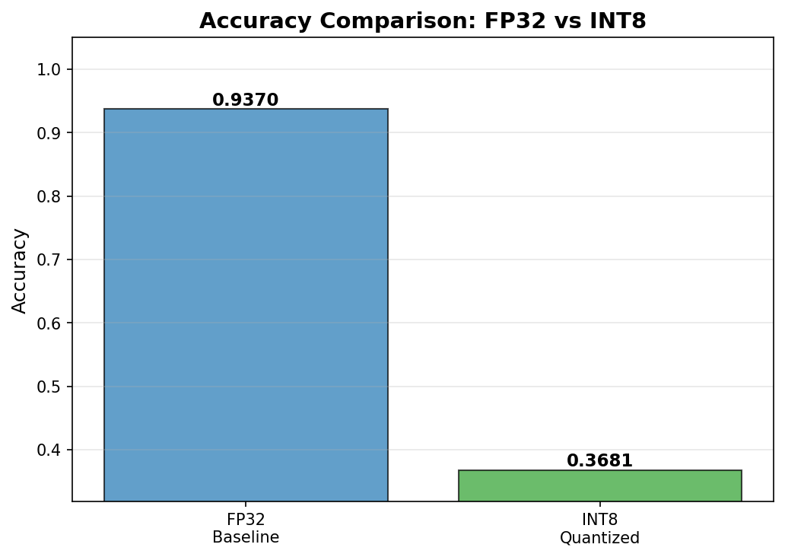
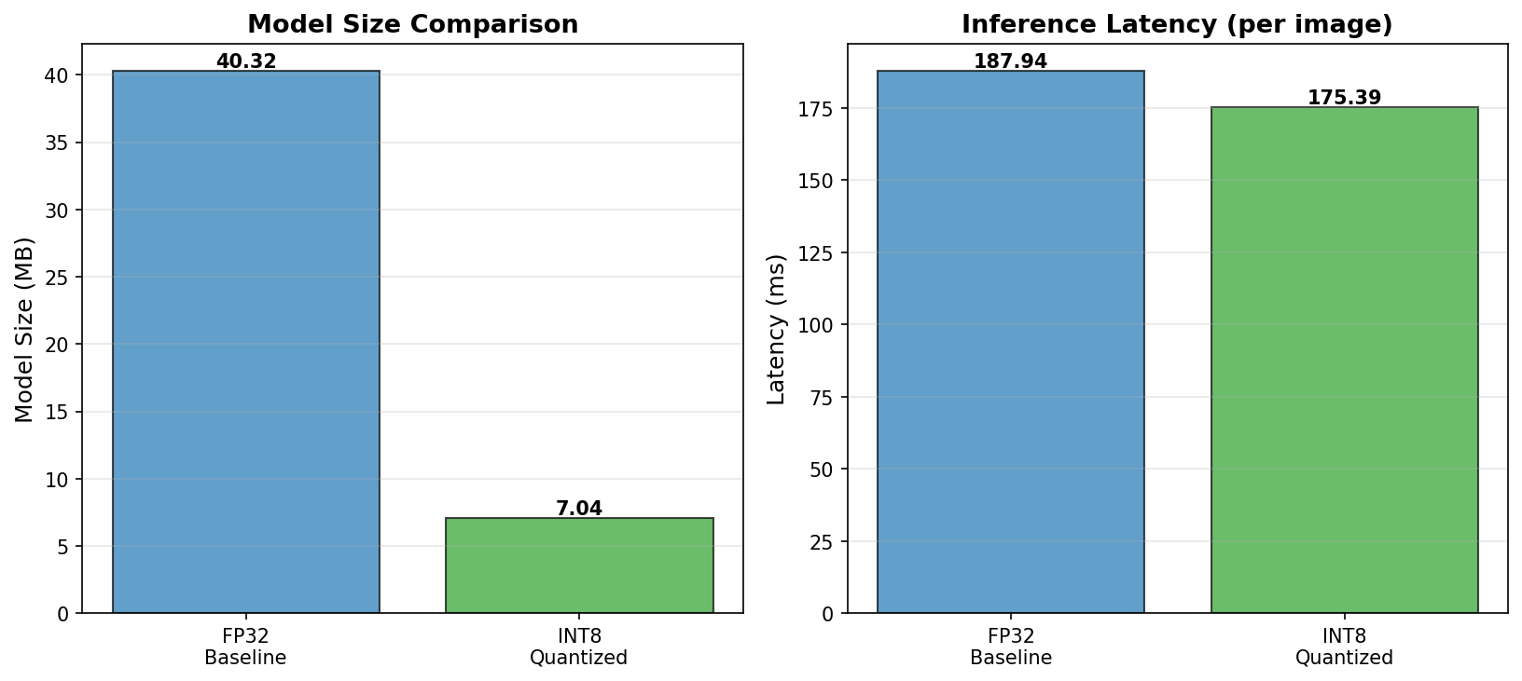

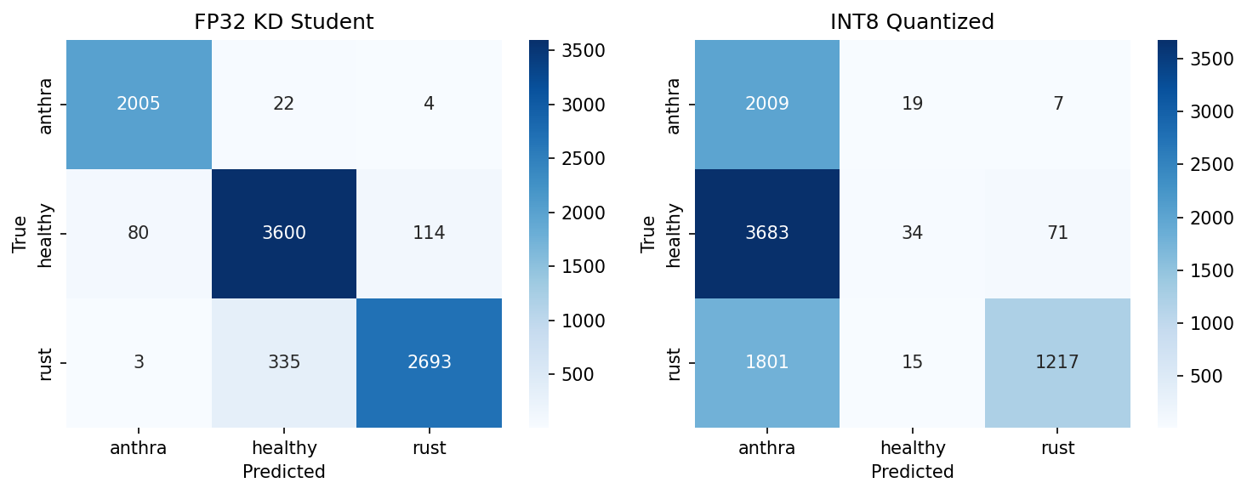

EfficientNetB1

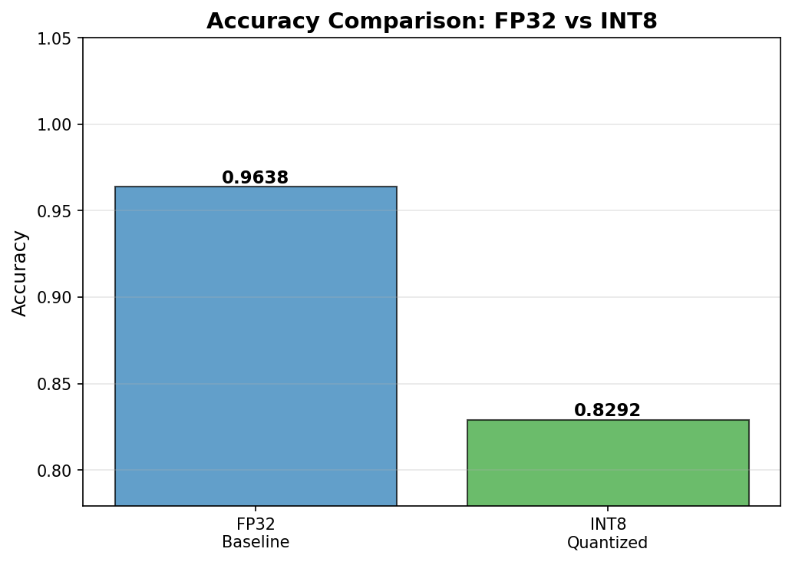
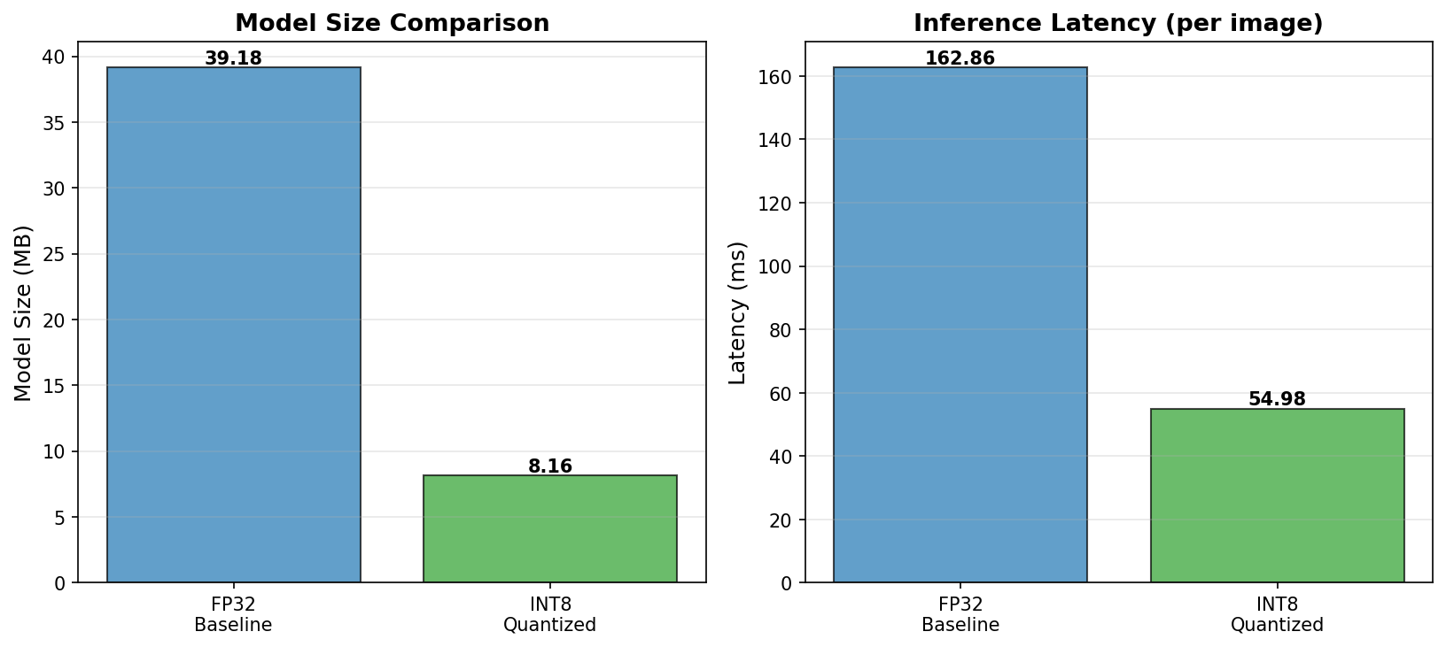
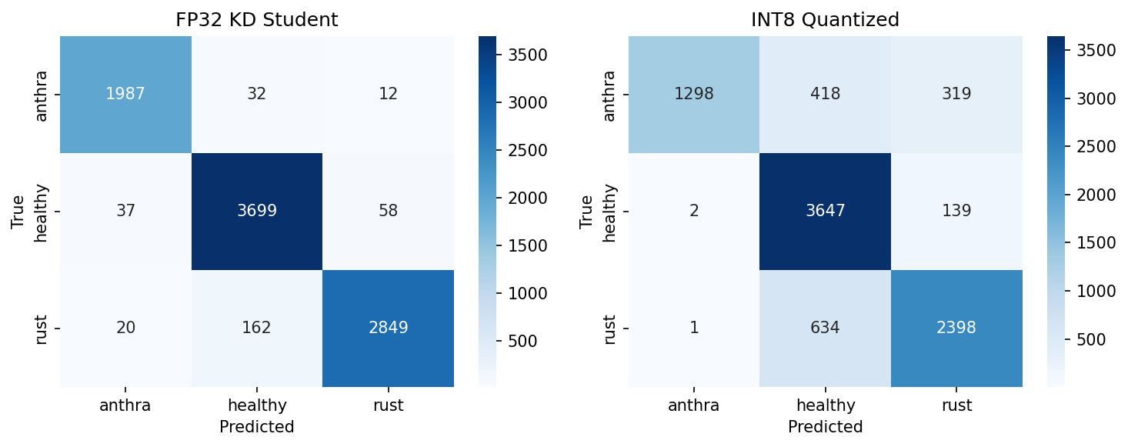

ResNet101

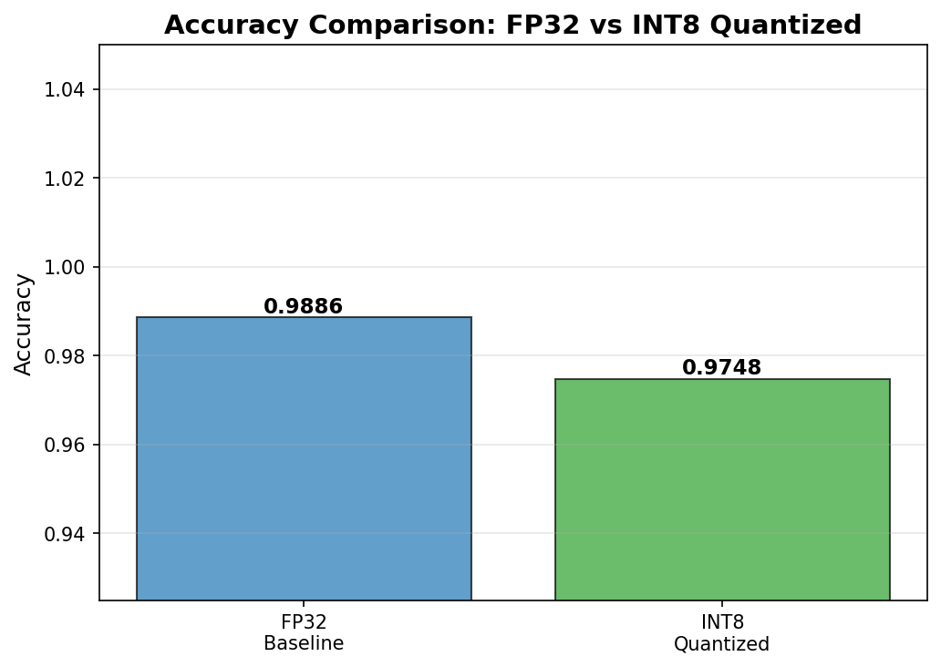
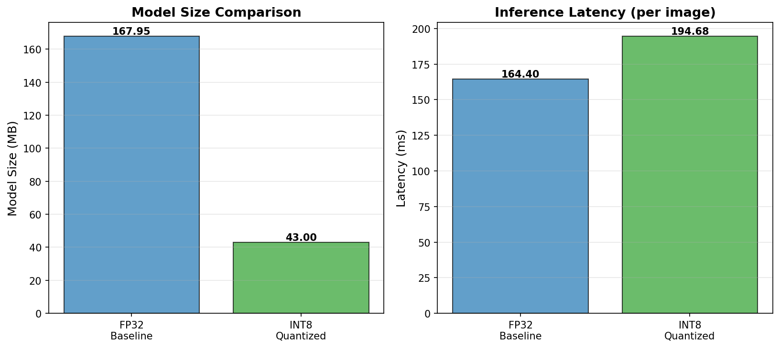

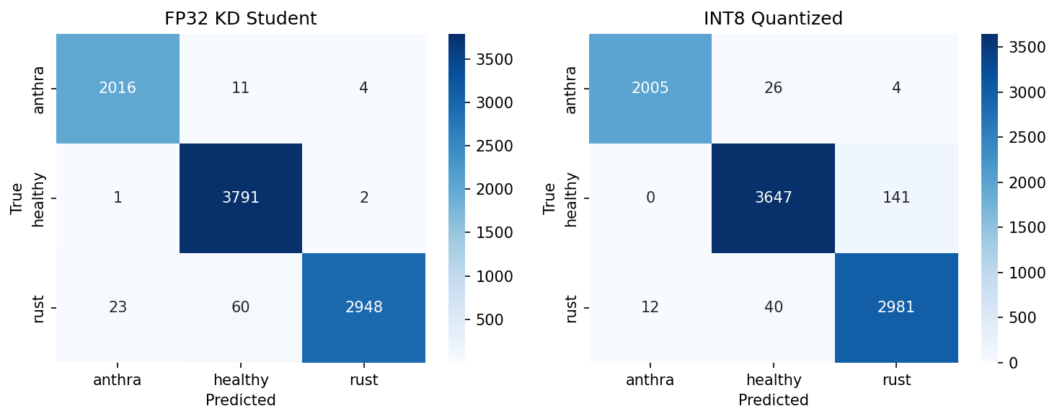

Xception

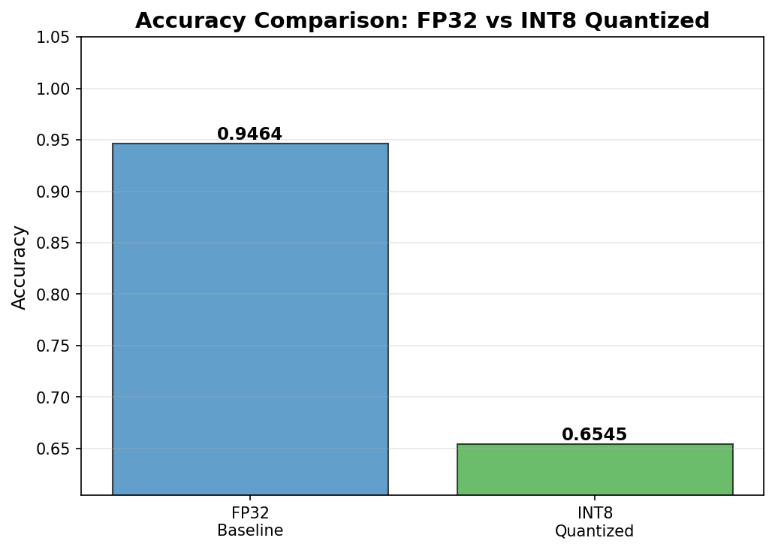

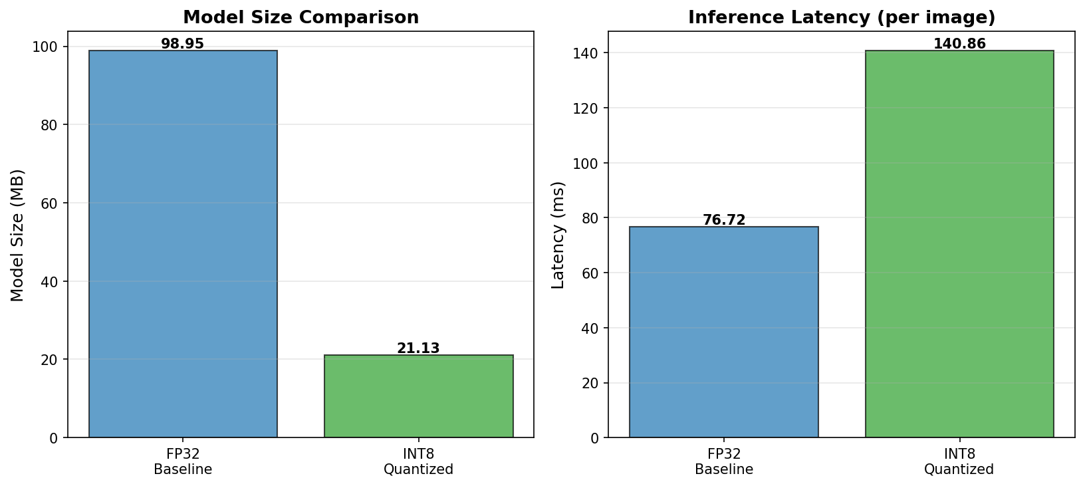
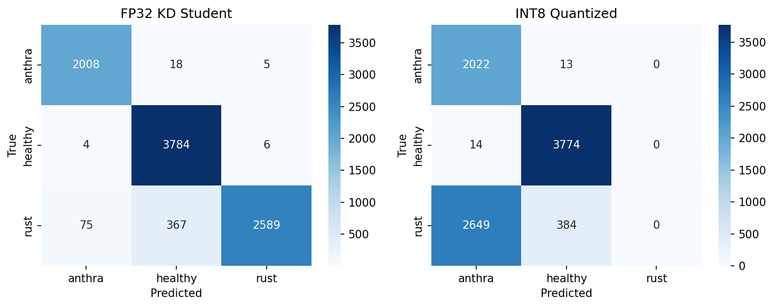

Comparison Table

Model | Metrics | FP32 | INT8
DenseNet121 | Accuracy | 94 | 37
 | Size (MB) | 41 | 7
 | Latency (MS) | 187.9 | 175.3
MobileNet | Accuracy | 92 | 91
 | Size (MB) | 23.7 | 3.5
 | Latency (MS) | 36.8 | 27.80
ResNet101 | Accuracy | 98.8 | 98.8
 | Size (MB) | 172 | 44
 | Latency (MS) | 164.4 | 194.7
Xception | Accuracy | 94.6 | 65.4
 | Size (MB) | 101.3 | 21.6
 | Latency (MB) | 76.7 | 140.86
EfficientNetB1 | Accuracy | 96.3 | 82.9
 | Size (MB) | 40.1 | 8.3
 | Latency (MS) | 162.8 | 54.9

