Installation of jenkins usinfg puppet code

Directory Structure of puppet

Cd /etc/puppet/

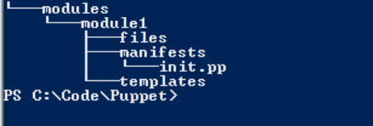

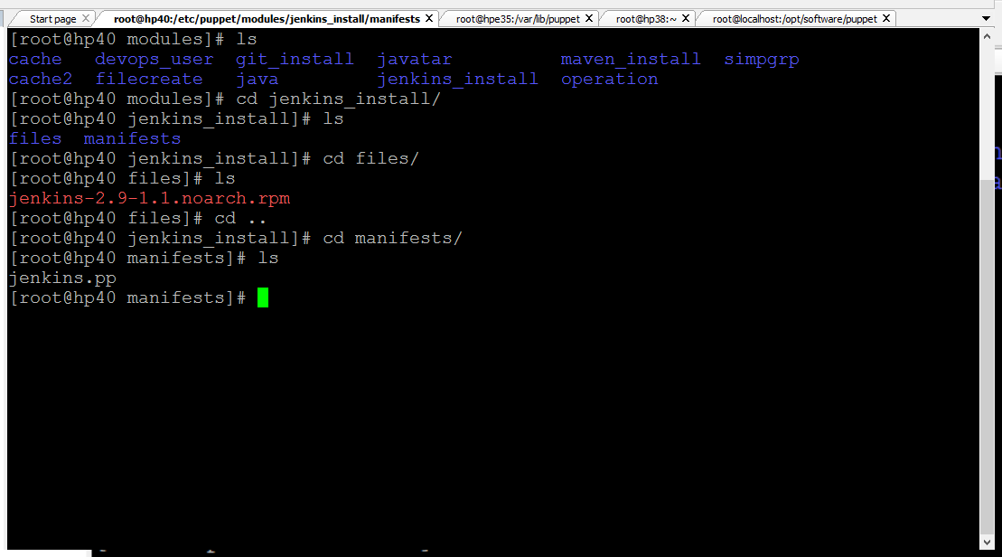

class jenkins_install::jenkins {

file { "/tmp/jenkins-2.9-1.1.noarch.rpm" :

ensure => 'present',

source => 'puppet:///modules/jenkins_install/jenkins-2.9-1.1.noarch.rpm',

}

exec { "install" :

require => File['/tmp/jenkins-2.9-1.1.noarch.rpm'],

path => ["/bin/", "/usr/bin/", "/sbin/", "/usr/sbin/"],

cwd => '/tmp/',

command => 'rpm -ivh jenkins-2.9-1.1.noarch.rpm',

}

}

