FTP

**FTP** – File Transfer Protocol **vsftpd** – Very Secure FTP Server

**Installation and Transfer the file**

Following steps are given below:

1. Install vsftpd and ftp both packages

*yum install vsftpd ftp - y*

1. Open vsftpd configuration file

*cd /etc/vsftpd*

*vim vsftpd*

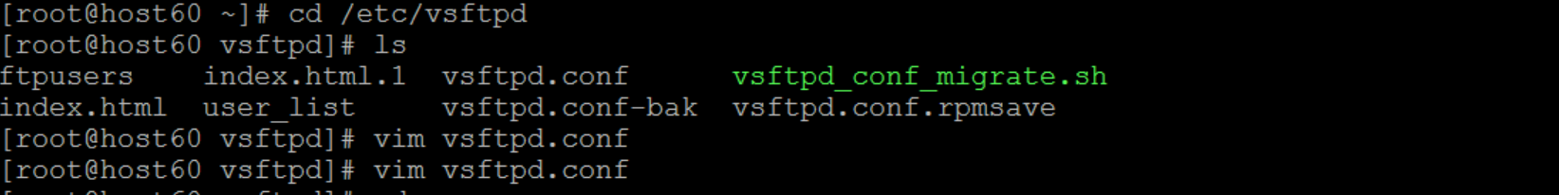

change -> *anonymous_enable = yes*

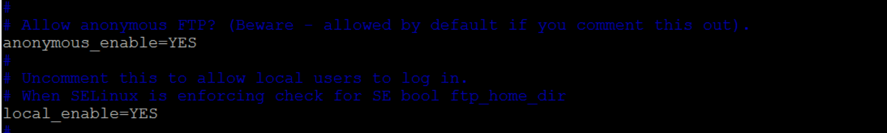

1. Start vsftpd service and check status , enable :

*service vsftpd start*

*service vsftpd status*

*systemctl enable vsftpd*

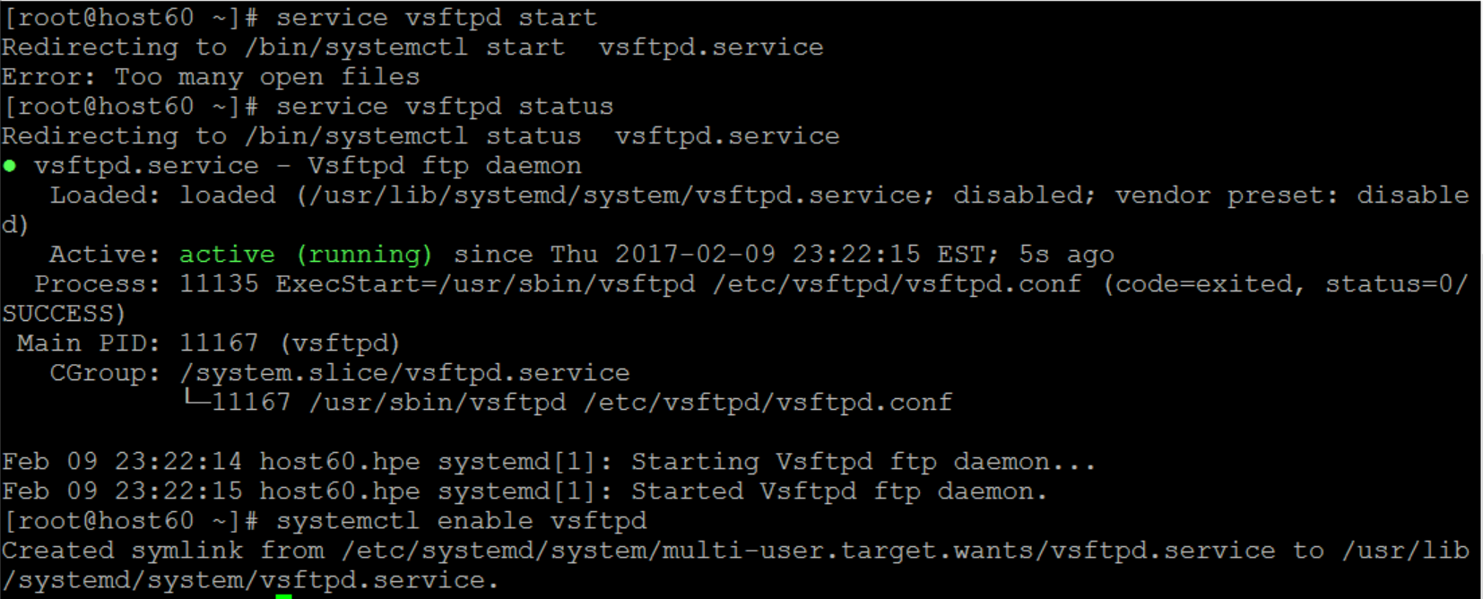

1. Open pub directory and create a file

*cd /var/ftp*

*ls -> pub directory*

*mkdir ftptest*

*cd ftptest*

*cat > sample.txt*

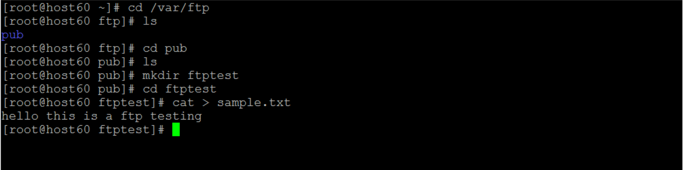

1. Check and transferring the file in ftp

*ftp <ip address>*

*ex: ftp 192.168.70.60*

Authentication for few packages

*username : anonymous*

*password : no password (or) anonymous*

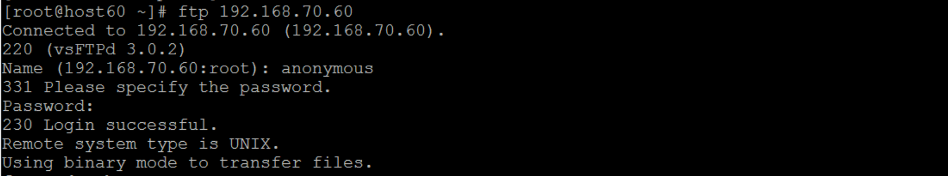

*cd pub*

*cd ftptest*

*get sample.txt*

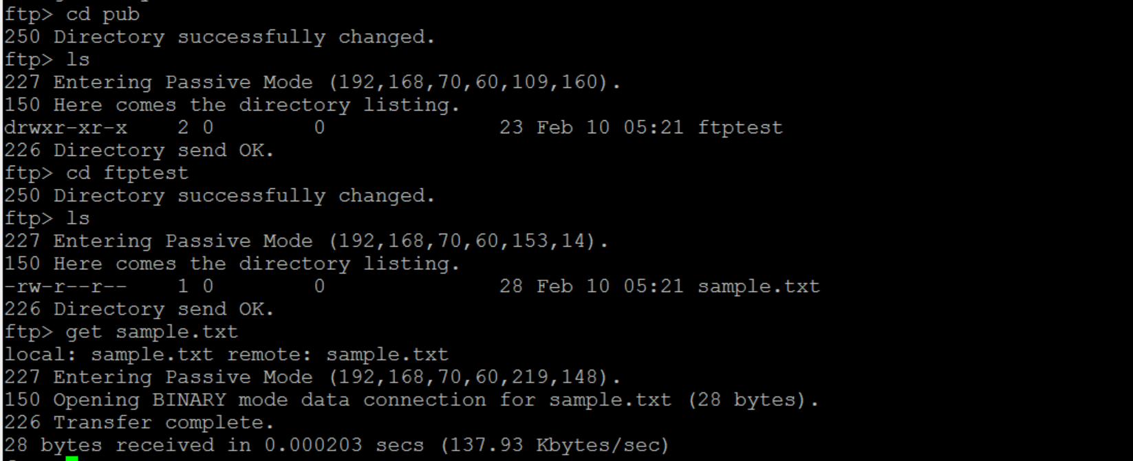

1. Check in browser -> <ftp://192.168.70.60>

