NFS

NFS – Network File Share

From linux to linux – file share

Port num – 111

1. Install nfs packages

*yum install nfs-utils nfs-utils-lib*

1. Start the services ,check status and enable the service

*service rpcbind start*

*service rpcbind status*

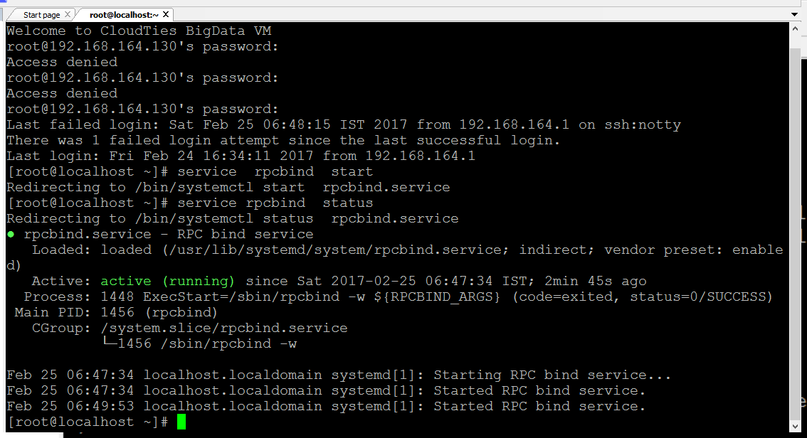

*service nfs-server start*

*service nfs-server status*

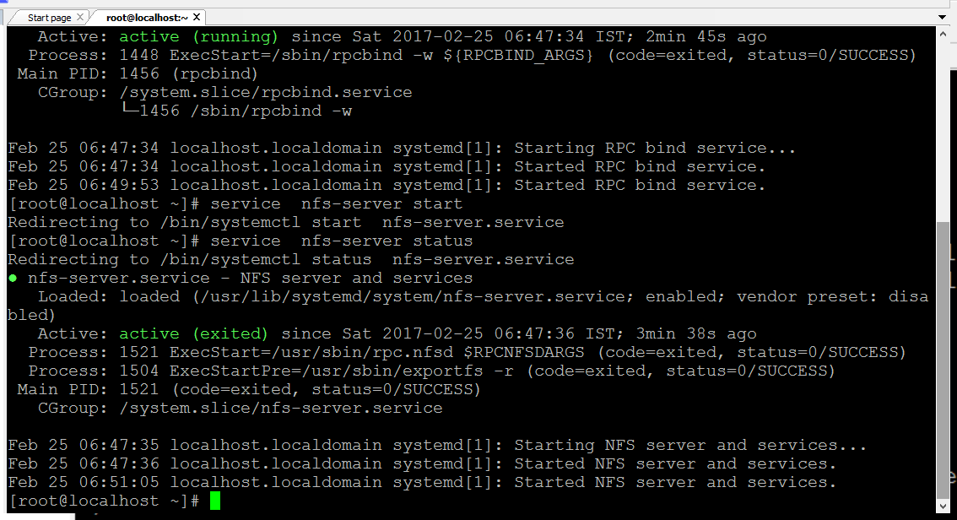

*service nfs-lock start*

*service nfs-lock status*

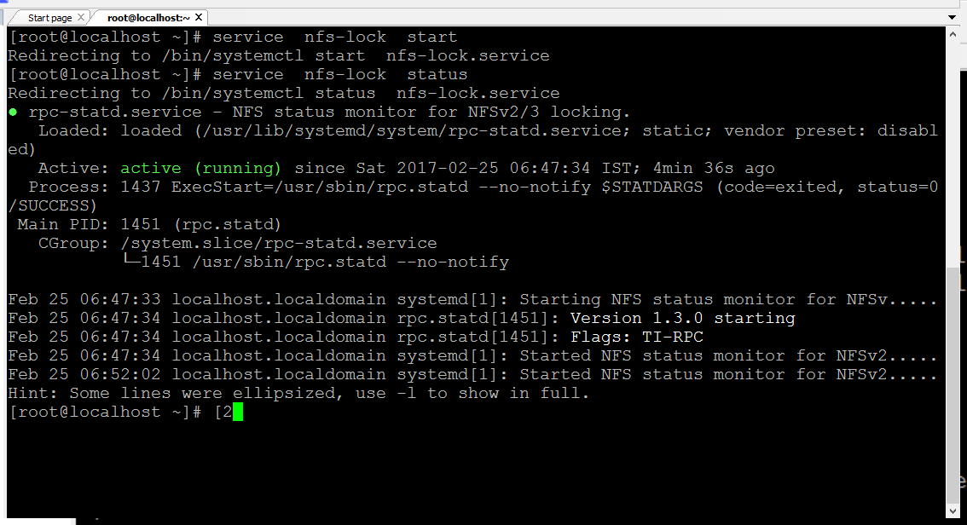

*service nfs-idmap start*

*service nfs-idmap status*

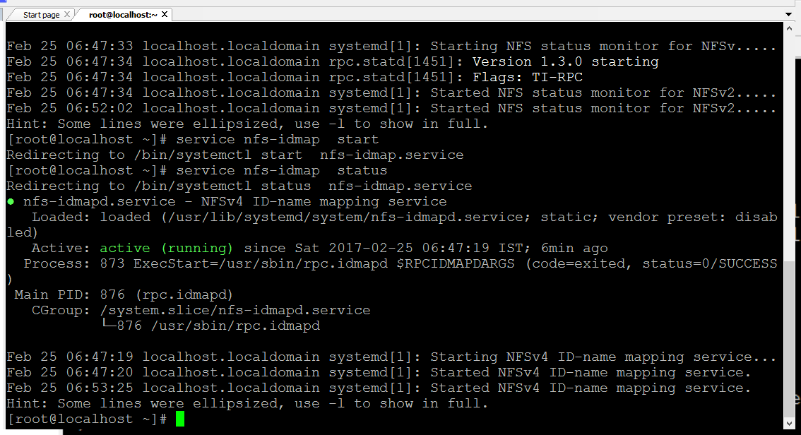

*systemctl enable nfs-server*

*systemctl enable nfs-lock*

1. Make directory nfsshare and change mode

*mkdir /var/nfsshare*

*chmod 777 /var/nfsshare*

*cd /var/nfsshare*

*mkdir nfstesting*

*cd nfstesting*

*cat > test.txt*

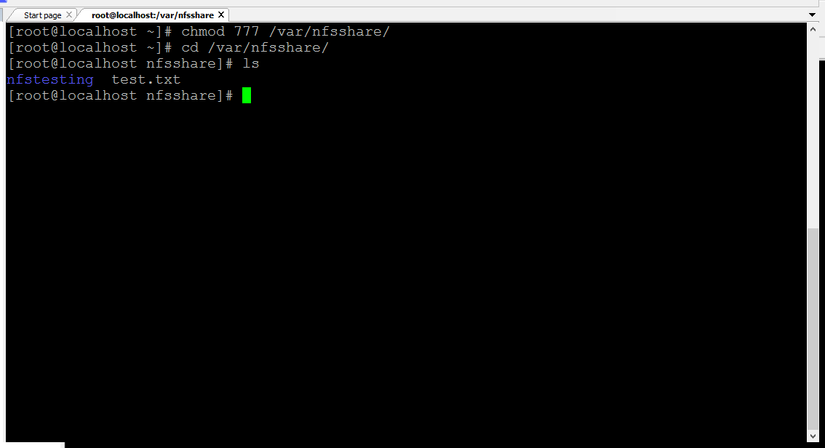

1. Modification in exports

*vim /etc/exports*

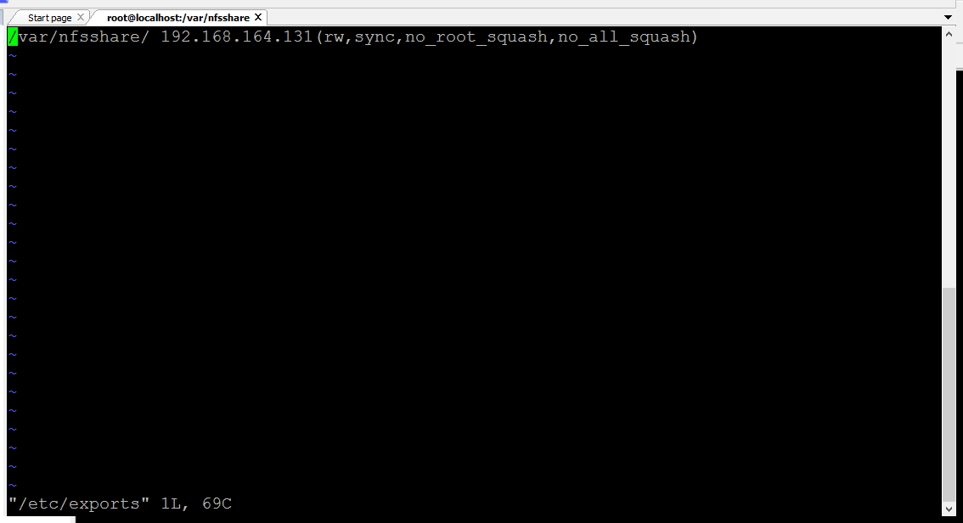

*insert -> /var/nfsshare/192.168.70.61 (rw, sync, no_root_squash, no_all_squash)*

1. Restart the service

*service nfs-server restart*

1. Login the receiver server

*ssh 192.168.70.61*

1. Make directory

*mkdir /var/nfs*

1. Mount the file

*mount -t nfs 192.168.70.60:var/nfs/share/ /var/nfs*

*service nfs-server restart*

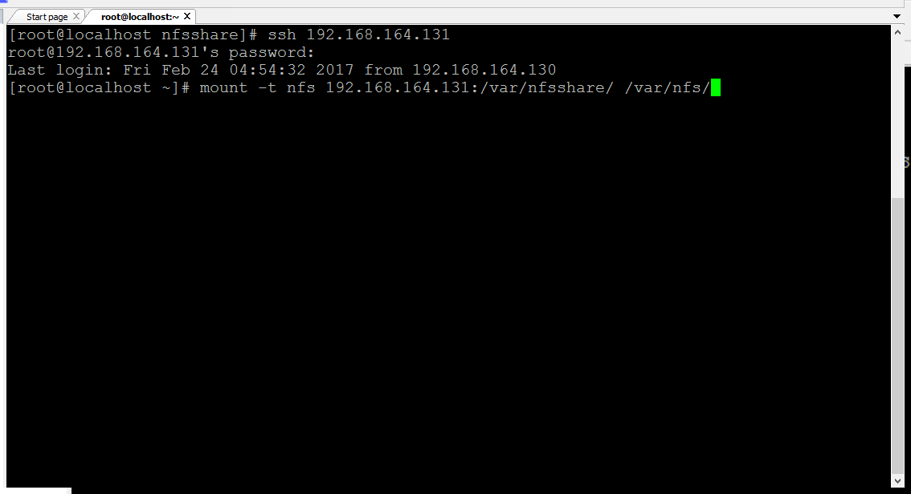

1. check the file:

*cd /var/nfs*

*ls*

*nfstesting*

*pwd -> /var/nfs*

*test.txt*