**Git:**

Install git:

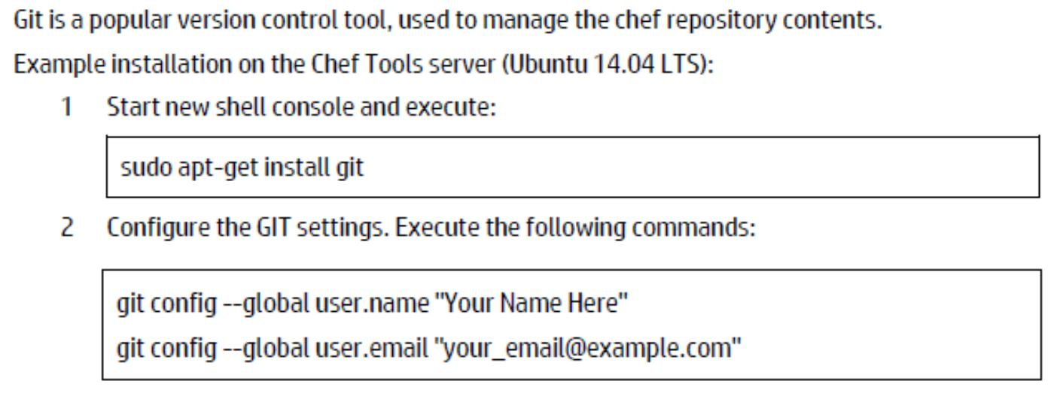

18

Git screenshots:

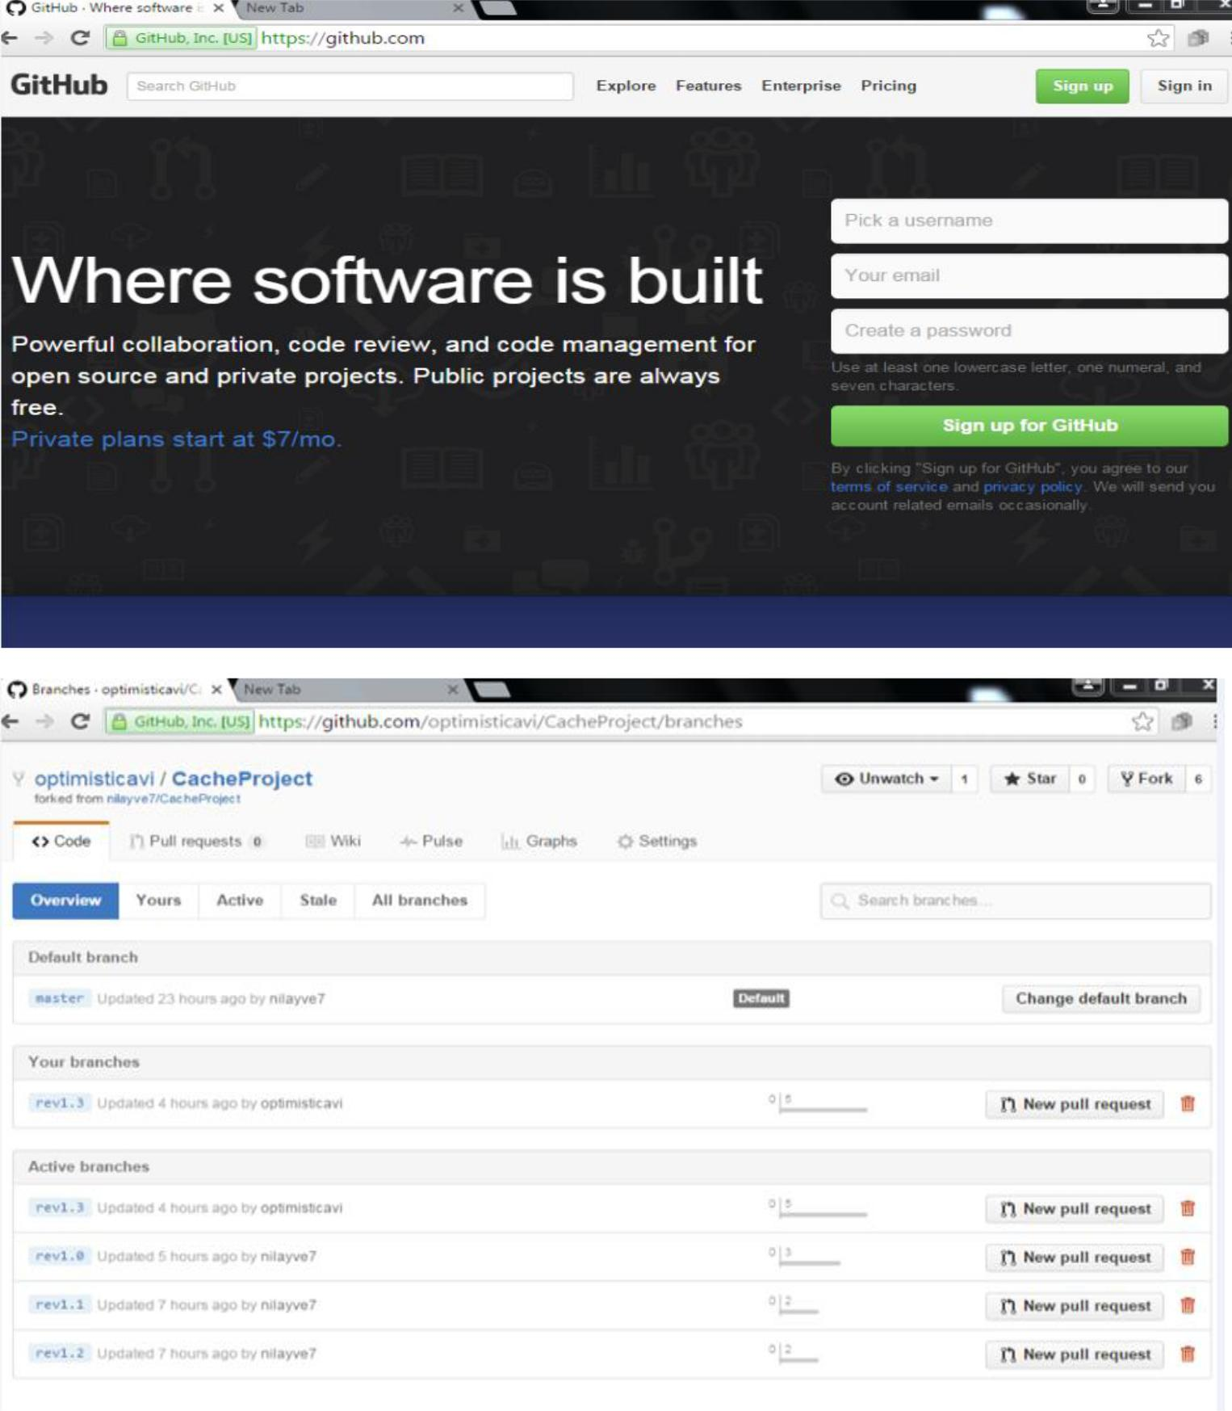

19

* **MAVEN**

MAVEN, a Yiddish word meaning aggregator of information, was initially begun as an endeavor to rearrange the assemble forms in the Jakarta Turbine venture. There were a few tasks each with their own Ant construct documents that were all marginally distinctive and JARs were registered with CVS. We needed a standard approach to construct the ventures, an unmistakable meaning of what the undertaking comprised of, a simple approach to distribute venture data and an approach to share JARs over a few tasks.

The outcome is an instrument that can now be utilized for building and dealing with any Java-based undertaking. We trust that we have made something that will make the everyday work of Java designers less demanding and for the most part help with the appreciation of any Java-based task. Maven's essential objective is to permit a designer to understand the complete condition of an improvement exertion in the most limited timeframe. Keeping in mind the end goal to achieve this objective there are a few zones of worry that Maven endeavors to manage:

* + Making the manufacture prepare simple
  + Giving a uniform form framework
  + Giving quality undertaking data
  + Giving rules to best practices advancement
  + Permitting straightforward movement to new elements

Expert permits a venture to assemble utilizing its task object model (POM) and an arrangement of modules that are shared by all anticipates utilizing Maven, giving a uniform form framework. When you acclimate yourself with how one Maven venture manufactures you consequently know how all Maven ventures assemble sparing you gigantic measures of time when attempting to explore numerous tasks. Giving quality task data, maven gives a lot of helpful task data that is to some extent taken from your POM and to a limited extent produced from your venture's sources. For instance, Maven can give:

* Change log report made specifically from source control
* Cross referenced sources
* Mailing records
* Reliance list
* Unit test reports including scope

As Maven enhances the data set gave will enhance, all of which will be straightforward to clients of Maven. Different items can likewise give Maven modules to permit their arrangement of task data close by a percentage of the standard data given by Maven, despite everything all taking into account the POM. Giving rules to best practices improvement Maven expects to accumulate current standards for best practices improvement, and make it simple to manage a venture in that heading.

For instance, determination, execution, and reporting of unit tests are a piece of the typical form cycle utilizing Maven. Current unit testing best practices were utilized as rules:

* Keeping your test source code in a different, yet parallel source tree
* Utilizing experiment naming traditions to find and execute tests
* Have test cases setup their surroundings and don't depend on modifying the work for test arrangement.

Maven additionally means to help with undertaking work process, for example, discharge administration and issue following. Maven additionally proposes a few rules on the most proficient method to format your venture's registry structure so that once you take in the design you can without much of a stretch explore some other undertaking that utilizations Maven and the same defaults. Permitting straightforward relocation to new components

Maven gives a simple approach to Maven customers to upgrade their establishments with the goal that they can exploit any progressions that been made to Maven itself. Establishment of new or redesigned modules from outsiders or Maven itself has been made insignificant thus.

**What is Maven Not?**

You may have heard a portion of the accompanying things about Maven:

 Maven is a site and documentation instrument

21

* Maven stretches out Ant to give you a chance to download conditions
* Maven is an arrangement of reusable Ant scriptlets

While Maven does these things, as you can read above in the "What is Maven?" segment, these are by all account not the only elements Maven has, and its destinations are entirely distinctive. Maven encourages best practices, yet we understand that some anticipates may not fit with these goals for verifiable reasons. While Maven is intended to be adaptable, to a degree, in these circumstances and to the requirements of various tasks, it can not oblige each circumstance without making bargains to the trustworthiness of its targets.

On the off chance that you choose to utilize Maven, and have an irregular form structure that you can't redesign, you may need to swear off some elements or the utilization of Maven inside and out.

* **JIRA**

As indicated by Atlassian, JIRA is utilized for issue tracking and bug tracking and for management purpose. Some of the associations utilizing JIRA for bug-following and venture administration are Fedora Commons, Hibernate, and The Apache Software Foundation utilizes JIRA and Bugzilla. JIRA incorporates instruments permitting relocation from contender Bugzilla.

Contrasted with Bugzilla, JIRA is all the more inside customisable. Bugzilla has a solitary, altered, state machine to speak to the lifecycle of a 'bug'. All such bugs are accepted to take after the same settled example of location, repair and test. All bugs should likewise have the same lifecycle. JIRA permits this state machine to be changed by its clients, furthermore for various classes of issue to be followed, each with their own particular state machine. This makes JIRA significantly more adaptable: it might be utilized as a more broad "issue tracker" as opposed to exclusively a bug tracker, following new element demands, framework administrator errands, Scrum undertakings or some other component that its clients may require. To dodge the overhead of arranging JIRA for each new assignment sort, pre-assembled setups, for example, GreenHopper (now JIRA Agile) can be purchased in,

22

which give a pre-designed JIRA environment with errands and practices suitable for

prevalent administration methodologies.

* JIRA is offered in three packages
* JIRA Core incorporates the base programming.
* JIRA Software is expected for use by programming improvement groups and incorporates JIRA Core and JIRA Agile.
* JIRA Service Desk is expected for use by IT or business administration work areas.

JIRA is composed in Java and utilizations the Pico reversal of control holder, Apache OFBiz element motor, and WebWork 1 innovation stack. It ships with different interpretations including English, French, German, Japanese, and Spanish.The primary components of JIRA for spry programming improvement are the usefulness to arrange advancement cycles, the emphasis reports and the bug following usefulness (A JIRA Bug is typically truncated to JB).

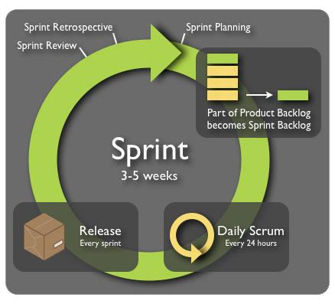

Fig 4.3 : Jira scrumbs and sprint

23

Installation steps for jira:

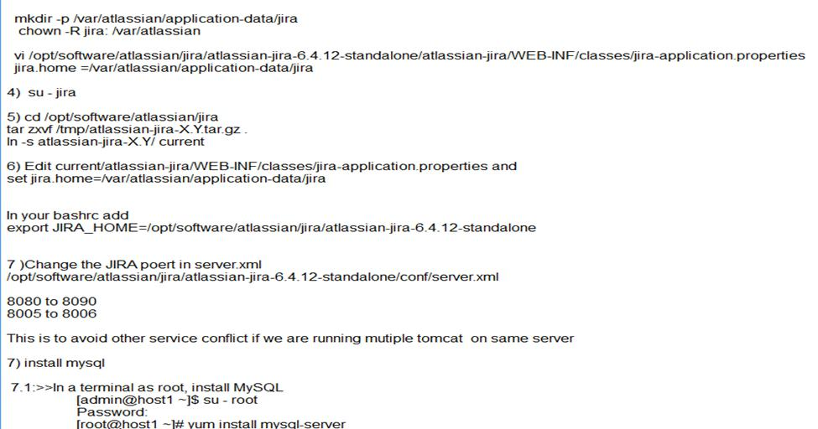

Jira screens:

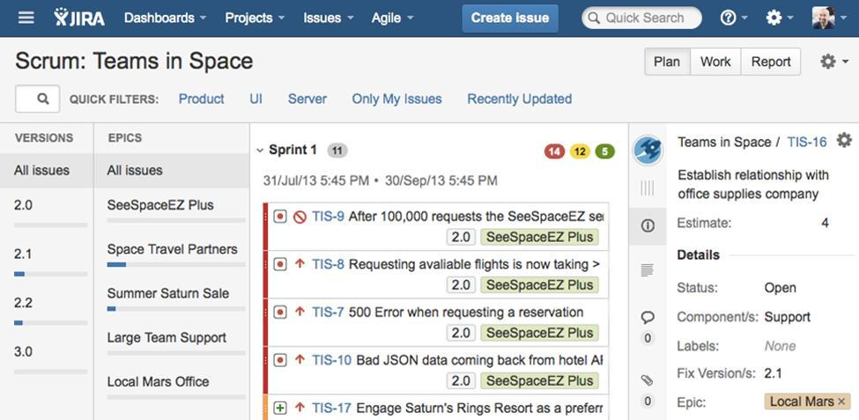

24

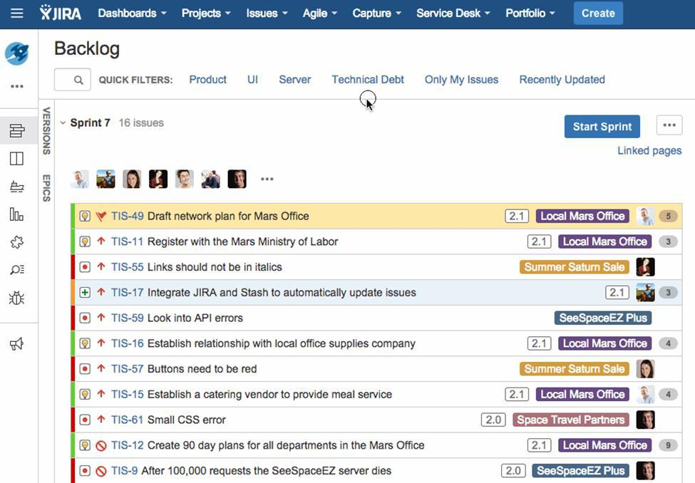

 **JENKINS:**

It is an open-source ceaseless reconciliation programming instrument written in the Java programming dialect for testing and investigating confined changes in a bigger code base continuously. The product empowers engineers to discover and illuminate deformities in a code base quickly and to mechanize testing of their constructs.

Constant incorporation has developed since its origination. Initially, a day by day manufacture was the standard. Presently, the typical tenet is for every colleague to submit take a shot at a day by day (or more successive) premise and for a work to be directed with each critical change. At the point when utilized appropriately, persistent incorporation gives different advantages, for example, steady input on the status of the product. Since CI recognizes lacks at an early stage being developed, imperfections are regularly littler, less mind boggling and simpler to determine.

25

Jenkins is a fork of a task called Hudson, which is trademarked by Oracle and is presently being created parallel to Jenkins. The advancement group and its representing body has open gatherings about the product.

Jenkins is a Continuous Integration server. Essentially Continuous Integration is the act of running your tests on a non-designer machine naturally everytime somebody pushes new code into the source storehouse.

This has the huge point of interest of continually knowing whether all tests work and getting quick input. The quick input is imperative so you generally know directly after you broke the fabricate (presented changes that made either the accumulate/assemble cycle or the tests fall flat) what you did that fizzled and how to return it.

On the off chance that you just run your tests every so often the issue is that a considerable measure of code changes may have happened subsequent to the last time and it is somewhat difficult to make sense of which change presented the issue. When it is run naturally on each push then it is constantly quite clear what and who presented the issue. Based on top of Continuous Integration are Continuous Deployment/Delivery where after a fruitful test run your in a split second and consequently discharge the most recent adaptation of your codebase. Makes organization a non-issue and helps you accelerate your improvement.

There are loads of Alternatives to Jenkins, both standalone and facilitated (full exposure I am the organizer of a facilitated arrangement). Jenkins is a capable computerization stage that makes it generally clear to robotize manufacture testing and coordination. The reason you would need to do this is :

* Engineer time is centered around work that matters — Much of the work of incessant mixes is taken care of via robotized construct and testing frameworks, which means designer time isn't squandered on expansive scale mistake ridden mixes.
* Programming quality is enhanced — Any issues are identified and determined very quickly, keeping programming in a state where it can be securely discharged whenever.

26

* Quicker Development - Integration expenses are decreased both on the grounds that genuine mix issues are more outlandish and on the grounds that a significant part of the work of joining is robotized.

Most organizations who utilize consistent incorporation utilize their own particular cloud-construct ceaseless joining servers worked in light of uses like Jenkins. Don't hesitate to look at my late post here for more data. outscale.comContinuous Integration And Delivery In the Cloud.

The main features are:

 Nonstop Integration and Continuous Delivery:

As an extensible computerization server, Jenkins can be utilized as a straightforward CI server or transformed into the constant conveyance center point for any task.

 Simple establishment:

Jenkins is an independent Java-based project, prepared to come up short on the-container, with bundles for Windows, Mac OS X and other Unix-like working frameworks.

 Simple design:

Jenkins can be effectively set up and arranged by means of its web interface, which incorporates on-the-fly mistake checks and inherent help.

 Modules:

With many modules in the Update Center, Jenkins coordinates with basically every apparatus in the persistent joining and nonstop conveyance toolchain.

 Extensible:

Jenkins can be broadened by means of its module design, giving about unbounded potential outcomes to what Jenkins can do.

 Disseminated:

Jenkins can without much of a stretch disperse work over different machines, driving forms, tests and organizations over numerous stages quicker.

27

Jenkins screenshots:

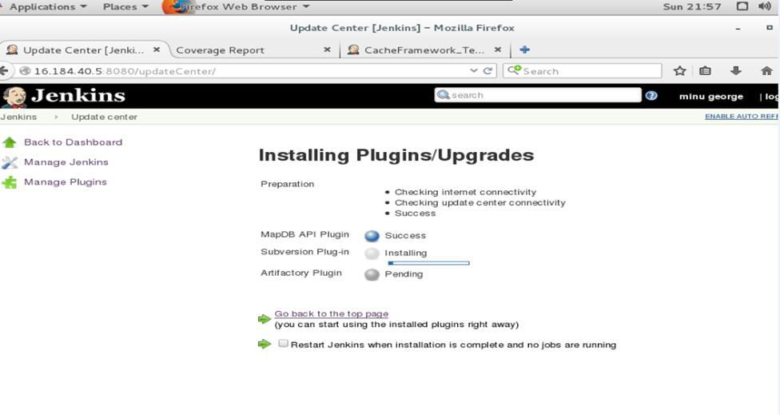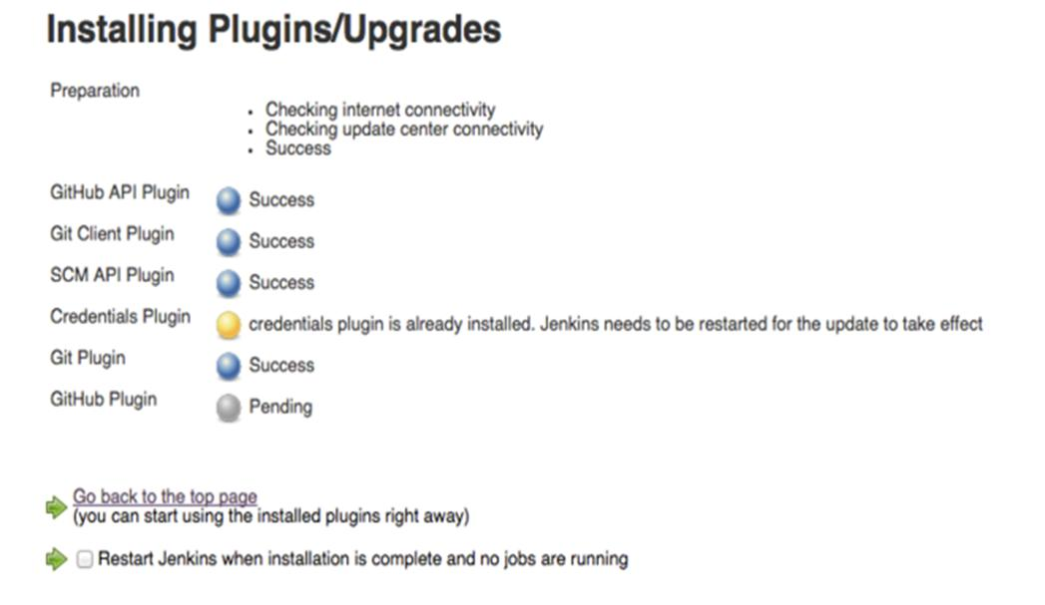

28

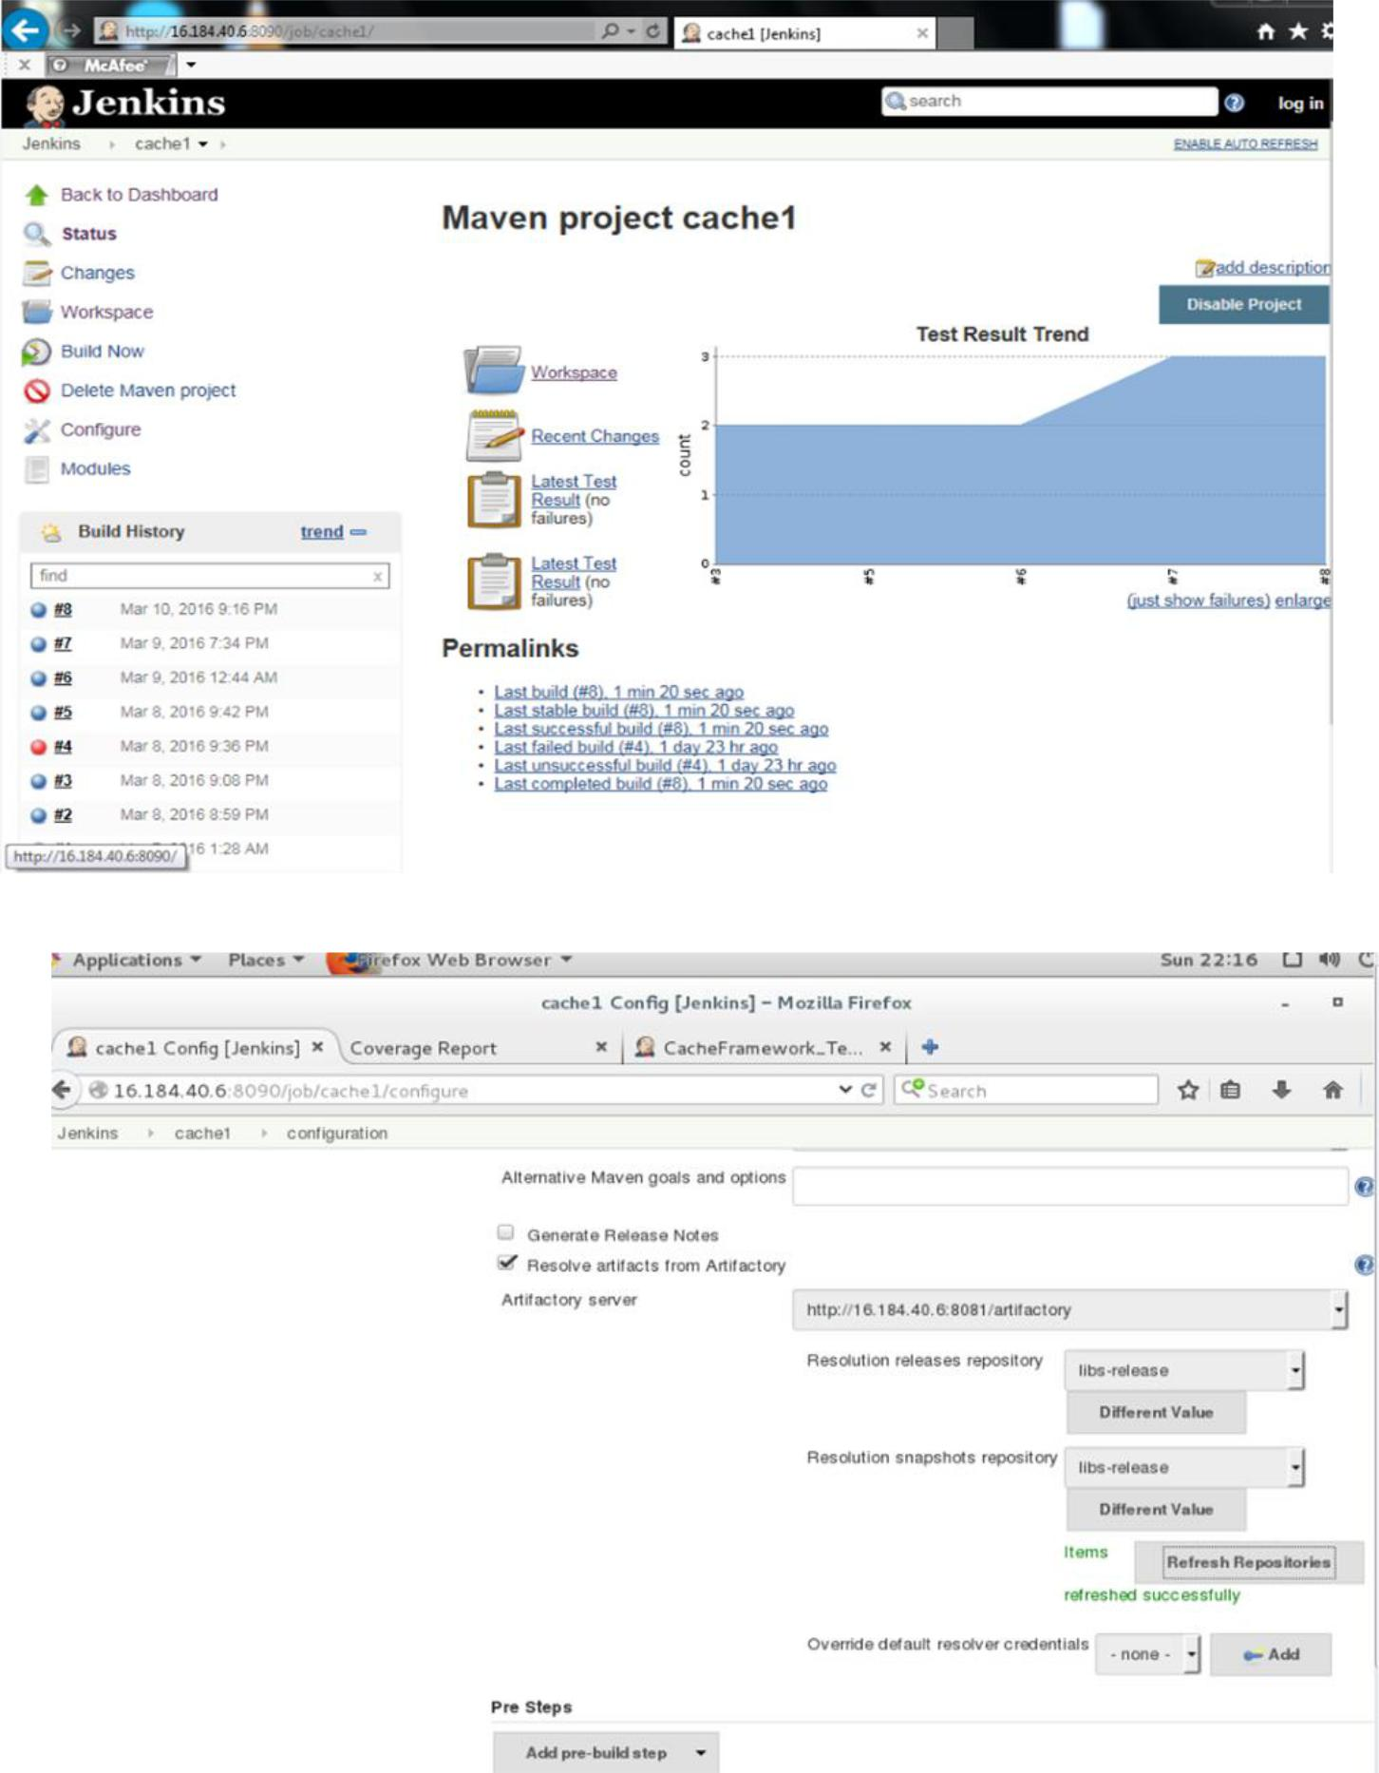

**Jfrog Artifactory**

A twofold archive supervisor is a product apparatus intended to improve the download and capacity of parallel records utilized and delivered as a part of programming advancement. It unifies the administration of all the parallel relics produced and utilized by the association to conquer the multifaceted nature emerging from the differing qualities of double ancient rarity sorts, their position in the general work process and the conditions between them.

42

Programming advancement can be a to a great degree complex process including numerous engineers, or groups of designers taking a shot at shared code bases, getting to the same form instruments, downloading and utilizing a common arrangement of parallel assets, and conveying segments into the same programming item. To deal with the source records utilized as a part of programming advancement, associations will normally utilize update control. The numerous source records utilized as a part of programming improvement are in the end incorporated with the paired curios (otherwise called "parallels") which constitute the segments of a product item. Moreover, keeping in mind the end goal to give their usefulness and list of capabilities, programming items may utilize numerous outsider ancient rarities downloaded from free open source stores or acquired from business sources.

Consequently, a product item may contain tens, hundreds and even a large number of individual paired relics which must be overseen so as to proficiently keep up an intelligent and practical programming item. This capacity of dealing with the paired antiques is finished by a parallel storehouse director. A paired archive administrator can be considered as being to doubles what modification control is to source documents.

The product and innovation industry keeps on changing and develop, twofold archive administrators are the same. They are starting to move towards situating as a widespread bundle managers.[4] These bundle administrators intend to institutionalize the way ventures treat all bundle sorts utilized as a part of the product improvement process. They give clients the capacity to apply security and consistence measurements over all antiquity sorts. General bundle administrators have been alluded to as being at the focal point of a DevOps toolchain.

As a major aspect of the advancement lifecycle, source code is ceaselessly being incorporated with twofold relics utilizing persistent coordination. This may communicate with a parallel vault chief much like a designer would by getting relics from the storehouses and pushing works there. Tight joining with CI servers empowers the capacity of essential metadata, for example,

* Which client set off the fabricate (whether physically or by focusing on update control)
* Which modules were fabricated
* Which sources were utilized (confer id, correction, branch)
* Conditions utilized

43

* Environment variables
* Bundles introduced

A paired store is a product archive for bundles, ancient rarities and their relating metadata. It can be utilized to store parallels delivered by an association itself, for example, discharges and daily forms, or for outsider doubles which must be dealt with distinctively for both specialized and lawful reasons.

**Ancient rarities and Packages**

Bundles and Artifact innately mean distinctive things. Curios are just a yield or accumulation of records (ex. Jug, WAR, DLLS, RPM and so forth.) and one of those documents may contain metadata (eg. POM document). While bundles are single file record of an all around characterized design (ex. NuGet) that contain records fitting for the bundle sort (ex. DLL, PDB).[6] Many antiques result from fabricates yet different sorts are essential also.. Bundle are basically one of two things: a library or an application.

Contrasted with source documents, double antiques are frequently bigger by requests of extent, they are once in a while erased or overwritten (aside from uncommon cases, for example, previews or daily forms), and they are typically joined by loads of metadata, for example, id, bundle name, adaptation, permit and then some.

**Metadata**

Metadata portrays a paired relic, is put away and indicated independently from the ancient rarity itself, and can have a few extra employments. The accompanying table demonstrates some regular metadata sorts and their employments:

44

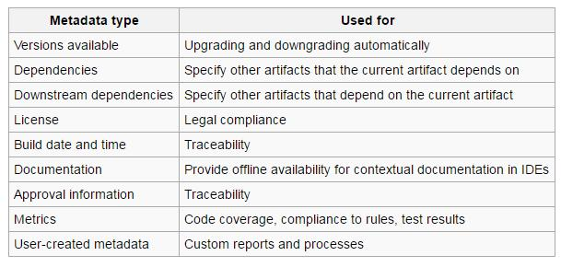

Fig: metadata table

Key components and elements when consider the selection of a bundle chief include:

* Reserving – Caching essentially stores neighborhood duplicates of bundles. This expands execution for moderate web associations by permitting the client to pull from the nearby vault rather than remotely. Storing locally permits as often as possible utilized bundles to be accessible notwithstanding amid times of outer storehouse blackouts.
* Maintenance strategies - Repository directors can be utilized and designed to bolster association cleansing approaches to guarantee sensible plate space utilization. Neighborhood vaults for outsider curios may likewise be cleansed after not being utilized by any discharge for a predefined time.
* Permit sifting - Third gathering relics might be liable to endorsement forms because of permitting and lawful issues. Bundle administrator consider confinement of just affirmed antiquities into arrangement.
* High accessibility - Since a twofold storehouse administrator keeps up all the advancement conditions, it is crucial to dependably keep up access to these antiquities.. Any down-time of the twofold store supervisor can stop improvement with all the noteworthy outcomes to the association. A High Availability occurrence permits an endeavor to conquer the danger connected with downtime, through

45

programmed failover. This is accomplished by having an excess arrangement of storehouse supervisors conflict with the same database and record stockpiling. Keeping up big business wide strength and execution at all times.

* Client limitations - Repository administrators can be coordinated with other association frameworks, for example, LDAP or Single Sign-on servers to streamline and bring together client administration. This gives a venture granular control over who has admittance to imperative programming parts.

**Jfrog installation file:**

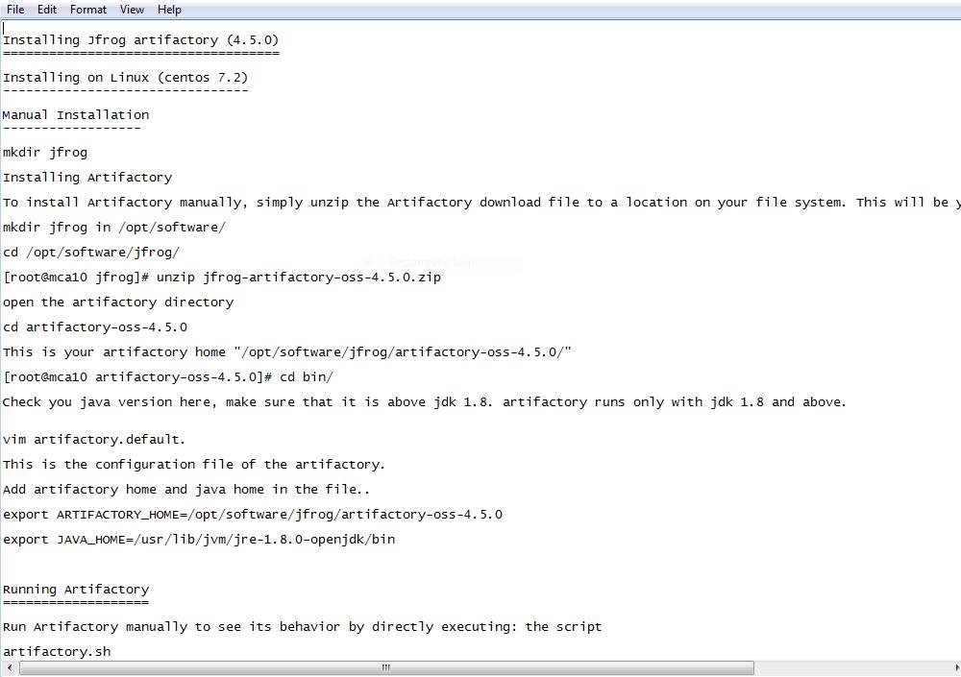

46

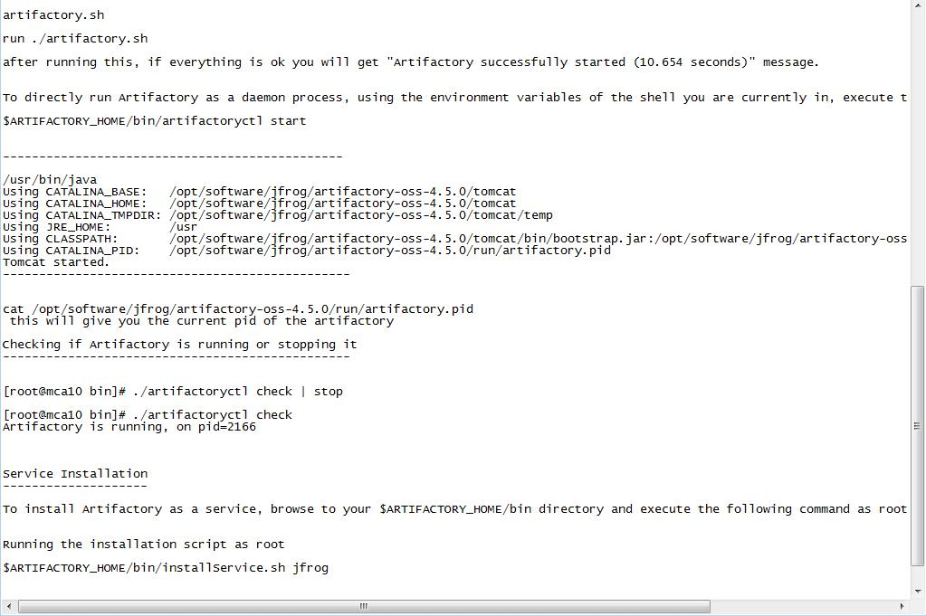

* With these installations jfrog will be set up.
* After completing all the above steps check if the artifactory is running
* Setup the port and open it in web browser with the corresponding url
* With Jenkins make a build and deploy it to artifactory and here maven is integrated with artifactory
* Artifactory helps to download all the dependencies directly without any manuall installations hereafter for the project to run.
* The number of artifacts increases in each build and release
* From artifactory we can directly move to Jenkins and vice versa.

47

Jfrog s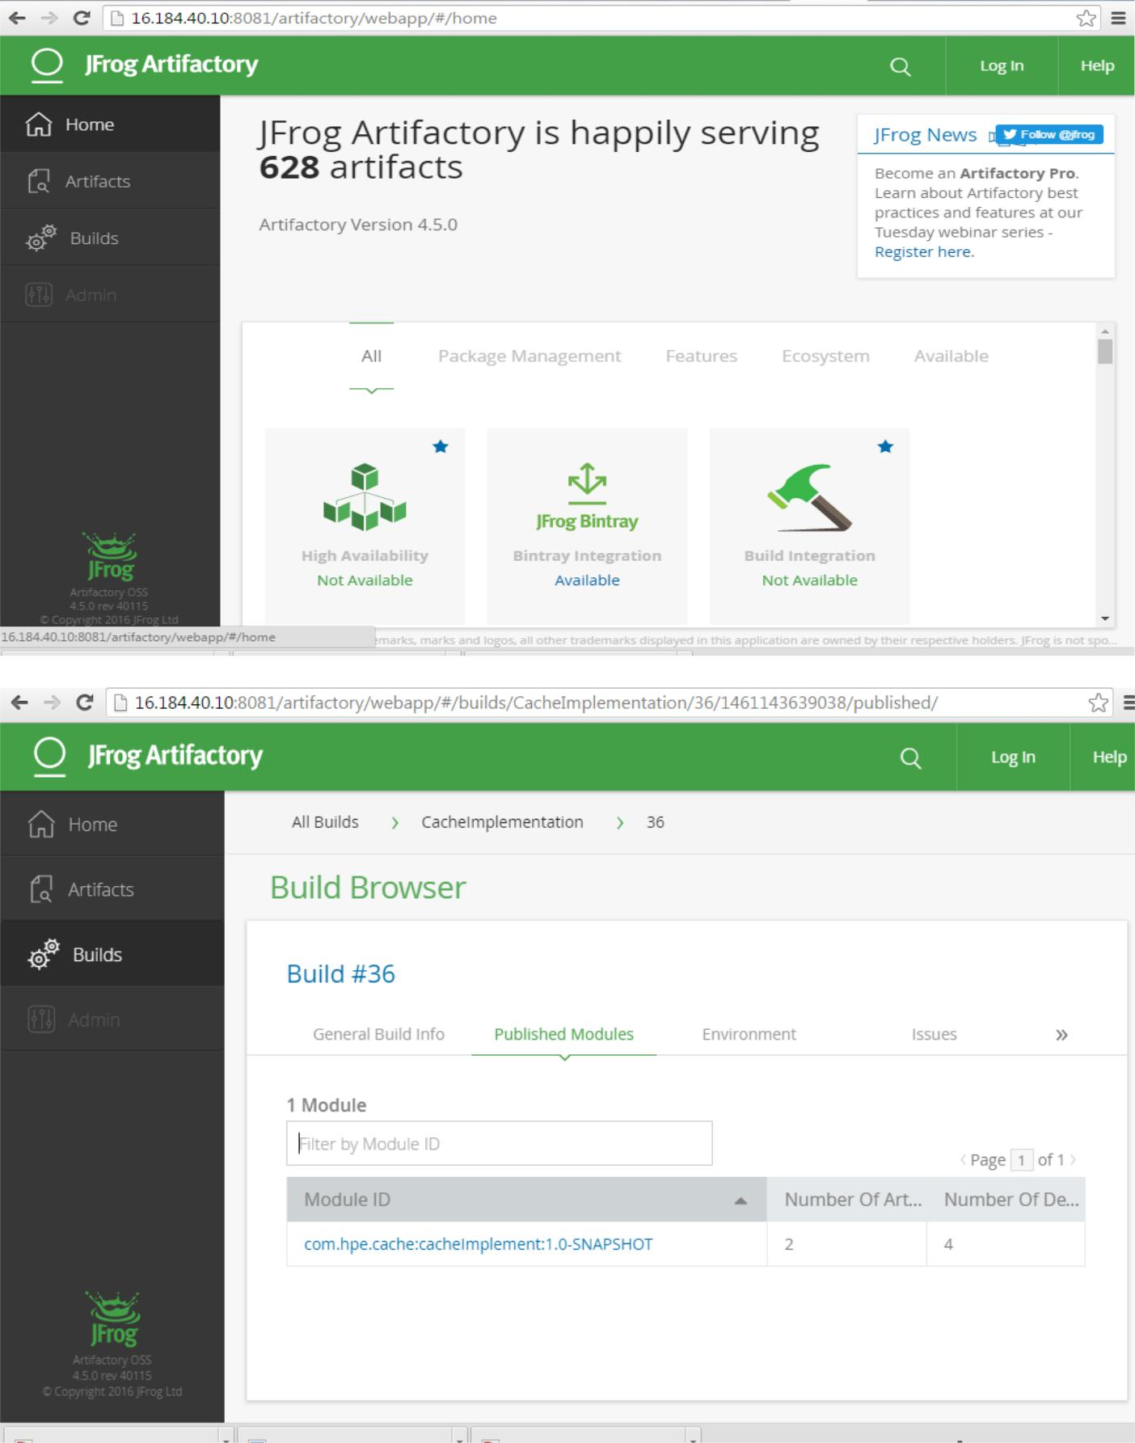

**Nagios screenshots:**

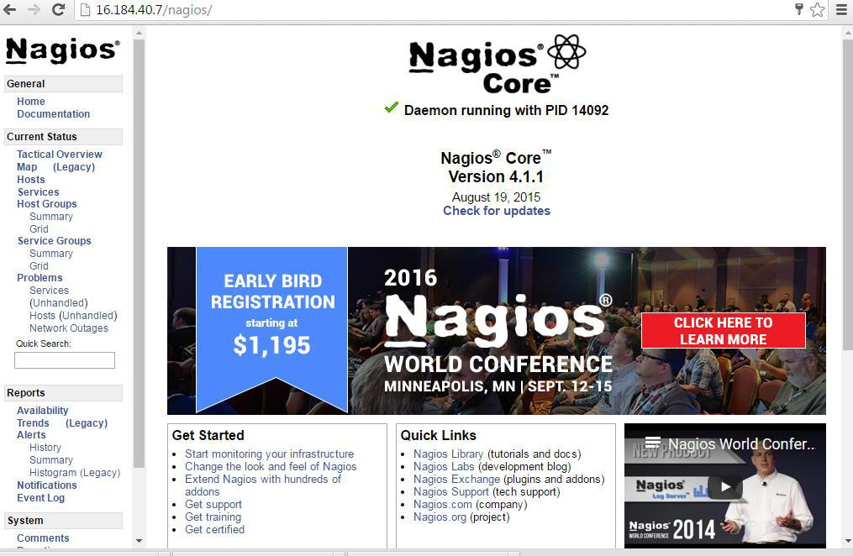

53

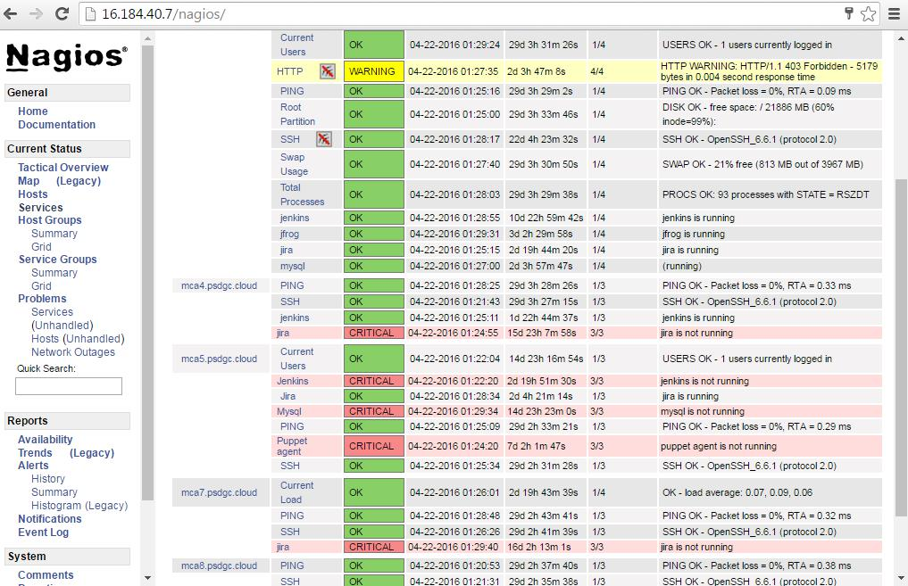

**COMPLETE AUTOMATION:**

* **PUPPET**

In registering, Puppet is an open-source arrangement administration apparatus. It keeps running on numerous Unix-like frameworks and additionally on Microsoft Windows, and incorporates its own definitive dialect to depict framework arrangement.

Puppet is delivered by Puppet Labs, established by Luke Kanies in 2005. It is composed in Ruby and discharged as free programming under the GNU General Public License (GPL) until adaptation 2.7.0 and the Apache License 2.0 after that.

Puppet is intended to deal with the design of Unix-like and Microsoft Windows frameworks definitively. The client portrays framework assets and their state, either utilizing Puppet's definitive dialect or a Ruby DSL (area particular dialect). This data is put away in records called "Puppet shows". Puppet finds the framework data through an utility called Facter, and

54

accumulates the Puppet shows into a framework particular list containing assets and asset reliance, which are connected against the objective frameworks. Any moves made by Puppet are then reported.

Puppet comprises of a custom revelatory dialect to depict framework setup, which can be either connected specifically on the framework, or gathered into an inventory and appropriated to the objective framework through client–server worldview (utilizing a REST API), and the operators utilizes framework particular suppliers to uphold the asset determined in the shows. The asset deliberation layer empowers executives to portray the arrangement in abnormal state terms, for example, clients, administrations and bundles without the need to determine OS particular orders, (for example, rpm, yum, able).

Puppet is model-driven, requiring restricted programming learning to utilize. It oversees base as code, giving the establishment to DevOps practices, for example, forming, robotized testing and consistent conveyance. You send changes with certainty and recoup all the more rapidly from disappointments, liberating your group to be more nimble and receptive to business needs.

 Convey better innovation quicker

Build unwavering quality as you reduction process durations so you can move quick and with certainty. Manikin Enterprise guarantees consistency crosswise over dev, test and generation situations so when changes are advanced, you know they're predictable and your frameworks are steady.

 Expand profitability and operational proficiency

DevOps makes your business more light-footed, wiping out storehouses and enhancing cooperation crosswise over groups. Computerize the whole programming conveyance cycle, from center framework through applications, with Puppet Enterprise, and you'll free up time to take a shot at activities that convey more business worth to your association.

 Security and consistence

55

Implement your security arrangements and demonstrate consistence. With Puppet, guaranteeing and demonstrating security and consistence gets to be productive, programmed, and straightforward

 Cloud

Receive, bind together and oversee cloud situations – open, private, and half and half – via computerizing each phase of your cutting edge server farm. Basically, at scale, and safely.

Puppet Installation file:

