**SQL Join Types:**

There are different types of joins available in SQL:

* [INNER JOIN:](https://www.tutorialspoint.com/sql/sql-inner-joins.htm) returns rows when there is a match in both tables.
* [LEFT JOIN:](https://www.tutorialspoint.com/sql/sql-left-joins.htm) returns all rows from the left table, even if there are no matches in the right table.
* [RIGHT JOIN:](https://www.tutorialspoint.com/sql/sql-right-joins.htm) returns all rows from the right table, even if there are no matches in the left table.
* [FULL JOIN:](https://www.tutorialspoint.com/sql/sql-full-joins.htm) returns rows when there is a match in one of the tables.
* [SELF JOIN:](https://www.tutorialspoint.com/sql/sql-self-joins.htm) is used to join a table to itself as if the table were two tables, temporarily renaming at least one table in the SQL statement.
* [CARTESIAN JOIN:](https://www.tutorialspoint.com/sql/sql-cartesian-joins.htm) returns the Cartesian product of the sets of records from the two or more joined tables.

### Database Keys

Keys are very important part of Relational database. They are used to establish and identify relation between tables. They also ensure that each record within a table can be uniquely identified by combination of one or more fields within a table.

#### Super Key

**Super Key** is defined as a set of attributes within a table that uniquely identifies each record within a table. Super Key is a superset of Candidate key.

#### Candidate Key

Candidate keys are defined as the set of fields from which primary key can be selected. It is an attribute or set of attribute that can act as a primary key for a table to uniquely identify each record in that table.

#### Primary Key

Primary key is a candidate key that is most appropriate to become main key of the table. It is a key that uniquely identify each record in a table.

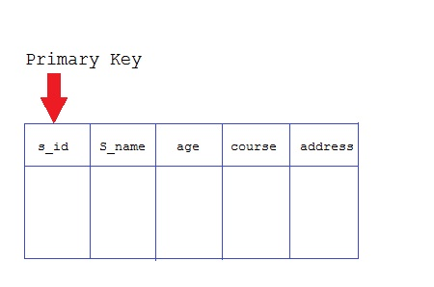

#### Composite Key

Key that consist of two or more attributes that uniquely identify an entity occurance is called **Composite key**. But any attribute that makes up the **Composite key** is not a simple key in its own.

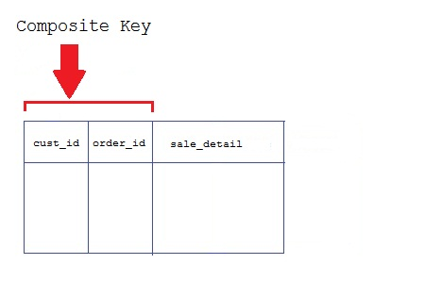

#### Secondary or Alternative key

The candidate key which are not selected for primary key are known as secondary keys or alternative keys

#### Non-key Attribute

**Non-key** attributes are attributes other than **candidate key** attributes in a table.

#### Non-prime Attribute

**Non-prime** Attributes are attributes other than **Primary attribute**.

These rules can be applied on any database system that manages stored data using only its relational capabilities. This is a foundation rule, which acts as a base for all the other rules.

## Rule 1: Information Rule

The data stored in a database, may it be user data or metadata, must be a value of some table cell. Everything in a database must be stored in a table format.

## Rule 2: Guaranteed Access Rule

Every single data element (value) is guaranteed to be accessible logically with a combination of table-name, primary-key (row value), and attribute-name (column value). No other means, such as pointers, can be used to access data.

## Rule 3: Systematic Treatment of NULL Values

The NULL values in a database must be given a systematic and uniform treatment. This is a very important rule because a NULL can be interpreted as one the following − data is missing, data is not known, or data is not applicable.

## Rule 4: Active Online Catalog

The structure description of the entire database must be stored in an online catalog, known as **data dictionary**, which can be accessed by authorized users. Users can use the same query language to access the catalog which they use to access the database itself.

## Rule 5: Comprehensive Data Sub-Language Rule

A database can only be accessed using a language having linear syntax that supports data definition, data manipulation, and transaction management operations. This language can be used directly or by means of some application. If the database allows access to data without any help of this language, then it is considered as a violation.

## Rule 6: View Updating Rule

All the views of a database, which can theoretically be updated, must also be updatable by the system.

## Rule 7: High-Level Insert, Update, and Delete Rule

A database must support high-level insertion, updation, and deletion. This must not be limited to a single row, that is, it must also support union, intersection and minus operations to yield sets of data records.

## Rule 8: Physical Data Independence

The data stored in a database must be independent of the applications that access the database. Any change in the physical structure of a database must not have any impact on how the data is being accessed by external applications.

## Rule 9: Logical Data Independence

The logical data in a database must be independent of its user’s view (application). Any change in logical data must not affect the applications using it. For example, if two tables are merged or one is split into two different tables, there should be no impact or change on the user application. This is one of the most difficult rule to apply.

## Rule 10: Integrity Independence

A database must be independent of the application that uses it. All its integrity constraints can be independently modified without the need of any change in the application. This rule makes a database independent of the front-end application and its interface.

## Rule 11: Distribution Independence

The end-user must not be able to see that the data is distributed over various locations. Users should always get the impression that the data is located at one site only. This rule has been regarded as the foundation of distributed database systems.

## Rule 12: Non-Subversion Rule

If a system has an interface that provides access to low-level records, then the interface must not be able to subvert the system and bypass security and integrity constraints.

ACID

A transaction is a very small unit of a program and it may contain several lowlevel tasks. A transaction in a database system must maintain **A**tomicity, **C**onsistency, **I**solation, and **D**urability − commonly known as ACID properties − in order to ensure accuracy, completeness, and data integrity.

* **Atomicity** − This property states that a transaction must be treated as an atomic unit, that is, either all of its operations are executed or none. There must be no state in a database where a transaction is left partially completed. States should be defined either before the execution of the transaction or after the execution/abortion/failure of the transaction.
* **Consistency** − The database must remain in a consistent state after any transaction. No transaction should have any adverse effect on the data residing in the database. If the database was in a consistent state before the execution of a transaction, it must remain consistent after the execution of the transaction as well.
* **Durability** − The database should be durable enough to hold all its latest updates even if the system fails or restarts. If a transaction updates a chunk of data in a database and commits, then the database will hold the modified data. If a transaction commits but the system fails before the data could be written on to the disk, then that data will be updated once the system springs back into action.
* **Isolation** − In a database system where more than one transaction are being executed simultaneously and in parallel, the property of isolation states that all the transactions will be carried out and executed as if it is the only transaction in the system. No transaction will affect the existence of any other transaction.