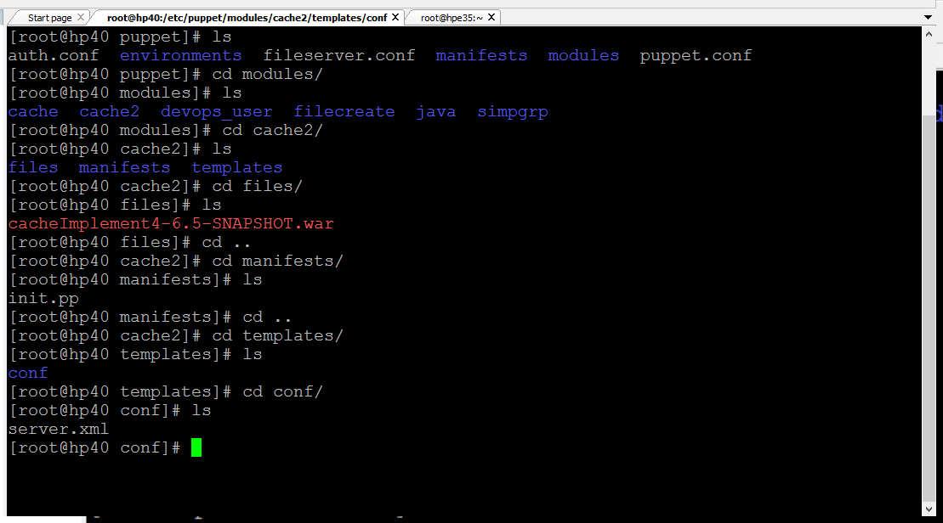

class cache2{

$war = "cacheImplement4-6.5-SNAPSHOT.war" #declaring variables

exec {'deletewar':

path =>['/bin','/sbin/','/usr/bin','/usr/sbin'],

command =>'rm -rf /var/lib/tomcat/webapps/cacheImplement4-6.5-SNAPSHOT.war /var/lib/tomcat/webapps/cacheImplement4-6.5-SNAPSHOT.war',

}->

file { "$war":

path => "/usr/share/tomcat/webapps/$war",

source => "puppet:///modules/cache/$war",#actual path /etc/puppet/module/modulename(class)/files/cacheImplement5-6.5-SNAPSHOT.war

#create a directory called files inside module and put the .war file in it.

ensure => present,

owner => tomcat,

group => tomcat,

before => Service['tomcat'],

}->

file { "tomcat_conf":

path => "/etc/tomcat/server.xml",

content => template("cache2/conf/server.xml"),

before =>Service['tomcat'],

}~>

service { 'tomcat' :

ensure => running,

hasstatus => true,

hasrestart => true,

}

}

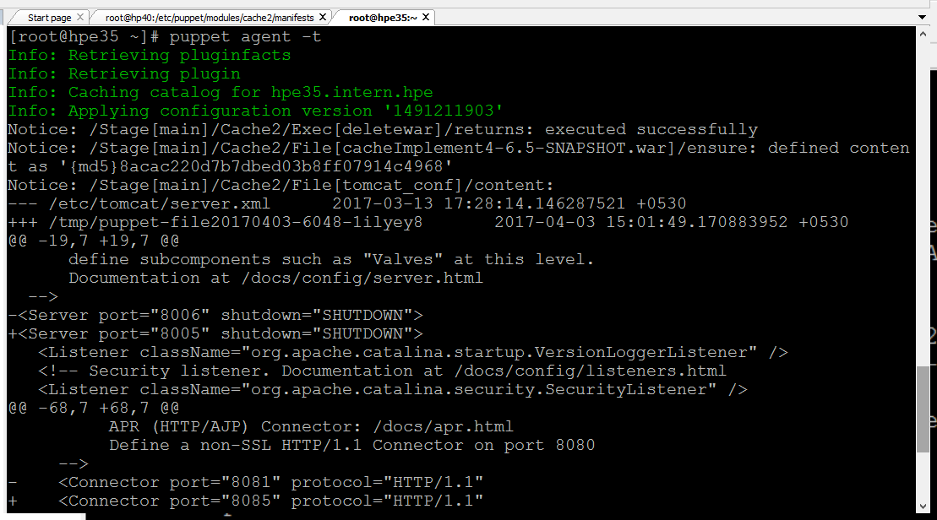

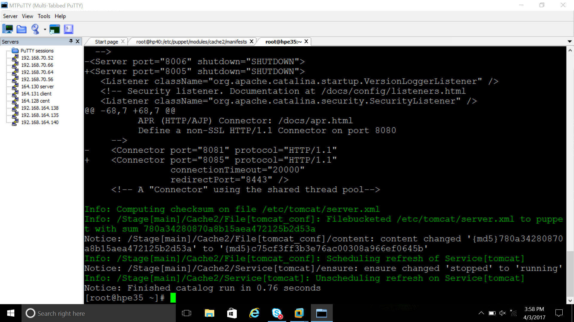

Example 2

