Report on Mail

The requirement of packages

* Postfix
* Mutt
* Dovecott Inactive

In configuration files i.e /etc/postfix/main.cf – take backup

Set mail owner=postfix

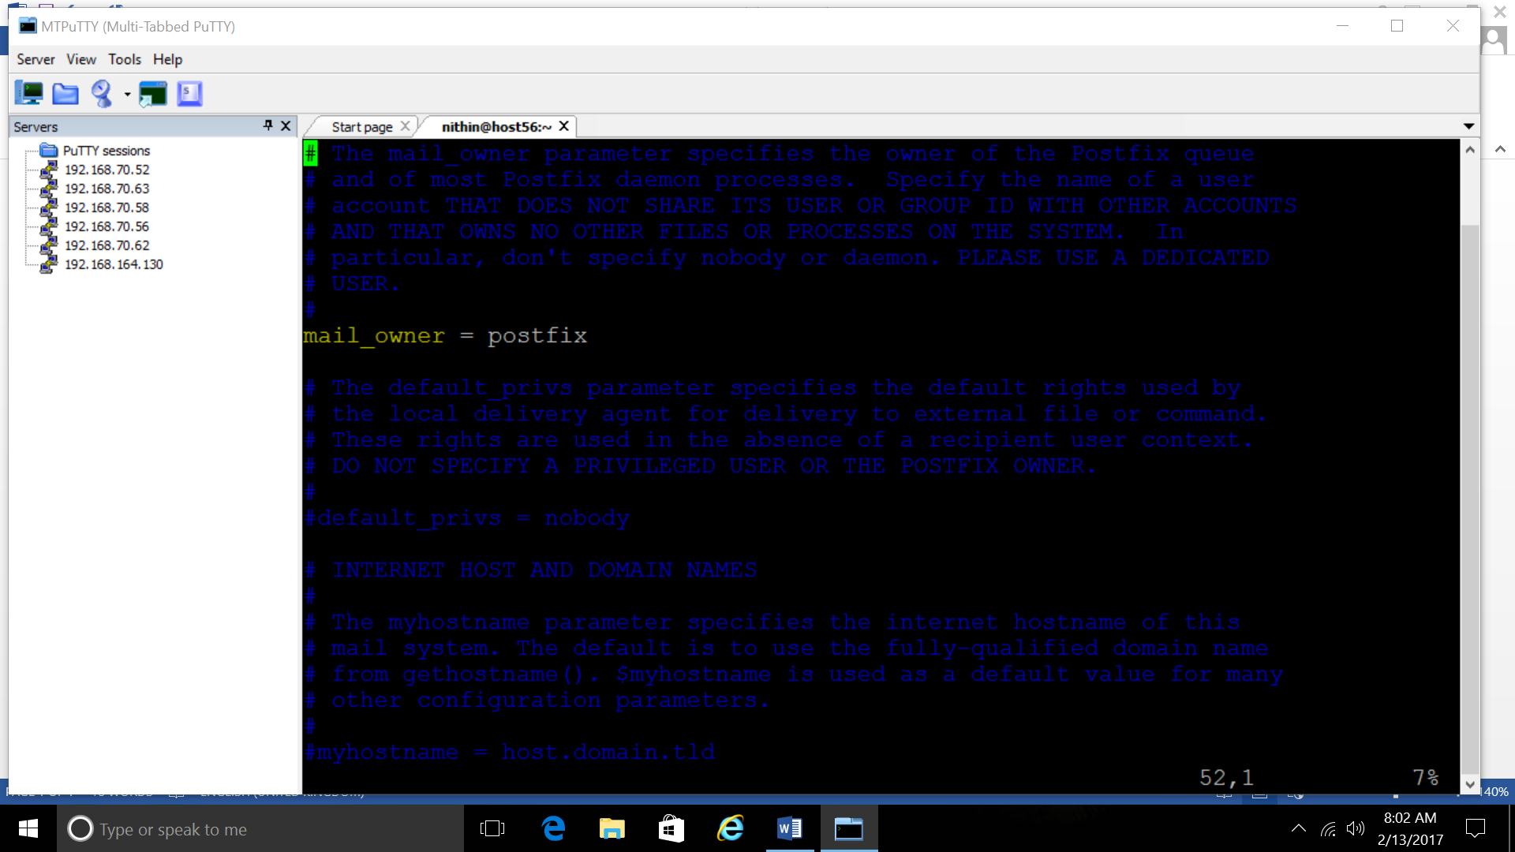

* Set myhostname and domain names

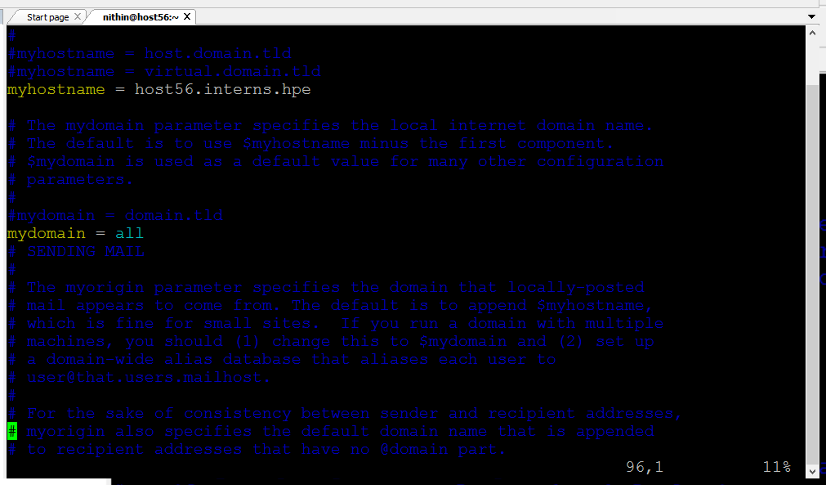

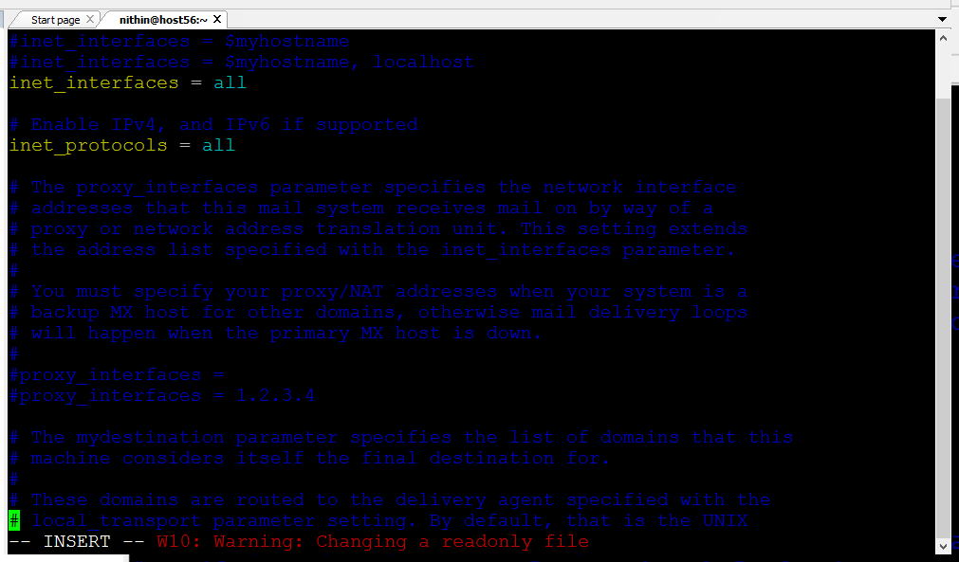

* Uncomment inet_interfaces=all
* Umcomment mydestination and set values

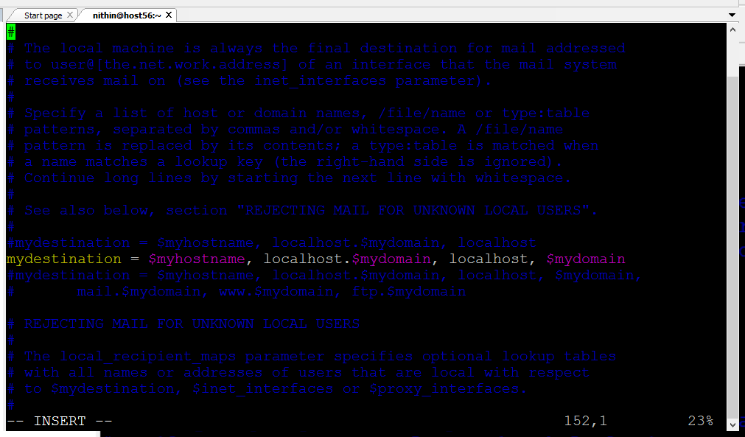

* Un comment and set my network

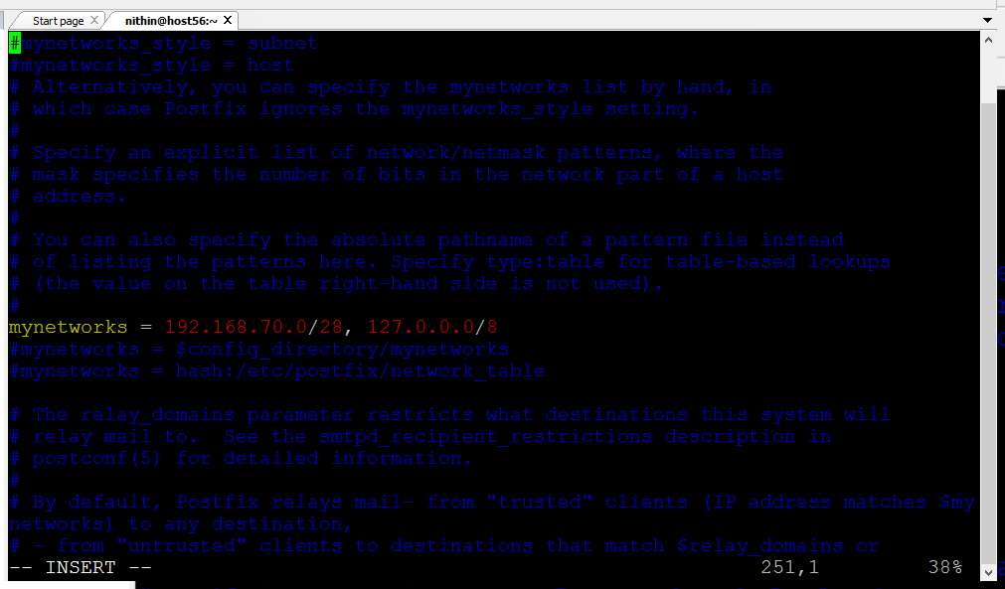

* Un comment home mail box

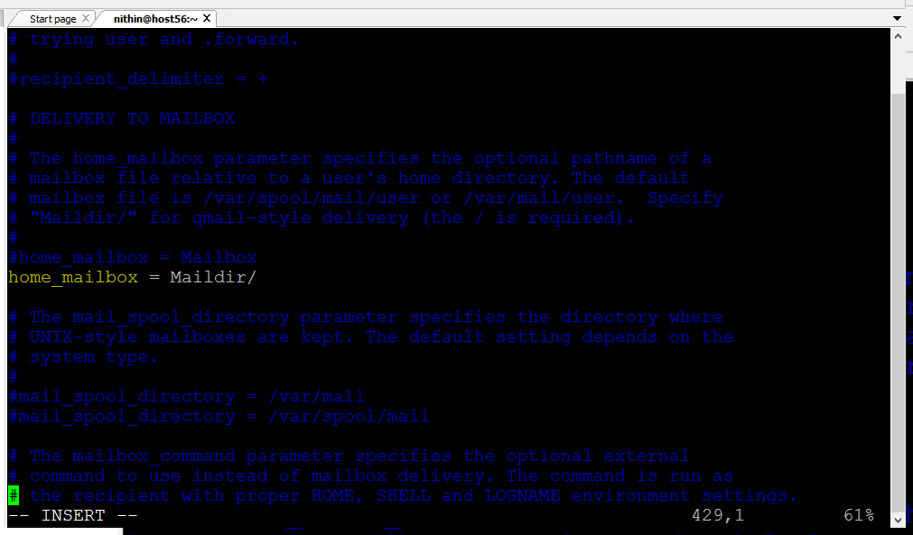

Vi /etc/dovecot/dovecott.config

Now configure in dovecot

Uncomment protocols

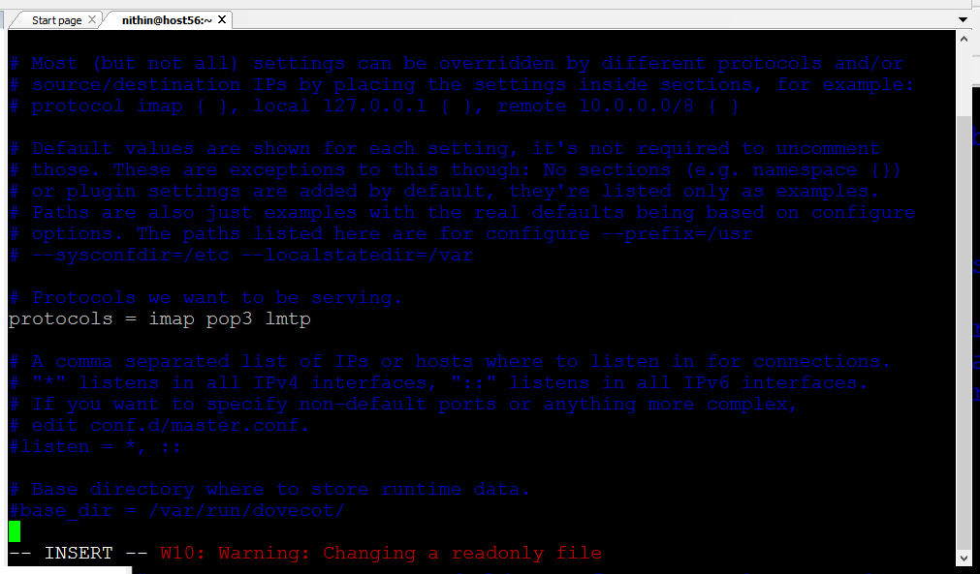

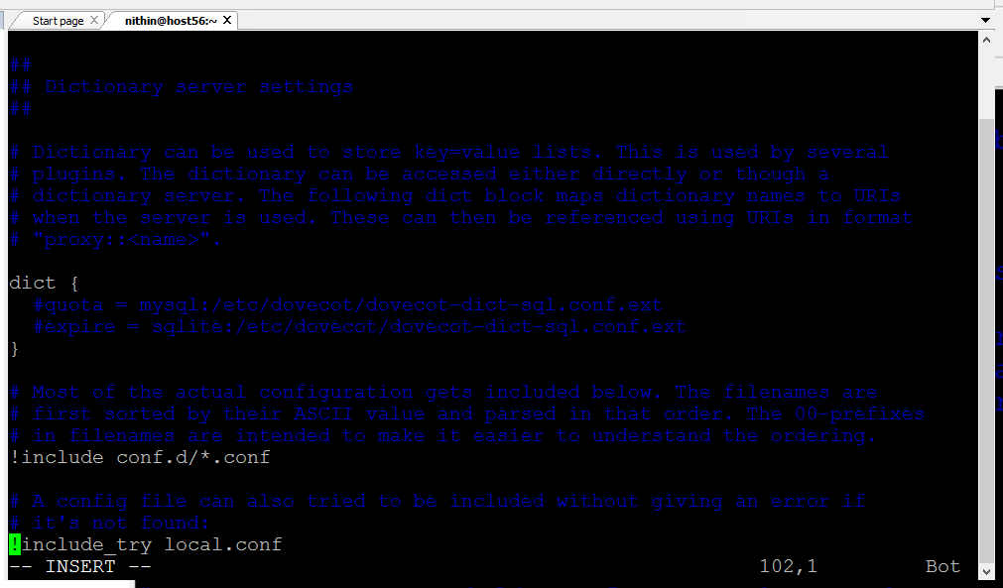

Vi /etc/con

Service postfix start

Systemctl enable postfix

Service dovecott start

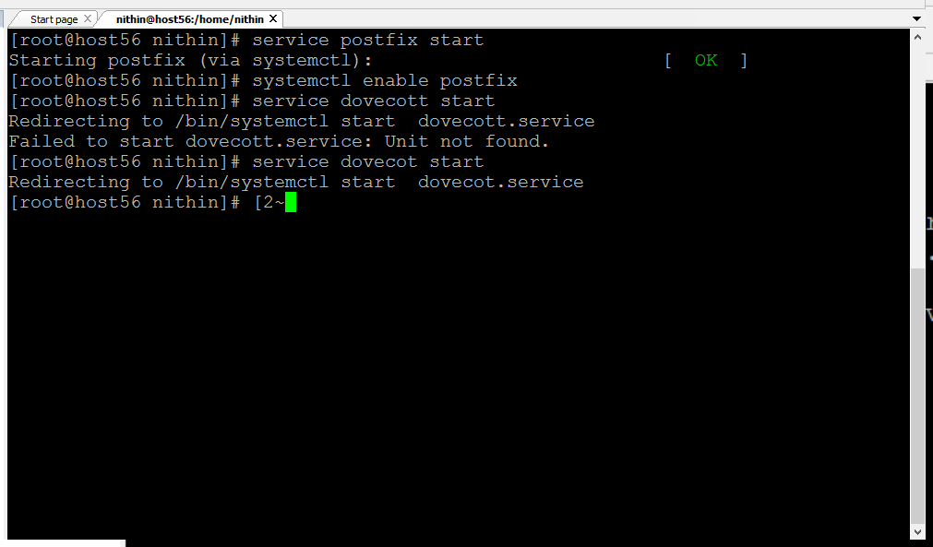

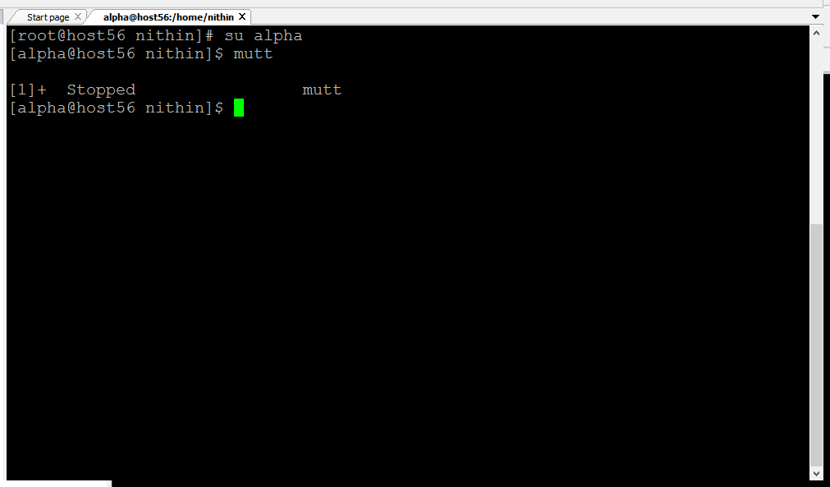

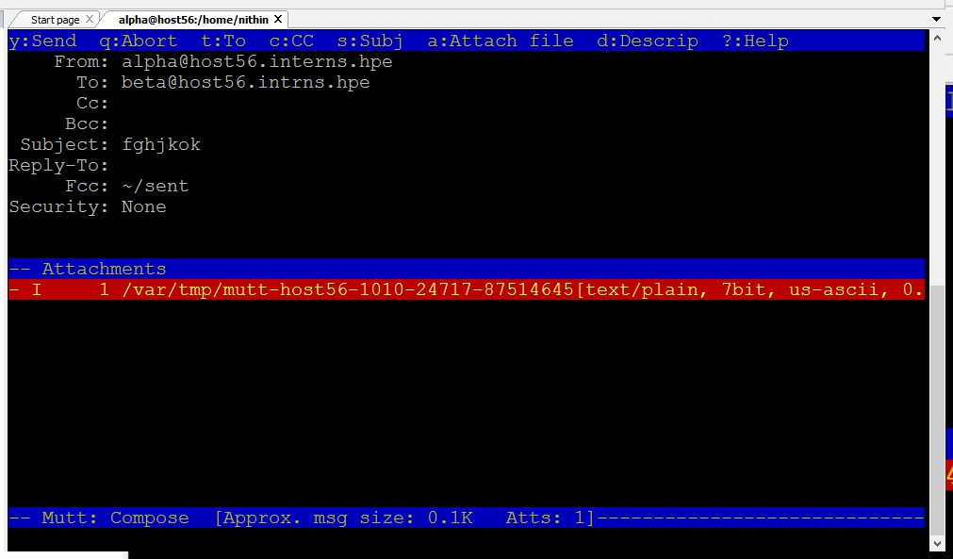

Report GIT

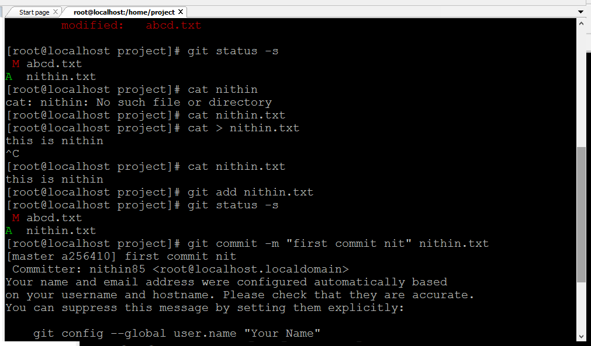

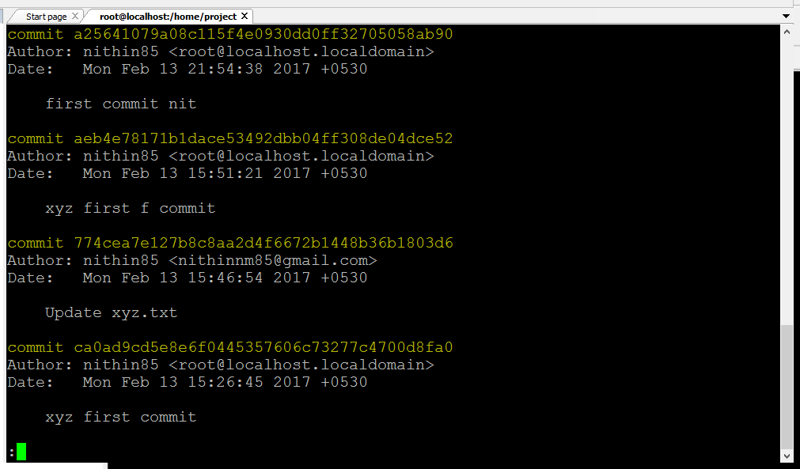

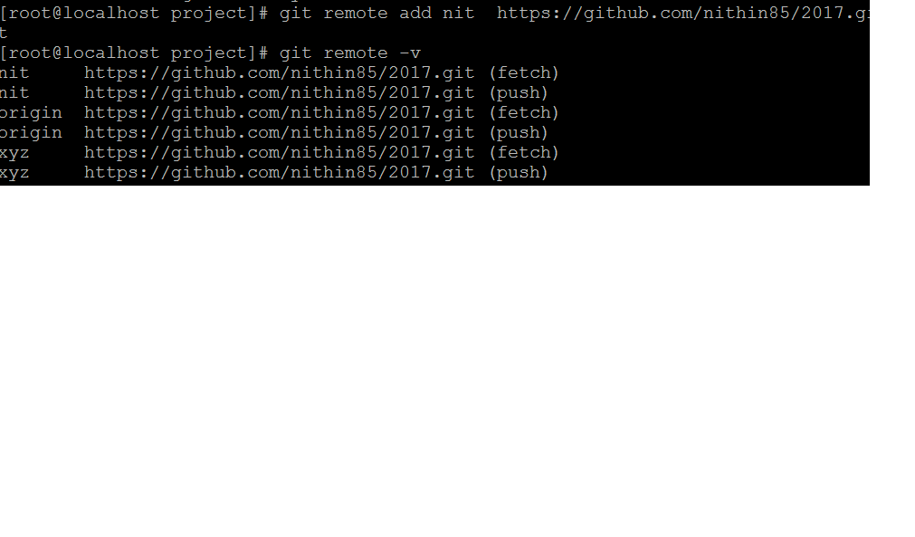

Clone a git :

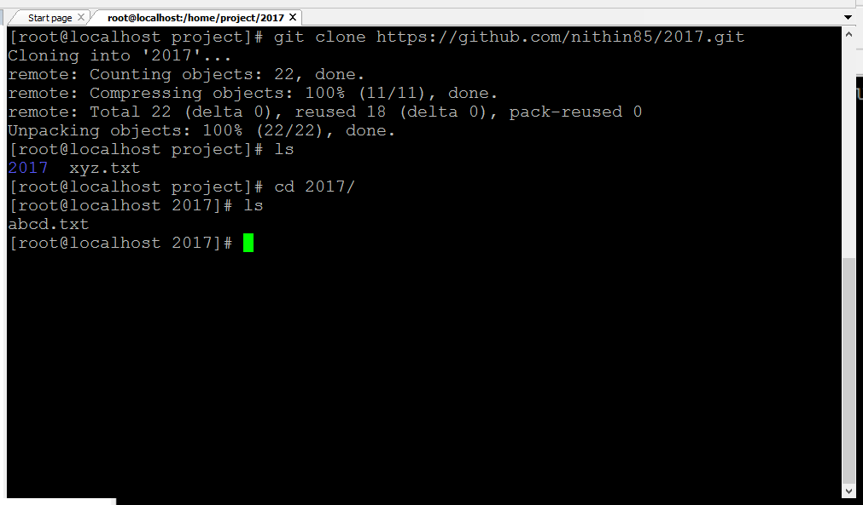

Tag

1.Annotated tag:

2.Lightweighted: