Go to https://console.aws.amazon.com and sign in

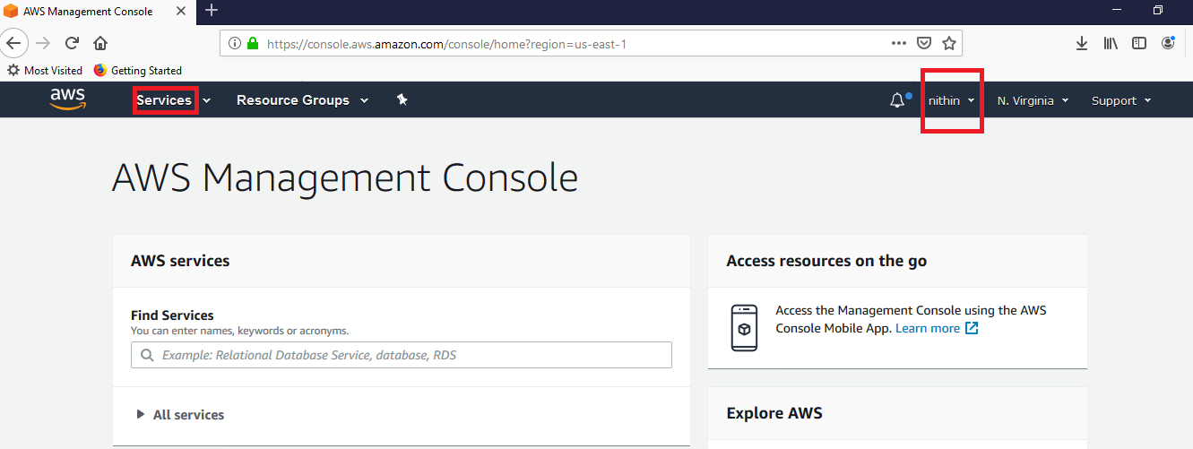

Click Services Menu and search for EC2 and click EC2 under Compute category

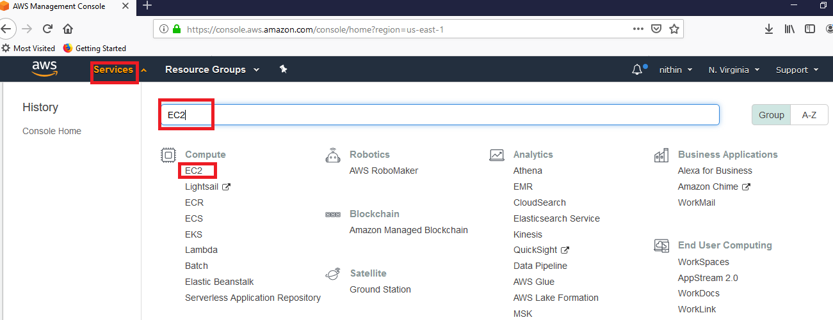

Click Launch Instance

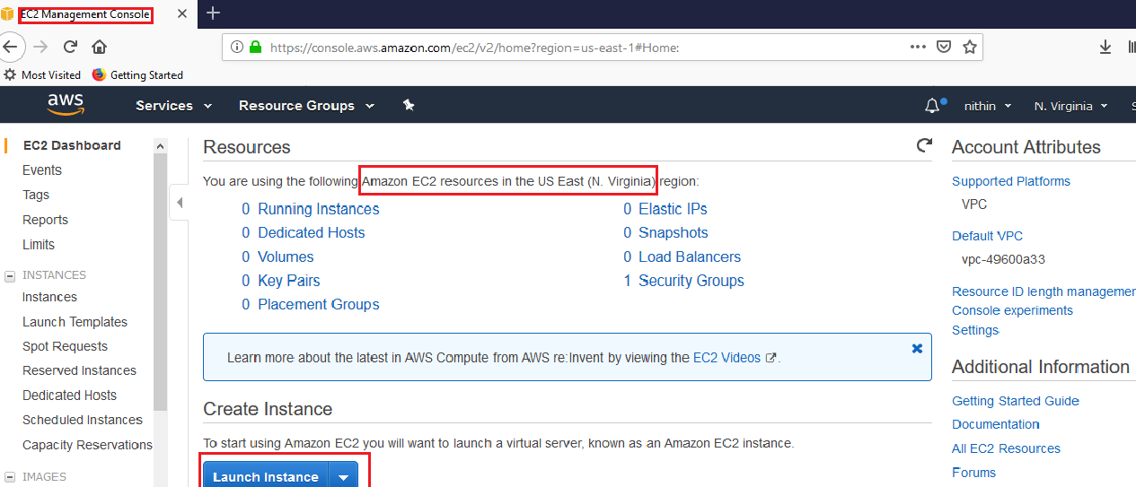

Choose Ubuntu Server 18.04 LTS

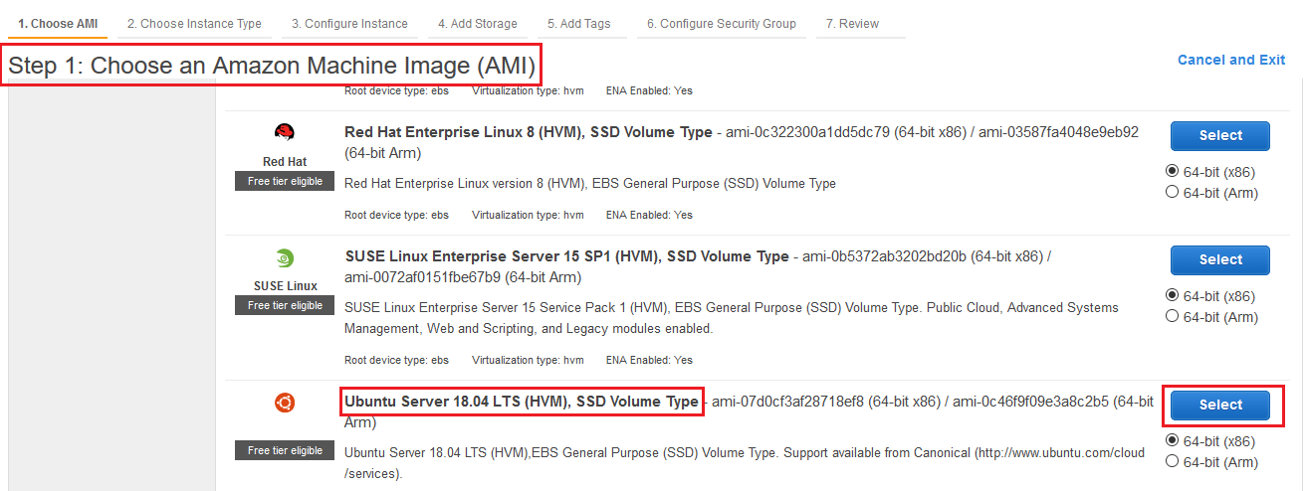

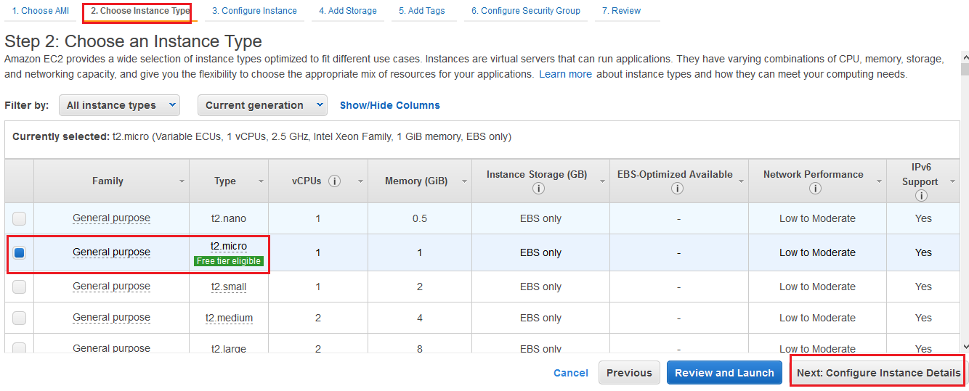

By default cluster will be 1. Increase to more clusters based on data.

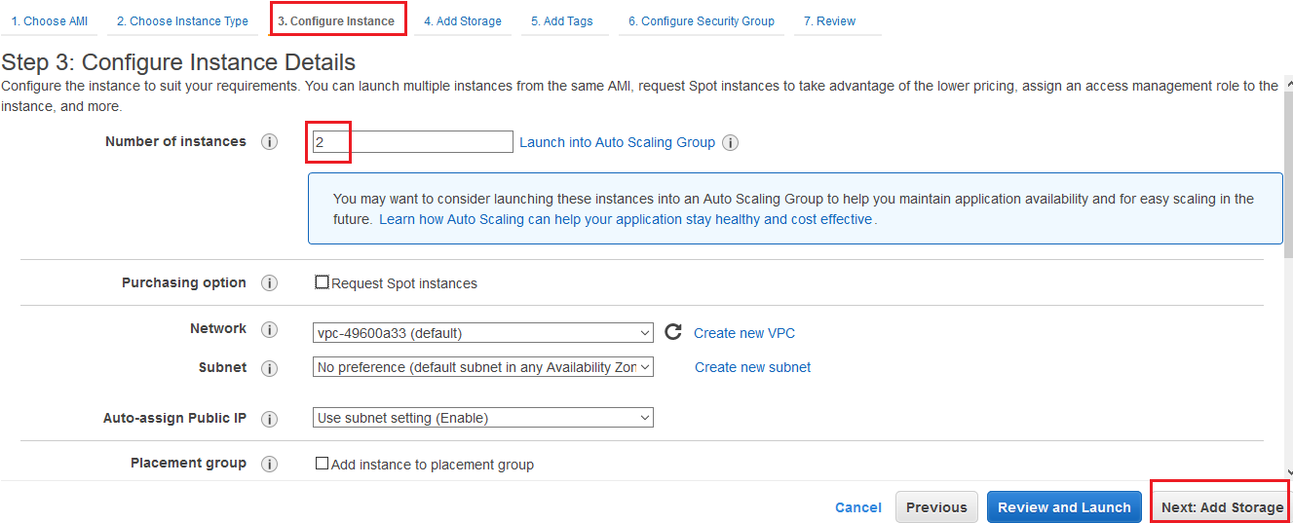

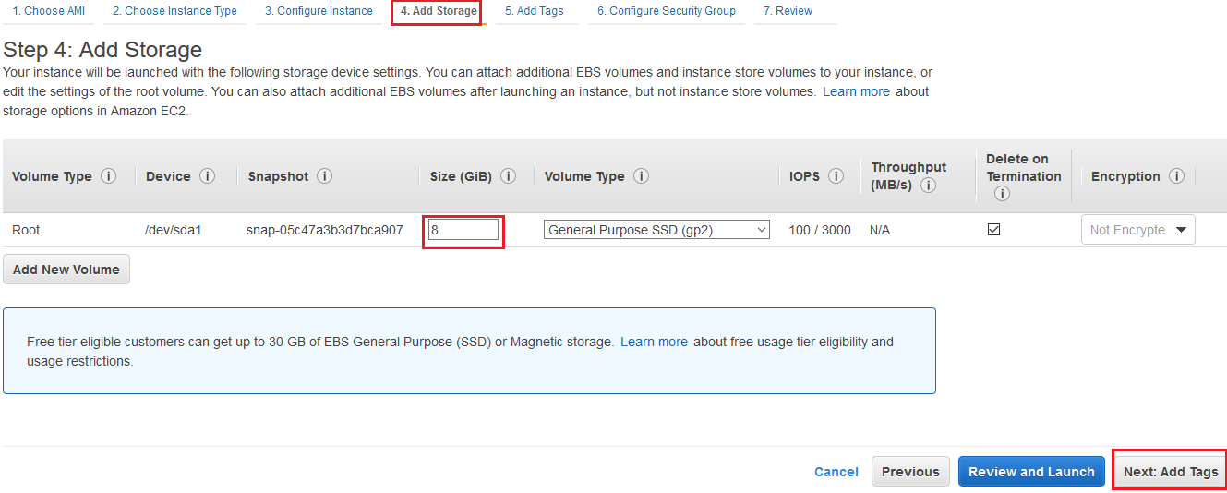

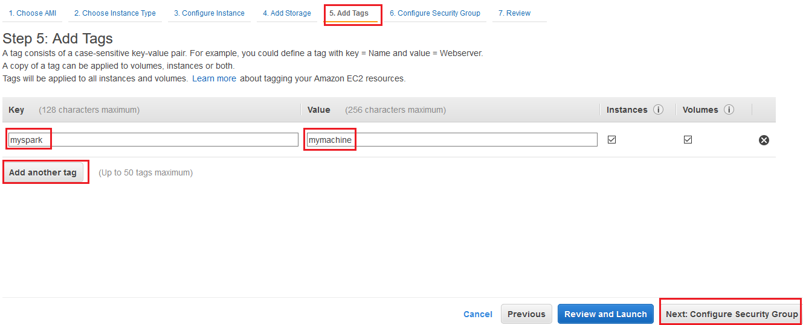

Change Type from “SSH” to “All traffic” for easy accessing.
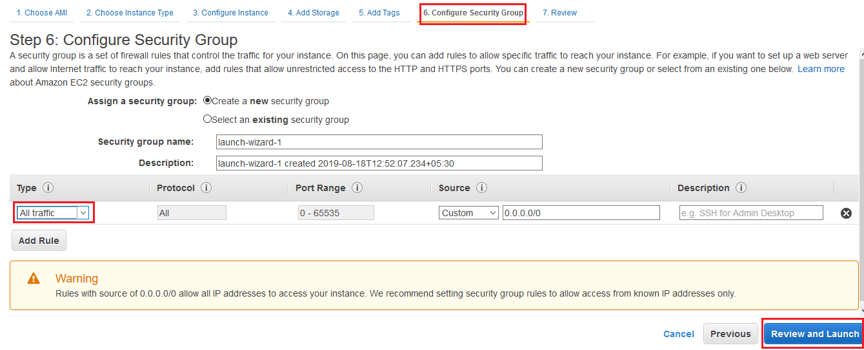
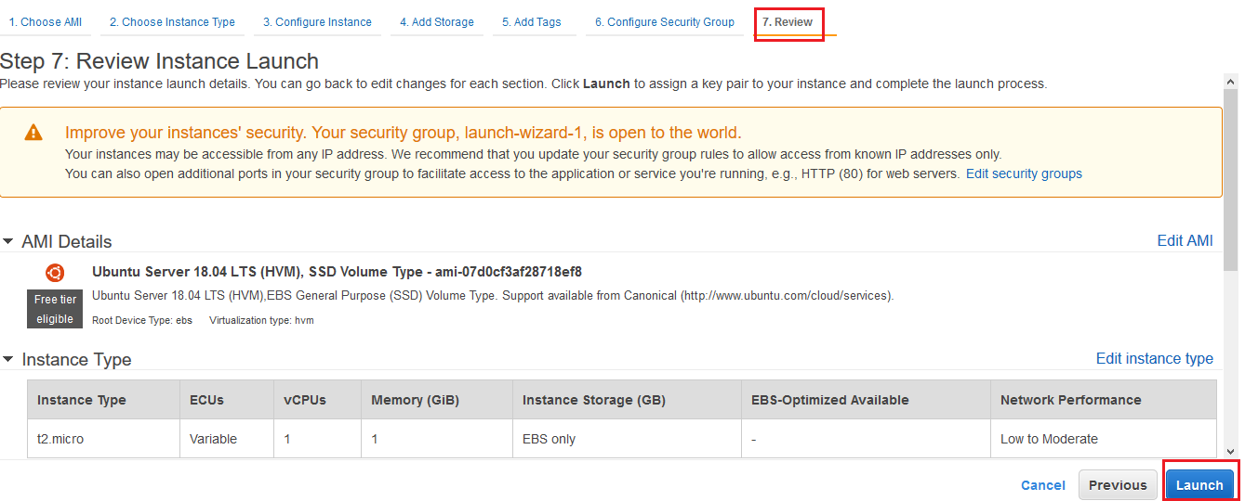

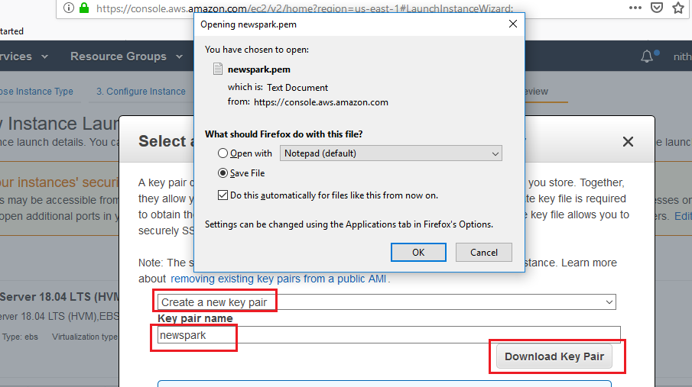

Now Click Launch Instance.

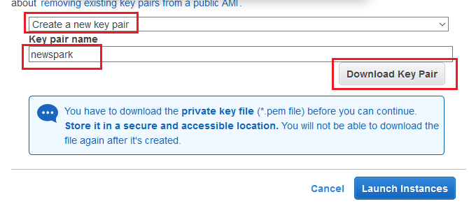

Click the Instance ID

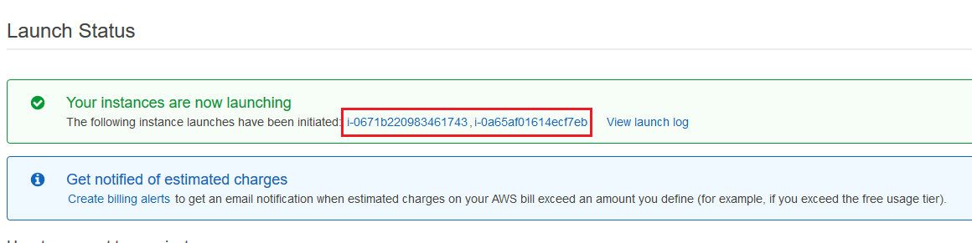

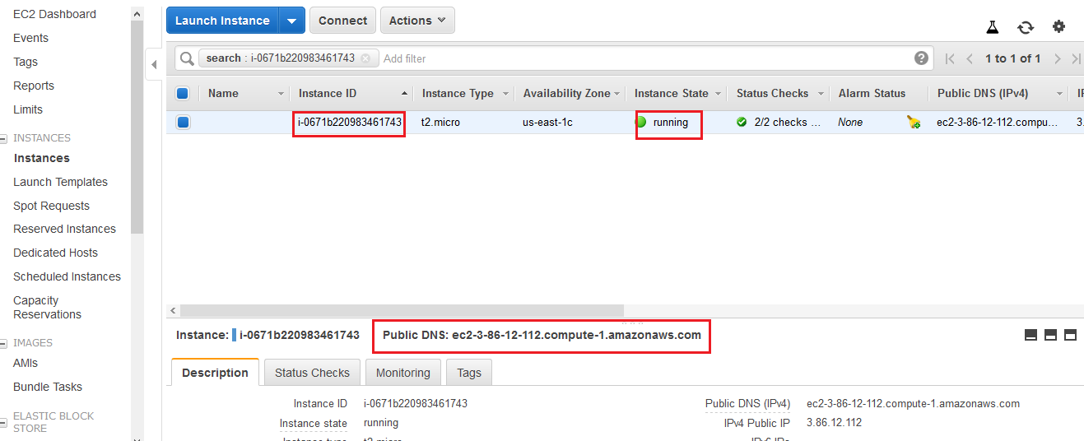

Next we need to open Instance from Windows using Putty. Follow the steps from the below link.
https://docs.aws.amazon.com/AWSEC2/latest/UserGuide/putty.html

Open PuttyGen → Click Load → Map with .pem file which we downloaded

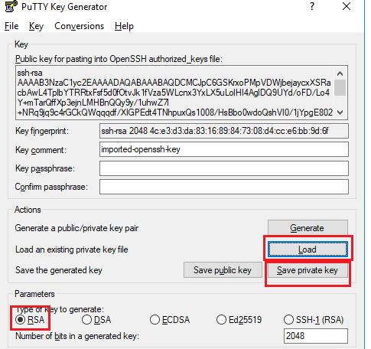

Open Putty

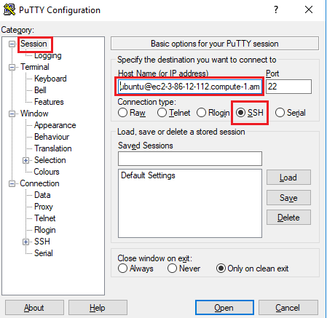

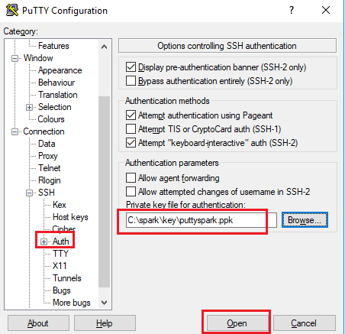

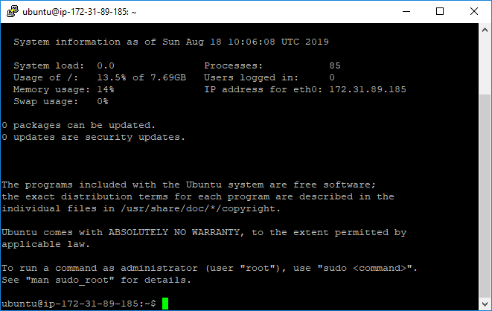

Type python3 in the shell.

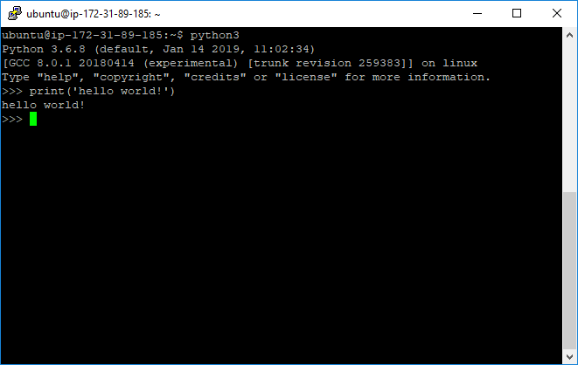

To update the softwares
sudo apt-get update
sudo apt install python3-pip
pip3 install jupyter
sudo apt-get install default-jre
sudo apt-get install scala
pip3 install py4j
wget https://archive.apache.org/dist/spark/spark-2.4.3/spark-2.4.3-bin-hadoop2.7.tgz
sudo tar -zxvf spark-2.4.3-bin-hadoop2.7.tgz
cd spark-2.4.3-bin-hadoop2.7/
pwd
ubuntu@ip-172-31-89-185:~/spark-2.4.3-bin-hadoop2.7$ pwd
/home/ubuntu/spark-2.4.3-bin-hadoop2.7
cd
sudo apt install jupyter-notebook
pip3 install findspark
ubuntu@ip-172-31-89-185:~$ jupyter notebook –generate-config

mkdir certs
cd certs
sudo openssl req -x509 -nodes -days 365 -newkey rsa:1024 -keyout mycert.pem -out mycert.pem

Country Name (2 letter code) [AU]:US
State or Province Name (full name) [Some-State]:CA
Locality Name (eg, city) []:
Organization Name (eg, company) [Internet Widgits Pty Ltd]:
Organizational Unit Name (eg, section) []:
Common Name (e.g. server FQDN or YOUR name) []:
Email Address []:

https://chrisalbon.com/aws/basics/run_project_jupyter_on_amazon_ec2/
https://medium.com/@alexjsanchez/python-3-notebooks-on-aws-ec2-in-15-mostly-easy-steps-2ec5e662c6c6

ubuntu@ip-172-31-89-185:~/certs$ cd ~/.jupyter/
ubuntu@ip-172-31-89-185:~/.jupyter$ vi jupyter_notebook_config.py

c = get_config()
c.NotebookApp.certfile = u'/home/ubuntu/certs/mycert.pem'
c.NotebookApp.ip = '*'
c.NotebookApp.open_browser = False
c.NotebookApp.port = 8888
press Esc Key
:wq! And then enter

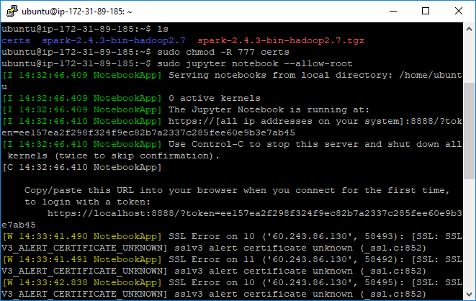

https://ec2-3-86-12-112.compute-1.amazonaws.com:8888/?token=ee157ea2f298f324f9ec82b7a2337c285fee60e9b3e7ab45

