DNSenum : bandhanbank.com

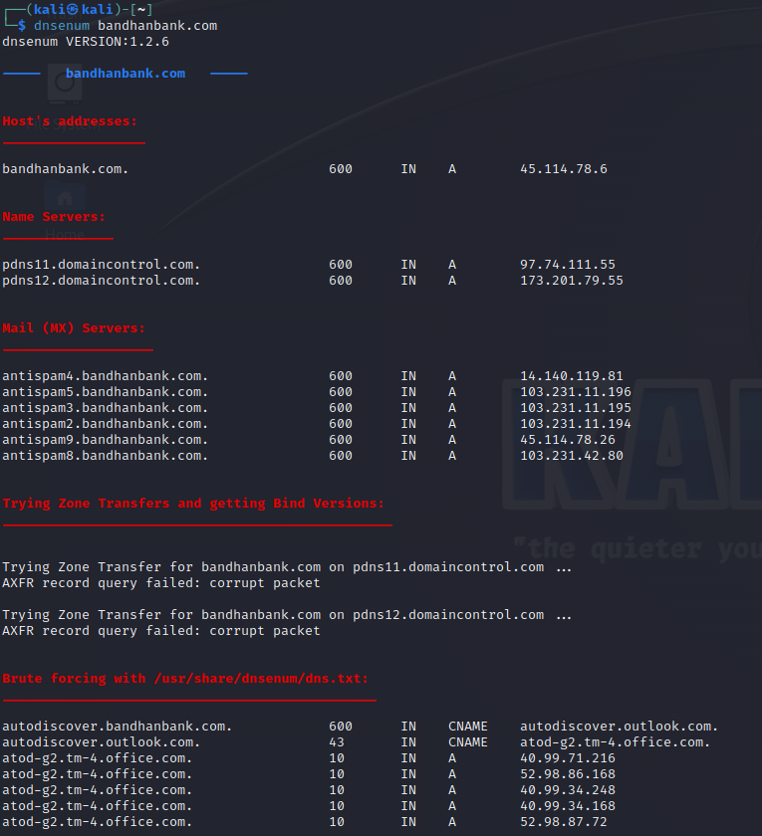

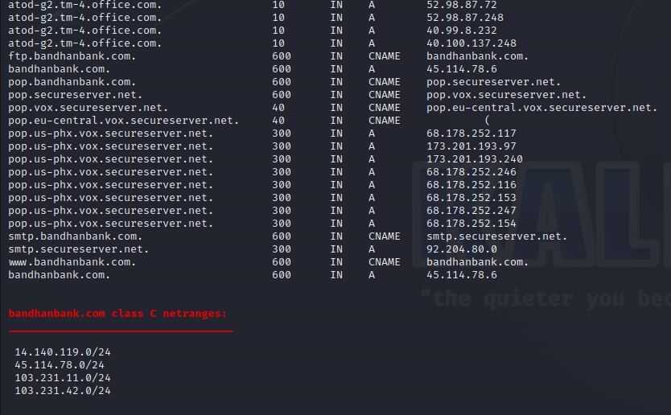

Enum4linux : bandhanbank.com

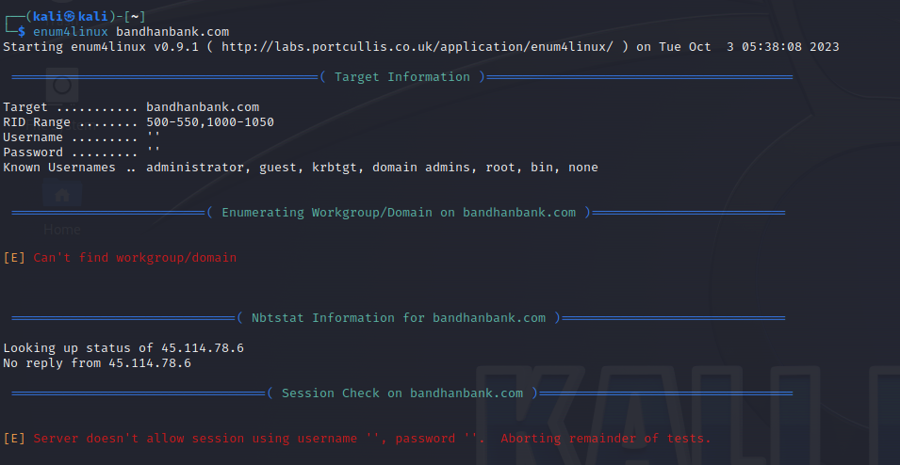

Advance ip scanner [45.114.78.6] /

: [**3.111.190.30**](https://www.shodan.io/host/3.111.190.30)

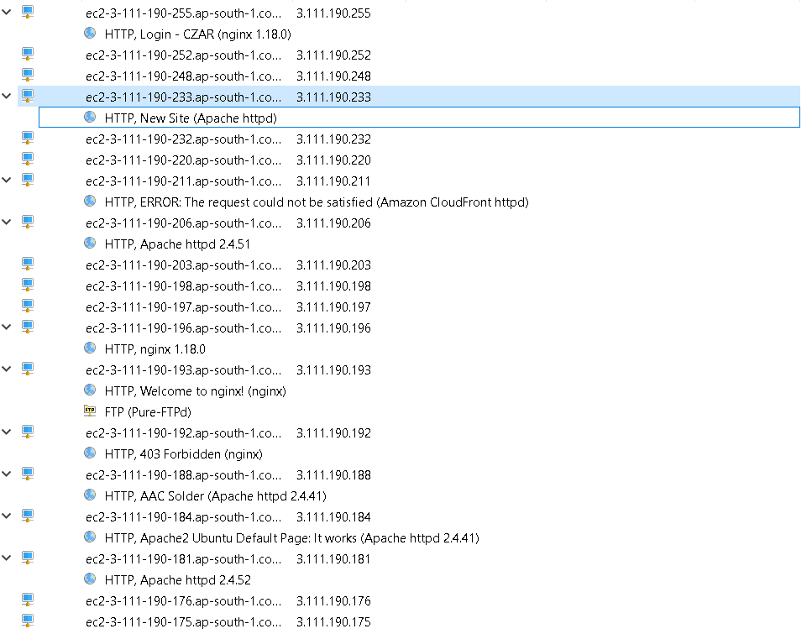

Scanning NMAP 3.111.190.30

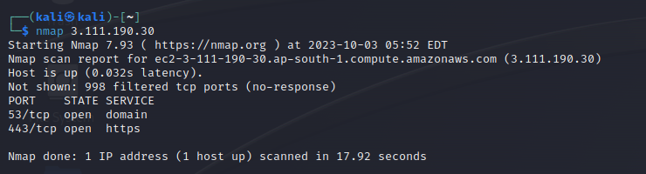

NMAP -sA

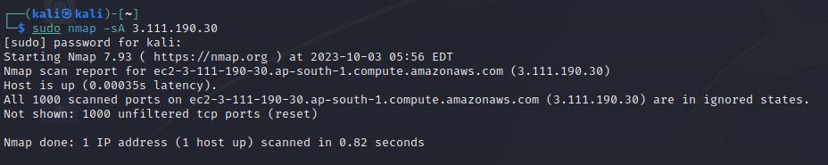

NMAP -sT

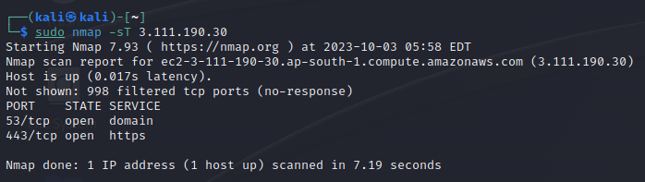

NMAP -sU

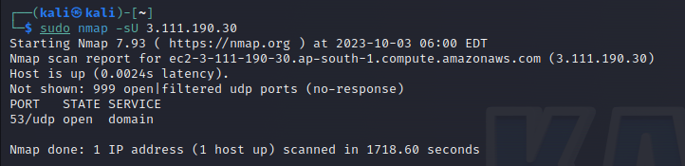

Nmap -O 3.111.190.30

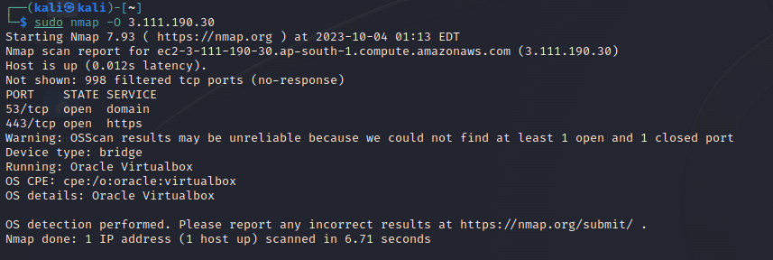

Nmap -sV 3.111.190.30

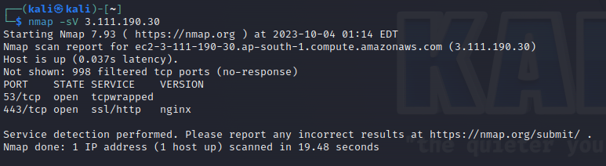

Advance ip scanner : 45.114.78.6

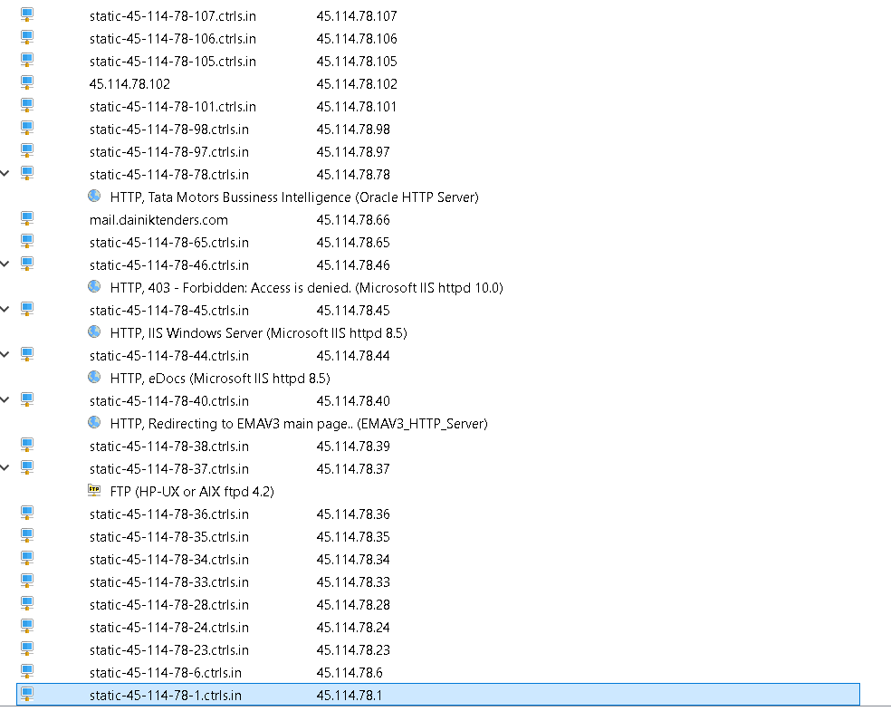

2. **Inoxmovies.com**

**Ip** : 3.108.91.124

DNSenum: **Inoxmovies.com**

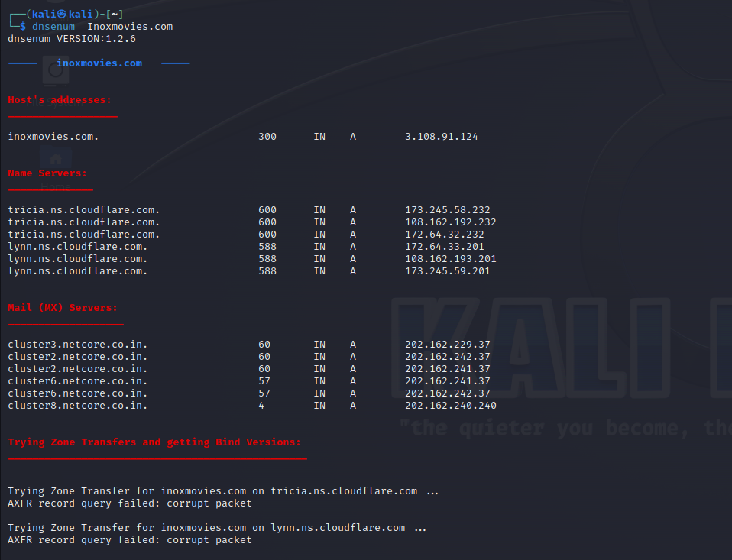

Enum4linux: inoxmovies.com

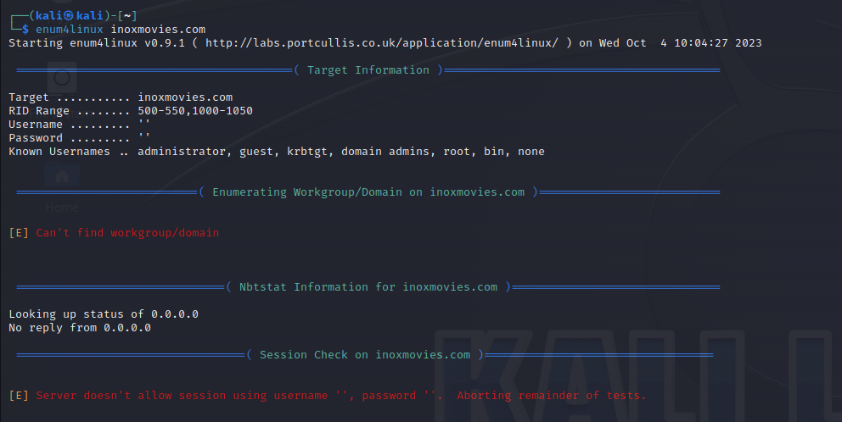

Dnsrecon:inoxmovies.com

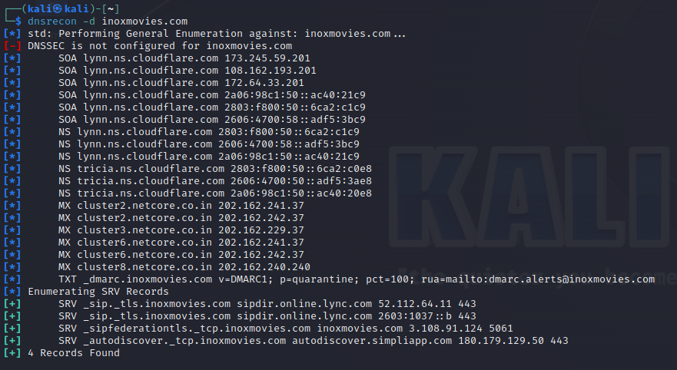

Nmap:

sudo nmap -sF -sV --vv 3.108.91.124

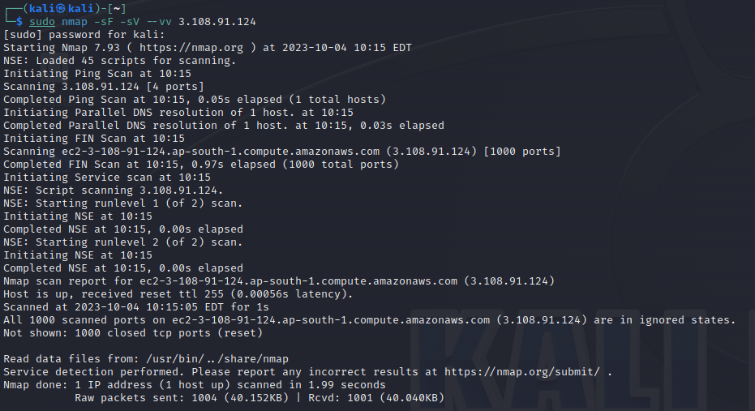

sudo nmap -sA

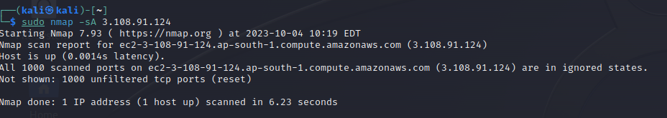

sudo nmap -sT -Pn 3.108.91.124

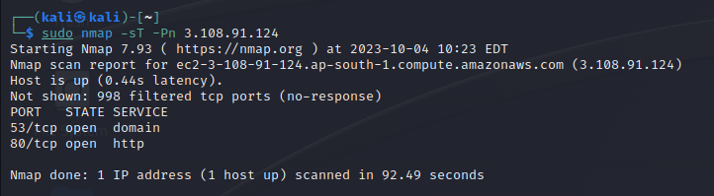

sudo nmap -sU -Pn 3.108.91.124

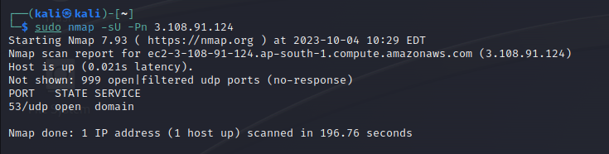

Sudo nmap -O 3.108.91.124

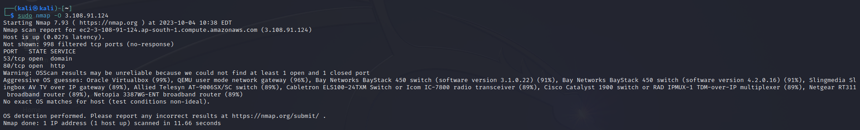

Sudo nmap -A 3.108.91.124

