1. Ip address : 95.217.213.83

Command : nmap -p 389 -script=ldap-search 95.217.213.83

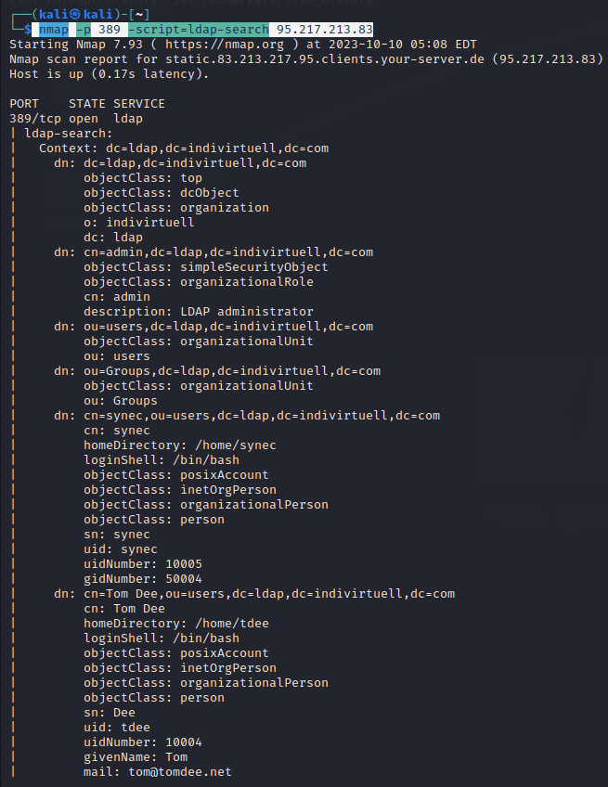

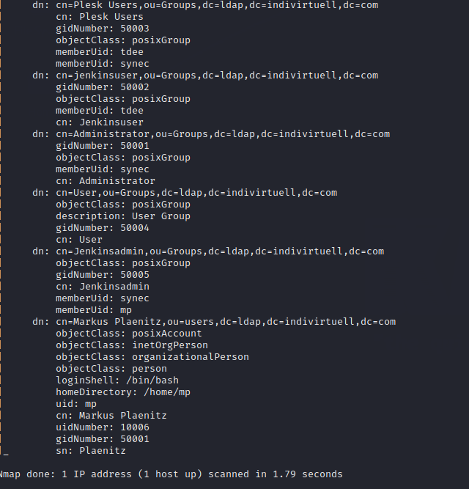

Command : nmap -sV --script=ldap\*

Ip address : 95.217.213.83

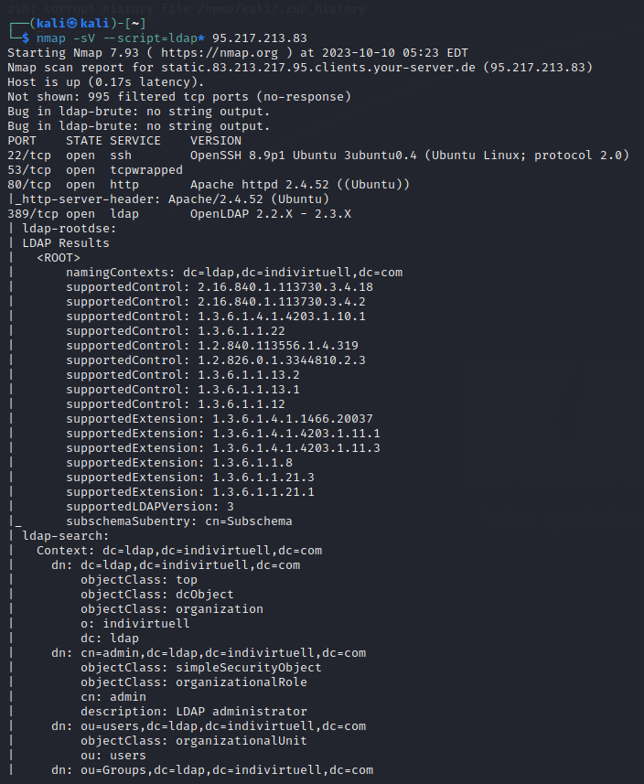

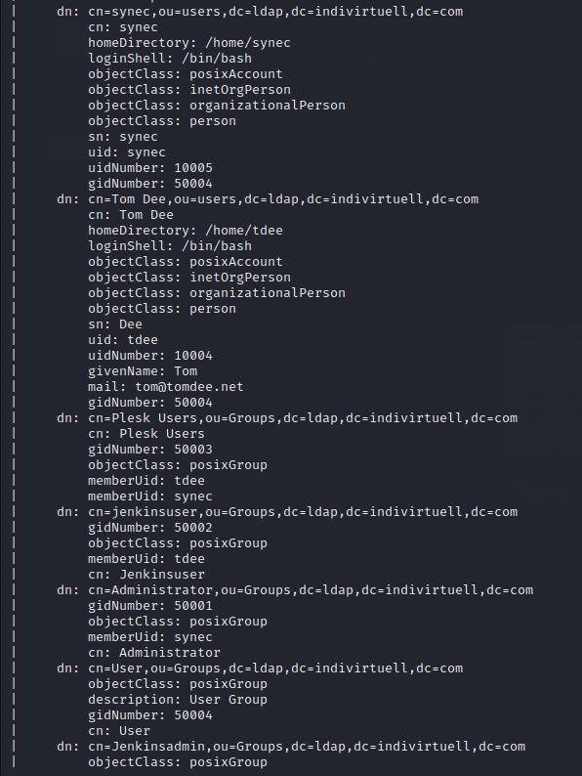

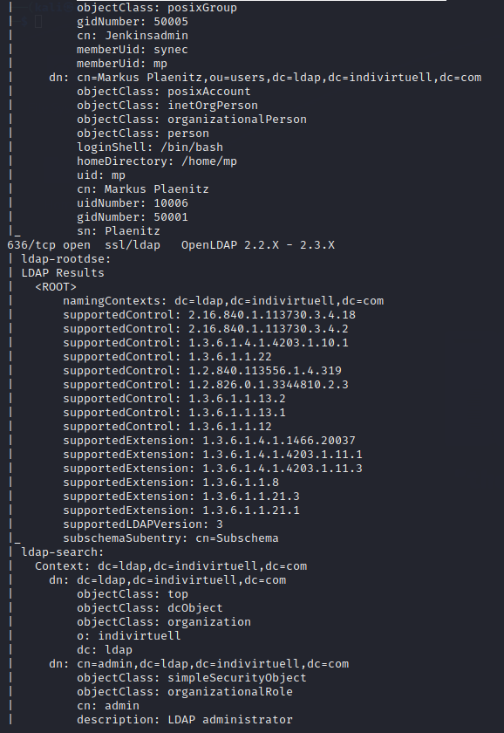

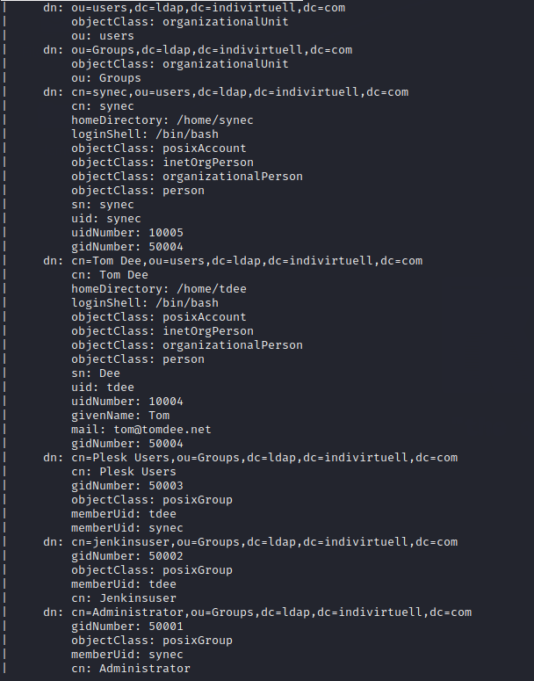

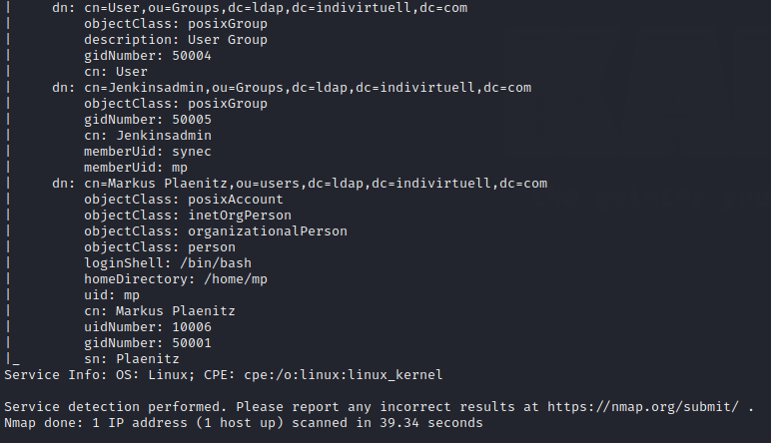

Command : sudo nmap -sU -p 123 -script=ntp-info

Ip address : 95.217.213.83

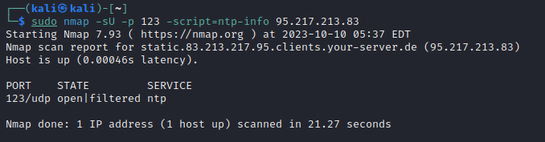

Command : sudo nmap -p 389 -O -sV -script=ldap-search

Ip adress : 95.217.213.83

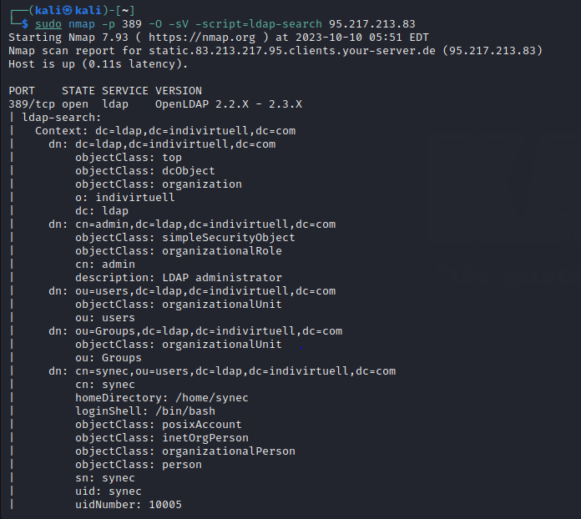

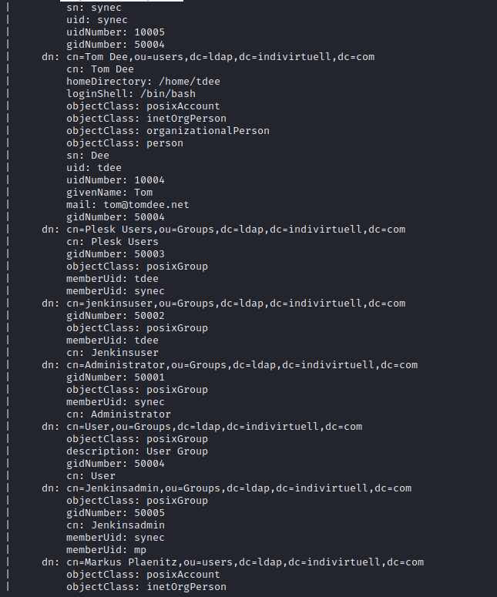

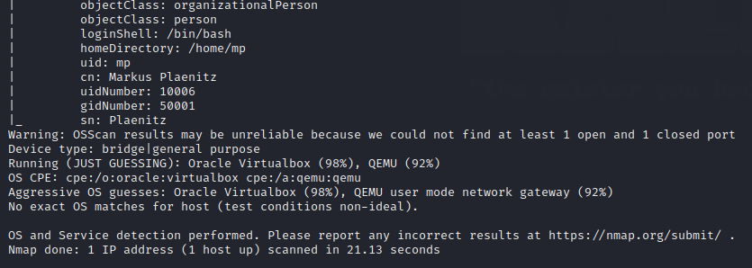



Command : nmap -p 389 -script=ldap-search

Ip address : 118.68.218.102

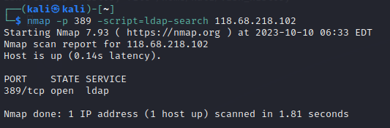

Command : nmap -Pn -script=ldap-search

IP address : 118.68.218.102

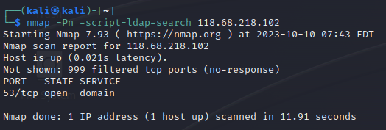

Command : nmap -sU -p 123 -script=ntp–info

Ip address : 118.68.218.102

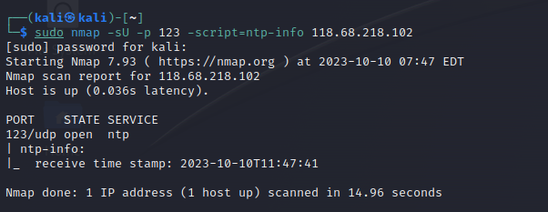

Command : nmap -Pn -sT -A -script=ldap-search

Ip address : 118.68.218.102

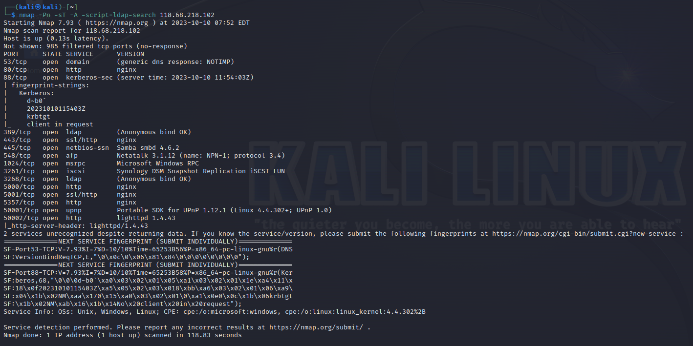

Command : nmap -p 389 -script=ldap-search

Ip address : 4.224.84.149

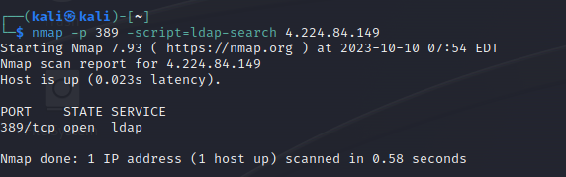

Command : nmap -sV -script=ldap\*

Ip address : 4.224.84.149

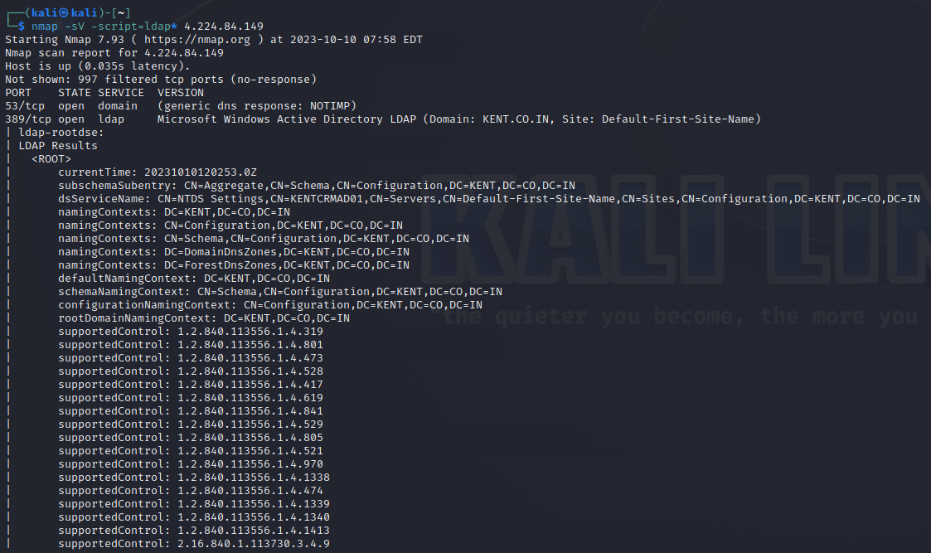

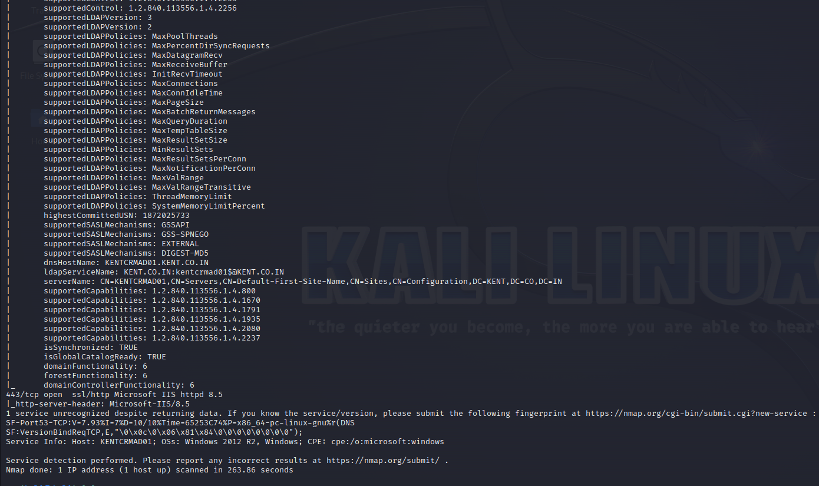

Command : nmap -Pn -script=ldap-search

Ip address : 4.224.84.189.

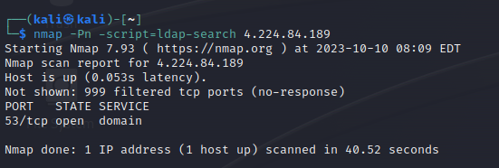

Command : nmap -sU -p 123 -script=ntp-info

Ip address ; 4.224.84.189

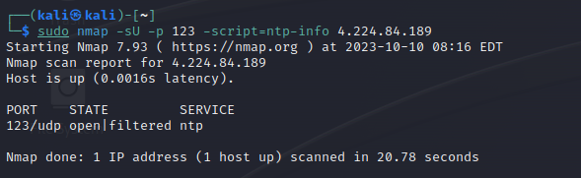

Command : nmap -Pn -sT -A -script=ldap-search

Ip address : 4.244.84.189

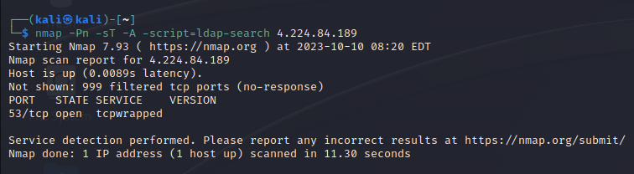



Command : nmap -p 389 -script=ldap-search

Ip address : 45.118.162.207

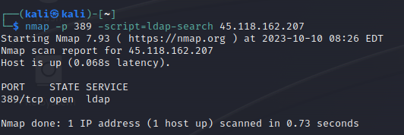

Command : nmap -sV -script=ldap\*

Ip address : 45.118.162.207

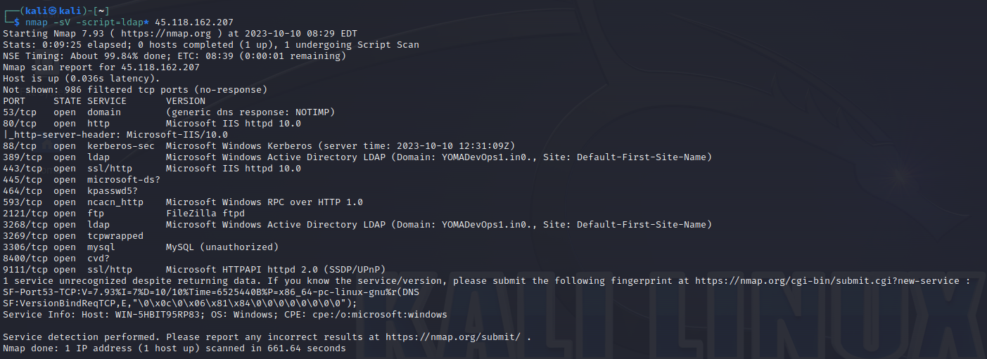

Command : nmap -Pn -script=ldap-search

Ip address : 45.118.162.207

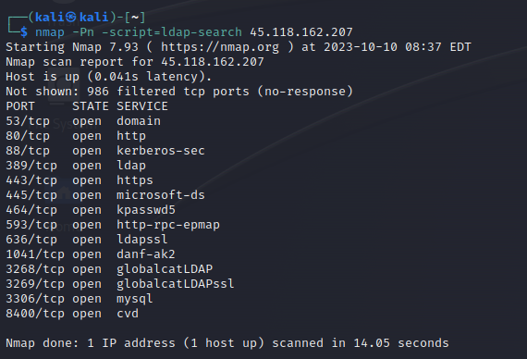

Command : nmap -sU -p 1023 -script=ntp-info

IP address : 45.118.162.207

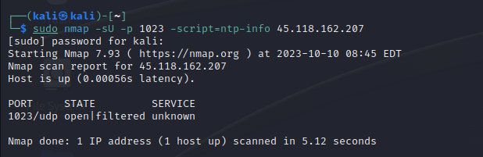

Command : nmap -sU -P 123 -script=ntp-info

Ip address : 45.118.162.207

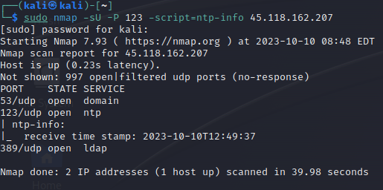

Command : nmap -Pn -sT -A -script=ldap-search

Ip address : 45.118.162.207

