1.tracert inox.com

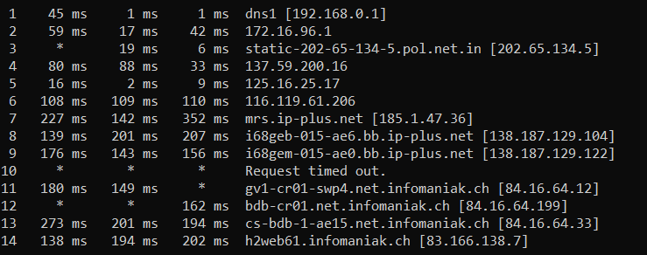

switzerland>telangana>Telangana>>Telangana>Marseille

>Switzerland>SwitzerlandGeneve>Switzerland Geneva

2. tracert netflix.com

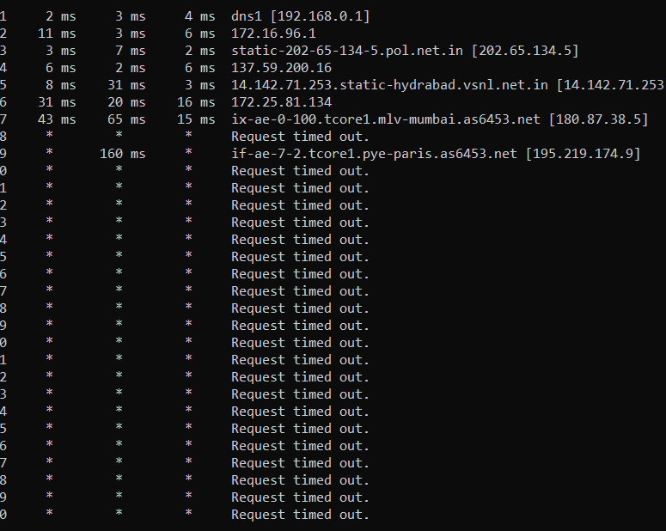

Ireland>IndiaTelangana>IndiaTelangana>IndiaTelangana>mumbai>

france

3.tracert phonepe.com

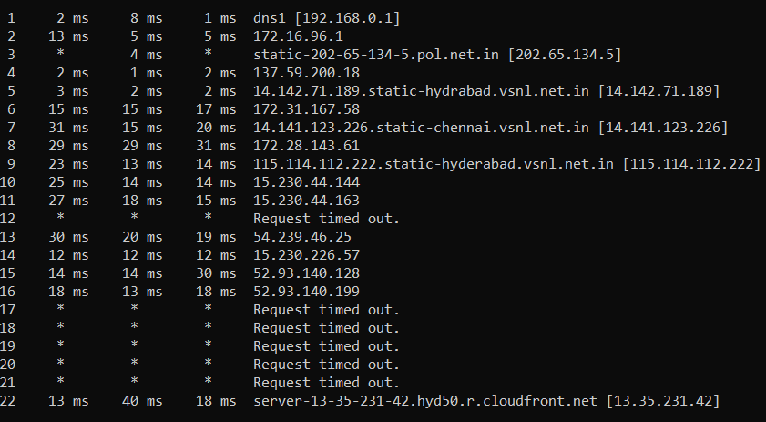

India telangana>India telangana>india Kerala>India telangana>hyderabad

>United States washington>United States washington>United States washington> United States washington>india maharashtra>india maharashtra