1. D:\git\python_all>git clone <https://github.com/nithinadi/Pythonworks.git>

Go to the required folder in windows and clone from the github

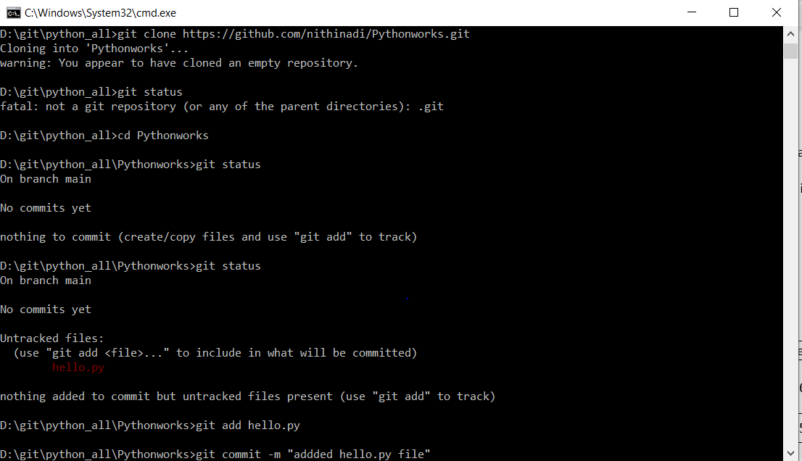

1. Do git status
2. Create a new file
3. To add git file do git add “filename”
4. Comiit the above file to the git D:\git\python_all\Pythonworks>git add hello.py & D:\git\python_all\Pythonworks>git commit -m "addded hello.py file"
5. D:\git\python_all\Pythonworks>git push origin main
6. D:\git\python_all\Pythonworks>git pull origin main

