**ABSTRACT**

The word "vote" means to choose from a list, to elect or to determine. The main goal of voting(in a scenario involving the citizens of a given country) is to come up with leaders of the people's choice.

Most countries,Kenya not an exception have problems when it comes to voting.Some of the problems involved include ridging votes during election,insecure or inaccessible the polling stations,inadequate polling materials and also inexperienced personnel.

This online voting/polling system seeks to address the above issues. It should be noted that with this system in place,the users,citizens in this case shall be given ample time during the voting period.They shall also be trained on how to vote online before the election time.

**CHAPTER 1**

**INTRODUCTION**

"E-VOTING SYSTEM" is an online technique. In this system people who have citizenship of India and whose age is 18 years of age and any sex can give his/her vote online without going to any physical polling station.

There is a database which is maintained in which all the names of voters with complete information is stored.

In " E-VOTING SYSTEM" a voter can use his/her voting right online without any difficulty.He\She has to be registered first for him/her to vote.Registration is mainly done by the system adminstrator for security reasons. The system Administrator registers the voters on a special site of the system visited by him only by simply filling a registration from to register vote.Citizens seeking registration are expected to contact the system administrator to submit their details.After the validity of them being citizens of India has ben confirmed by the system admintrator by comparing their details submitted with those in exsisting databases such as those as the Registrar of Persons, the citizen is then registered as a voter.

After registration,the voter is assigned a secret Voter ID with he/she can use to log into the system and enjoy services provided by the system such as voting.If invalid/wrong details are submitted,then the citizen is not registered to vote.

**1.1 PROJECT AIMS AND OBJECTIVES**

**IMPROVEMENT IN CONTROL AND PERFORMANCE**

The system is developed to cope up with the current issues and problems of voting.

**SAVE COST**

E-voting certainly would make it easier to participate in the democratic process. Instead of schlepping to the polls, we could vote from the comfort of our homes simply by clicking a computer mouse or swiping a smart phone.

**SAVE TIME**

The best thing about electronic voting machines is that they are real time savers.

one can count the votes in few minutes which makes life easier for the election officers on duty. In a paper ballot, the vote counting process is quite tedious and time-consuming

The project aims and objectives that will be achieved after completion of this project are discussed in this subchapter.

* Creates ADHAR ID for each user
* Adds the candidate details
* Creates the party for each candidate
* Views the count of votes earned by each party

**1.2 BACKGROUND OF PROJECT**

The E-voting System is also known as Online voting Sysetm(OVS) is a term encompassing several different types of voting embracing both electronic means of counting votes.Electronic voting technology can include punched cards, optical scan voting systems and specialized voting kiosks(including self contained direct recording electronic voting systems or DRE).It can also involve transmission of ballots and votes via telephones,private computer networks,or the internet.

E-voting is an electronic way of choosing leaders via a web driven application. The advantage of online voting over the common "queue method" is that the voters have the choice of voting at their own free and there is reduced congestion. It also minimizes on errors of vote counting. The individual votes are submitted in a database which can be queried to find out who of the aspirants for a given post has the highest number of votes.

this system is geared towards increasing the voting percentage in India .With the "E-VOTING SYSTEM" ,a voter can use his\her voting right online without any difficulty. He\She has to register as a voter first before being authorized to vote. The registration should be done prior to voting date to enable data update in the database.

However, not just anybody can vote.For one to participate int he elections, he/she must have the requirements. For instance, he/she must be a registered citizen i.e. must be 18 and above years old. As already started, the project 'Online Voting' provides means for fast and convenient voting and access to this system is limited only to registered voters.

Internet voting systems are appealing for several reasons which include; People are getting more used to work with computers to do all sort of things, namely sensitive operations such as shopping and home banking and they allow people to vote far from where they usually live,helping to reduce absenteeism rate.

**1.3 OPERATION ENVIRONMENT**

In this section we will see the minimum basic requirements in which the software runs.

i.**SQL SERVER:** SQL Server is Microsoft's relational database management system (RDBMS). It is a full-featured database primarily designed to compete against competitors Oracle Database (DB) and MySQL.

Like all major RBDMS, SQL Server supports ANSI SQL, the standard SQL language. However, SQL Server also contains T-SQL, its own SQL implemention. SQL Server Management Studio (SSMS) (previously known as Enterprise Manager) is SQL Server's main interface tool, and it supports 32-bit and 64-bit environments.

ii.**C# OR C SHARP** C# is a general object-oriented programming (OOP) language for networking and Web development. C# is specified as a common language infrastructure (CLI) language.

In January 1999, Dutch software engineer Anders Hejlsberg formed a team to develop C# as a complement to Microsoft’s NET framework. Initially, C# was developed as C-Like Object Oriented Language (Cool). The actual name was changed to avert potential trademark issues. In January 2000, NET was released as C#. Its NET framework promotes multiple Web technologies.

**HARDWARE REQUIREMENTS:**

* **Microsoft Windows XP Professional SP3/Vista SP1/Windows 7 Professional:**

**Processor:** 800MHz Intel Pentium III or equivalent

**Memory:**512 MB

**Disk space:**750 MB of free disk space.

* **Ubuntu 9.10:**

**Processor:**800MHz Intel Pentium III or equivalent

**Memory:**512 MB

**Disk space:**650 MB of free disk space

**CHAPTER 2**

**LITERATURE SURVEY**

**2.1 USER DEFINED FUNCTIONS:**

**DROP FUNCTION**: To drop a function, you must have the DELETE privilege for the MySQL database. This is because DROP FUNCTION removes a row from the mysql.func. system table that records the function's name, type, and shared library name.

It is also used to drop stored functions.

**CREATE FUNCTION**: The CREATE FUNCTION statement is also used in MySQL to support UDFs (user-defined functions). A User Define Function can be regarded as an external stored function. Stored functions share their namespace with User Define Functions, for the rules describing how the server interprets references to different kinds of functions.

**SET:** The SET statement has several forms. Descriptions for those forms that are not associated with a specific server capability appear in subsections of this section:

SET var_name = value enables you to assign values to variables that affect the operation of the server or clients.

SET CHARACTER SET and SET NAMES assign values to character set and collation variables associated with the current connection to the server.

**SELECT**: SELECT is used to retrieve rows selected from one or more tables, and can include UNION statements and sub queries. Each select_expr indicates a column that you want to retrieve. There must be at least one select_expr.

**CHAPTER 3**

**SYSTEM ANALYSIS**

In this chapter, we will discuss and analyse about the developing process of E-voting Management System including software requirement specification (SRS) and comparison between existing and proposed system. The functional and non-functional requirements are included in SRS part to provide complete description and overview of system requirement before the developing process is carried out.

**3.1 SOFTWARE REQUIREMENT SPECIFICATION**

**3.1.1 PRODUCT DESCRIPTION:**

Library Management System is a computerized system which helps user(Administrators) to manage the Voting activity and maintain the Aadhar records of the user in electronic format. It reduces the risk of paper work such as file lost, file damaged and time consuming. It can help user to manage the transaction or record more effectively and time-saving.

**PROBLEM STATEMENT:**

The problem occurred before having computerized system includes:

* File lost -When computerized system is not implemented file is always lost because of human environment. Sometimes due to some human error there may be a loss of records.
* File damaged -When a computerized system is not there file is always lost due to some accident like spilling of water by some member on file accidentally. Besides some natural disaster like floods or fires may also damage the files.
* Difficult to search record -When there is no computerized system there is always a difficulty in searching of records if the records are large in numbers.
* Space consuming- After the number of records become large the space for physical storage of file and records also increases if no computerized system is implemented.
* Cost consuming -As there is no computerized system the cost to add each record paper will be needed which will increase the cost for the management of physical voting.

**3.1.2 SYSTEM REQUIREMENTS**

* **NON-FUNCTIONAL REQIREMENTS**

**EFFICIENCY REQUIREMENT**

When a E-voting management system will be implemented USER whose age is above 18 can easily register through his/her Aadhar id and cast vote through online

**RELIABILITY REQUIREMENT**

The system should accurately perform voter registration, candidate registration and validation of votes.

**USABILITY REQUIREMENT**

The system is designed for a user-friendly environment so that USER can perform the various tasks easily and in an effective way.

**IMPLEMENTATION REQUIREMNTS**

In implementing whole system, it uses Java in front end and the database part is developed using MySQL.

* **FUNCTIONAL REQIREMENTS**

**REGISTER NEW VOTER**

* This feature allows to create Aadhar for each user.
* System must be able to verify information
* System must be able to alter the Aadhar details of the user
* System must allow the voter to register through Aadhar id
* System must be able to not allow two users having same Aadhar id.

**ADDING CANDIDATES AND CANDIDATE PARTY**

* This feature allows to add personal details of the contesting candidates like, age phone number, address, blood group etc
* System must be able to enter the name, and image of the party/house which the candidate is representing.
* System must be able to update and delete the candidate details.
* System must be able to
* System should be able to trigger a error message when a single voter tries to vote for multiple times
* System should generate the count of votes earned by each candidate house.

**3.2 SOFTWARE TOOLS USED**

3.2.1 Front end-The front end is designed using of C# or C Sharp.

  ack end-The back end is developed using of SQL Server

**3.2.1 C# OR C Sharp**

C# is an elegant and type-safe object-oriented language that enables developers to build a variety of secure and robust applications that run on the .NET Framework. You can use C# to create Windows client applications, XML Web services, distributed components, client-server applications, database applications, and much, much more. Visual C# provides an advanced code editor, convenient user interface designers, integrated debugger, and many other tools to make it easier to develop applications based on the C# language and the .NET Framework.

**3.2.2 Microsoft SQL Server**

Microsoft SQL Server is a relational database management system, or RDBMS, that supports a wide variety of transaction processing, business intelligence and analytics applications in corporate IT environments. It's one of the three market-leading database technologies, along with Oracle Database and IBM's DB2. Like other [RDBMS](https://searchdatamanagement.techtarget.com/definition/RDBMS-relational-database-management-system) software, Microsoft SQL Server is built on top of [SQL](https://searchsqlserver.techtarget.com/definition/SQL), a standardized programming language that database administrators ([DBAs](https://searchsqlserver.techtarget.com/definition/database-administrator)) and other IT professionals use to manage databases and query the data they contain. SQL Server is tied to Transact-SQL ([T-SQL](https://searchsqlserver.techtarget.com/definition/T-SQL)), an implementation of SQL from Microsoft that adds a set of proprietary programming extensions to the standard language.

**CHAPTER 4**

**SYSTEM DESIGN**

**ER DIAGRAM FOR LIBRARY DATABASE**

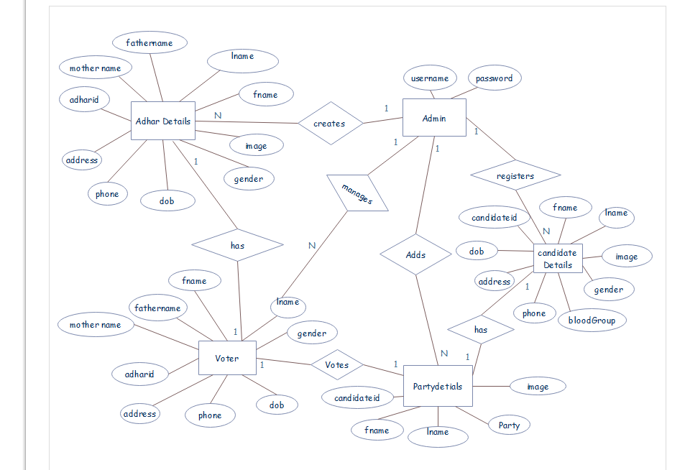

Fig(1)

**SCHEMA DIAGRAM FOR LIBRARY DATABASE**

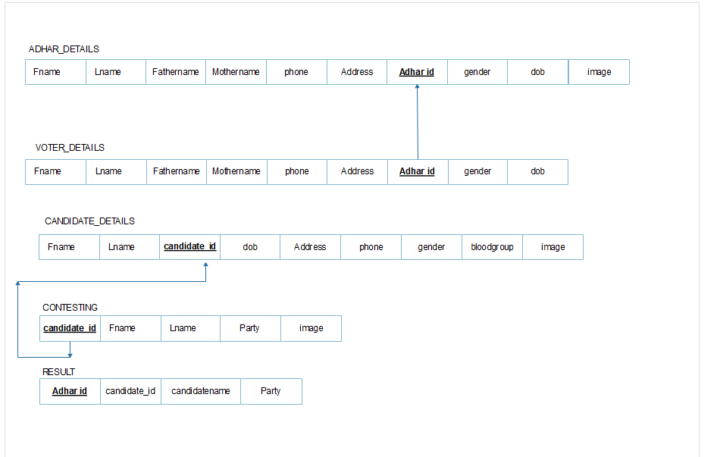

**Fig(2)**

**CHAPTER 5**

**SYSTEM IMPLEMENTATION & SCREENSHOTS**

This project provides a computerized version of VOTING SYSTEM which will benefit the people to vote online.

It makes entire process computerized where user can register through Aadhar id and cast vote online

**Screenshot of homepage**

Here in this page the Administrator has to login with his username and password by entering the details in the fields which is present in the frame.

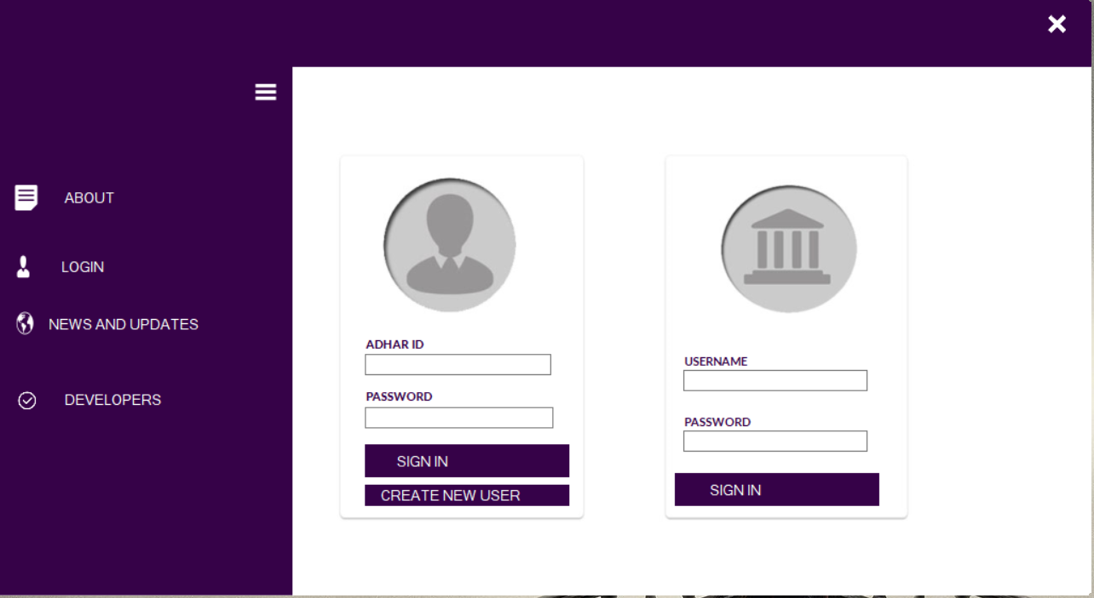1

Fig(1)

After login in to the home page a dialog box will pop up and the Administrator will go to the next page, if the entered details are correct (fig1) else he will get a pop up that the details are in invalid(fig2).

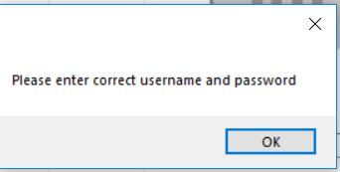v 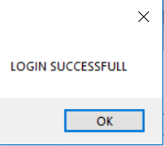

(fig1) (fig2)

After he has been successfully logged in into his account he will be on the next page where he is supposed to do his next work such as adding Aadhar details and candidate details to the voting database, alter them and view the final results.

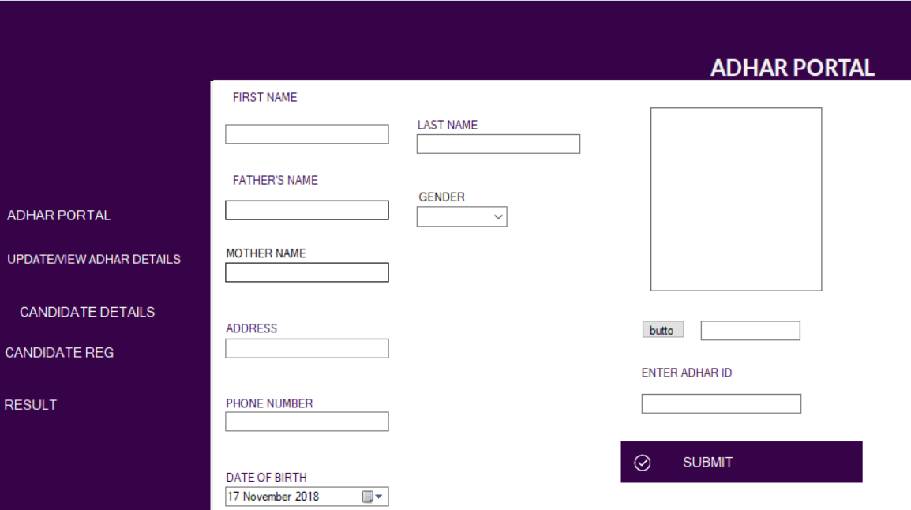

Fig(3)

Now the Administrator has successfully logged in so he is supposed to do his next task. Suppose he is adding the new Aadhar details then he has to click on to the [Aadhar portal] button and enter all the details Fig(4) .

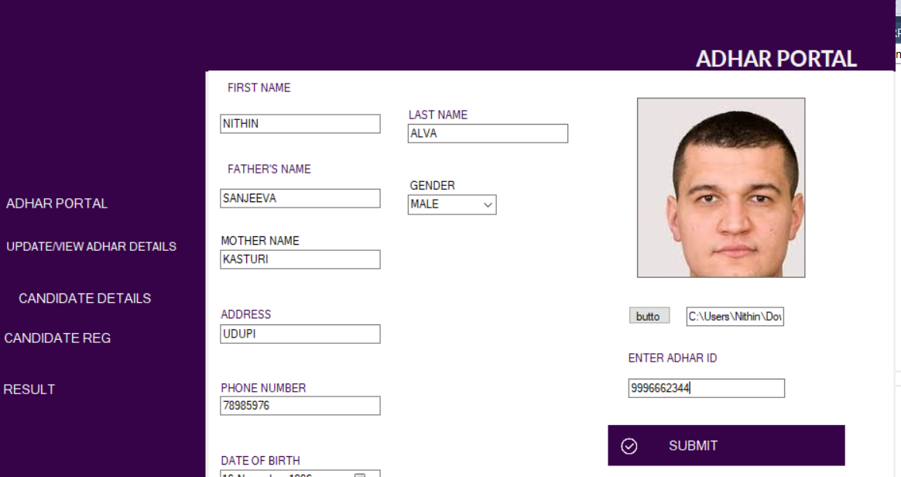

**Fig(4)**

After all the Aadhaar id has been successfully added. The Administrator will get a pop up that books added successfully and it is now being displayed by clicking on the [update/view button]

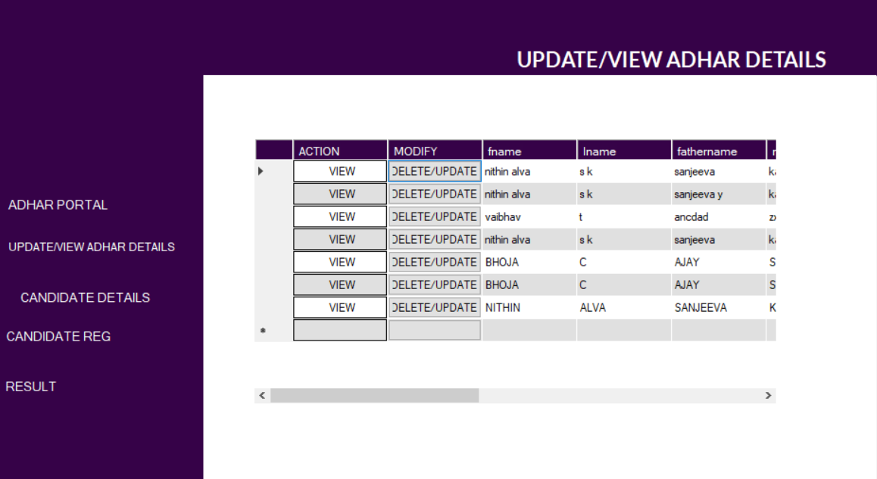

fig(5)

Now for deleting the Aadhar details the Administrator has to click on the delete button in the Grid view and a new frame will get open where he has to fill the details through which he can delete the Aadhar details .

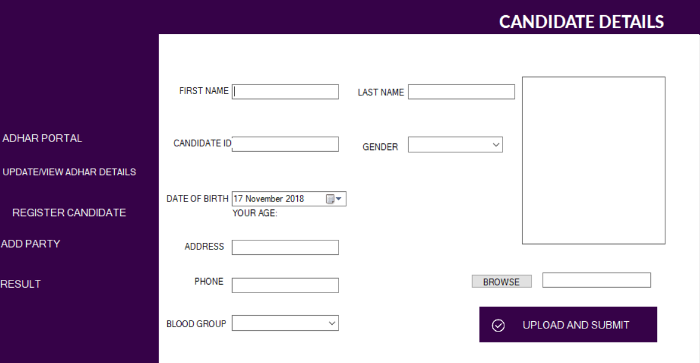

For registering new candidates click on [register candidate] button and fill the details of the candidates. if the candidate is less than 25 years of age the message Box pops out notifying that the candidate is not eligible for contesting election[fig 6].

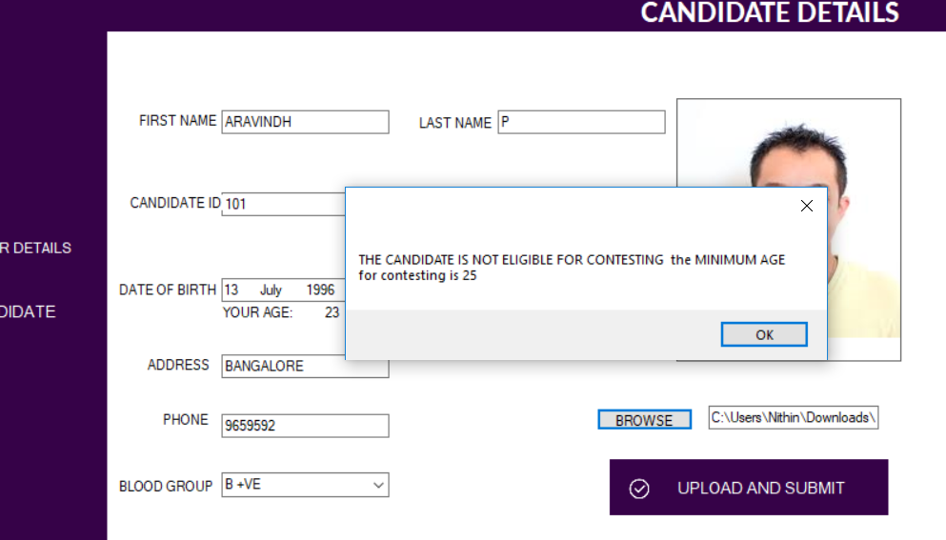

Fig[6]

After the candidates details are successfully entered the administrator next adds candidate’s house/party by clicking on [add party] button .Fig[7]

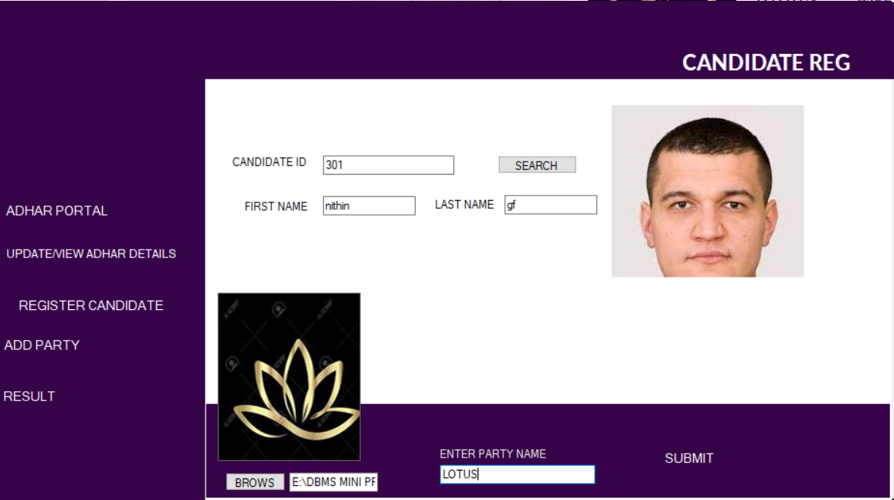

Fig[7]

Now the registered voter logs into the e-voting application by entering his “AADHAR ID AND PASSWORD”. If the voter has not registered then he has to click on [create new user] button .After clicking on [create new user] button a new window pops out where user has to enter his ADHAR ID & create a password

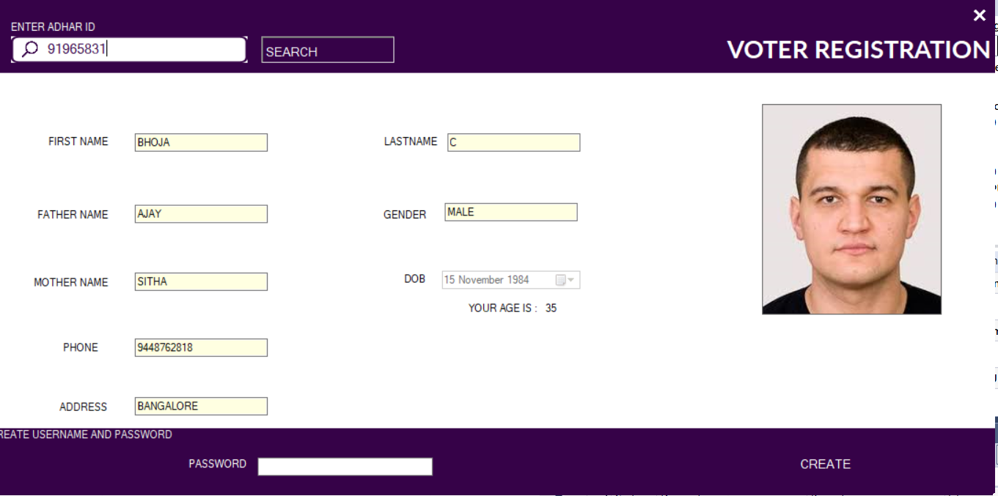

Fig[8]

Once the Aadhar id and password is created the user now login through the registered Aadhar id and password once he logs in, he will be directed to the voting window where he casts his votes to the candidates by selecting the candidate house/party

d te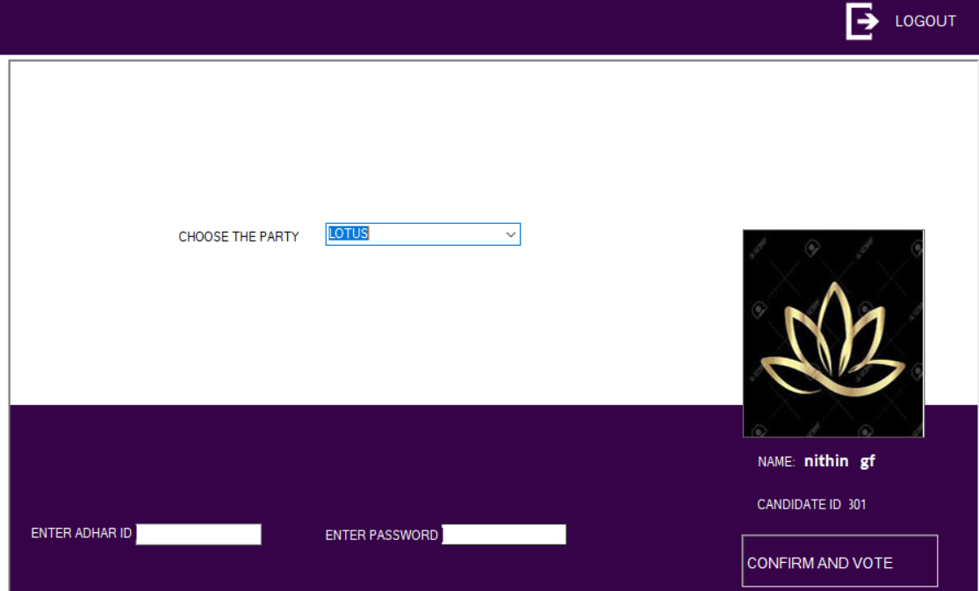

Finally After selecting the party name he/she has to confirm his/her vote by re-entering the Aadhar id and password and click on [confirm and submit] once he clicks on [confirm and submit] Button message Box pops out notifying “you have successfully casted your vote”[Fig 10] and his/her vote will be inserted & saved in the result Database. Which are viewed by the Administrator

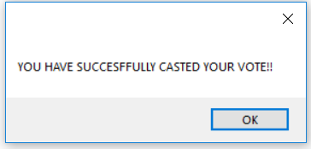

[Fig 10]

**CONCLUSION AND FUTURE WORK**

This project provides a computerized version of voting management system which will benefit the many number of users to vote online Just by clicking a computer mouse or swiping a smart phone.

It makes entire process computerized where voter can vote the candidates and the results are generated immediately Thus, this process is very time-consuming

We learned several project management techniques used by professionals to develop large scale project. The experience of working in team and integration of modules developed independently, with just requirement specifications, is a very important achievement for the team.

There is a future scope that many more features can be added to this project thus making it more interactive more user friendly and project which fulfils each user need in the best way possible

**BIBLIOGRAPHY**

**BOOK REFERENCES:**

* Datebase systems Models, Languages, Design and Application Programming

Ramez Elmasri and Sham kant B .Navathe ,7th Edition, 2017, Pearson

**WEBSITE REFERENCES:**

**C# or C Sharp Learning:**

* [**https://www.codeacademy.com**](https://www.codeacademy.com/)**/**
* [**https://stackoverflow.com**](https://stackoverflow.com/) **/**
* [**https://www.google.com**](https://www.google.com/)**/**

**SQL Learning:**

* [**http://www.tutorialspoint.com**](http://www.tutorialspoint.com/)
* [**http://www.youtube.com**](http://www.youtube.com/)