**Steps to run the Application:**

Requirements:

* Java 7
* User with read and write access to the folder.

Steps:

1. Copy Search_Words folder to your local machine. This folder has Sample Test Files and executable jar to run the program.

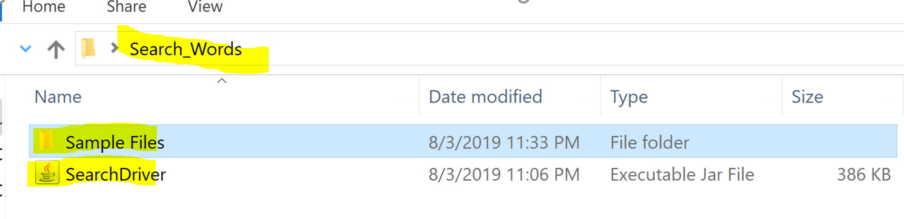

1. Open command prompt and navigate to Search_Words folder. Once you are in this folder type below command and press enter to start the program.

**java -jar SearchDriver.jar**

1. You will be seeing below welcome message.

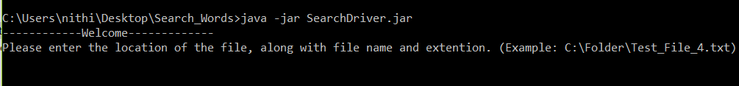

1. Type the file name along with the path and press enter.

**Eg: C:\Users\nitin.cholleti\Downloads\TestData\Test_File_4.txt**

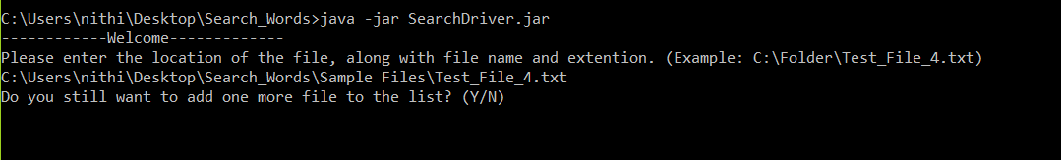

1. If you would like to add more files to process please type Y and enter the file name as if you have entered in step 4. If you have are done adding files type ‘N’ to proceed.
2. Enter the output file directory path. This is the place where app writes results to a Result.txt file.

Also, make sure that this directory has read and write permission. Eg: C:\Data\

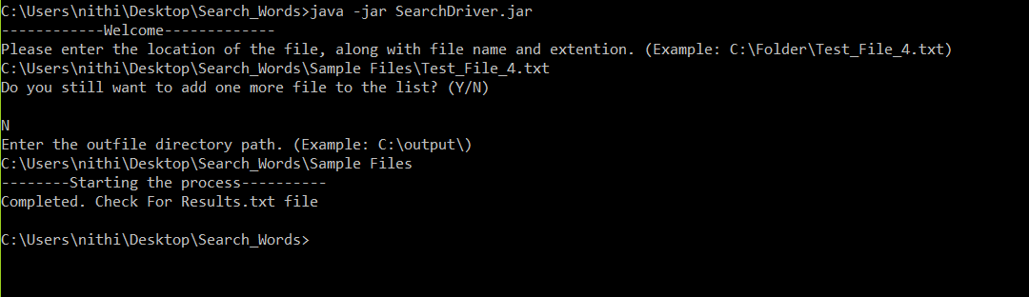

1. Press enter to start the process. Once done you will be seeing below message
2. You can check for Results.txt file in the output folder.

