**CHAPTER 3**

**SYSTEM DESIGN**

Systems design is the process of defining the architecture, modules, interfaces, and data for a system to satisfy specified requirements. Systems design could be seen as the application of systems theory to product development. It is meant to satisfy specific needs and requirements of a business or organization through the engineering of a coherent and well-running system.

* 1. **Basic Information**

In this project keyboard functions are used for the interaction. Sound effect is provided for the waves and ship.

**3.2 Flow Chart**

A flowchart is a type of diagram that represents an algorithm, workflow or process. The flowchart shows the steps as boxes of various kinds, and their order by connecting the boxes with arrows. This diagrammatic representation illustrates a solution model to a given problem. With proper design and construction, it communicates the steps in a process very effectively and efficiently. Figure 3.1 depicts the flow chart of The Lighthouse which shows various processing steps based on different events, actions and conditions.

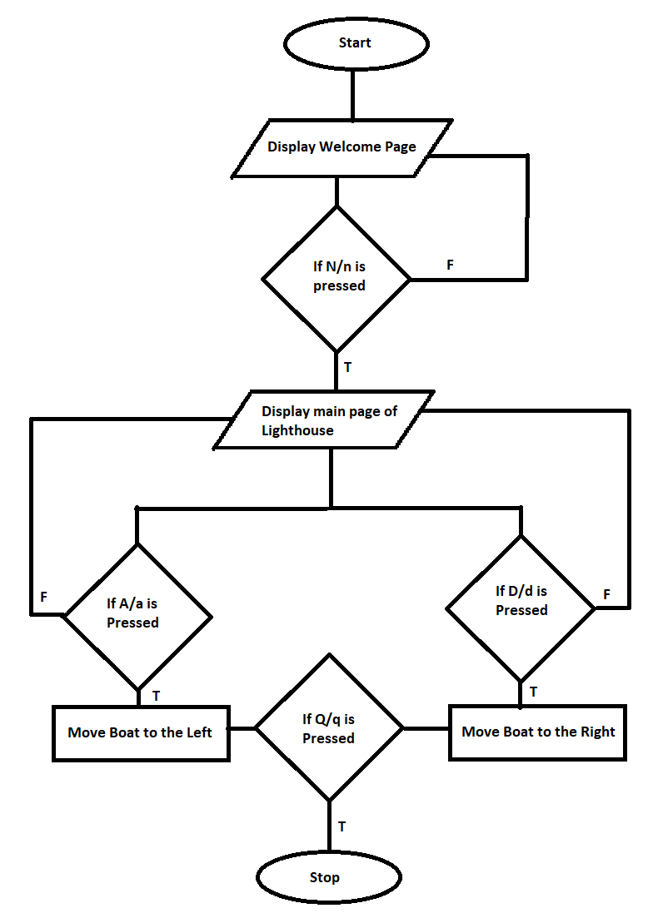

**Fig 3.1:** *Flow chart of the lighthouse*

**3.3 Prototype of The Lighthouse**

A prototype is an early sample, model, or release of a product built to test a concept or process or to act as a thing to be replicated or learned from. It is a term used in a variety of contexts, including [semantics](https://en.wikipedia.org/wiki/Semantics), [design](https://en.wikipedia.org/wiki/Design), [electronics](https://en.wikipedia.org/wiki/Electronics), and [software programming](https://en.wikipedia.org/wiki/Software_prototyping). A prototype is generally used to evaluate a new design to enhance precision by system analysts and users. Prototyping serves to provide specifications for a real, working system rather than a theoretical one.

Prototype for The Lighthouse is as shown in graph sheets.

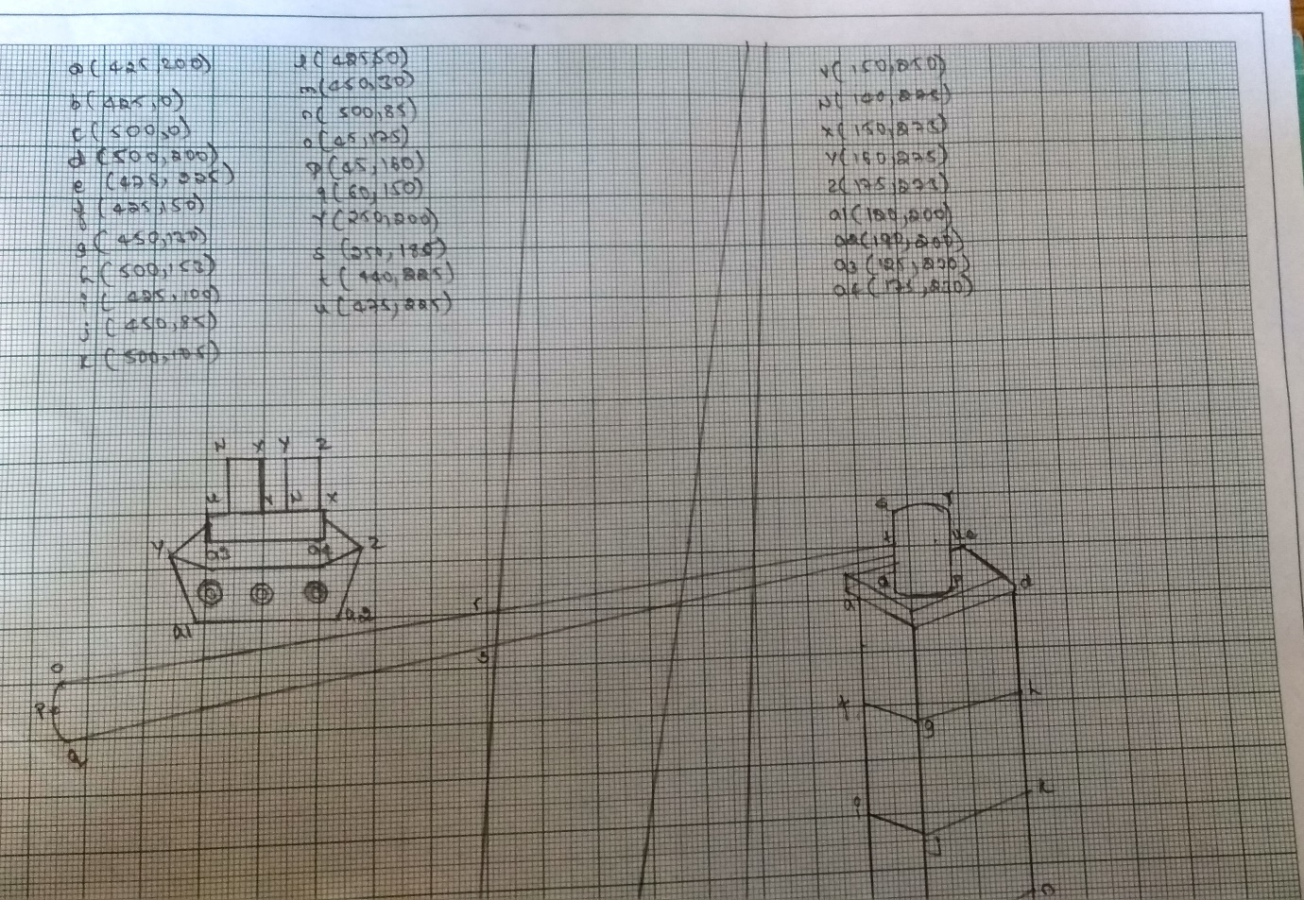

**Fig 3.2**: *Designing of the lighthouse*