**CHAPTER 6**

**SCREEN SHOTS**

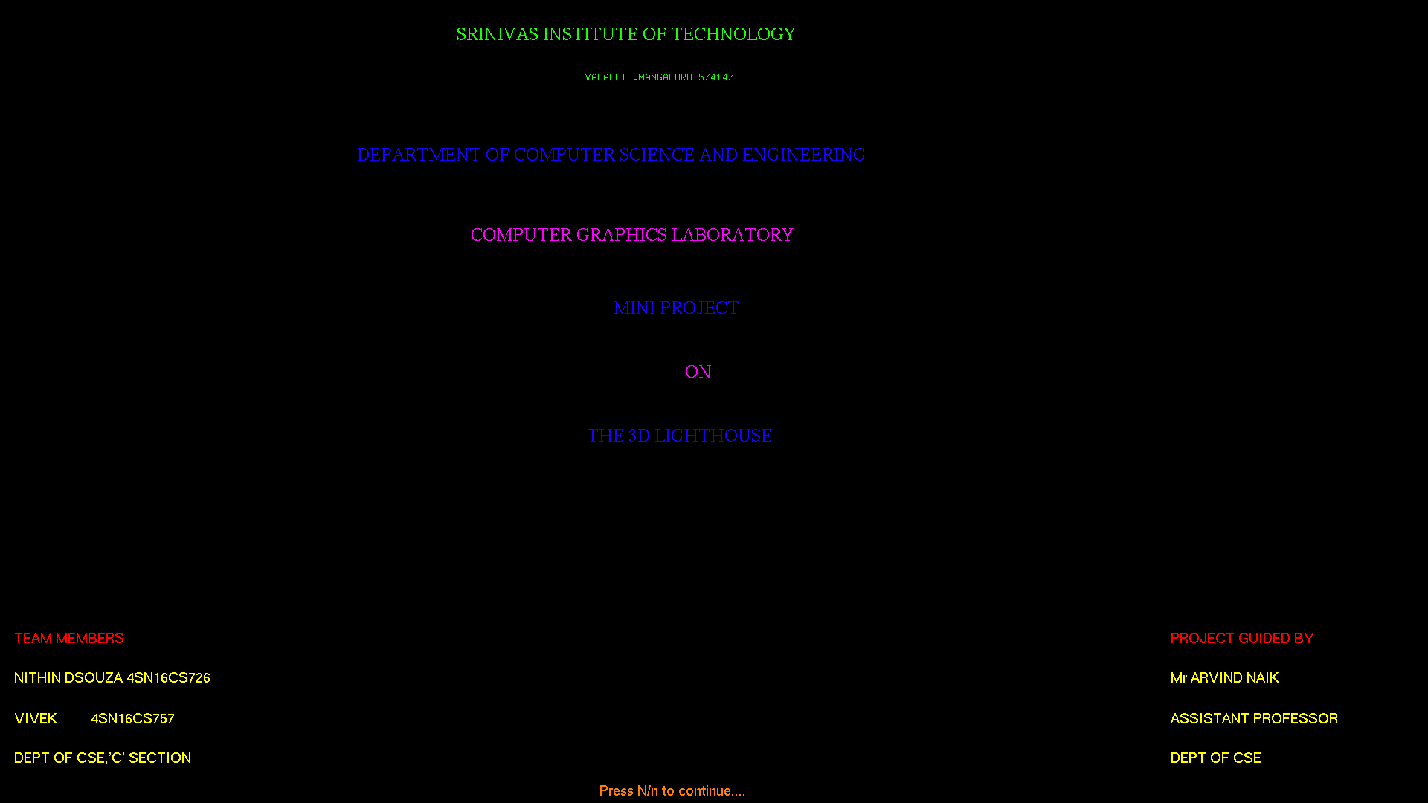

**Fig 6.1**: *Front Screen*

Fig. 6.1 shows front page of the project which contains name of the project ,college name ,team members , project guide name and key ‘N/n’ is provide to move next page.

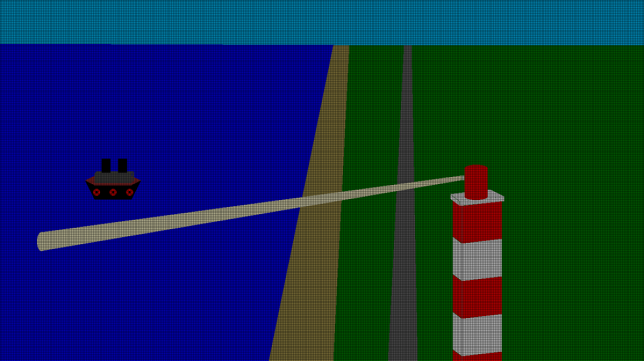

**Fig 6.2**: *The lighthouse*

Fig 6.2 shows 3D lighthouse screen here it to give the introduction of basic idea that how lighthouse on the shores work also key is provided to move the ship on the ocean.

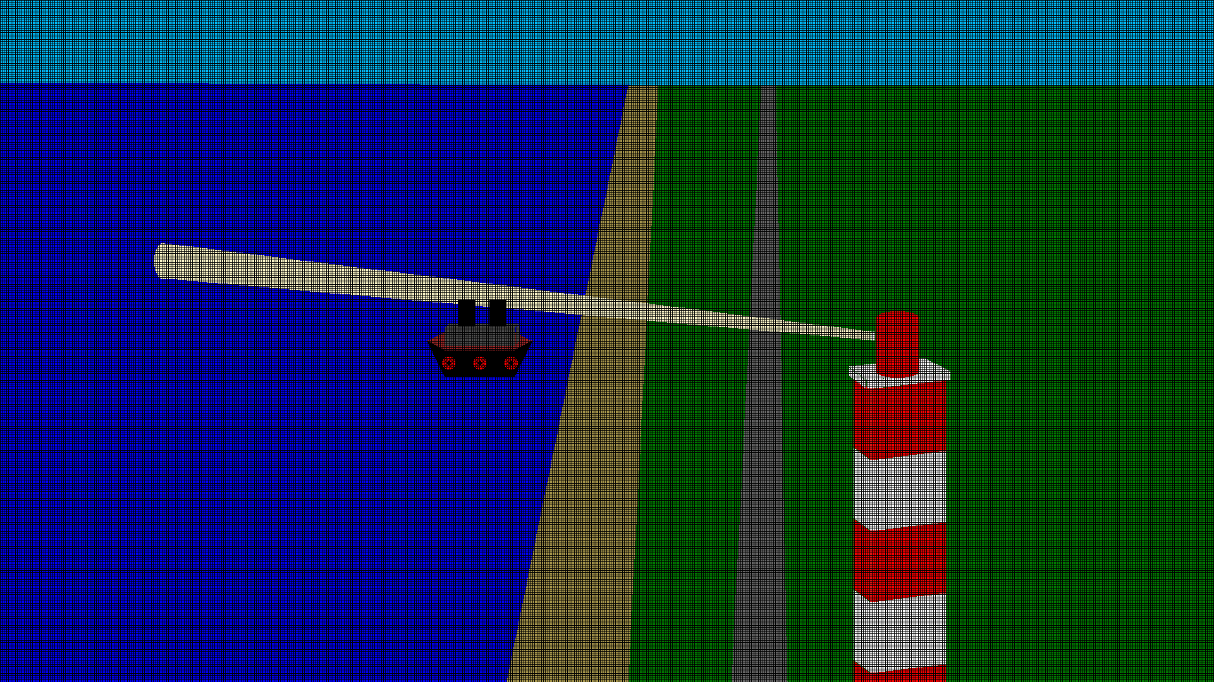

**Fig 6.3**: *Ship sailing towards Shore*

Fig 6.3 shows that the ship is sailed towards the shore by abiding all the rules and proper naviagations.