Used Car Price Prediction System
  - Final report: data cleansing, exploratory analysis, model building, evaluation and GUI
[Student name and USN]
2026-11-09
Table of Contents

Abstract
This project builds a system that estimates the selling price of a used car in India from eleven specifications a seller or buyer can read off the car: brand, model, age, kilometres driven, seller type, fuel, transmission, mileage, engine size, power and seats. The data are 15,411 CarDekho listings. After a documented cleaning process that removed 167 exact duplicates and repaired 18 implausible values (2 seat counts, 4 fuel labels and 12 odometer readings), 15,244 listings remained. A stratified 80/20 split locked away 3,049 cars as a test set before any model or encoder was fitted. Ten algorithms were compared by five-fold cross-validation on the training split; the three gradient-boosting models were tuned with Optuna, and a tuned XGBoost pipeline that predicts log price was selected on cross-validated log RMSE alone (0.1654). [Sources: report_key_figures.csv, cleaning_log.csv, test_metrics.csv, configs/config.yaml, models/best_params.json.]
Scored once on the locked test set, the model is off by ₹ 94,648 on average (95% bootstrap interval ₹ 88,440 to ₹ 1,01,444) and prices 50.97% of cars within 10% and 82.09% within 20% of their listed price. That is an 18.30% lower average error than a Ridge regression baseline. Its 80% price range contains the true price for 79.96% of test cars, so the interval is well calibrated on average. The model is weakest for cars 9 or more years old, for luxury cars above ₹ 20 lakh and for the cheapest cars. A four-page Streamlit application exposes the model with plain-language explanations and warnings for those weak segments. [Sources: test_metrics.csv, bootstrap_ci.csv, report_key_figures.csv, interval_coverage.csv.]
Every number in this report is read from a file in reports/tables/, reports/predictions/, models/ or configs/config.yaml; Appendix D lists each number with its source file.

1 Introduction and problem definition

1.1 Motivation
The used car market in India is large and informal. A private seller listing a car, or a buyer comparing listings, has few objective reference points: two cars of the same model can differ in age, kilometres, fuel, gearbox and seller, and each of these moves the price. A data-driven estimate with an honest range gives both sides a starting point for negotiation and flags listings that look unusually cheap or expensive.

1.2 Problem statement
Given the specification of a used car, estimate its selling price in Indian rupees, together with a range that the true price is likely to fall in, and explain which inputs moved the estimate. This is a supervised regression problem. The target is the listed selling price (selling_price), and the inputs are eleven fields that a non-expert can supply.

1.3 The four requirements
The project is assessed against four requirements. Each is restated here with the chapter that answers it; reports/requirements_traceability.md maps each to the exact files.
- Data cleansing and pre-processing, with every cleaning decision justified (Chapter 3).
- A complete exploratory data analysis at univariate, bivariate and multivariate level, with written interpretation (Chapter 4).
- Suitable algorithms, built and tuned in a defensible, leak-free way (Chapter 5).
- Evaluation with proper metrics, prediction results and a GUI that demonstrates them (Chapters 6, 7 and 8).

1.4 Objectives
- Produce a cleaned dataset from the read-only raw file, with each rule logged and its effect counted.
- Explain the market structure and the drivers of price before modelling, and use that to choose the target transformation, features and algorithms.
- Compare a diverse set of algorithms fairly, tune the best, and select a final model using training data only.
- Measure accuracy once on a locked test set, with metrics a car buyer understands, uncertainty intervals and a breakdown by segment.
- Deliver an application that a non-technical person can use, which explains each estimate and warns when the model is unreliable.

1.5 Scope
In scope are the eleven input fields of the CarDekho dataset, point estimates with an 80% range, per-car explanations and a GUI that runs locally. Out of scope are features not in the data (city, condition, accident and ownership history, trim and variant), real transaction prices (the target is a listing price), deployment to a public server and any retraining after the test set was used.

1.6 Approach and tools
All reusable logic lives in the Python package src/carprice/, configured by configs/config.yaml with one global random seed (42). Notebooks only display results. The tools are pandas and numpy for data, matplotlib and seaborn for static figures, scikit-learn, XGBoost and LightGBM for models, Optuna for tuning, SHAP and permutation importance for explanation, joblib for persistence, Streamlit with plotly for the GUI, and pytest and ruff for quality. Every non-trivial choice is recorded in decisions.md as a numbered entry (D-001 onwards); this report cites those numbers in brackets.

2 Dataset description

2.1 Source
The dataset is the CarDekho used car listings file, data/raw/cardekho_dataset.csv, used here for academic purposes only. It is treated as read-only: no step in the project writes to it (D-002). Each row is one listing on the CarDekho platform.

2.2 Size and columns
The raw file has 15,411 rows and 14 columns, with no missing values [cleaning_log.csv, report_key_figures.csv, audit_schema.csv]. The table below describes the columns.
Raw columns [audit_schema.csv, audit_numeric_summary.csv]
Column | Type | Unit or values | Notes
Unnamed: 0 | integer | row id | Index left over from an export; not a feature
car_name | text | brand + model | Exactly brand + ” ” + model on every row
brand | text | 32 raw values | Manufacturer
model | text | 120 values | Model line, e.g. “City”, “Swift Dzire”
vehicle_age | integer | years, 0 to 29 | Age at the time of listing
km_driven | integer | kilometres | Odometer reading
seller_type | text | Dealer, Individual, Trustmark Dealer | Sales channel
fuel_type | text | Petrol, Diesel, CNG, LPG, Electric | Fuel
transmission_type | text | Manual, Automatic | Gearbox
mileage | decimal | kmpl (km/kg for CNG) | Rated fuel economy
engine | integer | cc | Engine displacement
max_power | decimal | bhp | Peak power
seats | integer | seats | Seating capacity
selling_price | integer | ₹ | Listed price; the prediction target

2.3 Initial observations
The Phase 1 audit (notebooks/01_data_audit.ipynb) checked schema, duplicates, distributions, categorical levels and physical plausibility. Its main observations were:
- Price is extremely skewed. Prices run from ₹ 40,000 to ₹ 3.95 crore with a median of ₹ 5.56 lakh [audit_numeric_summary.csv].
- Odometer outliers. The 99th percentile of km_driven is 1,80,000 km but the maximum is 38,00,000 km; 12 listings exceed 5,00,000 km [audit_numeric_summary.csv, audit_logical_checks.csv].
- Impossible seat counts. Two listings have seats = 0 [audit_seats_anomalies.csv].
- Mislabelled fuel. Four listings are labelled Electric, but all four are Toyota Camry cars with a 2,494 cc engine and 157.7 bhp, which identifies them as petrol hybrids [audit_electric_rows.csv].
- Duplicates. Ignoring the row id and the redundant car_name, 167 rows (1.084%) are exact copies of another row, and 2,148 rows share all specifications with another row but have a different price [audit_duplicates.csv].
- Imbalanced categories. Dealers list 9,539 cars and individuals 5,699; manuals make up 79.326% of listings; LPG (44 rows) and Electric (4 rows) are rare [audit_categorical_frequencies.csv].
- Other plausibility checks flag listings that are genuine rather than errors: 5 cars aged 0 years, 13 cars averaging more than 1,00,000 km a year, 105 cars with mileage outside 8 to 30, 175 with unusual power per litre and 2 priced under ₹ 50,000 [audit_logical_checks.csv]. These were inspected and kept.

3 Data cleansing and pre-processing

3.1 Cleaning rules
Cleaning is a sequence of pure functions in src/carprice/data.py; each takes a DataFrame and returns a new one, and the row counts before and after are logged to reports/tables/cleaning_log.csv. A rule that removed more than 2% of rows would stop the pipeline (cleaning.max_drop_row_fraction in the config); no rule came close. The table below lists every rule.
Cleaning rules and their effect [cleaning_log.csv]
Rule | Rows before | Rows after | Rows affected | What it does and why
drop_identifier_columns | 15,411 | 15,411 | 15,411 | Drops Unnamed: 0 (an export index) and car_name (always brand + model), D-008
normalise_text | 15,411 | 15,411 | 3,344 | Trims spaces and title-cases categories, so “BMW” and “Bmw” become one level
drop_exact_duplicates | 15,411 | 15,244 | 167 | Keeps the first of each exact duplicate; duplicates split across train and test would leak, D-003
fix_invalid_seats | 15,244 | 15,244 | 2 | Replaces seats = 0 with the modal seat count of the same brand and model (5 for both), D-006
fix_fuel_labels | 15,244 | 15,244 | 4 | Recodes the four “Electric” Camry hybrids to Petrol, D-005
treat_km_outliers | 15,244 | 15,244 | 12 | Caps km_driven at 5,00,000 and adds a km_was_capped flag, D-004
validate_ranges | 15,244 | 15,244 | 0 | Asserts engine, power, mileage, age and price lie in plausible ranges
The cleaned file, data/interim/cars_clean.csv, has 15,244 rows and 13 columns and no missing values. Only 167 rows (1.084%) were removed, all exact duplicates.
Justifications in brief.
- Duplicates (D-003): an exact copy of a listing in both training and test data lets the model “remember” the answer, which inflates test scores. Rows with identical specifications but different prices were kept, because that spread is real market variation the model must learn to live with.
- Odometer cap (D-004): a 3-year-old car with 38,00,000 km is a data-entry error. Capping keeps the row while limiting its leverage on linear models. Note that the km_was_capped flag was later found not to be an input of the final pipeline (D-024); with 12 affected rows the effect is negligible, and permutation importance confirms it carries no weight [permutation_importance.csv].
- Seats (D-006): both cars (a Honda City and a Nissan Kicks) are five-seaters by manufacturer specification; imputing from the same brand and model gives the correct value.
- Fuel labels (D-005): a battery electric car has no engine displacement; a four-row category would also break stratified folds.
- Luxury cars kept (D-007): listings up to ₹ 3.95 crore are genuine. Dropping them would improve error metrics dishonestly; instead, Chapter 6 reports accuracy by price segment.

3.2 Train/test split
Immediately after cleaning, and before any statistic was computed for modelling, the data were split 80/20 into data/processed/train.csv (12,195 rows) and data/processed/test.csv (3,049 rows) [models/model_card.json, test_metrics.csv]. The split is stratified on five quantile bins of price, with seed 42, so that cheap, mid-range and luxury cars appear in the same proportions in both parts (D-012). The row indices are saved in data/processed/split_indices.json, and re-running the split reproduces it byte for byte.
The test set was then locked: the training code refuses to read it (load_training_data() raises an error, tested in tests/test_train.py), and it was scored exactly once, after the final model and the metrics had been fixed and committed (D-023, D-025).

3.3 Pre-processing pipeline
Everything that learns from data is inside one scikit-learn object, so it is fitted on the training fold only, in cross-validation and in the final fit, as summarised in the diagram after the list:
- TransformedTargetRegressor wraps the whole pipeline. It trains on log1p(price) and returns expm1 of the prediction, so callers work in rupees while the loss is computed on the log scale (D-009, D-017).
- DomainFeatureEngineer adds four measured features: km_per_year, power_per_litre, is_luxury_brand and age_x_power (see Feature screening in Chapter 5).
- ColumnTransformer prepares three groups of columns:
  - numeric columns: median imputation (plus standard scaling for linear and distance-based models);
  - brand, fuel_type, transmission_type, seller_type: a RareCategoryEncoder that maps levels seen fewer than 20 times in the training fold to “Other” (D-015), then one-hot encoding that ignores unseen levels;
  - model: scikit-learn’s TargetEncoder with internal five-fold cross-fitting (D-014).
- The estimator (XGBoost in the final model).
TransformedTargetRegressor(log1p / expm1)
└── Pipeline
├── DomainFeatureEngineer km_per_year, power_per_litre, is_luxury_brand, age_x_power
├── ColumnTransformer
│ ├── numeric SimpleImputer(median) [+ StandardScaler for linear models]
│ ├── categorical RareCategoryEncoder(min 20) -> OneHotEncoder(ignore unknown)
│ └── model TargetEncoder(cross-fitted, smooth="auto")
└── XGBRegressor (tuned)
Structure of the saved pipeline, models/final_pipeline.joblib.

3.4 Leakage prevention
Leakage, where information about the test answers reaches the model during training, is the most common way a regression project reports scores it cannot repeat. It was prevented as follows:
- the split happened before any modelling statistic was computed;
- every fitted transformation is inside the pipeline, refitted on each training fold;
- the target encoder uses internal cross-fitting, so a training row’s encoded value never includes its own price;
- feature screening, encoder comparison, algorithm comparison and tuning used training data only;
- the test set was read once (D-025), and no change was made after its results were seen.
Three steps do touch the full cleaned dataset; each was assessed (D-022). The seat imputation affects 2 rows and uses no price information. The brand-tier mapping in the config is derived from full-data prices but is used only for reporting, never as a model input. The list of luxury brands is fixed domain knowledge, not fitted. None of these can carry test prices into the model.

4 Exploratory data analysis
The full analysis is in notebooks/02_eda.ipynb with the written findings in reports/eda_findings.md. The analysis uses the cleaned dataset; it informs choices but fits nothing that the model uses. Every figure is regenerated by python tasks.py eda. In Phase 8 the numbers in the EDA notes were re-checked against their tables and several were corrected (D-038); the values below are the corrected ones.

4.1 Univariate analysis
The target. Selling price has a skewness of 10.11; after log1p the skewness is 0.56 [report_key_figures.csv]. The median listing is ₹ 5.59 lakh and three in four list below ₹ 8.25 lakh, while the mean (₹ 7.75 lakh) is pulled up by a long luxury tail [eda_numeric_summary.csv]. This is the single most consequential finding of the EDA: a model trained on raw rupees with squared error would spend most of its effort on a few hundred expensive cars.
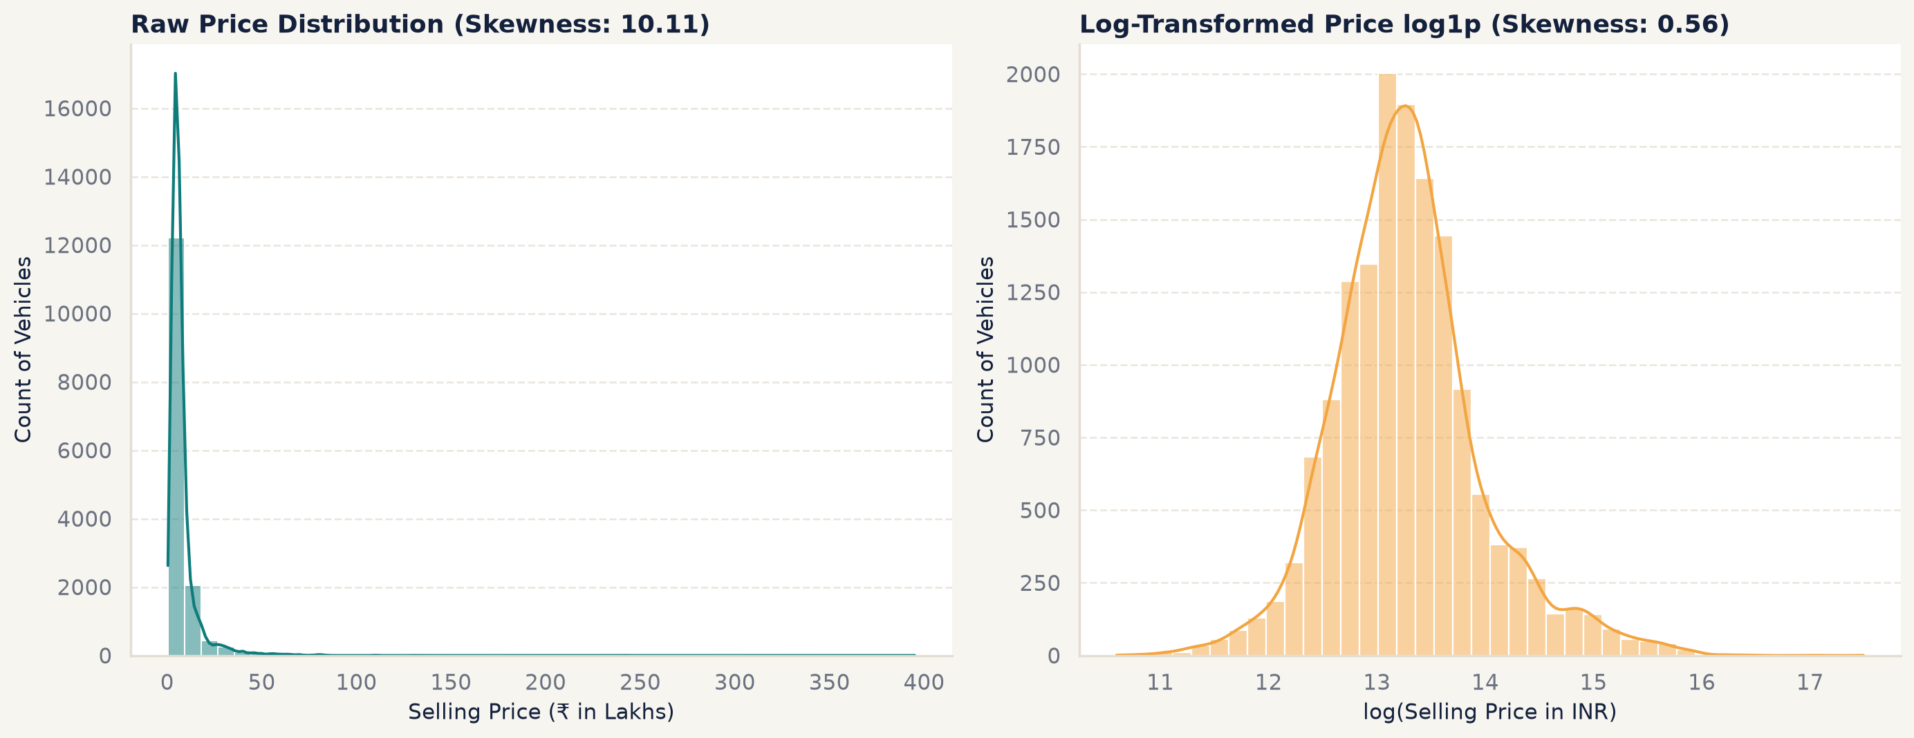
Selling price on the raw and log scale. The log transform turns a long right tail into a nearly symmetric shape.
Numeric inputs. The median car is 6 years old with 50,000 km on the odometer [eda_numeric_summary.csv]. Engine size clusters at common commuter displacements, and power has a long right tail of performance cars.
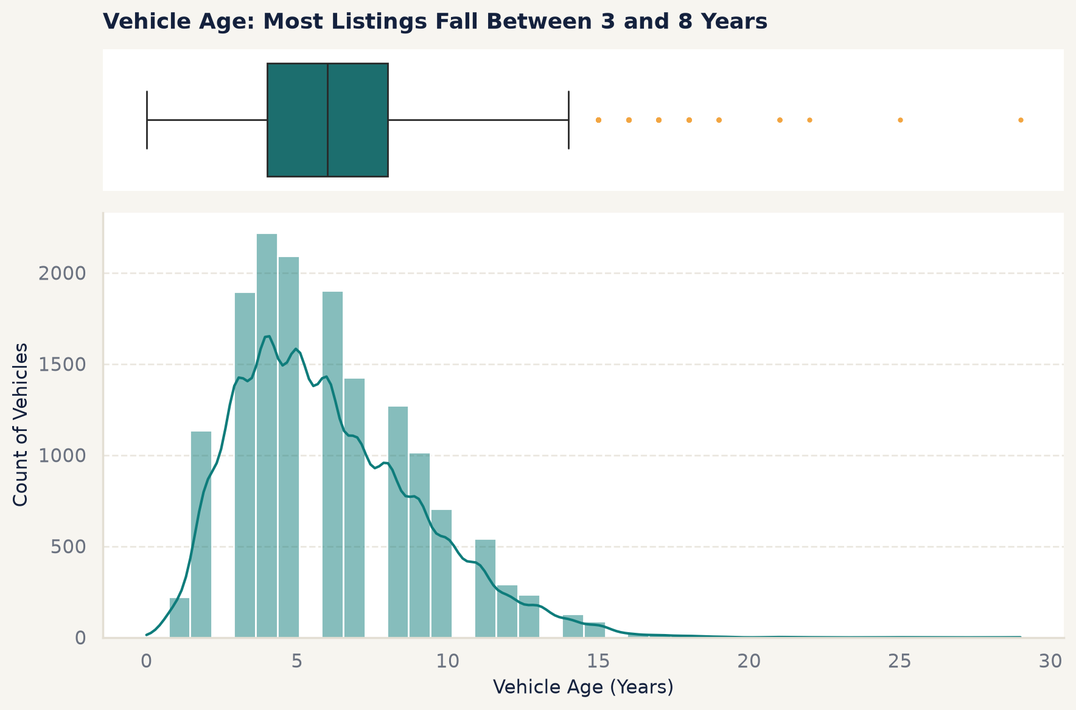
Vehicle age is concentrated between 4 and 8 years.
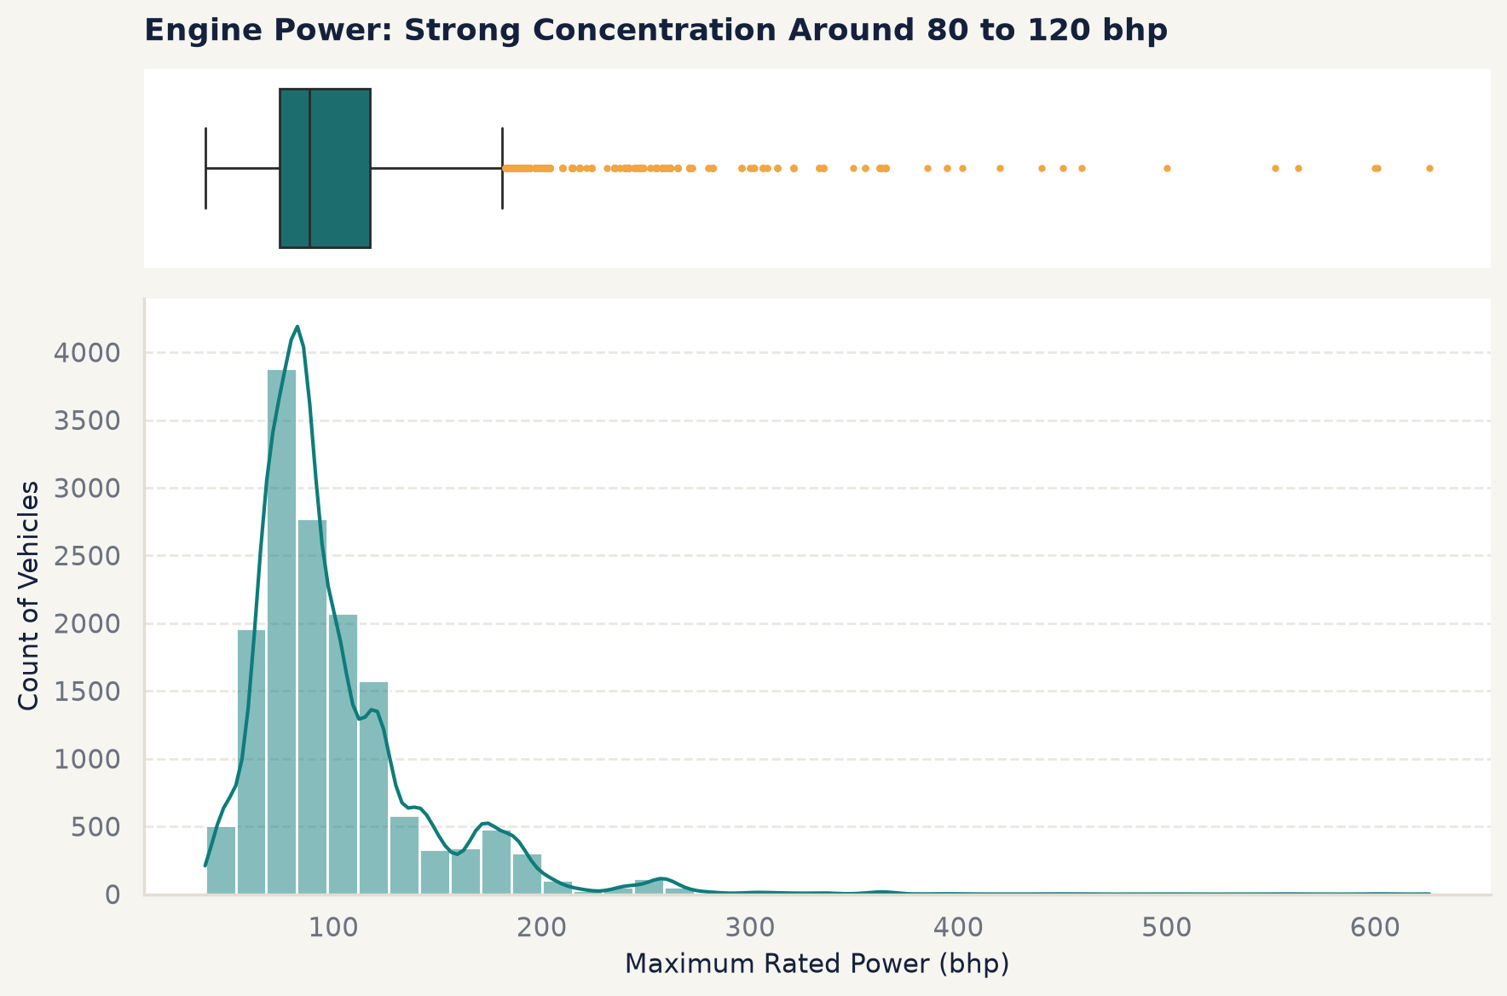
Power has a long right tail of high-performance cars.
Categorical inputs. Maruti (32.36%) and Hyundai (19.36%) together account for 51.73% of listings; manual gearboxes 79.34%; petrol 49.59% and diesel 48.16%; five-seaters 83.76% [report_key_figures.csv]. The cleaned data contain 31 brands, 13 of which have fewer than 30 listings [report_key_figures.csv, eda_rare_brands.csv]. This imbalance means the model will see few examples of rare brands, which Chapter 6 confirms as a weakness.
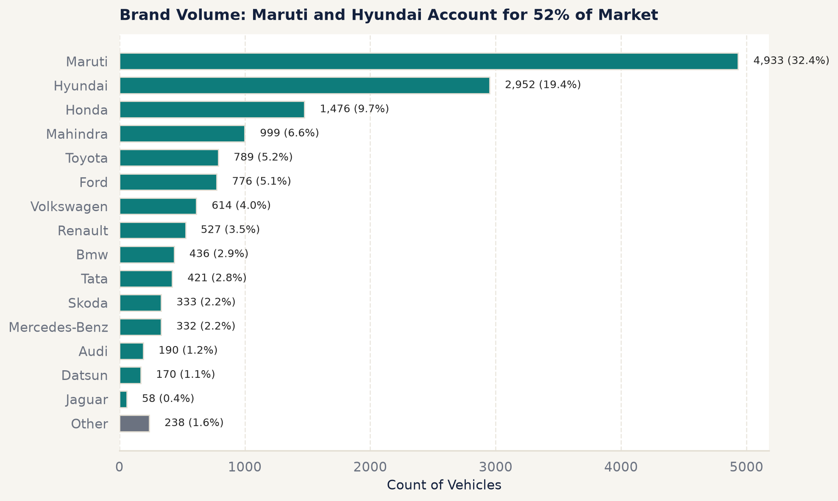
Two brands dominate the listings; many brands are rare.

4.2 Bivariate analysis
Power and engine. Power has the strongest rank correlation with price (Spearman ρ = 0.72), followed by engine size (ρ = 0.64); the Pearson correlation of power with log price is 0.76 [eda_spearman_correlation.csv, eda_pearson_correlation.csv]. The relationship is steep and curved, which favours tree models and a log target.
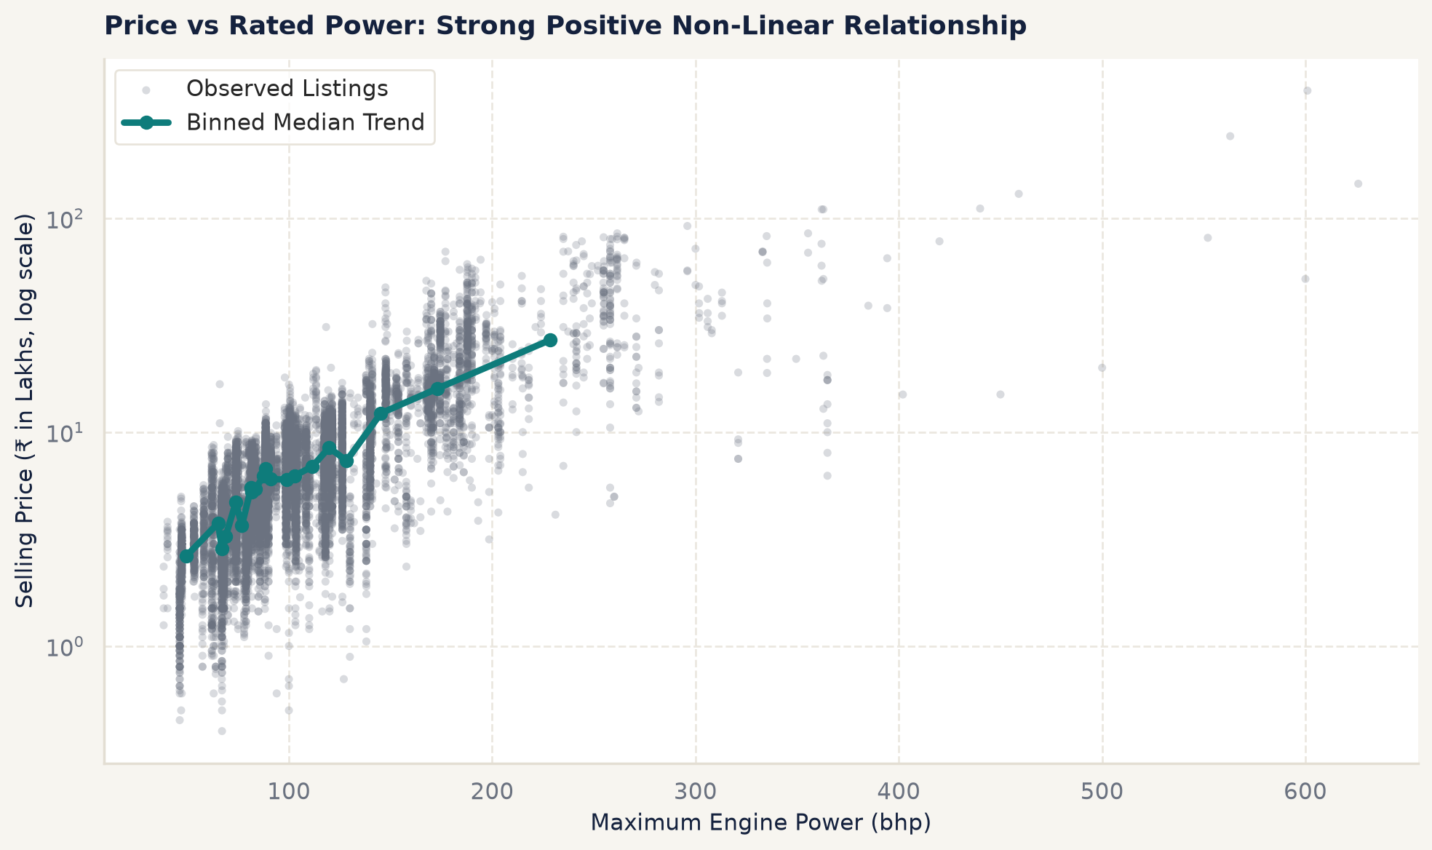
Price rises steeply and non-linearly with power.
Age. Age is the main downward driver (ρ = -0.48) [eda_spearman_correlation.csv]. For the five highest-volume brands, the estimated average loss per year of age ranges from 9.39% (Mahindra) to 12.89% (Hyundai) [eda_depreciation_rates.csv].
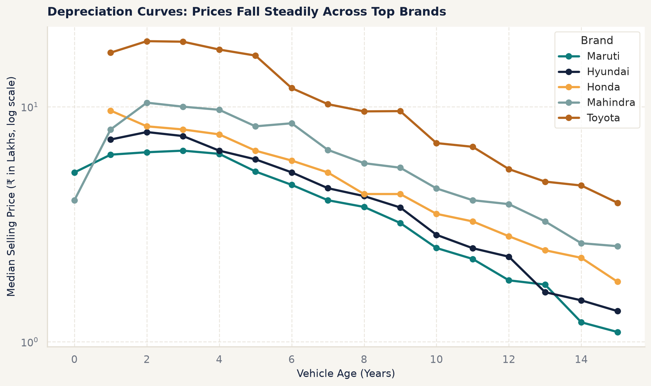
Depreciation curves for the five highest-volume brands.
Kilometres. Kilometres driven correlate only weakly with price (ρ = -0.17), and strongly with age (ρ = 0.58), so much of their effect is carried by age [eda_spearman_correlation.csv].
Transmission, fuel and seller. Median prices differ sharply by transmission (automatic ₹ 10,50,000 against manual ₹ 5,00,000, a ratio of 2.10) and fuel (diesel ₹ 7,00,000 against petrol ₹ 4,60,000, ratio 1.52), and only slightly by seller (dealer ₹ 5,90,000 against individual ₹ 5,10,000, ratio 1.16) [eda_transmission_medians.csv, eda_fuel_medians.csv, eda_seller_medians.csv, report_key_figures.csv].
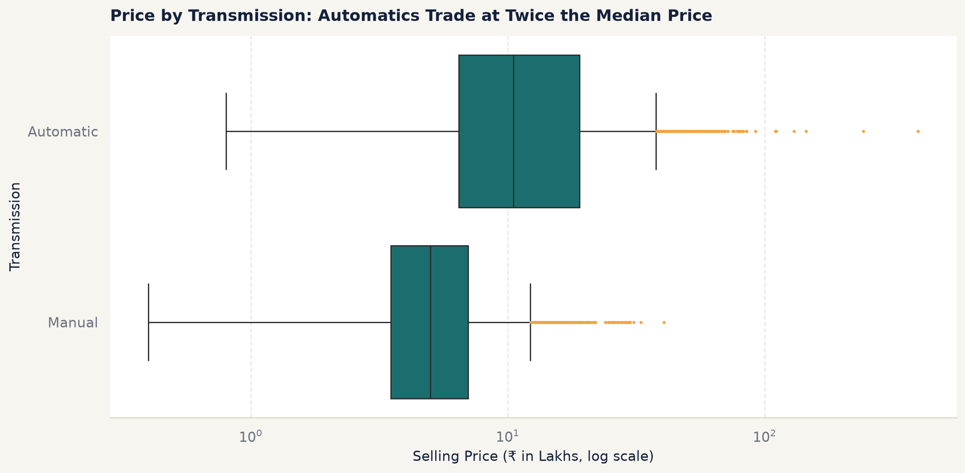
Automatic cars list at about twice the median price of manual cars.
Brand. Brand medians span two orders of magnitude, from ₹ 3,00,000 (Datsun) through ₹ 12,75,000 (Toyota) and ₹ 22,87,500 (BMW) to ₹ 50,00,000 (Porsche) [eda_brand_medians.csv].
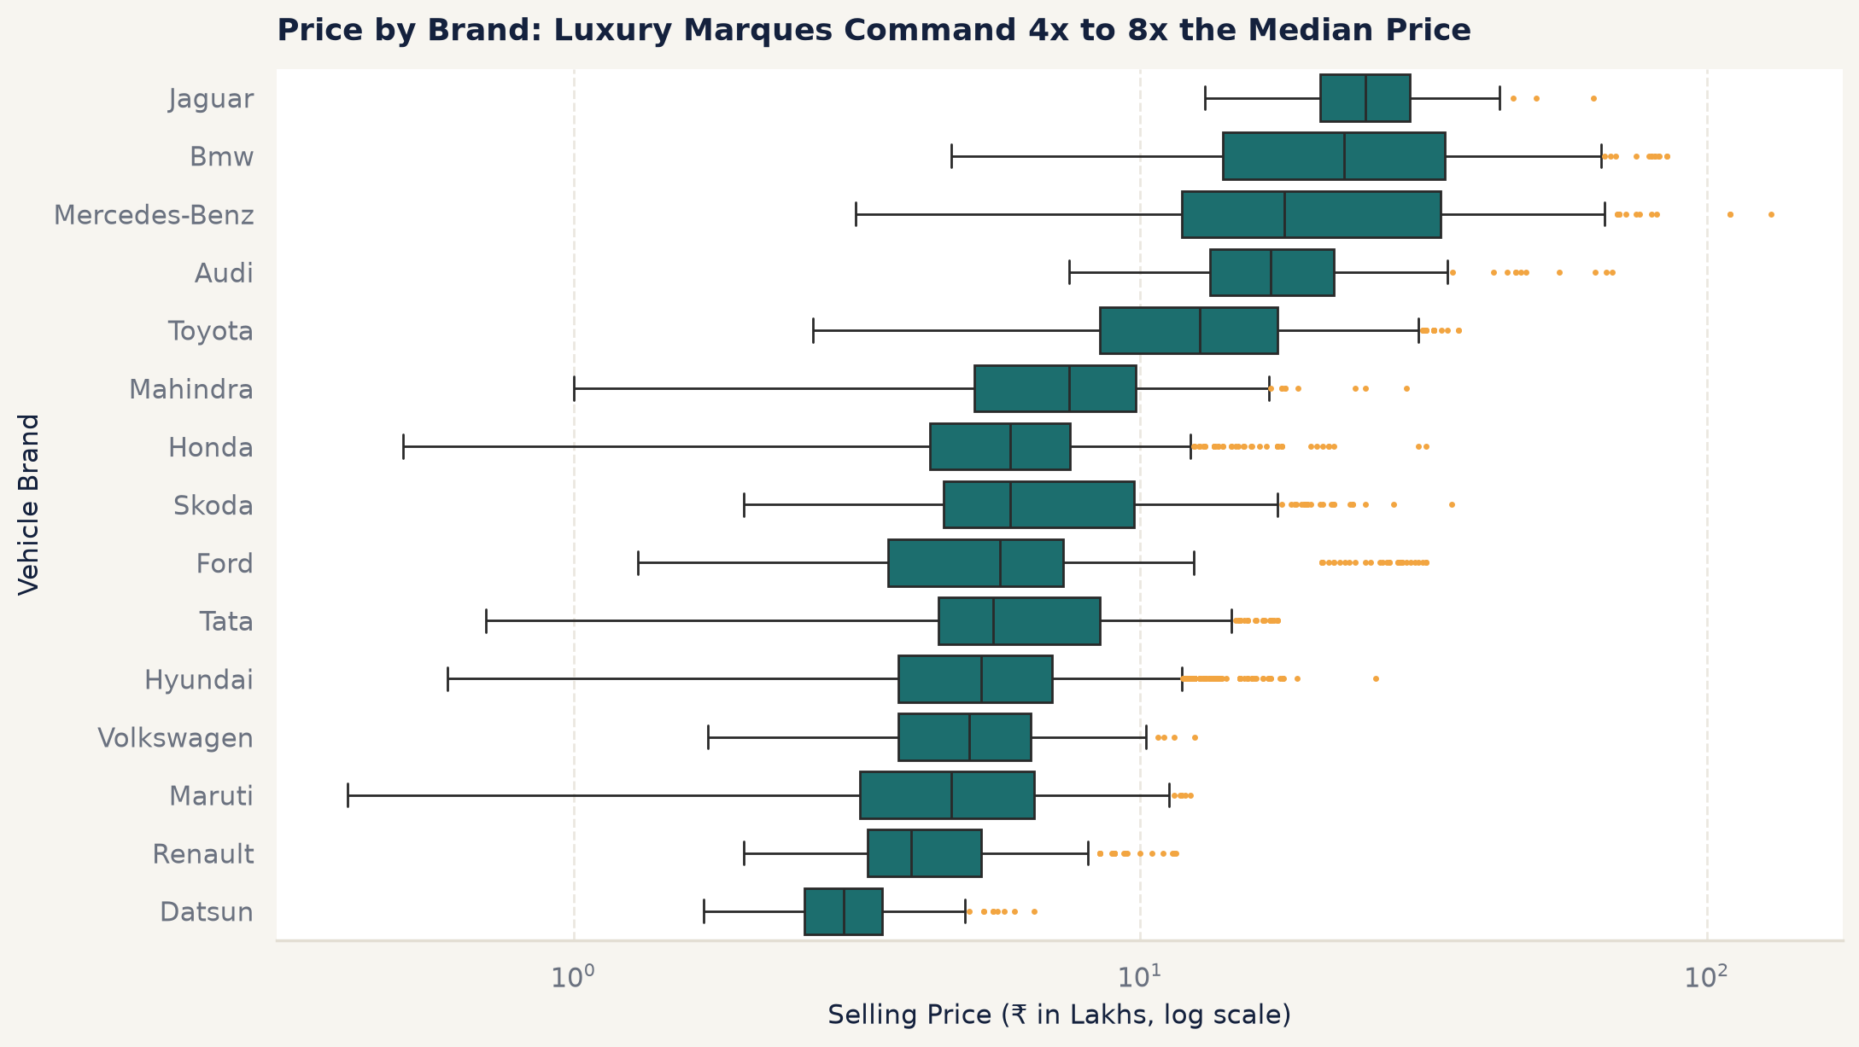
Median price by brand.

4.3 Multivariate analysis
Correlation and collinearity. Engine size and power are strongly correlated (Pearson r = 0.81, Spearman ρ = 0.83). Their variance inflation factors are 6.41 and 4.56; all other numeric inputs lie between 1.43 and 2.27 [eda_pearson_correlation.csv, eda_spearman_correlation.csv, eda_vif_summary.csv]. This argues for regularised linear baselines and for tree ensembles, which are not harmed by correlated inputs.
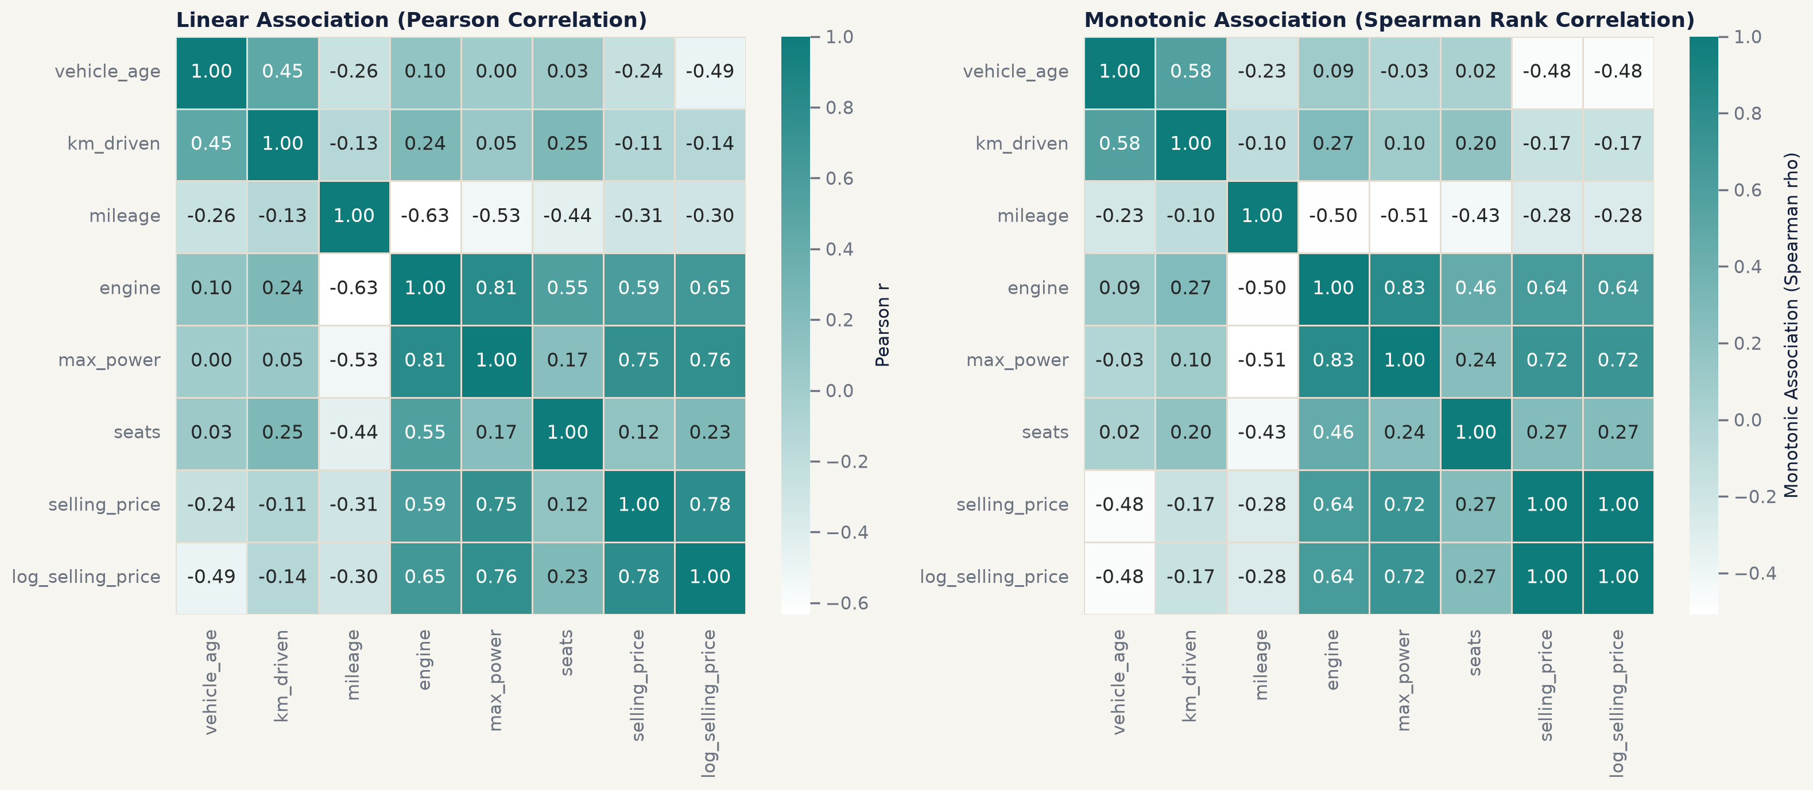
Pearson and Spearman correlation matrices.
Is the automatic premium just a power effect? Automatics tend to be more powerful cars, so the raw ratio of 2.10 overstates the gearbox effect. Splitting the data into power quartiles and testing within each one shows that automatics remain dearer in every quartile: for example ₹ 4,49,500 against ₹ 3,40,000 in the lowest quartile (38 to 74 bhp). Mann-Whitney U tests are significant in all four quartiles (p < 0.001) with rank-biserial effect sizes from 0.26 to 0.61 [eda_hypothesis_tests.csv].
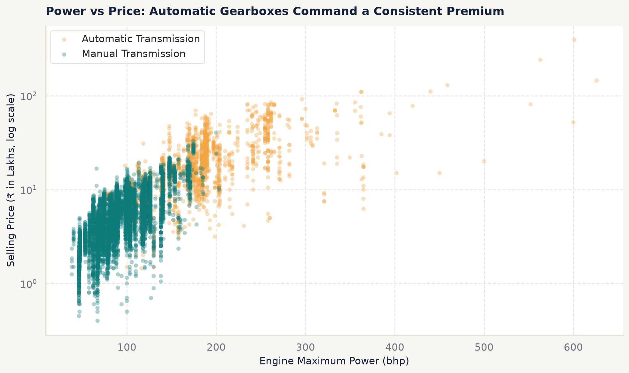
Within each power band, automatics still list higher than manuals.
Age by fuel. Diesel cars list above petrol cars at every age, and the two decline at a similar rate.
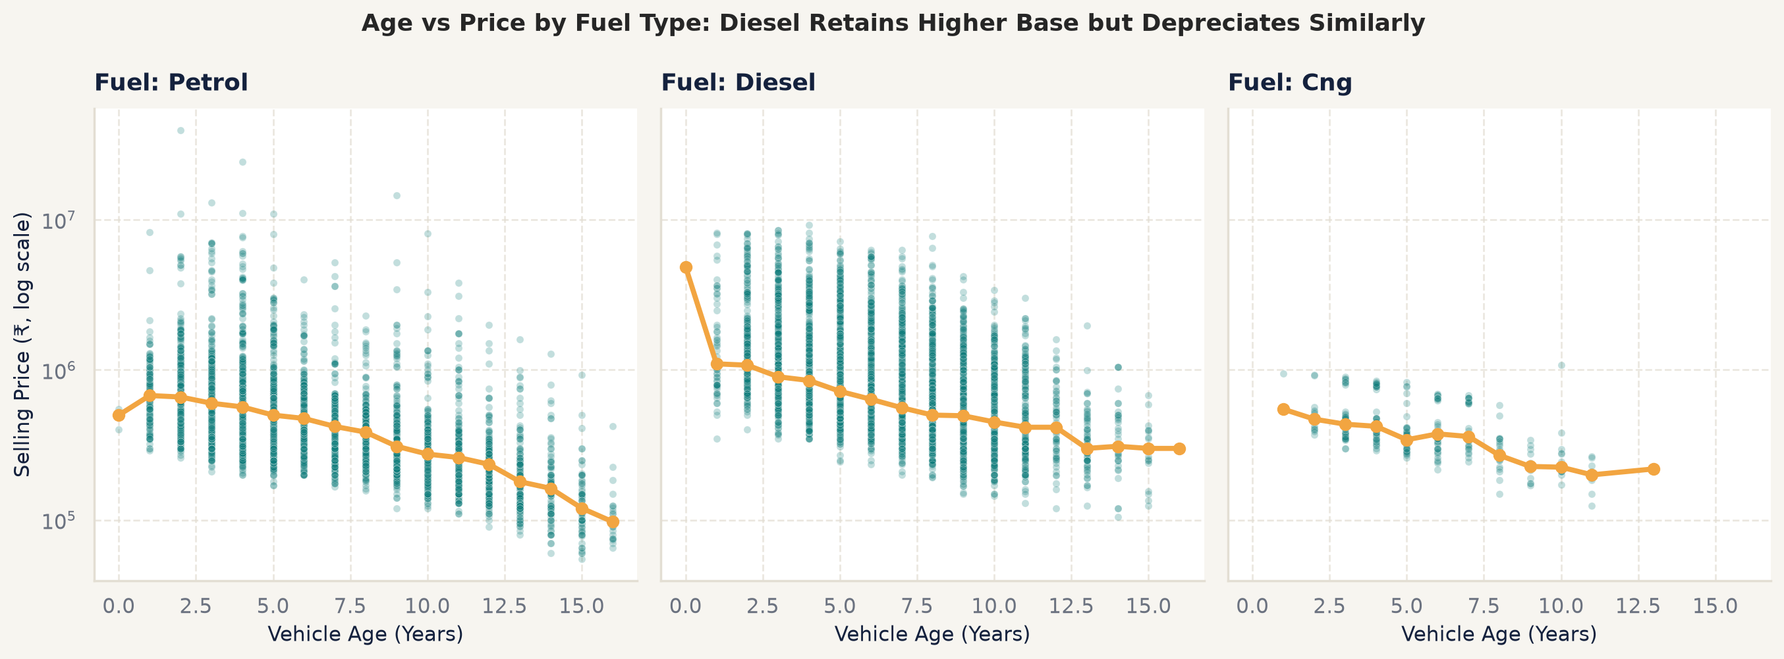
Price against age by fuel type.
Hypothesis tests. Non-parametric tests were chosen because prices are not normally distributed even after transformation (D-011). In addition to the transmission tests, dealer prices exceed individual prices (Mann-Whitney U, p < 0.001, small effect size 0.18) and prices differ across diesel, petrol and CNG (Kruskal-Wallis H = 2527.5, p < 0.001, effect size 0.32) [eda_hypothesis_tests.csv].
Luxury outliers. The most expensive listings come from genuine luxury brands, which supports keeping them (D-007).
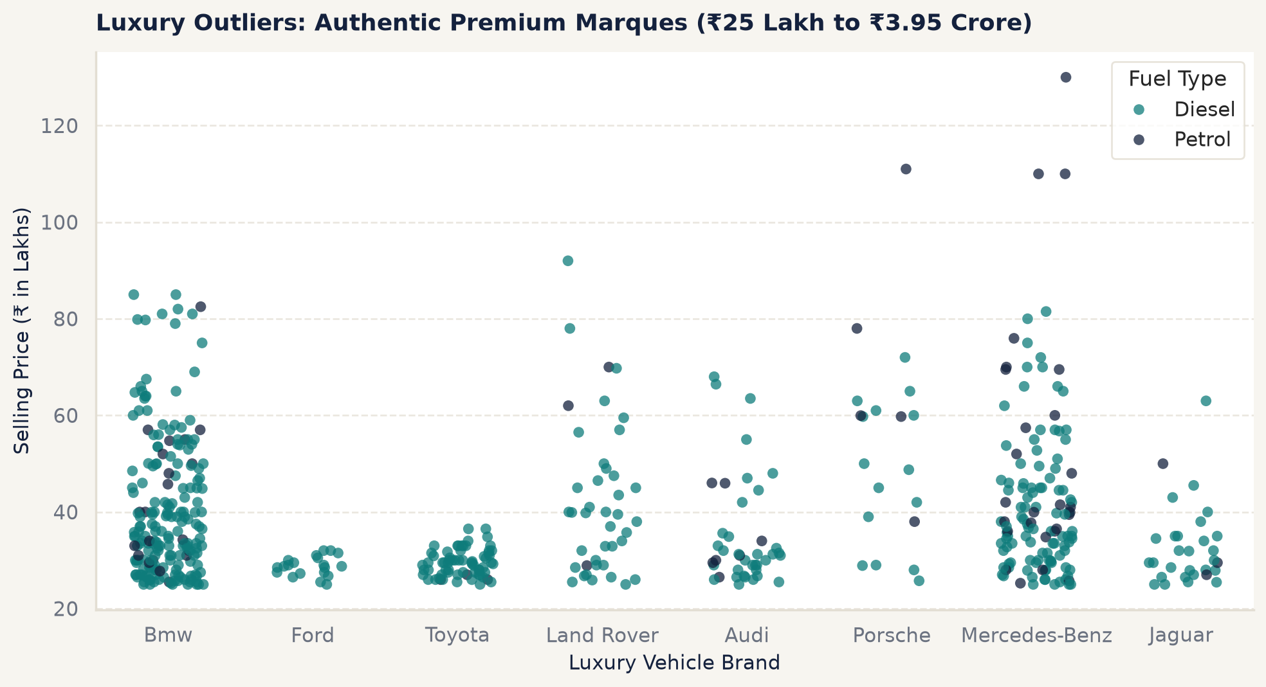
High-priced listings belong to genuine luxury brands.

4.4 What the EDA meant for modelling
- Predict log1p(price) (D-009).
- Propose engineered features: power per litre, kilometres per year, a luxury-brand flag and interactions. Each would be measured in Phase 3, not assumed (D-010, D-013).
- Expect tree ensembles to do better than linear models, because the relationships are curved and interacting; keep a Ridge baseline to prove it.
- Encode the 120-level model column compactly, and group rare brands (D-014, D-015).

5 Algorithm selection and model building

5.1 Cross-validation protocol
All model choices use five-fold cross-validation on the 12,195 training rows with seed 42. The main selection metric is log RMSE: the root mean squared error of log1p(price), which is the quantity the models minimise. On the log scale an error of one tenth corresponds to a miss of roughly 10% at any price level, so expensive and cheap cars count equally.

5.2 Feature screening
Each feature proposed by the EDA was added to a scaled Ridge “probe” model and kept only if it lowered CV log RMSE by at least 0.0001 (feature_checks.min_rmse_gain in configs/config.yaml, D-013). The table below shows the result.
Feature screening on the training split [feature_checks.csv]
Candidate | CV log RMSE | Change vs base 0.202 | Decision
km_per_year | 0.2018 | -0.0002 | Keep
power_per_litre | 0.2016 | -0.0005 | Keep
log_km_driven | 0.2025 | +0.0004 | Reject
is_luxury_brand | 0.2009 | -0.0011 | Keep
age_x_power | 0.1925 | -0.0095 | Keep
power_x_automatic | 0.2021 | 0.0 | Reject
All kept together | 0.1903 | -0.0117 | Keep
age_x_power carries most of the gain: powerful cars lose value faster, which a linear model cannot express without the interaction.
For the high-cardinality model column, target encoding and one-hot encoding were compared (D-014). For the tuned XGBoost, target encoding was better (0.1654 against 0.1673); for the Ridge probe the result reverses (0.202 against 0.1895), because one coefficient per model gives a linear model more freedom [encoder_comparison.csv]. Since the deployed model is XGBoost, target encoding was kept.

5.3 Algorithm shortlist
Ten algorithms were compared, chosen to cover different learning biases rather than to hunt for one winner (D-016) [model_candidates.csv]:
- Baselines: a dummy regressor that always predicts the training median, and ordinary least squares.
- Regularised linear models: Ridge (L2) and Lasso (L1), which handle the engine and power collinearity.
- Instance-based: k-nearest neighbours, which prices a car by similar cars.
- Single tree: a depth-limited decision tree, interpretable but high-variance.
- Bagging: a random forest, which averages many decorrelated trees.
- Boosting: scikit-learn’s histogram gradient boosting, XGBoost and LightGBM, the usual leaders on tabular data.

5.4 Untuned comparison
Each algorithm was run with fixed default settings from the config (models.candidate_params) inside the same pipeline.
Untuned five-fold CV results on the training split [cv_results.csv]
Algorithm | CV log RMSE (± std) | CV R² (log) | Out-of-fold MAE (₹)
Histogram gradient boosting | 0.1667 ± 0.0046 | 0.9417 | 98,692
XGBoost | 0.1668 ± 0.0047 | 0.9416 | 97,642
LightGBM | 0.1678 ± 0.0047 | 0.9409 | 99,748
Random forest | 0.1745 ± 0.005 | 0.9361 | 1,00,988
Linear regression | 0.1903 ± 0.0045 | 0.9239 | 1,20,592
Ridge | 0.1903 ± 0.0046 | 0.9239 | 1,20,518
Lasso | 0.1905 ± 0.0049 | 0.9238 | 1,20,469
k-nearest neighbours | 0.1955 ± 0.002 | 0.9197 | 1,13,089
Decision tree | 0.2004 ± 0.0073 | 0.9158 | 1,24,304
Dummy (median) | 0.6921 ± 0.008 | -0.0052 | 4,04,328
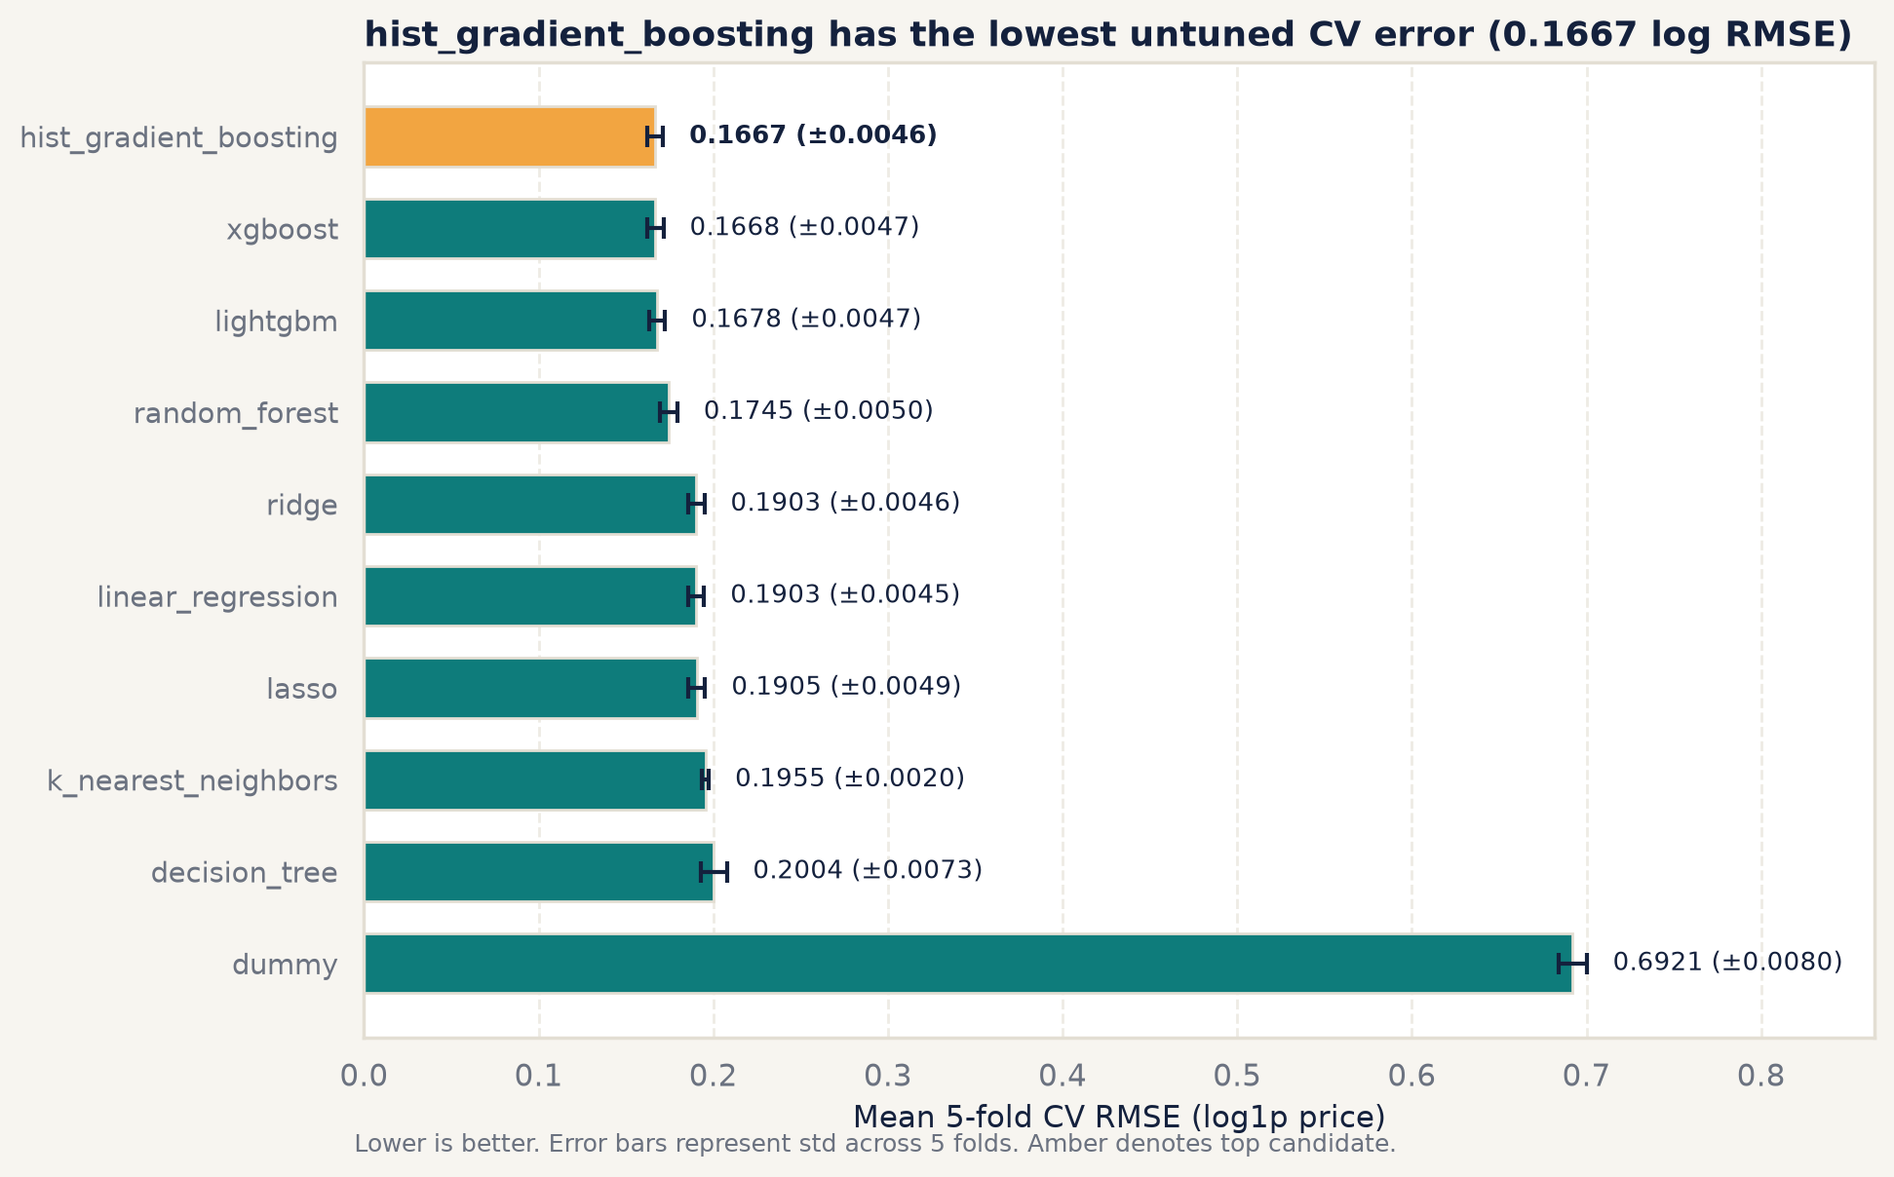
Untuned CV comparison of the ten algorithms.
The three boosting models lead, and are within one fold standard deviation of one another. Linear models are clearly behind: they cannot represent the curved price-power relationship or the way depreciation differs between car types without hand-built interactions. A single tree overfits, and the random forest, while better, does not reach the boosters.

5.5 Tuning
The three boosting models were tuned with Optuna’s Tree-structured Parzen Estimator, 35 trials each, seed 42, over the search spaces in configs/config.yaml (models.search_spaces) (D-018). To make tuning affordable without leakage, the preprocessing for each of the five folds was fitted once on that fold’s training part and reused across trials; this is mathematically the same as fitting the full pipeline in every trial. Every trial is logged in reports/tables/tuning_trials_*.csv.
Best tuned scores [models/best_params.json]
Model | Best CV log RMSE after tuning
XGBoost | 0.1654
LightGBM | 0.1660
Histogram gradient boosting | 0.1660
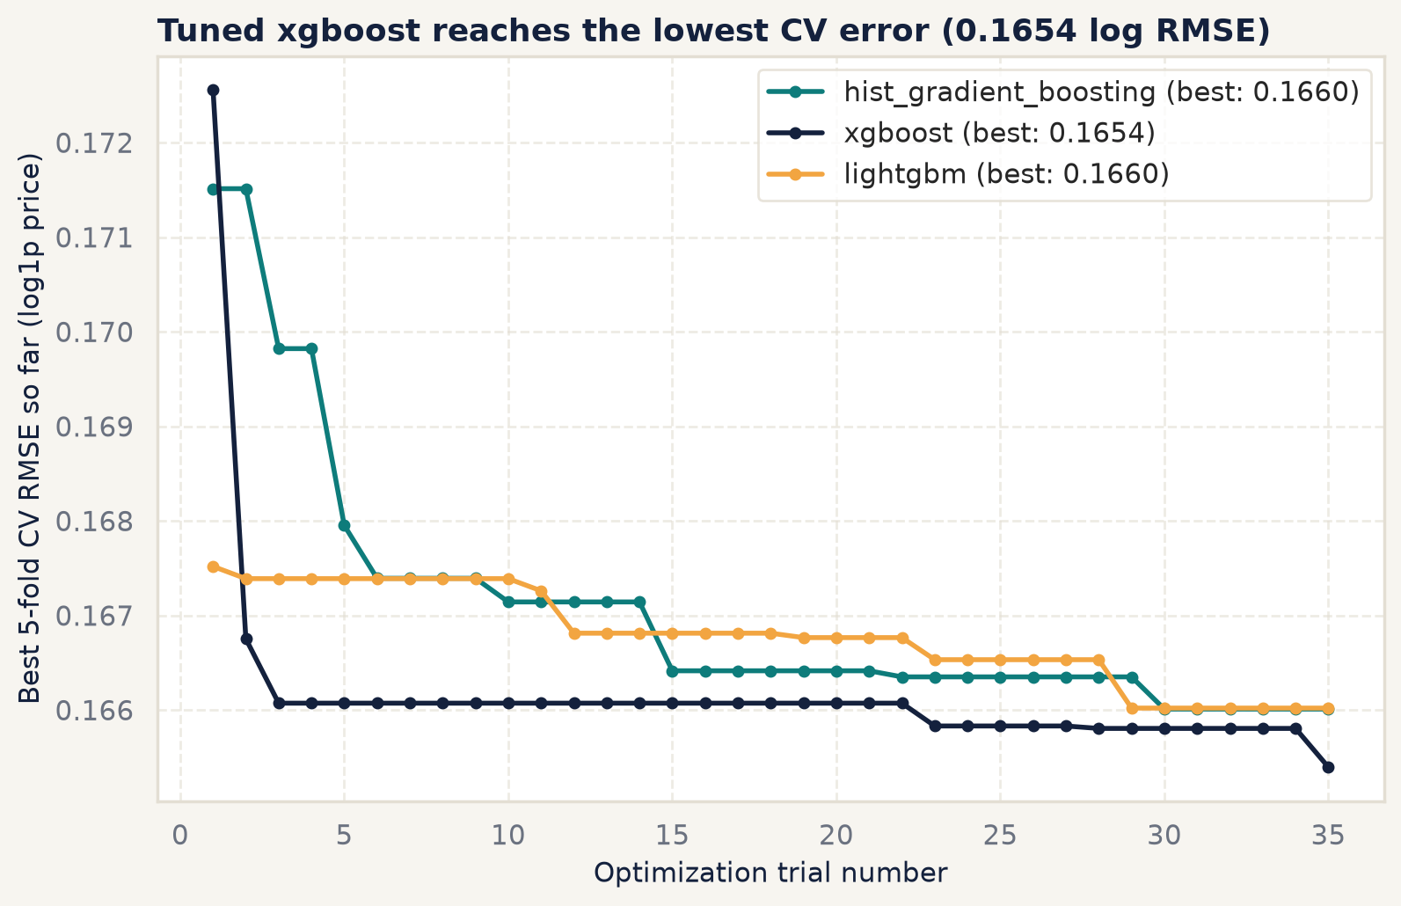
Optuna optimisation history.

5.6 Final model choice
The selection rule, fixed before tuning, was the lowest mean CV log RMSE, with ties broken by fold stability, simplicity and speed (D-019). Tuned XGBoost won with 0.1654 (out-of-fold R² 0.9426). Its tuned settings are 200 trees of depth 6, learning rate 0.05, and row and column subsampling of 0.86 and 0.68 [models/model_card.json]. The margin over LightGBM and histogram boosting is smaller than one fold standard deviation, so the three are effectively tied; XGBoost is chosen because the rule says so, and any of the three would have served. Against the baselines, the tuned model’s CV log RMSE is 76.1% below the dummy and 13.06% below Ridge [models/model_card.json].
The final pipeline was refitted on all 12,195 training rows and saved with joblib as models/final_pipeline.joblib, together with a model card (models/model_card.json) recording the commit, training date, hyperparameters, CV scores and interval quantiles.

5.7 Prediction interval
A point estimate alone hides how uncertain it is. The 80% range is built from the out-of-fold residuals on the log scale (D-020): their 10th and 90th percentiles are -0.1903 and 0.1915, and for a new car the range is expm1(log prediction + q10) to expm1(log prediction + q90) [models/model_card.json]. Because it uses residuals the model never trained on, it makes no normality assumption, and because it is additive on the log scale the range in rupees widens in proportion to price.

6 Model evaluation

6.1 Metric choice
The metrics were fixed and committed before the test set was opened, so the results could not influence which ones were reported (D-023):
- MAE in rupees answers “how far off, on average”, in the unit users care about. It is one half of the headline.
- Share within 10% of the true price answers “how often is it close”, independent of price level. It is the other half of the headline.
- RMSE in rupees shows how much of the error sits in large misses on expensive cars.
- MAE, RMSE and R² on log price match the training objective and are comparable with the CV scores.
- MAPE and median absolute percentage error describe relative error; MAPE is pulled up by cheap cars, the median is robust.
- Adjusted R² is reported because it was requested; with 3,049 test rows the adjustment is negligible.
- Interval coverage with a 95% Wilson confidence interval checks the 80% range.
- Bootstrap 95% intervals (1,000 resamples, seed 42) give uncertainty for the main metrics [bootstrap_ci.csv].

6.2 Test results
Results on the locked test set of 3,049 cars [test_metrics.csv]
Metric | Final model (tuned XGBoost) | Ridge baseline | Dummy (train median)
MAE (₹) | 94,648 | 1,15,850 | 3,85,255
RMSE (₹) | 2,02,801 | 2,66,575 | 8,07,416
R² (₹) / adjusted | 0.9328 / 0.9319 | 0.8839 / 0.8824 | -0.0654 / -0.0654
MAE (log) | 0.1247 | 0.1457 | 0.5016
RMSE (log) | 0.1648 | 0.1881 | 0.6732
R² (log) / adjusted | 0.9399 / 0.9391 | 0.9216 / 0.9206 | -0.0036 / -0.0036
MAPE | 12.7% | 14.86% | 53.67%
Median absolute % error | 9.75% | 12.04% | 37.08%
Within 10% | 50.97% | 42.93% | 14.43%
Within 20% | 82.09% | 75.11% | 29.94%
Median signed % error (bias) | -0.34% | -0.65% | 1.08%
On a typical car the model is about a tenth off: the median absolute error is 9.75%, about half of cars are within 10% and four in five are within 20%. The average miss is ₹ 94,648, with a 95% bootstrap interval of ₹ 88,440 to ₹ 1,01,444 [bootstrap_ci.csv].
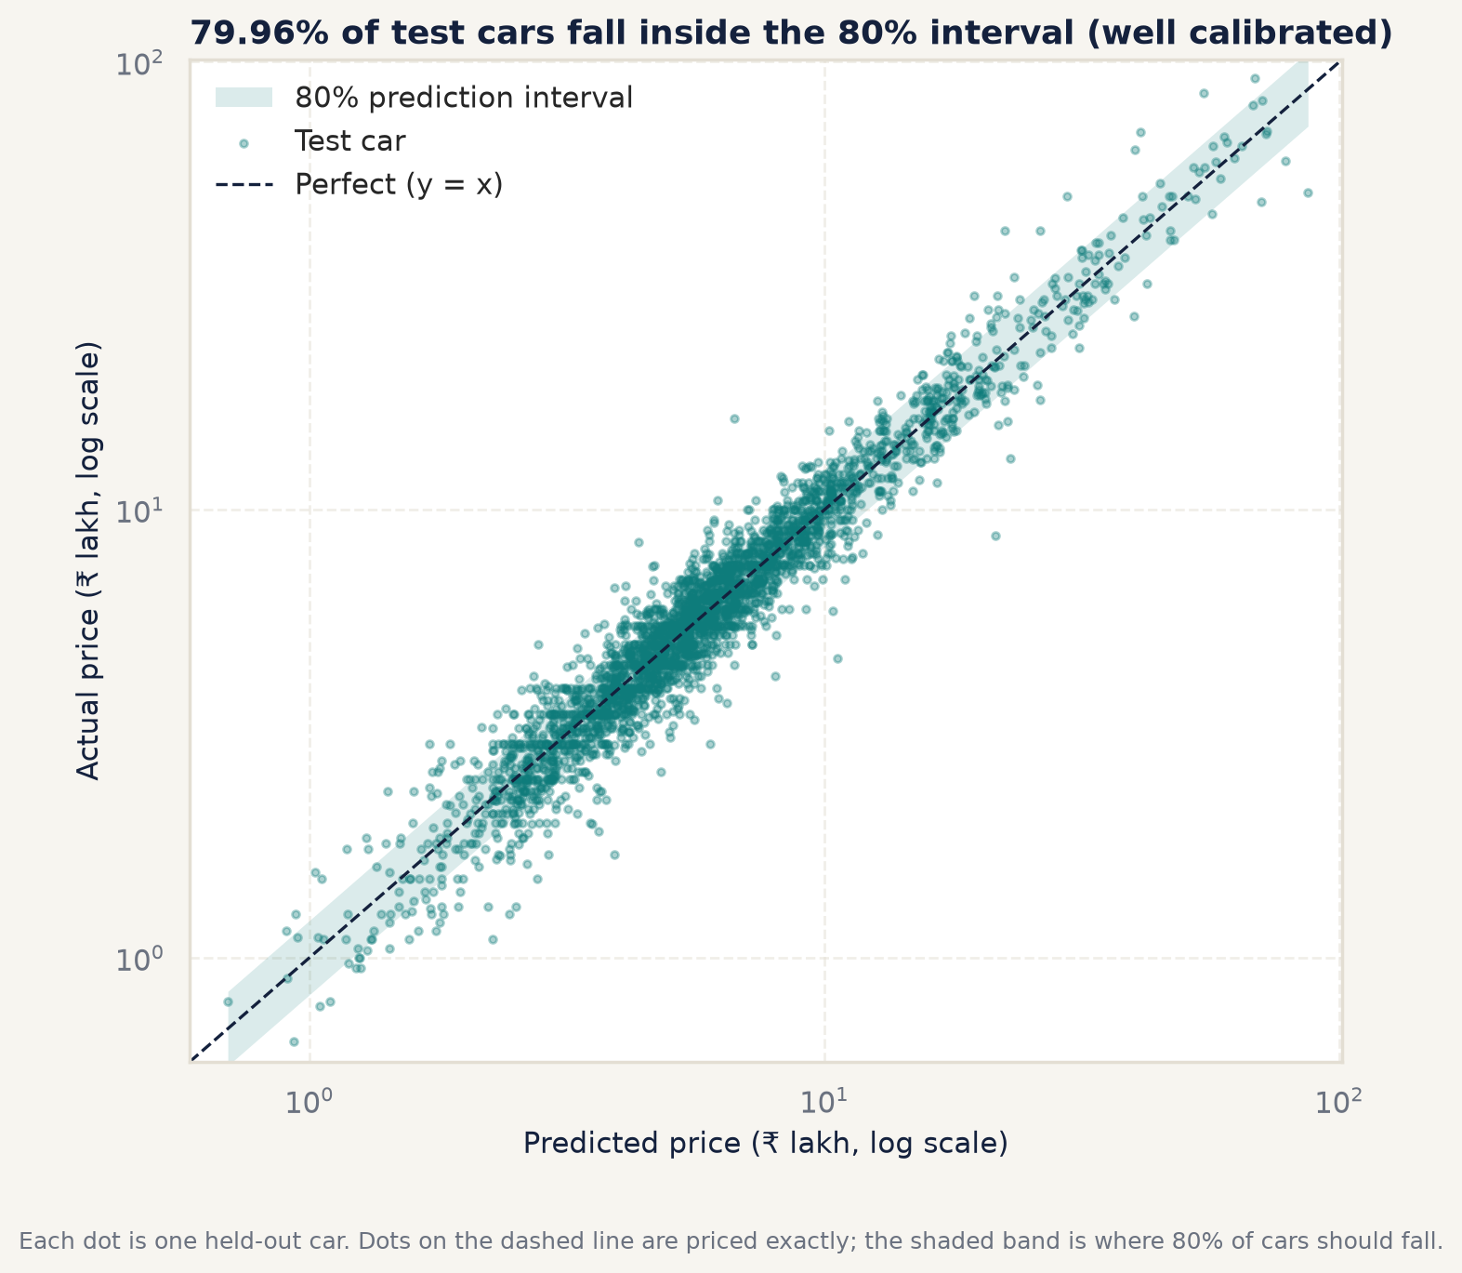
Predicted against actual price on the test set (log scales).

6.3 Comparison with baselines
The final model lowers MAE by 18.30% and log RMSE by 12.39% relative to Ridge, and prices 8.04 percentage points more cars within 10% [report_key_figures.csv]. The bootstrap interval for the MAE difference (final minus Ridge) is -₹ 28,252 to -₹ 14,851, which excludes zero, so the improvement is not an accident of which cars ended up in the test set [bootstrap_ci.csv]. Against the dummy baseline, MAE is 75.43% lower [report_key_figures.csv].
Why does XGBoost beat Ridge? Three reasons, each visible in the data. Price rises non-linearly with power (Chapter 4), which a linear model on log price captures only approximately. Depreciation differs between car types (the age_x_power interaction gave the largest gain in feature screening), and trees learn such interactions automatically. Finally, the car model is the most important input (see Explainability below), and its effect combines with age and power in ways that a single linear coefficient per encoded model cannot express.
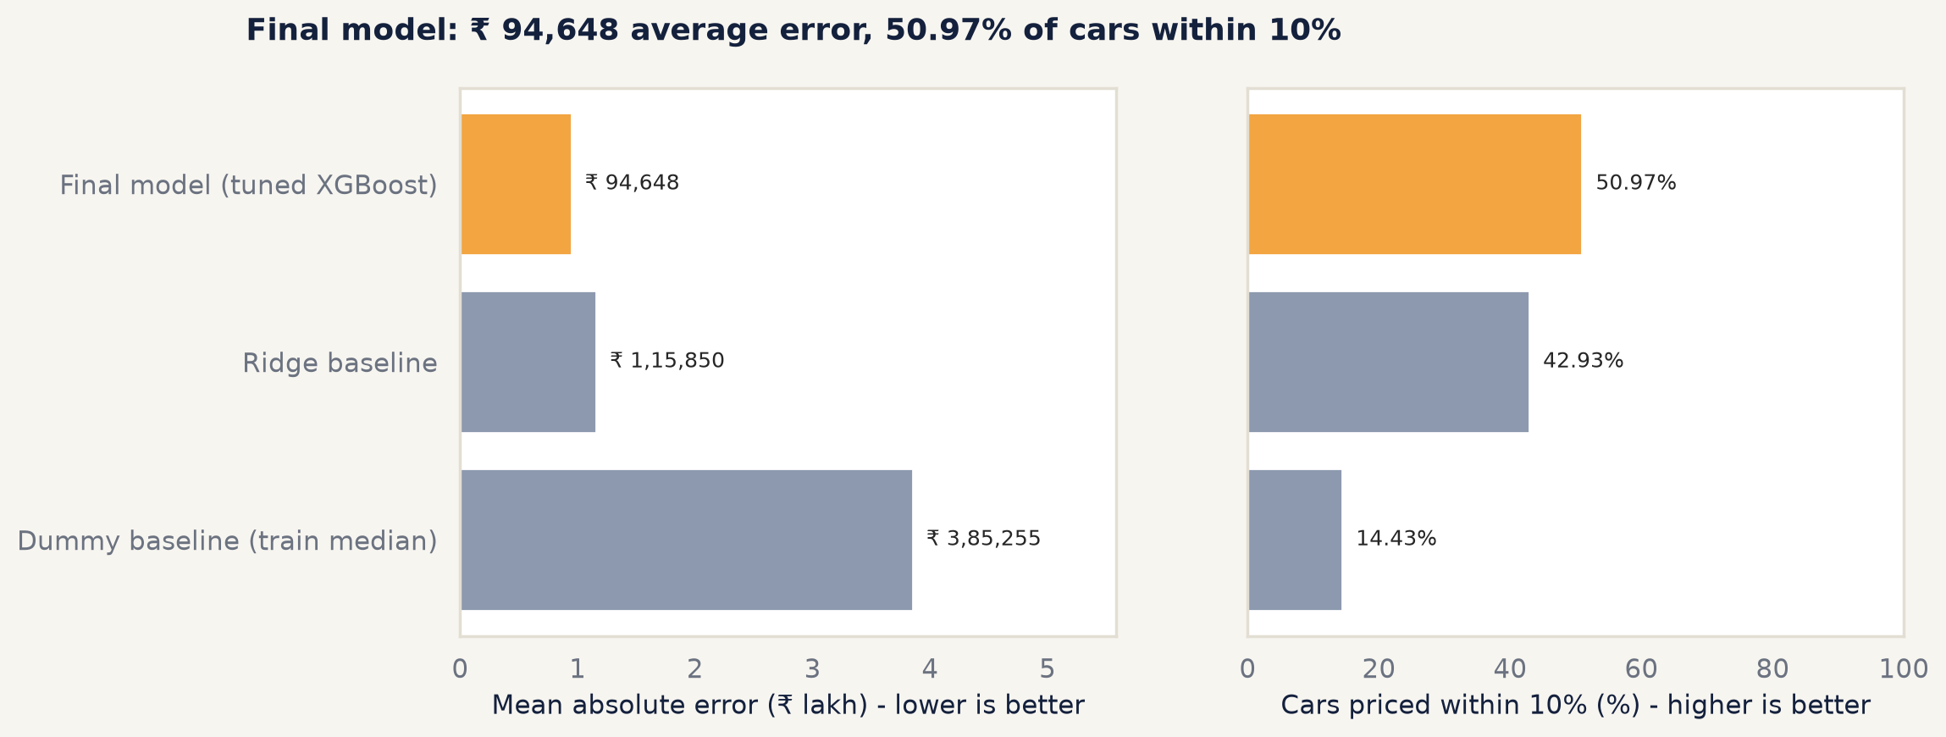
Final model compared with the baselines on the test set.

6.4 Generalisation
Training, cross-validation and test error [train_vs_test.csv]
Data | Log RMSE | R² (log)
Training rows, in-sample fit | 0.1387 | 0.9596
Training rows, five-fold out-of-fold | 0.1654 | 0.9426
Test set, scored once | 0.1648 | 0.9399
The test error (0.1648) matches the cross-validation estimate (0.1654) to within 0.36% [train_vs_test.csv], so the CV protocol predicted test performance well and the model is not overfitted to its training folds. The tighter in-sample fit is normal for boosted trees and did not carry over into a test penalty.

6.5 Residuals and calibration
The residuals on the log scale are centred: mean -0.0009, median 0.0034. They are slightly heavier-tailed than a normal distribution (excess kurtosis 1.875; 5.21% of residuals lie beyond two standard deviations against 4.55% expected) [residual_stats.csv]. There is no systematic over- or under-pricing overall.
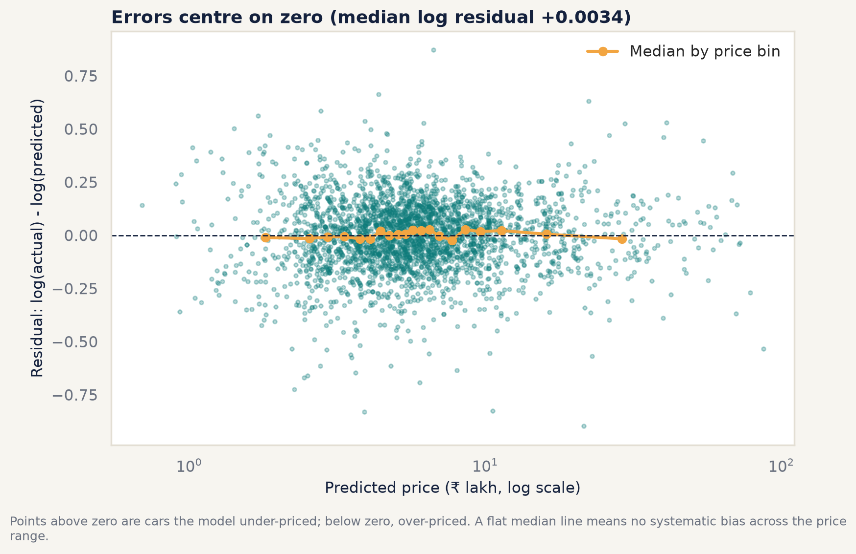
Residuals against predicted price.
Interval coverage. The 80% range contains the true price for 79.96% of test cars (2,438 of 3,049), with a 95% confidence interval of 78.5% to 81.34% that includes the nominal 80%: well calibrated [interval_coverage.csv]. Misses are balanced (10.07% below the range, 9.97% above). The median range is 38.44% of the predicted price wide. Calibration holds on average but not for every group: coverage is 92.45% for 0 to 2 year-old cars and only 52.38% for cars 12 years or older [segment_errors.csv].
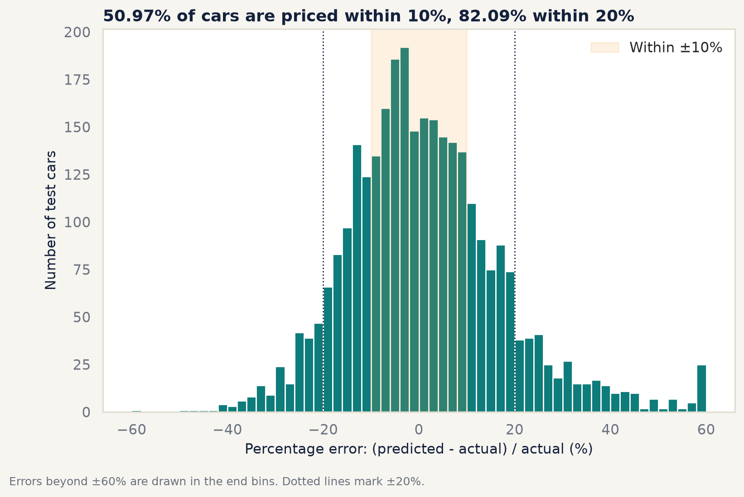
Distribution of percentage errors on the test set.

6.6 Segment analysis
The test set was broken down by price band (training-set quintiles, so test data never define the bands), luxury band, brand, fuel, transmission, age band and seller (D-027). The five weakest segments, ranked by the share within 10% among segments with at least 30 test cars, are:
The five weakest segments [segment_errors.csv]
Rank | Segment | Test cars | Within 10% | Median abs % error | Interval coverage
1 | Vehicle age 12+ yrs | 168 | 32.74% | 18.9% | 52.38%
2 | Vehicle age 9-11 yrs | 451 | 33.92% | 14.39% | 65.41%
3 | Brand: BMW | 76 | 34.21% | 14.94% | 68.42%
4 | Price band Q1 (₹ 0.4 to 3.5 lakh) | 650 | 39.23% | 12.96% | 68.92%
5 | Above ₹ 20 lakh | 136 | 41.18% | 12.18% | 71.32%
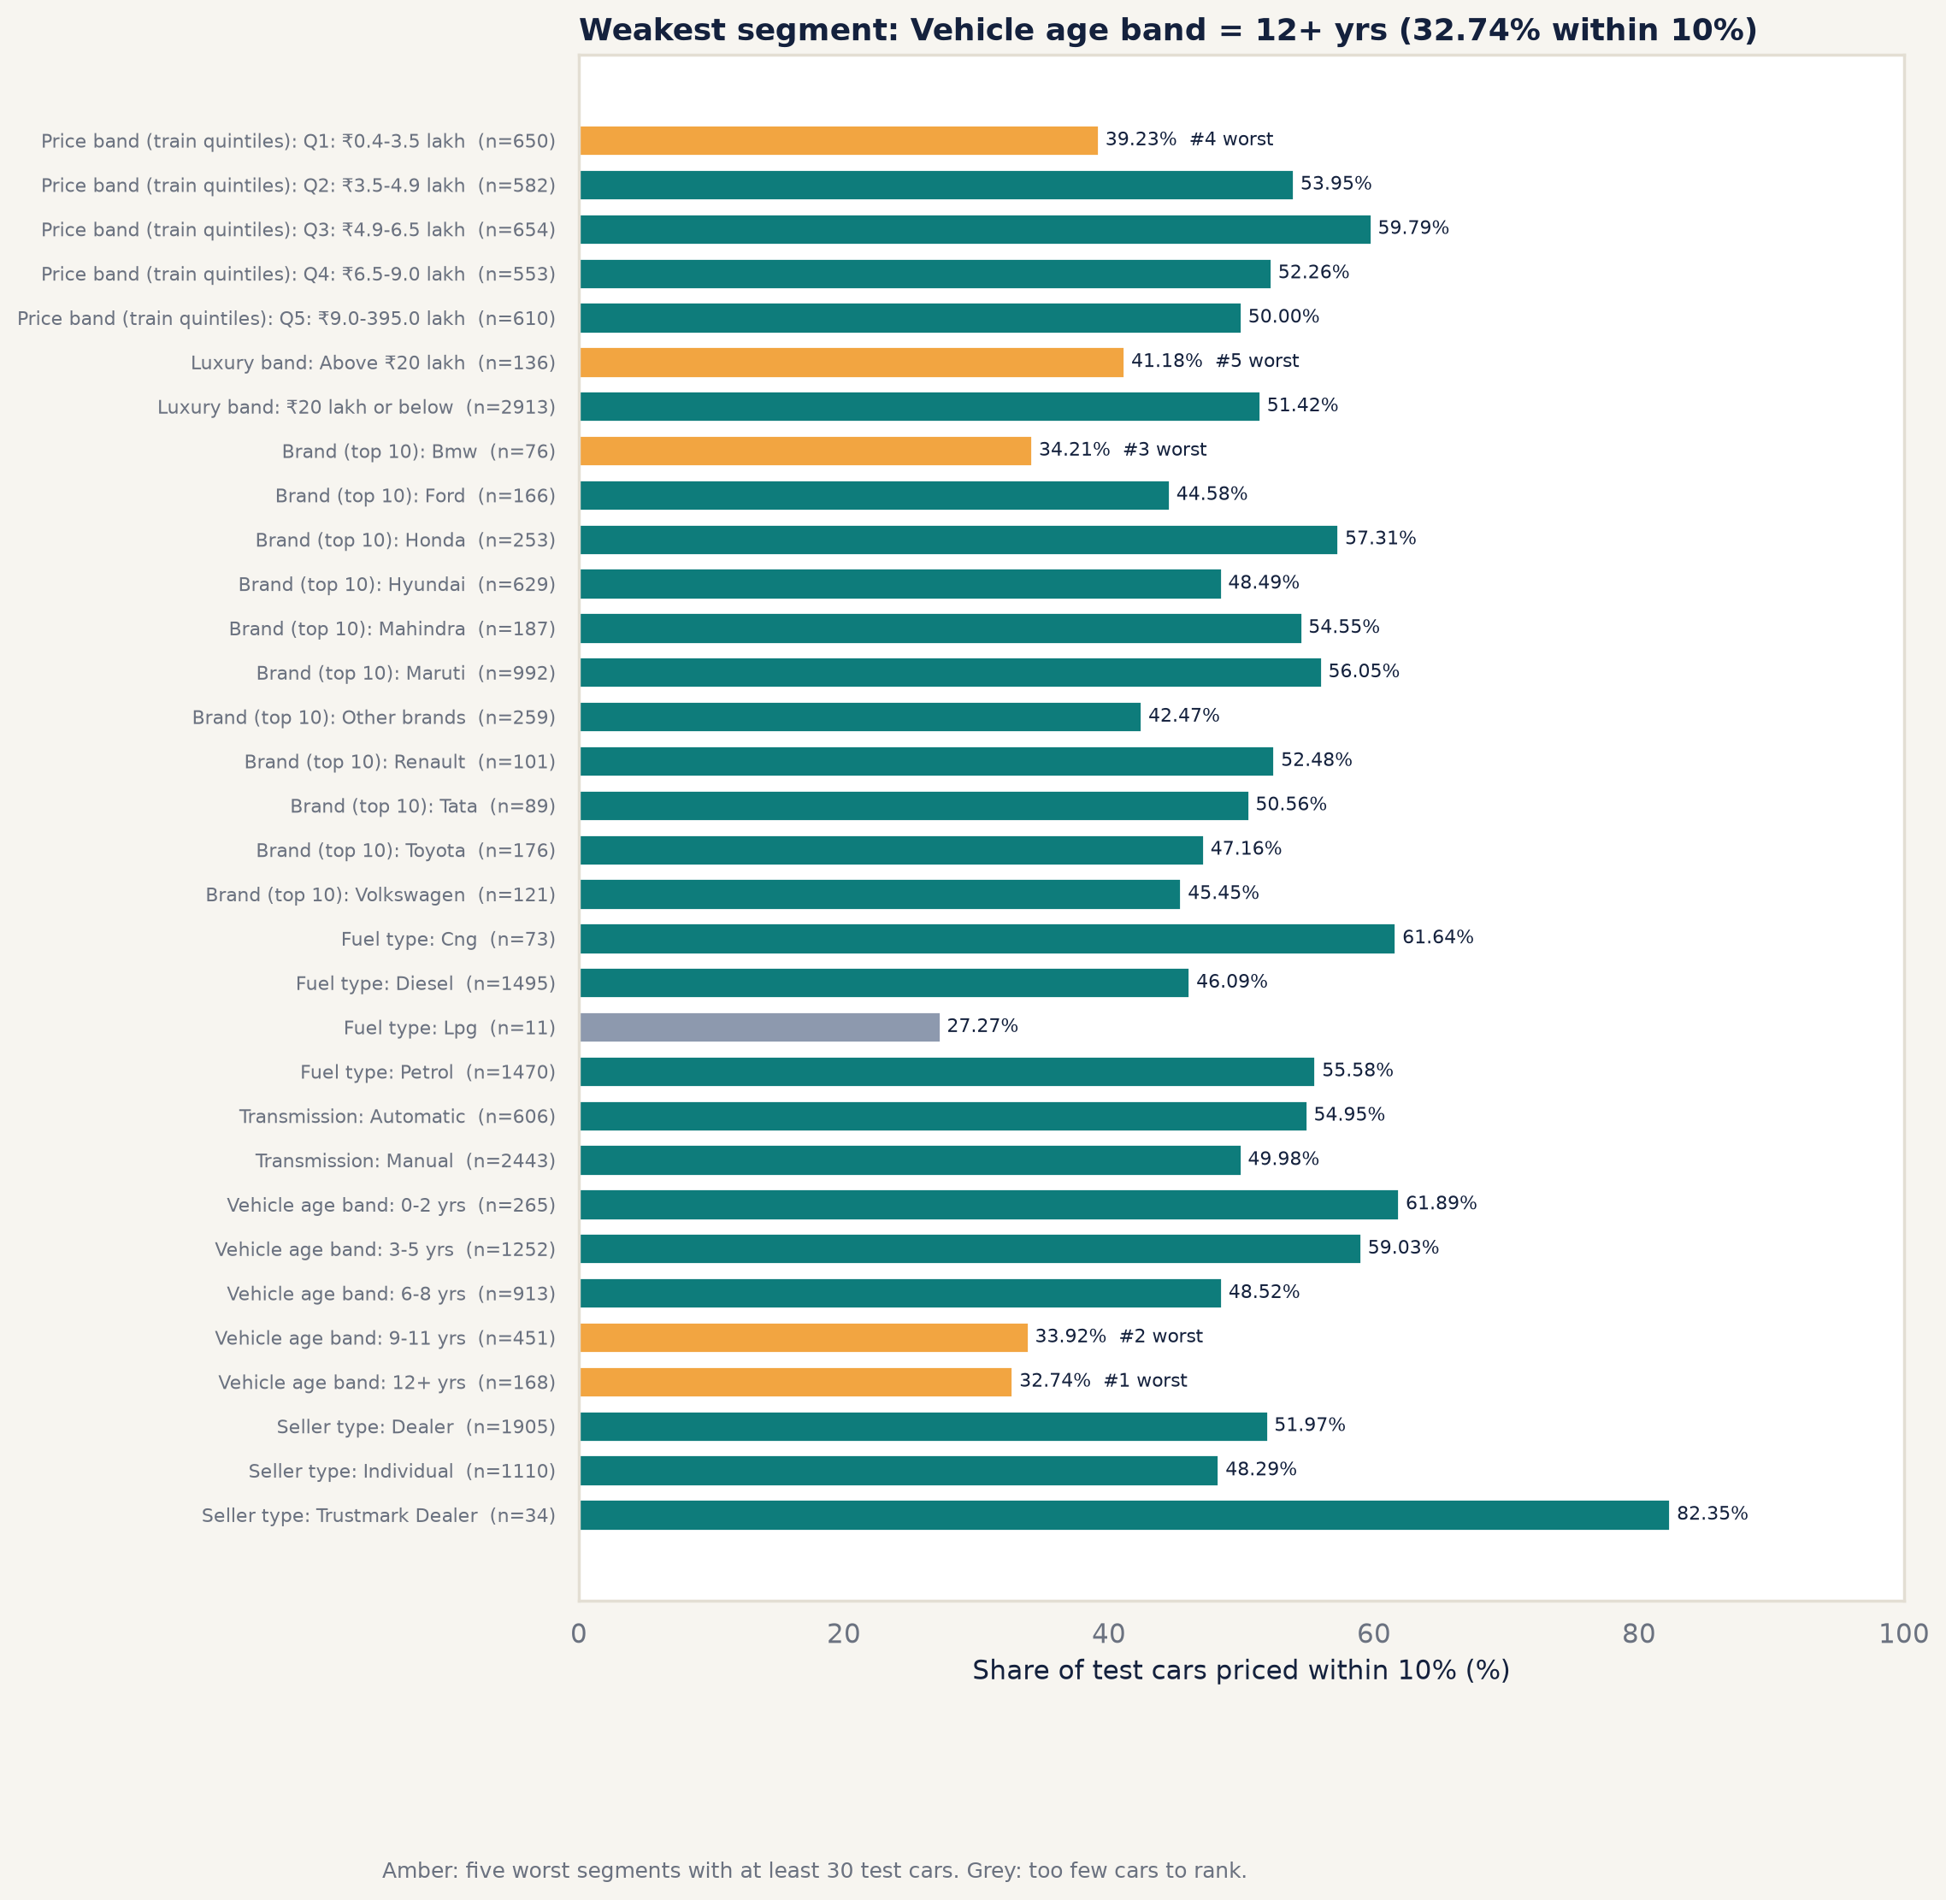
Share within 10% by segment.
Three patterns stand out. Accuracy falls with age, from 61.89% within 10% at 0 to 2 years to 32.74% at 12 years and older: the condition of old cars varies much more and is not recorded. The cheapest cars are over-priced (median signed error +7.26% in Q1) and luxury cars under-priced (-5.76% above ₹ 20 lakh), both pulled towards the middle of the market. And rare categories cannot be judged: LPG has only 11 test cars. Strong segments include CNG cars (61.64% within 10%), Trustmark dealers (82.35%) and cars aged 0 to 5 years [segment_errors.csv].
The largest errors. The 20 largest rupee errors are 0.66% of test cars but 12.04% of all rupee error. Eighteen are luxury brands, 17 sell for over ₹ 20 lakh, all 20 are automatics and 18 fall outside their 80% range [top_error_patterns.csv]. The common cause is coarse model labels: the data record “Rover” for every Land Rover and “C” for a Mercedes-AMG C-class, so variants that differ by tens of lakhs look identical to the model [top_errors.csv].

6.7 Explainability
Two independent methods agree on what drives the predictions.
Permutation importance (10 repeats on the test set) measures how much the test log RMSE rises when one input is shuffled: by 0.2854 for vehicle age, 0.2788 for car model and 0.117 for power; kilometres (0.023), transmission (0.0148) and brand (0.0137) matter much less, and km_was_capped has exactly zero effect, confirming it is not used (D-024) [permutation_importance.csv].
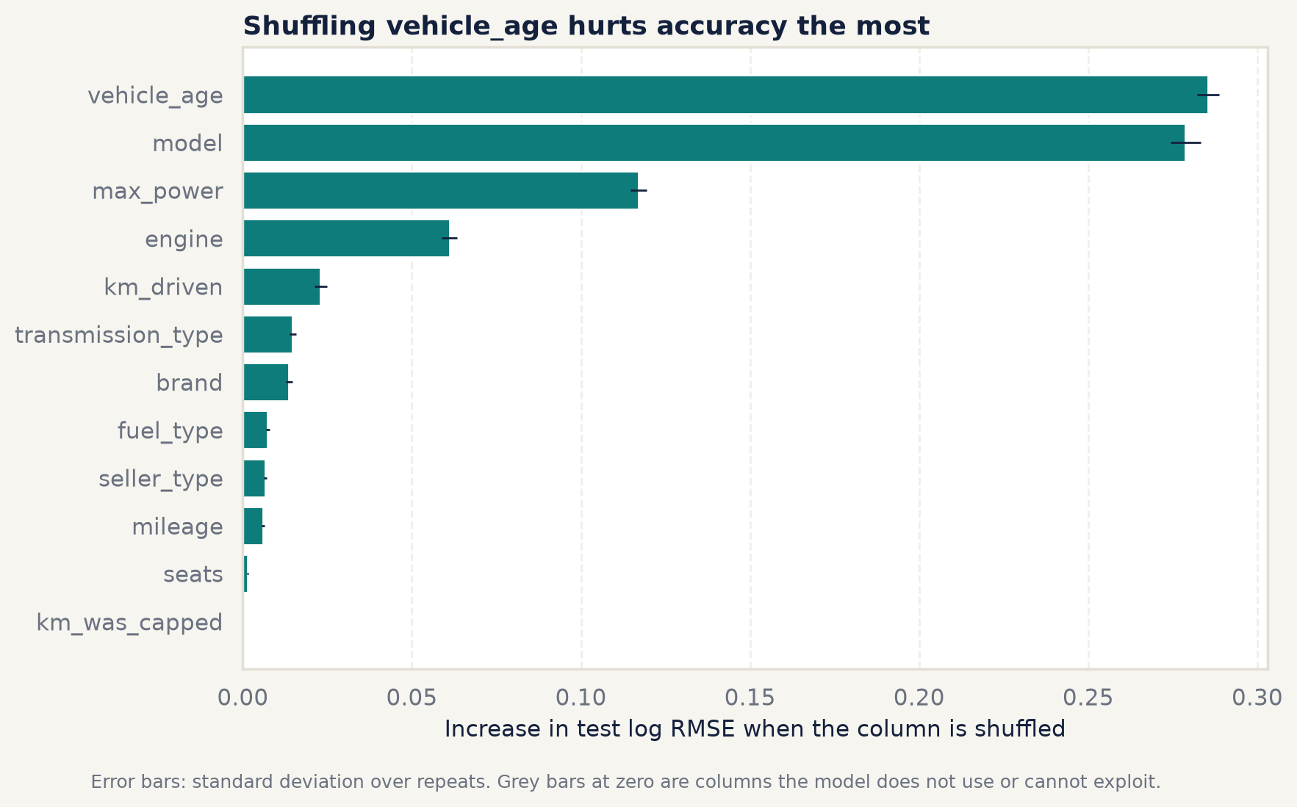
Permutation importance on the test set.
SHAP (TreeExplainer on 2,000 test cars, evaluation.shap_sample_rows in configs/config.yaml) attributes 30.41% of the total effect to the car model, 20.35% to age, 12.78% to power and 8.16% to engine size, with the engineered age_x_power next at 6.47% [shap_importance.csv].
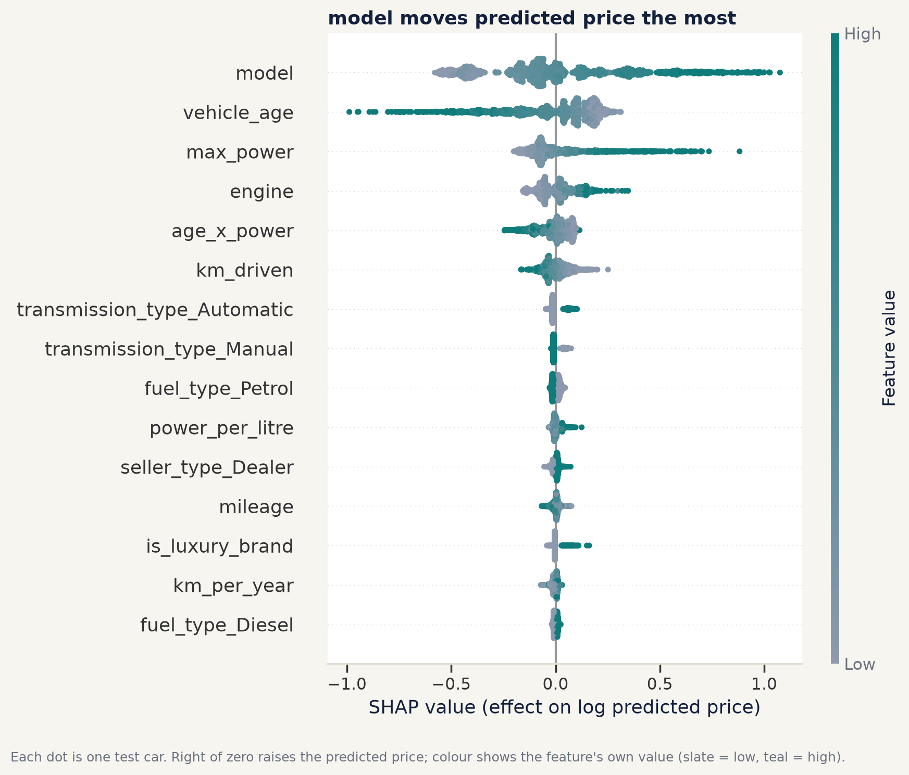
SHAP summary: each dot is one test car.
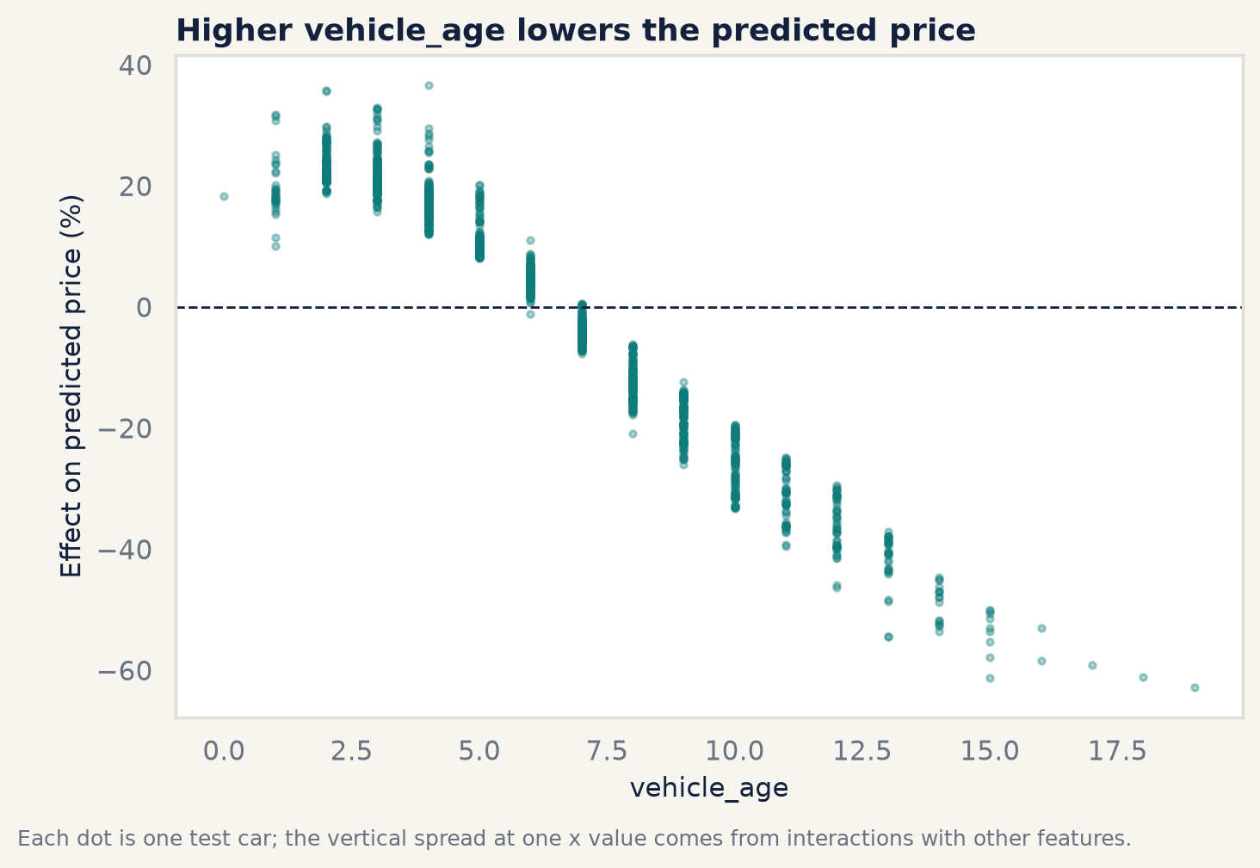
Effect of vehicle age on the predicted price (SHAP dependence).
This matches the EDA: power, engine and age were the strongest numeric correlates of price. Transmission and fuel matter less to the model (SHAP shares 5.15% and 2.82% [shap_importance.csv]) than their raw price gaps suggest, because most of those gaps are explained by power, engine and the car model, which differ systematically between automatics and manuals or diesels and petrols.

7 Prediction results

7.1 Test-set predictions
Every one of the 3,049 test cars was scored with the saved pipeline and written to reports/predictions/test_predictions.csv, with the 80% range, the error and whether the input passes the GUI’s validation rules. One test car, a Mercedes-AMG C, belongs to a brand absent from the training data; the GUI would refuse it, so it is scored without validation and flagged (D-030, D-031). The predictions are identical to those behind the Chapter 6 metrics.

7.2 Worked examples
Ten real test cars illustrate the model (D-031). Eight are the typical car of a category, chosen by rule as the car whose error is closest to that category’s median error, so the examples are representative rather than flattering; the last two are the single best and worst predictions.
Worked examples [reports/predictions/worked_examples.csv]
Category | Car | Actual | Predicted | Error | In 80% range
Cheap petrol hatchback | Datsun Redigo, 5 yrs | ₹ 2,35,000 | ₹ 2,63,272 | +12.03% | Yes
Family diesel SUV or MPV | Maruti Ertiga, 5 yrs | ₹ 8,11,000 | ₹ 7,18,623 | -11.39% | Yes
Old car (12+ years) | Hyundai Santro, 13 yrs | ₹ 1,20,000 | ₹ 1,42,660 | +18.88% | Yes
Luxury car | Jaguar XE, 4 yrs | ₹ 29,50,000 | ₹ 33,04,602 | +12.02% | Yes
CNG car | Maruti Eeco, 8 yrs | ₹ 3,25,000 | ₹ 2,98,398 | -8.19% | Yes
Automatic petrol city car | Honda City, 3 yrs | ₹ 11,50,000 | ₹ 10,72,861 | -6.71% | Yes
High-kilometre car | Hyundai i20, 1,50,000 km | ₹ 6,20,000 | ₹ 5,20,167 | -16.1% | Yes
Nearly new car | Renault Duster, 1 yr | ₹ 6,00,000 | ₹ 6,58,459 | +9.74% | Yes
Best prediction | Maruti Alto, 10 yrs | ₹ 1,85,000 | ₹ 1,84,967 | -0.02% | Yes
Worst prediction | Volkswagen Polo, 3 yrs | ₹ 8,75,000 | ₹ 21,47,143 | +145.39% | No
Each example in reports/predictions/worked_examples.md has a generated explanation from that car’s own TreeSHAP contributions. Two are worth describing here (figures from reports/predictions/worked_examples.csv):
- Honda City (accurate). A 3-year-old automatic with 606 training examples of its model. The biggest influences were its young age (+26%) and power (+13%); the estimate is 6.71% below the listing and well inside the range. [reports/predictions/worked_examples.csv]
- Volkswagen Polo (worst). The listing describes a 3-year-old Polo with a 1,798 cc, 189 bhp engine and an automatic gearbox, which matches a high-performance variant. The model, following the power (+89% influence), predicts ₹ 21,47,143, but the car listed at ₹ 8,75,000. Either the specification or the price is wrong, or the car has a problem the data cannot show. It is a reminder that the model trusts its inputs. [reports/predictions/worked_examples.csv]

7.3 What-if analysis
To show how the model responds to age and kilometres, the most common car in the training data, a Maruti Swift Dzire with its typical specification, was priced on a grid of ages from 1 to 12 years and kilometre levels from 10,000 to 1,50,000 (prediction.whatif_ages and whatif_km in configs/config.yaml, D-031) [reports/predictions/whatif_age_km.csv]. At 10,000 km, the estimate falls from ₹ 7,66,034 at 1 year to ₹ 3,12,029 at 12 years. At a fixed age, extra kilometres reduce the price far less than extra years do, consistent with the weak kilometre correlation in the EDA.
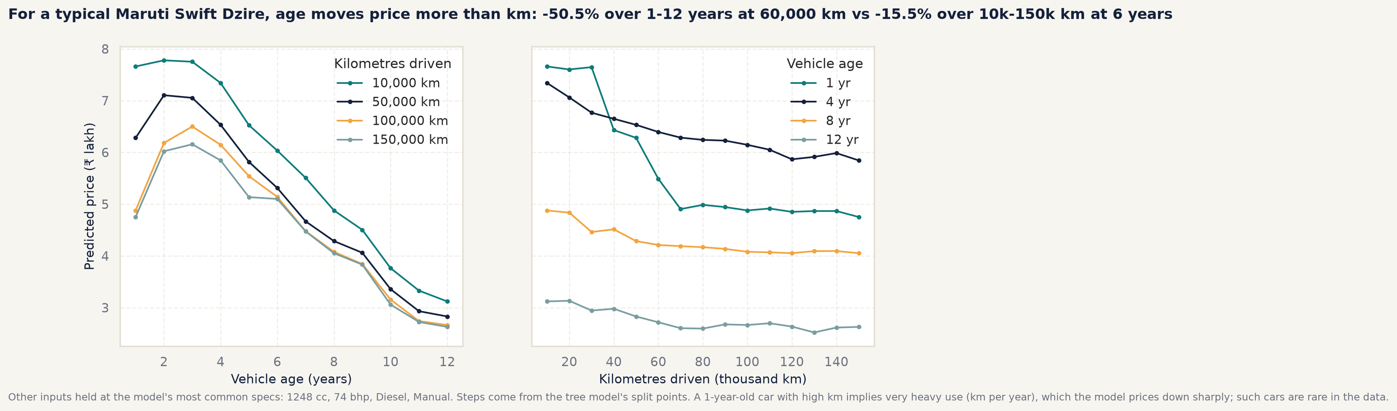
What-if sweep for the reference car over age and kilometres.

7.4 Speed
The predictor must load in under 2.0 seconds and answer one car in under 100 ms (prediction.max_load_seconds and max_single_prediction_ms in configs/config.yaml). Timing is measured in five fresh processes by python tasks.py predict and written to reports/tables/predictor_timing.csv; on the development laptop on mains power every run passed both targets with a wide margin (D-044). Timings vary from machine to machine and run to run, so the exact values are not quoted here as results. An earlier measurement on battery in a power-saving plan was several times slower, which is why the targets are checked on both the fastest and the slowest of the five runs (D-031). The GUI’s full response (validation, prediction, explanation and comparisons) is held to the 2.0-second budget by an automated test (gui.max_response_seconds, D-033).

8 Graphical user interface

8.1 Design rationale
The application is written in Streamlit and follows a fixed design system (A7 in AGENTS.md, D-035): a warm off-white background, white cards with thin borders, one teal primary colour, and a single amber highlight per view reserved for the most important element. Headings use Fraunces, body text Inter, and numbers JetBrains Mono. Prices appear in Indian digit grouping and in lakh, with units beside every value. Each chart has a title that states its finding and a sentence of interpretation beneath it, so no reading relies on colour alone. The app follows the visitor’s light or dark system setting, with a dark palette derived from the same colours (D-036).
Three principles guided the layout. The task a visitor came for, pricing a car, is the first page and needs no scrolling. The estimate is never shown without its range and, where relevant, a warning in words. And no number is typed into the interface code: metrics are read from reports/tables/ and the model card, and market figures are computed live from the cleaned data (D-032).

8.2 Page walkthrough
Price estimator (default page). The form on the left (two fifths of the width) groups inputs into Vehicle, Condition and Engine and fuel. Brand and model are drop-down lists drawn from the training data, so an unseen brand or a model of another brand cannot be entered (D-030, D-034); choosing a model fills in its typical engine, power, mileage, seats and fuel, all still editable. Numeric inputs are bounded by the training range. Pressing Estimate price shows, on the right, the estimate as the largest element on the page, the 80% range as a bar with an amber marker, a message about similar listings, and a “Lower confidence” note when the car falls in a weak segment. Below are three panels: Why this price (the top five factors from TreeSHAP for this car), Compare (this car against the median of the same brand and age) and What if (the estimate as age or kilometres change). A second tab, Batch estimate, prices a whole CSV file with a downloadable template.
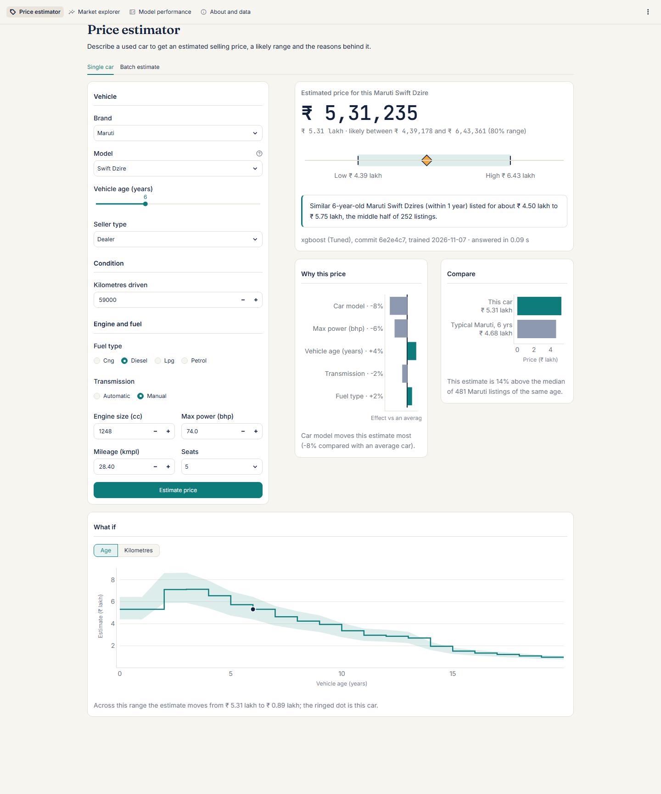
Price estimator page.
Market explorer. Filters for brand, fuel, transmission, age and price drive a summary strip (listings, median price, median age) and four charts: the price distribution, median price by age with a count-weighted trend, price against power by fuel, and top brands by median price.
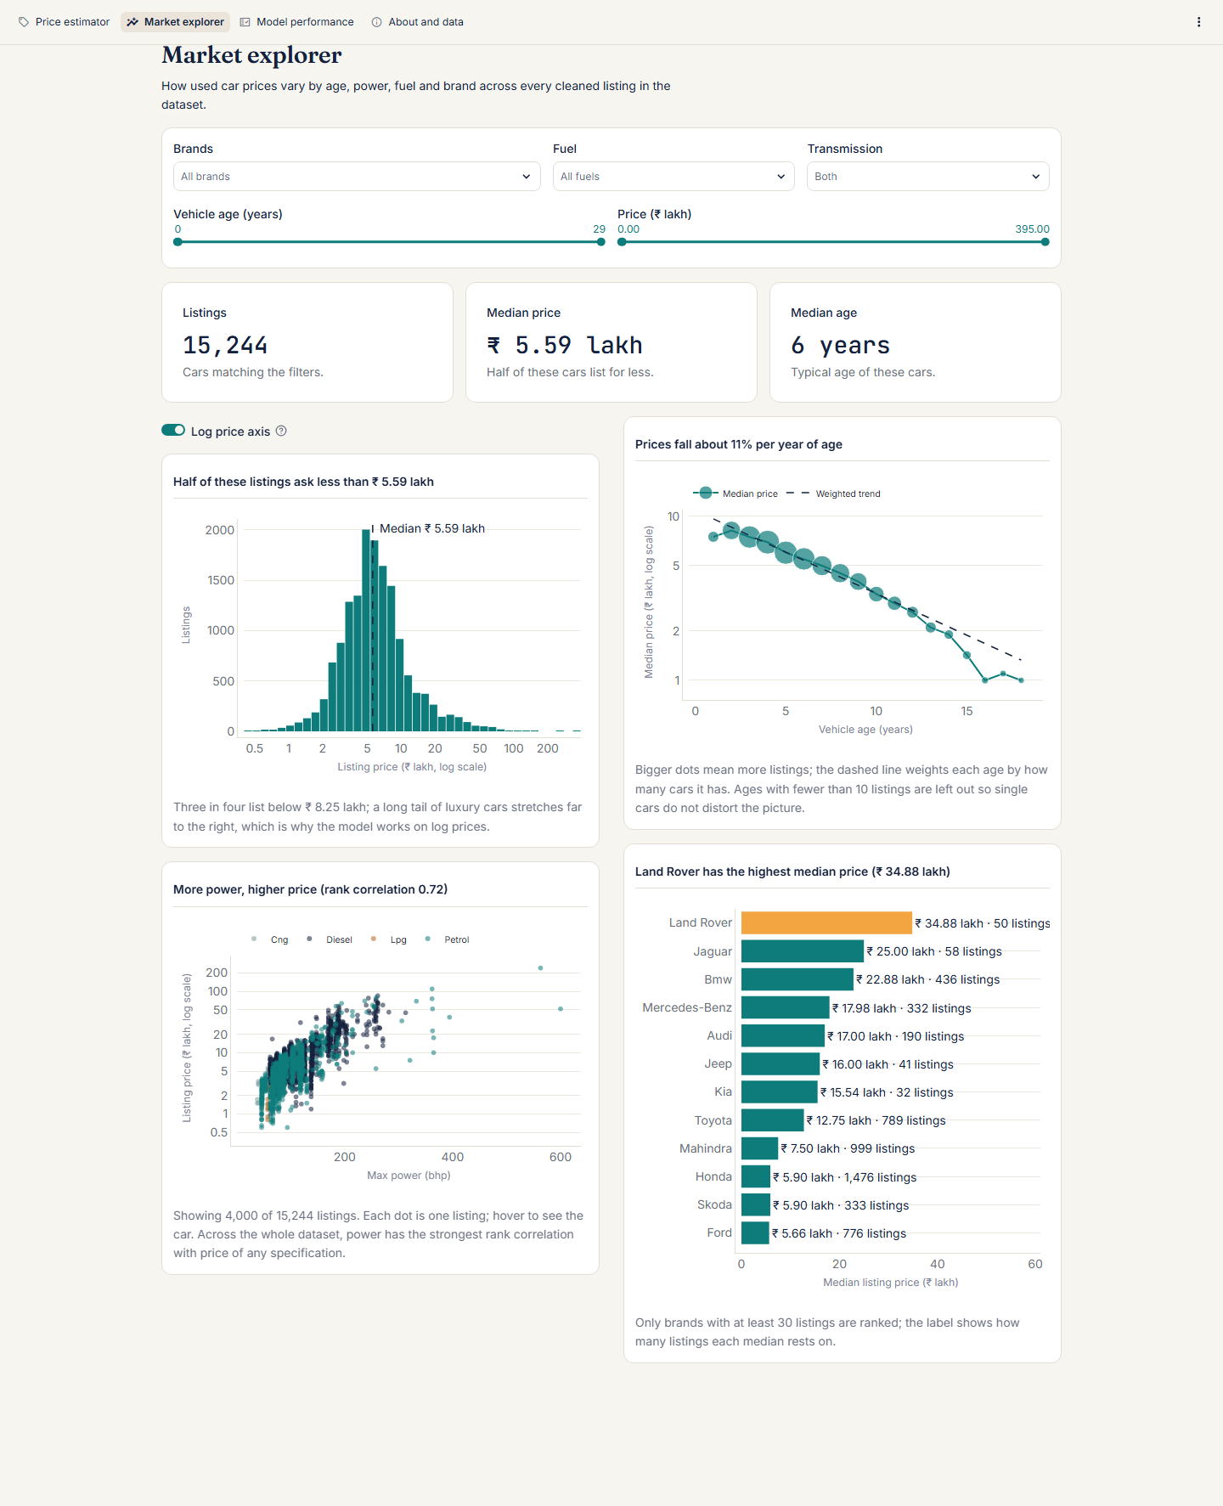
Market explorer page.
Model performance. Metric cards for the headline results, an interactive predicted-against-actual chart, the error distribution, segment accuracy with the weakest segment highlighted, the ten-algorithm comparison table and the SHAP summary with a plain-language paragraph.
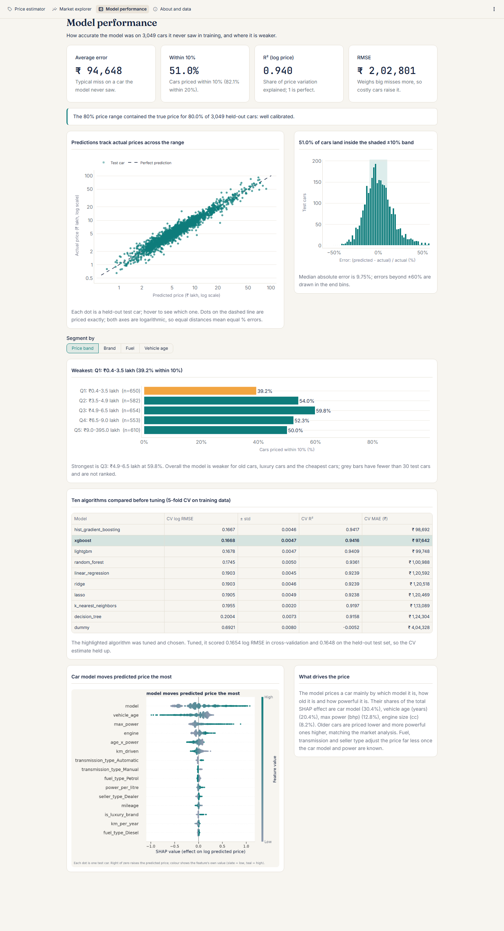
Model performance page.
About and data. The dataset, the cleaning steps (from cleaning_log.csv), how the model works in four sentences, the limitations and the model card.

8.3 User flow and states
A first-time visitor sees an estimate for the most common car immediately, so the page is never blank. They change the brand and model (the specification fills in), adjust age and kilometres, and press the button. If they change an input afterwards, an “Inputs changed” marker shows the result is stale rather than silently re-pricing. Every page has an empty state (for example, filters that match nothing), a loading state and an error state in plain language; Python tracebacks never reach the browser (client.showErrorDetails = "none"). On narrow screens the columns stack into one.
The interface is covered by automated tests (tests/test_app_helpers.py) that load all four pages, change the brand, check the pre-fill, press the button and check that an estimate with its explanation returns within the 2-second budget.

9 Limitations, ethical considerations and future work

9.1 Limitations
The final list of known limitations (D-026, D-042):
- Missing information. The data contain no condition, accident or service history, number of owners, city, colour, trim or variant. These explain most of the remaining error, especially for old and luxury cars.
- Old cars. For cars 9 years or older the model prices only about a third within 10% (33.92% at 9 to 11 years, 32.74% at 12+), against 50.97% overall [segment_errors.csv].
- Luxury and cheapest cars. Cars above ₹ 20 lakh are under-priced by a median 5.76% and the cheapest quintile over-priced by 7.26%; 17 of the 20 largest errors are above ₹ 20 lakh [segment_errors.csv, top_error_patterns.csv].
- Interval calibrated only on average. Coverage is 79.96% overall but 92.45% for cars up to 2 years and 52.38% for 12+ years.
- Rare categories. LPG cars and brands outside the top ten have too few test cars to evaluate reliably; brands absent from training cannot be priced.
- Listing prices, not sale prices, from one platform and one period.
- An unused input. The km_was_capped flag is not a model input (D-024); with 12 affected rows the effect is nil.

9.2 Ethical considerations
- Use as guidance, not as a valuation. An estimate that is wrong by 20% on an old car can cost a private seller a meaningful sum. The GUI therefore always shows the range, adds warnings in words for weak segments, and the About page states the limitations.
- Fairness across brands and segments. The model is most accurate for high-volume, mass-market brands and least accurate for rare brands, old cars and luxury cars. Owners of older, cheaper cars, who may be the least able to absorb a mispricing, receive the least reliable estimates; the cheapest quintile is also over-priced on average, which could mislead buyers of those cars. This is reported openly rather than hidden by removing difficult cars (D-007).
- Data provenance. The CarDekho data are used for academic purposes only. They contain no personal information about sellers.
- Feedback loops. If many sellers priced cars with this model, listing prices would drift towards its estimates and future training data would partly reflect the model itself.

9.3 Future work
- Richer data: trim and variant, condition, accident and ownership history, and city. This is where the largest gains lie.
- Intervals that adapt: conformal or quantile-regression intervals that widen with age and price band, fixing limitation 4.
- Drift monitoring: prices change with fuel prices, new models and the economy. A deployed version should compare live error against the test results and retrain on fresh data with a fresh hold-out set.
- Separate models or weighting for the luxury segment, once more such data are available.
- Deployment behind authentication with logging of predictions, so that real-world accuracy can be measured.

10 Conclusion
The project met its four requirements. The raw data were audited and cleaned by logged, justified rules that removed only 167 duplicate rows. The exploratory analysis established that price is heavily skewed, that power, engine, age and the car model drive it, and that relationships are curved and interacting; it led directly to a log target, measured engineered features and a preference for tree ensembles. Ten algorithms were compared fairly by cross-validation on training data only, the boosters were tuned, and a tuned XGBoost pipeline was chosen by a rule fixed in advance. On a locked test set scored once it achieved an average error of ₹ 94,648, priced 50.97% of cars within 10% and 82.09% within 20%, beat the Ridge baseline by a margin the bootstrap shows is real, and matched its cross-validation estimate, with an 80% range that is well calibrated overall.
The model is fit for its intended purpose as a first-opinion price guide for mainstream cars, and it says so less confidently, in words, where it is weak: old cars, luxury cars, the cheapest cars and rare models. Its main limitation is the data rather than the algorithm, and the most valuable next step would be richer information about each car’s variant and condition.

Appendix A: Decision log summary
The full log with options considered, evidence and how to reverse each choice is in decisions.md.
Decision log summary
Id | Decision
D-001 | Fixed tech stack: Python 3.11, pinned requirements, scikit-learn, XGBoost, LightGBM, Optuna, SHAP, Streamlit
D-002 | Modular repository; raw data read-only
D-003 | Drop 167 exact duplicates; keep same-spec rows with different prices
D-004 | Cap odometer at 5,00,000 km with a flag
D-005 | Recode four “Electric” Camry hybrids to Petrol
D-006 | Impute two zero-seat rows from the brand/model mode
D-007 | Keep genuine luxury cars; evaluate by segment
D-008 | Drop identifier columns; validate schema at every stage
D-009 | Model log1p(price)
D-010 | Feature proposals from the EDA (later measured in D-013)
D-011 | Non-parametric hypothesis tests with effect sizes
D-012 | Stratified 80/20 split on price quintiles, seed 42
D-013 | Keep four engineered features by measured CV gain
D-014 | Target-encode model (better for XGBoost)
D-015 | Group rare brands per fold; brand tiers for reporting only
D-016 | Ten-algorithm shortlist
D-017 | TransformedTargetRegressor around the whole pipeline
D-018 | Optuna TPE, 35 trials per booster, precomputed folds
D-019 | Lowest CV log RMSE wins: tuned XGBoost
D-020 | 80% interval from out-of-fold residual quantiles
D-021 | Phase 4 consistency review and corrections
D-022 | Pre-split steps assessed for leakage
D-023 | Metrics and headline fixed before test scoring
D-024 | km_was_capped not a model input; left unchanged
D-025 | Test set scored once; no post-hoc changes
D-026 | Known limitations from the test evaluation
D-027 | Evaluation implementation choices
D-028 | Resolution of Phase 4 and 5 open questions
D-029 | Prediction input validation rules
D-030 | Strict brand/model consistency
D-031 | Prediction outputs, worked-example rules, timing method
D-032 | GUI page structure and architecture
D-033 | Native TreeSHAP in the app; response time
D-034 | Rare and luxury cars in the UI
D-035 | Design system implementation
D-036 | Dark mode
D-037 | Phase 8 reproducibility audit and build fixes
D-038 | EDA notebook display fix and audit of Phase 1 and 2 figures
D-039 | Number provenance checks and derived-figure table
D-040 | Report export toolchain
D-041 | Final model and why (confirmation)
D-042 | Final list of known limitations
D-043 | Scope not delivered
D-044 | Resolution of the remaining open questions

Appendix B: Repository map
configs/config.yaml every path, seed, threshold, grid and search space
data/raw/ the read-only CarDekho CSV
data/interim/ cars_clean.csv (generated)
data/processed/ train.csv, test.csv (generated), split_indices.json
src/carprice/ the package
config.py typed settings loaded from the YAML
data.py load, validate, audit, clean (Phase 1)
viz.py, palette.py shared plot style and EDA figures (Phase 2)
features.py split, engineered features, ColumnTransformer (Phase 3)
train.py CV benchmark, Optuna tuning, final fit (Phase 4)
evaluate.py, eval_plots.py test metrics, segments, bootstrap, SHAP (Phase 5)
predict.py, insights.py validated predictor, explanations, what-if (Phase 6)
prediction_reports.py Phase 6 output files
formatting.py, market.py rupee formatting; market summaries for the GUI
report_facts.py derived figures for this report (Phase 8)
provenance.py number-to-source checks (Phase 8)
app/ Streamlit app: Home.py, pages/, components/
models/ final_pipeline.joblib (generated), model card, schema
notebooks/ 01 data audit, 02 EDA, 03 model evaluation
reports/figures/, tables/ every figure and table used here
reports/predictions/ test predictions, worked examples, what-if grid
scripts/ screenshots, report export, run comparison
tests/ pytest suite

Appendix C: How to reproduce
From a fresh clone with Python 3.11 (full details and timings in README.md and reports/reproducibility_check.md):
make setup # or: python tasks.py setup (creates .venv, installs requirements)
make all # or: python tasks.py all (clean data, EDA, split, train, evaluate, predict)
make test # or: python tasks.py test
make app # or: python tasks.py app (streamlit run app/Home.py)
make report # or: python tasks.py report (this report to .docx and .pdf)
On Windows without make, the python tasks.py commands do the same. Each step reads its settings from configs/config.yaml and uses seed 42, so the numbers in this report are reproduced; only run times differ between machines.

Appendix D: Source of every number
Every number quoted in this report, in order of first appearance, with the file it was matched to. The table is generated by python -m carprice.provenance reports/final_report.md, and tests/test_provenance.py fails if any number lacks a source or if this table is out of date. Whole numbers up to 12 (list positions, “5-fold”, “Q1”), file names, commands, dates and decision ids are not listed. Each number is matched to a file cited beside it in the text (a table caption counts for its table); file names without a folder are in reports/tables/. A number that could only be matched by searching all files would be marked with an asterisk; the test requires there to be none.
Number | Source | Number | Source
15,411 | cleaning_log.csv | 167 | cleaning_log.csv
18 | report_key_figures.csv | 15,244 | cleaning_log.csv
80 | configs/config.yaml | 20 | test_metrics.csv
3,049 | test_metrics.csv | 0.1654 | models/best_params.json
94,648 | test_metrics.csv | 95 | bootstrap_ci.csv
88,440 | bootstrap_ci.csv | 1,01,444 | bootstrap_ci.csv
50.97 | bootstrap_ci.csv | 82.09 | test_metrics.csv
18.30 | report_key_figures.csv | 79.96 | interval_coverage.csv
42 | configs/config.yaml | 14 | report_key_figures.csv
32 | audit_schema.csv | 120 | audit_schema.csv
29 | audit_numeric_summary.csv | 40,000 | audit_numeric_summary.csv
3.95 | audit_numeric_summary.csv | 5.56 | audit_numeric_summary.csv
99 | audit_numeric_summary.csv | 1,80,000 | audit_numeric_summary.csv
38,00,000 | audit_numeric_summary.csv | 5,00,000 | audit_logical_checks.csv
2,494 | audit_electric_rows.csv | 157.7 | audit_electric_rows.csv
1.084 | audit_duplicates.csv | 2,148 | audit_duplicates.csv
9,539 | audit_categorical_frequencies.csv | 5,699 | audit_categorical_frequencies.csv
79.326 | audit_categorical_frequencies.csv | 44 | audit_categorical_frequencies.csv
13 | audit_categorical_frequencies.csv | 1,00,000 | audit_logical_checks.csv
105 | audit_logical_checks.csv | 30 | audit_logical_checks.csv
175 | audit_logical_checks.csv | 50,000 | audit_logical_checks.csv
3,344 | cleaning_log.csv | 12,195 | models/model_card.json
10.11 | report_key_figures.csv | 0.56 | report_key_figures.csv
5.59 | eda_numeric_summary.csv | 8.25 | eda_numeric_summary.csv
7.75 | eda_numeric_summary.csv | 32.36 | report_key_figures.csv
19.36 | report_key_figures.csv | 51.73 | report_key_figures.csv
79.34 | report_key_figures.csv | 49.59 | report_key_figures.csv
48.16 | report_key_figures.csv | 83.76 | report_key_figures.csv
31 | report_key_figures.csv | 0.72 | eda_spearman_correlation.csv
0.64 | eda_spearman_correlation.csv | 0.76 | eda_pearson_correlation.csv
0.48 | eda_spearman_correlation.csv | 9.39 | eda_depreciation_rates.csv
12.89 | eda_depreciation_rates.csv | 0.17 | eda_spearman_correlation.csv
0.58 | eda_spearman_correlation.csv | 10,50,000 | eda_transmission_medians.csv
2.10 | report_key_figures.csv | 7,00,000 | eda_fuel_medians.csv
4,60,000 | eda_fuel_medians.csv | 1.52 | report_key_figures.csv
5,90,000 | eda_seller_medians.csv | 5,10,000 | eda_seller_medians.csv
1.16 | report_key_figures.csv | 3,00,000 | eda_brand_medians.csv
12,75,000 | eda_brand_medians.csv | 22,87,500 | eda_brand_medians.csv
50,00,000 | eda_brand_medians.csv | 0.81 | eda_pearson_correlation.csv
0.83 | eda_spearman_correlation.csv | 6.41 | eda_vif_summary.csv
4.56 | eda_vif_summary.csv | 1.43 | eda_vif_summary.csv
2.27 | eda_vif_summary.csv | 4,49,500 | eda_hypothesis_tests.csv
3,40,000 | eda_hypothesis_tests.csv | 38 | eda_hypothesis_tests.csv
74 | eda_hypothesis_tests.csv | 0.001 | eda_hypothesis_tests.csv
0.26 | eda_hypothesis_tests.csv | 0.61 | eda_hypothesis_tests.csv
0.18 | eda_hypothesis_tests.csv | 2527.5 | eda_hypothesis_tests.csv
0.32 | eda_hypothesis_tests.csv | 0.0001 | configs/config.yaml
0.202 | feature_checks.csv | 0.2018 | feature_checks.csv
0.0002 | feature_checks.csv | 0.2016 | feature_checks.csv
0.0005 | feature_checks.csv | 0.2025 | feature_checks.csv
0.0004 | feature_checks.csv | 0.2009 | feature_checks.csv
0.0011 | feature_checks.csv | 0.1925 | feature_checks.csv
0.0095 | feature_checks.csv | 0.2021 | feature_checks.csv
0.0 | feature_checks.csv | 0.1903 | feature_checks.csv
0.0117 | feature_checks.csv | 0.1673 | encoder_comparison.csv
0.1895 | encoder_comparison.csv | 0.1667 | cv_results.csv
0.0046 | cv_results.csv | 0.9417 | cv_results.csv
98,692 | cv_results.csv | 0.1668 | cv_results.csv
0.0047 | cv_results.csv | 0.9416 | cv_results.csv
97,642 | cv_results.csv | 0.1678 | cv_results.csv
0.9409 | cv_results.csv | 99,748 | cv_results.csv
0.1745 | cv_results.csv | 0.005 | cv_results.csv
0.9361 | cv_results.csv | 1,00,988 | cv_results.csv
0.0045 | cv_results.csv | 0.9239 | cv_results.csv
1,20,592 | cv_results.csv | 1,20,518 | cv_results.csv
0.1905 | cv_results.csv | 0.0049 | cv_results.csv
0.9238 | cv_results.csv | 1,20,469 | cv_results.csv
0.1955 | cv_results.csv | 0.002 | cv_results.csv
0.9197 | cv_results.csv | 1,13,089 | cv_results.csv
0.2004 | cv_results.csv | 0.0073 | cv_results.csv
0.9158 | cv_results.csv | 1,24,304 | cv_results.csv
0.6921 | cv_results.csv | 0.008 | cv_results.csv
0.0052 | cv_results.csv | 4,04,328 | cv_results.csv
35 | configs/config.yaml | 0.1660 | models/best_params.json
0.9426 | models/model_card.json | 200 | models/model_card.json
0.05 | models/model_card.json | 0.86 | models/model_card.json
0.68 | models/model_card.json | 76.1 | models/model_card.json
13.06 | models/model_card.json | 90 | models/model_card.json
0.1915 | models/model_card.json | 1,000 | bootstrap_ci.csv
1,15,850 | test_metrics.csv | 3,85,255 | test_metrics.csv
2,02,801 | test_metrics.csv | 2,66,575 | test_metrics.csv
8,07,416 | test_metrics.csv | 0.9328 | test_metrics.csv
0.9319 | test_metrics.csv | 0.8839 | test_metrics.csv
0.8824 | test_metrics.csv | 0.0654 | test_metrics.csv
0.1247 | test_metrics.csv | 0.1457 | test_metrics.csv
0.5016 | test_metrics.csv | 0.1648 | test_metrics.csv
0.1881 | test_metrics.csv | 0.6732 | test_metrics.csv
0.9399 | test_metrics.csv | 0.9391 | test_metrics.csv
0.9216 | test_metrics.csv | 0.9206 | test_metrics.csv
0.0036 | test_metrics.csv | 12.7 | test_metrics.csv
14.86 | test_metrics.csv | 53.67 | test_metrics.csv
9.75 | test_metrics.csv | 12.04 | test_metrics.csv
37.08 | test_metrics.csv | 42.93 | test_metrics.csv
14.43 | test_metrics.csv | 75.11 | test_metrics.csv
29.94 | test_metrics.csv | 0.34 | test_metrics.csv
0.65 | test_metrics.csv | 1.08 | test_metrics.csv
12.39 | report_key_figures.csv | 8.04 | report_key_figures.csv
28,252 | bootstrap_ci.csv | 14,851 | bootstrap_ci.csv
75.43 | report_key_figures.csv | 0.1387 | train_vs_test.csv
0.9596 | train_vs_test.csv | 0.36 | train_vs_test.csv
0.0009 | residual_stats.csv | 0.0034 | residual_stats.csv
1.875 | residual_stats.csv | 5.21 | residual_stats.csv
4.55 | residual_stats.csv | 2,438 | interval_coverage.csv
78.5 | interval_coverage.csv | 81.34 | interval_coverage.csv
10.07 | interval_coverage.csv | 9.97 | interval_coverage.csv
38.44 | interval_coverage.csv | 92.45 | segment_errors.csv
52.38 | segment_errors.csv | 168 | segment_errors.csv
32.74 | segment_errors.csv | 18.9 | segment_errors.csv
451 | segment_errors.csv | 33.92 | segment_errors.csv
14.39 | segment_errors.csv | 65.41 | segment_errors.csv
76 | segment_errors.csv | 34.21 | segment_errors.csv
14.94 | segment_errors.csv | 68.42 | segment_errors.csv
0.4 | segment_errors.csv | 3.5 | segment_errors.csv
650 | segment_errors.csv | 39.23 | segment_errors.csv
12.96 | segment_errors.csv | 68.92 | segment_errors.csv
136 | segment_errors.csv | 41.18 | segment_errors.csv
12.18 | segment_errors.csv | 71.32 | segment_errors.csv
61.89 | segment_errors.csv | 7.26 | segment_errors.csv
5.76 | segment_errors.csv | 61.64 | segment_errors.csv
82.35 | segment_errors.csv | 0.66 | top_error_patterns.csv
17 | top_error_patterns.csv | 0.2854 | permutation_importance.csv
0.2788 | permutation_importance.csv | 0.117 | permutation_importance.csv
0.023 | permutation_importance.csv | 0.0148 | permutation_importance.csv
0.0137 | permutation_importance.csv | 2,000 | configs/config.yaml
30.41 | shap_importance.csv | 20.35 | shap_importance.csv
12.78 | shap_importance.csv | 8.16 | shap_importance.csv
6.47 | shap_importance.csv | 5.15 | shap_importance.csv
2.82 | shap_importance.csv | 2,35,000 | reports/predictions/worked_examples.csv
2,63,272 | reports/predictions/worked_examples.csv | 12.03 | reports/predictions/worked_examples.csv
8,11,000 | reports/predictions/worked_examples.csv | 7,18,623 | reports/predictions/worked_examples.csv
11.39 | reports/predictions/worked_examples.csv | 1,20,000 | reports/predictions/worked_examples.csv
1,42,660 | reports/predictions/worked_examples.csv | 18.88 | reports/predictions/worked_examples.csv
29,50,000 | reports/predictions/worked_examples.csv | 33,04,602 | reports/predictions/worked_examples.csv
12.02 | reports/predictions/worked_examples.csv | 3,25,000 | reports/predictions/worked_examples.csv
2,98,398 | reports/predictions/worked_examples.csv | 8.19 | reports/predictions/worked_examples.csv
11,50,000 | reports/predictions/worked_examples.csv | 10,72,861 | reports/predictions/worked_examples.csv
6.71 | reports/predictions/worked_examples.csv | 1,50,000 | reports/predictions/worked_examples.csv
6,20,000 | reports/predictions/worked_examples.csv | 5,20,167 | reports/predictions/worked_examples.csv
16.1 | reports/predictions/worked_examples.csv | 6,00,000 | reports/predictions/worked_examples.csv
6,58,459 | reports/predictions/worked_examples.csv | 9.74 | reports/predictions/worked_examples.csv
1,85,000 | reports/predictions/worked_examples.csv | 1,84,967 | reports/predictions/worked_examples.csv
0.02 | reports/predictions/worked_examples.csv | 8,75,000 | reports/predictions/worked_examples.csv
21,47,143 | reports/predictions/worked_examples.csv | 145.39 | reports/predictions/worked_examples.csv
606 | reports/predictions/worked_examples.csv | 26 | reports/predictions/worked_examples.csv
1,798 | reports/predictions/worked_examples.csv | 189 | reports/predictions/worked_examples.csv
89 | reports/predictions/worked_examples.csv | 10,000 | reports/predictions/whatif_age_km.csv
7,66,034 | reports/predictions/whatif_age_km.csv | 3,12,029 | reports/predictions/whatif_age_km.csv
2.0 | configs/config.yaml | 100 | configs/config.yaml

