Machine Problem 4: Virtual Memory Management and Memory Allocation
Nithin Gowtham Saravanan
UIN: 337001954
CSCE611: Operating Systems

Assigned Tasks
Main: Completed.
Bonus Option 1: Testing of VM pool by disabling the flag _TEST_PAGE_TABLE_
Bonus Option 2: Not applicable.
Bonus Option 3: Not applicable.
Bonus Option 4: Not applicable.

System Design
The objective of this machine problem is to extend the existing kernel paging infrastructure (from MP3) with dynamic page allocation and virtual memory pool management. The design is categorized into 3 parts
- The page table pages (and even page table directories) are allocated in mapped memory, i.e. memory above 4MB in our case. These frames are handled by the process frame pool.
- Prepare the page table to support virtual memory
- To implement a simple virtual-memory allocator

Paging Architecture
The paging system follows a x86-style two-level hierarchy:
- Page Directory (PDE): Points to page tables.
- Page Tables (PTE): Contain mappings of virtual to physical pages.
This project is designed based on Recursive Page Table Lookup (i.e.,) the last entry (1023) of the page directory recursively maps to itself, enabling a self-referential view where both PDEs and PTEs can be accessed via logical addresses without physical translation. This allows quick computation of PDE_address() and PTE_address().

Method of Implementation:
- Contiguous Frame Pool (CFP): Implemented a 2-bit/entry bitmap (Free, Used, Head-of-Sequence) to support contiguous frame allocation and release; maintained a static list of pools for release_frames() lookup.
- Metadata Placement: Stored the CFP bitmap inside a designated info frame (or pool’s first frame if _info_frame_no==0) and marked it HoS/Used; computed info size via needed_info_frames() (2 bits/frame).
- Physical Layout Setup: Created two pools in kernel.C: Kernel pool (2 MB at 2 MB) and Process pool (28 MB at 4 MB). Marked the 15–16 MB hole as inaccessible in the process pool.
- Paging Init (PageTable::init_paging): Registered kernel/process pools and shared region size (4 MB). Deferred enabling until PD/PTs exist.
- Page Directory & Recursive Mapping: Allocated a PD frame (process pool), zeroed it, set PDE[1023] to point to the PD itself (recursive trick). Built identity-mapped PT(s) for the 4 MB shared region.
- Address Translation Helpers: Implemented PDE_address(addr) and PTE_address(addr) using the recursive windows (0xFFFFF000 and 0xFFC00000) to get pointers to PDE/PTE in VA space.
- Page Fault Handling: On fault, if VM pools are registered, validate the VA with VMPool::is_legitimate. Created a PT on demand if PDE is not present; then allocated a data frame and installed the PTE; flushed TLB for that VA.
- Virtual Memory Pools (VMPool): Added first-fit sub allocator over a [base, size] VA range, tracking free/allocated regions (page granularity). allocate() returns a VA; first touch faults and maps frames. release() frees all pages in the region via PageTable::free_page.
- Validation Modes (via _TEST_PAGE_TABLE_):
- Defined: Demand-page writes at VA 4 MB; expect PT creation + 2 data pages, readback verifies.
- Undefined: Create Code/Heap pools; new[] uses VMPool; touches fault-map pages; delete[] releases pages; both pools pass integrity checks.

Code Description
This implementation modifies the following files:
- cont_frame_pool.C
- page_table.H
- page_table.C
- vm_pool.H
- vm_pool.C
- kernel.C

cont_frame_pool.C
The same file used for MP2, and MP3 is used with little modifications to improve the implementation of memory manager.
- Updated the constructor to correctly handle both cases where the bitmap frame lies within the pool (_info_frame_no inside range) or outside it (_info_frame_no == 0). This ensures that only the valid metadata frame is marked HoS and reduces accidental marking of unrelated frames.
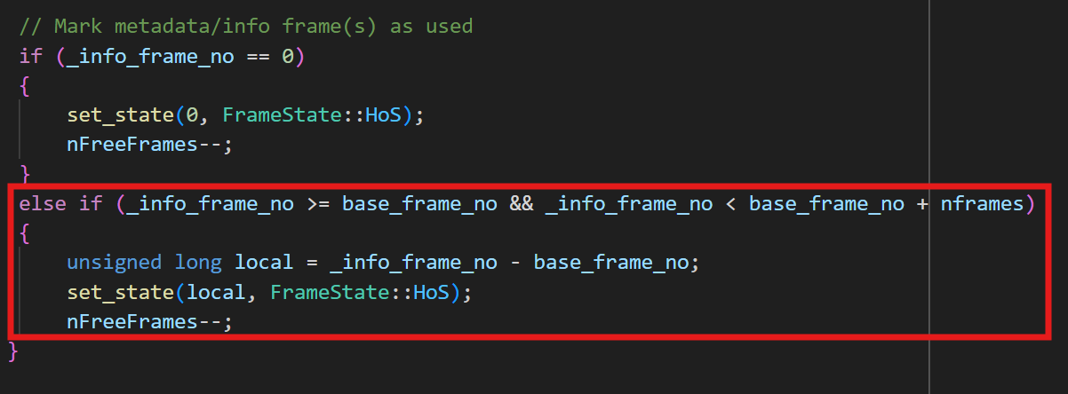
- Replaced hard assertions in get_frames() with safe return-based error handling for invalid or insufficient allocations, preventing kernel crashes during transient memory fragmentation or low-memory conditions.
- Refined mark_inaccessible() to decrement nFreeFrames only when a frame transitions from Free to Used/HoS, eliminating double decrements and keeping pool statistics accurate across overlapping metadata and hole markings.
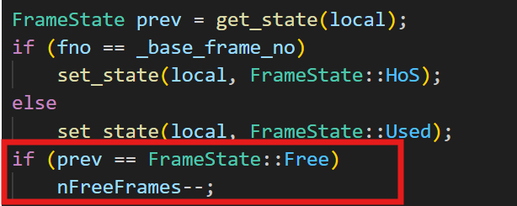

page_table.H
- Introduced a pointer “vm_pools_head” to point to the head of linked list of registered VMPools
- Function prototypes for recursive lookup helpers PDE_address and PTE_address
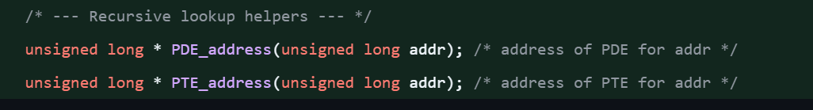

page_table.C
- Recursive Mapping Setup - Added constants RECURSIVE_PDE_BASE and RECURSIVE_PTE_BASE to enable direct logical access to all PDEs and PTEs using the recursive mapping trick (PDE[1023] → PD).
→ Simplifies updates and avoids unsafe physical dereferences.
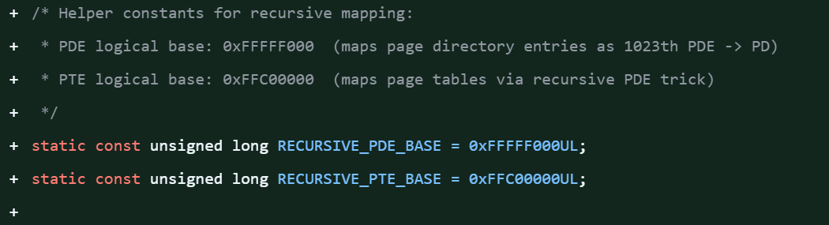
- init_paging() - Initializes paging globals (kernel_mem_pool, process_mem_pool, shared_size), separating kernel and process pools.
→ Provides a consistent setup before any PageTable is created or paging enabled.
- PDE_address() / PTE_address() - New helper functions returning logical pointers to a page’s PDE or PTE via the recursive window.
→ Enables safe and fast manipulation of page-table entries.
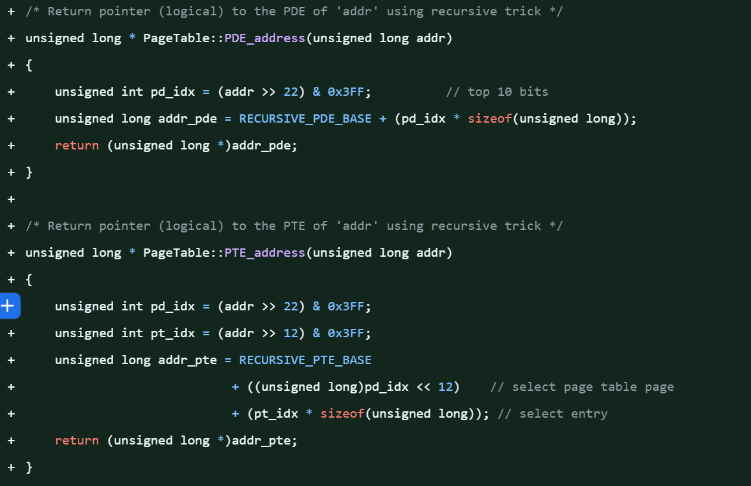
- PageTable() Constructor - Now allocates all page-directory and table frames from the process memory pool (not kernel).
Builds identity-mapped tables for the shared 4 MB region and sets up recursive mapping (PDE[1023] = PD).
→ Ensures proper memory ownership and enables recursive lookups.

- handle_fault() - Rewritten to support both test modes:
- Page-table test: demand-pages directly.
- VMPool test validates faults only for legitimate allocated regions.
Dynamically allocates missing PTs and data frames from the process pool, zeroes via recursive mapping, and flushes TLB selectively.
→ Enables clean demand paging and safe region enforcement.
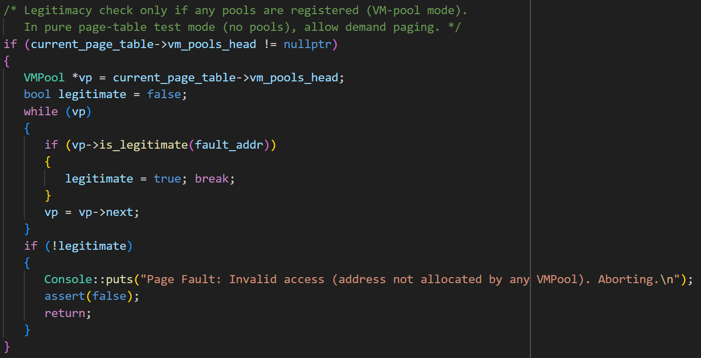
- register_pool() - Implements a linked list of registered VMPools for address-legitimacy checks in handle_fault().
→ Allows PageTable to differentiate valid from invalid page faults.
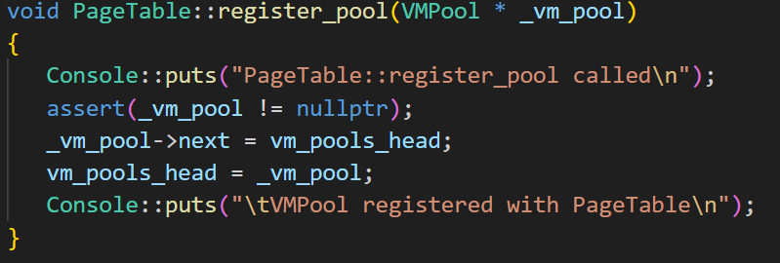
- free_page()
Frees a physical frame mapped to a given virtual page and clears its PTE with invlpg.
→ Supports VMPool’s release logic and keeps memory consistent.
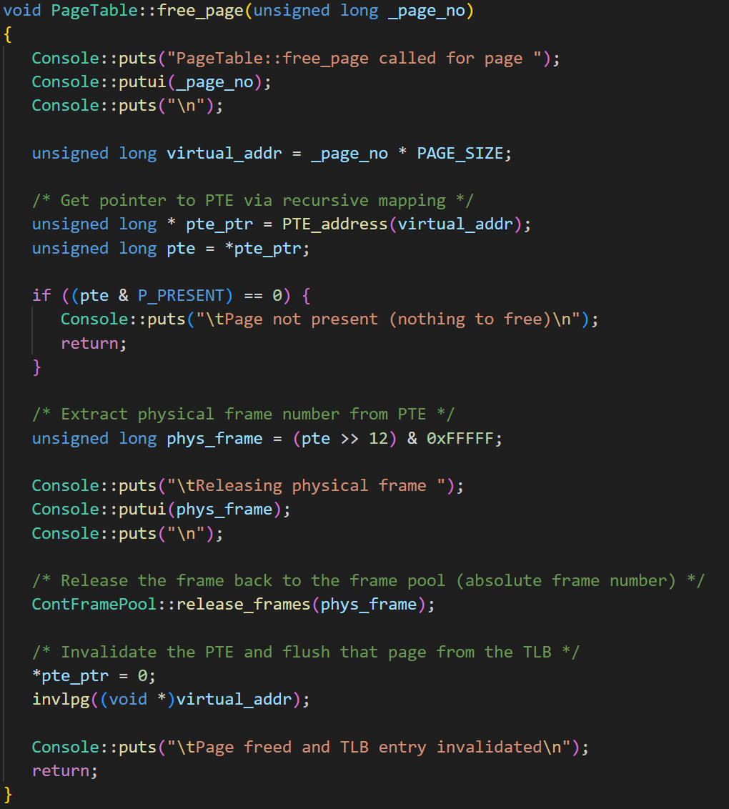
- Frame Pool Policy Update
All PD/PT/data allocations now draw from the process frame pool to maintain kernel–process separation and adhere to MP4 specs.
→ Aligns paging with assignment design and ensures isolation.

vm_pool.H
- The allocated_regions and free_regions arrays (with Region structs) provide a simple bookkeeping mechanism to manage memory allocation within each virtual memory pool — tracking which pages are in use and which remain available.
- Each VMPool maintains its own base_address, size_bytes, and frame_pool, ensuring isolation between different virtual memory regions (e.g., code, heap) and mapping them independently through their associated PageTable.
- Storing regions in pages (base_page, length) simplifies operations such as allocation, release, and legitimacy checks, aligning directly with paging granularity.
- The next pointer allows VMPool objects to be registered as a linked list within PageTable, enabling the fault handler to validate whether a faulting address belongs to a legitimate allocated region.
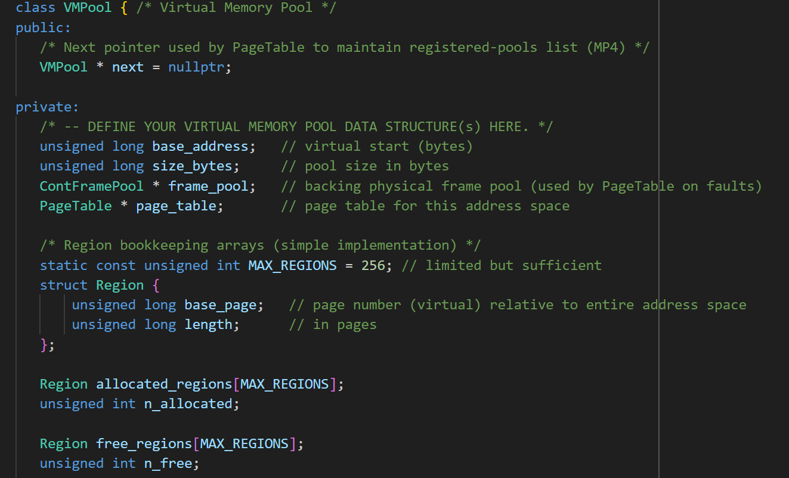

vm_pool.C

VMPool::VMPool()
- This constructor initializes the virtual memory pool by defining its base virtual address and total size in bytes, linking it to a specific frame pool and page table.
- It divides the address space into page-sized units, marks the entire pool as initially free, and inserts the pool into the page table’s registry (register_pool) so that page faults can be validated against legitimate address ranges.
- Console messages provide initialization feedback, including base address, size, and total pages.
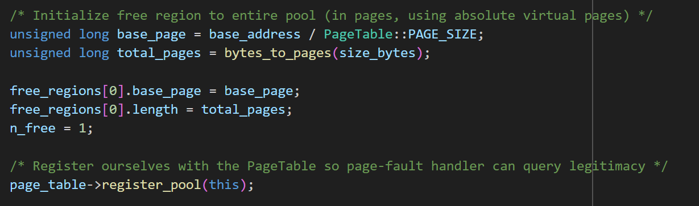

VMPool::allocate()
- This function implements a first-fit allocation policy to locate the first available free region large enough to satisfy the request.
- It converts the requested byte size to the number of required pages, updates the free and allocated region lists, and returns the starting virtual address of the allocated block.
- If no contiguous free region can satisfy the request, the function logs a failure and returns 0.
- This operation does not immediately map physical frames — pages are mapped lazily upon page faults handled by the PageTable.
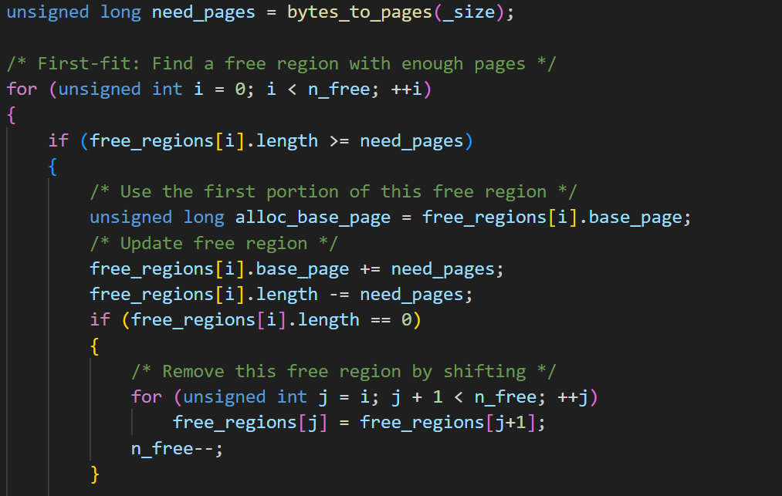
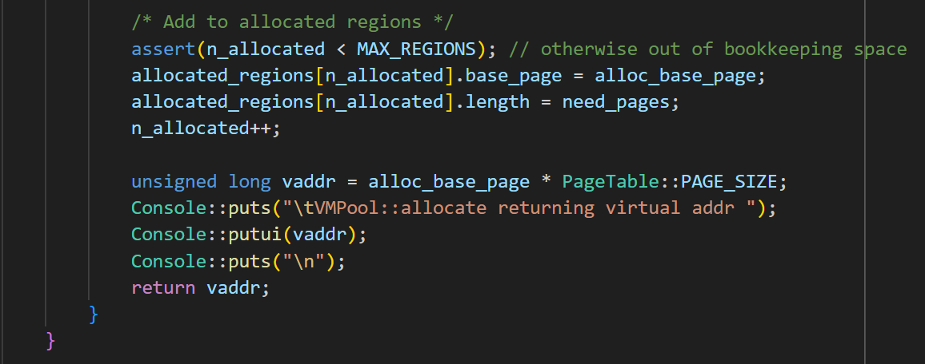

VMPool::release()
- The release() function deallocates a previously allocated memory region identified by its starting address.
- It first locates the corresponding region in the allocated_regions list, then iterates over all its pages and calls PageTable::free_page() for each to release the associated physical frames.
- Once all pages are freed, the region metadata is moved back into the free_regions list (without coalescing adjacent blocks for simplicity).
- This ensures both the page table and virtual memory bookkeeping remain consistent.
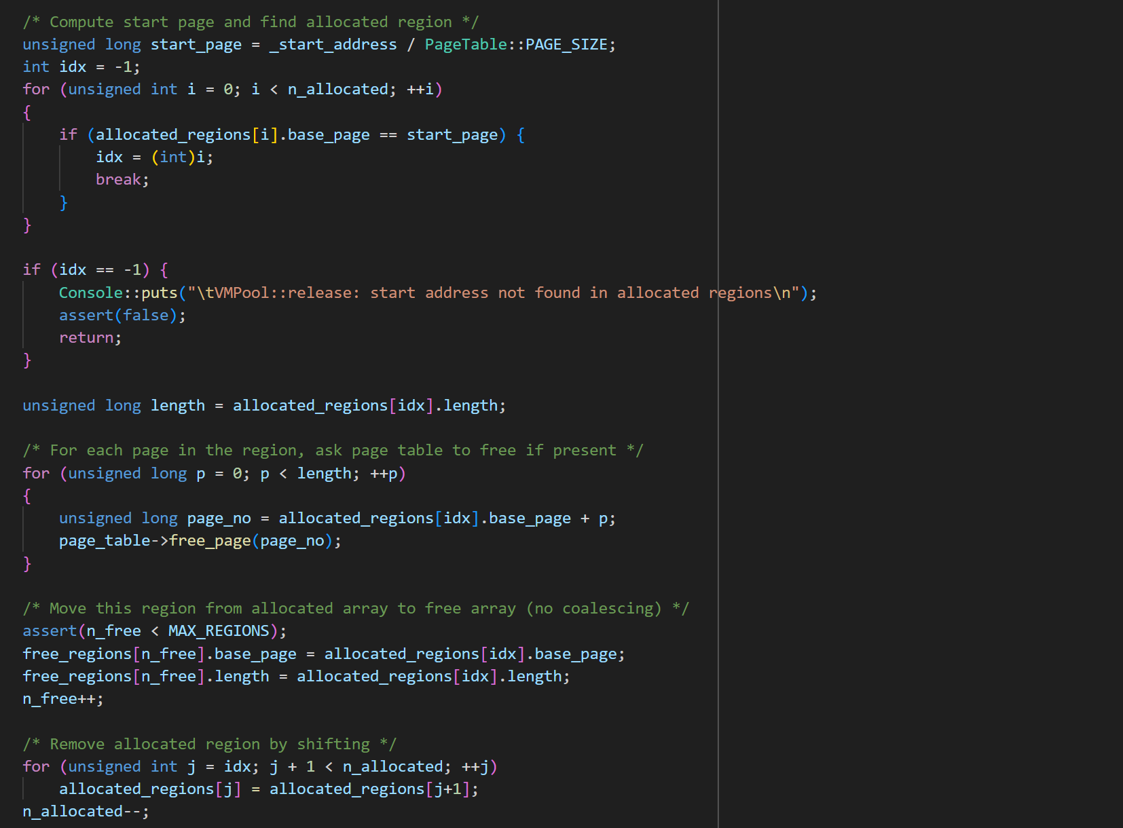
VMPool::is_legitimate()
- Checks whether a given virtual address falls within a currently allocated region of the pool.
- It iterates through all active regions in allocated_regions and returns true if the address lies between the region’s start and end pages.
- This function is crucial for the page fault handler — it prevents illegal memory access by ensuring only addresses belonging to legitimate allocated regions are serviced.
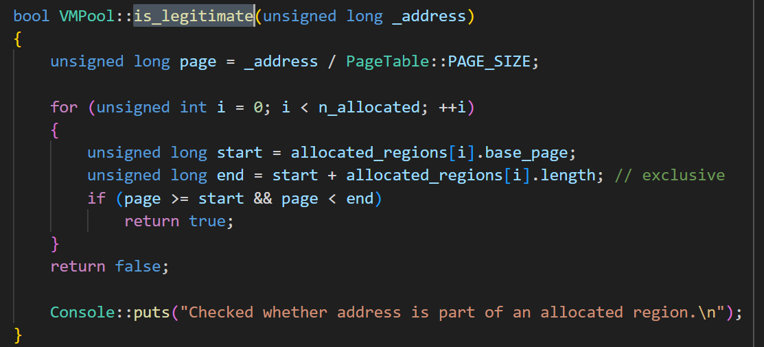

kernel.C
The flag “_TEST_PAGE_TABLE_” has been enabled and disabled to test the scenarios of just the page table and just the virtual memory pool respectively.
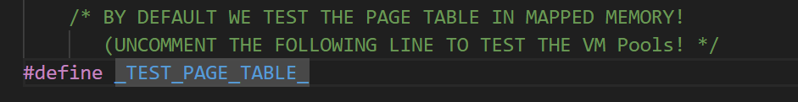

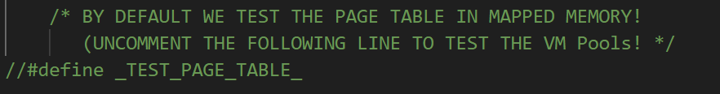

Bonus Option 1:
Testing of VM pool by disabling the flag _TEST_PAGE_TABLE_
To test the VM pool, disable the flag “_TEST_PAGE_TABLE_” and the log report is stored in kernel_log_vm_pool.txt by executing the command
make run > kernel_log_vm_pool.txt 2>&1

TESTING

Scenario 1: _TEST_PAGE_TABLE_ is enabled to test the page table
- Shows paging initialization, creation of the kernel and process frame pools, page directory + table allocation, and activation of paging.
- A single page fault sequence occurs: the page fault handler detects a missing table, allocates it, and maps one data frame from the frame pool.
- The run ends with “Test Passed! Congratulations!” — confirming that page-table construction, page-fault handling, and frame mapping are correct.

This validates that ContFramePool and PageTable operate correctly without the VM-pool layer: frame allocation, PTE setup, and TLB invalidation all behave exactly as required in the handout.
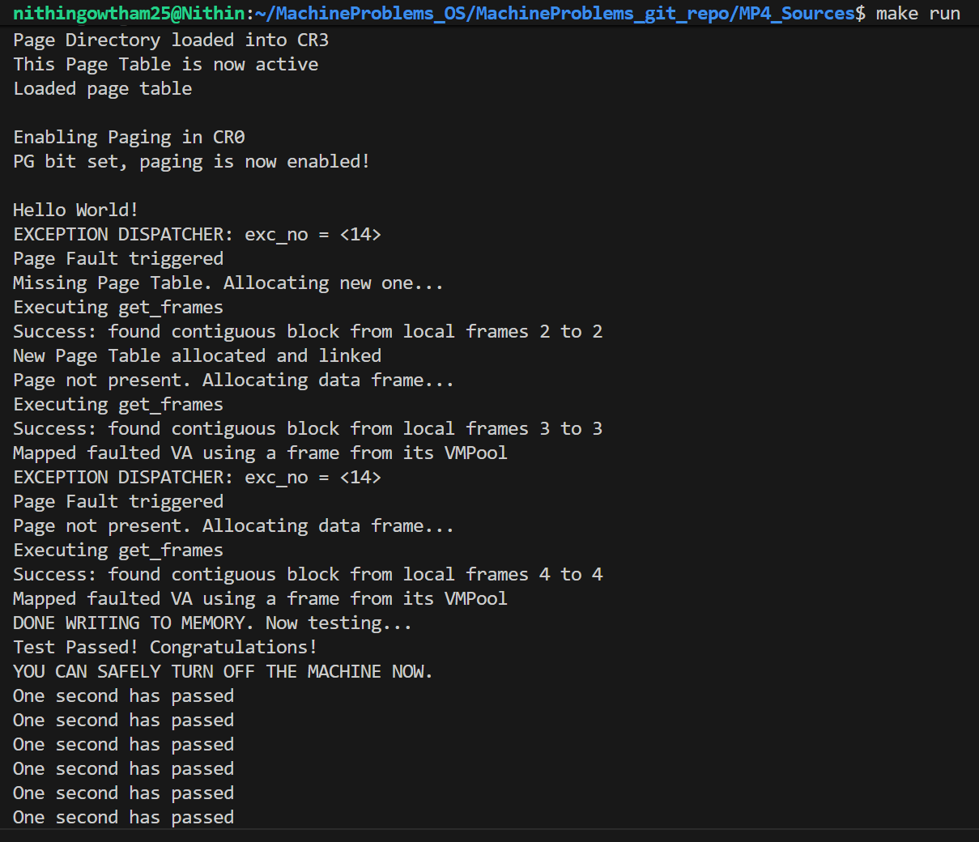
The complete log is available in kernel_log_page_table.txt

Scenario 2: _TEST_PAGE_TABLE_ is disabled to test the virtual memory pool

- Setup & Registration - After paging is enabled and the shared region is identity-mapped, two VMPools are constructed (e.g., code @ 512 MB, heap @ 1 GB). Each pool registers with the PageTable via register_pool, enabling the page-fault handler to validate accesses with is_legitimate.
- Allocation Pattern (First-Fit, Page-Granular) - The test harness repeatedly calls VMPool::allocate(size_in_bytes) with increasing sizes. The pool converts bytes → pages and carves the first sufficiently large free region, returning the starting virtual address (VA). No frames are grabbed here—mapping is lazy.
- Demand Paging on First Touch
Writes to the returned VA trigger page faults:
- If the PDE is missing, the handler allocates a new page table (from the process pool), links it, flushes CR3, and zeroes the PT page via the recursive mapping window.
- For each faulted page, the handler allocates a data frame (process pool), writes the PTE (present | RW), and invlpg the VA.
- Logs show the sequence: “Page Fault triggered → Missing PT (once per new 4 MB region) → Page not present → Mapped faulted VA”.
- Legitimacy Enforcement - Before mapping, the handler walks the VMPool list; is_legitimate(fault_addr) must return true (address ∈ an allocated region). This prevents accidental/illegal mapping outside pool allocations. In Scenario 2 the check must pass for all accesses; otherwise the handler aborts.
- Data Integrity Check - For each allocated block, the test writes deterministic values and reads them back in reverse to validate correctness of mappings across multiple pages and tables. Success here confirms the end-to-end path: VA allocation → fault → PT/PT entry creation → physical frame mapping → usable memory.
- Release & Frame Reclamation - The test then calls VMPool::release(start_va). For every page in the region, PageTable::free_page clears the PTE, calls ContFramePool::release_frames on the physical frame (HoS + trailing Used frames), and invlpgs the VA. Log shows “Freeing HoS/Used… → Page freed and TLB entry invalidated”, confirming frames return to the pool(s).
- Allocator Behavior & Limits Observed - The pool uses first-fit and no coalescing of free regions (intentionally simple). Despite fragmentation risk, the scripted pattern (allocate → touch → verify → release) repeatedly succeeds, demonstrating correct bookkeeping (allocated_regions / free_regions) and stable interaction with the page-table and frame-pool layers.
These steps together validate that, under VM-Pool mode, allocations are legitimate, demand-paged correctly, memory reads/writes are consistent, and resources are fully reclaimed.

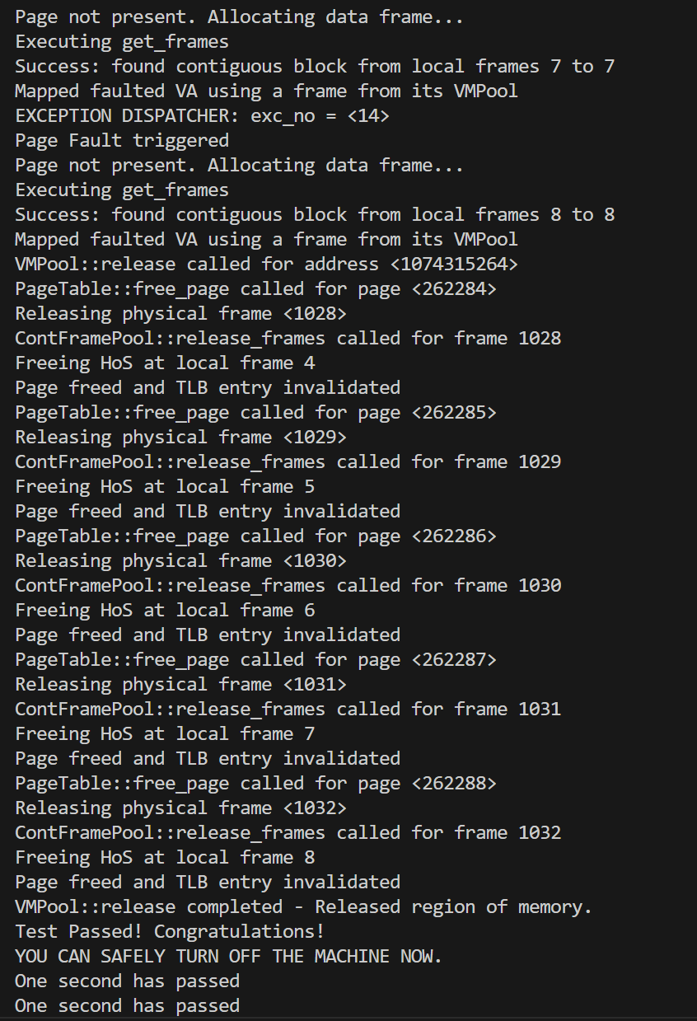

Since multiple commands are used for the purpose of debugging, the screenshot of the last few messages is enclosed to ensure the proper working of virtual memory pool.

The complete log for this test scenario is available in kernel_log_vm_pool.txt

