AGRIGUIDEAI
A Multilingual AI-Based Farmer Advisory Assistant
Using Evidence-Grounded Retrieval

PROJECT TECHNICAL REPORT

Submitted by: Nithin H
Project: AgriGuideAI
Academic Year: 2026–2027
November 2026

REPORT STRUCTURE MAPPED TO THE ASSESSMENT RUBRIC
Assessment criterion | Report coverage
Problem definition & relevance | Chapter 1
Model / dataset selection | Chapter 2
Working end-to-end application | Chapter 4 and Figures 1–7
GenAI / RAG / agentic integration | Chapter 3
Quantitative testing & error analysis | Chapter 5
Demo, documentation & repository | Chapter 6

ABSTRACT
Agriculture is an important part of India's economy, and farmers need accessible information about crop production, irrigation, fertilizers and agricultural practices. Relevant guidance is often distributed across lengthy technical documents, while language differences can make it difficult to locate and understand the information.
AgriGuideAI is a multilingual agricultural information assistant that supports questions in English, Hindi and Kannada. It retrieves evidence from curated agricultural documents using multilingual text embeddings, FAISS vector search and BM25 keyword retrieval. AI4Bharat IndicTrans2 translates Hindi and Kannada questions into English for retrieval and translates extracted evidence back into the selected language. Responses include source details, page references and quoted passages. When sufficient evidence is unavailable, the system can abstain rather than provide a guessed recommendation.
The application was evaluated using 48 representative test cases, 16 in each supported language. The final post-remediation evaluation achieved 38 strict passes out of 48 (79.2%). English achieved 100%, while Hindi and Kannada each achieved 68.8%. The system is an extractive, evidence-grounded RAG implementation; it does not generate new agricultural advice using a generative language model. BharatGen AgriParam was explored but was not integrated into the final application.
Keywords: Agriculture, multilingual AI, RAG, IndicTrans2, FAISS, BM25, evidence retrieval, Streamlit.

CHAPTER 1 – PROBLEM DEFINITION AND RELEVANCE

1.1 Background
Farmers need dependable information on crop varieties, sowing practices, irrigation schedules, fertilizer use and crop protection. Government and agricultural institutions publish such information in manuals and technical guides. Finding a specific answer in a long PDF can be time-consuming, and language barriers can make technical information less accessible. AgriGuideAI addresses this information-access problem through a conversational interface over a curated set of agricultural documents.

1.2 Problem statement
There is a need for a simple multilingual interface that helps users locate relevant information in curated agricultural documents without presenting unsupported statements as verified advice. The system must support regional-language questions, retrieve relevant evidence, expose its sources and abstain when the available knowledge base does not contain adequate supporting information.

1.3 Objectives
- Develop a usable web application for agricultural information retrieval.
- Support English, Hindi and Kannada queries.
- Index curated agricultural documents and retrieve relevant passages.
- Combine semantic vector retrieval with keyword-based retrieval.
- Integrate IndicTrans2 for English, Hindi and Kannada translation through an English pivot.
- Display extracted evidence with document and page-level citations.
- Abstain when sufficient evidence is not available.
- Evaluate the application quantitatively and analyse failure cases.

1.4 Relevance and intended users
The project is relevant to farmers, students and other users who need to search agricultural guidance in a familiar language. It is an information-access assistant, not a substitute for agricultural officers, qualified experts or region-specific advice. Important decisions should be checked against cited sources and local expert guidance.

CHAPTER 2 – MODEL AND DATASET SELECTION

2.1 Agricultural document collection
The current indexed knowledge base uses three agricultural PDF sources:
- Crop Production Guide – Agriculture (2020).
- Crop Production Guide – Horticulture Crops (2020).
- Crop-Specific SOP for Drone Pesticide Application (2023).
The PDFs are processed to extract text and page metadata. Content is divided into smaller passages while retaining source and page provenance. The processed index contains approximately 977 chunks.

2.2 Models and technologies
Component | Selection | Role
Programming language | Python 3.10.11 | Application and retrieval pipeline.
User interface | Streamlit | Web interaction and evidence display.
Embedding model | intfloat/multilingual-e5-small | Multilingual vector representations.
Vector search | FAISS | Semantic similarity search.
Keyword retrieval | BM25 | Lexical term relevance.
Ranking fusion | Weighted Reciprocal Rank Fusion | Combines dense and keyword rankings.
Translation | AI4Bharat IndicTrans2 | Hindi/Kannada ↔ English translation.
Testing | Pytest | Automated and regression testing.

2.3 Why hybrid retrieval was selected
Dense retrieval can identify semantically related passages even when wording differs. BM25 complements it by matching important terms, crop names and technical expressions. The two rankings are combined using weighted Reciprocal Rank Fusion so the system does not depend only on semantic similarity or exact keyword overlap.

2.4 Multilingual processing
English questions are processed directly. Hindi and Kannada questions are translated into English before retrieval; the extracted English evidence is translated back into the selected language. The interface also presents the original English evidence so users can inspect the source wording. The interface discloses that machine translation may contain errors.

2.5 BharatGen AgriParam exploration
BharatGen AgriParam was investigated because it was explicitly identified in the project requirements. It was not integrated into the final application because the diagnostic work raised concerns about answer reliability as well as deployment feasibility. In tested examples, its outputs included incorrect agricultural information relating to soybean fertilizer, sorghum irrigation and finger-millet spacing or seed-rate guidance. For an agricultural information assistant, unreliable recommendations are a more important concern than simply achieving a technically successful model load.
The available development laptop has an NVIDIA RTX 3050 with 4 GB of VRAM. AgriParam contains approximately 2.86 billion parameters; its full-precision weights alone require roughly 11.44 GB, before additional memory needed for runtime, activations and context. Limited CPU diagnostics were possible, but generation with a real RAG context took approximately 226–443 seconds, which was not suitable for a responsive classroom demonstration.
Compatibility issues were also encountered between the model's custom tokenizer/model implementation and the attempted software runtime. Compatibility with the production application's Transformers 5.20.2 environment was not established. Therefore, it would have been misleading to claim a verified integration. AgriParam was explored and deliberately excluded from the final running system; the final application uses retrieval and extractive evidence presentation instead. This remains an unmet model-integration requirement and may affect the model/dataset-selection and GenAI-integration assessment criteria.

CHAPTER 3 – GENAI / RAG INTEGRATION AND SYSTEM ARCHITECTURE

3.1 Architecture overview
AgriGuideAI implements a retrieval-augmented workflow: it retrieves relevant evidence from a curated document collection and uses that evidence as the basis for the displayed response. The answer stage is extractive rather than generative.
Stage | Operation
1. User input | Select English, Hindi or Kannada and submit an agricultural question.
2. Language processing | English continues directly; Hindi/Kannada is translated into English using IndicTrans2.
3. Retrieval | BM25 keyword retrieval and multilingual-E5/FAISS dense retrieval search indexed passages.
4. Ranking | Weighted Reciprocal Rank Fusion combines retrieval rankings.
5. Evidence checks | Relevance, context and phrase checks filter unsuitable passages; the pipeline can abstain.
6. Extractive response | Relevant text is selected from retrieved source passages; new advice is not freely generated.
7. Translation | For Hindi/Kannada, extracted evidence is translated into the selected language.
8. Presentation | The UI displays the response, translation caveat, original English evidence and page-level sources.

3.2 Document ingestion and indexing
PDF content is extracted, split into chunks and stored with metadata such as source document and page. The multilingual embedding model creates vector representations for the chunks. FAISS stores these vectors for similarity search, while BM25 supports lexical retrieval.

3.3 Retrieval and evidence handling
At query time, the application searches using both dense and keyword retrieval. The combined ranking passes through relevance and context checks. The pipeline includes protections against unsuitable passages and supports abstention when evidence is insufficient. Citation display is tied to retrieved document metadata.

3.4 RAG versus generative answer generation
Although the application follows a RAG-style retrieve-and-ground workflow, the current response stage is extractive. The UI explicitly states that the answer is quoted from retrieved source text and is not LLM-generated. Therefore, the project should be described as an evidence-grounded multilingual RAG retrieval application, not as a system that generates novel agricultural advice or uses an agentic workflow. No agentic planning or tool-using agent is claimed.

3.5 Abstention behaviour
When the knowledge base does not contain adequate evidence, the application displays an insufficient-evidence response. It explains that no recommendation is being guessed and suggests consulting a qualified agricultural expert or local Krishi Vigyan Kendra for crop-, soil- and region-specific guidance.

CHAPTER 4 – WORKING END-TO-END APPLICATION

4.1 User interface and visual design
The Streamlit interface uses an AI-generated agricultural landscape background and translucent light-coloured content panels. It presents the AgriGuideAI identity, language selector, question area, conversation messages, answer cards and source citations. The design keeps the background visible while maintaining readable foreground panels.

4.2 English query and evidence response
The English example asks whether pesticide should be sprayed using a drone when heavy rain is forecast in the next one to two days. The displayed extract says not to spray if heavy rain is forecast in the next one to two days. The answer card identifies the response as extracted evidence and cites the Crop-Specific SOP for the Application of Pesticides with Drones, page 18.

4.3 Unsupported question and abstention
The screenshot shows an unrelated question, “what is your name?”. The system returns an insufficient-evidence status and explains that the knowledge base does not contain enough evidence to answer reliably. It does not invent an answer.

4.4 Hindi interaction
The Hindi example asks about pesticide spraying when heavy rain is forecast. The interface marks the response as machine-translated using IndicTrans2, shows the Hindi translation, provides an English interpretation of the question and retains the original English evidence and source information. The interface warns that automatic translation may contain errors.

4.5 Kannada interaction
The Kannada example asks about finger millet (ragi) seed rate and row spacing. The answer card displays the Kannada translation and original English evidence. The visible source excerpt states row spacing of 22.5–30 cm and a recommended seed rate of 10 kg/ha, with thinning within the row to 7.5–10 cm between plants. The cited source is Crop Production Guide – Agriculture 2020, page 111. The displayed Kannada output also illustrates a remaining translation placeholder artefact; translated technical details should be checked against the original English evidence.

4.6 End-to-end workflow summary
The screenshots demonstrate language selection, question submission, evidence retrieval, answer display, source inspection, Hindi/Kannada translation and abstention for an unsupported question. The screenshots were captured from the running local application at 127.0.0.1:8502.

CHAPTER 5 – QUANTITATIVE TESTING AND ERROR ANALYSIS

5.1 Evaluation dataset
The evaluation dataset contains 48 representative questions: 16 English, 16 Hindi and 16 Kannada. It includes answerable and unanswerable questions covering crop production, irrigation, fertilizer and horticulture. The dataset was used during development and remediation; therefore, the final score is not an independent held-out test.
Language | Cases | Strict passes | Strict accuracy
English | 16 | 16 | 100.0%
Hindi | 16 | 11 | 68.8%
Kannada | 16 | 11 | 68.8%
Overall | 48 | 38 | 79.2%

5.2 Additional evaluation measures
Measure | Result | Interpretation
Behaviour accuracy | 44/48 | Correct expected answer/abstention behaviour.
Unsupported questions correctly abstained | 12/12 | All unsupported test cases were correctly abstained.
Unsupported false answers | 0 | No unsupported false answer in final evaluation.
Full required-point coverage | 26/36 | Answerable cases satisfying all required content points.
Exact citation cases | 27/32 | Answered cases with exact expected citation matches.

5.3 Baseline comparison
The baseline strict accuracy was 17/48 (35.4%). After remediation, the final result was 38/48 (79.2%), an increase of 43.8 percentage points on the same development-used dataset. This demonstrates improvement on the project's evaluation set, but it is not an independent generalisation result.

5.4 Automated and browser testing
The automated test suite completed with 288 passing tests in the reported final run. Tests covered retrieval behaviour, multilingual processing, evaluation scoring, regression cases and application behaviour. The UI redesign was also checked through browser-based English, Hindi, Kannada and abstention flows, with no reported Streamlit exceptions or browser console errors during that test session.

5.5 Failure analysis
- Strict accuracy was lower for Hindi and Kannada than English, indicating that translation and multilingual retrieval remain weaker parts of the pipeline.
- Some translated crop or irrigation terms changed meaning, affecting retrieval or causing safe abstention.
- Some cases retrieved related passages that did not match the expected source page or required answer points.
- Some answerable Hindi and Kannada questions were incorrectly abstained on.
- Occasional Kannada output contained visible <ID>-style placeholder artefacts.
- Some strict-passing translated responses did not preserve all identifiers, units or variety names; the evaluation matching method does not fully capture every translated-fidelity issue.

5.6 Evaluation limitations and validity
The 48-question dataset was used during development and remediation, so the final score is a post-remediation measurement on a development-used dataset, not a blind independent test. Hindi/Kannada answer scoring is partly performed on the English-side answer, so the strict score does not fully measure translated-text quality. Manual review of Hindi and Kannada question wording was completed, but native-speaker validation has not been established. These limitations should accompany the numerical results.

CHAPTER 6 – DEMO, DOCUMENTATION AND REPOSITORY

6.1 Demonstration sequence
- Open the Streamlit application at http://127.0.0.1:8502.
- Show the landing page and English/Hindi/Kannada language selector.
- Submit an English agricultural question and explain the extracted evidence and page-level citation.
- Open the quoted source passage and show how the user can inspect the original evidence.
- Switch to Hindi and demonstrate the translated answer and original English evidence.
- Switch to Kannada and demonstrate the translated answer and citation.
- Submit an unsupported question and demonstrate the insufficient-evidence abstention.

6.2 Repository organisation
The following describes the project’s logical directory structure. It does not imply that every local data file is included in the public repository. In particular, raw source PDFs, generated indexes, model caches, secrets and local evaluation outputs may be excluded by .gitignore.
Path | Purpose / publication note
app/ | Streamlit application and user interface.
src/ | Retrieval, RAG pipeline and multilingual processing modules.
data/raw/ | Local source agricultural PDF documents; verify redistribution rights before publishing.
data/processed/ | Locally generated chunks, metadata and FAISS index; may need to be generated during setup.
evaluation/ | 48-case dataset, evaluation scripts and reports, subject to the repository's tracked-file selection.
tests/ | Automated and regression tests.
artifacts/ | Supporting reports, screenshots and test evidence; only selected files are tracked.

6.3 Running the application
From PowerShell, change to the directory where the repository was cloned, activate or use the project's configured virtual environment, and run:
cd <path-to-cloned-repository>
.\.venv\Scripts\python.exe -m streamlit run app\streamlit_app.py --server.address 127.0.0.1 --server.port 8502 --server.headless true --server.fileWatcherType none
Then open http://127.0.0.1:8502 in a browser. Keep the terminal open while using the application. Press Ctrl+C in the terminal to stop the server.

6.4 Repository and submission checklist
- Confirm README includes project overview, features, architecture and setup instructions.
- Confirm requirements and environment setup instructions are current.
- Ensure secrets, access tokens and local environment files are not committed.
- Include the evaluation report and methodology with the development-set caveat.
- Include final UI screenshots and this technical report.
- Verify the repository can be understood and run by another person using the documented setup.
- Before submission, verify that the intended files have actually been committed and pushed; this report does not claim that a final commit or push has been made.

CHAPTER 7 – LIMITATIONS AND FUTURE SCOPE

7.1 Current limitations

7.1.1 Reason for not integrating BharatGen AgriParam
The primary reason for excluding AgriParam was the reliability of the diagnostic agricultural answers: some tested outputs contained incorrect crop-related recommendations. For an agricultural assistant, a fast but incorrect answer would be unacceptable. The hardware and runtime constraints reinforced this decision. The available laptop has 4 GB of GPU VRAM, while the model's full-precision weights alone require approximately 11.44 GB; CPU generation with a real RAG context took approximately 226–443 seconds.
The attempted integration also encountered compatibility issues involving the model's custom tokenizer/model implementation. Compatibility with the production Transformers 5.20.2 environment was not established. These findings describe the tested development setup and do not establish that AgriParam is unsuitable on all hardware or software environments. A future attempt would require a verified compatible runtime, suitable compute resources and a fresh domain-specific evaluation before deployment.
- BharatGen AgriParam is not integrated; the reasons and measured constraints are explained above.
- The response stage is extractive and is not an LLM-generated answer.
- Hindi and Kannada accuracy is lower than English.
- Some Kannada translation placeholder artefacts remain.
- The first Indic-language query can be slower because the translation worker loads on demand.
- The current knowledge base does not provide location-specific recommendations.
- There is no dedicated fertilizer/pesticide dose-safety validation layer.
- The evaluation set is development-used and has not been independently held out.
- Interface labels are primarily in English.

7.2 Future scope
- Evaluate with an independent, unseen multilingual agricultural test set.
- Obtain native-speaker review of Hindi and Kannada translations and responses.
- Improve translation fidelity for crop names, units, identifiers and technical terms.
- Expand the curated document collection with additional verified agricultural sources.
- Introduce location- and crop-stage-aware retrieval where authoritative data is available.
- Add a dedicated safety and validation layer for fertilizer and pesticide recommendations.
- Explore a suitable domain-specific language model when hardware and licensing constraints permit.
- Improve regional-language interface labels and consider voice-based access.

CONCLUSION
AgriGuideAI provides a working multilingual interface for retrieving agricultural information from a curated document collection. It combines multilingual embeddings, FAISS vector search, BM25 keyword retrieval, weighted ranking fusion, IndicTrans2 translation, extractive evidence presentation, citations and abstention. The supplied screenshots demonstrate English, Hindi and Kannada interactions, source inspection and unsupported-query handling.
The final post-remediation evaluation achieved 79.2% strict accuracy across 48 development-used test cases, with English at 100% and Hindi and Kannada each at 68.8%. The results also show the need for further work on multilingual fidelity and retrieval. AgriParam was explored but not integrated, and the application does not claim generative or agentic answer generation.

REFERENCES
- AI4Bharat. IndicTrans2: Multilingual Machine Translation. Project repository and documentation.
- Johnson, J., Douze, M., and Jégou, H. “Billion-scale similarity search with GPUs.” IEEE Transactions on Big Data, 2019.
- Robertson, S. and Zaragoza, H. “The Probabilistic Relevance Framework: BM25 and Beyond.” Foundations and Trends in Information Retrieval, 2009.
- FAISS. Facebook AI Similarity Search. Official documentation.
- Hugging Face. intfloat/multilingual-e5-small model documentation.
- Streamlit. Official documentation.
- Crop Production Guide – Agriculture, 2020.
- Crop Production Guide – Horticulture Crops, 2020.
- Crop-Specific SOP for Drone Pesticide Application, 2023.

APPENDIX – USER INTERFACE SCREENSHOTS
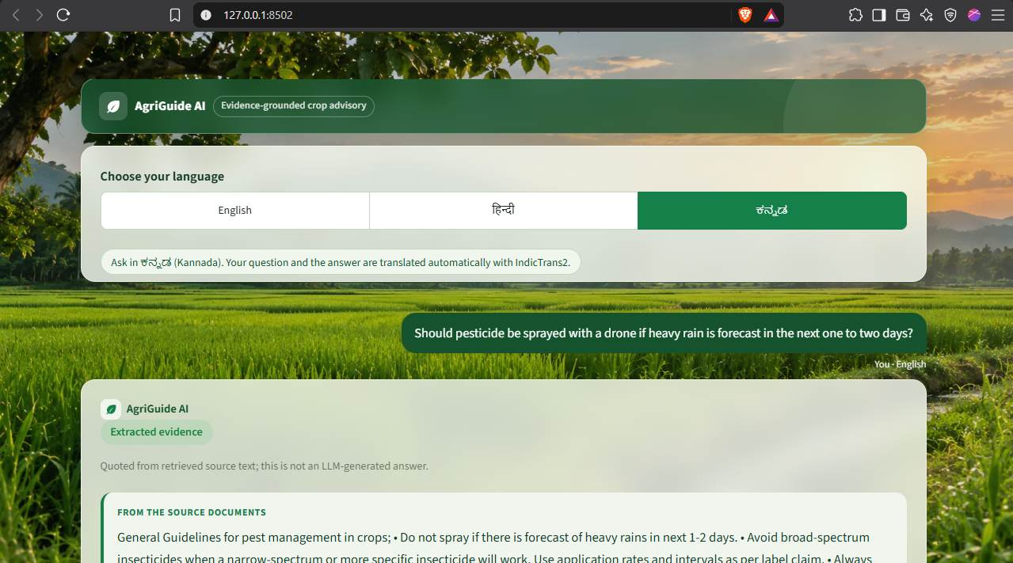
Figure 1. Landing page showing the agricultural background, language selector and question entry.
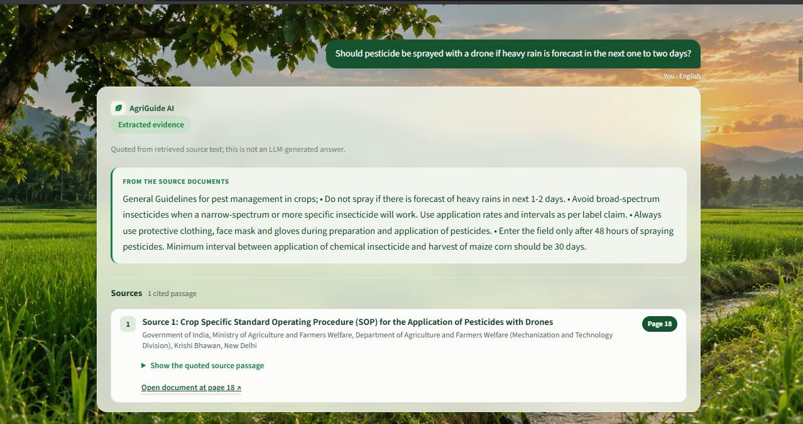
Figure 2. English extracted response with source citation to the drone-pesticide SOP, page 18.

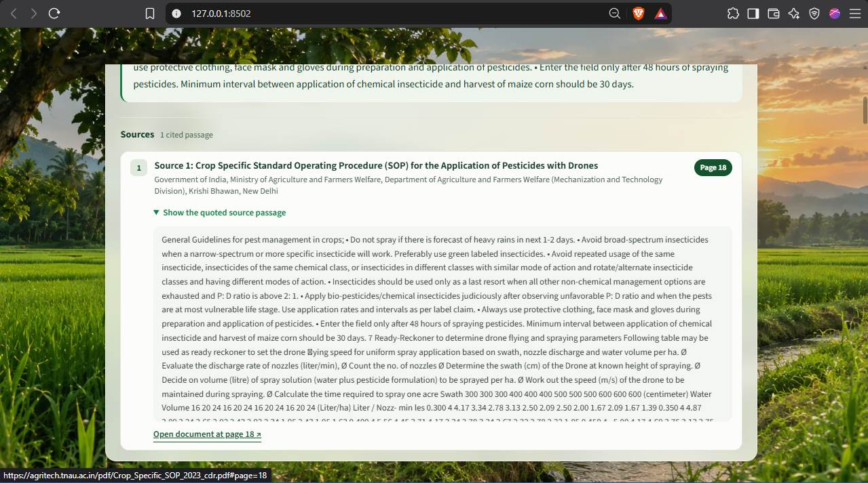
Figure 3. Expanded source passage, allowing inspection of the original evidence.
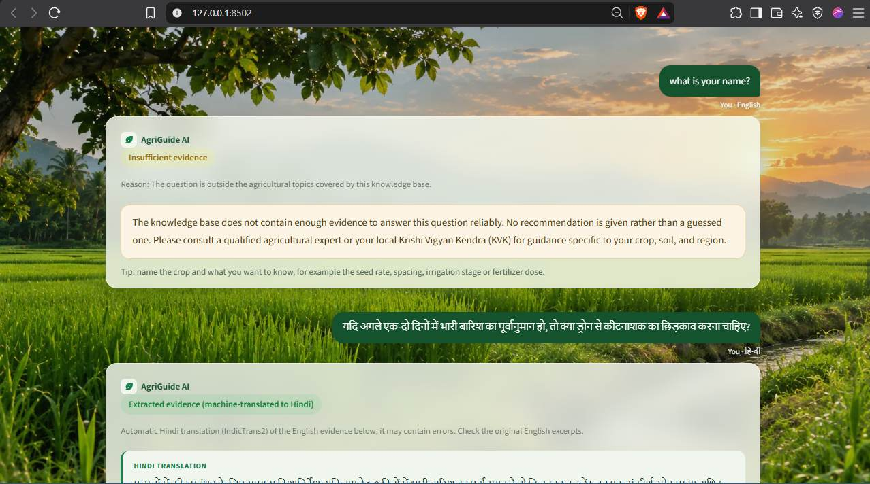
Figure 4. Unsupported query abstention followed by the Hindi-language interaction.

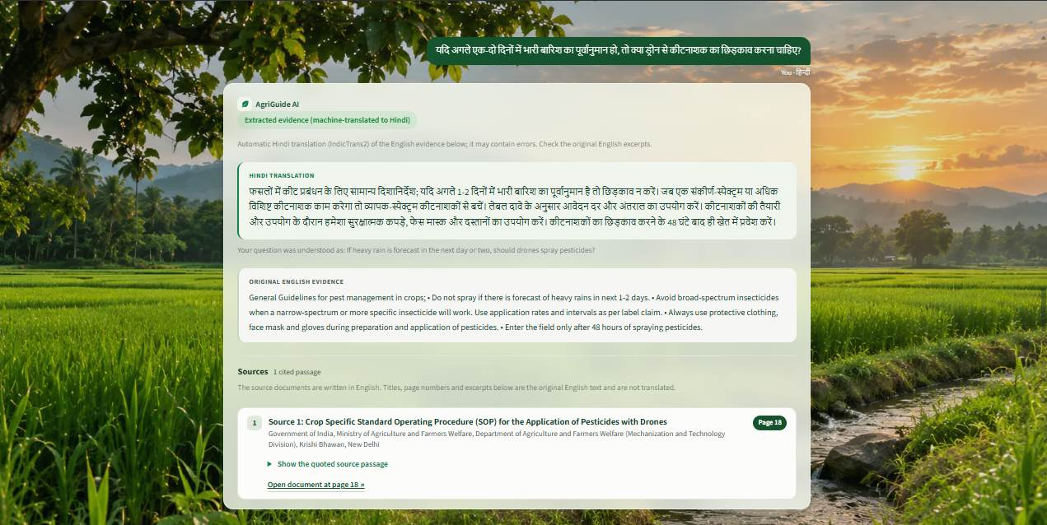
Figure 5. Hindi translated response with original English evidence and source citation.
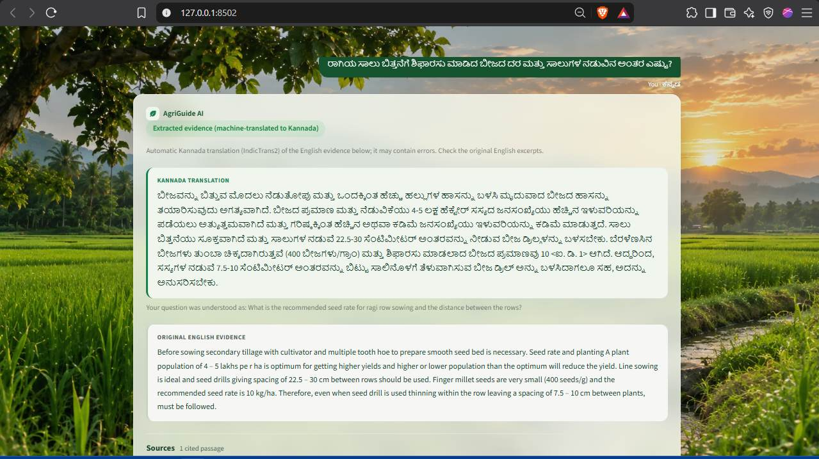
Figure 6. Kannada translated response and original English evidence. A visible placeholder artefact remains in the translated output.

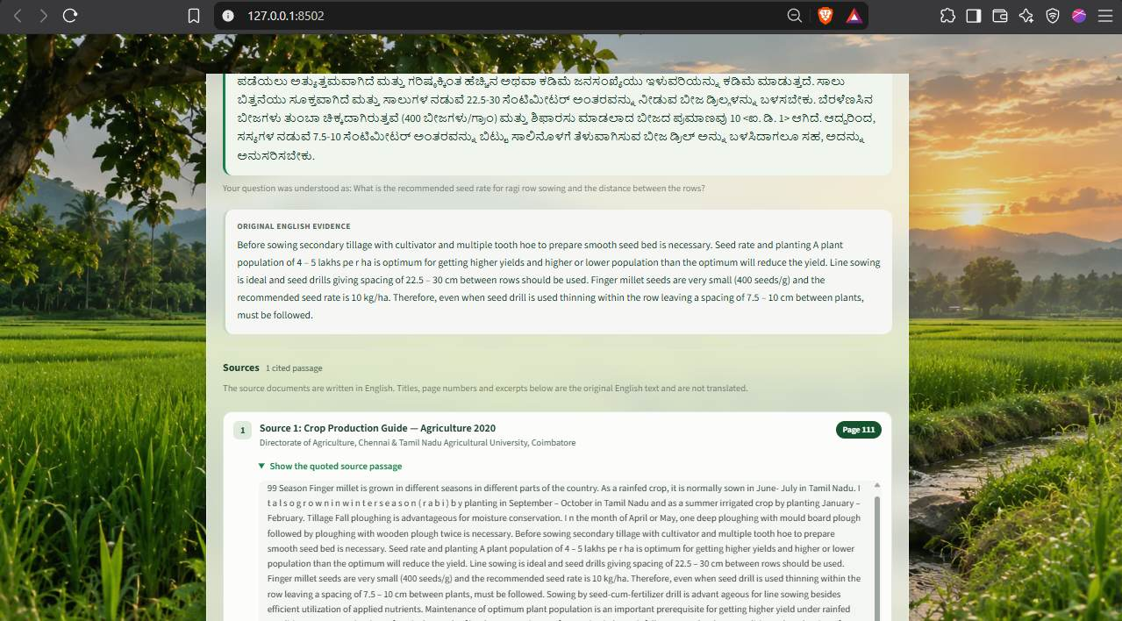
Figure 7. Expanded Kannada evidence and citation to Crop Production Guide – Agriculture 2020, page 111.

