1. Write a script that builds three EC2 Instances and returns the Public IP of each instance. Use ubuntu AMI.(use t2.micro)

Step1:- To create a 3 instances on tcp protocol and allow other incoming traffic using cidr from port 22. Creating resource of ec2 and using ImageId of ubuntu using instancetype of t2.micro and it can increase the maxcount of instances to 3

Step2:- The private key pair is generated and used by further reference and outputs the data instances in json format

So here the 3 instances are created and its in running state using the configurations accordingly

Configurations like AMI ID of ubuntu and name of ubuntu..

1. Write a script that snapshots a volume in us-west2.

Step1:-The resource of ec2 with a us-west2 using the volume ID accepting as input it creates a snapshot and tags it accordingly.

1. Write a script that will create 2 EC2 instances and add them to the new Elastic Load Balancer.

Step1:-Using low level connection we can connect to elb resource and from that we can create aload balancer with a appropriate name by accepting linsteners as parameters which accepts which protocol, instanceport number, loadbalancerport number etc..

And configuring availability zones to be inside region any instance can go to any any zones and finally registering insatances by attaching them into load balancer by their IDs

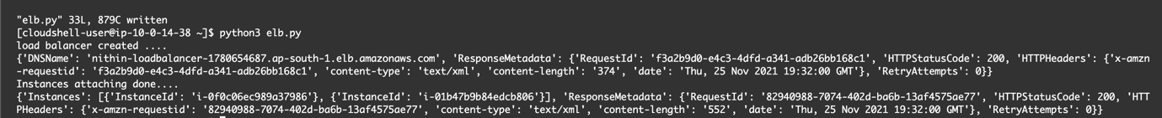

All the configuration values can be seen here as output in json format.

Here we can find the output which shows nithin-loadbalancer is the name and loadbalancer created and attached with the instances indicating with their ids.

Now loadbalancer can serve traffic to2 of the instances.

1. Write a script to create S3 bucket and upload a bunch of files to it.

Creating a low level connection to s3 bucket resource with a name nithin-hu19-bucket and uploading files into bucket.

Bucket is created with a appropriate name given to it

Output of files uploaded to it.

1. Write code that deletes everything you have created from these exercises. It should:

a.)Stop and Delete all EC2 instances

b.)Delete all Volumes.

Step1:-select the instance ids and parallely create a resource like ec2 and with the help of instance filter out the ids and stop the running ones.

Output shows running intances been stopped

Step1:-select the instance ids and parallely create a resource like ec2 and with the help of instance filter out the ids and terminate the stopped ones.

Output shows stopped intances been terminated

By configuring the region and selecting resource like ec2 accept the volume ID and checked wheather it exist or not. If it exist then delete the volume and print volume deleted.

Output to check wheather code runs till the end and gives expected results