Introduction
I, Nithin Joshua Stephen,CS14M033 have implemented SLD resolution which takes horn clauses from text file as input and performs SLD resolution on them.
Horn Clause
A clause with at most one positive literal is a horn clause. If there is no positive literal, then it is a positive clause. If there is exactly one positive literal, it is a positive clause.
(or (not (Student ?X))(HardWorker ?X)) – Positive Horn Clause
(GradStudent Sue) – Positive Horn Clause
(not (HardWorker Sue)) – Negative Horn Clause
(or (not (Student ?X)) (not (HardWorker ?X))) - Negative Horn Clause.
Two positive clauses can be resolved to get a positive clause. A positive clause and a negative clause can be resolved to get a negative clause. Two negative clauses cannot be resolved as there are no positive literals in both of the clauses.

SLD Resolution
A SLD resolution is a series of derivations where a negative clause is resolved with a positive clause to yield a resolved clause which is again a negative clause which is then resolved with a positive clause from the knowledge base. This process goes on until the empty clause is derived which indicates that SLD resolution was successful or there are no positive clauses in KB which can be resolved with the negative/resolved clause indicating that SLD Resolution was unsuccessful. SLD Resolution is complete for Horn Clauses.
Clause Representation
A clause is represented in prefix notation where operators like AND/OR/NOT comes before the operands. It is represented in list notation where a large clause consists of many child clauses.
(or (not (GradStudent ?X))(Student ?X)) is a clause whose operator is OR and consists of two child clauses (not (GradStudent ?X) and (Student ?X). A clause does not contain exists operator and all variables are implicitly quantified. A variable is preceded by a ?.
Input File
Input file consists of a clause per line where the last clause is the negated goal. So all the clauses but the last one constitute the knowledge base and the last clause is the negated goal which can be a positive or a negative clause. So a sample test file looks as follows.
(or (not (GradStudent ?X))(Student ?X))

(or (not (Student ?X))(HardWorker ?X))
(GradStudent Sue)
(not (HardWorker Sue)) – Negated goal
Code Structure
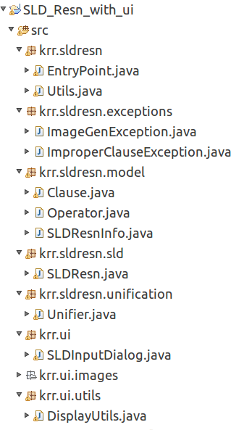

The implementation is in Java programming language and the code is structred as follows. The packages are
- krr.sldresn package consists of
  - EntryPoint class – This class is the entry point for performing SLD resolution in non GUI mode.
  - Utils class – This class consists of utility functions like creating image file when SLD resolution was successful.
- krr.sldresn.exceptions package consists of classes which are exceptions which can occur during the execution of the program.
  - ImageGenException - Instance of this exception are created when SLD resolution was successful but image generation failed.
  - ImproperClauseException - Instance of this exception occur when an input clause is in improper format.
- krr.sldresn.model package consists of classes which represent how the information is stored.
  - Clause – This is the model class which represents a clause.
  - Operator – This is an enumeration which can take one of AND/OR/NOT values.
  - SLDResnInfo – This is the model class which stores the goal tree.
- krr.sldresn.sld package consists of
  - SLDResn – This class contains methods where SLD resolution is performed.
- krr.sldresn.unification package consits of
  - Unifier – It consists of methods like unify,subunify,varunify which is required in unification.
  - UnifyInfo – It is a static class inside Unifier class which contains the information like whether unification was successful or not and the substitution if successful.
- krr.ui package conists of
  - SLDInputDialog – This class represents the UI component for performing SLD resolution in GUI mode.
- krr.ui.utils package conists of
  - DisplayUtils - This class contains utility methods related to display of widgets

Sample Execution
The code can be executed in either non GUI mode or GUI mode.
1) Non GUI Mode – To execute the code in non GUI mode, the class EntryPoint is executed. The folder where test case file exists is specified in the variable TEST_CASE_FOLDER and the name of the test case file is specified in TEST_CASE_FILE
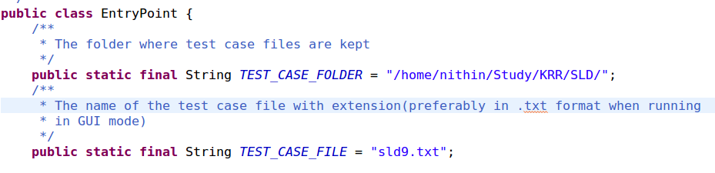
2) GUI Mode – To execute the code in GUI mode, the class SLDInputDialog is executed. Input can be specified as a test case file or can be typed in the text box specified.
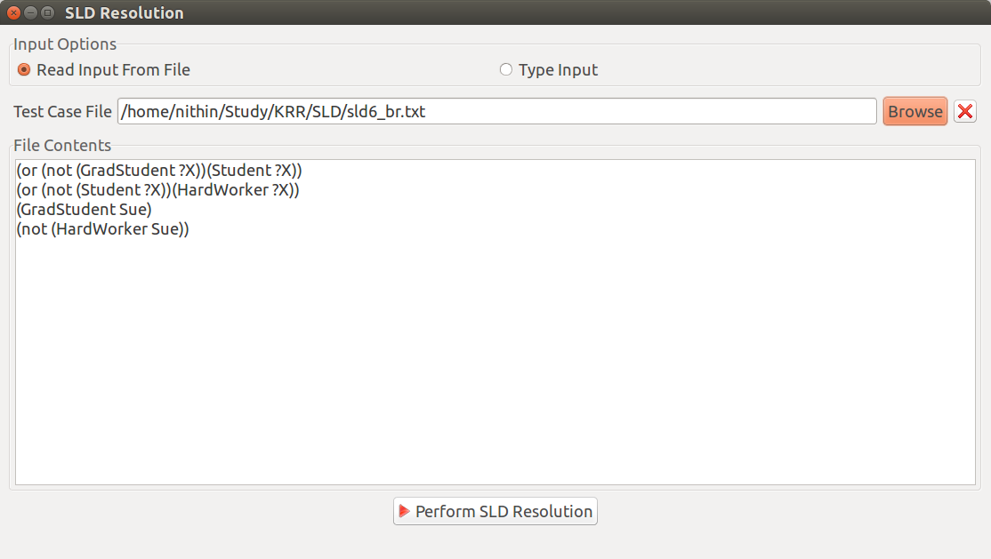
If clauses are in proper format, “Perform SLD Resolution” will be enabled. On clicking the button, if SLD resolution was successful, a message box indicating success is displayed.
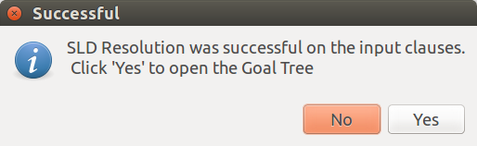

To display the image corresponding to the goal tree, click on the “Yes” button. The nodes with red border indicates negative clauses and nodes with blue border indicates positive clauses.
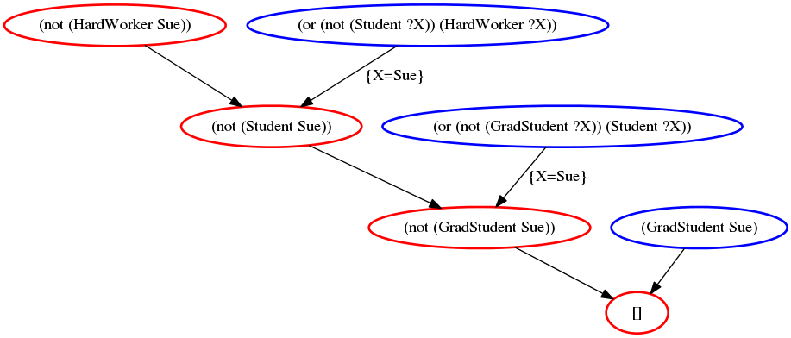
If SLD resolution was unsuccessful, a message box indicating unsuccessful SLD resolution is displayed.
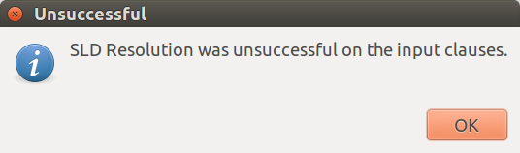

Contents of the submission
1) Extract the contents of “CS14M033.tar.gz”
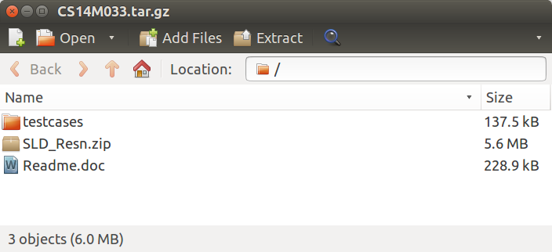

2) Import the zip file “SLD_Resn.zip” into Eclipse IDE.
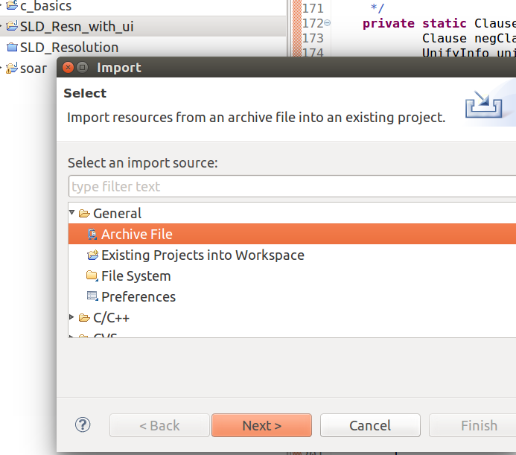

3) Inside the testcases folder, some sample testcases and their goal trees if SLD resolution was successful are shown.
