Introduction
I (Nithin Joshua Stephen,CS14M033), have implemented a generic sudoku solver which solves sudoku's of any dimension like 4X4 or 9X9. Complex sudokus of higher dimension like 16x16 may not work as it requires change in existing rules like
a) Hidden twin rule must be extended to hidden triplet rule.
b) Lonely twin rule must be extended to lonely triplet rule.
c) Subgroup exclusion must be similarly extended to handle higher counts.
Representation
1) The top level class of type state, has attribute cell which represents the cells in sudoku.
A sample representation is as follows.
(<state> ^cell <cell27>) - This corresponds to the cell in 2nd row and 7th column.
- Each cell has the following attributes
- row -the row in which the cell belongs (numbering starts from 0)
- col - the column in which the cell belongs (numbering starts from 0)
- grid - the grid in which the cell belongs (numbering starts from 0)
- value - the value assigned to the cell. If value is 0, it indicates that the value of the cell has not been fixed yet.
- probable - the probable values for the cell.
- count - the number of probable values for the cell.
A cell whose value is fixed as 1 is represented as
(<cell13> ^row 1 ^col 3 ^grid 1 ^value 1 ^count 0),
whereas a cell whose value is not fixed is represented as follows
(<cell83> ^row 8 ^col 3 ^grid 7 ^value 0 ^count 2 ^probable 1 ^probable 2)
state also has attribute counter for each digit for each row,column and grid.
- Each counter has
  - row/col/grid – The row/col/grid to which the counter is assigned.
  - digit – the digit tracked by the counter.
  - count - the number of cells in the row/col/grid which can contain the digit.
So the counter tracking the digit 4 for 6th row is represented as
(<state> ^counter <counter-row-6-digit-4>) and its attributes are represented as
(<counter-row-6-digit-4> ^row 6 ^digit 4 ^count 7)

Executing the code to solve the sudoku
1) Extract the contents of CS14M033.tar.gz
2) Inside you will find “soar_java.zip” which contains the java code to create the soar rule file used for initializing and printing sudoku
3) Inside you will find “Sudoku_soar.zip” which contains the soar code. Copy the contents to Agents folder where soar is installed.
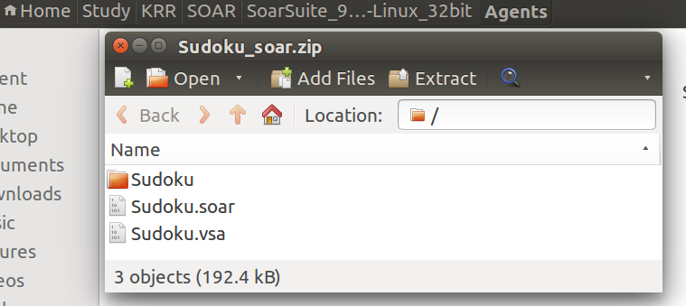

4) Inside you will find the images in “images.zip” for the test cases.

Running Java Code to create soar files
1) If eclipse is installed in the system, import the soar_java.zip into eclipse. Run the file “InitializeSoar.java”
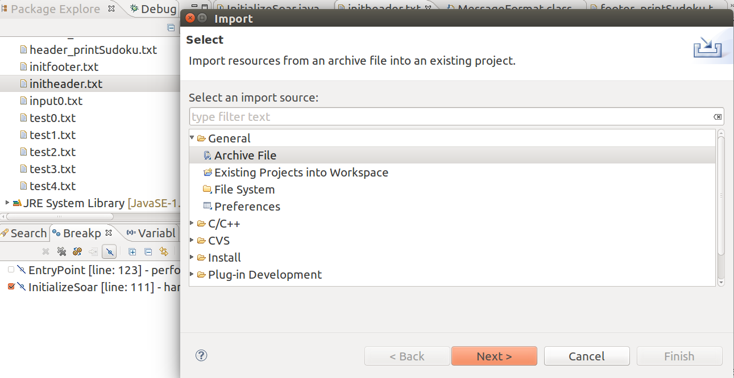
If eclipse is not installed, copy the contents in “soar/src” folder inside the “soar_java.zip” file and run the file “InitializeSoar.java”

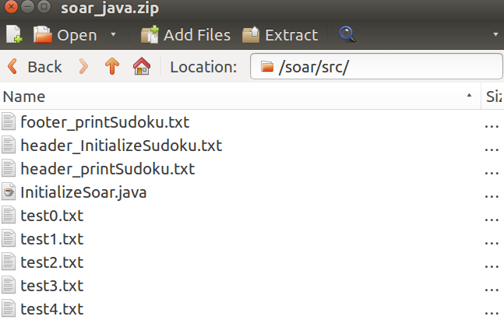

Making changes in “InitializeSoar.java”
1) To solve a sudoku of 9x9 sudoku, change SUDOKU_INT,to 3. So to solve a 4x4 sudoku change SUDOKU_INT to 2.
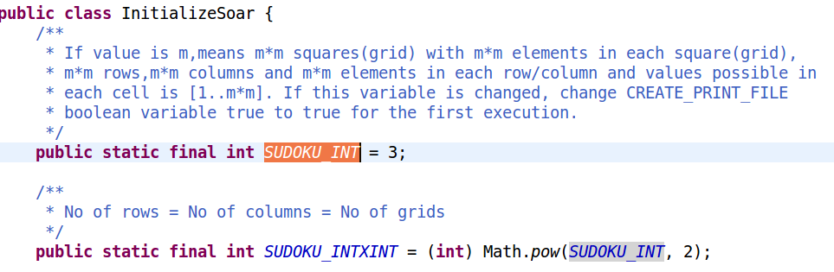
The source and destination folder locations and filenames are changed as follows.
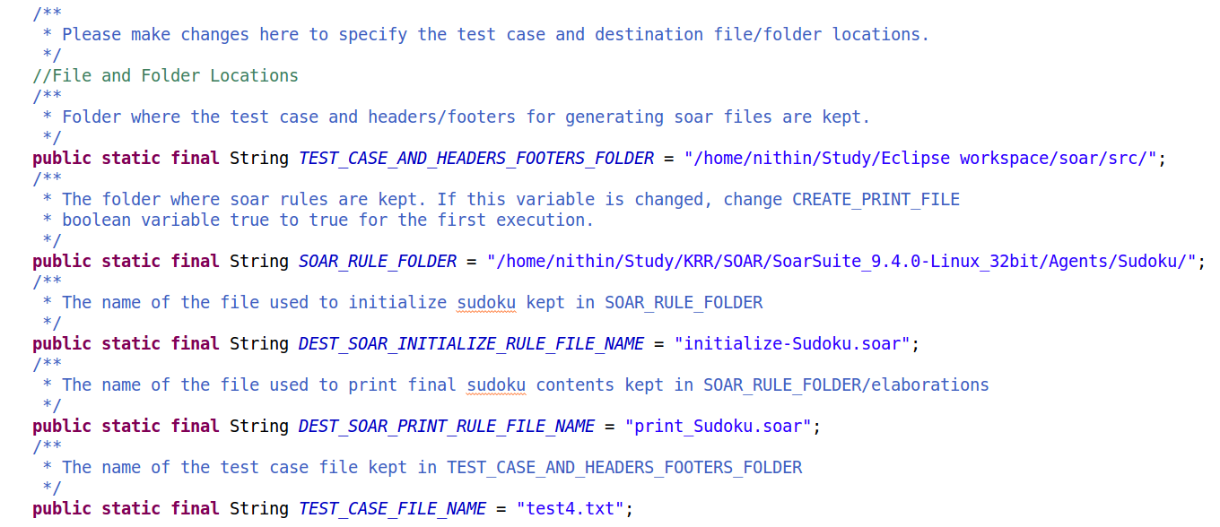
2) The name of the test case file with extension is specified in the variable TEST_CASE_FILE_NAME
3) The test case file to check also should be in the same folder as “InitializeSoar.java”.The path of the folder is specified in the variable TEST_CASE_AND_HEADERS_FOOTERS_FOLDER
4) The folder where soar rules are specified in the variable SOAR_RULE_FOLDER
5) The name of soar rule file used to initialize sudoku is specified in the variable DEST_SOAR_INITIALIZE_RULE_FILE_NAME and the name of soar rule file used to print sudoku contents is specified in the variable DEST_SOAR_PRINT_RULE_FILE_NAME. There is no need to change these two variables.
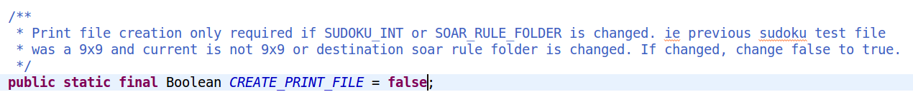
6) CREATE_PRINT_FILE is a boolean variable indicating whether to generate the soar rule file for printing sudoku contents.The soar file to print contents is to be regenerated if SUDOKU_INT or SOAR_RULE_FOLDER is changed. If any one of SUDOKU_INT or SOAR_RULE_FOLDER , change CREATE_PRINT_FILE to true for the first execution.

Executing SOAR
1) Install SOAR-Suite(SOAR_Tutorial optional)
http://soar.eecs.umich.edu/articles/downloads/soar-suite
2) Open VisualSoar(displays SOAR programs)
$./VisualSoar.sh in SoarSuite folder.
- Open Project by File->Open Project
- Select .vsa file
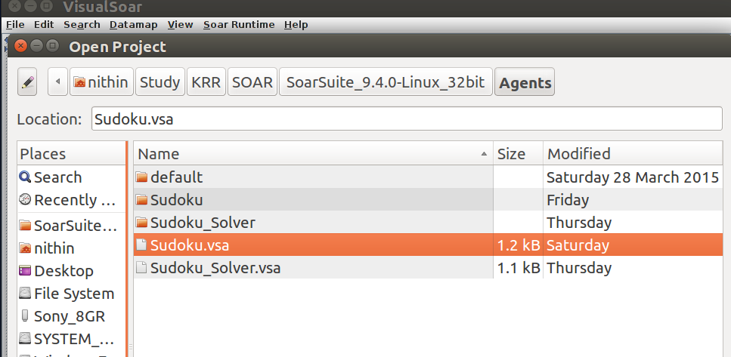
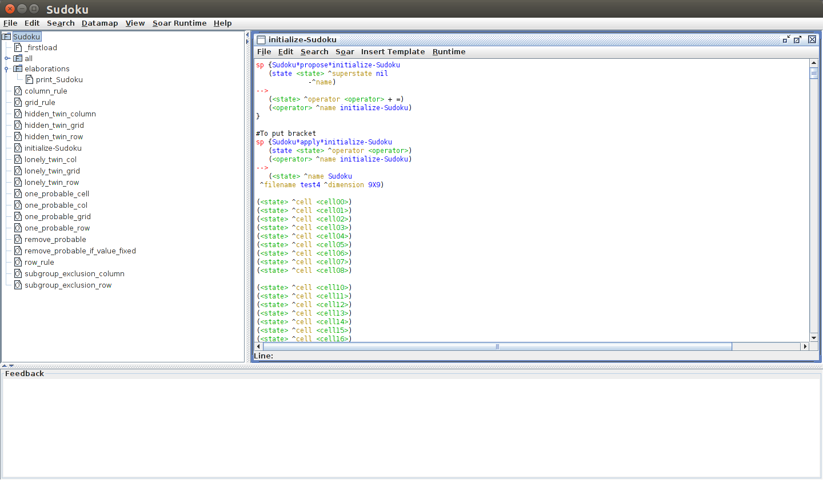
- To add an operator, Right click on Sudoku -> Add a SubOperator and add the rule file
- Whenever a change is made, generate datamap by
Datamap -> Generate datamap for current hierarchy
- Once datamap is generated, check for syntax errors by
Datamap -> Check all productions against datamap
3) Open SOAR Java debugger (to run soar programs)
- $./SoarJavaDebugger.sh in SoarSuite folder.
- File -> Load Source File -> Sudoku.soar
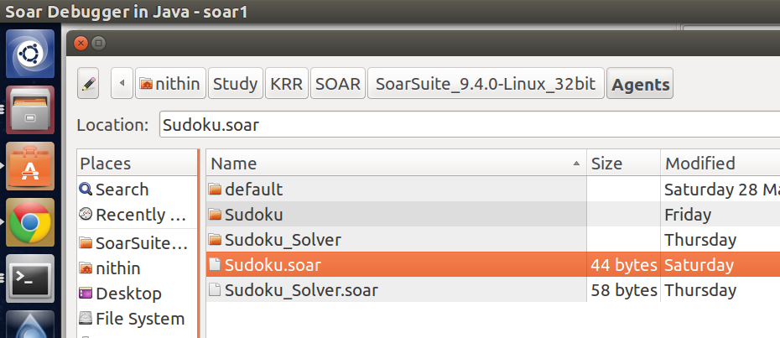
- To run for the first time click on Run
- Else Init-Soar and Source->Select same source file again
