Methodology
- The two machine learning techniques used
- Decision tree Classifier [Sec. (8 c i) of ipynb]
- Logistic Regression Classifier [Sec. (8 c ii) of ipynb]

Overview
- Objective: Analyze and Build models for Predicting Rating [Sec. 1 a i of ipynb]
- Methodology: Understand data, reduce features by feature selection, feature engineering, clustering, building model, evaluating model.

Results
- Table for the evaluation metric for each ML technique used [Sec. (10 a) of ipynb]
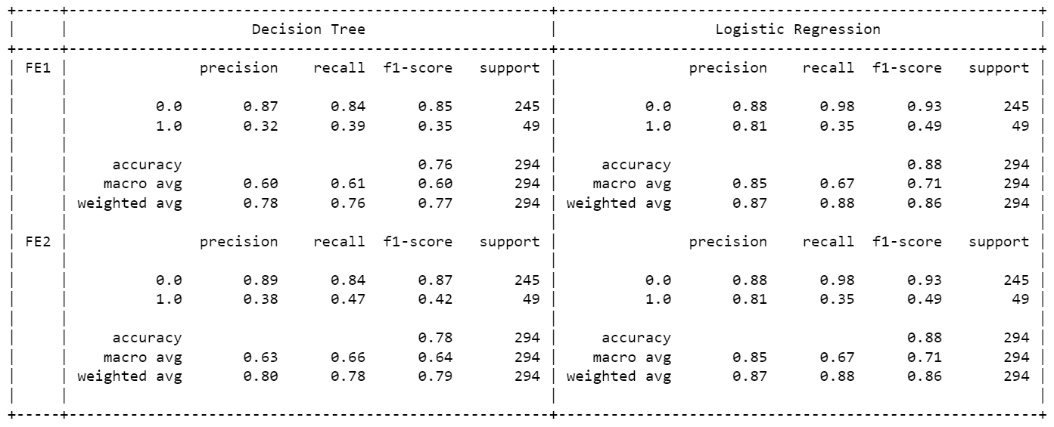
- Plot of the curves [Sec. (10 b) of ipynb]
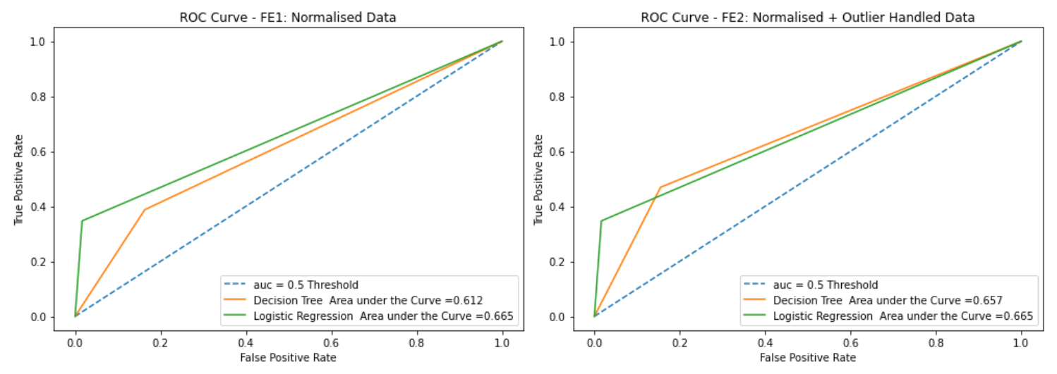
- Conclusion
Logistic Regression Training Algorithm proved better while dealing with dataset having more categorical variables. It Proved better that Decision Tree Algorithm for normalized, outlier smoothened data [Refer Sec (11, 12) ipynb file]

Dataset
- Size of the dataset
Total records: 1470, Total Attributes: 33 [Sec. 3 c of ipynb]
- Variable type– Categorical / Interval ….
Data types can be found in the excel object [Sec. (3 c) ipynb)

- Data Distribution and handling imbalanced data
Analyzed spread of data with histogram plots for continuous variables and categorical variables [Sec. (3 e) and (4 b) of ipynb]
- Feature Wrangling
Filled NANs with mean, median, mode values [Sec (5 a i) ipynb]. Checked for duplicates in the dataset.
- EDA outcomes and discussion
Analysed data by drawing count plots for categorical data, histogram plots for numeric data. [Sec. (4 b) ipynb]

Feature Engineering Techniques
- Features removed:
Two features were removed manually, the ‘EmployeeNumber’ and ‘Over18’ fields and using Kbest ChiSquare approach selected top 20 fields [Sec. (6 b, 6d) ipynb]
- Feature ranking:
KBest Chisquare and Info Gain techniques are used to determine for feature selection [Sec. (6 c, 6d) ipynb]
- Any other:
Using Normalisation using min-max scaler and outlier smoothening by capping the outlier at 0.95 quantile levels
[Sec. (7 c) ipynb]

