16833 Robot Localization and Mapping

NITHIN KUMAR SATHISH

DEPARTMENT OF ELECTRICAL AND COMPUTER ENGINEERING

[nsathish@andrew.cmu.edu](mailto:nsathish@andrew.cmu.edu)

1.

1.1

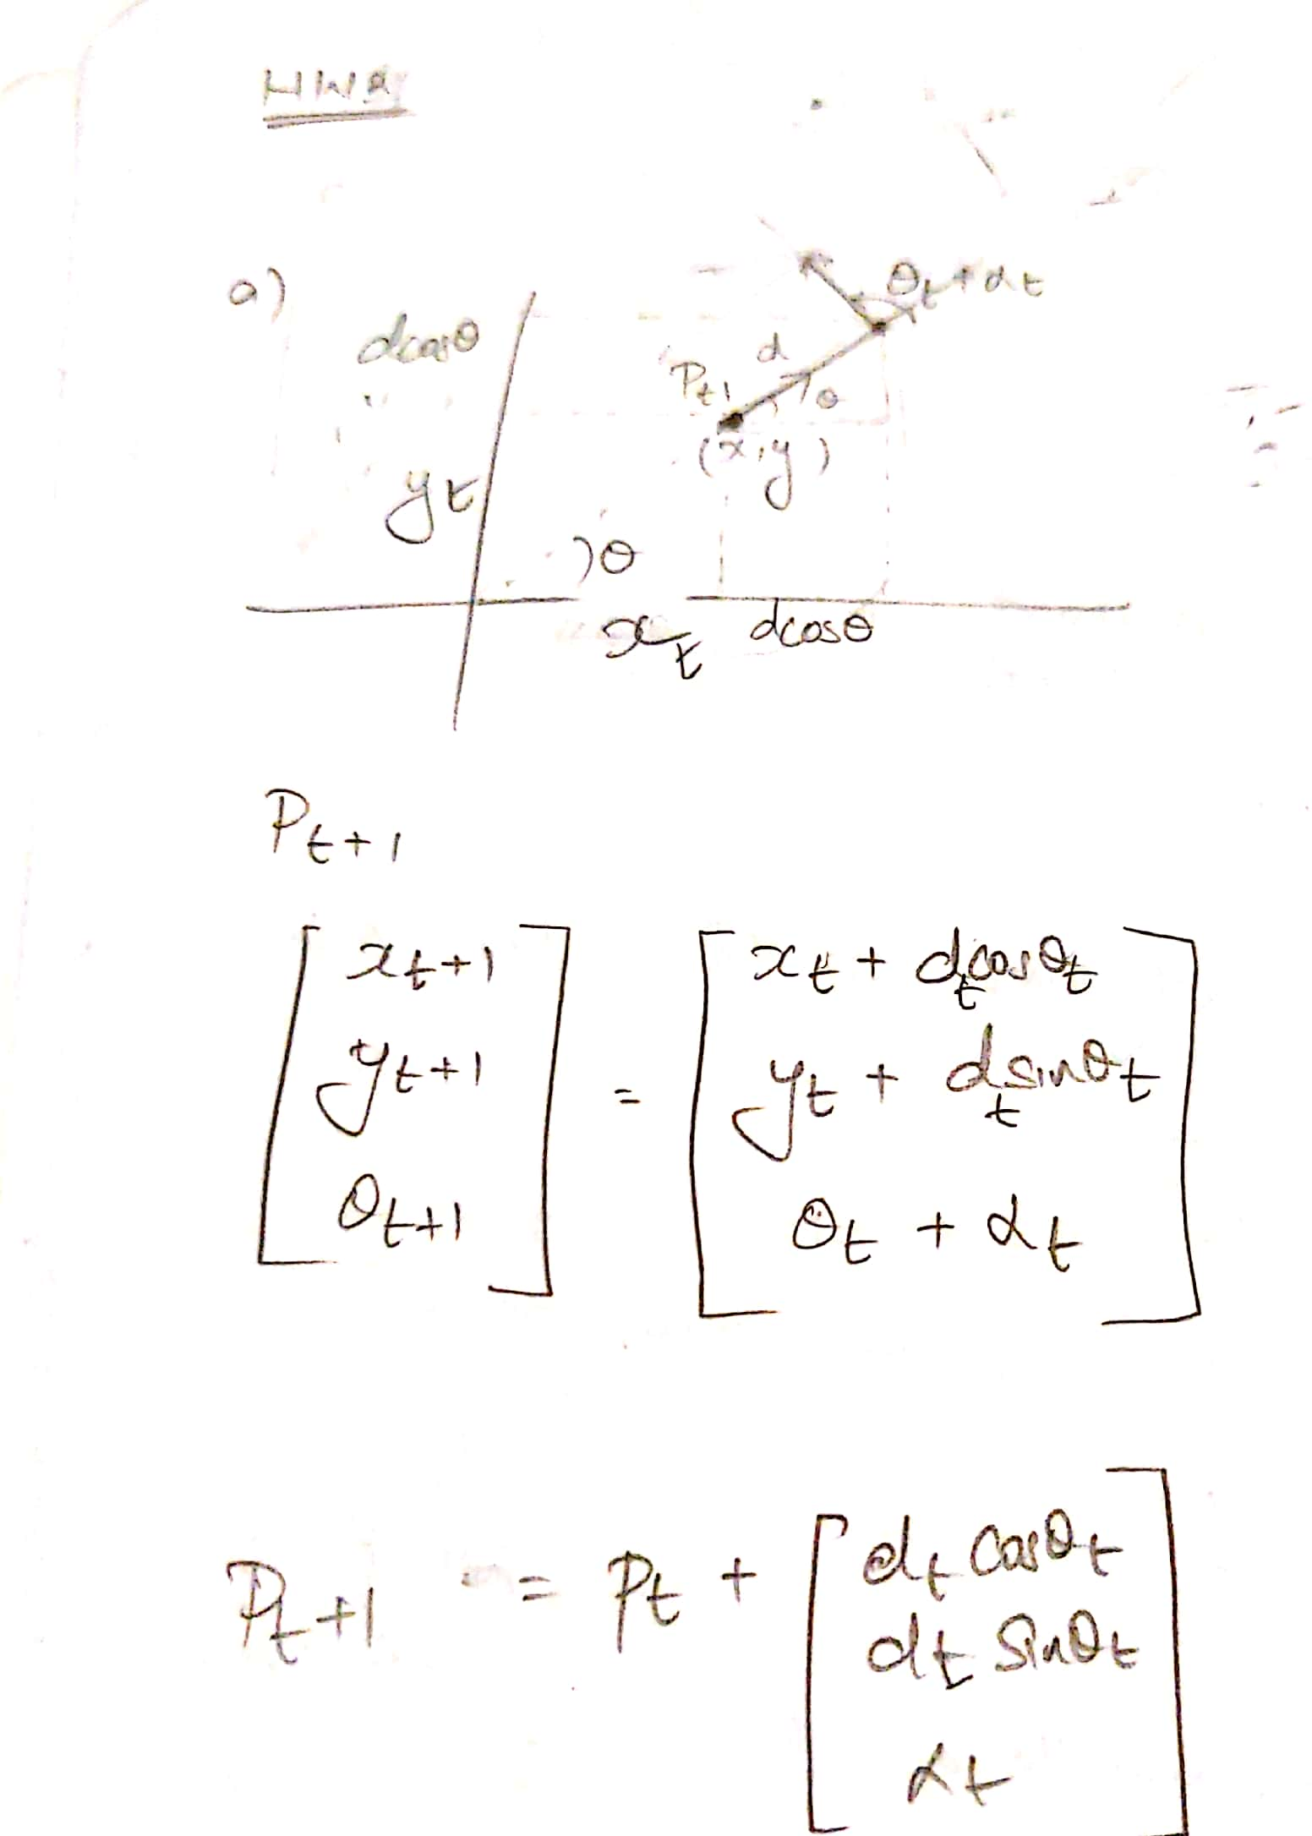

1.2

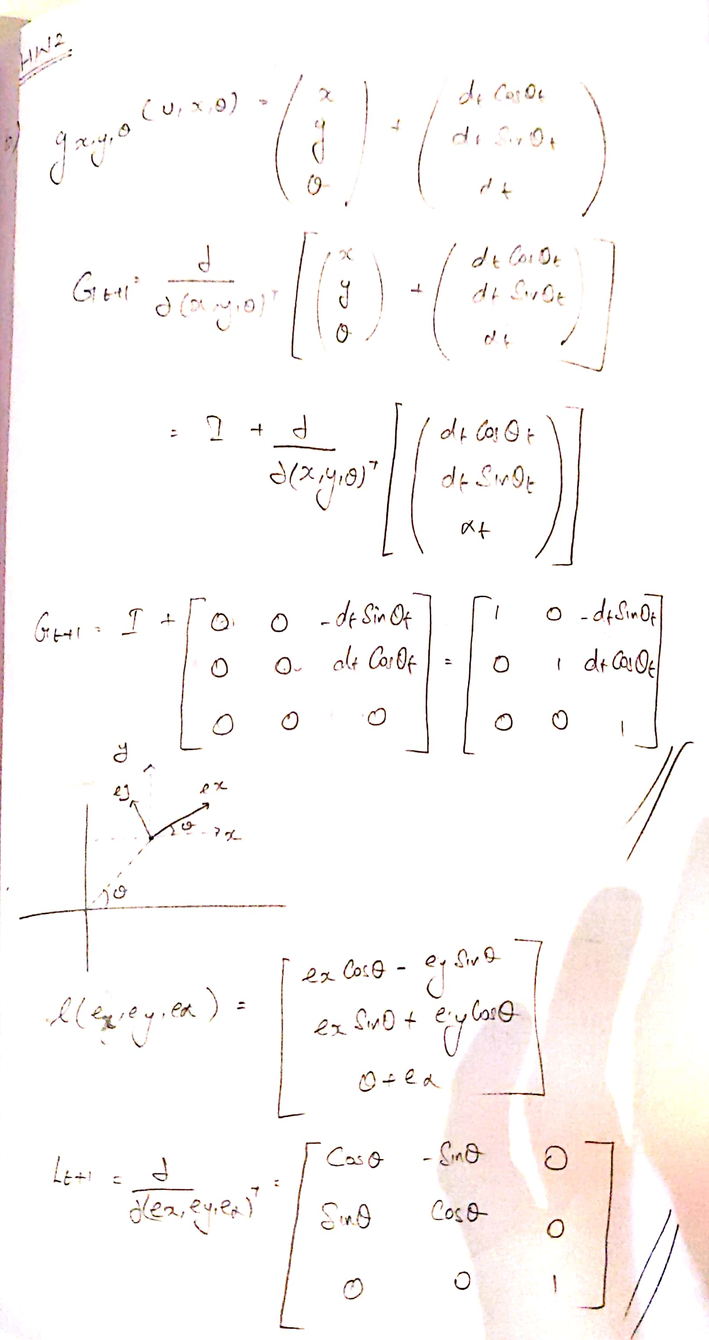

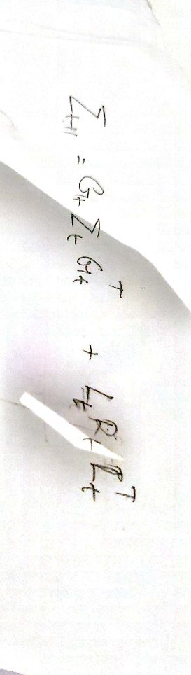

1.3

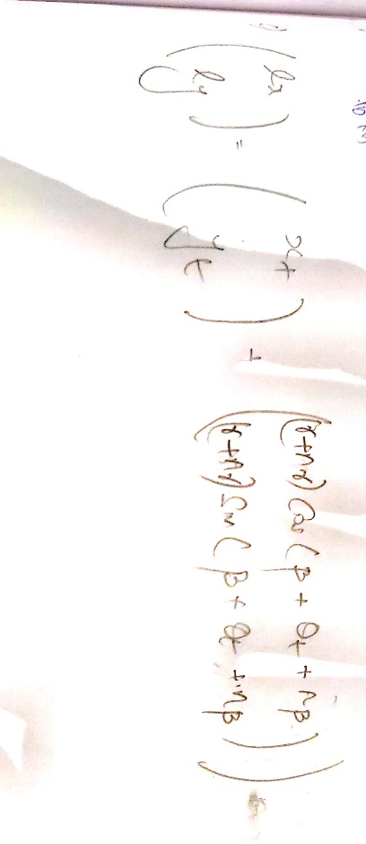

1.4

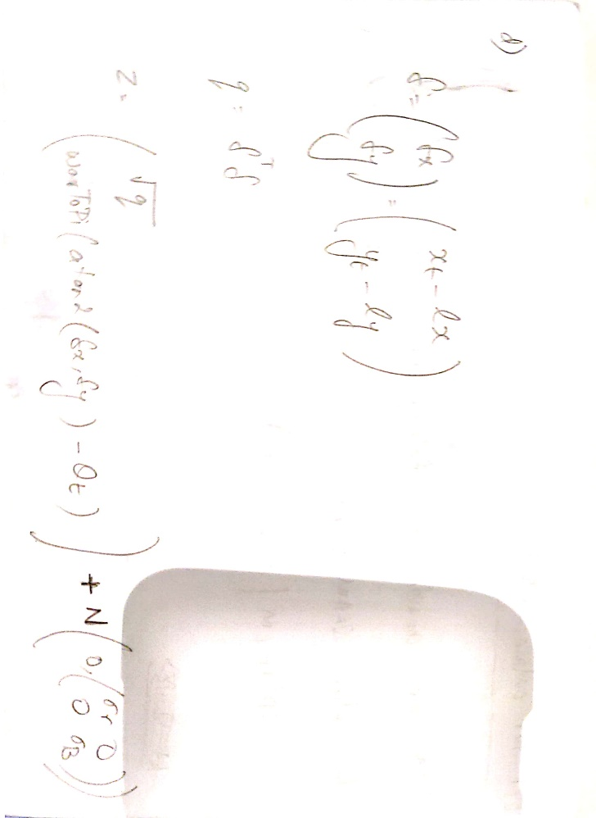

1.5

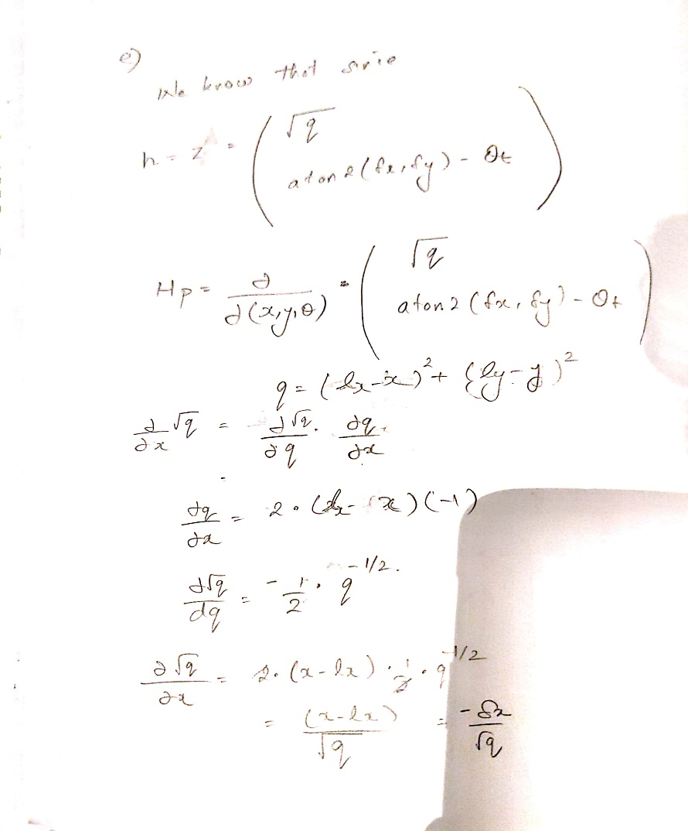

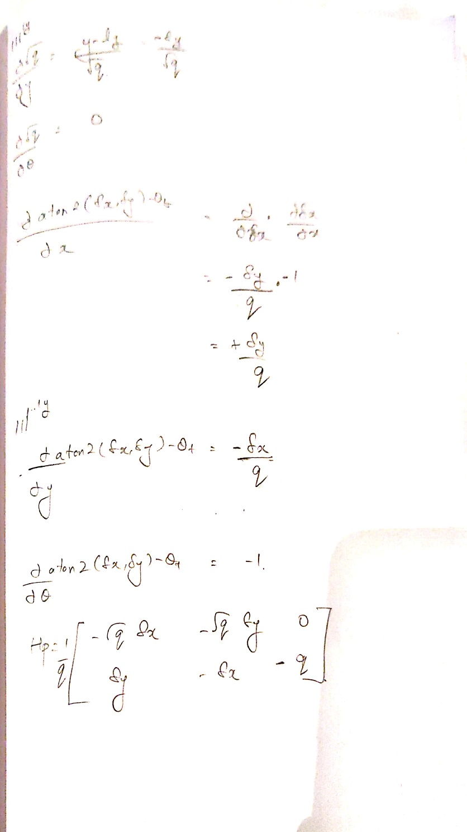

1.6

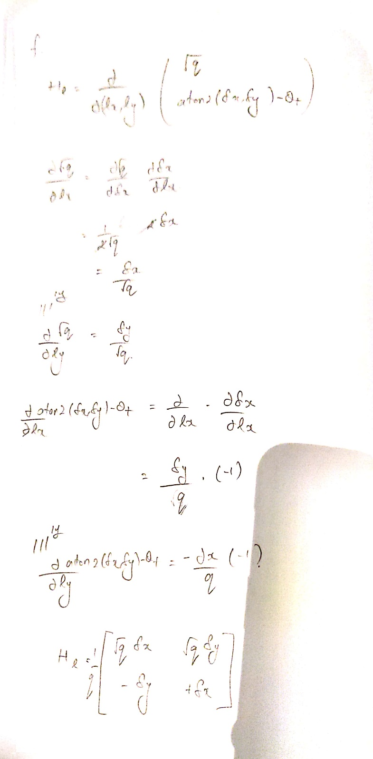

We don’t have to take derivative with other landmarks because they will be zero anyways.

2.1 Six landmarks were achieved at every timestep.

2.2 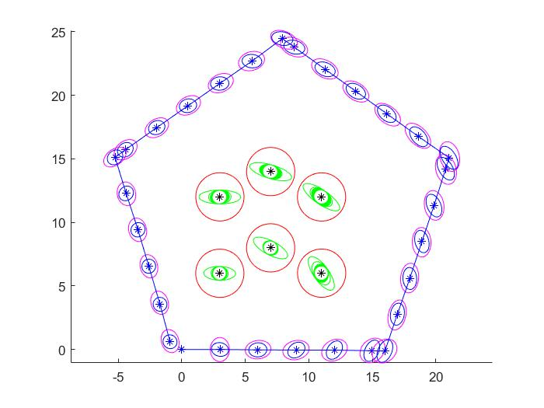

2.3 It can been seen from the above figure that the uncertainty of the updated location of the robot (blue ellipse) is lesser than the predicted location of the robot (magenta ellipse). Similarly, we can see that the uncertainty for estimating the position of the landmarks decrease after each time step.

2.4

Euclidean Distance = [0.0241,0.0354,0.0297,0.0440,0.0258,0.0365]

Mahalanobis Distance = [0.0220, 0.0309, 0.0274, 0.0525, 0.0166, 0.0462]



Yes, the ground truth(black star) is inside the smallest ellipse. This means that the mean of the predicted locations is close to the ground truth values.

3.1

The zero terms in the landmark covariance becomes non-zero because there is co-relation between the landmarks, i.e. observing one landmark is helpful for updating the covariance between the other landmarks. The assumptions made when P matrix is initialized with zeros are:

1. There is no covariance between the state of the robot pose and the state of the landmarks
2. There is no covariance between the state of the landmarks.

3.2

1. With default values of variance for poses and landmarks



2. Variance for poses increased with variance of landmarks constant

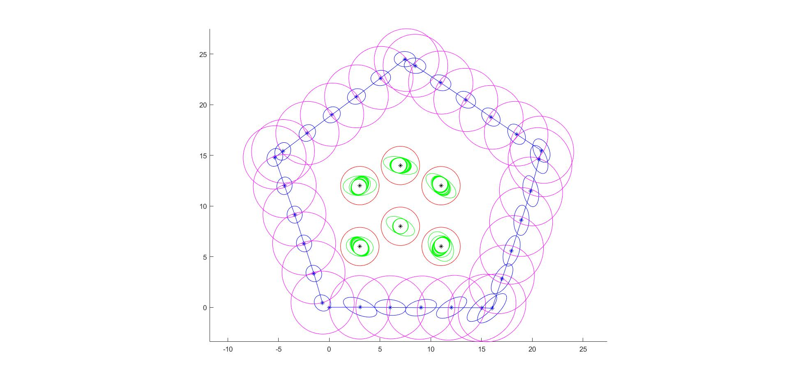

3. Variance for landmarks increased with variance of poses constant

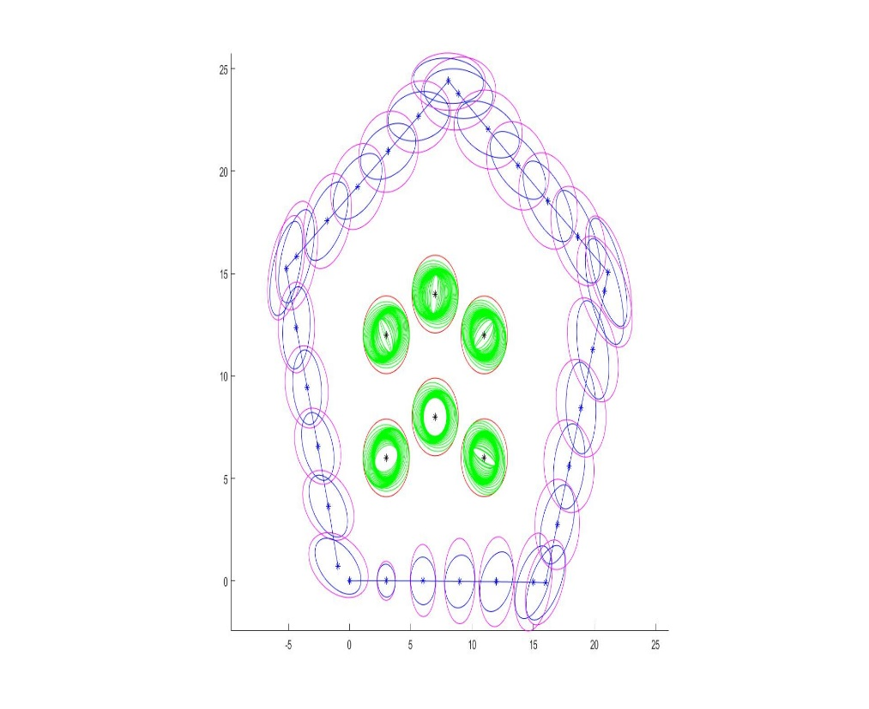

4. Variance for both landmarks and pose increased.

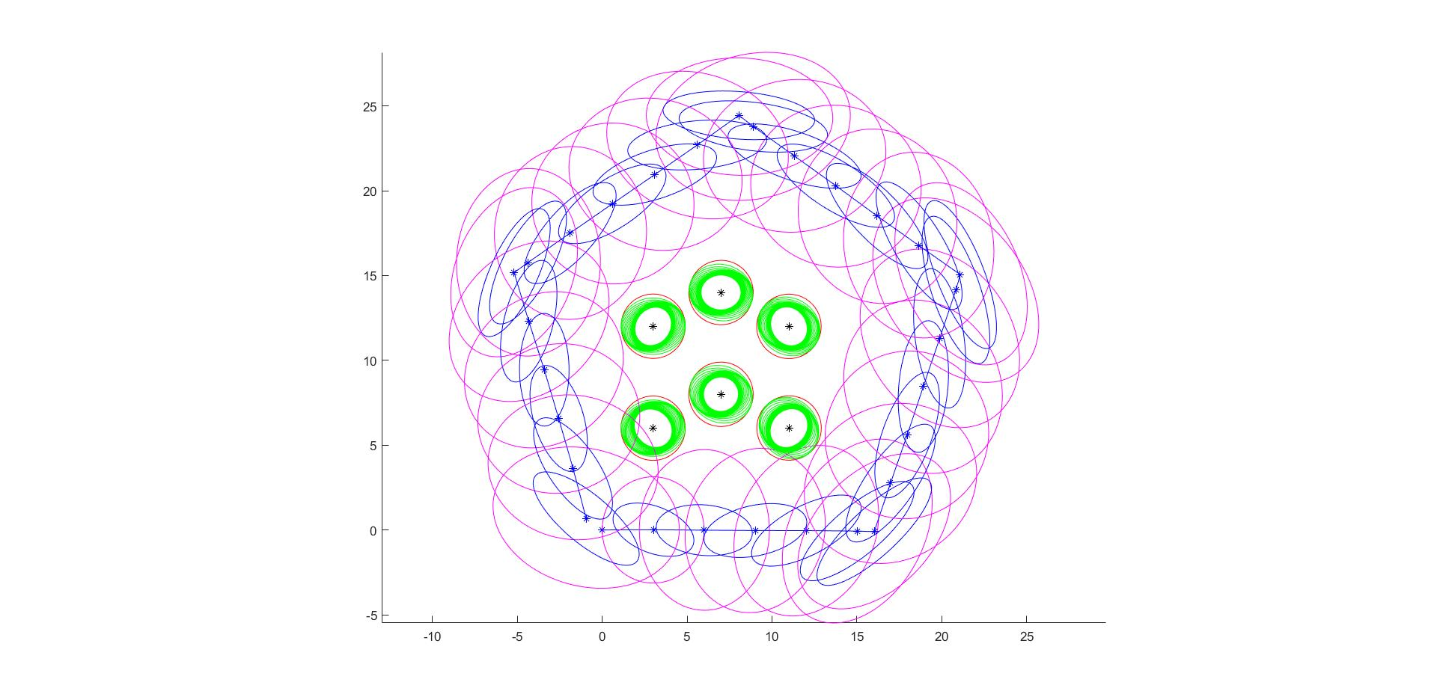

In figure 2, when the variance of pose is increased, initially the variance is high but as the robot progresses, the variance of pose decreases but still it is higher than the ideal case. Also, we can notice that the variance of landmarks increase.

Similarly, in figure 3, when the variance of landmarks is increased, initially the variance is high but as the robot progresses, the variance of landmarks decreases but it is still higher than the ideal case. Also, we can notice that the variance of robot increases.

From these two figures, we can conclude that the high variance in one of the state is trying to improve the variance in the other, but in the process increasing the variance of itself.

Finally, in figure 4, when the variance of both landmarks and poses are increased, then both the landmarks and poses give bad results.

3.3 If the number of landmarks grow over time, we can do the following steps to still make EKF work pretty fast.

1. We only work with the landmarks which are currently observed by the robot.

2. We can further reduce the number of landmarks by removing those landmarks which have high variance because this will mostly not help much in the EKF.

References

1. Discussed with Gautam. Andrew id: ggare