Pub-Sub In Network Layer using SDN

Ziqi Li
EECS Department
Vanderbilt University
Nashville, TN
Nithin Kumar Guruswamy
EECS Department
Vanderbilt University
Nashville, TN

Abstract—Pub-Sub is widely used for messaging purpose in IoT technology, distributed systems, and cloud computing. The traditional Pub-Sub system is implemented in the application layer with an intermediate broker. However, dynamically assuring the QoS requirements like throughput (bandwidth) among different topics under different network scenarios becomes a formidable challenge especially in cases of IoT and big data. Thus, [1] designed network-layer Pub-Sub, using multicast routing and SDN technology which allows programmatic network resource allocation on need. In SDN based pub sub, we completely eliminate the software based broker and make use of network layer multicast routing and programmable SDN technology to act as hardware based broker and also implement QoS in hardware switch thereby boosting the performance and enforcement of Dynamic QoS. Finally, we compare messaging time between traditional Pub-Sub like Kafka and network-layer/SDN based Pub-Sub, to see how faster the latter can be in terms of message forwarding. Furthermore, we also test QoS parameter like throughput is enforced dynamically using SDN based pub sub.
Keywords—Pub-Sub, multicast, and Software defined networking (SDN)

Introduction
In software architecture, Pub-Sub is a messaging pattern where senders of messages, called publishers, do not program the messages to be sent directly to specific receivers, called subscribers, but instead categorize published messages into classes without the knowledge of which subscribers are going to receive them. Similarly, subscribers’ express interest in one or more classes and only receive messages that are of interest to them, without knowledge of which publishers published them.
It is widely used for messaging purpose in IoT and big data. In the traditional topic-based Pub-Sub, a broker is used to receive messages from publishers and forward them to subscribers. However, this approach can be slow due to software-based packet processing/forwarding in the application layer. As a result, we want to realize Pub-Sub in the network layer, to make it faster and more reliable in terms of QoS management.
The basic idea comes from the paper [1]. Software broker in traditional pub sub can be replaced by the SDN L3 router routing/forwarding pipelines using topics to be encoded in IP addresses/ports. SDN allows dynamic configuration of router/ switch resources based on QoS parameters to be enforced on packet types using match action tables and allocating/modifying Queues with different QoS values.
In this design, each topic ID has 1-to-1 relationship with a multicast IP address. Then, the messaging for a one topic can be handled by one multicast group. With the help of SDN, we can realize some other functionalities, such as registration of one group. Also, in SDN, messaging and group management of multicast will be more efficient. So, we expect the network-layer Pub-Sub to be far faster than before.
The rest of this paper is organized as follow: In section II, we will discuss the design and architecture of the network-layer Pub-Sub; In section III, we will discuss implementation details; In section IV, we compare the speed of traditional Pub-Sub with network-layer Pub-Sub. Finally, we conclude out work and point out the future work.

Architecture

Traditional Pub-Sub
In many traditional Pub-Sub system, publishers post messages to an intermediary message broker, and subscribers register subscriptions with that broker, letting the broker perform the filtering. The broker normally performs a store and forward function to route messages from publishers to subscribers. In addition, the broker may prioritize messages in a queue before routing.
For the topic-based Pub-Sub, the broker uses topic to do the filtering. It can have a table, where key is topic and value is who subscribe this topic. When it receives a message with a certain topic from publisher, it queries the table, to find out to whom it should forward the message to. Finally, it sends the message to all the interested subscribers.
However, this software-based broker architecture can be slow due to packet processing in software/application layer. Packet processing involves pub/sub header parsing, matching, removal, subscriber lookup and encapsulation etc. These operations are sometimes in O(n^2) and don’t scale well in software-based packet processing.
These operations are like network layer(L3) packet processing done by routers. Hence [1] and [2] both use network layer multicast routing/forwarding to replace the software-based broker by encoding topic in multicast address. This entails that pub sub packet processing is now done in router by specialized ASIC based packet processors in hardware containing TCAMs which do packet processing very fast in order of ns thus improving QoS parameters like reducing latency and increasing throughput.
Furthermore, we need to maintain differentiated QoS for different topics and assure it for IoT applications for varying network conditions continuously. Example include throughput should be assured for High priority topics like stock market messages over low priority topic like weather messages. Low priority messages should not usurp the bandwidth of high priority messages thus causing them to drop. In traditional pub sub, topic based QoS are not enforced/assured.
Also, many problems can happen in this process. For example, the broker may fail. One solution is to have multiple replicas for the broker, so that once one broker fails, others will take on its work. However, this fail-over process needs some time. It may violate QoS requirement in cases of IoT and big data with stringent real-time needs.

Design of Network-layer Pub-Sub

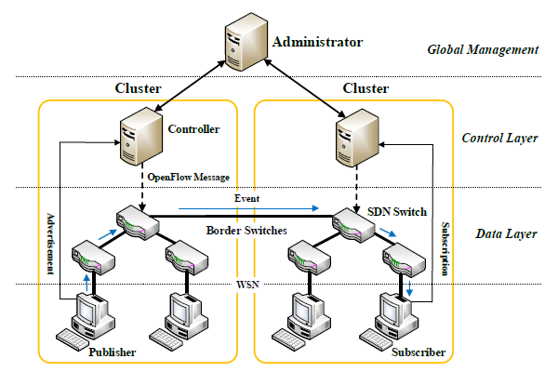

- SDN-based Pub-Sub

The idea comes from the paper [1]. To make Pub-Sub faster, we can encode each topic into a Multicast IP address. Then, we can create a group for multiple subscribers and publishers who are interested in one topic. Furthermore, we can use L3 multicast routing scheme to find the best route. We can use IGMP to manage the group, such as join and disjoin of subscribers. The SDN controller should be responsible for the work of topic registration, including management of multicast IP addresses.
Fig 1 shows the details of the IPv6 address. The first 8 bits indicate the range of multicast IP addresses. Here, we will not introduce the use of flags, global scope or event type. The queue priority is used for QoS purpose. A topic with higher priority should get more resources. The topic length indicates how many bits of topic code are valid. Topic code is similar to topic ID. 100 bits should be sufficient.
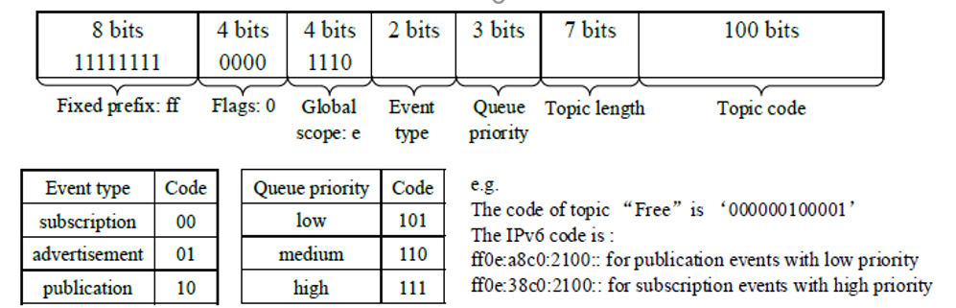
- Details of IPv6 address for SDN-based Pub-Sub
The Pub Sub can also be designed by eliminating the software broker with L3 unicast routing/fowarding. Here a publisher can be a TCP server using zmq PUB socket with topic encoded as hash of IP address and port number.The subscriber can connect to the pub using SUB socket of zmq.The QoS can be enforced using s SDN router by matching and seperating the topics using port numbers at switch and assigning it to apropriate QoS queues in accordance with the topic priority. Also the QoS parameters like throughput are measured periodically and queue parameters are modified on the fly to enforce topic QoS dynamically according to the changing network behavior.

Implementation

We used Mininet to simulate the network topology. Once the switch in Mininet receives a packet with multicast IP address, it will send a request to the SDN controller to create a multicast group. Then, the controller will find a multicast routing scheme and install it in the related switches. IGMP is used to manage the group. Also, we used pyzmq radio-dish pattern to simulate the multicast messaging. The radio code connects to a multicast IP address and the dish code binds a multicast IP address. One IP address can be connected and bound by multiple radio and dish users.
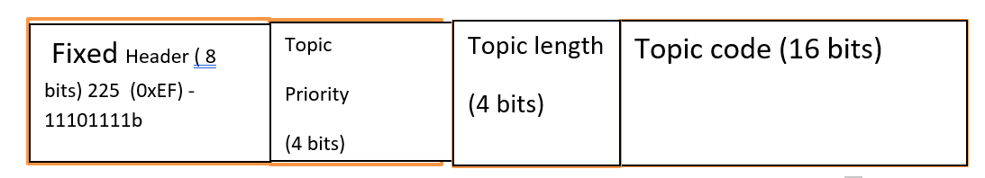
- Details of IPv4 address for SDN-based Pub-Sub
Since IPv6 is still not supported in the draft pyzmq radio-dish pattern, we only use IPv4 addresses for our experiments. The composition of IPv4 addresses is shown as Fig 2. The first 8 bits is fixed, indicating it is a multicast IP address. We have 4 bits for topic priority, 4 bits for topic length and the last 16 bits for topic code. Here, we ignore flags, global scope and event type to make it simple. We used a hashing algorithm to convert the topic string into a topic code. The details of this algorithm can be found in our Python code.

Evalution

Speed of Network-layer Pub-Sub
The first experiment is to compare the packet transfer speed in network-layer Pub-Sub with the one in traditional Pub-Sub, to see how fast the former can be. We use Kafka server as the broker in the traditional Pub-Sub and use IPv4 unicast IP address for it. The architecture of both is shown as Fig 3 and Fig 4.
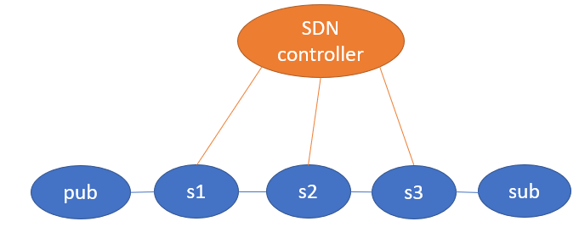
- Architecture of network-layer Pub-Sub
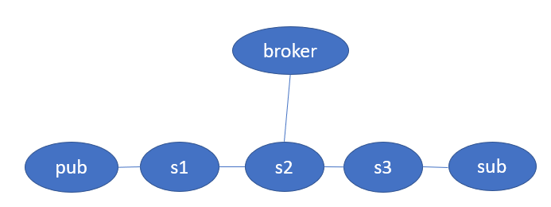
- Architecutre of tranditional Pub-Sub
The data flow for both architectures is as follow: for network-layer Pub-Sub, pub fist sends a packet with multicast address to s1, then the packet is sent to s2, then s3, finally sub. So, the data flow is pub -> s1 -> s2 -> s3 -> sub; for traditional Pub-Sub, once pub sends a packet with unicast IP address, it will be transferred to the Kafka broker first, then the broker will forward it to sub. So, the data flow is pub -> s1 -> s2 -> broker, broker -> s2 -> s3 -> sub. The messaging speed for network-layer Pub-Sub is expected to be faster than the broker-based Pub-Sub, since in the latter case, the routing path is longer than the former one and the broker needs time to receive and forward packets.
We define response time as the difference between the time when sub receives the packet and the time when pub sends the packet. We then compare the response time in both cases over 100 samples. Our results are as follow: the average response time for broker-based Pub-Sub is 0.0034s, while the one for network-layer Pub-Sub is 0.0036s. They are almost the same, which is out of our expectation. We think the reason is that the simulation tools are not perfect. The pyzmq radio-dish pattern written in Python is still a draft according to the official documentation, it may be slower compared to Kafka, which is written in Java. To exclude the simulation problem, we need to setup the experiment using hardware SDN switch rather than Mininet simulator which is also written in python. Another reason could be that switches take more time to look up the multicast flow table than the unicast flow table.

QoS requirment in Network-layer Pub-Sub
The second experiment checks the QoS enforcement between 2 topics. One is the high priority topic(stock) and other is low priority topic (weather). The high priority topic should be given more throughput to make its latency lesser. Also, the bandwidth is measured for all the topics and Queues in the SDN switch are modified dynamically using the POX SDN controller to enforce the QoS.

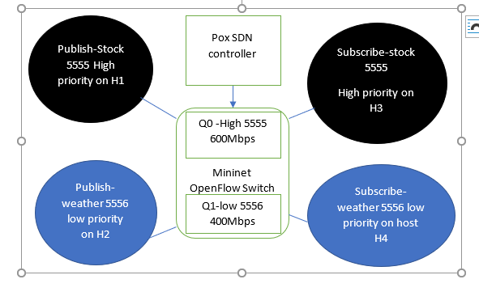
- Showing unicast Pox SDN based switch implementing assured QoS for SDN based pub sub

The test topology is as shown above which has a Mininet based SDN open flow switch simulator connected to a POX SDN controller and 4 hosts H1 runs the publish-stock, H3 runs subscribe-stock. H2 runs publish-weather and H4 runs subscribe-weather, respectively. Topic stock is having higher priority over weather topic. QoS is applied in the Mininet SDN Open flow switch by creating 2 queues Q0 having a bandwidth of 600 Mbps and Q1 having bandwidth of 400Mbps. Total bandwidth is restricted to 1Gbps for both queues. The OpenFlow switch match action table is modified by using POX SDN controller to match packets with port 5555(stock topic) to Q0 (600 Mbps queue) and with port 5556 (weather topic) to Q1(400Mbps queue). Results show that stock topic is given a higher bandwidth than weather topic as shown in fig 7.

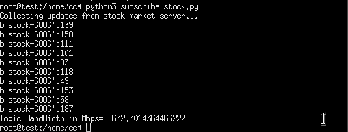

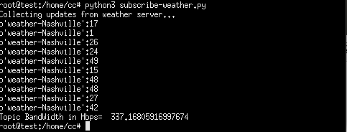

- Showing topic stock (high priority) is always allocated more throughput than for topic weather (low priority)

Teamwork
Ziqi’s work: Read pyzmq documentations and found radio-dish pattern can be used for multicast; wrote sample pub and sub code with radio-dish pattern. Designed and setup the experiment to compare the speed of network-layer Pub-Sub and traditional Pub-Sub.
Nithin’s work: Designed the topic to IPv4 address encoding. Created the multicast Publish middleware in pyzmq and python. I implemented and tested the unicast based SDN based pub sub middleware with 2 topics (1 high priority and 1 low priority) for QoS enforcement in Mininet Openflow switch and POX SDN controller.

Conclusion
To make Pub-Sub faster and to assure QoS between topics, we have implemented it in the network-layer using multicast with SDN technology. We have shown in experiments that even in POX based controller with SDN switch simulator like Mininet results show that QoS is enforced for high priority topics showing high throughput values for high priority topics and it is sure to work on a real hardware SDN switch. This is a good result as Assured QoS is not supported by traditional pub sub like Kafka.
However, the 2 experiments of measuring speed between SDN based pub sub on SDN switch simulator and traditional pub sub, the simulation does not show it is very faster. This is because the SDN simulator is Mininet and it is written in python and runs slower than Kafka which is native java application therefore, we believe that we can see very favorable results when real SDN switch is used rather than Mininet SDN switch simulator as our future work; second, giving a proper definition to Service-Level priority in multicast and implement it.

References

- Shi, Yulong & Zhang, Yang & Jacobsen, Hans-Arno & Tang, Lulu & Elliott, Geoffrey & Zhang, Guanqun & Chen, Xiwei & Chen, Junliang. (2019). Using Machine Learning to Provide Reliable Differentiated Services for IoT in SDN-Like Publish/Subscribe Middleware. Sensors (Switzerland). 19. 10.3390/s19061449.
- Wang, Y.; Zhang, Y.; Chen, J. Pursuing Differentiated Services in a SDN-Based IoT-Oriented Pub/Sub System. In Proceedings of the 2017 IEEE International Conference on Web Services (ICWS), Honolulu, HI, USA,25–30 June 2017; pp. 906–909.

