**keyvalue-db library**

This library contains functions as below. We can use both synchronous and asynchronous way

setpath() - (optional) to set the path of the db file, default is ./db.json

readkey() - to read the key-value pair from the db file. Argument: key

createkey() - to create new key-value pair and adds to the db file. Argument: key, value, timeout(default: 0)

deletekey() - to delete the existing key-value pair from the db file. Argument: key

Created a CLI app for synchronous way and Web app for asynchronous way. Attached the screenshot below.

* git clone <https://github.com/nithinleo14/keyvalue-db.git>
* npm install
* npm run start-web - to start the web app
* npm run start-cli - to start the cli

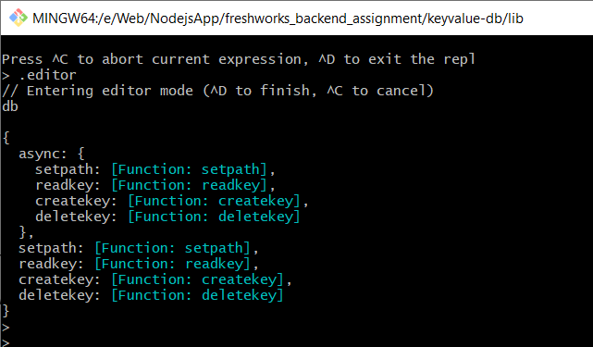

**Using keyvalue-db library in node shell**

Here we are adding apple with default timeout value (0). This value we can read at any time.

Next we are including number in the key which gives us the error.

Then we are a key: grape with 15 sec as timeout value. Reading grape within 15 secs.

Reading the key: grape after 15 secs gives us the error as below.

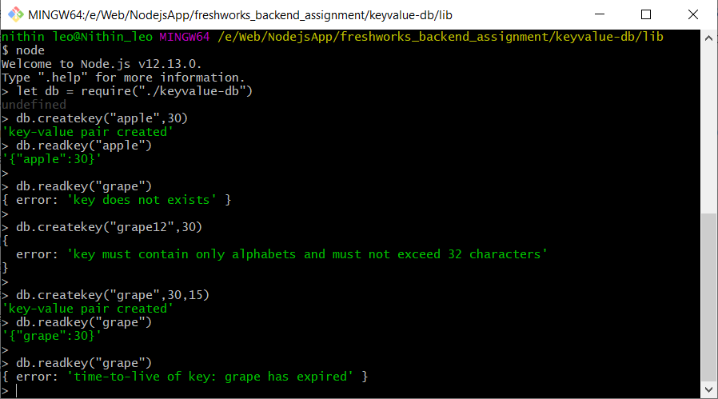

Here we creating new key-value pair with key lemon having timeout as 40 sec.

Again creating key: banana with timeout 0.

Next deleting banana is successful since timeout is 0.

While deleting lemon after 40 sec gives us the time-to-live expired error

Creating key which exceeds 32 characters gives us error.

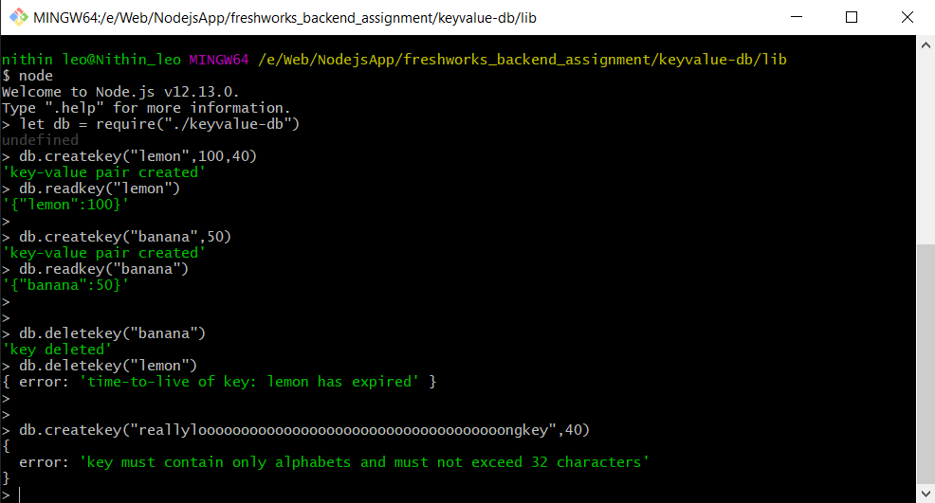

Here we can use setpath() to set a new path for the json file. Default path ./db.json

If we need to set a different path we can do that using setpath() like below.

If we give filename other than json file it gives us error. Also if the file name contains invalid characters it gives us error.

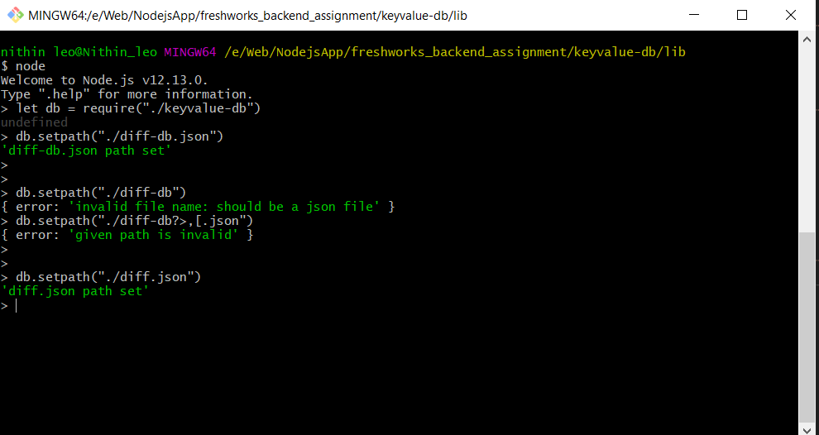

**CLI app using keyvalue-db library (synchronous way)**

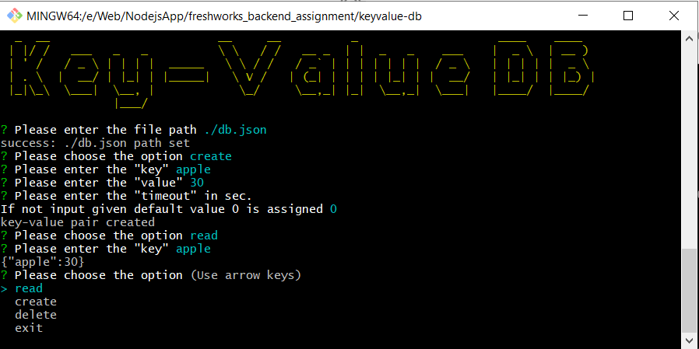

Errors:

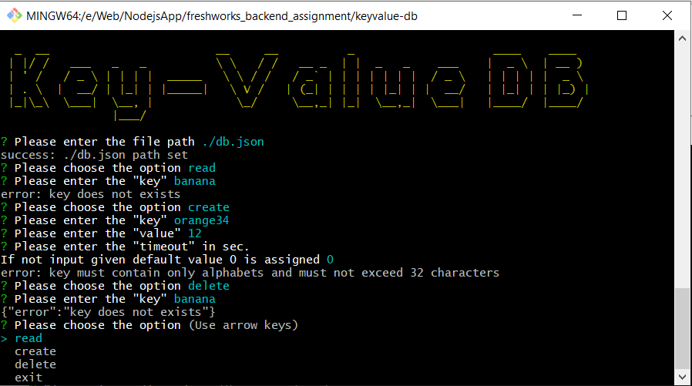

Error: time to live expired

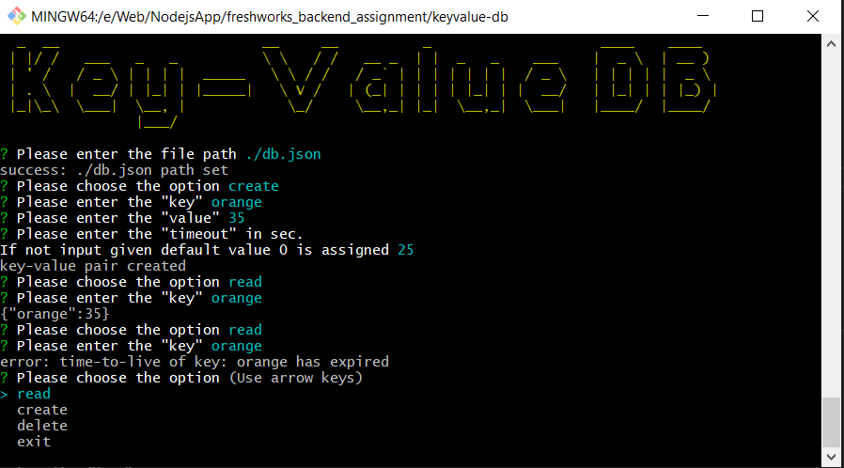

**Web app using keyvalue-db library (asynchronous way)**

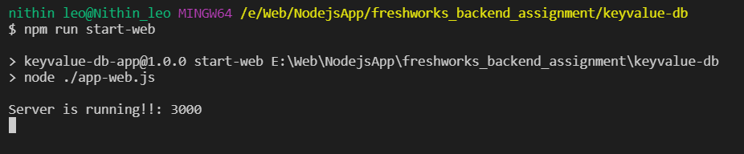

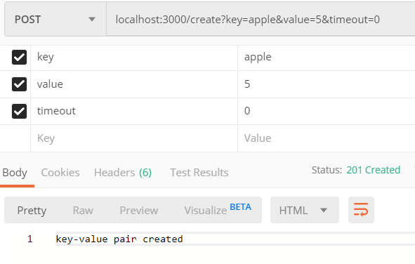

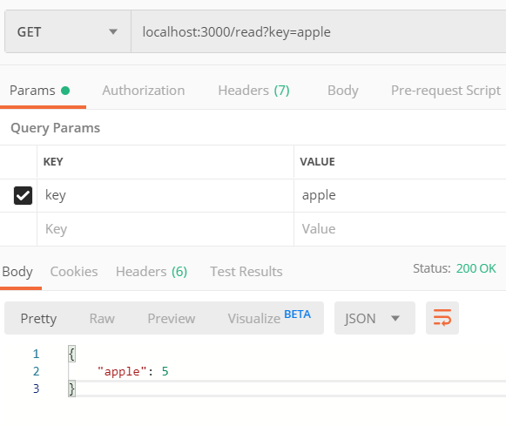

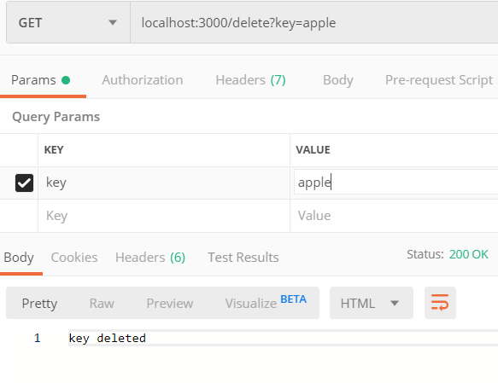

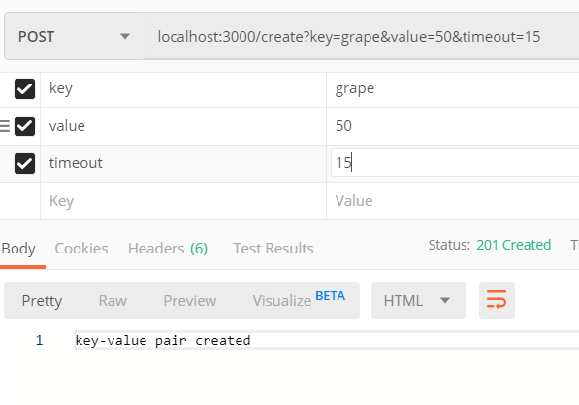

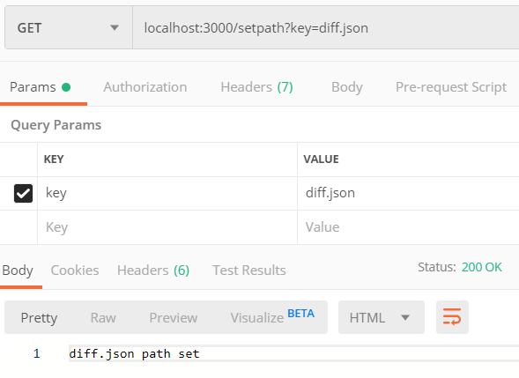

Errors:

