

School of Computer Science & Engineering

VIT-AP UNIVERSITY, INAVOLU, AMARAVATI

CREDIT CARD FRAUD PREDICTION

PROJECT NAME :- CREDIT CARD FRAUD PREDICTION

TEAM MEMBERS :-

CH. GEMINI KRISHNA (Team lead)
A. MAHENDRANADH CHOWDARY (Documentation)
M.NITHIN SAI (Data Scientist)

V.SAI KRISHNA (Data Analyst)

GUIDED BY :- Dr. Gopikrishnan S

INDEX

Introduction
Problem Statement
Abstract
What is Credit card Prediction
How does credit card fraud happen
Techniques used in Credit card fraud
Dataset
Data Cleaning
Loading data
Exploring data
Data Manipulation
Data Modelling
Prevention of Payment Credit card fraud
Conclusion
References
Acknowledgement

INTRODUCTION

A credit card is a thin handy plastic card that contains identification information such as a signature or picture, and authorizes the person named on it to charge purchases or services to his account - charges for which he will be billed periodically. Today, the information on the card is read by automated teller machines (ATMs), store readers, bank and is also used in online internet banking system. They have a unique card number which is of utmost importance. Its security relies on the physical security of the plastic card as well as the privacy of the credit card number. Credit cards are now the most preferred way for customers to transact either offline or online. There are a number of reasons, due to which consumers are slowly shifting from debit card transactions to credit cards, especially in developing countries like India.
Tie up credit cards with online and offline merchants, especially during festive seasons like Diwali, Eid, and Christmas, to offer further discounts on transactions. Several online merchants run their own promotional campaigns, which are tied up with credit cards—for example, Amazon Prime day, which happens at least once a year. Immediate needs can be fulfilled (for example, medical emergencies, lifetime events, etc.) quickly instead of having sufficient account balance for the same. Most credit cards offer 0% EMI options, so it makes it all the more worth pursuing this goal.
Due to its importance, it is possible to find a lot of studies on fraud prediction in literature. The most commonly used fraud prediction methods are rule-induction techniques, decision trees, neural networks, Support Vector Machines (SVM), logistic regression, and meta-heuristics such as genetic algorithms techniques can be used alone or in collaboration using ensemble or meta-learning techniques to build classifiers.

The main idea is first to determine a set of suspicious transactions and then run a Bayesian learning algorithm on this list to predict the frauds presented a different approach and used association rule mining to define the patterns for normal card usage and indicating the ones not fitting to these patterns as suspicious.

PROBLEM STATEMENT

The Credit Card Fraud Prediction Problem includes modelling past credit card transactions with the knowledge of the ones that turned out to be a fraud. This model is then used to identify whether a new transaction is fraudulent or not. Our aim here is to detect 100% of the fraudulent transactions while minimizing the incorrect fraud classifications. Credit card frauds can be made in many ways such as simple theft, application fraud, counterfeit cards, never received issue (NRI) and online fraud (where the card holder is not present). In online fraud, the transaction is made remotely and only the card’s details are needed. A manual signature, a PIN or a card imprint are not required at the time of purchase. Though prevention mechanisms like CHIP&PIN decrease the fraudulent activities through simple theft, counterfeit cards and NRI; online frauds (internet and mail order frauds) are still increasing in both amount and number of transactions. According to Visa reports about European countries, approximately 50% of the whole credit card fraud losses in 2008 are due to online frauds.

ABSTRACT

The usage of credit cards for online and regular purchases is exponentially increasing and so is the fraud related with it. A large number of fraud transactions are made every day. Various modern techniques like Data Mining, Genetic Programming, etc. are used in detecting fraudulent transactions. This paper uses genetic algorithm which comprises of techniques for finding optimal solution for the problem and implicitly generating the result of the fraudulent transaction. The main aim is to detect the fraudulent transaction and to develop a method of generating test data. This algorithm is a heuristic approach used to solve high complexity computational problems. It is an optimization technique and evolutionary search based on the genetic and natural selection. The implementation of an efficient fraud prediction system is imperative for all credit card issuing companies and their clients to minimize their losses.

Technologies Used:

- R Language
- Machine Learning Algorithms(Logistic Regression, Random Forest, Decision tree) for data prediction
- BaseR , stringr and dplyr,ggplot package for data cleaning

What is Credit Card Fraud Prediction?

Credit Card Fraud prediction is a set of activities that are taken to prevent money or property from being obtained through false pretences.

Fraud can be committed in different ways and in many industries. The majority of prediction methods combine a variety of fraud prediction datasets to form a connected overview of both valid and non-valid payment data to make a decision. This decision must consider IP address, geolocation, device identification, “BIN” data, global latitude/longitude, historic transaction patterns, and the actual transaction information. In practice, this means that merchants and issuers deploy analytically based responses that use internal and external data to apply a set of business rules or analytical algorithms to detect fraud.

How Does Credit Card Fraud Happen?

Credit card fraud is usually caused either by card owner’s negligence with his data or by a breach in a website’s security. Here are some examples:

- A consumer reveals his credit card number to unfamiliar individuals.
- A card is lost or stolen and someone else uses it.
- Mail is stolen from the intended recipient and used by criminals.
- Business employees copy cards or card numbers of its owner.
- Making a counterfeit credit card.

When your card is lost or stolen, an unauthorized charge can happen; in other words, the person who finds it uses it for a purchase. Criminals can also forge your name and use the card or order some goods through a mobile phone or computer. Also, there is the problem of using a counterfeit credit card – a fake card that has the real account information that was stolen from holders. That is especially dangerous because the victims have their real cards, but do not know that someone has copied their card. Such fraudulent cards look quite legitimate and have the logos and encoded magnetic strips of the original one. Fraudulent credit cards are usually destroyed by the criminals after several successful payments, just before a victim realizes the problem and reports it.

VARIOUS TECHNIQUES USED IN CREDIT CARD FRAUD

The advent of credit card has not just provided us with the comfort and convenience but has also attracted malicious characters as it is the easiest way to earn a huge amount of money over a very short span of time. Also, it takes a while
to realize such kind of fraud has occurred to the user.

A few common techniques that fraudster uses are:

- Copying a credit card and somehow getting hold of the secret pin of the user.

- Vendors charging more money from the user’s credit card compared to what they have agreed to and without the latter being aware of the charged money. So, not just the customers but, the bank issuing credit cards suffer from the losses and hence, it is their interest to reduce the illegitimate use of credit cards leading to development of various credit card fraud detection techniques.

CREDIT CARD FRAUD DETECTION METHODS

A proper and thorough literature survey concludes that there are various methods that can be used to detect credit card fraud detection. Some of these approaches are:

- Artificial Neural Network
- Bayesian Network
- Neural Network
- Hidden Markov Method
- Genetic Algorithm

DATASET
I have acquired the dataset from Kaggle.

Importing the dataset

Dataset = read_csv('data.csv')
This code imports our data stored in CSV format.
We can have a look at our data using the ‘view()’ function

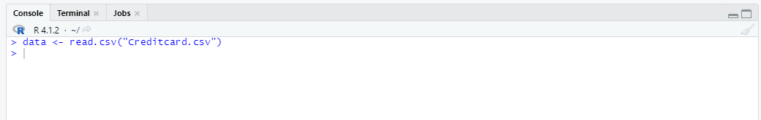



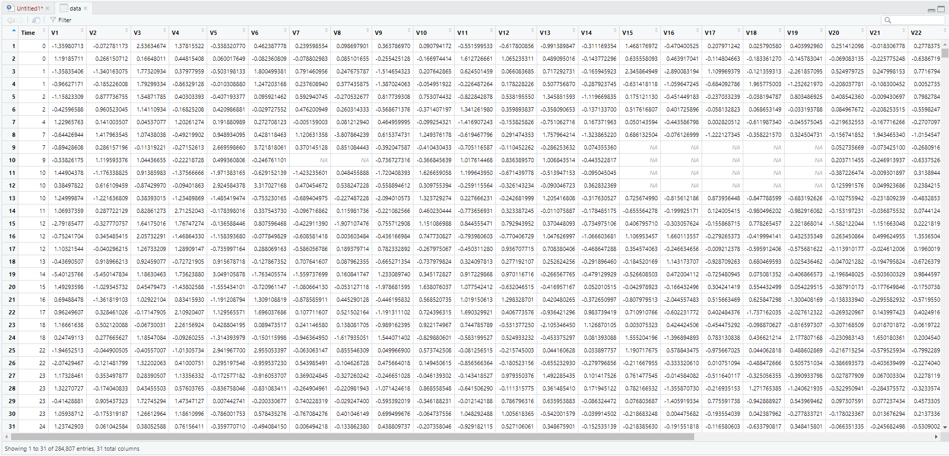
Using str() to understand the data

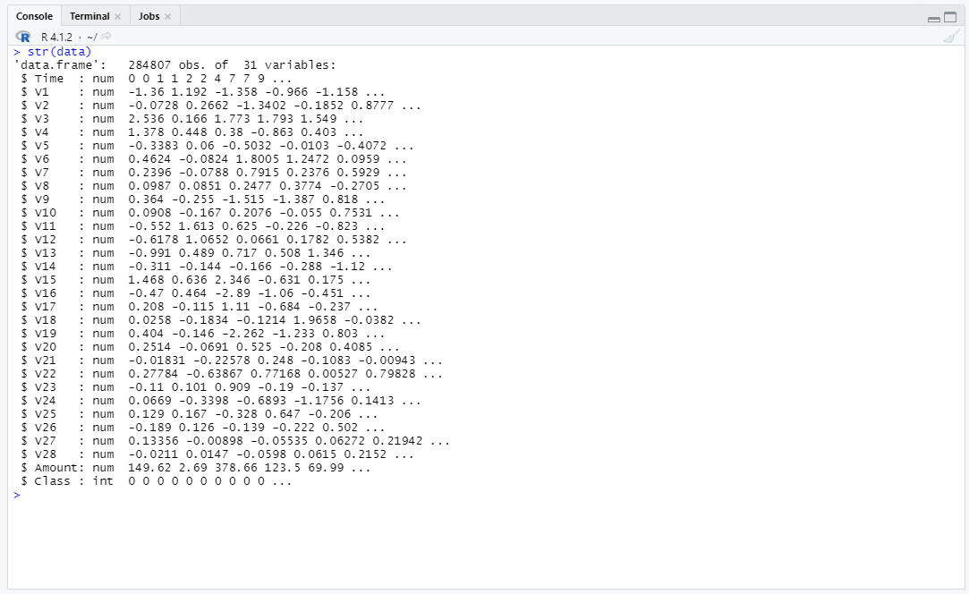

Performing Data Cleaning
Checking for null Values

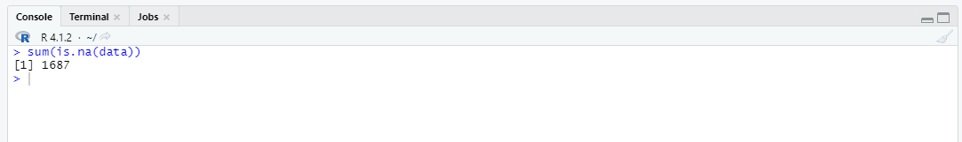

There are a total of 1687 null values in the dataset so we have to clear those null values to make the data better

Changing all columns to double



Replacing null values with mean for each column
First we check for null values in each column and change those na’s with mean of the column, and we again check for na’s to confirm that we replaced them.

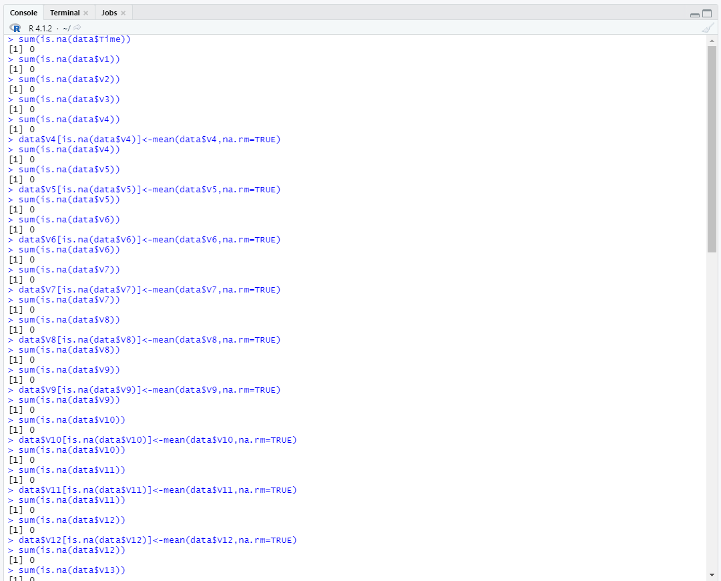

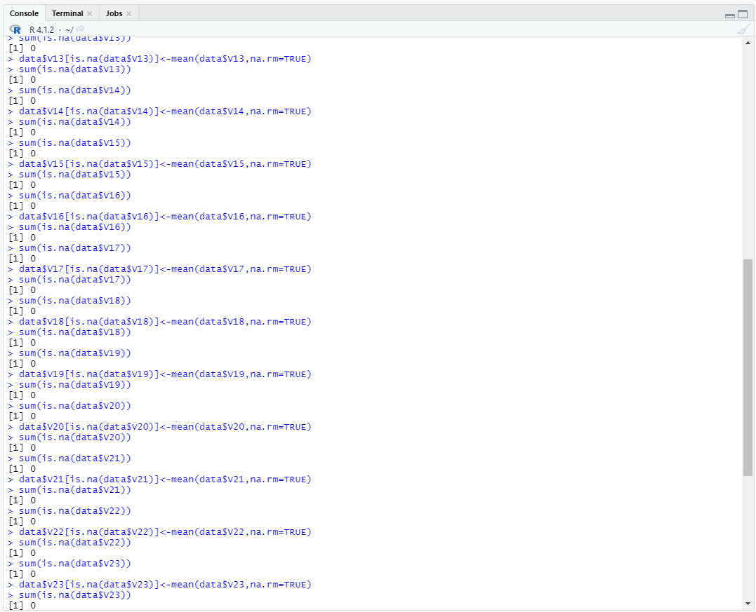

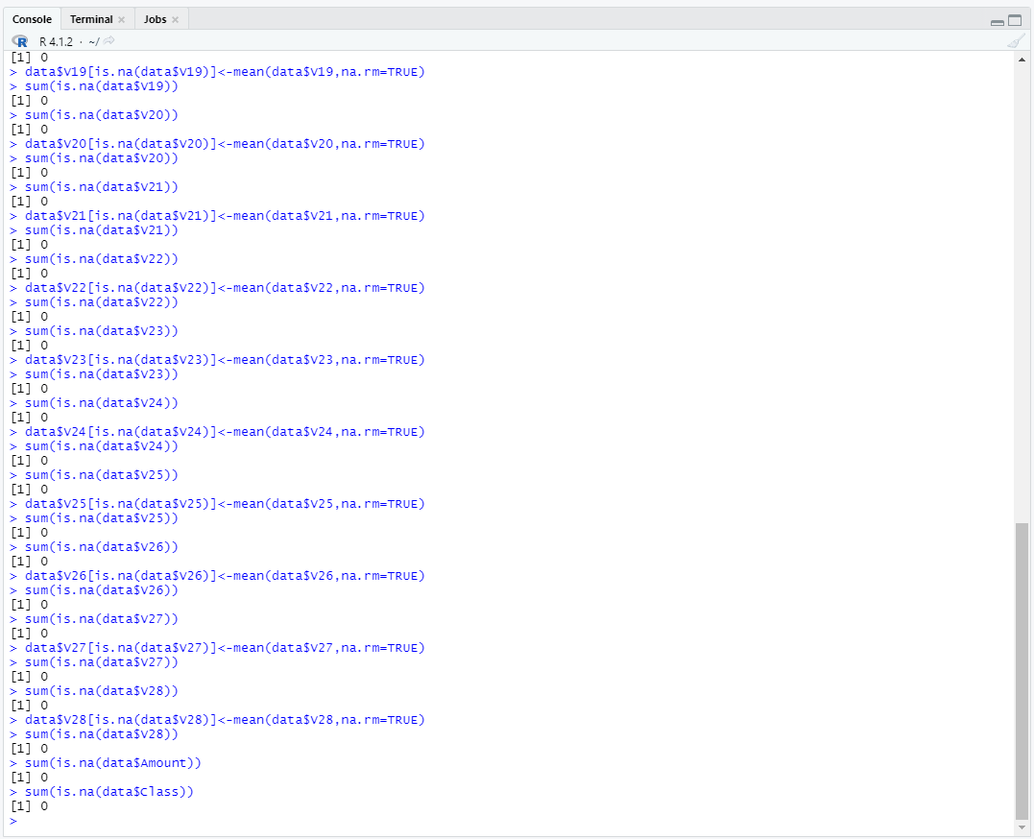



Now we check again for entire dataset for null values
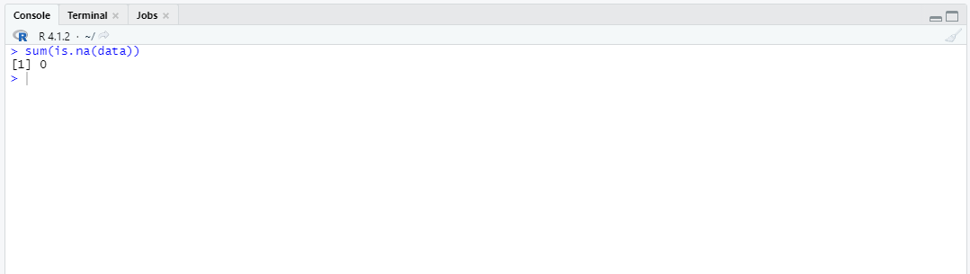

We got 0 so the data is clean Now we have to write this clean dataset into a new csv file

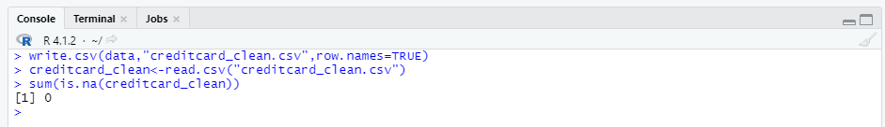

After cleaning the dataset we got 284807 obs. of 32 variables



Cleaned dataset

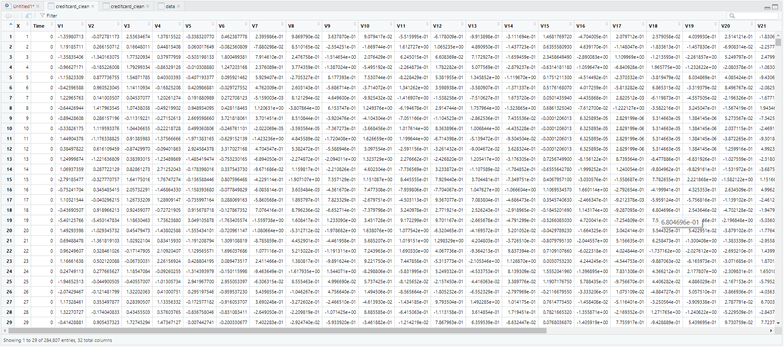

We have to load the required packages

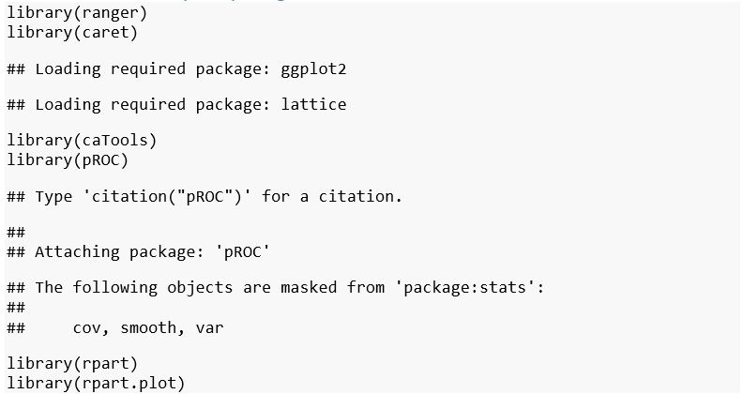

Loading Data
Head first 5 rows

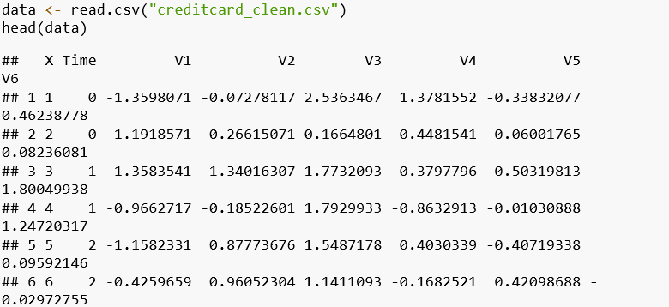
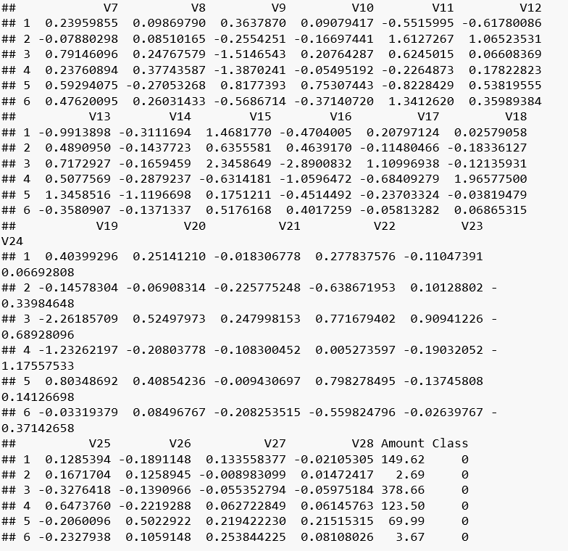

Tail last 5 rows

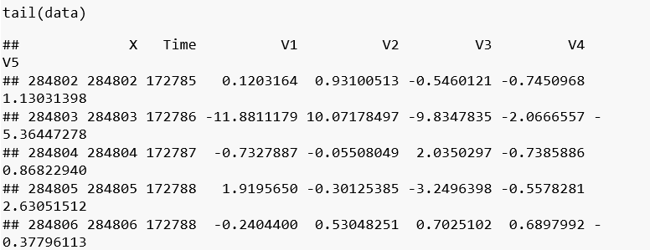
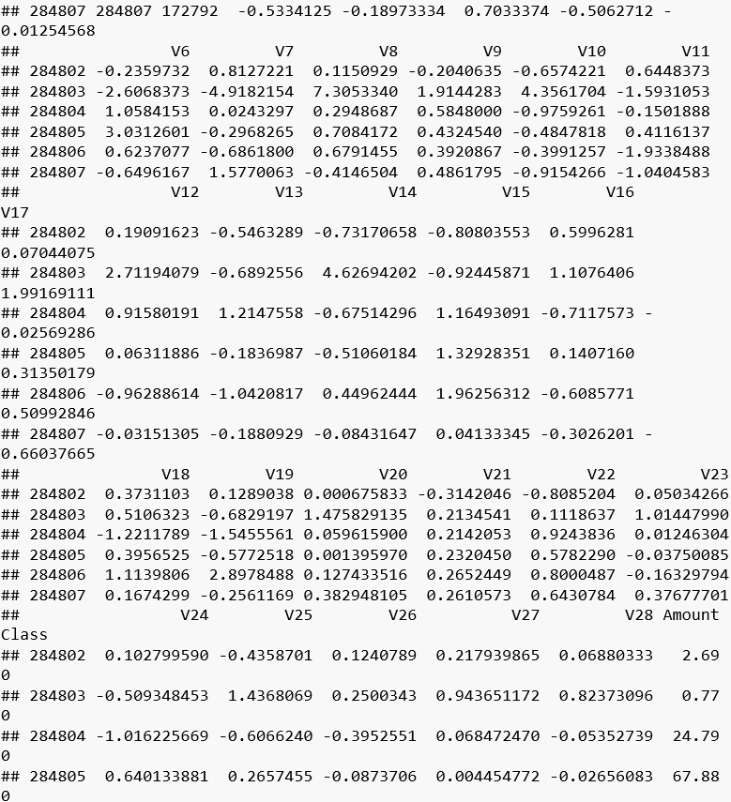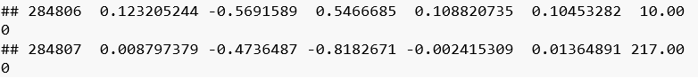
Exploring Data

A BRIEF OVERVIEW OF THE DATA

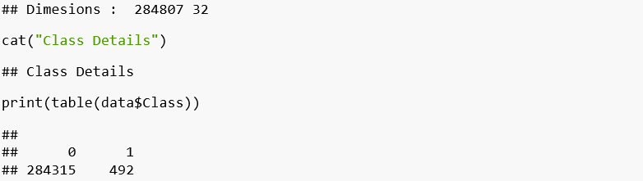
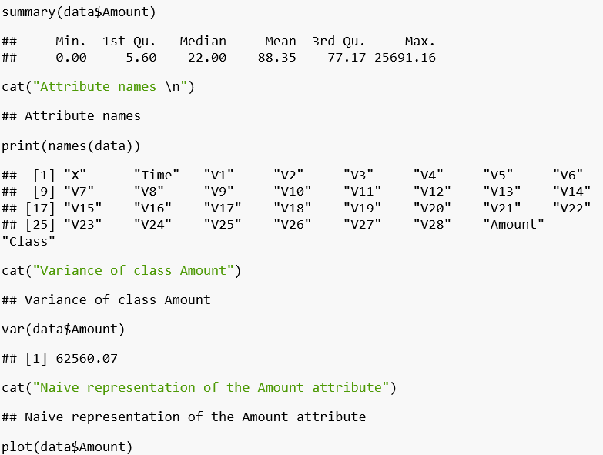

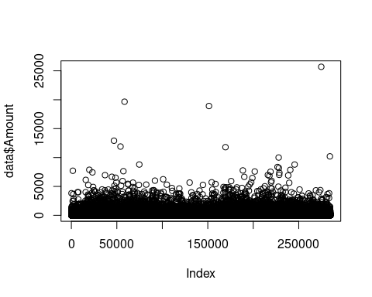

Data Manipulation
Data manipulation refers to the process of adjusting data to make it organized and easier to read for further processes.

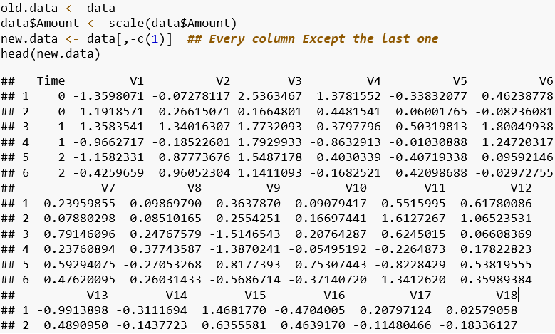
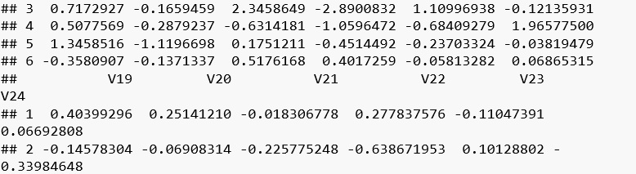
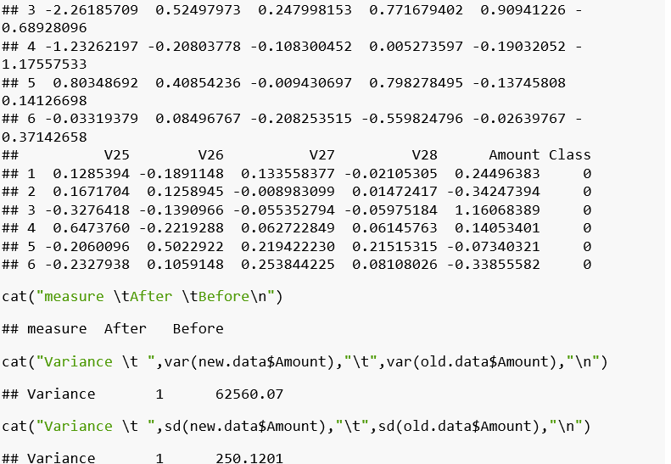

Data Modelling
Data Modelling is the process of analyzing the data objects and their relationship to the other objects. It is used to analyze the data requirements that are required for the business processes.

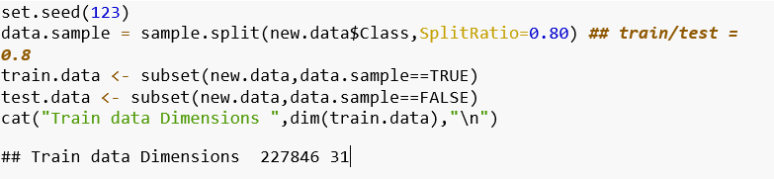

Fitting Model (Logistic Model)
Logistic regression, also called a logit model, is used to model dichotomous outcome variables. In the logit model the log odds of the outcome is modeled as a linear combination of the predictor variables.

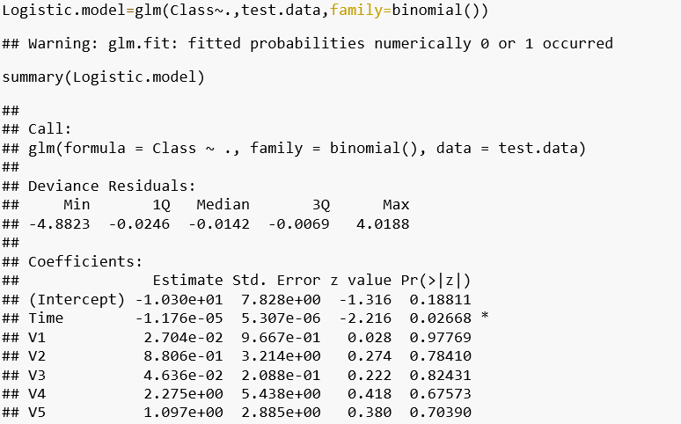
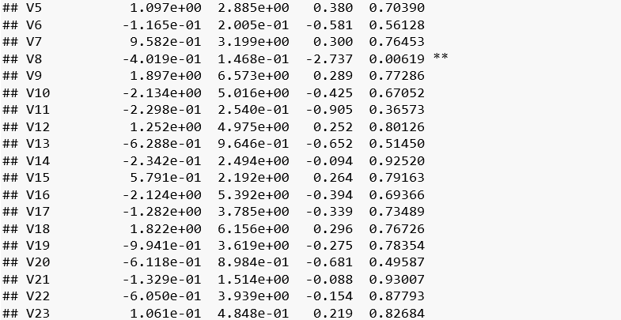
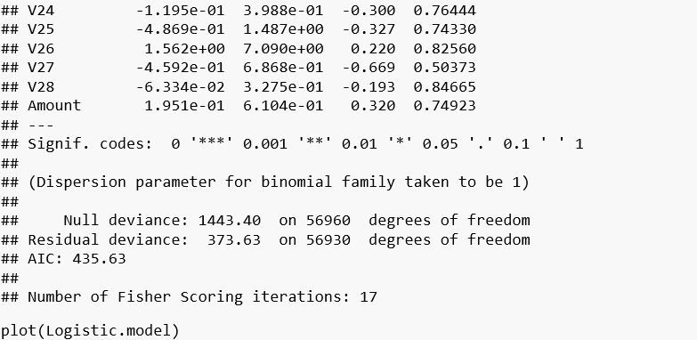

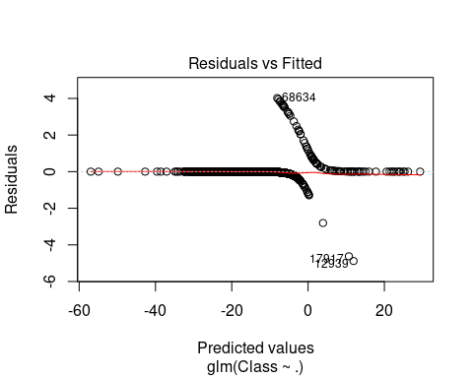

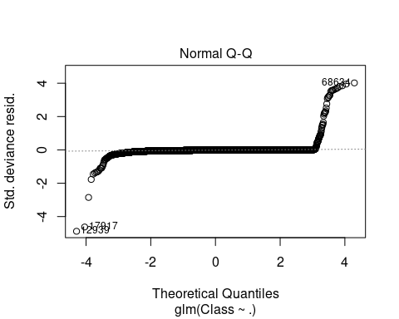

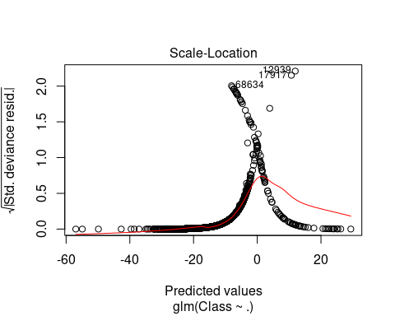

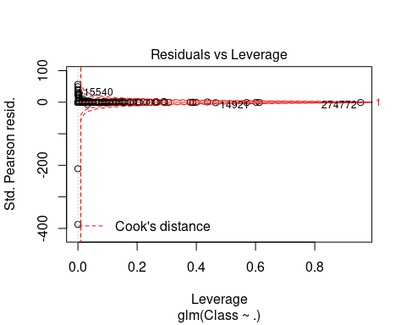

Fitting Decision Tree

Decision Trees are a popular Data Mining technique that makes use of a tree-like structure to deliver consequences based on input decisions. One important property of decision trees is that it is used for both regression and classification. This type of classification method is capable of handling heterogeneous as well as missing data. Decision Trees are further capable of producing understandable rules. Furthermore, classifications can be performed without many computations.

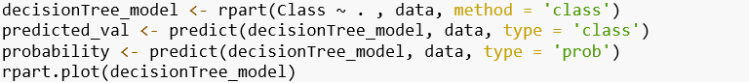
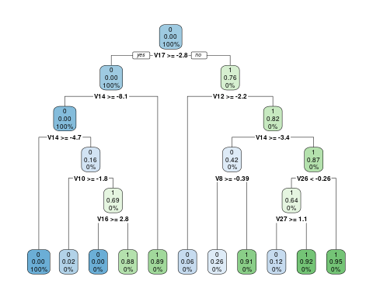

Prevention of payment card fraud

Card information is stored in a number of formats. Card numbers – formally the Primary Account Number (PAN) – are often embossed or imprinted on the card, and a magnetic stripe on the back contains the data in a machine-readable format. Fields can vary, but the most common include Name of the card holder Card number; Expiration date; and Verification CVV code. In Europe and Canada, most cards are equipped with an EMV chip which requires a 4 to 6 digit PIN to be entered into the merchant's terminal before payment will be authorized. However, a PIN isn't required for online transactions. In some European countries, if you don't have a card with a chip, you may be asked for photo-ID at the point of sale.

In some countries, a credit card holder can make a contactless payment for goods or services by tapping their card against a RFID or NFC reader without the need for a PIN or signature if the cost falls under a pre-determined limit. However, a stolen credit or debit card could be used for a number of smaller transactions prior to the fraudulent activity being flagged. Card issuers maintain several countermeasures, including software that can estimate the probability of fraud. For example, a large transaction occurring a great distance from the cardholder's home might seem suspicious. The merchant may be instructed to call the card issuer for verification or to decline the transaction, or even to hold the card and refuse to return it to the customer.

CONCLUSION

This method proves accurate in finding out the fraudulent transactions and minimizing the number of false alert. Genetic Algorithm is appropriate in such kind of application areas. The use of this algorithm in credit card fraud detection system results in detecting or predicting the fraud probably in a very short span of time after the transactions has been made. This will eventually prevent the banks and customers from great losses and also will reduce risks.
This method proves accurate in finding out the fraudulent transactions and minimizing the number of false alert. Genetic Algorithm is appropriate in such kind of application areas. The use of this algorithm in credit card fraud detection system results in detecting or predicting the fraud probably in a very short span of time after the transactions has been made. This will eventually prevent the banks and customers from great losses and also will reduce risks.
Credit card fraud is without a doubt an act of criminal dishonesty. This article has listed out the most common methods of fraud along with their detection methods and reviewed recent findings in this field. This paper has also explained in detail, how machine learning can be applied to get better results in fraud detection along with the algorithm, pseudocode, explanation its implementation and experimentation results. While the algorithm does reach over 99.6% accuracy, its precision remains only at 28% when a tenth of the data set is taken into consideration. However, when the entire dataset is fed into the algorithm, the precision rises to 33%. This high percentage of accuracy is to be expected due to the huge imbalance between the number of valid and number of genuine transactions.

REFERNCES

https://www.kaggle.com/chrisbow/credit-card-fraud-prediction-in-r

https://www.researchgate.net/publication/336800562_Credit_Card_Fraud_Detection_using_Machine_Learning_and_Data_Science

https://towardsdatascience.com/credit-card-fraud-detection-using-machine-learning-python-5b098d4a8edc

https://data-flair.training/blogs/data-science-machine-learning-project-credit-card-fraud-detection/

ACKNOWLEDGEMENT

I would like to convey my most heartfelt and sincere gratitude to my Faculty Dr. Gopikrishnan S of VIT-AP University, for his valuable guidance and advice. His willingness to motivate me contributed tremendously to achieve the goal successfully. I also feel thankful and express my kind gratitude for allowing me to conduct CREDIT CARD FRAUD PREDICTION project.

I would like to extend my deep appreciation to all my group members, without their support and coordination we would not have been able to complete this project.

