ASSIGNMENT NO.1
MTH 676 ECONOMETRICS

- Consider the linear regression model 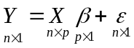 with usual assumptions. How would you find OLSE of  when X is not of full column rank. Will 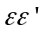attains minimum with such obtained estimator?

- Select five samples from the Monte Carlo data and for each sample compute the values of the OLSE and GLSE of and in a multiple linear regression model with 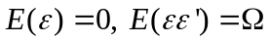 (positive definite).

- Develop a test for testing 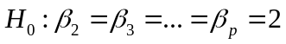 through the framework of general linear hypothesis 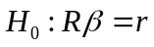 in the linear regression model under usual assumptions where R is 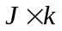 known matrix and r is 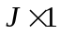 known vector.

- How would you find R² in the model with intercept term and (positive definite). What problems do you expect in such defined R².

- Prove or disprove that R² is valid only when the intercept term is present in the model.

- Prove or disprove that R² increases as the number of covariates increase in the model.
- Consider the linear regression model with usual assumptions under normality of random errors. Consider the least squares estimator of , i.e. 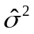. Find the bias and variance of . Also find the minimum mean squared error (MMSE) of

