ASSIGNMENT NO. 2
MTH 676 ECONOMETRICS

Consider the linear regression model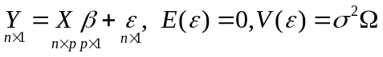 where  is a positive definite matrix.

1. Construct a predictor based on the GLSE of . Analyze its performance in terms of finding the predictive bias and predictive covariance matrix when it is used in within sample prediction for predicting the
(i) actual value of response variable,
(ii) average value of response variable and
(iii) simultaneous prediction of actual and average value of response variable.

2. Construct a predictor based on the GLSE of . Consider the set up of outside sample prediction where 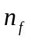 additional observations on each of 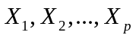 are available but no observations on 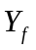 are available which are framed as 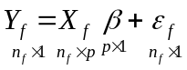 with 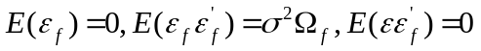. Analyze its performance in terms of finding the predictive bias and predictive covariance matrix when it is used in outside sample prediction for predicting the
(i) actual value of response variable,
(ii) average value of response variable and
(iii) simultaneous prediction of actual and average value of response variable.

3. Construct a predictor based on the GLSE of . Consider the set up of outside sample prediction where additional observations on each of are available but no observations on are available which are framed as with. Analyze its performance in terms of finding the predictive bias and predictive covariance matrix when it is used in outside sample prediction for predicting the
(i) actual value of response variable,
(ii) average value of response variable and
(iii) simultaneous prediction of actual and average value of response variable.

