ASSIGNMENT NO. 3
MTH 676 ECONOMETRICS

Consider the linear regression model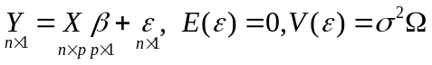 where  is a positive definite matrix in Questions 1 and 2.

1. Consider the availability of prior information or constraints in the form of exact restrictions 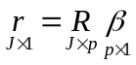 with usual assumptions.
(i) Derive the estimator of  which satisfy the constraints.
(ii) Find out its bias and covariance matrix.
(iii) Employ this estimator for predicting the average and actual values of response variable and derive the predictive bias and predictive covariance matrix in each case.

2. Consider the availability of prior information or constraints in the form of stochastic restrictions 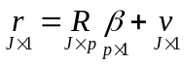 with usual assumptions 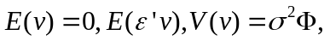 where  is a positive definite matrix.
(i) Derive the estimator of which satisfy the constraints.
(ii) Find out its bias and covariance matrix.
(iii) Employ this estimator for predicting the average and actual values of response variable and derive the predictive bias and predictive covariance matrix in each case.

3. Develop restricted least squares estimates of the parameter vector, using 100 samples of data, a restricted least squares estimator and the restriction
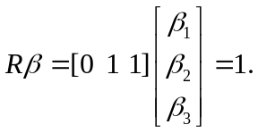
Compare the mean vector and covariance for the 100 samples and compare the sampling results with those results from using an unrestricted least squares estimator. Under a squared error loss measure, develop the risk for the restricted least squares estimates from the 100 samples and compare this empirical risk with the corresponding unrestricted least squares result.

4. Consider the restriction 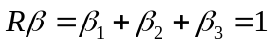as a general linear hypothesis and develop one hundred estimates of the vector by using a pretest estimator with the 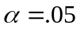 level of significance. Under a squared error loss measure, determine the empirical risk for the pretest estimator and compare it with that of the unrestricted and restricted least squares estimators. Change the restriction or general linear hypothesis to 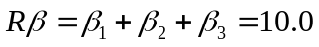and develop the empirical risks for the unrestricted, restricted, and pretest estimators. Discuss the results.

5. Using the stochastic restriction, 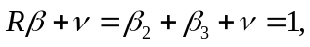 where is assumed to be normal with mean zero and variance 1/64 , obtain 100 estimates of the vector by using the stochastic restricted estimator under known and unknown variance. Develop the mean vector and covariance and contrast with the results from the unrestricted and restricted least squares estimators.

