ASSIGNMENT NO. 4
MTH 676 ECONOMETRICS

Balanced loss function: The balanced loss function is defined as the linear combination of variance and predictive variance. If 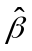 is an estimator of  in a linear regression model 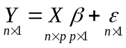 with usual assumptions, then the balanced loss function for is defined as
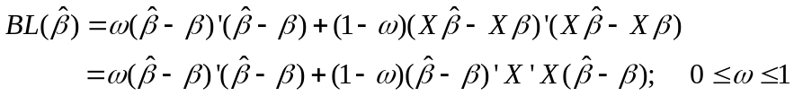
where is the weight assigned to the variance.

1. Consider the linear regression model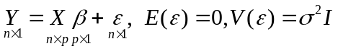. Derive the risk of OLSE under the balanced loss function.

2. Consider the linear regression model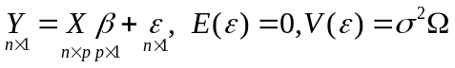 where  is a positive definite matrix. Derive the risk of GLSE under the balanced loss function.

3. Consider the model with availability of prior information or constraints in the form of exact restrictions 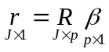 with usual assumptions. Derive the risk of restricted regression estimator of under the balanced loss function.

4. Consider the model and availability of prior information or constraints in the form of stochastic restrictions 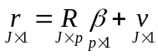 with usual assumptions 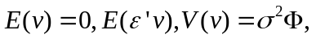 where  is a positive definite matrix. . Derive the risk of restricted regression estimator of under the balanced loss function.

