ASSIGNMENT NO. 6
MTH 676 ECONOMETRICS

- Consider the linear regression model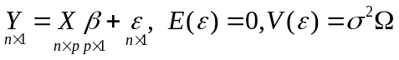 where  is a positive definite matrix. Assume that X and are correlated, in limit.
- Derive the instrumental variable estimator of  using the concept of GLSE.
- Derive the asymptotic distribution of the estimator derived in 1.

- Consider the model 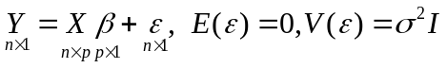. Assume that X and are correlated, in limit., i.e. 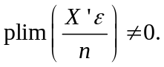
Conduct a Monte Carlo simulation study to find out the performance of IV estimator of by choosing the instruments by Wald’s method, Bartlett’s method and using ranks as instruments.

