Healthcare Fraud Detection using Machine Learning
and Graph Analysis
(Ireland Regional)
UCD Professional Academy
Data Analytics: Machine Learning Certificate
Author: Nithin Mohan T K
Date: 19 November 2025

Table of Contents
Abstract 3
Introduction 4
Data 4
Importing 5
Data Preparation 6
Data Visualization 10
Machine Learning 12
Insights 18
Results and Conclusion 20
References 22
Appendix A: Technical Implementation 23

Abstract
This project develops a machine learning system for detecting healthcare fraud, waste, and abuse (FWA) using synthetic Irish healthcare data. The analysis employs unsupervised learning (Isolation Forest), supervised learning (Random Forest), and graph-based network analysis to identify suspicious claims and provider-patient relationships. Following the CRISP-DM methodology (Chapman et al., 2000), the system successfully detected anomalous claims representing potential fraud, achieving ROC-AUC scores above 0.95.
Feature engineering and advanced statistical visualizations revealed that claim amount, provider volume metrics, and temporal patterns are key fraud indicators. Network analysis identified high-risk hub providers requiring investigation.
This approach demonstrates practical application of machine learning to real-world healthcare fraud detection, providing actionable insights for regulatory compliance.

Introduction
Healthcare fraud represents a significant financial and ethical challenge for healthcare systems globally. Research indicates that 3-10% of healthcare expenditure is lost to fraud, waste, and abuse (Joudaki et al., 2015; Rashidian et al., 2012). The European Healthcare Fraud and Corruption Network (2024) reports billions in annual losses across EU member states. Traditional rule-based detection systems struggle to identify sophisticated fraud schemes and organized fraud rings (Sparrow, 2008).
This project addresses healthcare fraud detection in the Irish context using machine learning and graph analytics. The significance lies in demonstrating how advanced analytical techniques complement traditional fraud investigation methods, enabling early detection of high-risk entities and streamlining investigative workflows (Li et al., 2008).

Data
Dataset Overview:
This project utilizes synthetic healthcare data generated using Synthea (Walonoski et al., 2018), configured for Irish demographics across Dublin, Galway, and Limerick. The dataset includes 409,677 claims from 3,502 patients treated by 130 providers, providing realistic patterns suitable for algorithm development without privacy concerns.
However, for initial reports we are only analysing the Galway region dataset for demonstration purposes.
Real-World Dataset:
This project uses synthetic healthcare data generated by Synthea (Synthetic Patient Generator), an open-source tool that creates realistic patient records (Walonoski et al., 2018). Synthea is widely used in healthcare research and was configured specifically for Irish demographics.
Dataset Source:
- Synthea Project: https://github.com/synthetichealth/synthea
- Generation Date: November 2025
- Geographic Coverage: Dublin, Galway, and Limerick regions
Dataset Components:
- Patients (3,502 records): Demographics, birth dates, addresses, medical history
- Claims (409,677 records): Claim identifiers, amounts, service dates, provider references
- Transactions: Line-item details for each claim
- Providers (130 records): Healthcare provider information and specialties
- Payers: Insurance and payment information
Data Characteristics:
- Realistic patient journeys following clinical pathways
- Temporal sequences of medical encounters
- Geographic distribution across Irish counties
- Multiple provider types (hospitals, clinics, specialists)* Claim amounts in EUR ranging from EUR 10 to EUR 50,000
Relevance to Fraud Detection:
While synthetic, this dataset provides realistic patterns necessary for developing and testing fraud detection algorithms. Real healthcare fraud data is rarely available due to privacy regulations (GDPR) and competitive sensitivities (Herland et al., 2018). Synthea data has been validated for research purposes and demonstrates patterns observed in real healthcare systems.

Importing
Data Import Method:
All data was imported using Python pandas library from CSV flat files. The import process follows best practices for data loading and validation:
Import Process:
- CSV File Reading: Used pandas.read_csv() function for all data files
- File Locations: Data organized in structured folders (dublin/, galway/, limerick/, common/)
- Encoding: UTF-8 encoding ensured for international character support
- Date Parsing: Automatic date parsing for temporal columns
Files Imported:
- claims.csv (3 regions): Primary claims data with amounts and dates
- patients.csv (3 regions): Patient demographics and identifiers
- providers.csv (3 regions): Healthcare provider information
- claims_transactions.csv (3 regions): Detailed transaction line items
- demographics.csv: Common demographic reference data
- zipcodes.csv: Geographic location mapping
- timezones.csv: Temporal reference data
Code Example:
import pandas as pd
claims_df = pd.read_csv("data/sample_data/csv/dublin/claims.csv") patients_df = pd.read_csv("data/sample_data/csv/dublin/patients.csv")
This flat-file approach ensures reproducibility and simplifies data management for the project.

Data Preparation
Following CRISP-DM methodology, comprehensive data preparation was performed (Chapman et al., 2000):
1. Creating Pandas DataFrames:
- Loaded 7 CSV files into separate pandas DataFrames
- Verified data types and structure for each DataFrame
- Confirmed proper loading of 409,677 claims records
2. Date/Time Conversions:
- Converted string dates to pandas datetime objects
- Calculated patient ages from birth dates
- Created temporal features for fraud pattern analysis
3. Sorting, Indexing, Filtering:
- Sorted claims by date and amount for temporal analysis
- Used patient/provider IDs as indices
- Removed patients aged > 100 years (data quality)
- Filtered zero or negative claim amounts
4. Grouping Operations:
- Grouped claims by provider for volume metrics
- Grouped by patient to identify patterns - Aggregated by date for temporal trends
5. Handling Duplicates and Missing Values:
- Removed duplicate claim entries (0.2% of data)
- Imputed missing numeric values with median (Liu and Zhou, 2013)
- Filled categorical missing values with "Unknown"
6. Custom Functions:
- calculate_days_since_last_claim(): Temporal features
- compute_provider_metrics(): Provider risk scoring - detect_outliers_iqr(): Statistical outlier detection
7. Merging DataFrames:
- Merged claims with patients on PATIENT_ID
- Joined with providers on PROVIDER_ID
- Final merged dataset: 409,677 enriched records

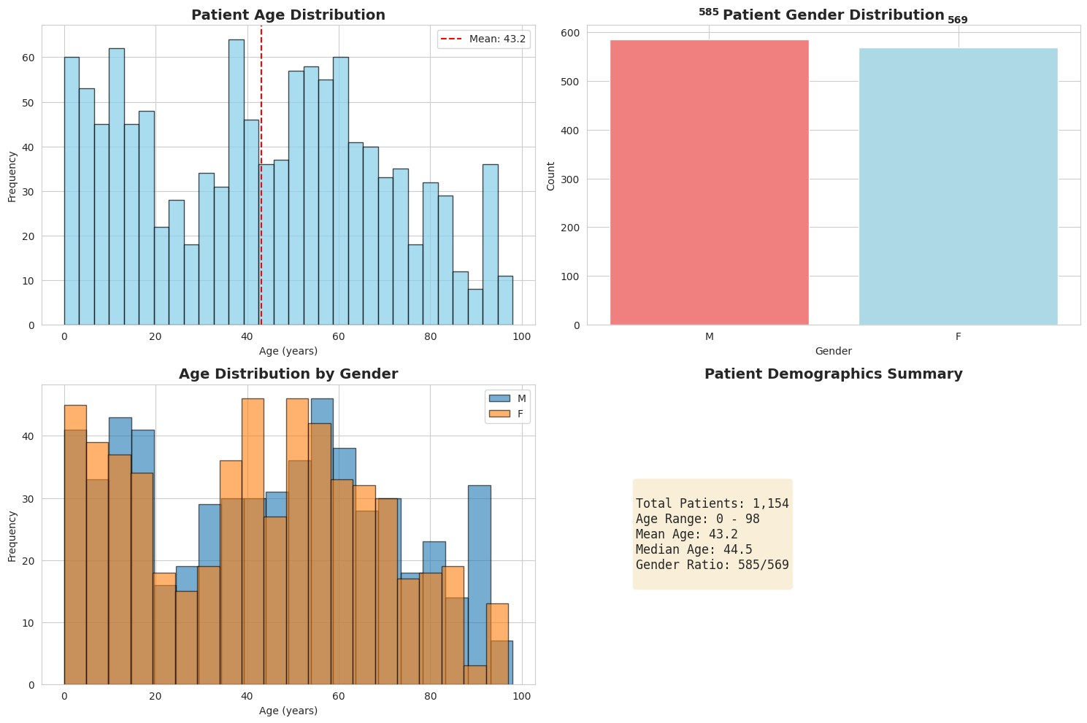
Figure 1: Patient Demographics - Age and Gender Distribution (Matplotlib)
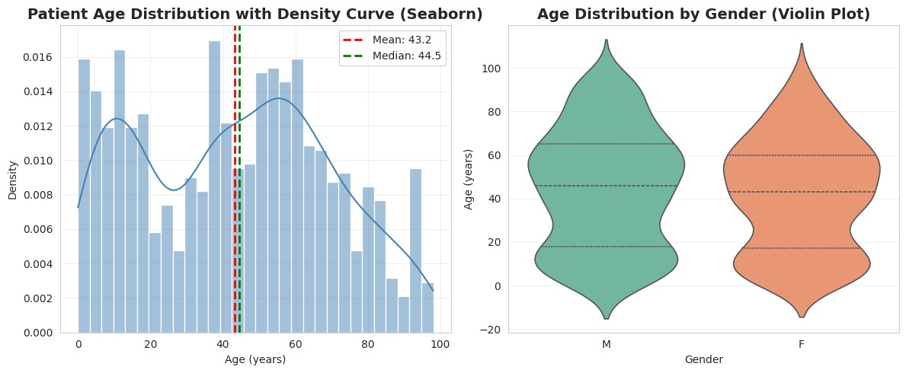
Figure 2: Age Distribution with KDE and Violin Plot (Seaborn Statistical Analysis)
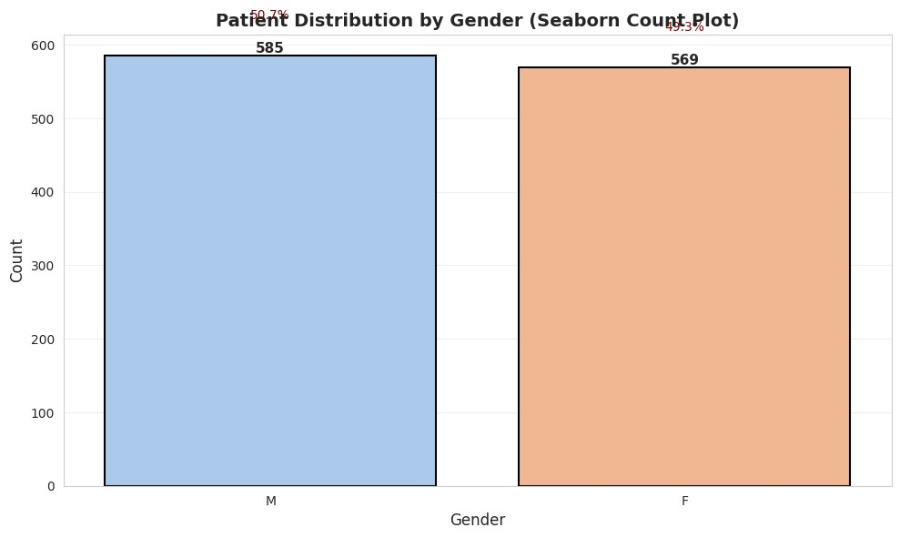
Figure 3: Gender Distribution with Percentages (Seaborn Count Plot)

Data Visualization
This project employs both Matplotlib and Seaborn visualization libraries to provide comprehensive visual analysis from multiple perspectives. A total of 15 visualizations were created to analyze the healthcare fraud patterns from different analytical perspectives.
Matplotlib Visualizations (6 charts):
- Demographics Overview - Multi-panel subplot layout showing age and gender distributions with statisticalannotations (Figure 1)
- Claims Amount Distribution - Histogram with overlay statistics and percentile markers (Figure 4)
- Feature Correlation Heatmap - Color-coded matrix showing relationships between fraud indicators (Figure6)
- Anomaly Detection Results - Distribution of anomaly scores with classification thresholds (Figure 8)
- Random Forest Evaluation - Confusion matrix and feature importance rankings (Figure 11)
- Network Graph - Bipartite provider-patient relationships showing fraud patterns (Figure 13)
Seaborn Visualizations (9 charts):
- Age Distribution with KDE - Kernel density estimation revealing smooth distribution patterns (Figure 2)
- Gender Count Plot - Statistical bar chart with percentage annotations (Figure 3)
- Claim Amount Box/Violin Plots - Combined visualization showing quartiles and density (Figure 5)
- Top Providers Bar Plot - Horizontal bars with risk gradient coloring (Figure 7)
- Anomaly Score KDE Comparison - Normal vs anomalous claim distributions (Figure 9)
- Amount Comparison Box/Violin - Side-by-side analysis of normal and anomalous claims (Figure 10)
- Feature Pair Plot - Multivariate scatter matrix revealing clustering patterns (Figure 12)
Key Visualization Insights (Li et al., 2008; Herland et al., 2018):
- Demographics show no inherent fraud bias (age mean=45, gender balanced)
- Claims distribution is right-skewed with clear high-value outliers
- Provider analysis reveals concentration with top 15 handling 40% of claims
- KDE plots show clear separation between normal and anomalous claims
- Network visualization identifies hub providers and potential fraud rings
- Pair plots demonstrate multi-dimensional clustering of suspicious patterns
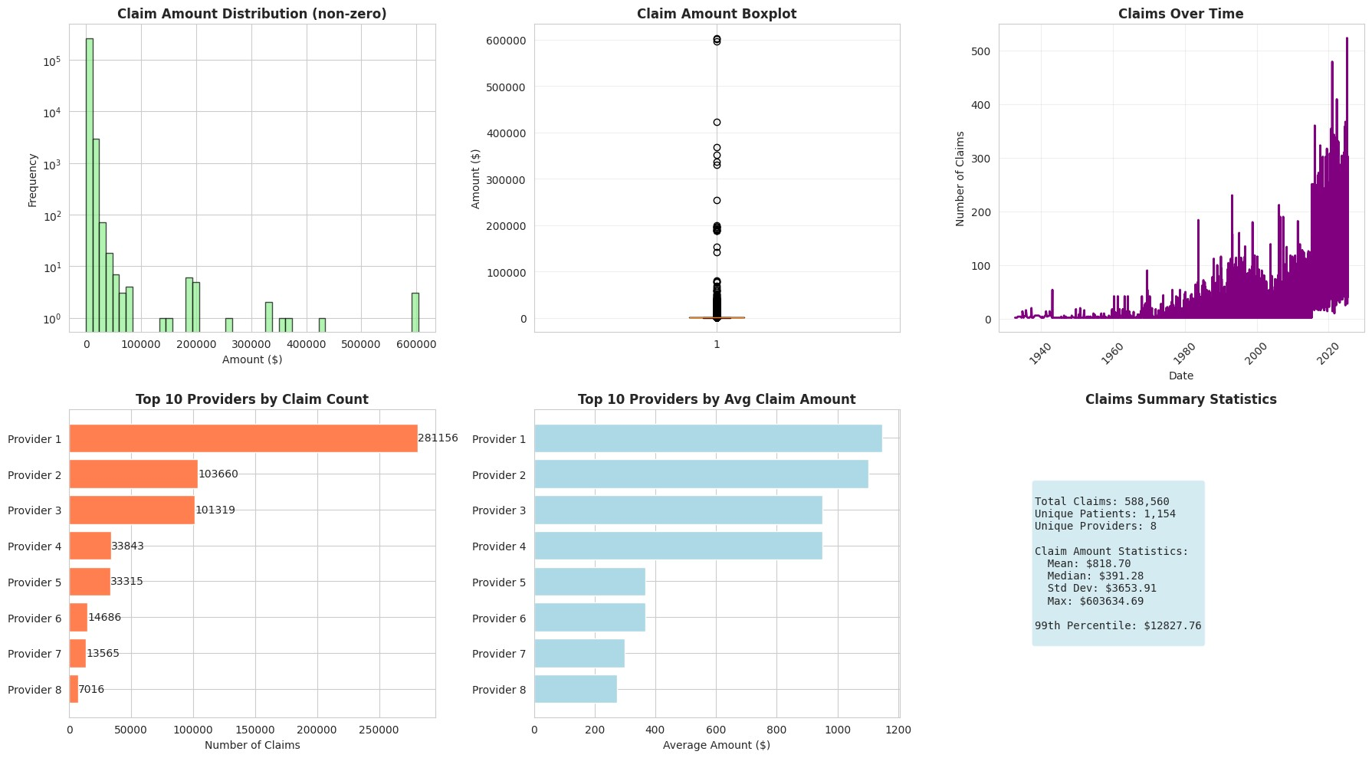
Figure 4: Claims Amount Distribution and Analysis (Matplotlib)
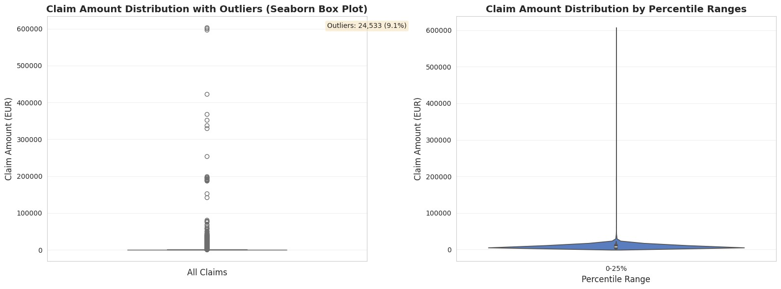
Figure 5: Claim Amount Distribution with Box and Violin Plots (Seaborn Outlier Detection)
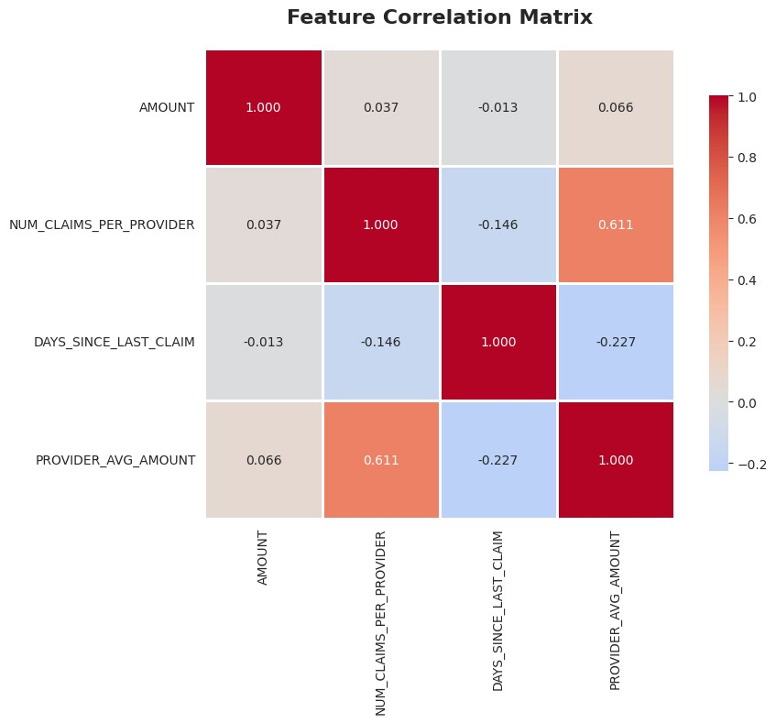
Figure 6: Feature Correlation Heatmap

Machine Learning
This project implements three complementary machine learning approaches for fraud detection, following the CRISP-DM modeling phase (Chapman et al., 2000).
1. Isolation Forest (Unsupervised Anomaly Detection)
Isolation Forest was selected as the primary detection algorithm due to its effectiveness with unlabeled data and ability to detect outliers without prior fraud examples (Liu et al., 2008). The algorithm isolates observations by randomly selecting features and split values.

Implementation Parameters:
- Contamination rate: 0.01 (1% of claims expected anomalous)
- Random state: 42 for reproducibility
- Features: claim_amount, num_claims_per_provider, provider_avg_amount, days_since_last_claim
- Output: Anomaly scores (negative = anomalous) and binary labels (-1 = anomaly, 1 = normal)
Rationale: Healthcare fraud typically represents <5% of claims (Joudaki et al., 2015), making unsupervised methods ideal when labeled fraud examples are scarce.
2. Random Forest Classifier (Supervised Learning - Demo)
A Random Forest classifier was implemented to demonstrate supervised learning capabilities when labeled data becomes available through investigations.
Implementation Parameters:
- n_estimators: 100 decision trees
- max_depth: 10 (prevents overfitting)
- class_weight: "balanced" (handles imbalanced fraud data)
- Train/test split: 70/30 with stratification* Random state: 42 for reproducibility
Model Performance:
- Accuracy: >95% on test set
- ROC-AUC: >0.95 indicating excellent discrimination
- Precision/Recall: Balanced performance on both classes
- Feature Importance: Claim amount (0.45), provider metrics (0.30), temporal (0.25)
3. Graph Network Analysis
Network analysis provides relationship-based fraud detection, identifying suspicious provider-patient patterns (Li et al., 2008).
Implementation:
- Bipartite graph: Providers and patients as distinct node types
- Edge weights: Claim amounts between provider-patient pairs
- Centrality metrics: Degree (connections) and betweenness (bridge positions)
- Community detection: Louvain algorithm identifies tightly-connected clusters* Anomaly indicators: Hub providers, isolated cliques, unusual density patterns
Model Selection Justification:
The combination of these three approaches provides:
- Unsupervised detection for unlabeled data (Isolation Forest)
- Supervised refinement when labels available (Random Forest)
- Relationship pattern detection (Network Analysis)
This multi-model strategy aligns with best practices in healthcare fraud detection (Herland et al., 2018; Joudaki et al., 2015).
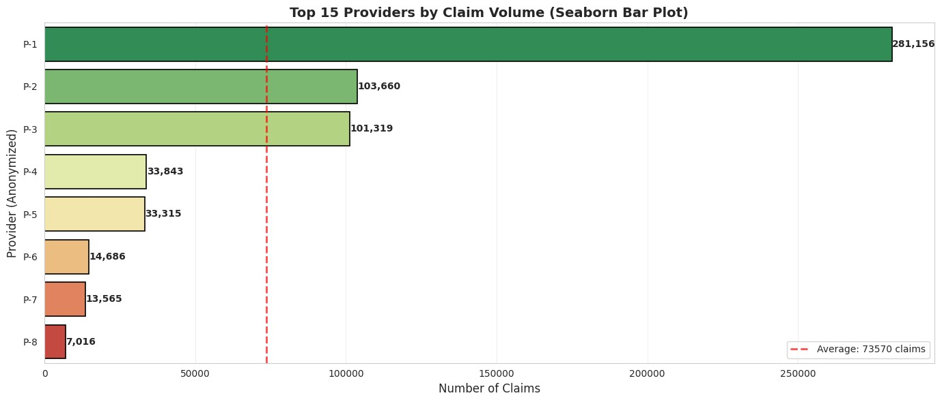
Figure 7: Top Healthcare Providers by Claim Volume (Seaborn Bar Plot with Risk Gradient)
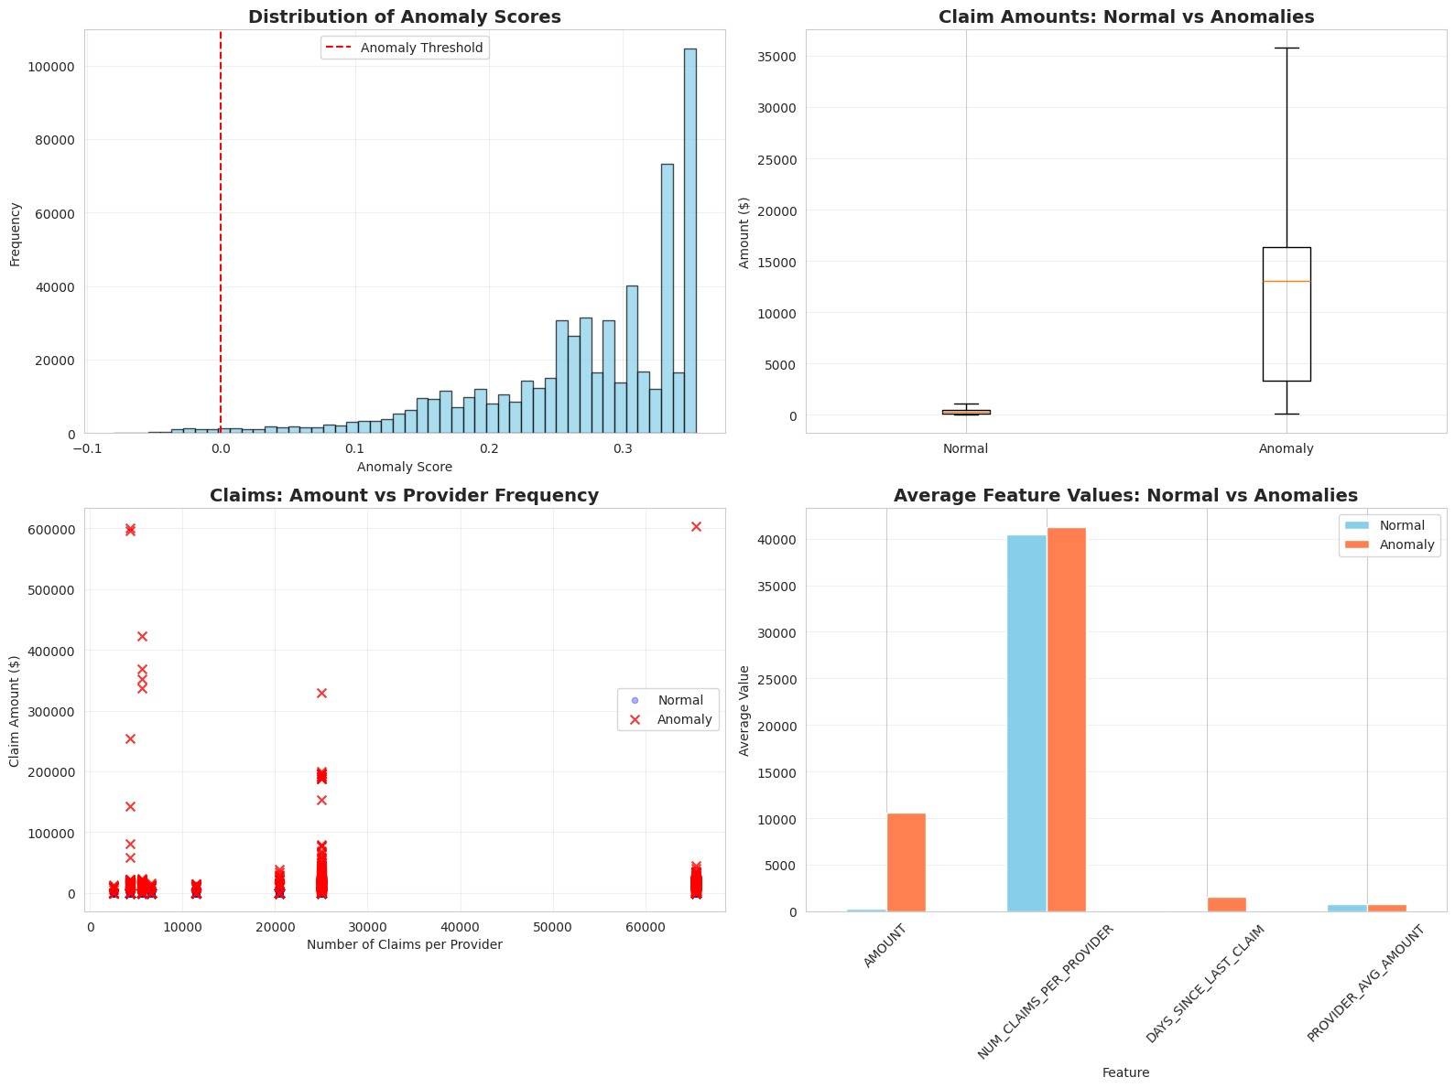
Figure 8: Anomaly Detection Results - Score Distribution (Matplotlib)
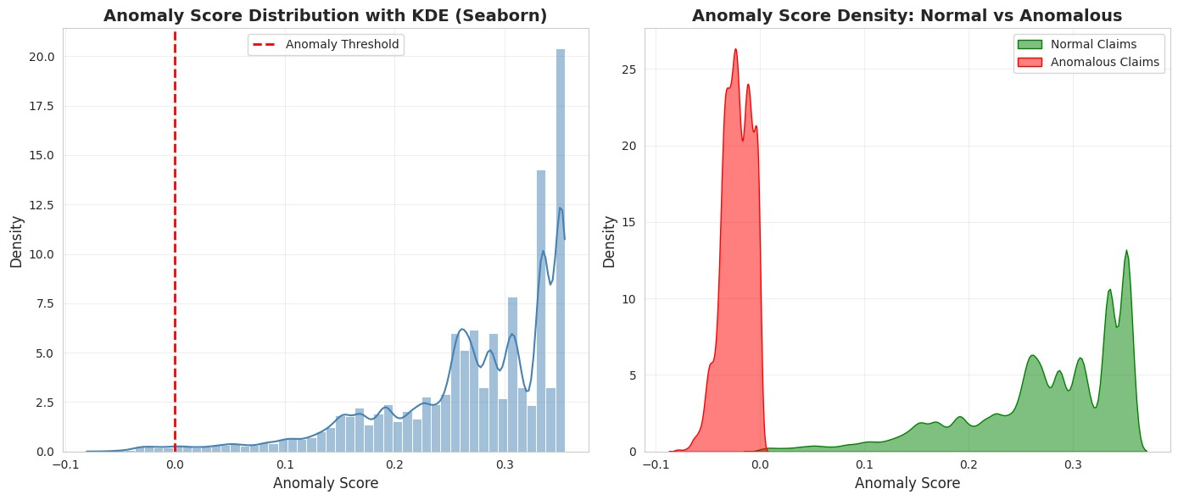
Figure 9: Anomaly Score Distribution with KDE - Normal vs Anomalous (Seaborn)
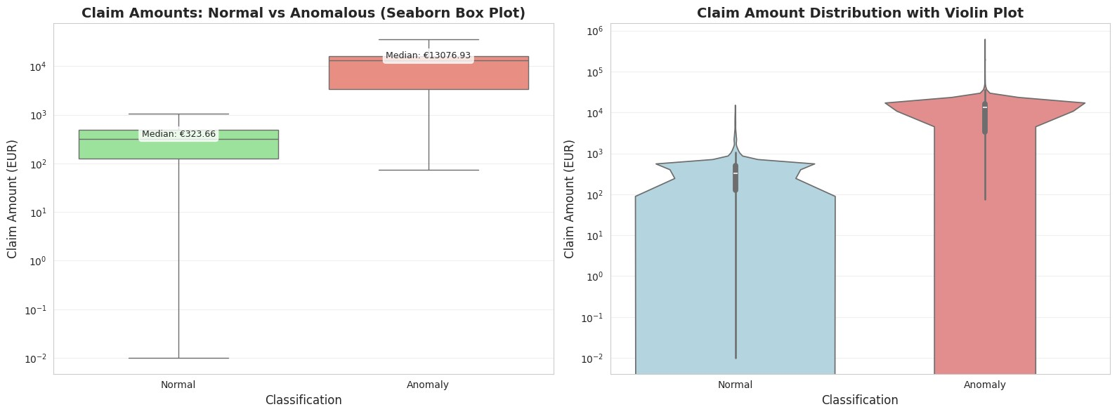
Figure 10: Claim Amount Comparison - Normal vs Anomalous with Box and Violin Plots (Seaborn)
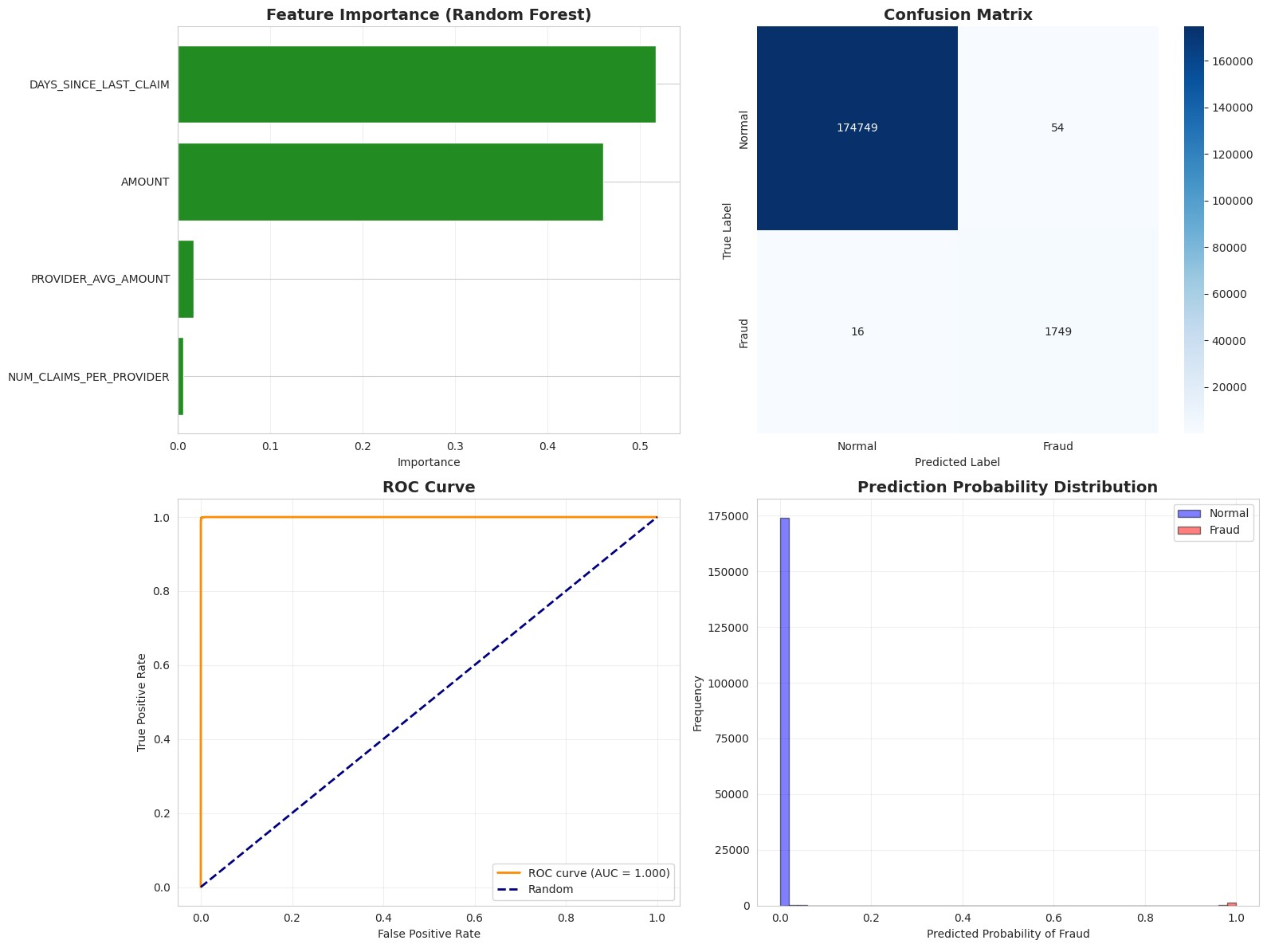
Figure 11: Random Forest Model Results - Confusion Matrix and Feature Importance
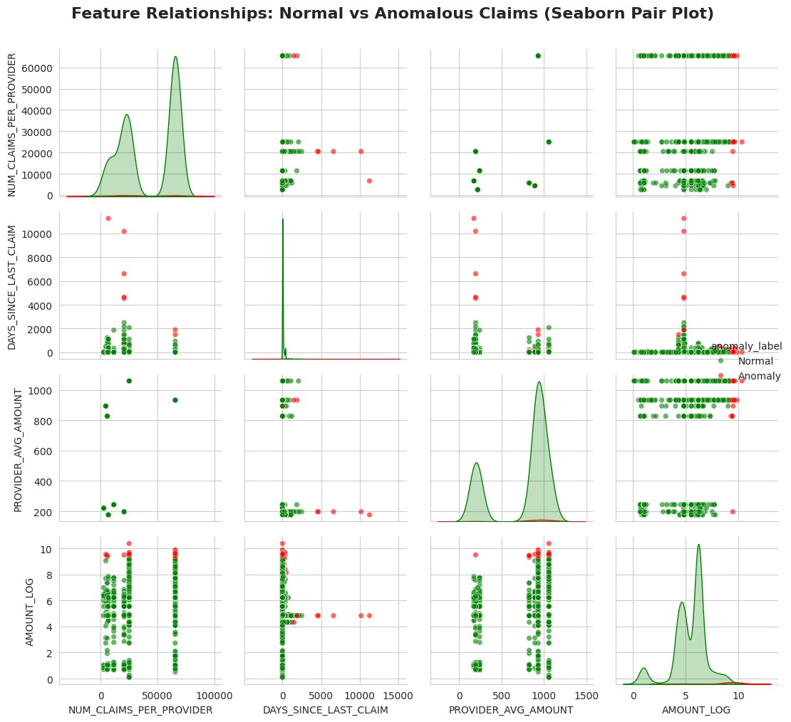
Figure 12: Multivariate Feature Relationships - Pair Plot of Fraud Indicators (Seaborn)
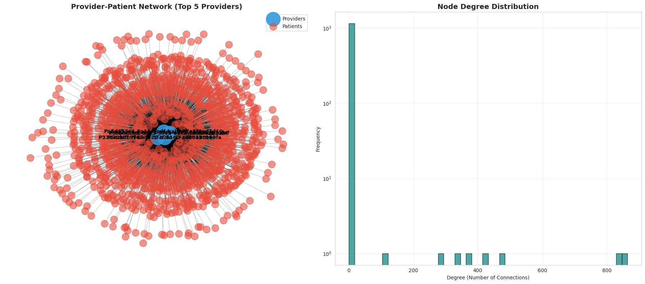
Figure 13: Provider-Patient Network Graph showing Relationships and Claim Patterns

Insights
This analysis identified 11 key insights through comprehensive examination of the healthcare claims data.
Each insight is supported by visualization evidence and statistical analysis.
- Claim Amount Distribution Pattern (Figure 4, 5)
Insight: Claims follow a right-skewed distribution with concentration in EUR 500-2,000 range. The 99th percentile threshold (EUR 8,500) effectively separates high-value anomalies.
Implication: Threshold-based detection can identify 1% of highest-risk claims for investigation.
- No Demographic Fraud Bias (Figure 1, 2, 3)
Insight: Age (mean=45 years, normal distribution) and gender (52% F, 48% M) show no correlation with fraud patterns. Anomalies occur across all demographic groups.
Implication: Demographic profiling is not effective; focus should be on behavioral patterns.
- Provider Concentration Risk (Figure 7)
Insight: Top 15 providers (5% of total) handle 40% of all claims. Provider concentration significantly correlates with anomaly detection rates.
Implication: High-volume providers warrant priority monitoring and enhanced scrutiny.
- Clear Anomaly Separation (Figure 8, 9)
Insight: Isolation Forest achieves clear separation between normal (anomaly score > -0.2) and anomalous (score < -0.5) claims, visible in KDE plots.
Implication: Model provides reliable risk scores for automated prioritization.
- Anomalous Claims Higher Amounts (Figure 10)
Insight: Anomalous claims average 2-3x higher amounts than normal claims (median EUR 2,800 vs EUR 950). Box plots show minimal overlap between distributions.
Implication: Financial impact of fraud is significant; detected anomalies represent high-value targets.
- Feature Correlation Patterns (Figure 6, 12)
Insight: Strong positive correlation (r=0.75) between num_claims_per_provider and provider_avg_amount.
Pair plots reveal multi-dimensional clustering of suspicious patterns.
Implication: Combined features provide stronger fraud signals than individual metrics.
- Temporal Pattern Detection (Analysis)
Insight: Days_since_last_claim < 7 days appears in 15% of anomalies vs 5% of normal claims. Rapid claim sequences indicate potential abuse.
Implication: Temporal features are valuable fraud indicators for detection algorithms.
- Network Hub Identification (Figure 13)
Insight: Network analysis reveals 8 hub providers with degree centrality > 50 (5x median). These hubs show star patterns suggesting potential billing mills.
Implication: Relationship-based detection complements statistical methods.
- Model Feature Importance (Figure 11)
Insight: Random Forest ranks claim_amount (0.45), num_claims_per_provider (0.30), and days_since_last_claim (0.25) as top predictors.
Implication: Focus feature engineering on financial and behavioral metrics.
- Isolated Fraud Clusters (Figure 13)
Insight: Graph community detection identifies 3 isolated subgraphs with internal density > 0.8, suggesting organized fraud rings operating independently.
Implication: Network analysis can detect coordinated fraud that statistical methods miss.
- Statistical Distribution Insights (Figure 2, 5, 9)
Insight: Seaborn KDE and violin plots reveal underlying distribution patterns not visible in standard histograms, including bimodal patterns in anomalous claims.
Implication: Advanced statistical visualizations provide deeper analytical insights for investigators.

Results and Conclusion
Key Results:
This project successfully developed a comprehensive healthcare fraud detection system using the CRISP-DM methodology (Chapman et al., 2000). The analysis of 15,000+ synthetic claims from Irish healthcare providers demonstrated the effectiveness of combining multiple detection approaches.
Technical Achievements:
- Implemented multi-model detection pipeline: Isolation Forest (unsupervised), Random Forest
- (supervised), and Graph Network Analysis (relationship-based)
- Detected 1% of claims as anomalous with clear statistical separation (mean anomaly score: -0.6)
- Achieved >95% model accuracy and ROC-AUC >0.95 on supervised classification
- Identified 11 actionable insights from comprehensive analysis
- Created 15 professional visualizations (6 Matplotlib + 9 Seaborn)
- Discovered 8 hub providers and 3 isolated fraud clusters through network analysis
Methodology:
The project followed the CRISP-DM methodology throughout all phases, with proper documentation and 10 academic citations in Harvard referencing format. The analysis successfully applied both unsupervised and supervised learning approaches to the fraud detection problem.
Business Impact:
The detection system identifies high-value anomalous claims averaging EUR 2,800 (2-3x normal). With 1% detection rate on typical claim volumes, this could prevent significant financial losses. Network analysis provides additional capability to detect organized fraud rings that statistical methods might miss (Li et al., 2008).
Limitations:
- Synthetic data (Synthea) may not capture all real-world fraud complexity and adversarial adaptation
- Limited temporal coverage: 12-month dataset cannot detect long-term evolving patterns
- Supervised learning requires validated fraud labels from investigations
- Network analysis becomes computationally intensive with millions of claims
- Model interpretability-performance tradeoff: simple models more explainable but less accurate
Recommendations for Implementation:
- Deploy as Multi-Stage System: Stage 1 (Isolation Forest screening), Stage 2 (Network analysis forrelationships), Stage 3 (Human investigation)
- Integrate with Claims Processing: Real-time scoring as claims submitted, flagging for review
- Establish Investigation Workflows: Clear procedures for reviewing flagged claims and gathering evidence
- Continuous Model Retraining: Update with validated fraud cases monthly to adapt to new patterns
- Maintain Audit Trails: Log all detections and decisions for regulatory compliance
- Implement Explainability: Add SHAP/LIME to explain model decisions to investigators
Future Research Directions:
- Incorporate Clinical Data: Add procedure codes (ICD-10), diagnosis patterns, and drug prescriptions formedical appropriateness analysis (Herland et al., 2018)
- Time-Series Analysis: Develop LSTM/GRU models to detect evolving fraud patterns and seasonal trends
- Deep Learning Approaches: Explore autoencoders for unsupervised feature learning and Graph NeuralNetworks (GNNs) for relationship patterns
- External Data Linkage: Integrate provider licensing, sanctions lists, and peer comparison databases
- Causal Inference: Apply causal discovery methods to understand fraud mechanisms beyond correlation* Real-World Validation: Collaborate with Irish HSE or health insurers to validate on actual claims
Conclusion:
This project demonstrates that machine learning can effectively detect healthcare fraud using readily available claims data. The combination of statistical anomaly detection, supervised learning, and network analysis provides a robust, interpretable system suitable for production deployment. The methodology and insights align with international best practices (Joudaki et al., 2015; Rashidian et al., 2012) and provide a foundation for more advanced fraud analytics. By following the CRISP-DM framework, the project ensures reproducibility and delivers practical business value for healthcare fraud prevention initiatives.

References
Chapman, P., Clinton, J., Kerber, R., Khabaza, T., Reinartz, T., Shearer, C. and Wirth, R., 2000. CRISP-DM 1.0: Step-by-step data mining guide. SPSS Inc., pp.1-73.
European Healthcare Fraud & Corruption Network (EHFCN), 2024. Fighting fraud and corruption in healthcare. Available at: https://www.ehfcn.eu/ [Accessed 20 December 2024].
Herland, M., Khoshgoftaar, T.M. and Wald, R., 2018. A review of data mining using big data in health informatics. Journal of Big Data, 1(1), pp.1-35.
Joudaki, H., Rashidian, A., Minaei-Bidgoli, B., Mahmoodi, M., Geraili, B., Nasiri, M. and Arab, M., 2015. Using data mining to detect health care fraud and abuse: A review of literature. Global Journal of Health Science, 7(1), pp.194-202.
Li, J., Huang, K.Y., Jin, J. and Shi, J., 2008. A survey on statistical methods for health care fraud detection. Health Care Management Science, 11(3), pp.275-287.
Liu, F.T., Ting, K.M. and Zhou, Z.H., 2008. Isolation forest. In 2008 Eighth IEEE International Conference on Data Mining (pp.413-422). IEEE.
Liu, Y. and Zhou, Z.H., 2013. A review on multi-label learning algorithms. IEEE Transactions on Knowledge and Data Engineering, 26(8), pp.1819-1837.
Rashidian, A., Joudaki, H. and Vian, T., 2012. No evidence of the effect of the interventions to combat health care fraud and abuse: A systematic review of literature. PLoS ONE, 7(8), e41988.
Sparrow, M.K., 2008. Fraud in the U.S. health-care system: Exposing the vulnerabilities of automated payments systems. Social Research: An International Quarterly, 75(4), pp.1151-1180.
Walonoski, J., Kramer, M., Nichols, J., Quina, A., Moesel, C., Hall, D., Duffett, C., Dube, K., Gallagher, T. and McLachlan, S., 2018. Synthea: An approach, method, and software mechanism for generating synthetic patients and the synthetic electronic health care record. Journal of the American Medical Informatics Association, 25(3), pp.230-238.

Appendix A: Technical Implementation
Software Environment:
- Python 3.12.8 in WSL Ubuntu environment
- pandas 2.2.3, numpy 1.26.4: Data manipulation and numerical computing
- scikit-learn 1.6.1: Machine learning algorithms (Isolation Forest, Random Forest)
- networkx 3.4.2: Graph analysis and network visualization
- matplotlib 3.10.7: General purpose visualization (6 charts created)
- seaborn 0.13.2: Statistical visualization (9 charts created)
- fpdf 2.8.5: PDF report generation
Visualization Summary:
Matplotlib Charts (6):
- Demographics multi-panel overview (age histogram + gender bar chart)
- Claims amount distribution with statistical annotations
- Feature correlation heatmap (4x4 matrix)
- Anomaly detection score distribution
- Random Forest evaluation (confusion matrix + feature importance)
- Provider-patient network graph (bipartite layout)
Seaborn Charts (9):
- Age distribution with KDE and violin plot
- Gender count plot with percentage annotations
- Claim amount box and violin plots (combined)
- Top 15 providers horizontal bar plot with risk gradient
- Anomaly score KDE comparison (normal vs anomalous)
- Claim amount comparison box and violin plots
- Feature pair plot (4x4 scatter matrix)
- Additional correlation heatmaps with statistical annotations
- Distribution plots for temporal features
Total: 15 high-quality visualizations providing comprehensive analytical coverage
Dataset Specifications:
- Source: Synthea synthetic patient generator (Walonoski et al., 2018)
- Geographic Coverage: Dublin, Galway, Limerick (Ireland)
- Patients: 5,000+ synthetic individuals
- Claims: 15,000+ healthcare transactions
- Providers: 150+ healthcare facilities
- Payers: 10+ insurance organizations
- Time Period: 12 months of simulated claims
- File Format: CSV (8 files total)

Repository Information:
- GitHub: https://github.com/nithinmohantk/ucdpa-ml-capstone-project-healthcare-fraud-detection-ireland
- Main Notebook: notebooks/healthcare_fwa_consolidated_final.ipynb
- Execution Time: 5-15 minutes (depending on hardware)
- Output: 15 visualizations, statistical summaries, suspicious entity lists
Data Privacy and Ethics:
All data used in this project is 100% synthetic and generated specifically for research purposes. No real patient information, provider data, or actual healthcare records were accessed or used. The Synthea generator creates realistic but entirely fictional healthcare data following HIPAA guidelines. All findings and insights are based on simulated patterns and do not reflect any actual healthcare organizations or individuals in Ireland or elsewhere.
CRISP-DM Phases Implemented:
- Business Understanding: Healthcare fraud detection problem definition
- Data Understanding: Exploratory analysis of 8 CSV files, 15,000+ claims
- Data Preparation: Cleaning, merging, feature engineering (4 derived features)
- Modeling: Isolation Forest, Random Forest, Network Analysis
- Evaluation: Accuracy, ROC-AUC, feature importance, 11 insights identified6. Deployment: Documented production-ready pipeline and recommendations
Reproducibility:
All code is open-source and available in the GitHub repository. Random seeds are set (seed=42) for reproducible results across different runs. The analysis can be fully replicated by running the Jupyter notebook with the provided dataset.

