  - 50Days-coding-challenge
  - Day-3[EXCEL]
Data preprocessing:
Average of veggie servings:
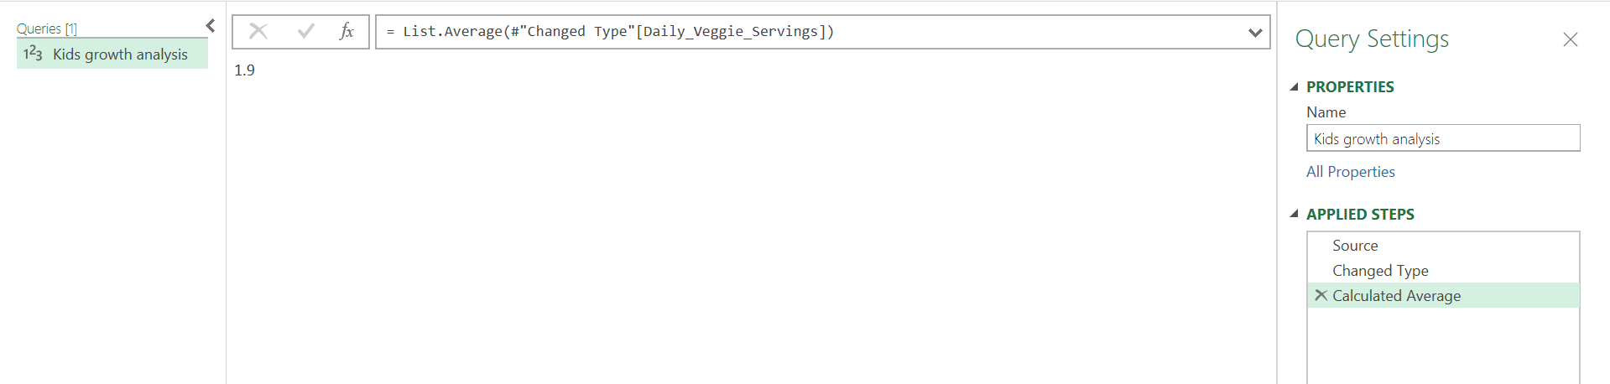
Average Daily Fruit Servings:
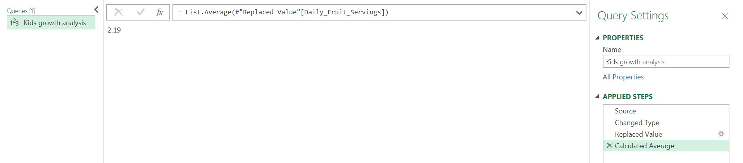
Pivot table:

1.Health Status by Age Group: Analyze the distribution of Health_Status across different age groups (e.g., 24-36 months, 37-48 months, etc.). Use a PivotTable and a clustered column chart.

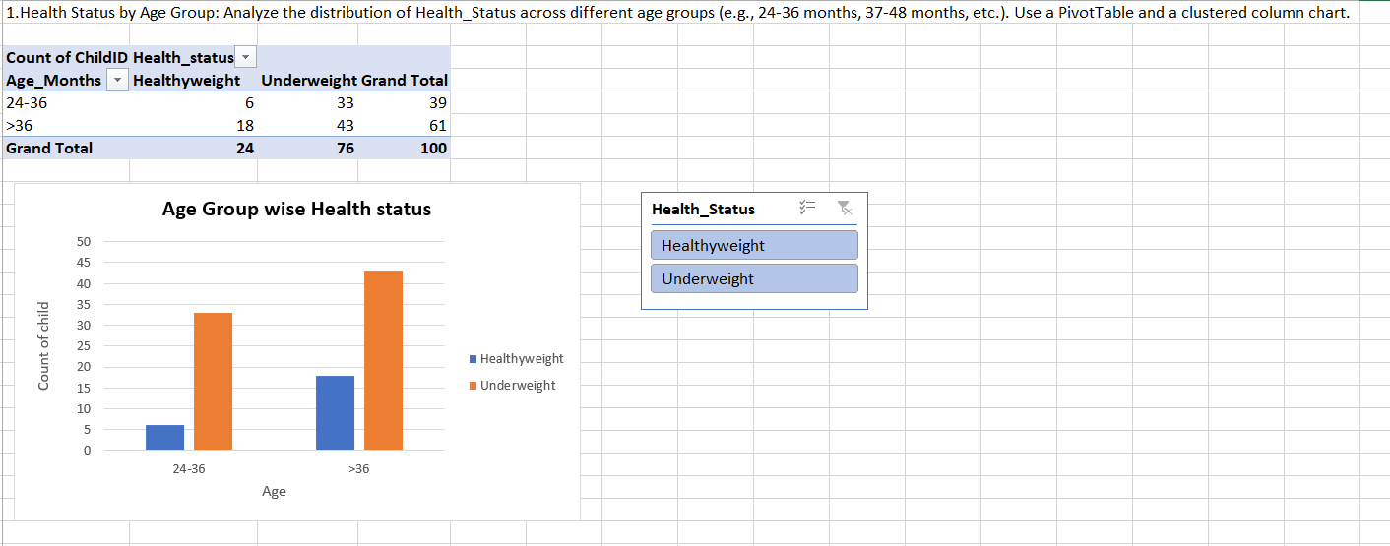

2.Nutrient Intake vs. BMI: Create a PivotTable to find the average BMI for children based on their Daily_Fruit_Servings and Daily_Veggie_Servings. Use a Slicer for Region to filter the data.
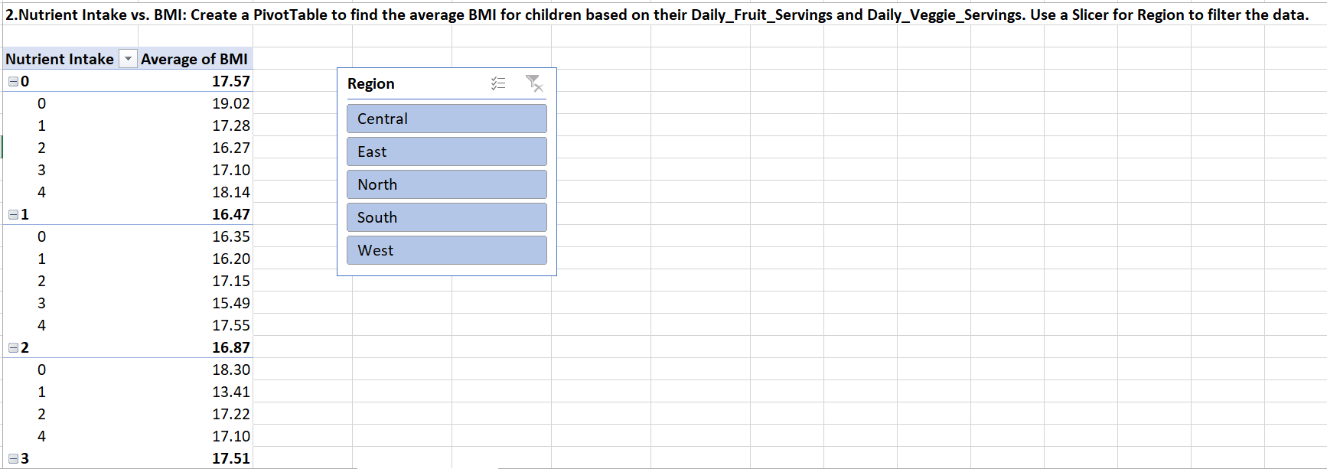

3.Correlation of Sugar and Screen Time: Find the average Daily_Sugar_Drinks and ScreenTime_Hours for each Health_Status category. A bar chart would be ideal to visualize this.
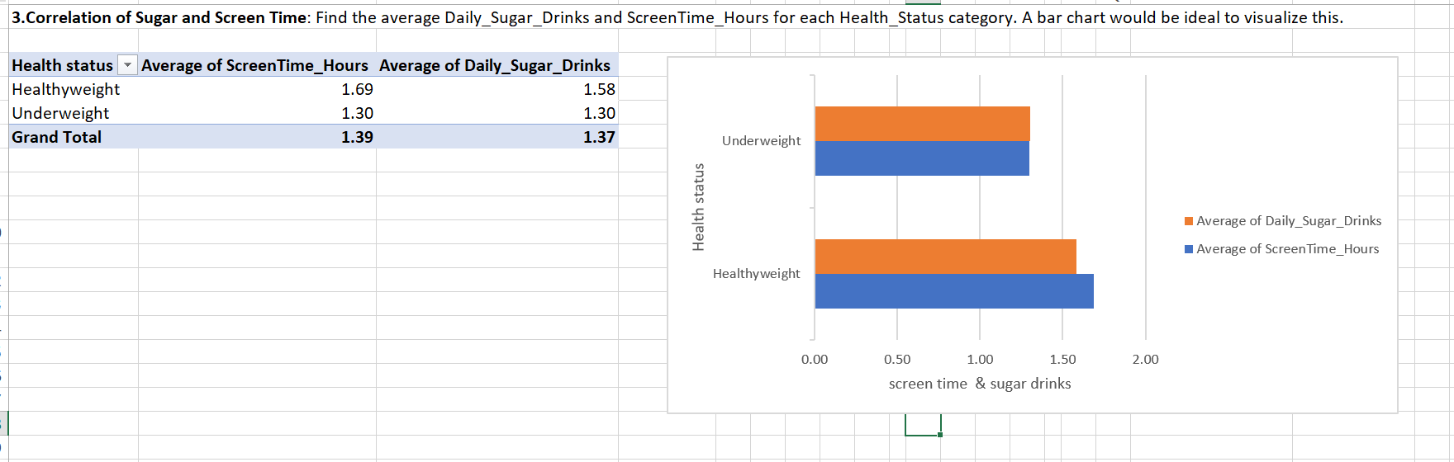

4.Regional Differences: Use a PivotTable to compare the average BMI and Daily_Fruit_Servings for each Region. Apply Conditional Formatting to highlight the highest and lowest values in the table.
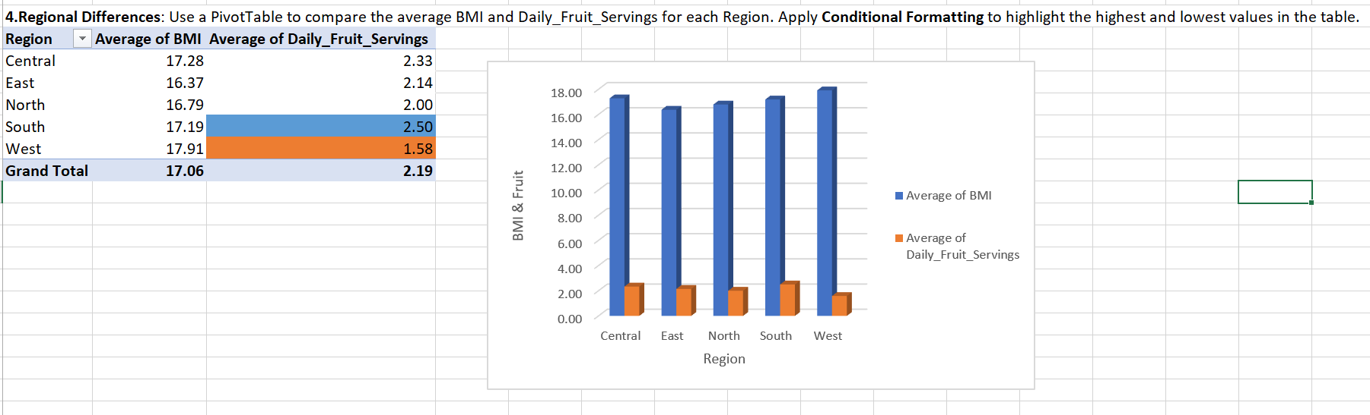
Final dashboard
