  - 50Days-coding-challenge
  - Day-2[EXCEL]
Data preprocessing:
Average study hours:
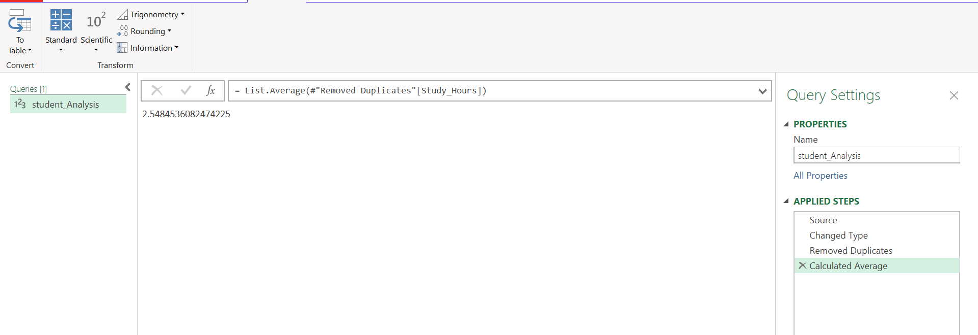
Average screen time:
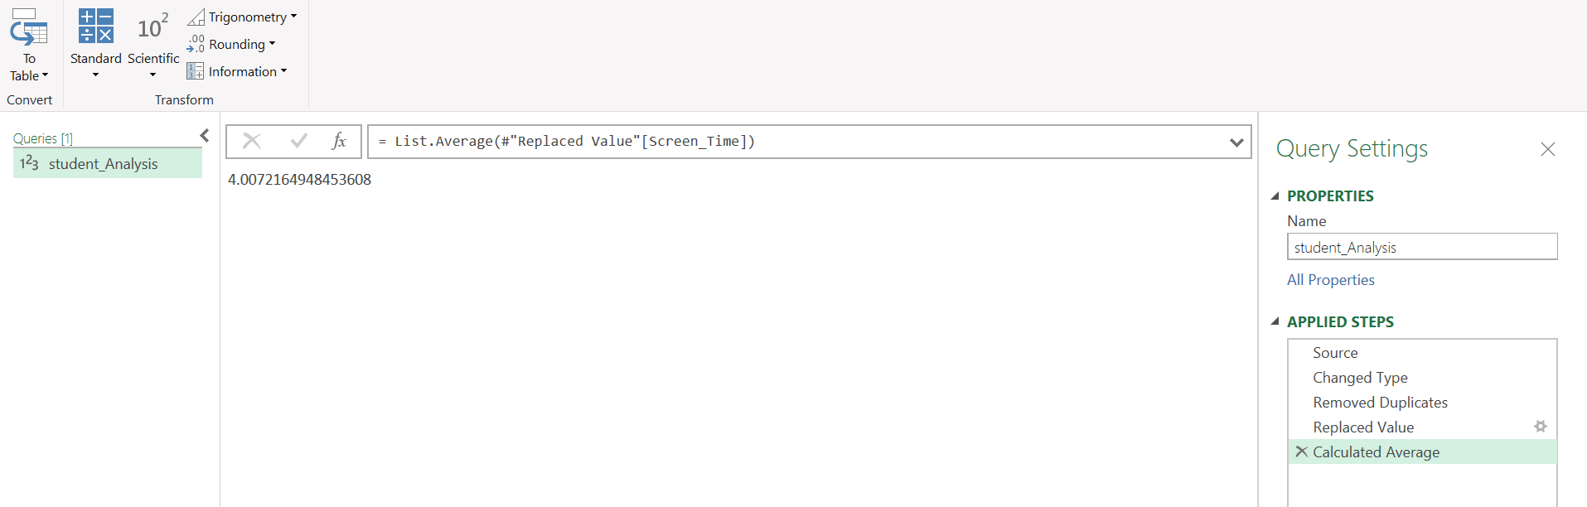
Average test score
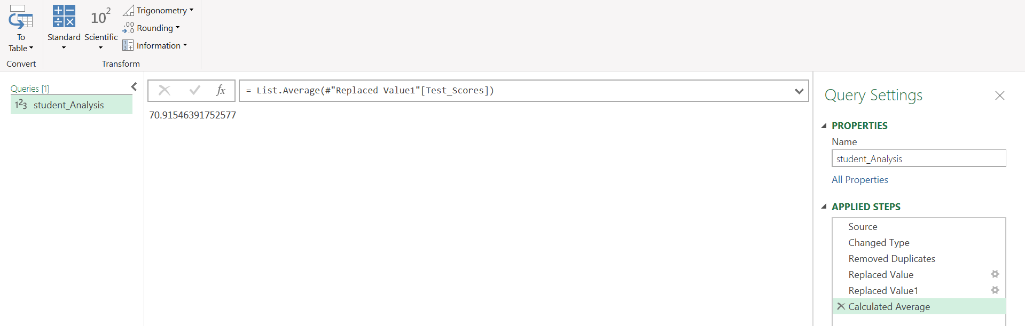
Pivot table:
1.Average test scores by screen time category
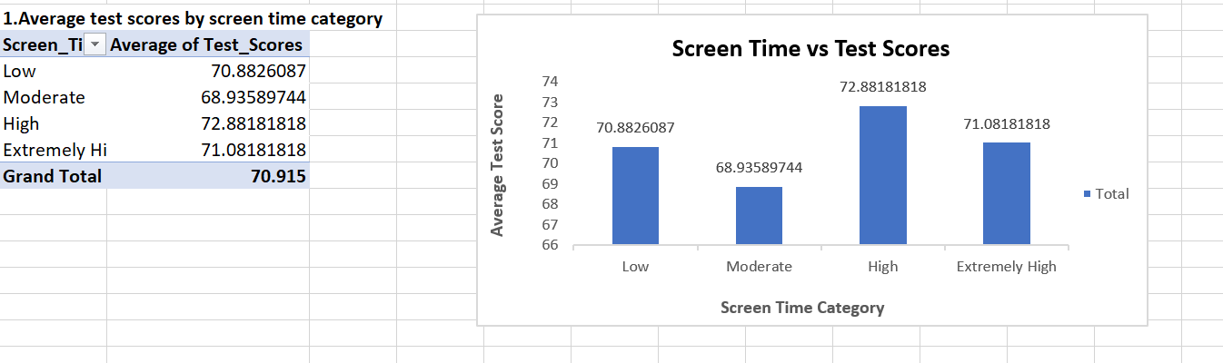

2.Screen time vs. extracurricular activity trends
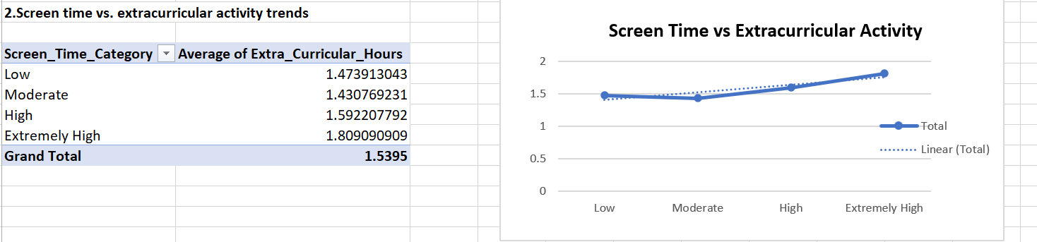
3.Age group-wise performance
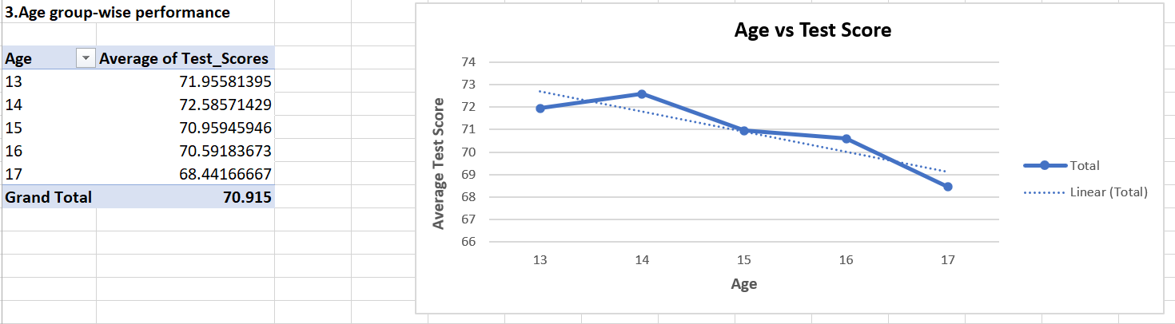
4.A scatter plot of Screen Time vs. Test Scores
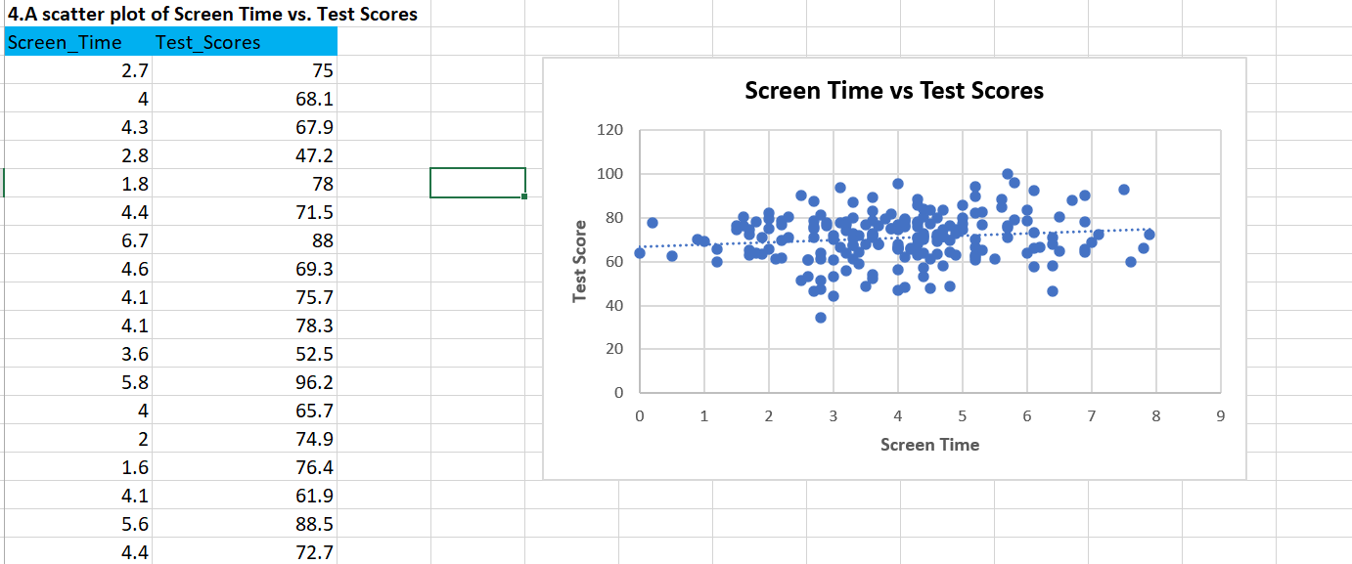

5. A bar chart comparing average test scores across screen time ranges
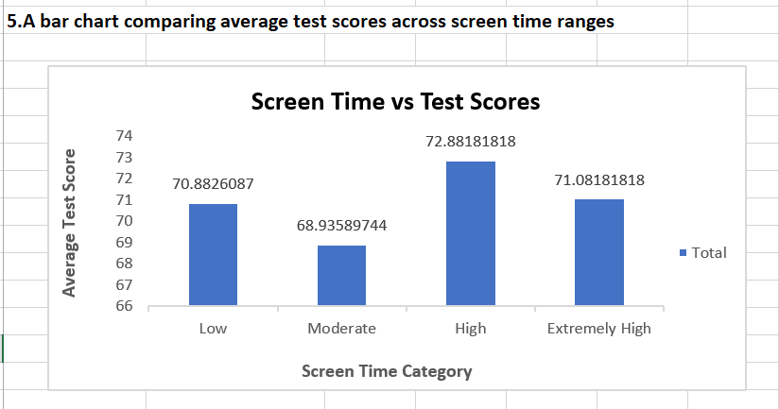
Final Dashboard:
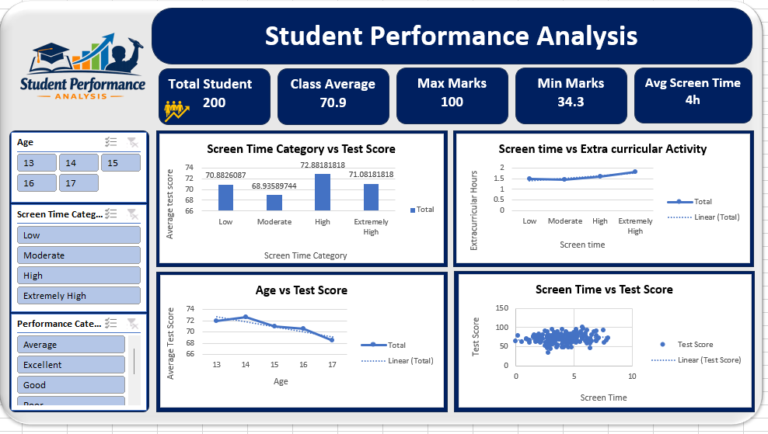

Insight:
- Screen time does not significantly affect academic performance
- Extracurricular activity is not negatively impacted by screen usage
- Study habits play a more important role in student success
- Students demonstrate a balanced lifestyle across academics, screen time, and activities

