REVIEW
WORKFORCE ANALYTICS: EMPLOYEE ATTRITION ANALYSIS

Faculty: Sunitha V
Student: M Nithin
Domain: Human Resource Analytics

Introduction
Employee attrition is one of the key challenges faced by organizations as it impacts productivity, operational costs, and workforce stability. Understanding the factors that influence employee turnover is essential for improving employee retention and organizational performance. This project focuses on preparing and cleaning employee-related data to ensure its quality and reliability for future attrition analysis. The study aims to establish a strong data foundation that supports meaningful insights and informed business decisions.

Problem Statement
Organizations often struggle to identify the factors contributing to employee attrition due to the presence of poor-quality data, including missing values, duplicate records, inconsistencies, and outliers. These issues can affect the accuracy of analysis and decision-making. This project aims to assess, clean, and standardize employee data to create a reliable dataset that can be used for future attrition analysis and workforce retention strategies.

Project Objectives
- Understand the employee dataset.
- Assess data quality issues.
- Perform data cleaning and preprocessing.
- Import cleaned data into PostgreSQL.
- Perform SQL-based attrition analysis.
- Generate business insights.
- Prepare data for Power BI dashboard development.

Dataset Overview
- Dataset Name: Employee Attrition Dataset
- Number of Records: 1225
- Number of Attributes: 15
- Target Variable: Attrition
- Granularity: One row represents one employee.

Data Dictionary
Attribute | Description
EmployeeID | Employee Identifier
EmployeeName | Employee Name
Department | Employee Department
JobRole | Employee Role
Gender | Employee Gender
Age | Employee Age
MonthlyIncome | Employee Monthly Income
YearsAtCompany | Employee Experience
OverTime | Overtime Status
JobSatisfaction | Satisfaction Rating
WorkLifeBalance | Work-Life Balance Rating
EnvironmentSatisfaction | Environment Satisfaction Rating
DistanceFromHome | Distance from Home
MaritalStatus | Marital Status
Attrition | Employee Attrition Status

DATA CLEANING AND PREPROCESSING

Dataset Loading
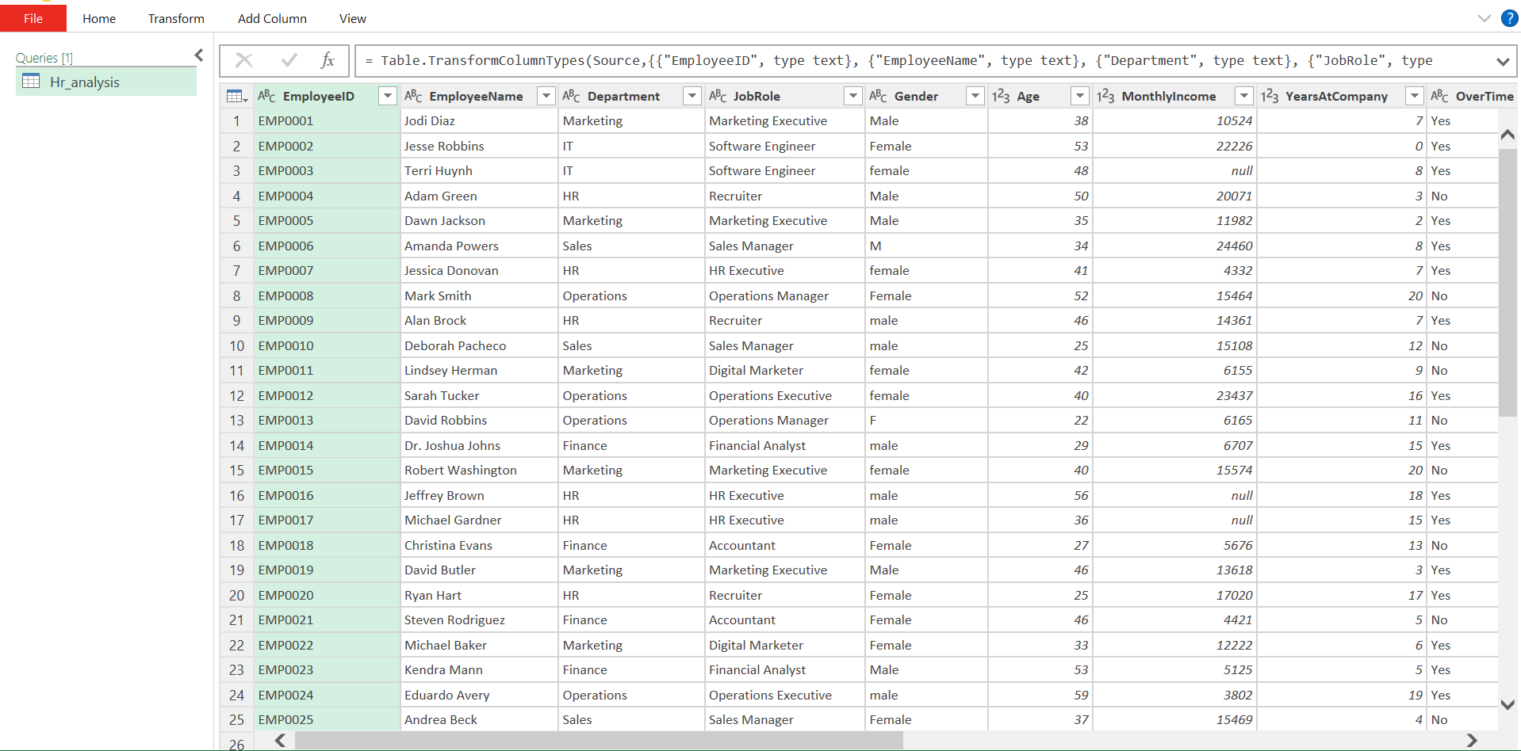
Description
- Employee attrition dataset was loaded into Excel and Power Query.
- Dataset structure and attributes were reviewed.
- Initial data assessment was performed.

Data Profiling

Description
- Dataset was profiled to understand attribute distributions.
- Data types and quality issues were examined.
- Potential cleaning requirements were identified.

Missing Value Identification
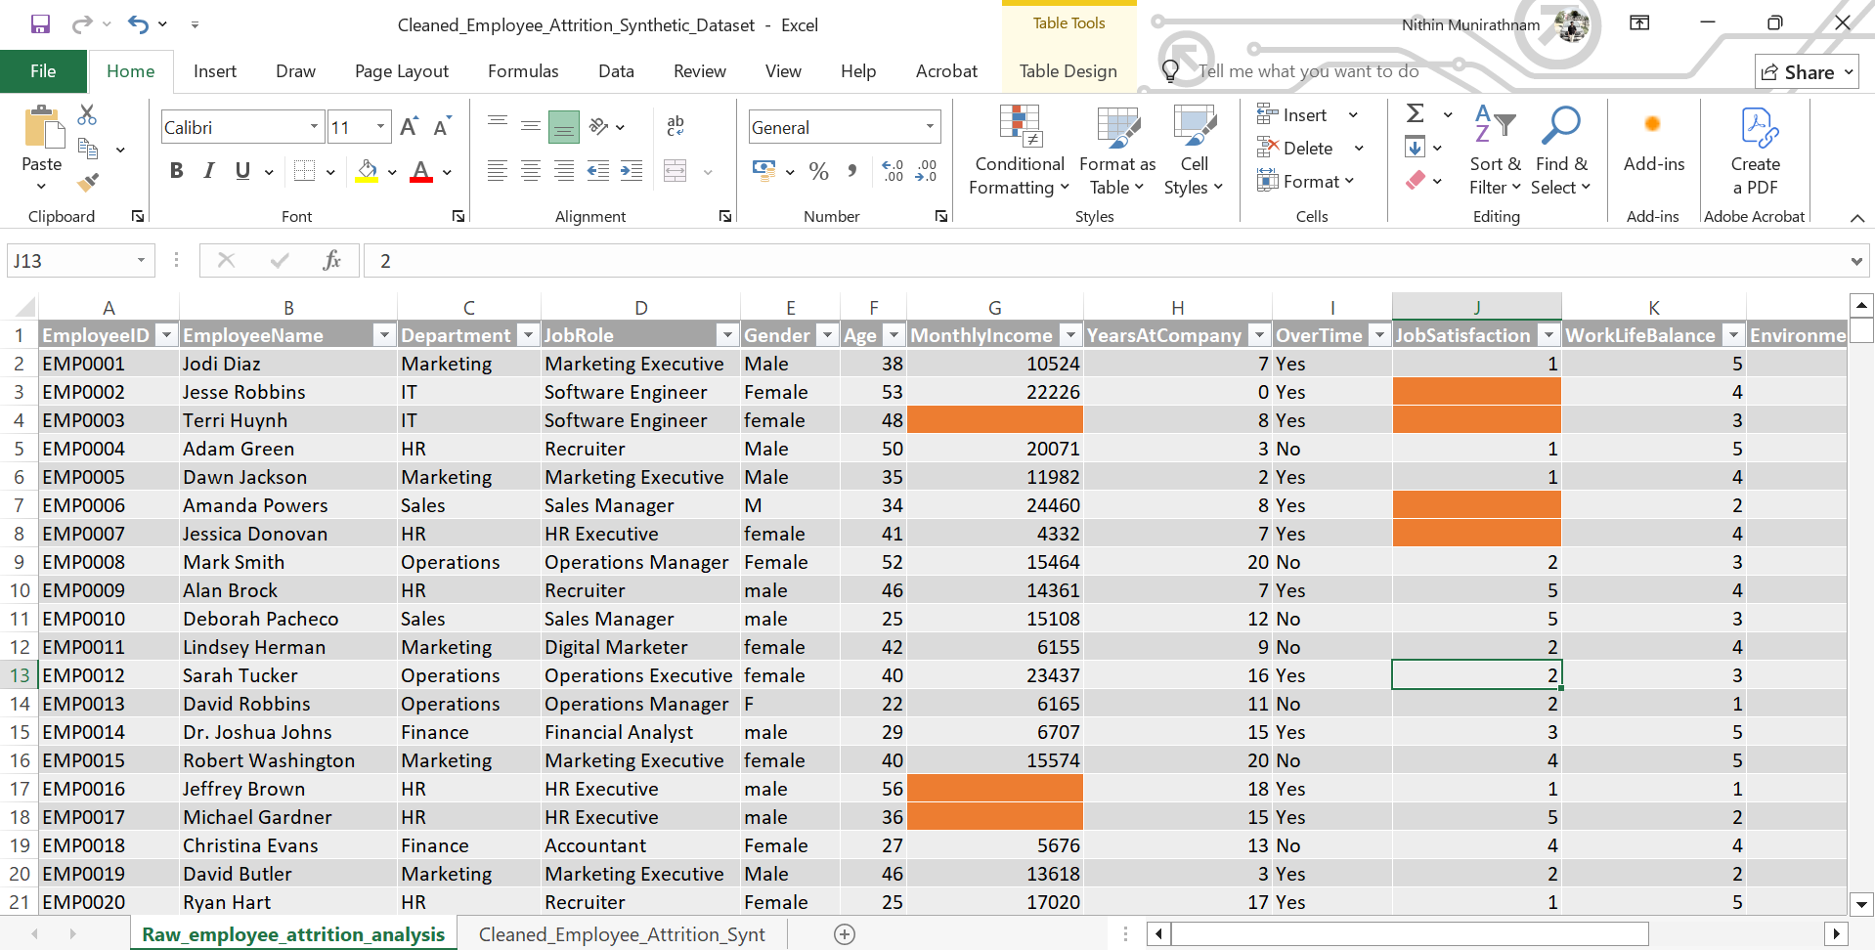
Description
- Missing values were identified in multiple attributes.
- Missing data can impact analytical accuracy.
- Missing values were documented for treatment.

Removed duplicates:
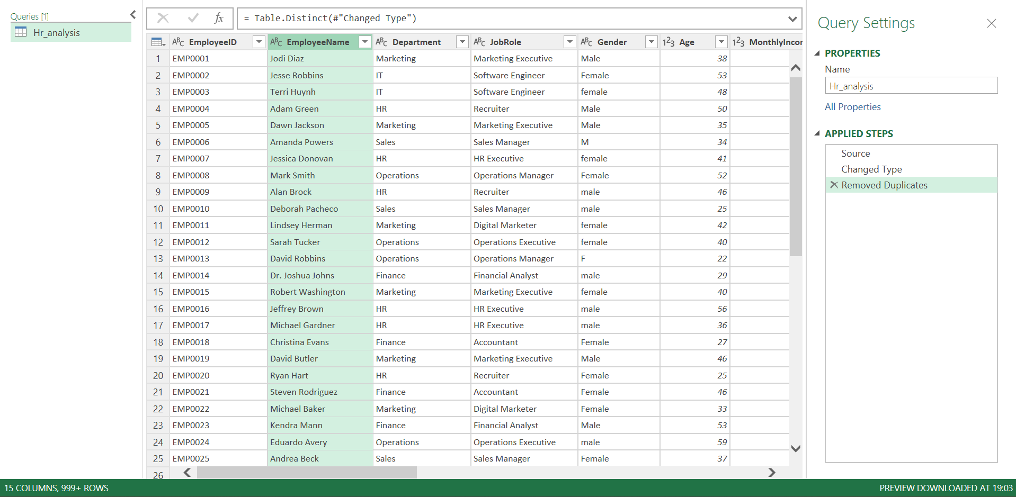
Description
- The dataset was examined for duplicate employee records.
- Duplicate entries can lead to inaccurate employee counts and misleading analytical results.
- All identified duplicate records were removed to maintain data integrity and consistency.

Data Standardization Capitalization:
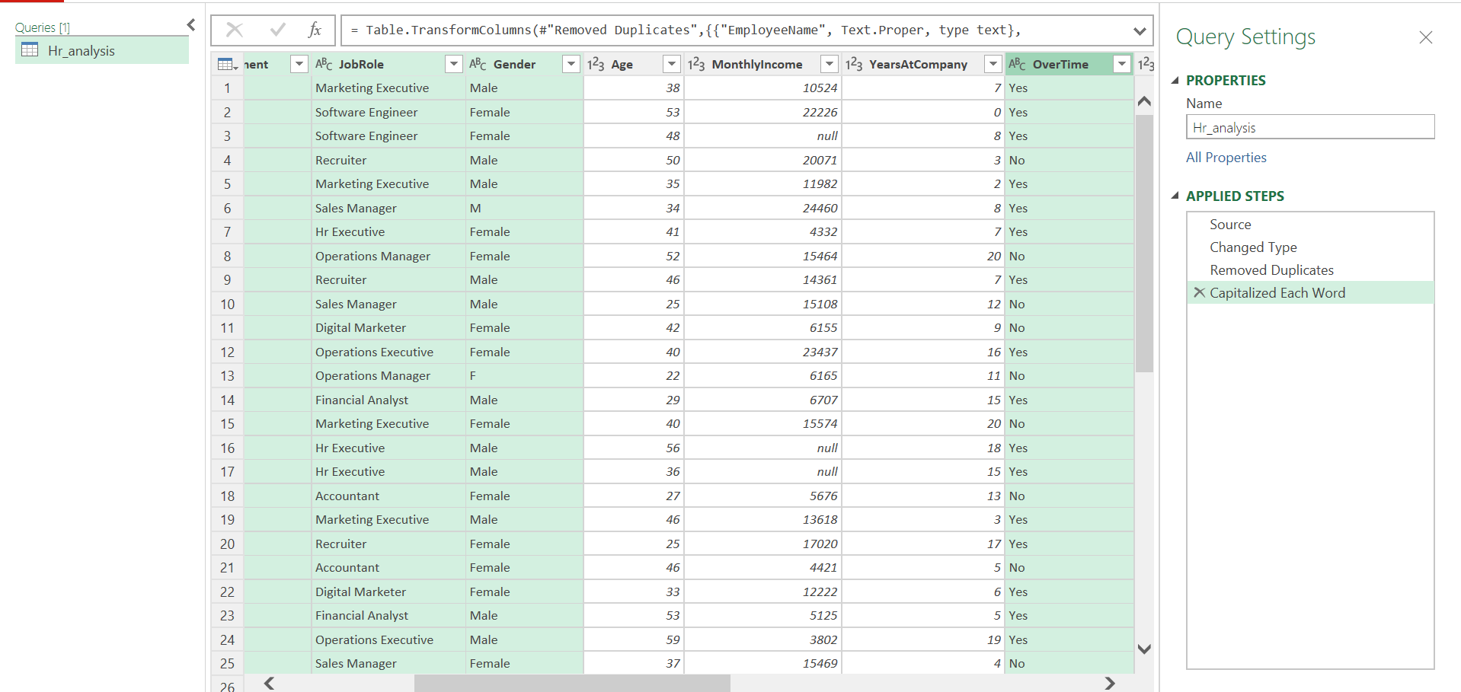
Description
- Text values were standardized using capitalization rules.
- Inconsistent text formats were corrected to improve data consistency.
- Standardized values help ensure accurate grouping and reporting during analysis.

Gender column
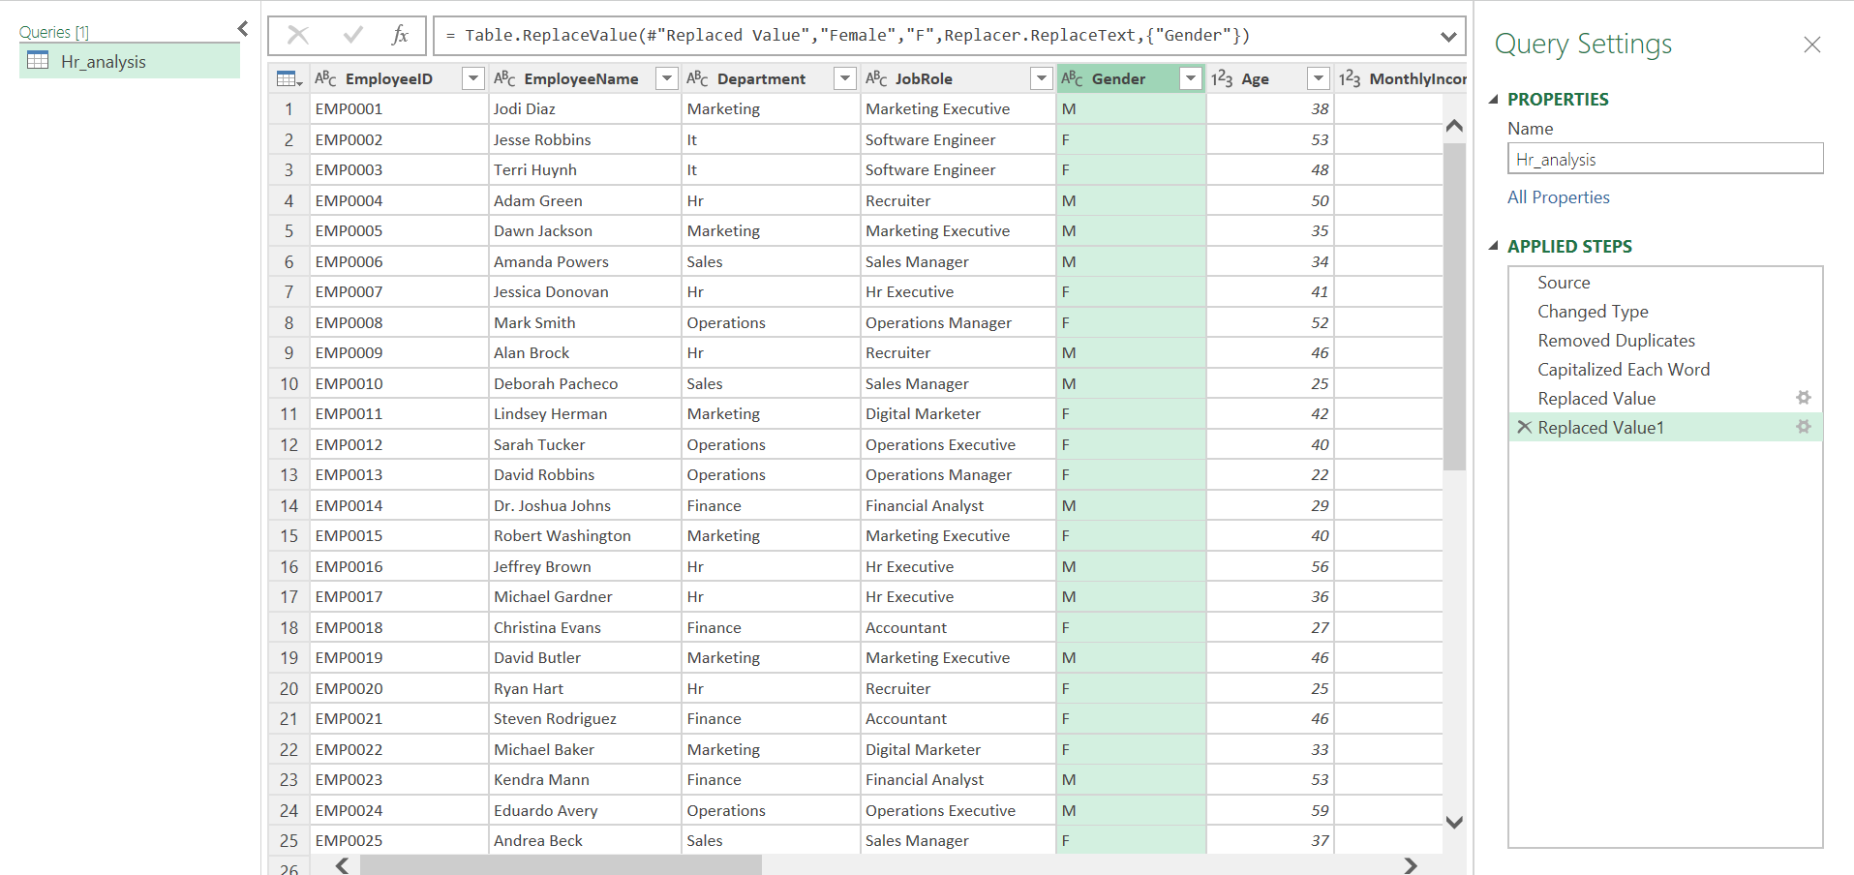
Description
- Inconsistent gender representations were identified in the dataset.
- Values were standardized into a consistent format to avoid duplicate categories.
- This transformation improves the accuracy of gender-based analysis and reporting.

Age Column
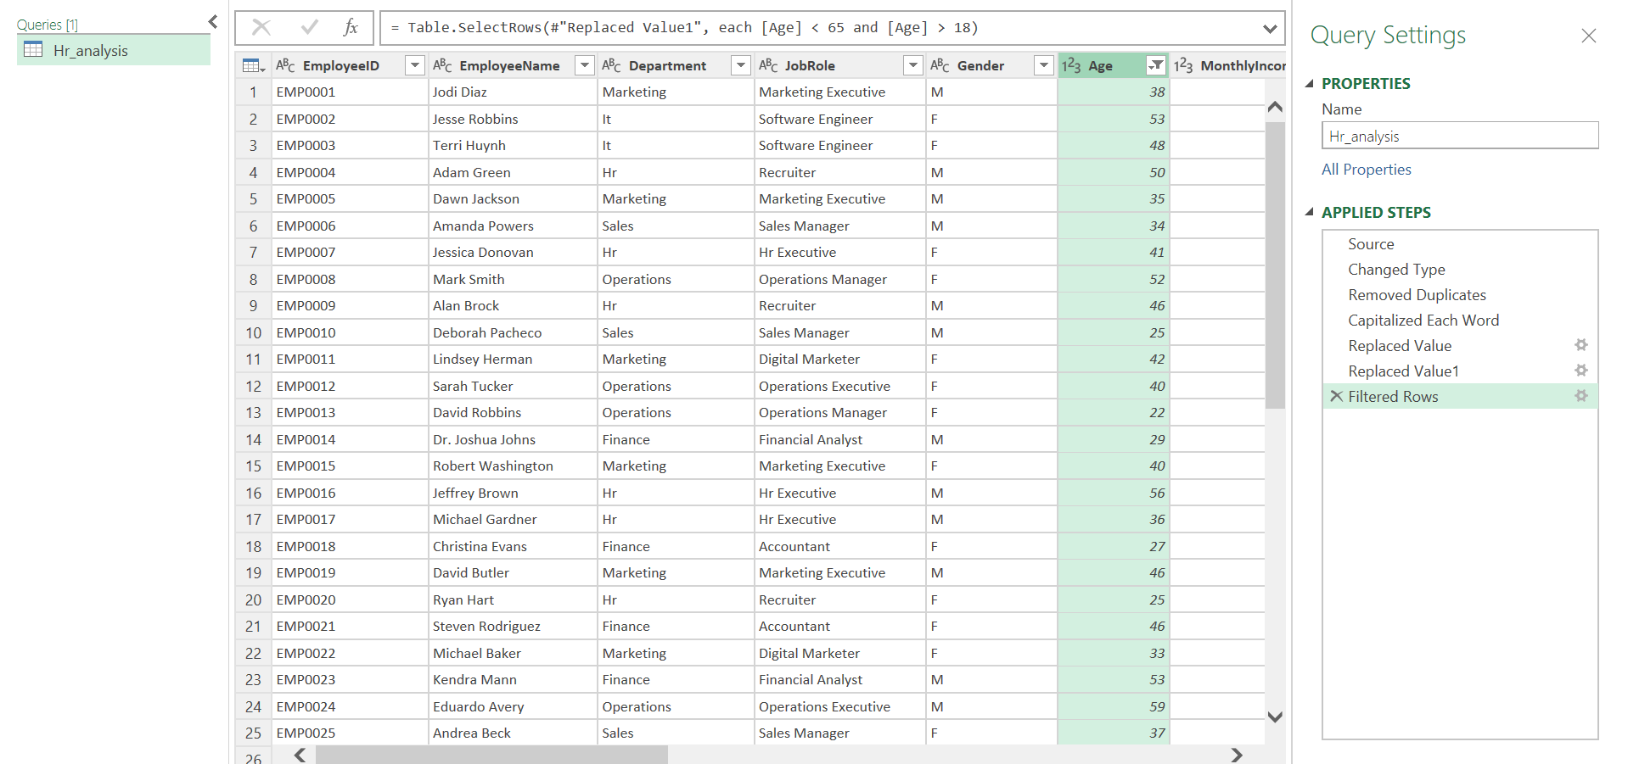

Description
- Invalid age values were identified during data quality assessment.
- Employee records with age values outside the acceptable business range were treated as outliers.
- Outlier records were removed using filtering techniques to improve data reliability.

Monthly income:
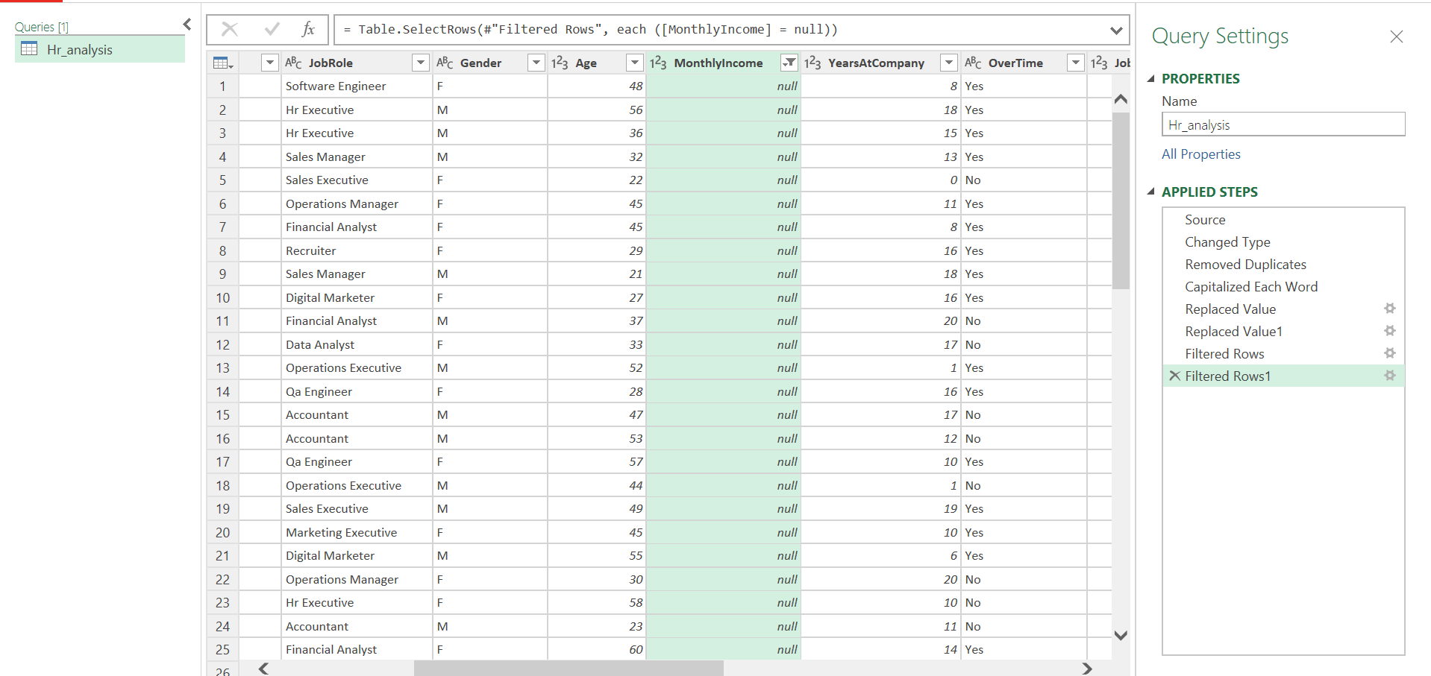
Description
- Missing values were identified in the Monthly Income attribute.
- Null values can negatively affect statistical analysis and reporting.
- Appropriate treatment was required to maintain dataset completeness.

Removed null values by median imputation:
Calculated median:
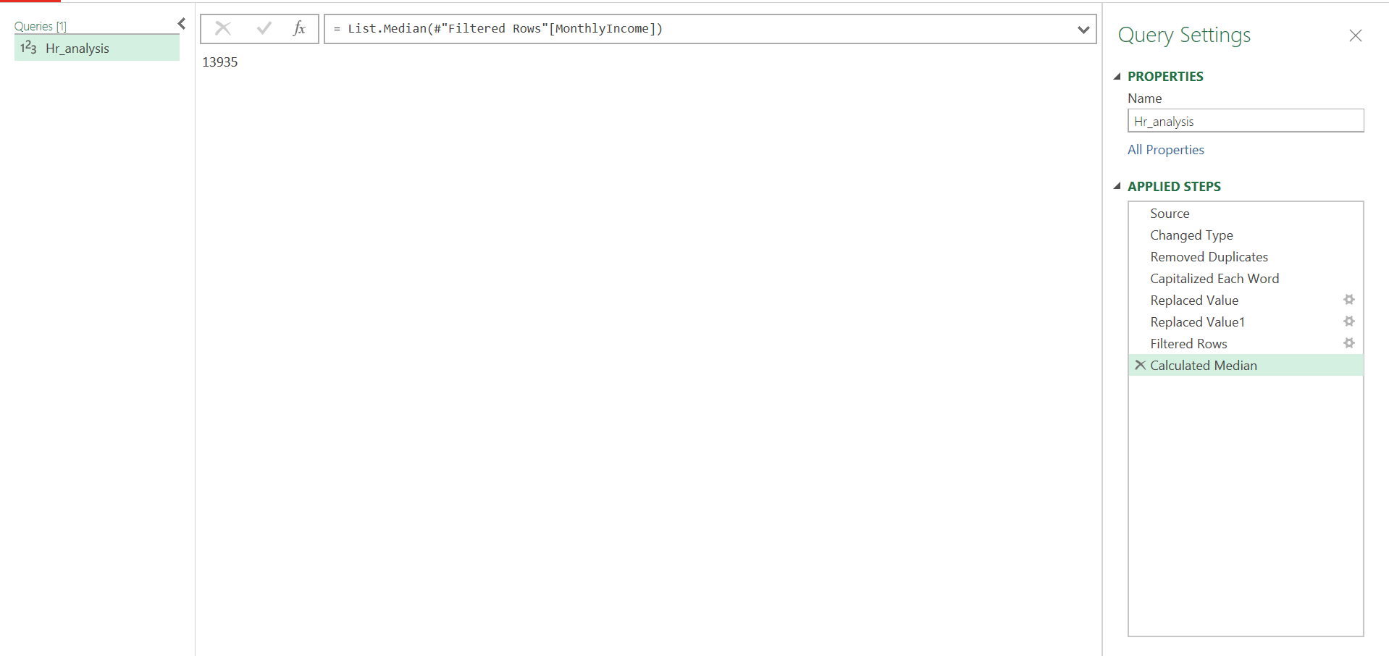
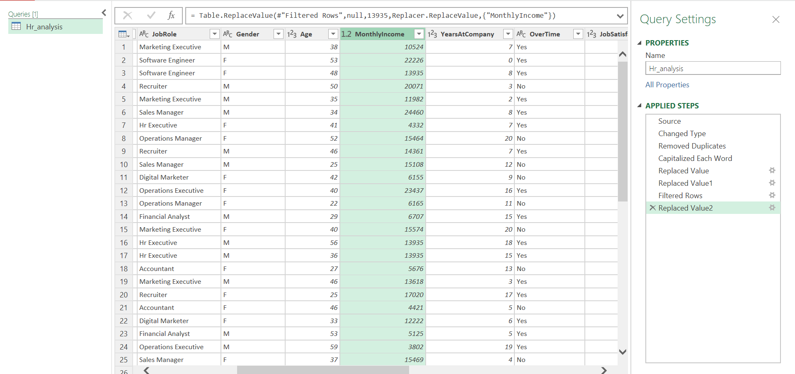
Description
- The median value of Monthly Income was calculated.
- Missing income values were replaced using median imputation.
- Median was selected because it is less affected by extreme income values and provides a more representative measure of central tendency.

Job satisfaction:
Replaced by mean and rounded of to 3
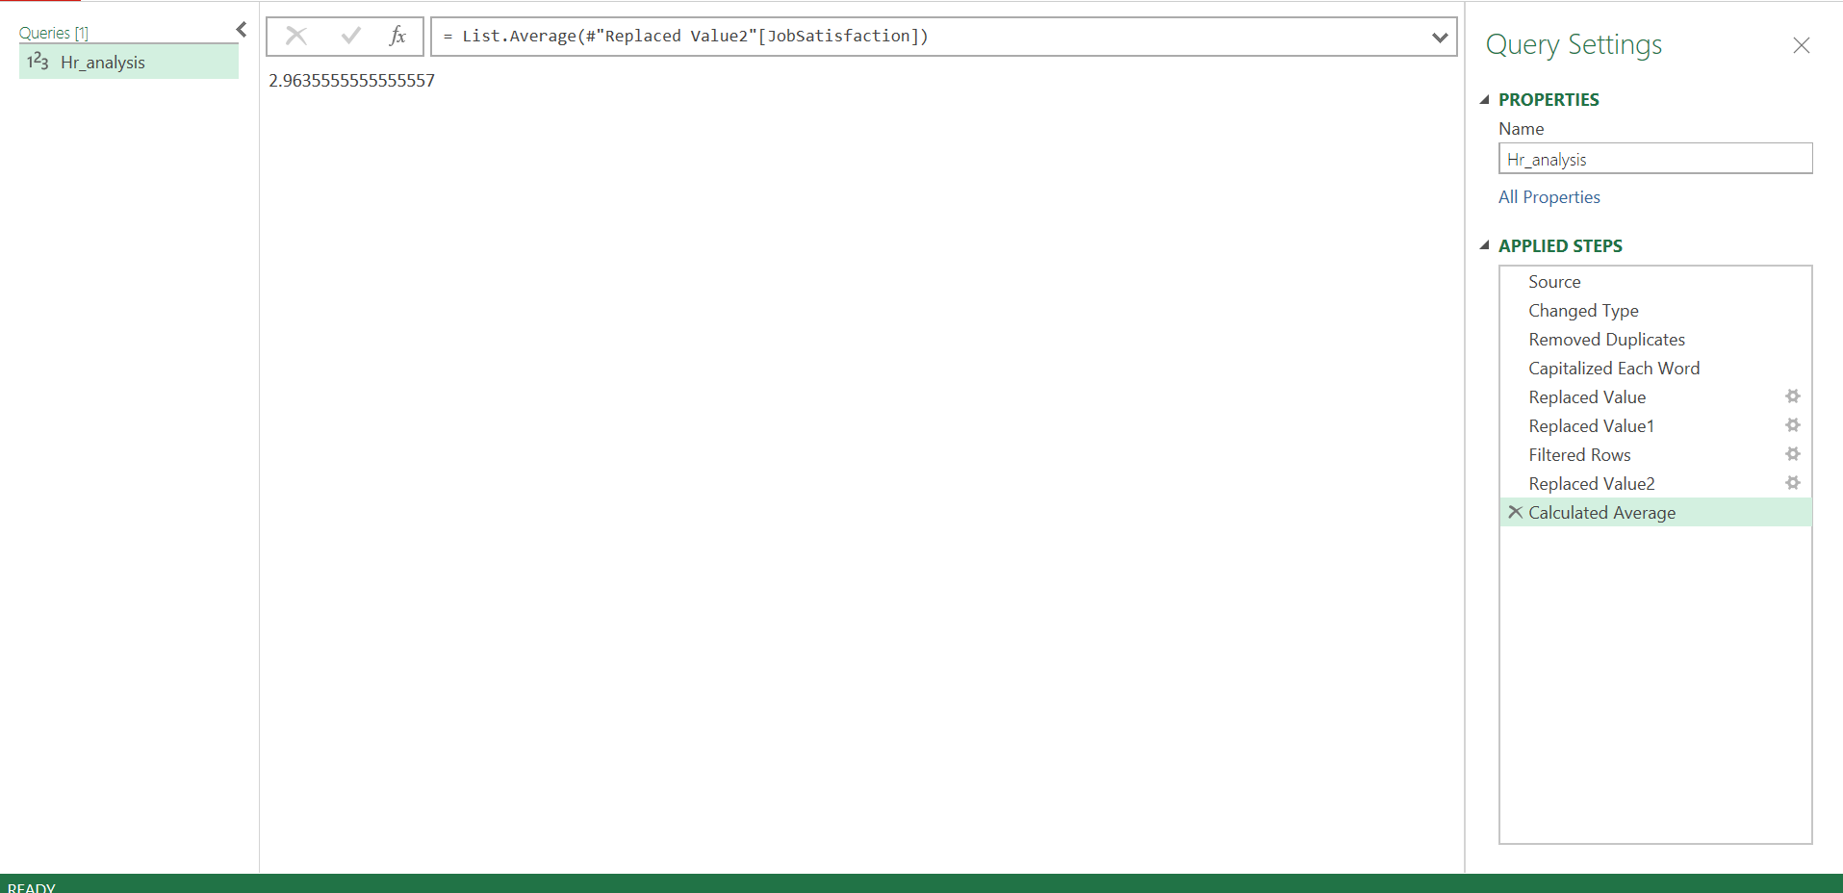
Description
- Missing values were identified in the JobSatisfaction attribute.
- The average value was calculated and rounded to the nearest whole number (3).
- Missing values were replaced with the rounded average value to maintain data consistency.

Work life balance:
Replaced by average and rounded of to 3
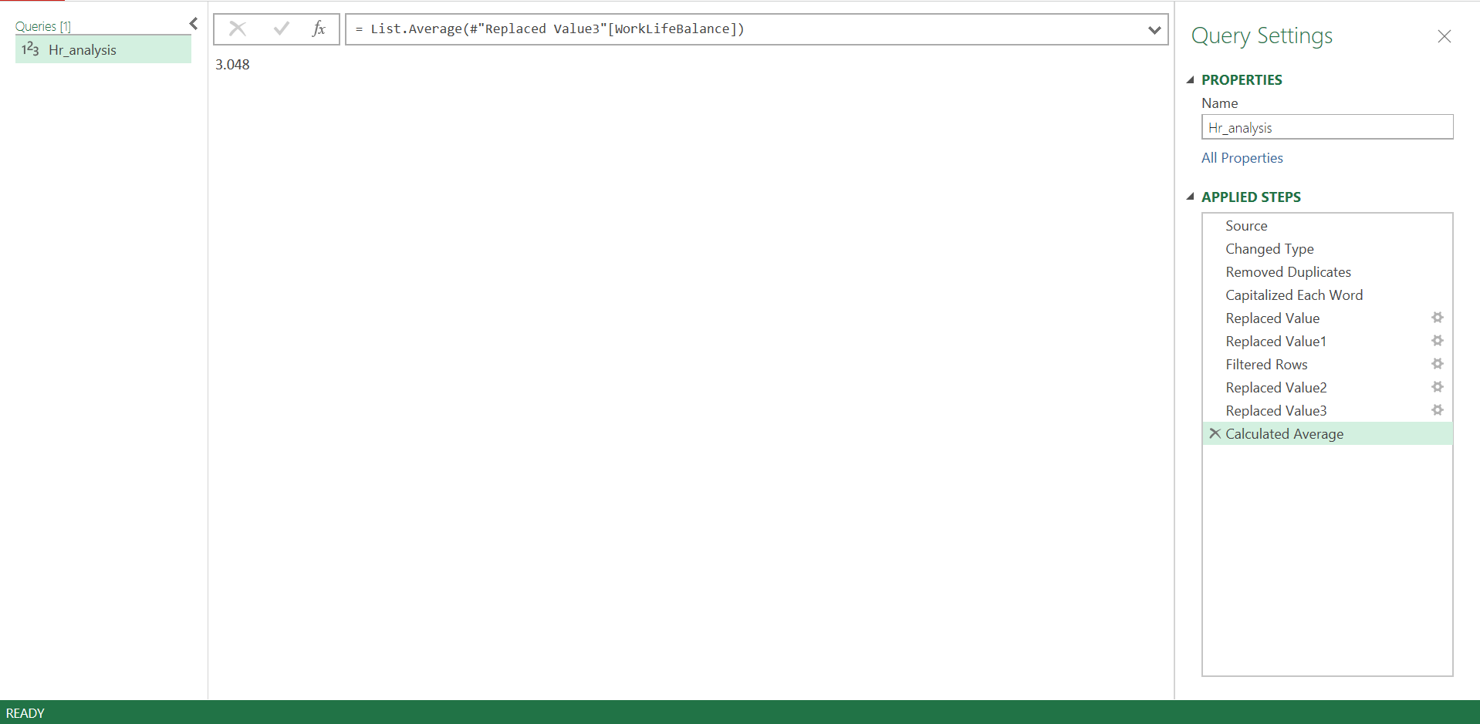

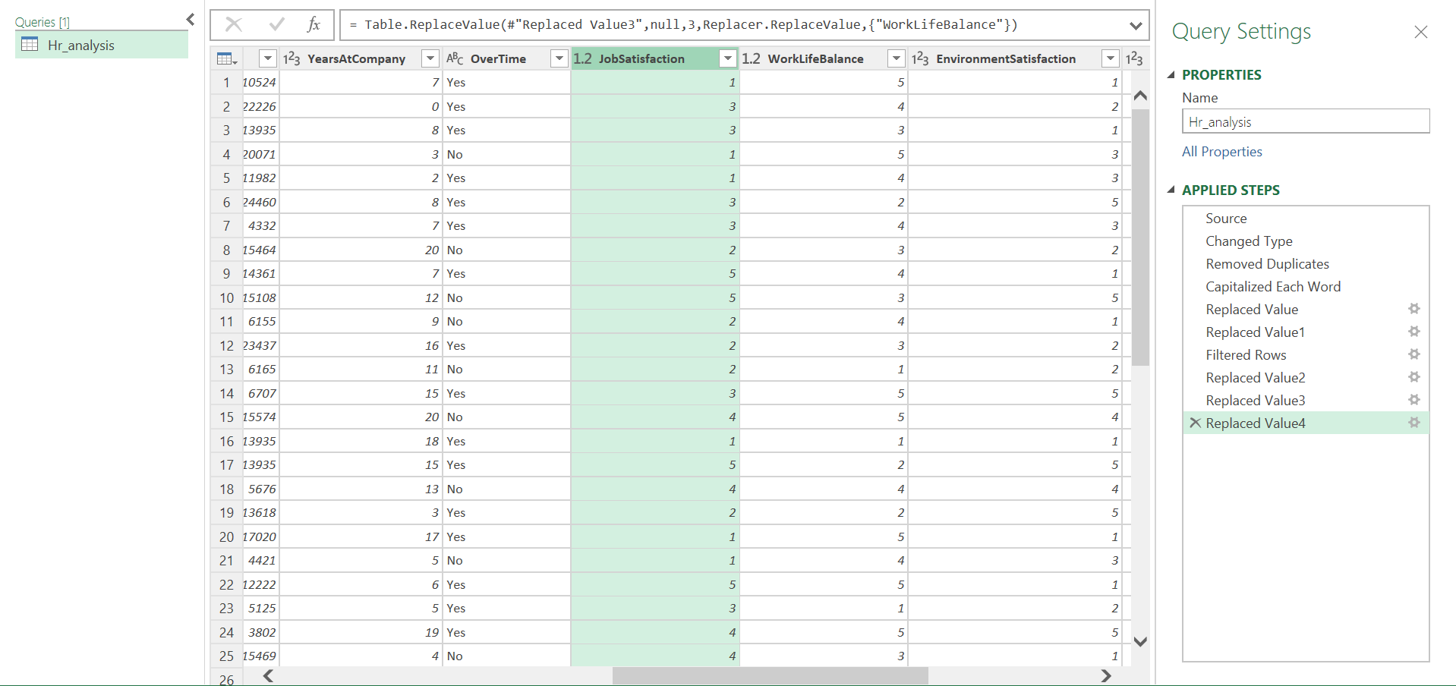
Description
- Missing values were identified in the WorkLifeBalance attribute.
- The average value was calculated and rounded to the nearest whole number (3).
- Missing values were replaced using the rounded average value to preserve the overall distribution of the data.

Final Data Validation
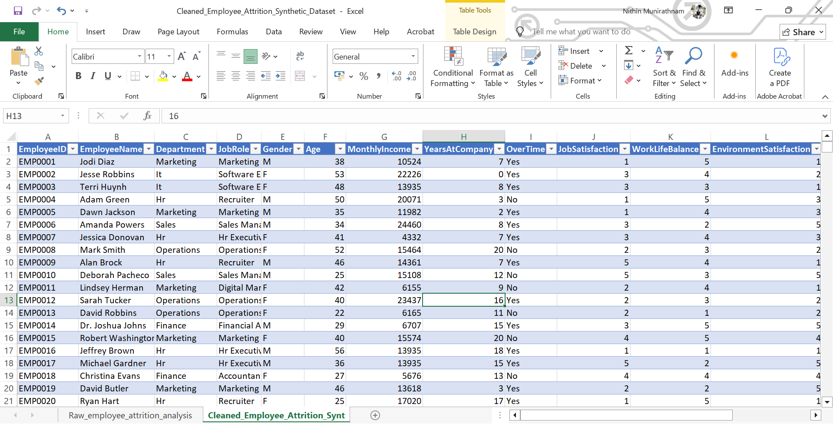
Description
- The cleaned dataset was reviewed to verify all transformations.
- Missing values, duplicate records, inconsistencies, and outliers were successfully addressed.
- The dataset was validated and prepared for SQL-based analysis.

Export of Cleaned Dataset
- Cleaned dataset was exported as CSV format.
- CSV file was prepared for PostgreSQL import.
- Data was validated before import.

SQL ANALYSIS

PostgreSQL Database Creation
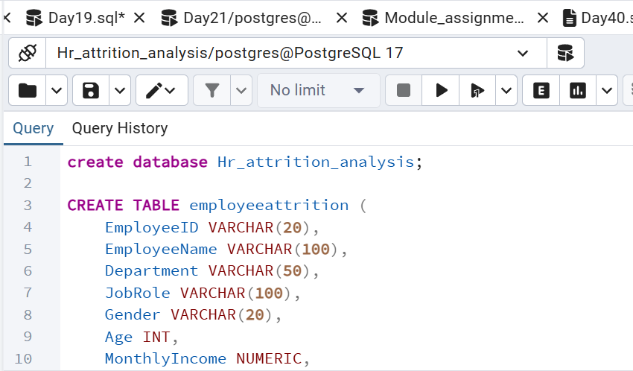
Description
- HR_Attrition_Analysis database was created.
- Database environment was configured.
- Prepared for storing employee data.

16. Table Creation
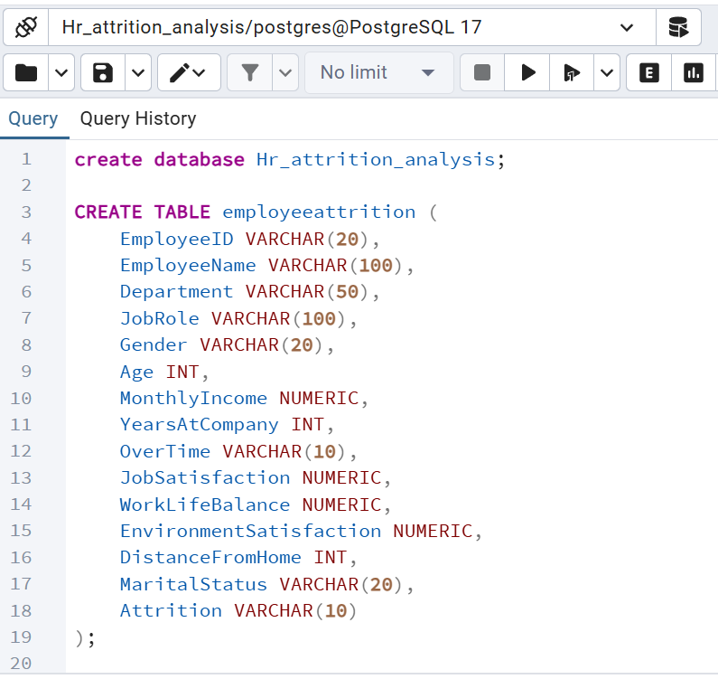
Description
- Employee Attrition table was created.
- Appropriate data types were assigned.
- Table structure was validated.

Data validation
Total records
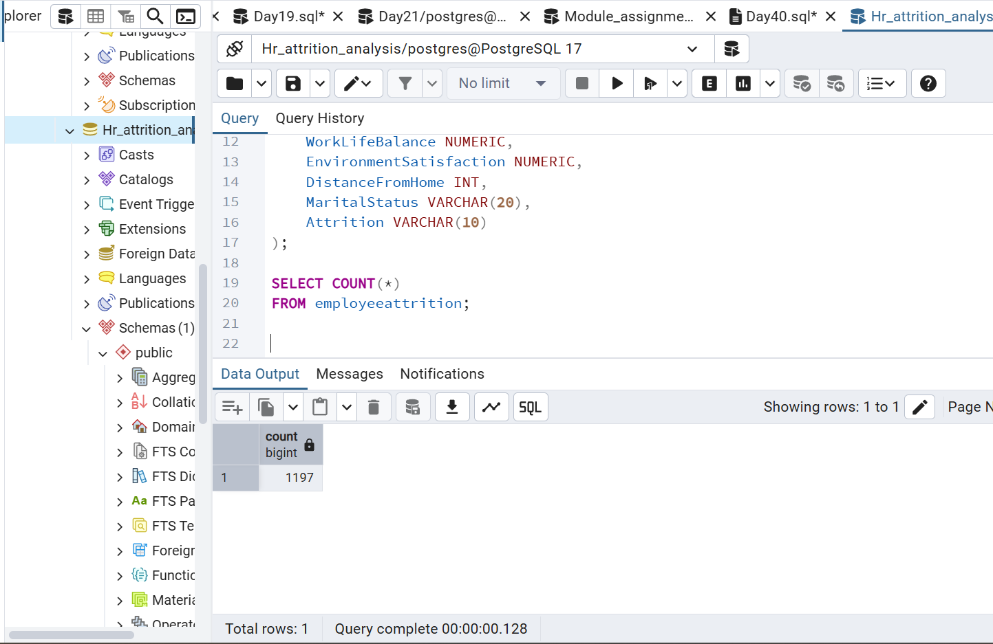

First 10 records:
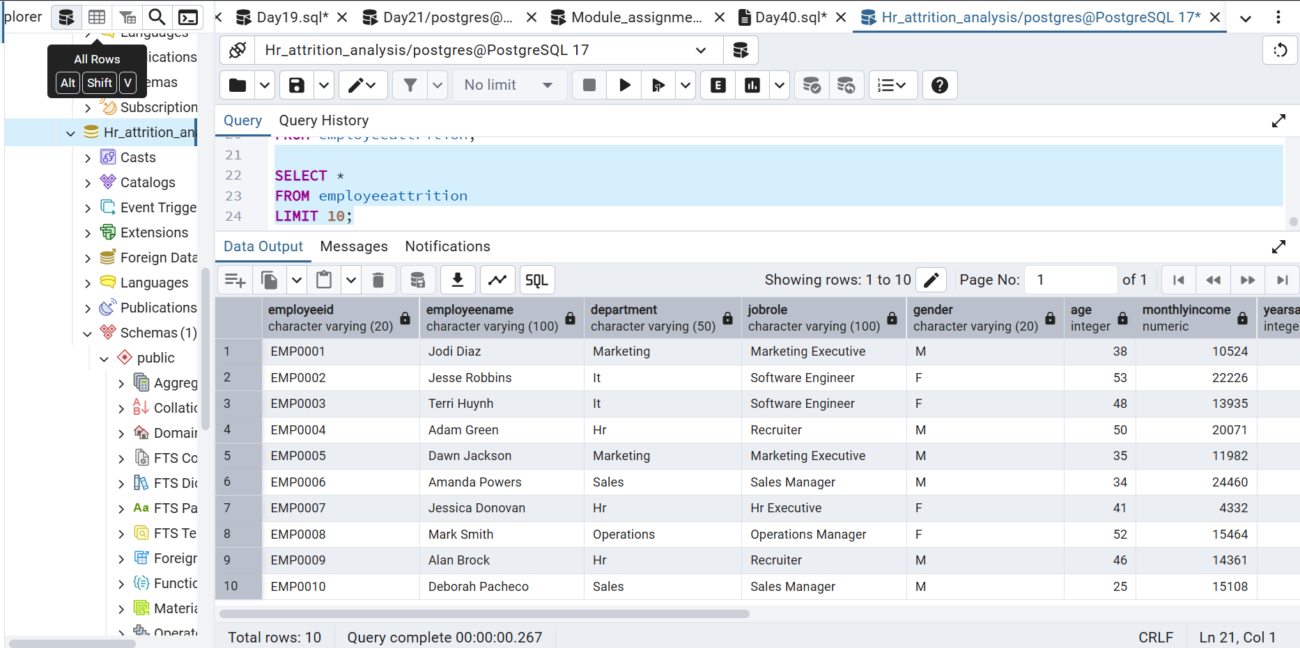

Total employees:
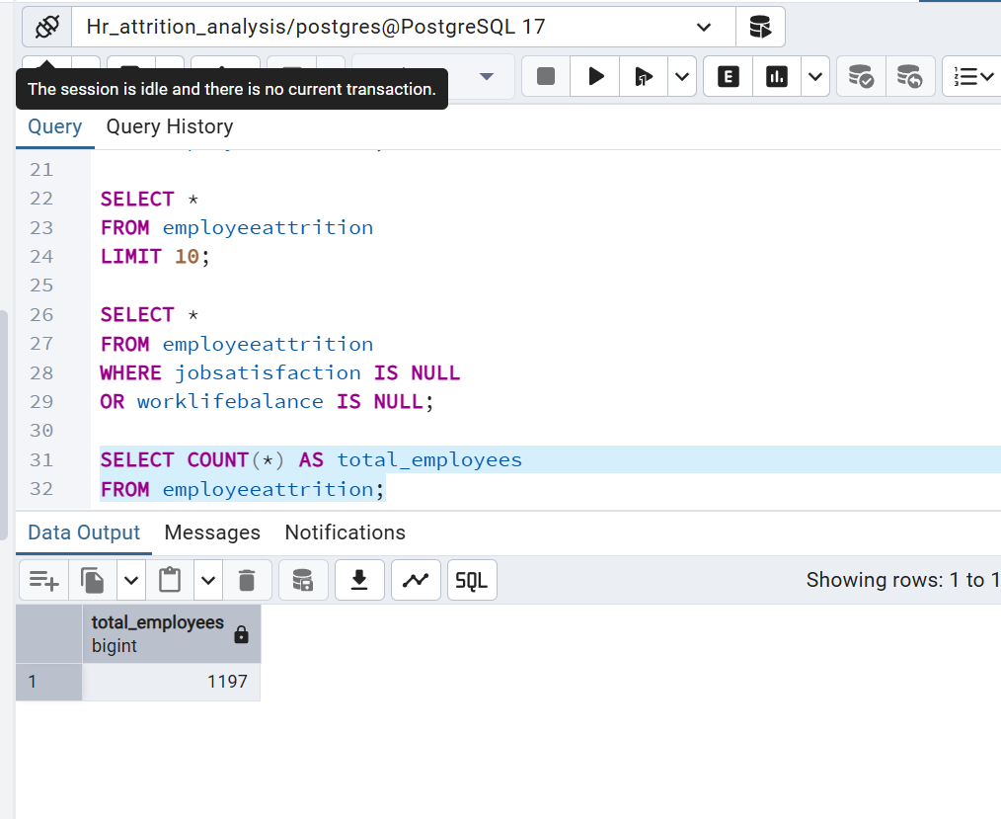
Description
- The total number of employees present in the organization was calculated.
- This analysis provides an overview of the workforce size available in the dataset.
- The result serves as the baseline for all further attrition and workforce analyses.

Employees by gender:
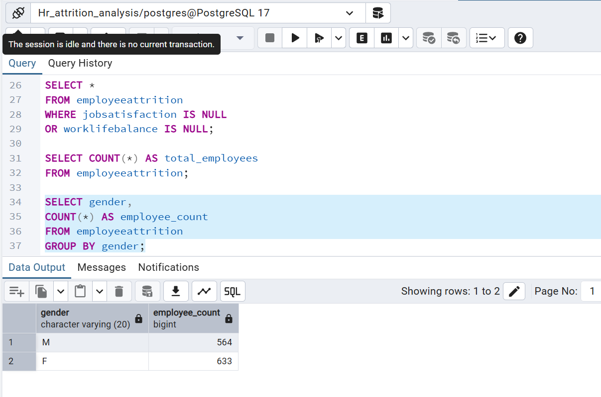
Description
- The workforce was analyzed based on gender distribution within the organization.
- This analysis helps understand the representation of different gender groups across the employee population.
- The findings provide insights into workforce diversity and support demographic analysis for organizational planning.

Job Satisfaction Analysis
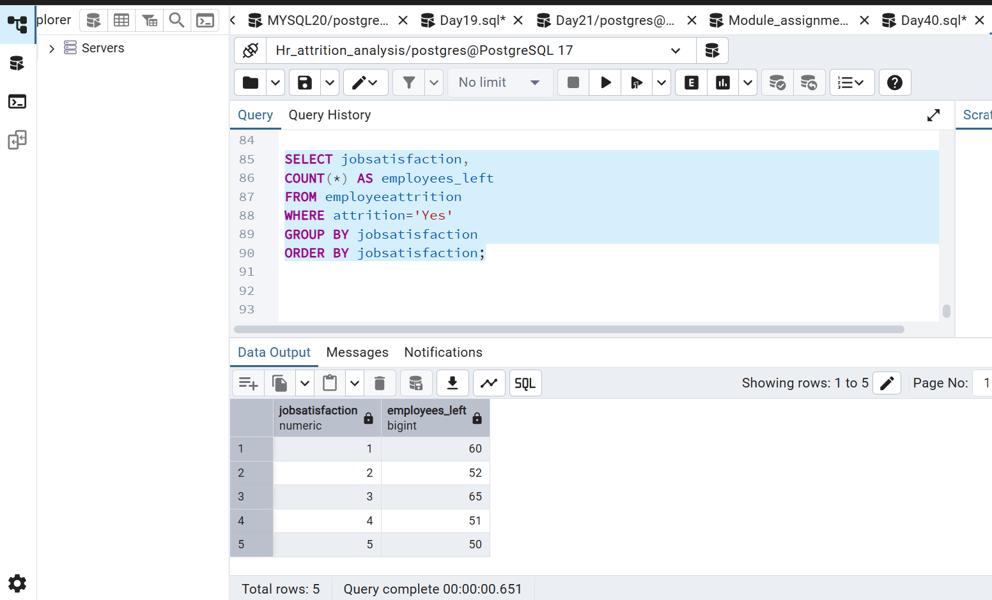
Description
- Employee attrition was analyzed based on job satisfaction levels.
- The analysis helps identify the relationship between employee satisfaction and turnover.
- The results support initiatives aimed at improving employee engagement and retention.

Work life balance by attrition
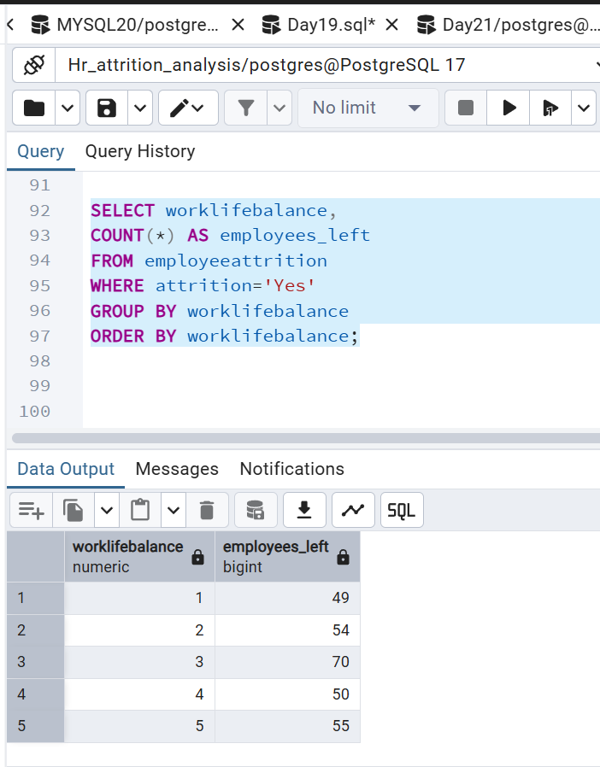

Description
• Employee turnover was examined across different work-life balance ratings.
• The objective was to assess whether work-life balance influences employee retention.
• The findings support organizational efforts to improve employee well-being.

Environment Satisfaction by Attrition
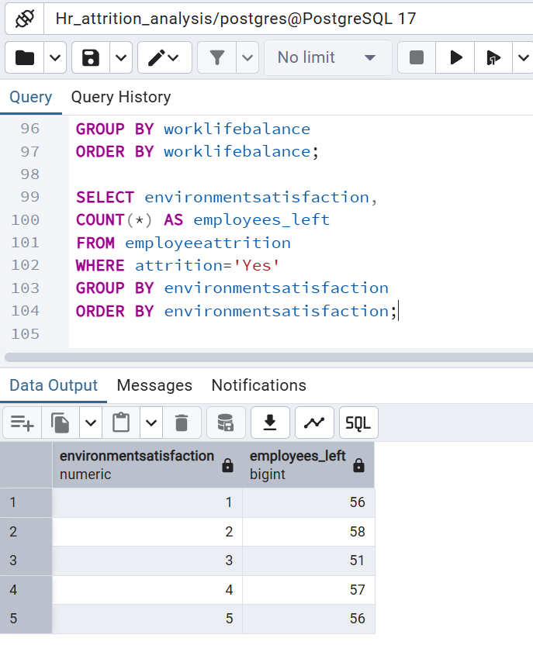
Description
- Employee attrition was analyzed based on workplace environment satisfaction levels.
- The analysis evaluated the impact of workplace conditions on retention.
- The results help identify opportunities to improve employee experience.

Monthly Income Analysis
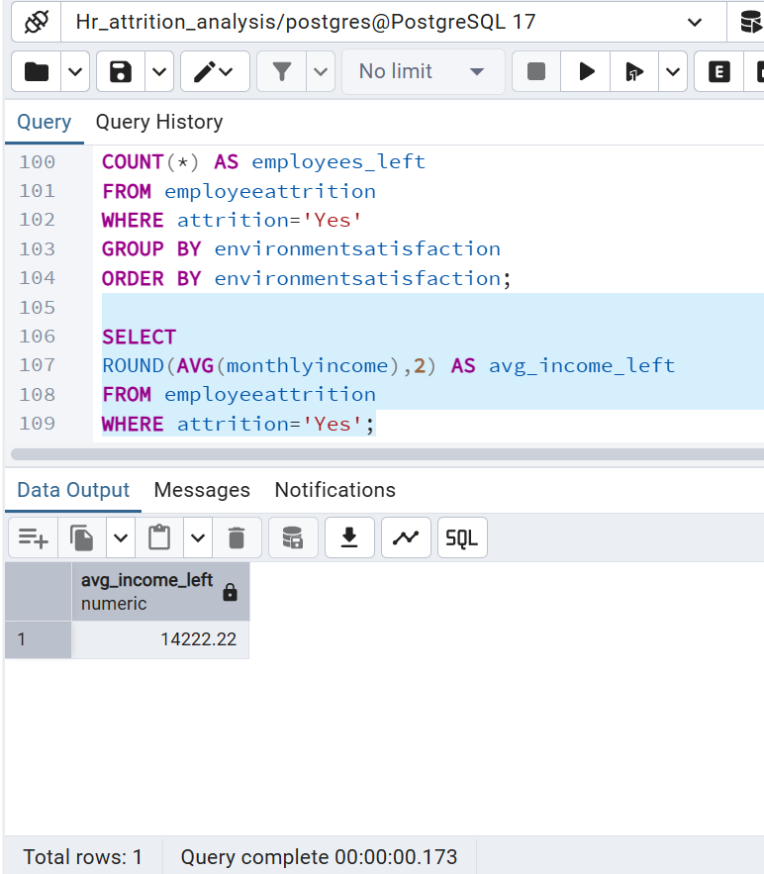

Description
- The average monthly income of employees who left the organization was analyzed.
- This analysis helps assess whether compensation plays a significant role in employee attrition.
- The results support decision-making related to salary and employee retention strategies.

Attrition by Salary Band
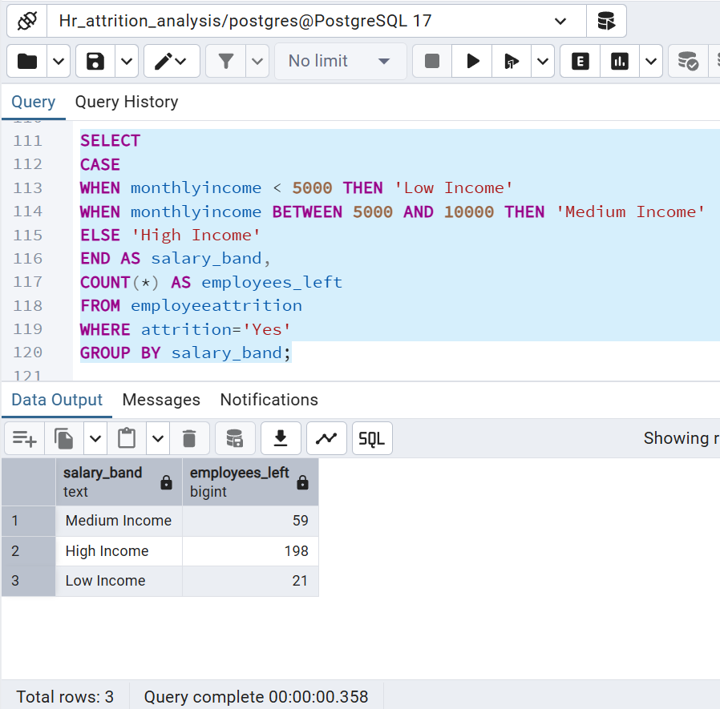

Description
- Employees were categorized into salary bands to study attrition patterns.
- The objective was to identify income groups experiencing higher employee turnover.
- The findings provide insights into compensation-related retention challenges.

Years at Company vs Attrition
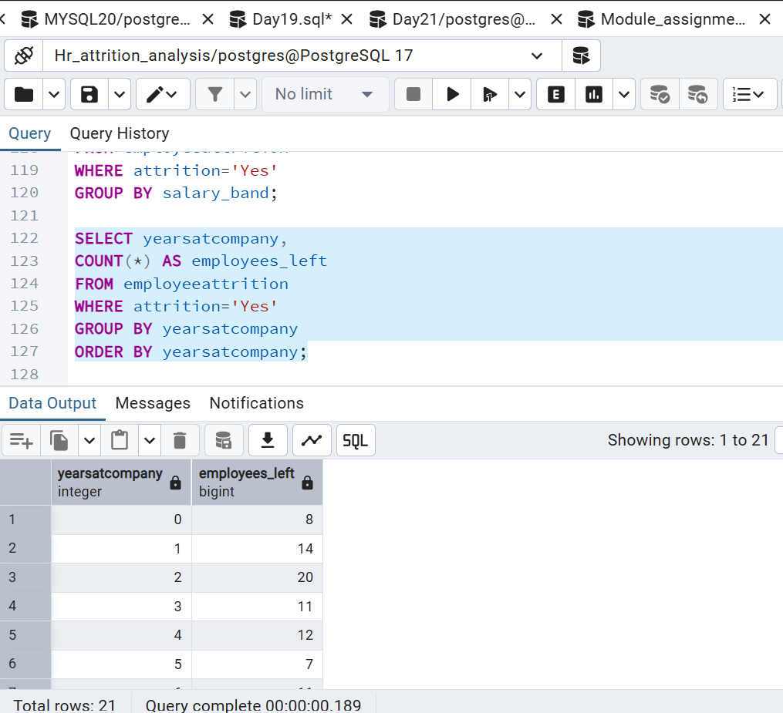

Description
- Employee attrition was analyzed based on years of service within the organization.
- The analysis helps identify at which stage employees are more likely to leave.
- Understanding tenure-based attrition supports workforce planning and retention programs.

Distance from Home vs Attrition
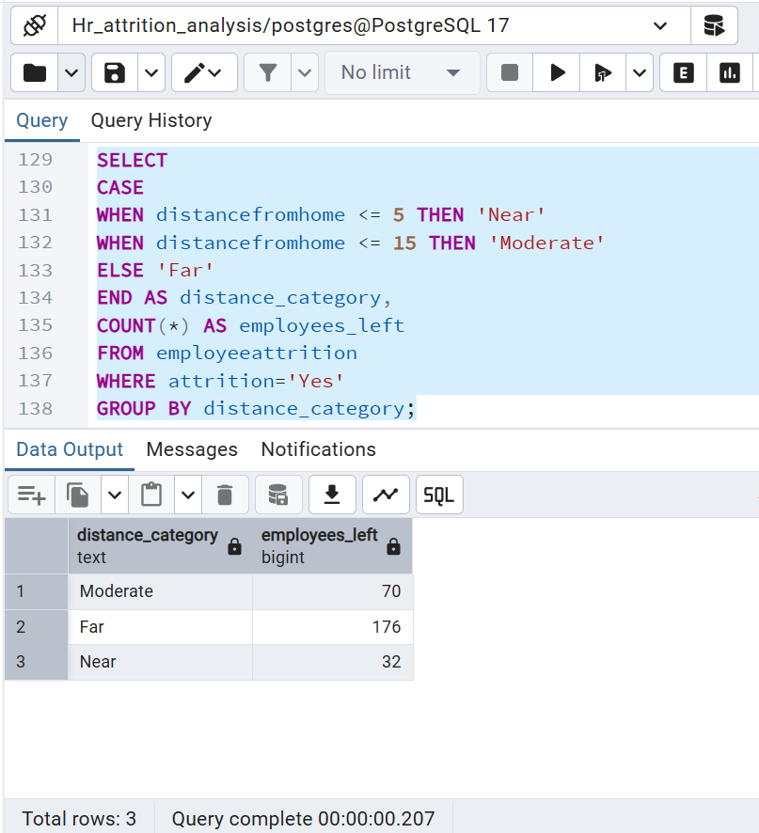

Description
- Employee turnover was examined based on commuting distance from home to workplace.
- The objective was to determine whether travel distance influences employee retention.
- The findings help evaluate the impact of commuting challenges on workforce stability.

Marital Status vs Attrition
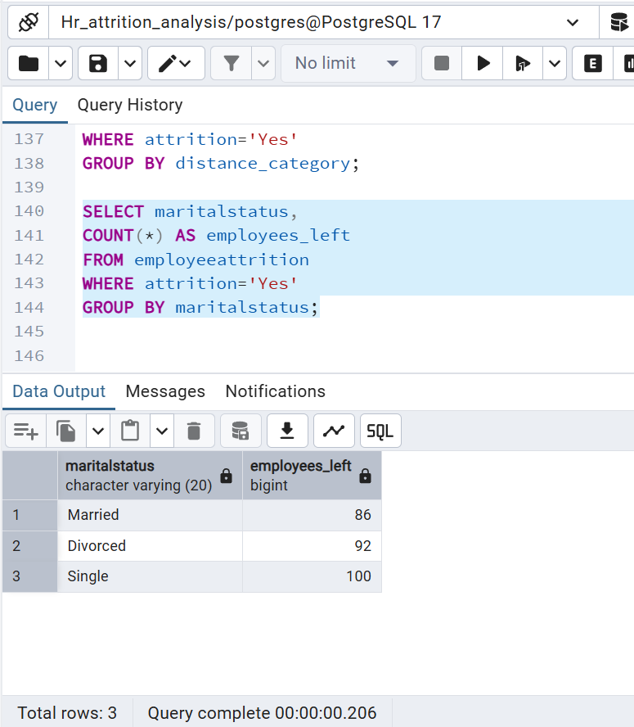

Description
- Employee attrition was analyzed across different marital status categories.
- The analysis helps understand whether personal and family-related factors affect retention.
- The results provide additional insights into employee demographics and turnover trends.

Age Group Analysis
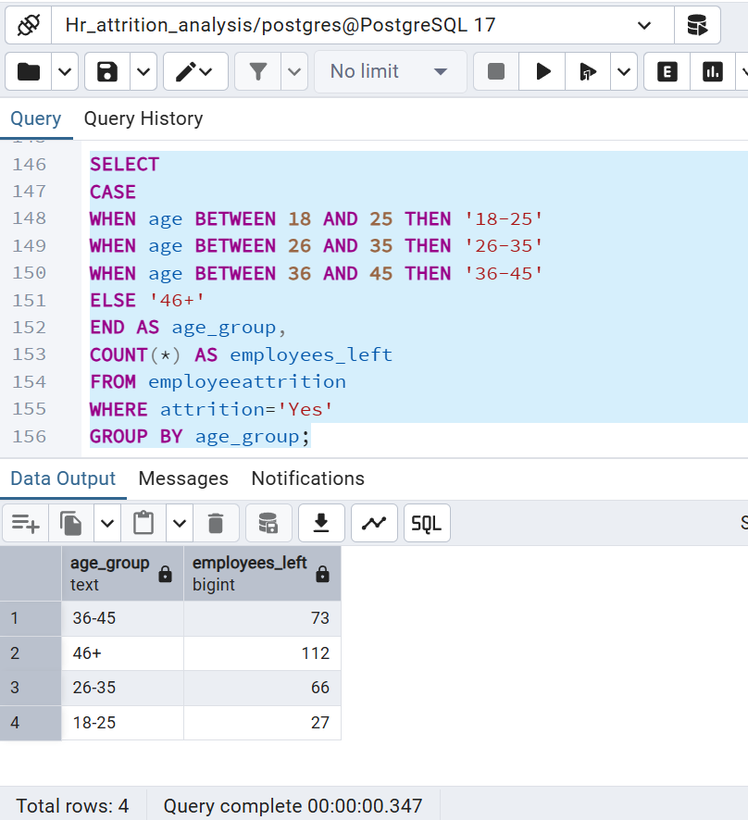

Description
- Employees were grouped into different age categories for attrition analysis.
- The objective was to identify age groups experiencing higher turnover rates.
- This analysis supports workforce planning and targeted employee engagement initiatives.

Power BI

Executive summary
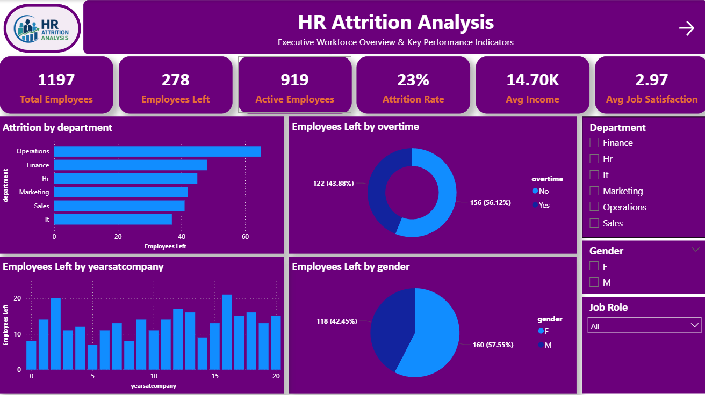

Description:
This dashboard provides an executive overview of the organization's employee attrition. It presents the key HR metrics, including Total Employees, Active Employees, Employees Left, Attrition Rate, Average Monthly Income, and Average Job Satisfaction. The dashboard also visualizes attrition across different departments, overtime status, gender, and years at the company. Interactive slicers allow users to filter the analysis by Department, Gender, and Job Role, helping HR managers quickly identify areas with higher employee turnover.

Business Outcome:
- Provides a high-level view of the organization's workforce.
- Identifies departments with the highest attrition.
- Shows the impact of overtime on employee turnover.
- Helps management monitor overall HR performance.

Root Cause Analysis of Employee Attrition
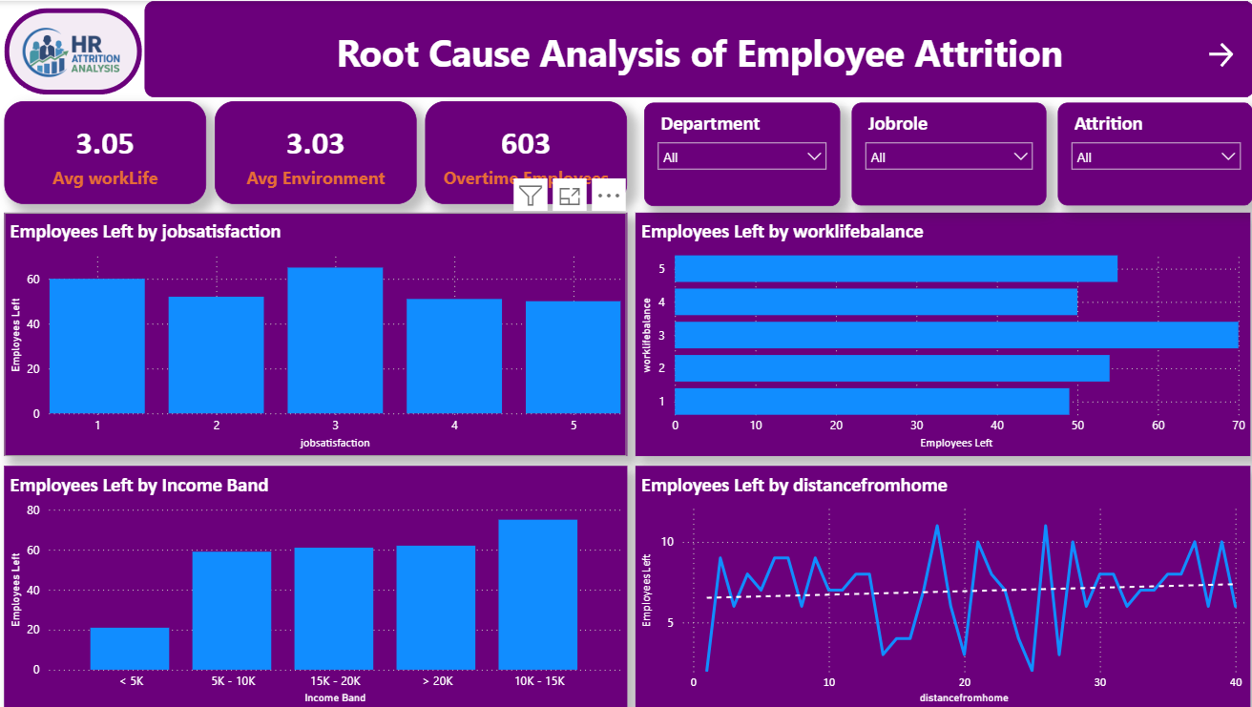

Description:
This dashboard focuses on identifying the major factors contributing to employee attrition. It displays KPIs such as Average Work-Life Balance, Average Environment Satisfaction, and Total Overtime Employees. Visualizations analyze employee attrition based on Job Satisfaction, Work-Life Balance, Monthly Income Bands, and Distance from Home. Slicers enable users to filter the analysis by Department, Job Role, and Attrition Status to identify patterns across different employee groups.

Business Outcome:
- Identifies the key drivers behind employee attrition.
- Highlights the relationship between overtime, job satisfaction, and work-life balance.
- Supports HR in prioritizing employee retention strategies.
- Enables department-wise analysis of attrition causes.

Workforce Insights & Retention Strategies
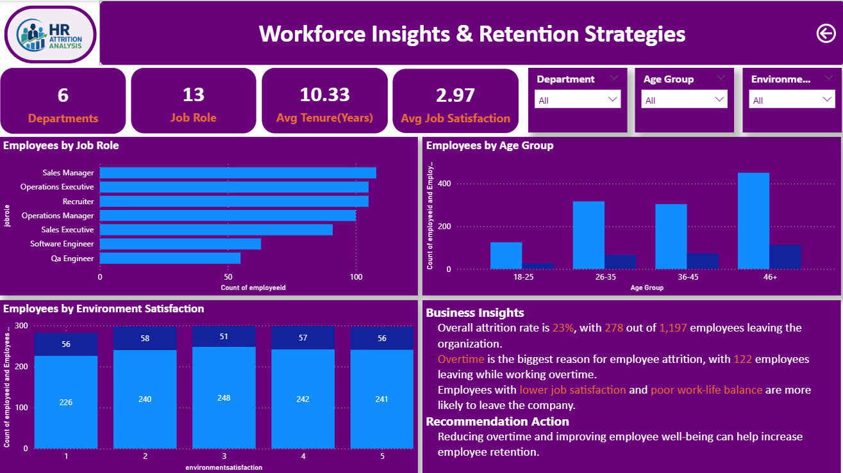

Description:
This dashboard provides workforce insights along with actionable recommendations for improving employee retention. It includes KPIs such as Total Departments, Total Job Roles, Average Tenure, and Average Job Satisfaction. The dashboard visualizes employee distribution by Job Role, Age Group, and Environment Satisfaction. A Key Insights section summarizes the major findings from the analysis, highlighting that overtime is the primary contributor to attrition, while lower job satisfaction and poor work-life balance further increase the likelihood of employees leaving the organization.

Business Outcome:
- Presents the overall workforce composition.
- Highlights important workforce trends across age groups and job roles.
- Summarizes the major findings from the analysis.
- Provides recommendations to reduce employee attrition through improved work-life balance and reduced overtime.

Conclusion
The HR Attrition Analysis project was developed to identify the major factors influencing employee attrition and to provide data-driven insights for improving employee retention. The analysis was performed using Excel for data cleaning, PostgreSQL for data analysis, and Power BI for interactive dashboard visualization.

The dashboard revealed that the organization has an attrition rate of 23%, with 278 out of 1,197 employees leaving the company. The analysis identified overtime as the most significant factor contributing to employee attrition. Employees with lower job satisfaction and poor work-life balance were also more likely to leave the organization. Department-wise and demographic analysis further helped identify areas with higher employee turnover.
Based on these findings, the organization can improve employee retention by reducing excessive overtime, promoting a healthier work-life balance, increasing employee engagement, and regularly monitoring employee satisfaction. The interactive dashboard enables HR teams to quickly analyze attrition trends and make informed, data-driven decisions.

