Mini project
Batch no: DA TE-008
Faculty: Sunitha.v
Student name: M Nithin
Dataset link: https://data.telangana.gov.in/dataset/tgspdcl-ev-charging-stations-consumption-data

Project title: TGSPDCL EV Charging Stations Consumption Analysis Telangana
Dashboard
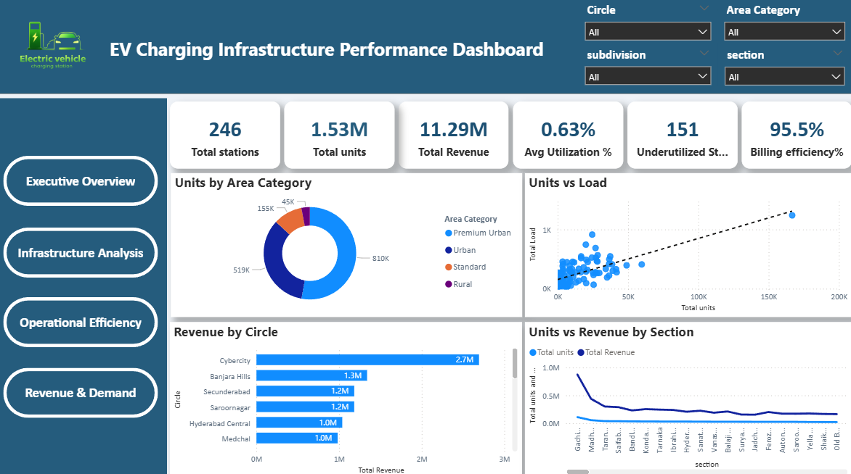
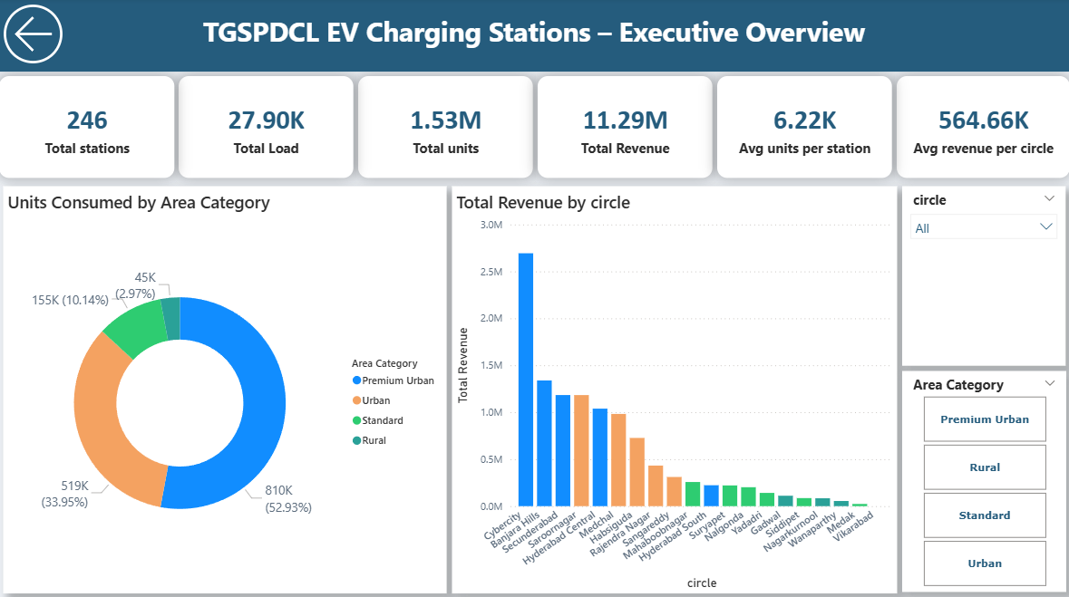
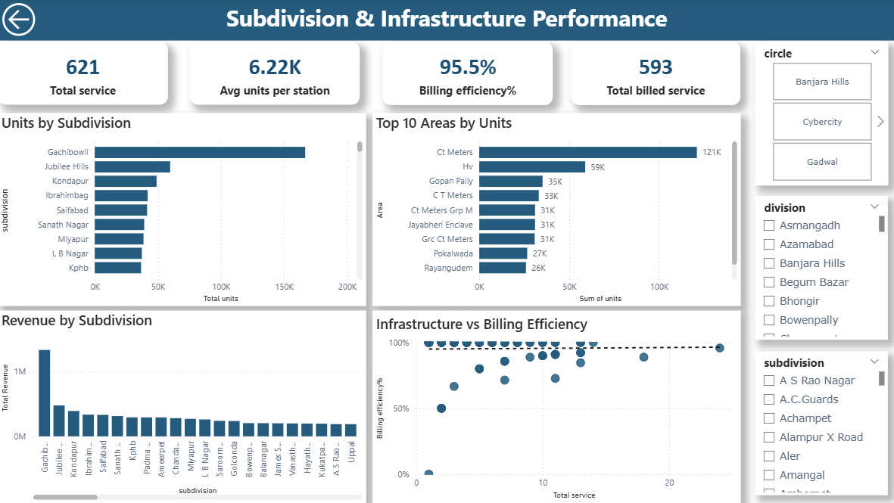
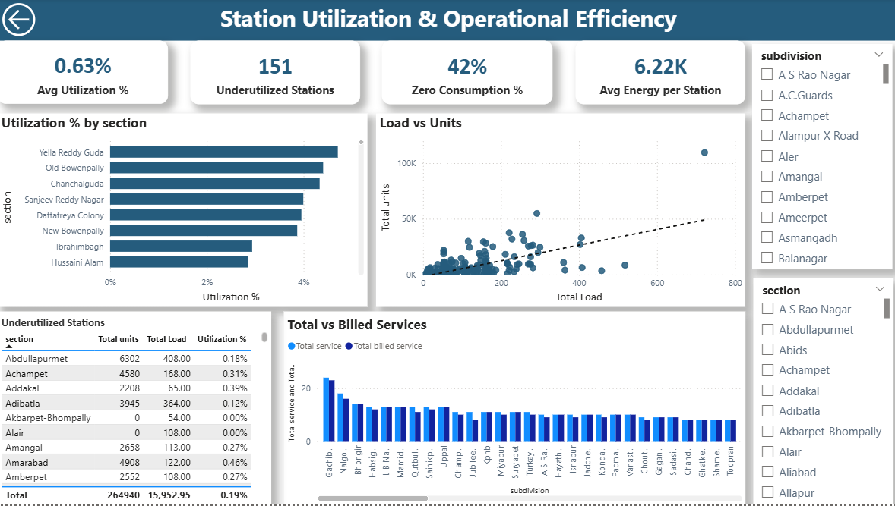
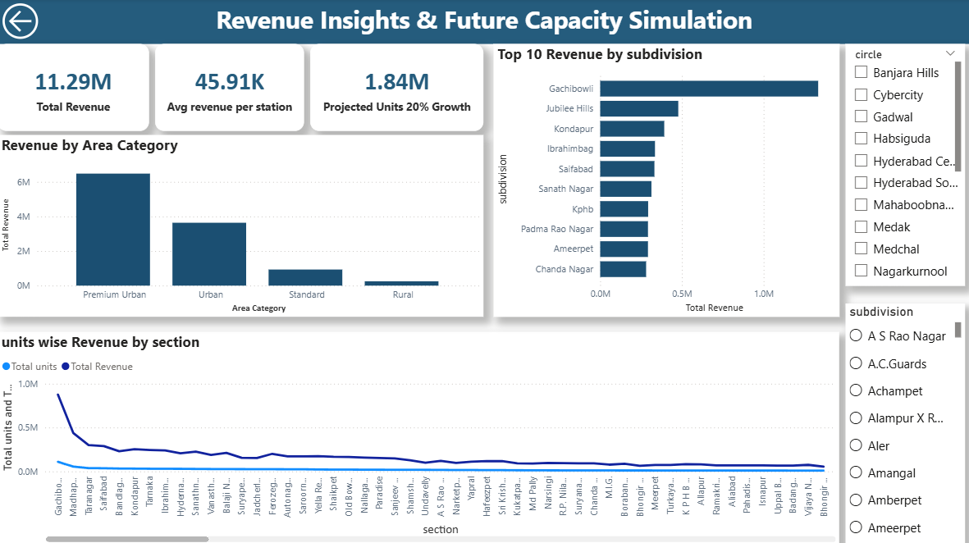

Conclusion:
A dashboard is an interactive visual interface that presents key insights and performance indicators in a single view. In this project, the dashboard was developed using Microsoft Power BI to provide a summarized overview of EV charging station performance. The dashboard integrates multiple analytical pages and displays important metrics such as station utilization, energy consumption, revenue generation, and demand growth.
The main objective of the dashboard is to enable users to quickly understand the operational performance of charging stations and make data-driven decisions. It contains various visual components including KPI cards, line charts, bar charts, and gauge charts that help in identifying trends and patterns in the dataset.
Interactive features such as slicers and page navigation buttons allow users to filter the data by different parameters and explore specific insights. This improves the usability of the dashboard and allows stakeholders to analyze charging station performance dynamically.
The final dashboard provides a consolidated view of the following analyses:
- Station Utilization Analysis
- Energy Consumption Analysis
- Revenue Analysis
- Demand and Growth Analysis
By presenting all these insights in a single interface, the dashboard simplifies complex data and enables efficient monitoring of EV charging station operations.

