Software Requirement Specification
Version
<<Annotated version>>
July 20,2015

PURCHASE ORDER MANAGEMENT

Team Members
1.Aditi Choubey
2.Heena
3.Mrunali Kalbut
4.Nitin Prasad
5.Pavithra Venkatraman
6.Pratik Nandankar
7.Shweta Malviya
8.Sweadha

PURCHASE ORDER MANAGEMENT

Module 2:Vendor Management and Vendor Order Processing

Client Name: SellMax Retailer

Client Logo:

Client Location: Trivandrum, Kerala
Document Release Notice:
Document Version No. : v4315
Revision Details: <action taken>

Purpose:

The module Vendor Management and Vendor Order Processing refers to the processing of order received from purchase order management.This module will enable the vendor to add ,view ,update,delete vendor employee, to update bill according to the partial or full delievery.Updation of the bill will decide the order's readiness for the shipment.Once the order is ready for shipment, truck managemnt system will be having the details of the truck and fixes the appointment with the retailer DC/store manager.

Indended Audience:

This document holds relevence to PO staff who places a order ,Vendor and "SellMax" retailer,Supervisor of DC or store at final delievery management system. Vendor Manager who will be doing all the final approval for all actions from vendor side.Vendor Employee who will be responsible for delivery management , truck management and defect management.Unit Head who will approve the new vendor registration request,

Related documents And References:

- http://www.javatpoint.com/
- http://getbootstrap.com/getting-started/

Acronyms and Abbreviations:

- PO : Purchase Order
- DC: Distribution Center

Table of Contents

1.Introduction
1.1 Background
1.2 Scope of module
1.3 Key Assumptions and Dependencies
1.4 Hardware and Software Platforms
1.5 Application Security

2.Requirements

2.1Functinal Requirements
2.2Use Cases
2.3UML Diagrams
2.3.1 Sequence Diagrams
2.3.2 Class Diagram

3.User Interface Specification

3.1GUI representation
3.2 Navigation Chart

4.Glossary

1 .Introduction

1.1 Background
Vendor Management and Vendor Order Processing is the second module of the project "Purchase order management". This module consists of three sub-modules,vendor management,
purchase order management and bill generation,truck management.

1.2 Scope of the module:
“SellMax”company has a list of trusted vendors who are already registered. A new vendor can always be registered by the company using Vendor management. After verification, unit head will approve/reject this.As per agreement with retailer ,all vendors must provide delivery to DC's and in some cases ,some vendors may provide services to store also.Once the order reaches the vendor, they start processing it.
The delivery will be based on the PO.Vendor can make a full or partial delivery.Bills will be generated for delivered items. If it is a partial delivery , bill will be generated only for that delivery under that PO Number.We can have many bills under one PO Number if it is a partial delivery.For the shipment, vendor has various truck services available to DC/store. For partial delivery, even if the bill generation is done, the status of the purchase order will not be “closed”.If it is a partial delivery ,it would be mentioned in the Bill. PO status can be changed to closed, once all the items are delivered.
For the shipment, vendor has various truck services available to DC/store. According to the delivery address employee will be selecting the truck. Truck should be fully loaded and that will be taken care by vendor employee,(offline process).In the system there should be a provision to enter the shortest and convenient path for the shipment .These details can be viewed/updated/deleted by vendor manager.Before the truck moving to the DC/store ,they inform the DC/store supervisor and fix an appointment for delivery. So that now the retailer DC/Store employee knows about the delivery . Using this module new truck can be added to this system for the vendor and also existing truck can be removed also.

1.3 Key Assumptions and Dependencies

Initially we are assuming that there are already registered vendors in the system while placing the order.The module has dependancy with the unit head of the system.New vendor can be added only when unit head will approve the request to register the vendor in the vendor management system. Truck will be ready for shipment only when it is fully loaded.

1.4 Hardware and Software Platforms

Hardware Platform:
1. Central Processing Unit
2.Hard Disk
3. Memory
4. Monitor
5. Keyboard
6. Mouse

Software Platform:
1.Apache-tomcat-6.0.32-Apache Tomcat is an open source web server and servlet container developed by the Apache Software Foundation(ASF). Tomcat implements several Java EE specifications including Java Servlet, Java Server Pages(JSP) and WebSocket and provides a pure Java HTTP web server environment for Java code to run in.
2. Eclipse-jee-indigo-Eclipse is an integrated development environment(IDE). It contains a base workspace and an extensible plug-in system for customizing the environment. Written mostly in Java,Eclipse can be used to develop applications not only in Java but also in other languages
1.5 Application Security
In our project,we have designed the database with two database security software.
1.Login
Here the user enters his user ID and password.Then he can view his home page,the database he created and manages the database. Here he can manage all his functionalities if he is an authenticated user.
2.Audit Trail
An audit trail is a security-relevant chronological record that provide documentary evidence of the sequence of all the activities that have affected at any time a specific operation procedure or event it can access and supervise all actions from all users. A normal users should not be allowed to change or stop it.
3.Log4j:
Apache log4j is a Java-based logging utility log4j is highly configurable through external configuration files at run-time. It views the logging process in terms of levels of priorities and offers mechanisms to direct logging information to a great variety of destinations, such as a database, file, console, UNIX Syslog, etc. This software helps the system to track the users who intentionally put errors into the system.

2. Requirements

Vendor Management and Vendor Order Processing consists of three sections:

1.Vendor management
Vendor Manager will be the user of this submodule,as he can send a request to unit head to register a new vendor to the system.After the approval from the unit head , products can be added to the stock of newly registered vendor and he /she can login with the userId and password.

2.Purchase Order Processing and Bill Generation
This submodule will be getting the purchase order created by the purchase order staff.Vendor Manager will decide the partial and full delievery of the order by compairing with the available stock of products.The bill generation will based on the type of delievery if it is partial then status of bill will be open,till full delievery,if order is fully delievered then status of the bill will be closed.

3 .Truck Management
For the shipment, vendor has various truck services available to DC/store. According to the delivery address employee will be selecting the truck. Truck should be fully loaded and that will be taken care by vendor employee,(offline process).In the system there should be a provision to enter the shortest and convenient path for the shipment .These details can be viewed/updated/deleted by vendor manager.Before the truck moving to the DC/store ,they inform the DC/store supervisor and fix an appointment for delivery. So that now the retailer DC/Store employee knows about the delivery . Using this module new truck can be added to this system for the vendor and also existing truck can be removed also.

2.1 Functinal Requirements
The functionality of this module includes four major operations
- Create
- Read/View
- Update
- Delete
Create
1.Vendor Registration form can add a new vendor to the vendor management system.
2. Vendor manager can add new vendor employee to the system.
3. Vendor manager can add new product to a particular vendor's stock.
4.Vendor manager can add a new truck to the system.

Read/View
1.Vendor manager can view vendor employee in the system.
2.Vendor manager can view product to a particular vendor's stock.
3.Vendor manager can view truck in the system.

Update
1. Vendor manager can update vendor employee in the system.
2.Vendor manager can update product to a particular vendor's stock.

Delete
1.Vendor manager can delete vendor employee in the system.
2.Vendor manager can delete product to a particular vendor's stock.
3.Vendor manager can delete truck in the system.

2.2 Use Cases
1.Use case: Create Vendor
Diagram:
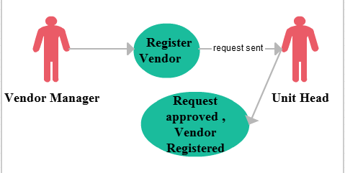
Brief Description

The Vendor manager enters information and sends a request to the unit head of the system .After his approval, new vendor can be registered.

Initial Step-By-Step Description

1.System presents a Vendor home page.
2.Vendor manager can select to login in if the vendor is already registered,but if the he wants to register then click on the RegisterVendor link.
3.Vendor Manager will reach to vendor registration form.
4.Fill the details in the fields given and click on Register button.
5.Request will be dispatched for the Unit head approval.

2.Use case : Product Management

Diagram:
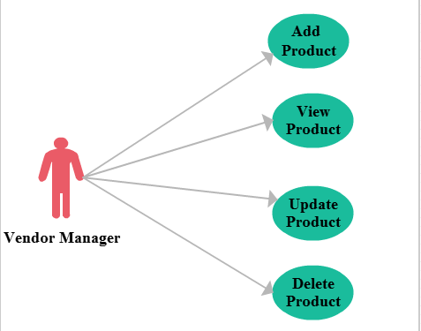
Brief Description:
When vendor manager enters in product management process he can perform different functions related to product.
Initial Step-By-Step Description
1.When Vendor Manager clicks on product management link, he will get 4 options and as per his choice he can do following practices addition of new product. remove product from list.View product list Update product details.
2.If the vendor manager clicks add product option , he will be receiving the popup window having registration foorm for the new product.
3.After filling the details, click on register button to add the product to the logged in vendor's stock.
4.Similarly process should be followed for the other operations.

3.Use case for Vendor Employee Management
Diagram:
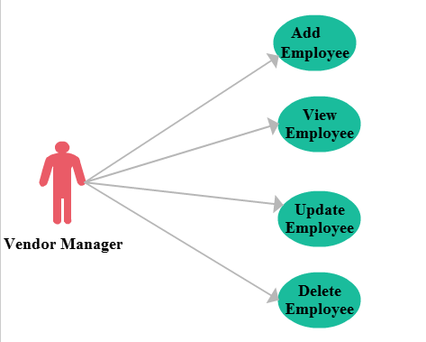
Brief Description

The Vendor manager clicks on the employee management button after vendor is logged in,there will be four options ,add employee,view employee,update employee,delete employee.

Initial Step-By-Step Description

1.System presents a VendorManagerlogin page,it shows 3 links add vendor employee,bill generation,truck management.
2.Vendor manager chooses add vendor employee link and adds a new vendor employee then click on the RegisterVendorEmployee link.
3.Vendor Manager will reach to vendorEmployee registration form.
4.Fill the details in the fields given and click on Register button.
5.Hence new vendor employee is created.
6.Similarly process should be followed for the other operations

4.Use case: Truck Management
Diagram:
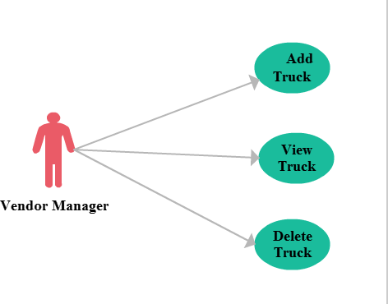
Brief Description
The Vendor manager clicks on the truck management button after vendor is logged in,there will be four options ,add truck,view truck,update truck,delete truck.The Vendor manager enters a details of new truck ,and new truck is registered.
Initial Step-By-Step Description
1.System presents a truck management system page.
2.Vendor manager chooses add truck link .
3.Vendor Manager will reach to truck registration form.
4.Fills the details in the fields given and click on Register button.
5.Hence new truck is registered.
6.Similarly process should be followed for the other operations

2.3UML Diagrams

2.3.1 Sequence Diagrams

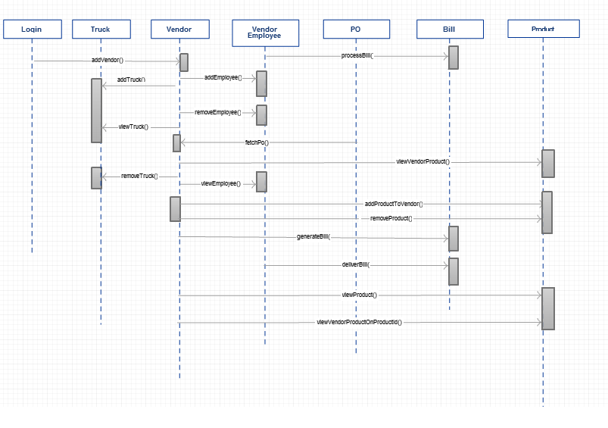

2.3.2Domain level class diagram

Vendor Management system contains different department having relationship with each other or we can say departments are dependent on other department(s) for their functionality.By using class diagram we can easily understand the relationship among departments of the system.
Here we have one main class that is Vendor class which handles the functionality of following classes,
1.User class
2.Vendor class
3.VendorProduct class
4.BillDetails class
5.VendorEmployee class
6.Truck class

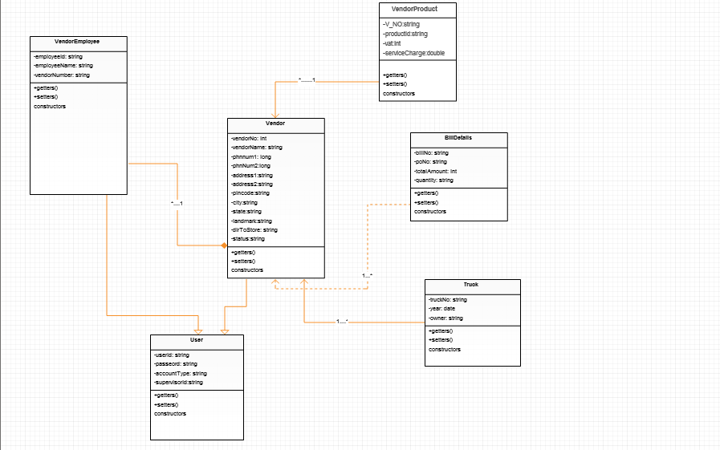

2.3.3 User Interface Specification
  - First is the Login Page. Here a new vendor can register by clicking on the link to register a new vendor.
  - Also, a registered vendor can login by entering his credentials on the login page.
  - Once a registered vendor login the profile page of vendor opens.
  - A vendor can have facilities like he can do employee management, product management, truck management .
  - Similarly, a registered employee can also login with his credentials on the login page.
  - An Employee profile page will open after that. On this page the employee has been provided with the links to select trucks and generate PO bills.
  - Vendor Manager can add employee ,view employee,update employee,delete employee by clicking vendor management button.
  - Vendor Manager can add product ,view product,update product,delete product by clicking product management button.
  - Vendor Manager can add truck ,view truck,update truck,delete truck by clicking truck management button.
  - Vendor Manager can logout by clicking logout option.

GUI Screen Layout

Screen 1: Home_vendor.jsp

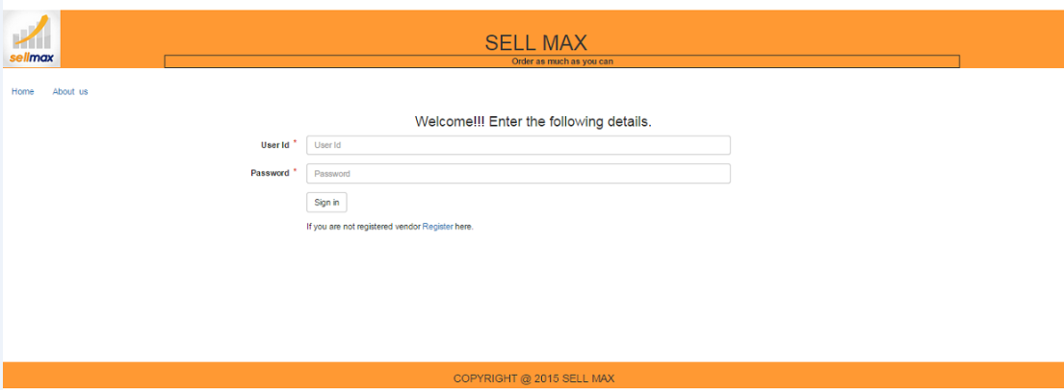

Screen2: RegisterVendor.jsp
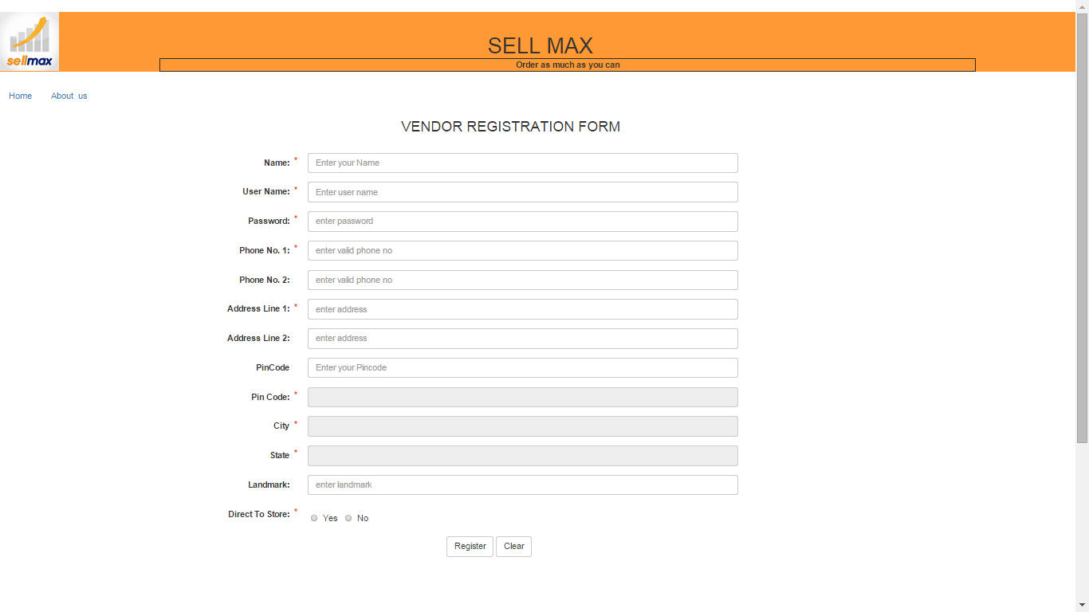

Screen 3: Vendorlogin.jsp

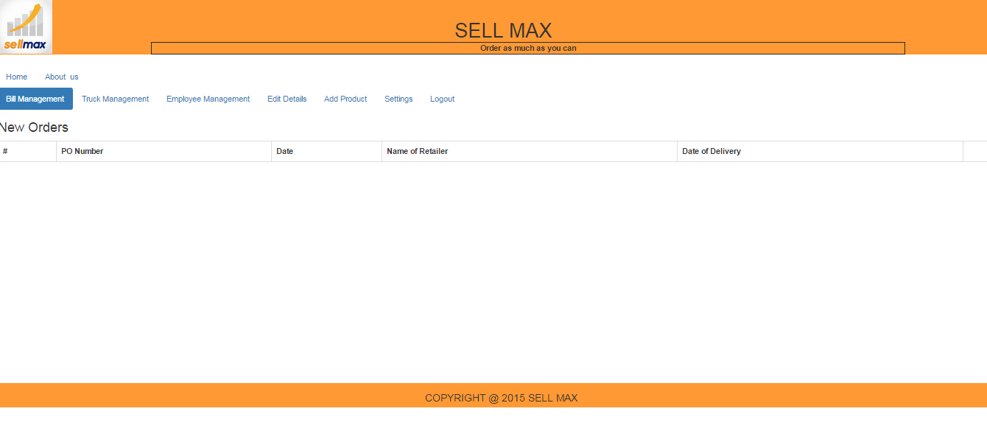

Screen 4:employee.jsp
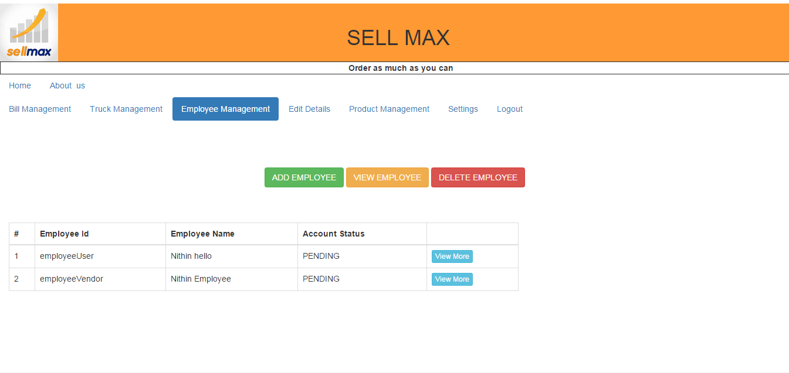

Screen 5:employee.jsp

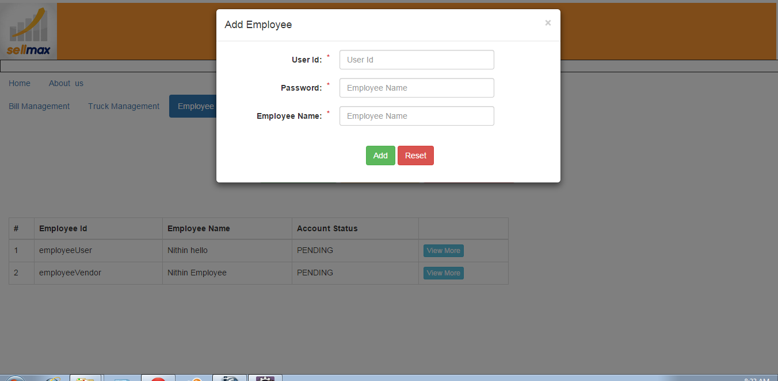

Screen 6:employee.jsp

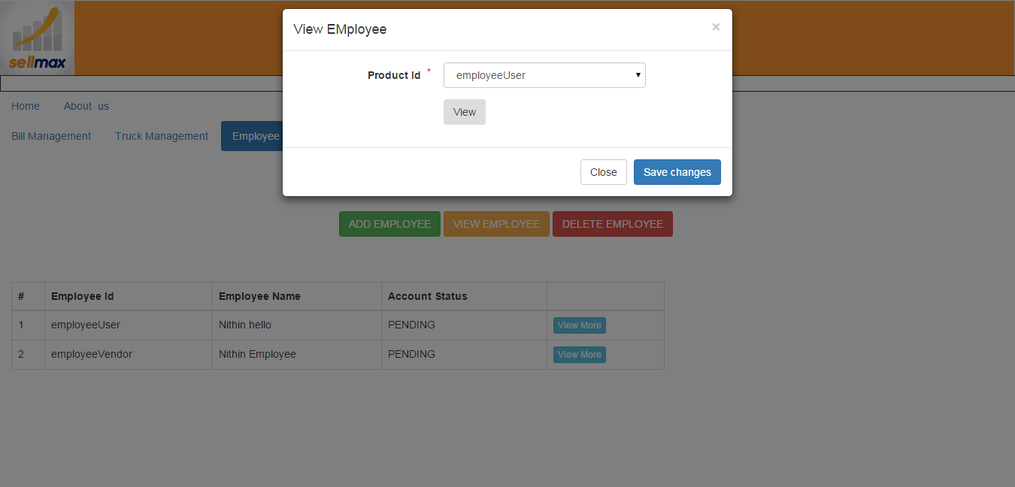

Screen 7:employee.jsp

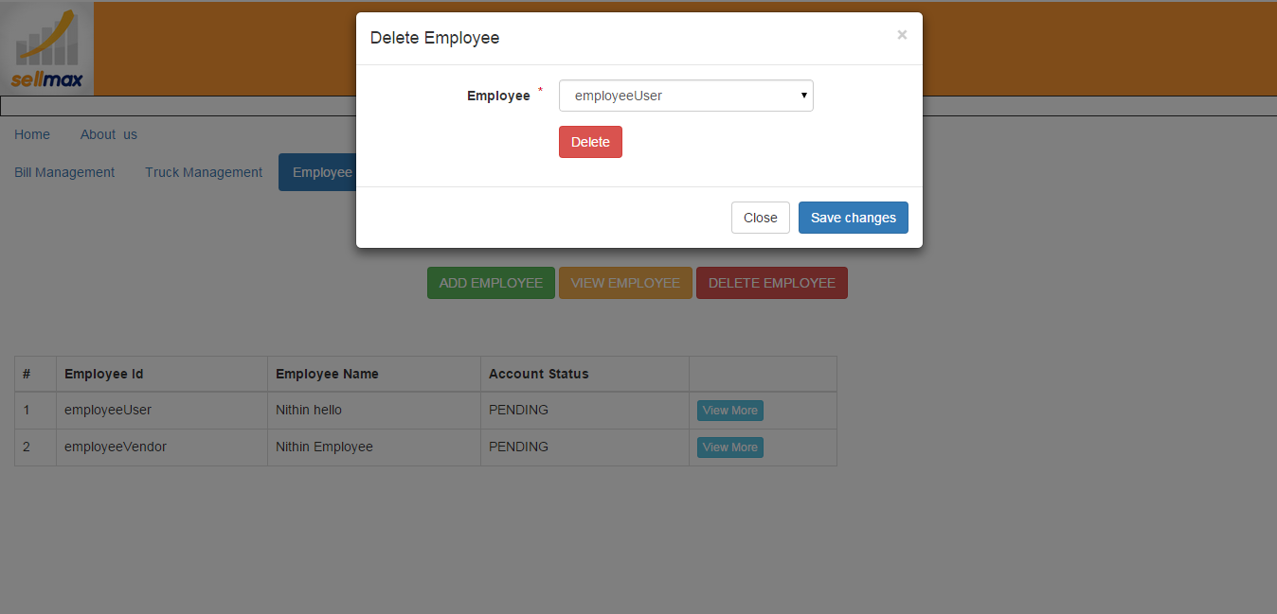
Screen8: Productmanagement.jsp
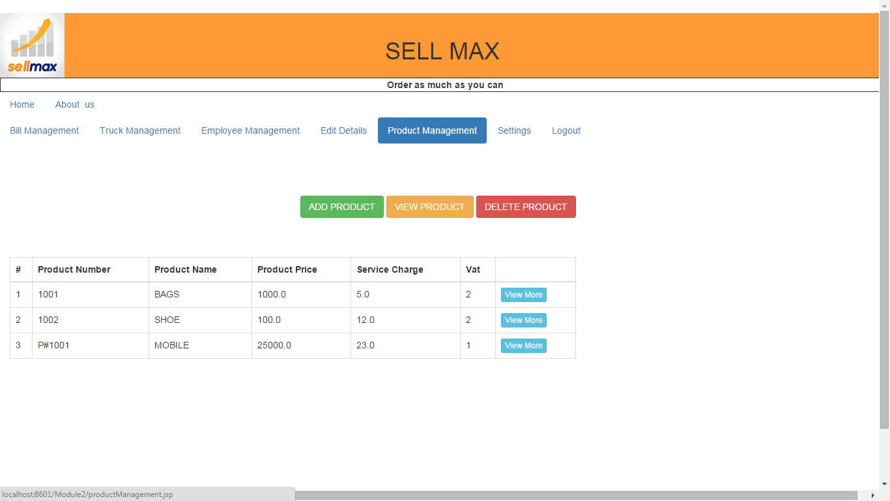

Screen 9: Productmanagement.jsp/addProduct

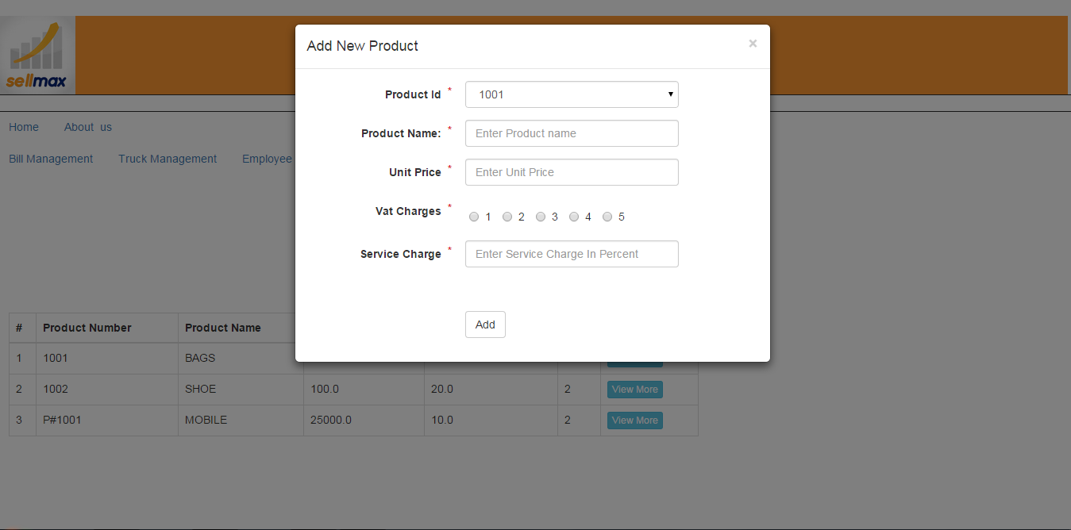

Screen 10: Productmanagement.jsp/viewProduct

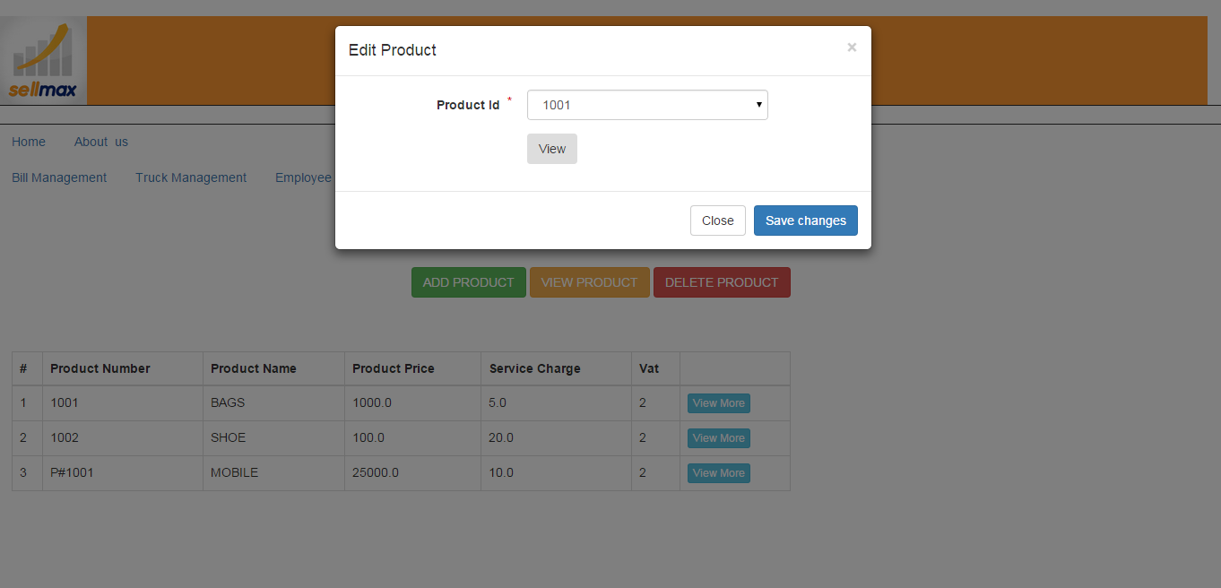

Screen 11: Productmanagement.jsp/deleteProduct

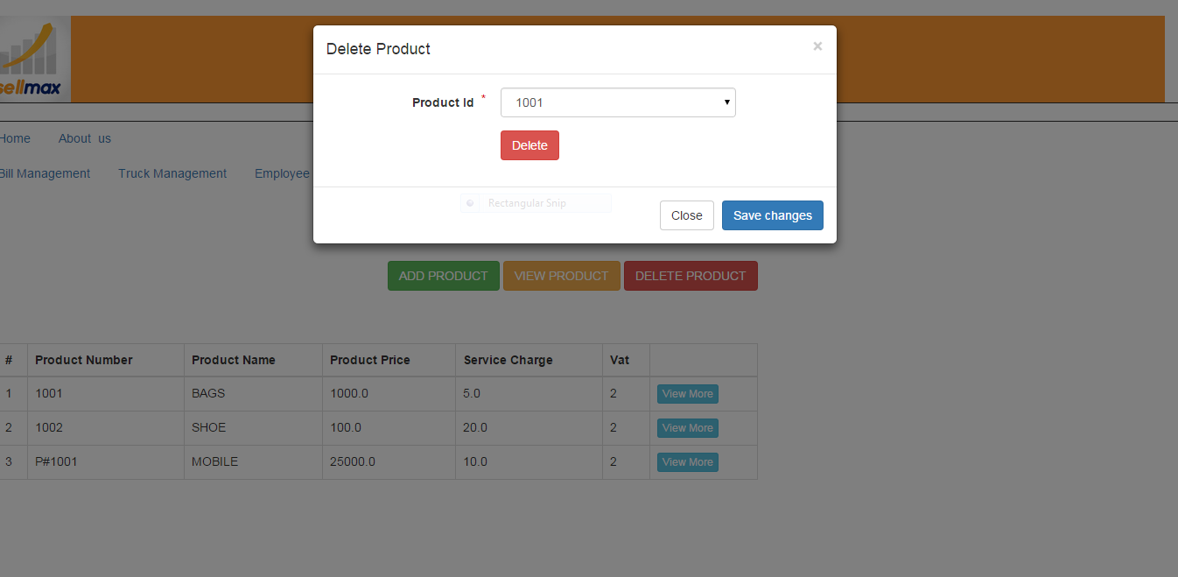
Screen 12: Vendorlogin.jsp
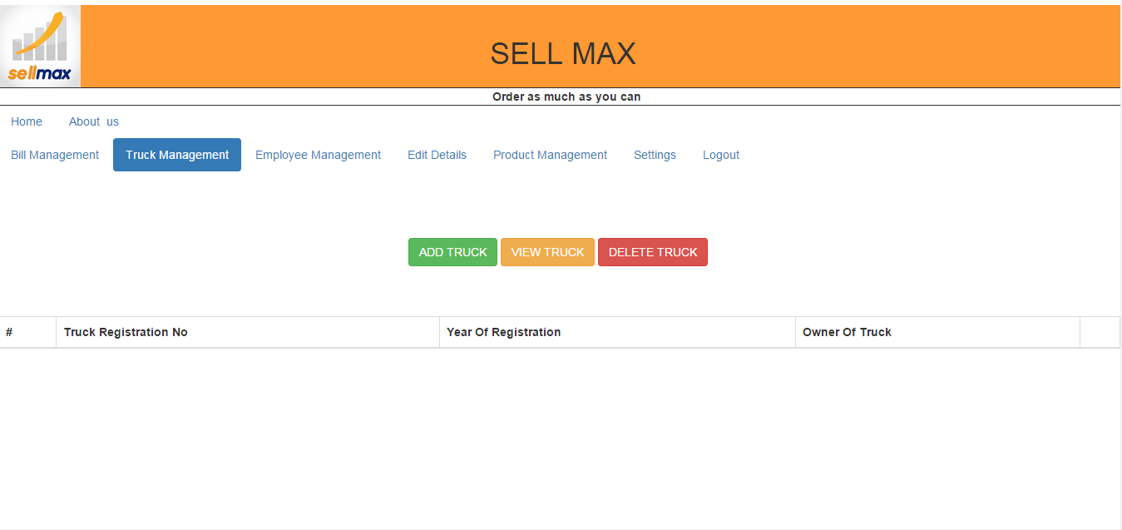

Screen 13:truckreg.jsp
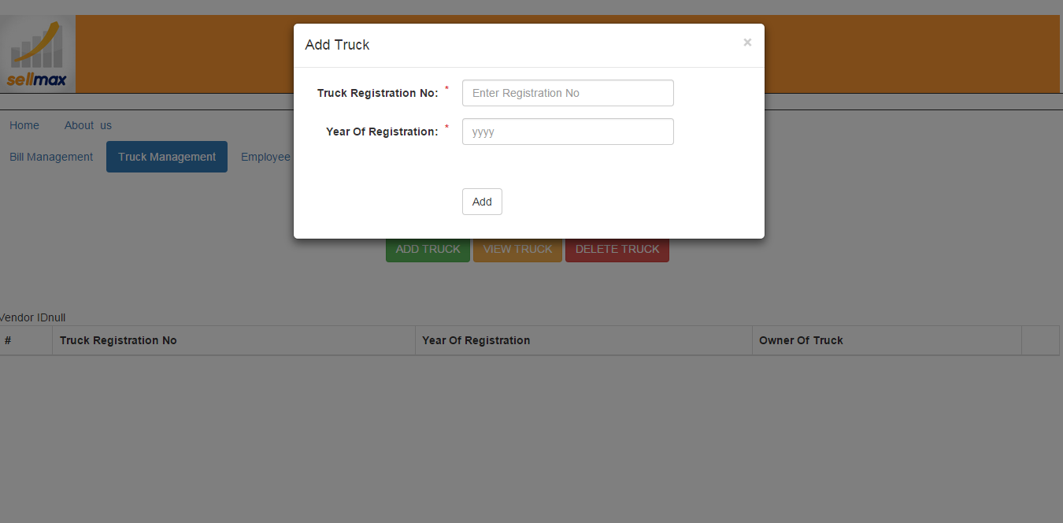
Screen14:truckreg.jsp
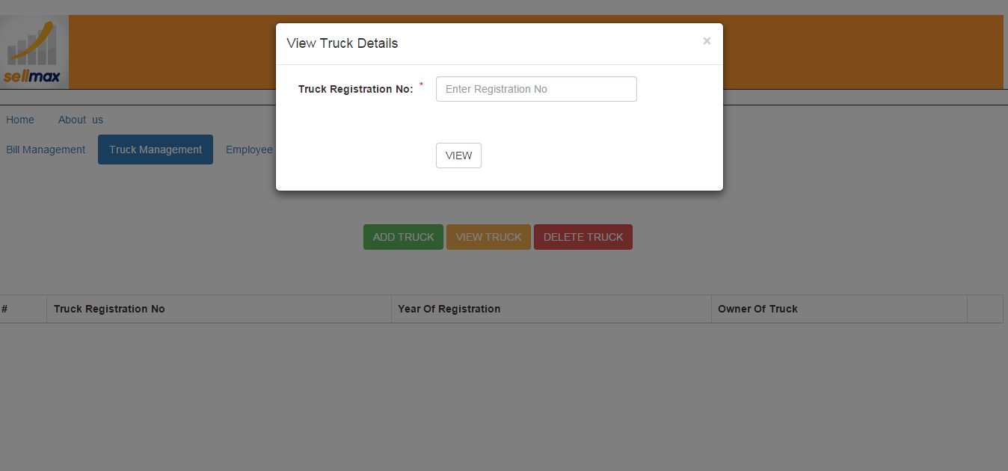

Screen15:truckreg.jsp

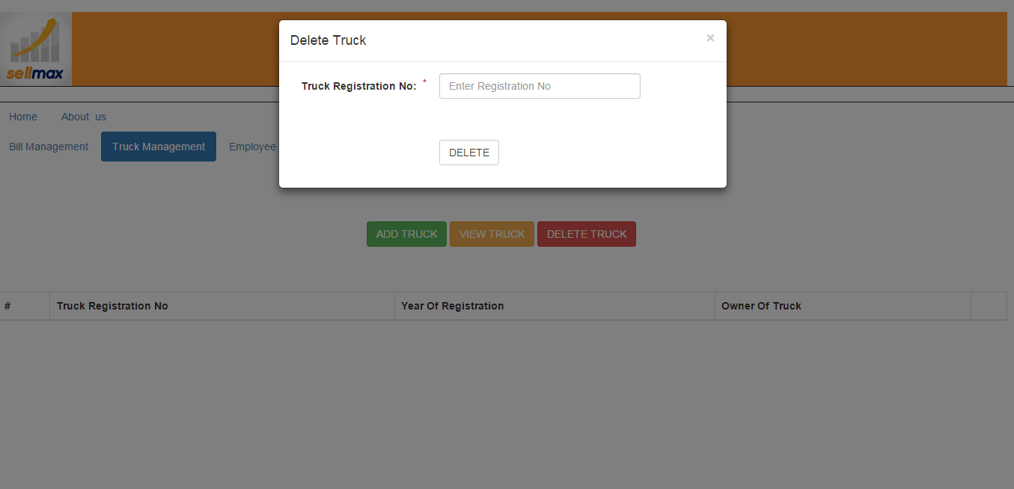

Screen 16:logoutuser.jsp
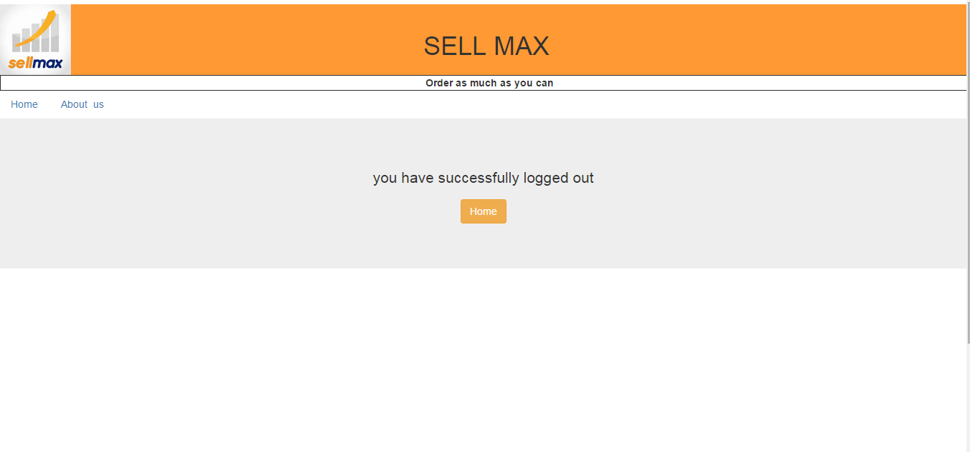

Navigation Chart:

No. | Form Name | Navigate To
1 | Home_Vendor.jsp | Login if UserId,password is available,or navigate to RegisterVendor.jsp to register.
2 | RegisterVendor.jsp | Fill the information and click on register button ,request will be sent to unit head for approval and after approval control will move to Home_Vendor.jsp.
3 | Vendorlogin.jsp | This page will be having navigation bar with options Employee management(to go to employee.jsp ),Product management( to go to Productmanagement.jsp),Truck management (to go to truckreg.jsp),Bill Management ,settings,logout (to go to logoutuser.jsp).
4 | employee.jsp | This page will be having three buttons:Add Employee ,View Employee,Delete Employee.
5 | Productmanagement.jsp | This page will be having three buttons:Add product ,View product,Delete product.
6 | truckreg.jsp | This page will be having three buttons:Add truck ,View truck,Delete truck.
7 | logoutuser.jsp

Glossary:
No. | Term | Defination
1 | Vendor Manager | - Employee Management  - Bill Management  - Truck management System  - Product Management
2 | Vendor Employee | - Selects truck for shipment

