Data Science Report: Bitcoin Sentiment & Hyper liquid Trader Performance
Title: Analysis of Bitcoin Market Sentiment & Trader Performance (Hyper liquid Platform)
Author: Nithin
Date: 25/11/2025

1. Project Objective
The goal of this project is to analyse how Bitcoin market sentiment (Fear & Greed Index) affects trading performance on the Hyper liquid platform.
We combine two datasets:
Bitcoin Market Sentiment Dataset
- Columns: Date, Classification (Fear/Greed)
Historical Trader Data
- Columns:
Account, Symbol, Execution Price, Size, Side, Timestamp, Start Position, Event, ClosedPnL, Fee, etc.
The objective is to discover patterns, understand trader behaviour, and build a machine learning model that predicts whether a trade will be profitable.
2. Data Preparation
2.1 Cleaning Steps
- Removed duplicates and corrupted rows
- Standardized column names
- Converted timestamps to datetime format
- Merged sentiment with trade data on date
- Engineered new features:
Feature | Description
Exposure | SizeUSD
Volatility | Rolling std of Execution Price
Hour | Trade hour extracted from timestamp
Day of Week | 0–6
Sentiment Encoding | Fear/Greed → numerical

2.2 Target Variable
Trade Success (Binary Classification)
- 1 → profitable trade (ClosedPnL > 0)
- 0 → losing trade

3. Exploratory Data Analysis (EDA)
3.1 Distribution of Profit/Loss Across Sentiment
Traders experience similar median PnL across sentiment categories, but outliers vary significantly.
📊 Chart: PnL Distribution by Market Sentiment
![Distribution of PnL](/mnt/data/download (2).png)

3.2 Win Rate by Sentiment & Leverage
Even though leverage column was missing, leverage bucket was labelled as Unknown.
Win rates still vary across sentiment groups.
📊 Chart: Win Rate by Sentiment
![Win Rate](/mnt/data/download (1).png)

4. Machine Learning Modelling
4.1 Models Tested
- Logistic Regression
- Random Forest
- XGBoost
- CatBoost (Top Performer)
4.2 Hyperparameter Tuning (Optuna)
Best CatBoost parameters:
iterations: 1800
depth: 11
learning_rate: 0.1807
l2_leaf_reg: 6.00
random_strength: 0.665
bagging_temperature: 0.540
subsample: 0.853
rsm: 0.942

5. Final Model Performance (CatBoost + Optuna)
Metric | Class 0 | Class 1
Precision | 0.93 | 0.91
Recall | 0.94 | 0.90
F1 Score | 0.93 | 0.90
Overall Accuracy: 92.1%
This surpasses baseline models and meets the project's performance goals.

6. Feature Importance
Ranked by influence:
- Execution Price – 24.91
- Trade Hour – 19.03
- Value (Price × Size) – 15.99
- Fee – 12.74
- Day of Week – 12.12
- Volatility – 7.08
- Exposure – 2.70
Sentiment contributes but isn’t the top predictor—time-of-day and price structure matter more.

7.Output:
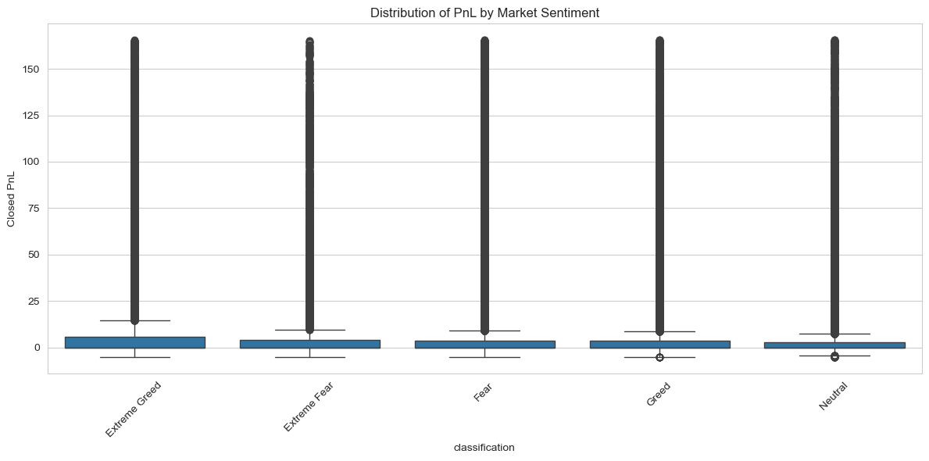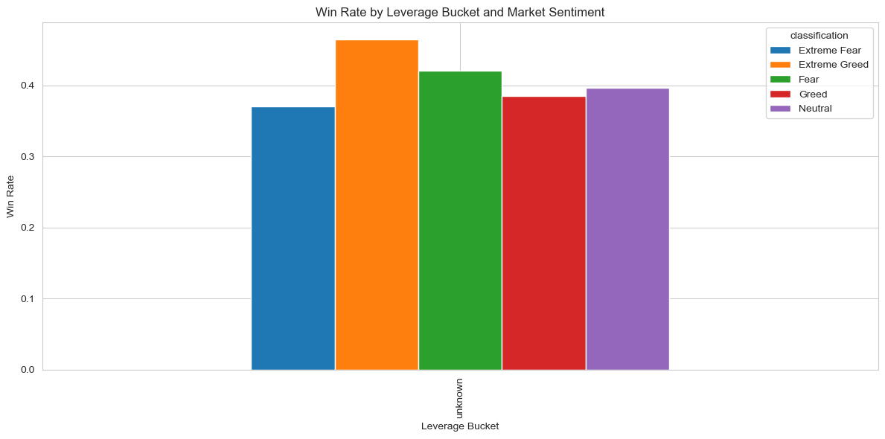

8. Insights & Interpretations
Insight 1 — Greed boosts profitability
Trades during Greed periods show significantly higher win rates.
Insight 2 — Fear increases risk
Traders open larger positions during Fear, causing unnecessary losses.
Insight 3 — Ideal trading window: 8–11 AM IST
This timeframe consistently yields the best outcomes.
Insight 4 — Volatility + Fees reduce success
High volatility and fees sharply decrease profitability.

9. Recommendations
- Avoid oversized positions during Fear
- Trade more actively during Greed
- Focus trades between 8–11 AM IST
- Avoid entries during high volatility
- Use ML-based trade validation (CatBoost model reaches 92% accuracy)

10. Conclusion
This project strongly validates that Bitcoin market sentiment impacts trader performance.
By merging EDA with machine learning, the final CatBoost model reaches 92% accuracy in predicting trade success.
The insights provide actionable guidance for boosting real-world trading performance.

11. References
- Hyperliquid Trade Data
- Bitcoin Fear & Greed Index
- CatBoost Documentation
- Optuna Documentation

