**CO2**

**10.Naive_Bayes_Classsification**

import numpy as np

import matplotlib.pyplot as plt

import pandas as pd

from sklearn.model_selection import train_test_split

from sklearn.preprocessing import StandardScaler

from sklearn.naive_bayes import GaussianNB

from sklearn.metrics import confusion_matrix, accuracy_score

from matplotlib.colors import ListedColormap

from sklearn import datasets

iris = datasets.load_iris()

X = iris.data

y = iris.target

# Split the dataset into training and testing sets

X_train, X_test, y_train, y_test = train_test_split(X, y, test_size=0.25, random_state=42)

sc = StandardScaler()

X_train = sc.fit_transform(X_train)

X_test = sc.transform(X_test)

classifier = GaussianNB()

classifier.fit(X_train, y_train)

def plot_decision_boundary(X_set, y_set, title):

X1, X2 = np.meshgrid(np.arange(start=X_set[:, 0].min() - 1, stop=X_set[:, 0].max() + 1, step=0.01),

np.arange(start=X_set[:, 1].min() - 1, stop=X_set[:, 1].max() + 1, step=0.01))

boundary_input = np.c_[X1.ravel(), X2.ravel(), np.tile(X_set[:, 2].mean(), X1.ravel().shape[0]), np.tile(X_set[:, 3].mean(), X1.ravel().shape[0])]

plt.contourf(X1, X2, classifier.predict(boundary_input).reshape(X1.shape),

alpha=0.75, cmap=ListedColormap(('red', 'green', 'blue')))

plt.xlim(X1.min(), X1.max())

plt.ylim(X2.min(), X2.max())

for i, j in enumerate(np.unique(y_set)):

plt.scatter(X_set[y_set == j, 0], X_set[y_set == j, 1],

c=ListedColormap(('red', 'green', 'blue'))(i), label=iris.target_names[j])

plt.title(title)

plt.xlabel('Sepal Length (cm)')

plt.ylabel('Sepal Width (cm)')

plt.legend()

plt.show()

plot_decision_boundary(X_train, y_train, title='Naive Bayes (Training set)')

plot_decision_boundary(X_test, y_test, title='Naive Bayes (Test set)')

iris_df = pd.DataFrame(data=np.c_[iris['data'], iris['target']], columns=iris['feature_names'] + ['target'])

print("Iris Dataset:")

print(iris_df)

**Output** 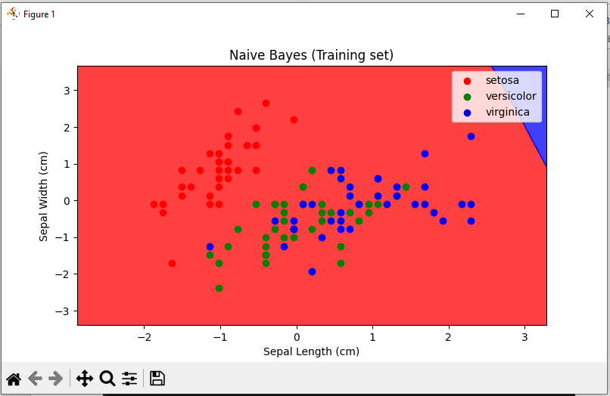

**11. KNN-CLASSIFICATION**

import numpy as np

from sklearn.model_selection import train_test_split

from sklearn.neighbors import KNeighborsClassifier

from sklearn.metrics import confusion_matrix, accuracy_score, classification_report

# Generate some sample data (replace this with your dataset)

X = np.random.rand(100, 2) # Features

y = np.random.randint(0, 2, 100) # Target labels (binary classification)

# Split the data into training and testing sets

X_train, X_test, y_train, y_test = train_test_split(X, y, test_size=0.2, random_state=42)

# Create a KNN classifier with k=3

knn = KNeighborsClassifier(n_neighbors=3)

# Fit the classifier to the training data

knn.fit(X_train, y_train)

# Make predictions on the test data

y_pred = knn.predict(X_test)

# Calculate and print the confusion matrix

conf_matrix = confusion_matrix(y_test, y_pred)

print("Confusion Matrix:")

print(conf_matrix)

# Calculate and print the accuracy score

accuracy = accuracy_score(y_test, y_pred)

print("Accuracy:", accuracy)

# Print the classification report (including precision, recall, f1-score, and support)

class_report = classification_report(y_test, y_pred)

print("Classification Report:")

print(class_report)

**Output**

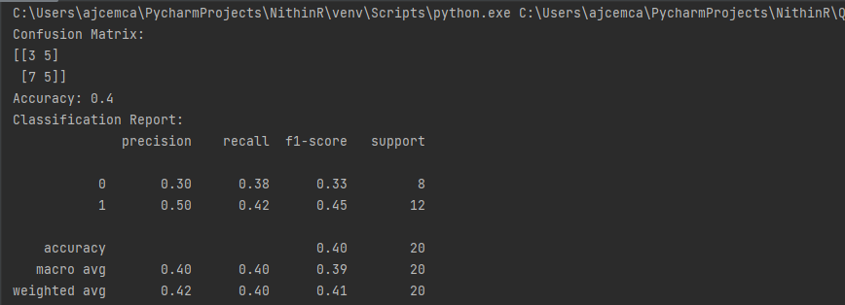

**12. Linear Regression(without csv)**

import numpy as np

import matplotlib.pyplot as plt

study_hours = np.array([2, 3, 4, 5, 6])

exam_scores = np.array([60, 75, 85, 90, 95])

mean_study_hours = np.mean(study_hours)

mean_exam_scores = np.mean(exam_scores)

m = np.sum((study_hours - mean_study_hours) * (exam_scores - mean_exam_scores)) / np.sum((study_hours - mean_study_hours) ** 2)

b = mean_exam_scores - m * mean_study_hours

def predict_exam_score(hours):

return m * hours + b

predicted_score = predict_exam_score(4)

print(f"Predicted Exam Score for 4 hours of study: {predicted_score}")

regression_line = m * study_hours + b

plt.scatter(study_hours, exam_scores, color='blue', label='Actual Data')

plt.plot(study_hours, regression_line, color='red', label='Regression Line')

plt.scatter(4, predicted_score, color='green', label='Predicted Point (4 hours)')

plt.xlabel('Study Hours')

plt.ylabel('Exam Score')

plt.title('Simple Linear Regression')

plt.legend()

plt.show()

**Output**

import numpy as np

import matplotlib.pyplot as plt

np.random.seed(42) # for reproducibility

num_samples = 100

education_level = np.random.uniform(0, 20, num_samples) # Simulated education levels

income = 1000 * education_level + np.random.normal(0, 5000, num_samples) # Simulated income

plt.figure(figsize=(12, 5))

plt.subplot(1, 2, 1)

plt.hist(education_level, bins=15, edgecolor='black', alpha=0.7, color='skyblue')

plt.xlabel('Education Level')

plt.ylabel('Frequency')

plt.title('Distribution of Education Level')

# Distribution chart for income

plt.subplot(1, 2, 2)

plt.hist(income, bins=15, edgecolor='black', alpha=0.7, color='orange')

plt.xlabel('Income')

plt.ylabel('Frequency')

plt.title('Distribution of Income')

plt.tight_layout()

plt.figure(figsize=(8, 6))

plt.scatter(education_level, income, color='blue', alpha=0.7)

plt.xlabel('Education Level')

plt.ylabel('Income')

plt.title('Income vs. Education Level')

plt.grid(True)

plt.show()

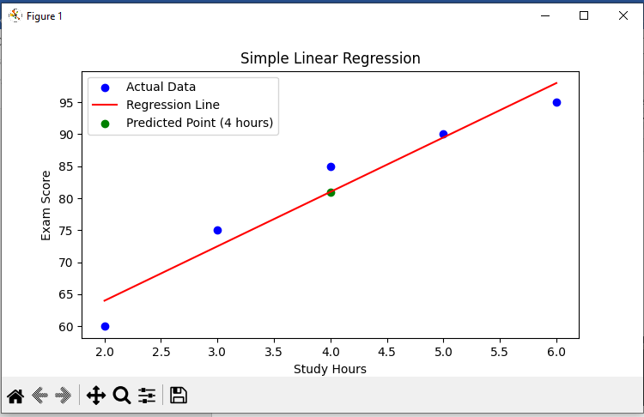

**13. Decision tree classifier(using iris dataset)**from sklearn.datasets import load_iris

from sklearn.model_selection import train_test_split

from sklearn.tree import DecisionTreeClassifier

from sklearn.metrics import accuracy_score, classification_report, confusion_matrix

import matplotlib.pyplot as plt

from sklearn import tree

# Load the Iris dataset

iris = load_iris()

X = iris.data

y = iris.target

# Split the dataset into training and testing sets

X_train, X_test, y_train, y_test = train_test_split(X, y, test_size=0.2, random_state=42)

# Create a Decision Tree classifier

clf = DecisionTreeClassifier()

clf.fit(X_train, y_train)

# Make predictions on the test set

y_pred = clf.predict(X_test)

# Calculate the accuracy

accuracy = accuracy_score(y_test, y_pred)

print(f'Accuracy: {accuracy:.2f}')

# Display the classification report and confusion matrix

print(classification_report(y_test, y_pred))

print(f'Confusion Matrix:\n{confusion_matrix(y_test, y_pred)}')

plt.figure(figsize=(12, 8))

tree.plot_tree(clf, feature_names=iris.feature_names, class_names=iris.target_names, filled=True)

plt.show()

**Output**

