**CO3**

**K-MEANS(without csv)**

import numpy as np

import matplotlib.pyplot as plt

# Generate sample data

data = np.array([[2, 3], [3, 4], [5, 6], [9, 10], [10, 8]])

# Number of clusters (you can change this)

k = 3

# Initialize centroids randomly

centroids = data[np.random.choice(data.shape[0], k, replace=False)]

# Main K-means algorithm

num_iterations = 100

for iteration in range(num_iterations):

# Calculate distances between data points and centroids

distances = np.linalg.norm(data[:, np.newaxis] - centroids, axis=2)

# Assign data points to the nearest centroid

labels = np.argmin(distances, axis=1)

print(labels)

# Plot data points and current centroids

plt.scatter(data[:, 0], data[:, 1], c=labels)

plt.scatter(centroids[:, 0], centroids[:, 1], c='red', marker='X', s=200)

plt.xlabel("X-axis")

plt.ylabel("Y-axis")

plt.title(f"Iteration {iteration}")

plt.show()

# Update centroids based on the mean of assigned data points

new_centroids = np.array([data[labels == i].mean(axis=0) for i in range(k)])

# Check for convergence

if np.array_equal(centroids,new_centroids):

break

centroids = new_centroids

# Print final cluster assignments and centroids

print(distances)

print("Final Cluster Assignments:", labels)

print("Final Cluster Centroids:", centroids)

OUTPUT

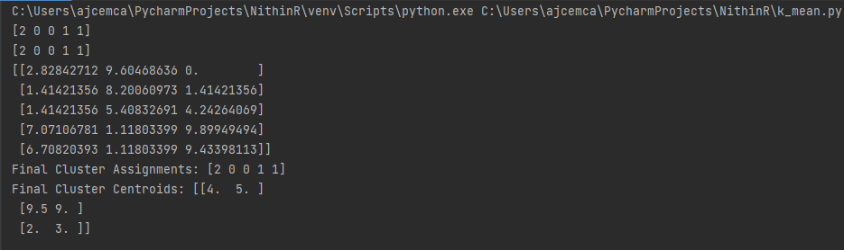

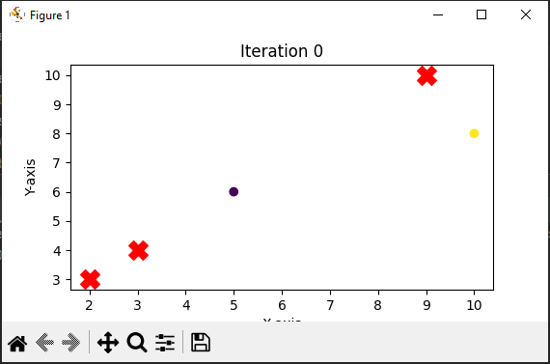

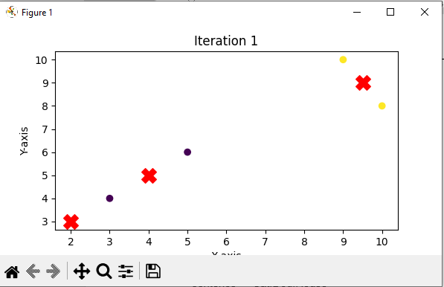

**POS**

import nltk

from nltk import pos_tag

from nltk.tokenize import word_tokenize

# Download necessary NLTK resources

nltk.download('punkt')

nltk.download('averaged_perceptron_tagger')

# Sample sentence

sentence = "Amal,jyotthi,kanjirappally"

# Tokenize the sentence

words = word_tokenize(sentence)

# Perform POS tagging

pos_tags = pos_tag(words)

# Display the result

print(pos_tags)

**Output**

**N-gram Modeling**from nltk import bigrams,word_tokenize

sentence="Hello Have a Good Day"

words=word_tokenize(sentence)

bigrams_list=list(bigrams(words))

print(bigrams_list)

**Output**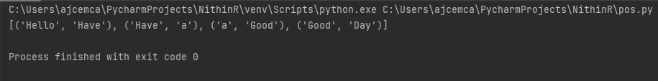

**WebCrawler**

import requests

from bs4 import BeautifulSoup

def simple_web_crawler(url, max_depth=2):

visited_urls = set()

def crawl(url, depth):

if depth > max_depth or url in visited_urls:

return

print(f"Crawling: {url}")

try:

response = requests.get(url)

visited_urls.add(url)

if response.status_code == 200:

soup = BeautifulSoup(response.text, 'html.parser')

title = soup.title.string.strip() if soup.title else 'No title found'

print(f"Page Title: {title}")

for link in soup.find_all('a', href=True):

next_url = link['href']

crawl(next_url, depth + 1)

except Exception as e:

print(f"Error crawling {url}: {e}")

crawl(url, depth=1)

if __name__ == "__main__":

start_url = "https://aesajce.in"

simple_web_crawler(start_url)

**Output**

