**Experiment No.: 5 Date 13-03-2023**

**AIM**: Familiarization of linux commands.

**CO2**: Perform system administration task.

**Procedure:**

1. read

he Linux read command is used to read the contents of a line into a variable

$read

$ echo $REPLY

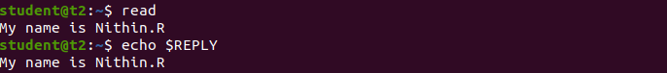

1.1. Read into variables

$ read var1 var2 var 3

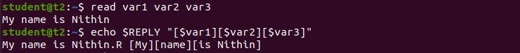

1.2 read multiple lines using backslash

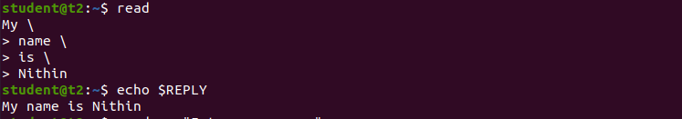

1.3 $read -p :

The '-p' option is used for the **prompt text**.





1.4 $read - n

Read only a specific length of characters



1.5 $read -s

read secure data like passwords

$read -s -p “Enter password”



2. $wc filename

display the details of file

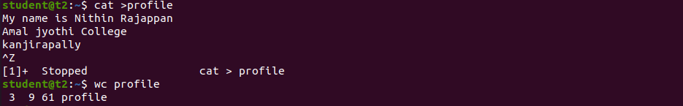

2.1 $wc -l : To display number of lines

$wc -l profile

$wc -m : To display number of bytes

$wc -m profile

$wc -c : To display number of characters

$wc -c profile

$wc -w: To display number of words

$wc -w profile

$wc -L : Length of the longest line

$wc -l profile

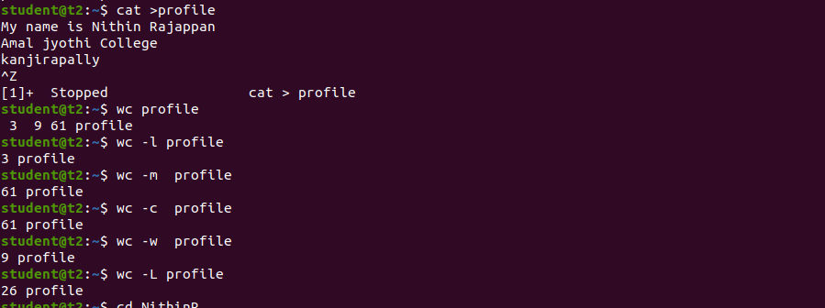

2.6 $more

command is used to view the text files in the command prompt, displaying one screen at a time in case the file is large

$more myfile.txt

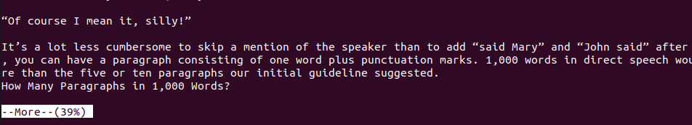

2.7 $more +4  
Type the number of lines that you want to display per screen.

$more +4 myfile.txt

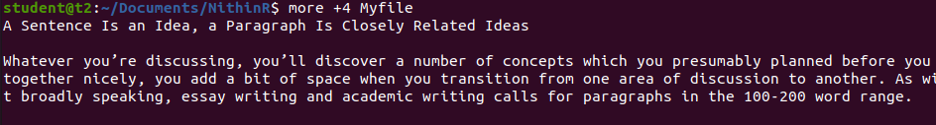

2.8 $more +/something

Search the pattern string

$more +/Ideas myfile.txt

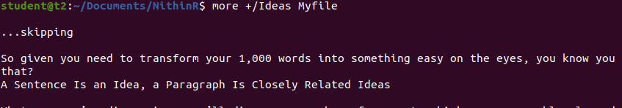

2.9 $more -d

help user to navigate , press space to continue, q to quit

$more -d Myfile.txt

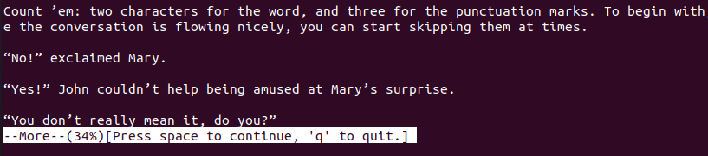

**Result**

The program was executed and the result was successfully obtained. Thus CO2 was obtained