Title : Multi-VPC Architecture with Transit Gateway & VPC Endpoints
CHALLENGE 1 — Build Multi-VPC Architecture
Objective
Create 3 VPCs representing different departments connected through Transit Gateway.
Steps
Step 1 — Create VPC-Shared (Hub VPC)
- VPC → Create VPC → VPC Only
Field | Value
Name | vpc-shared-services
CIDR | 10.0.0.0/16
Region | eu-north-1
- Create subnet:
  - Name: shared-private-subnet
  - CIDR: 10.0.1.0/24
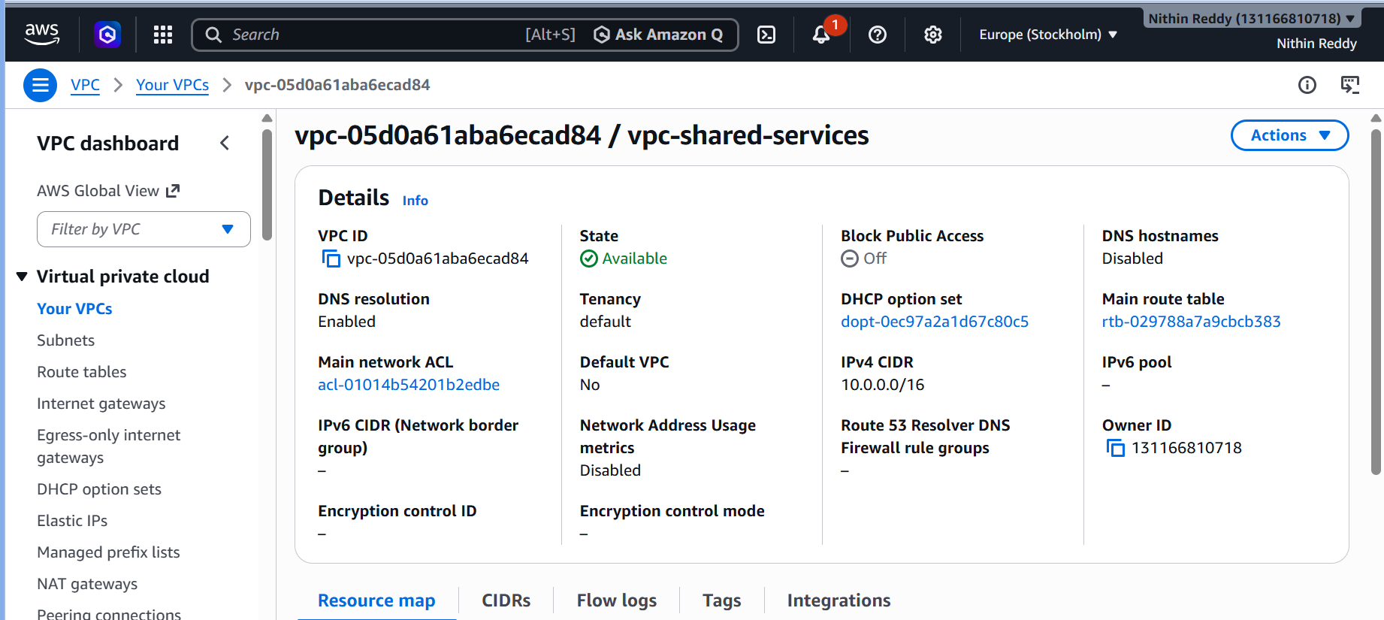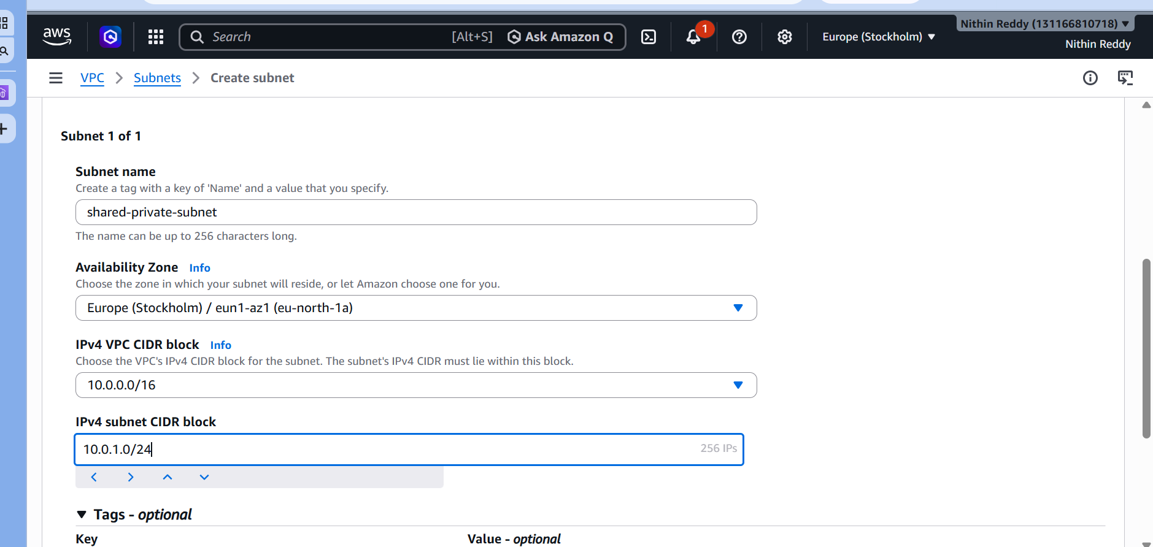
Step 2 — Create VPC-Dev (Department A)
- VPC → Create VPC
Field | Value
Name | vpc-dev
CIDR | 10.1.0.0/16
- Create subnet:
  - Name: dev-private-subnet
  - CIDR: 10.1.1.0/24
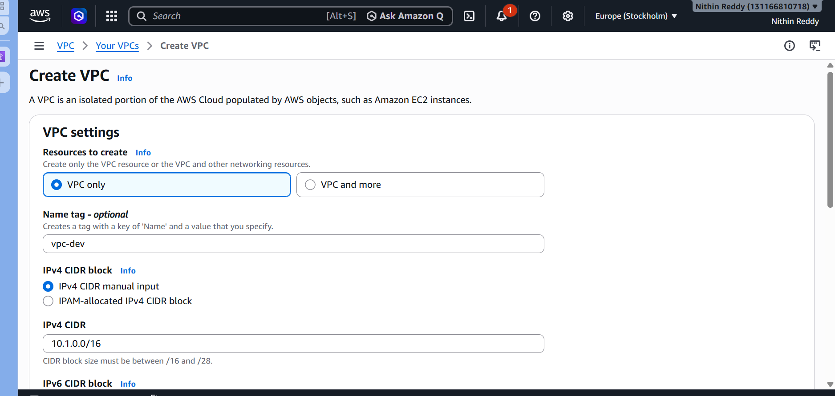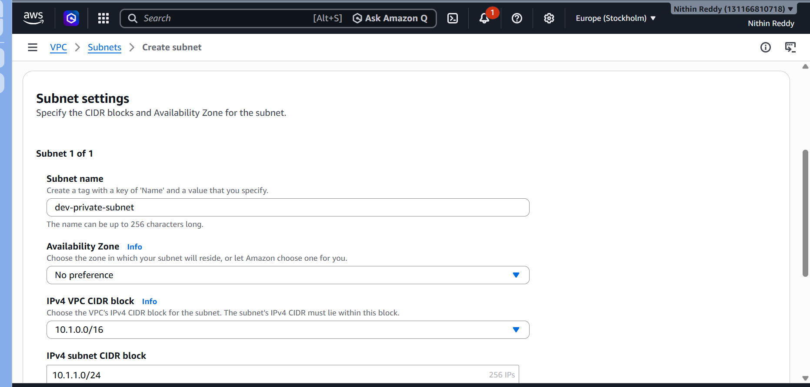
Step 3 — Create VPC-Prod (Department B)
- VPC → Create VPC
Field | Value
Name | vpc-prod
CIDR | 10.2.0.0/16
- Create subnet:
  - Name: prod-private-subnet
  - CIDR: 10.2.1.0/24
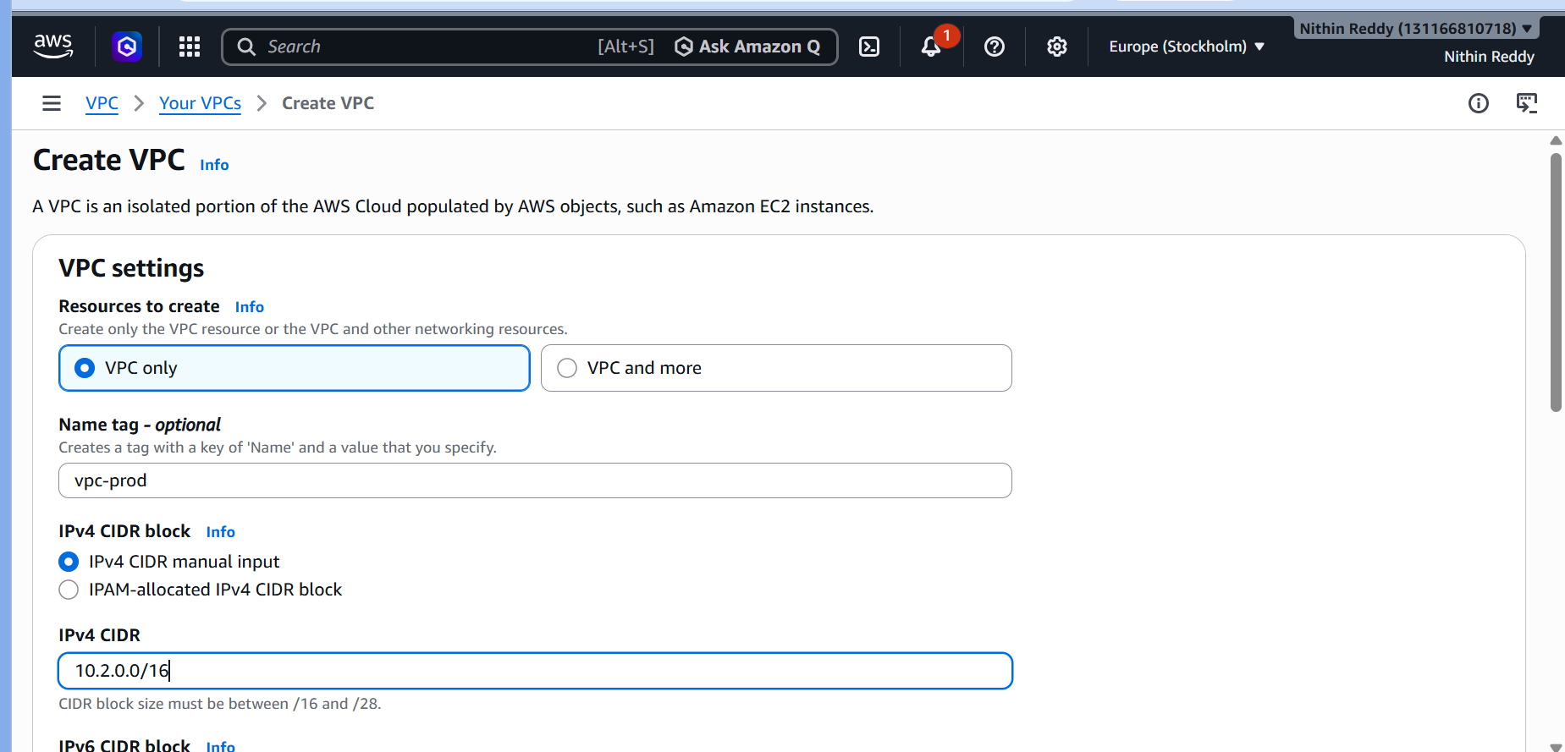
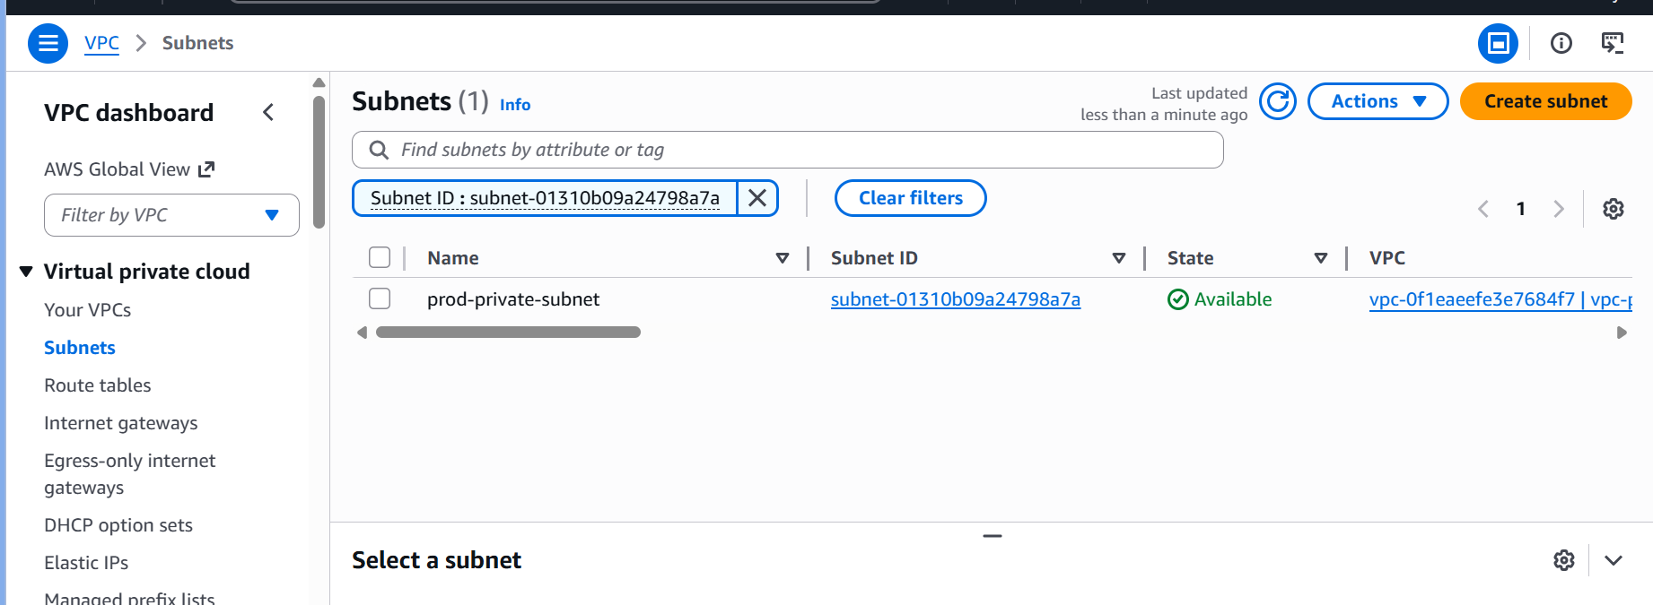
Screenshot — All 3 VPCs created
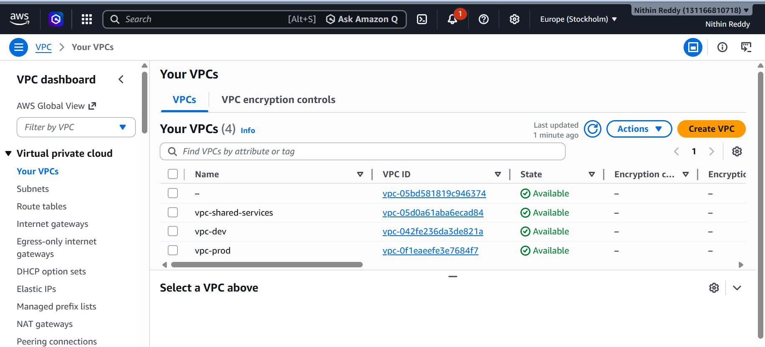

Step 4 — Launch EC2 in Each VPC
Repeat 3 times, one per VPC:
Instance | VPC | Subnet | Public IP
ec2-shared | vpc-shared-services | shared-private-subnet | Disable
ec2-dev | vpc-dev | dev-private-subnet | Disable
ec2-prod | vpc-prod | prod-private-subnet | Disable
Use same key pair for all 3
Screenshot — All 3 EC2 instances running
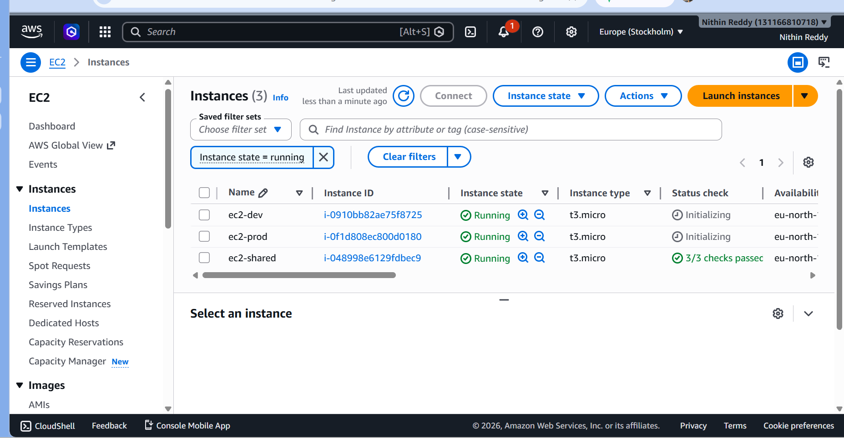

CHALLENGE 2 — Transit Gateway Multi-VPC Setup
Objective
Connect all 3 VPCs through a single Transit Gateway hub.
Steps
Step 5 — Create Transit Gateway
- VPC → Transit Gateways → Create
Field | Value
Name | org-transit-gateway
ASN | 64512
DNS Support | ✅ Enabled
Default route table association | ✅ Enabled
Default route table propagation | ✅ Enabled
- Wait until Status = Available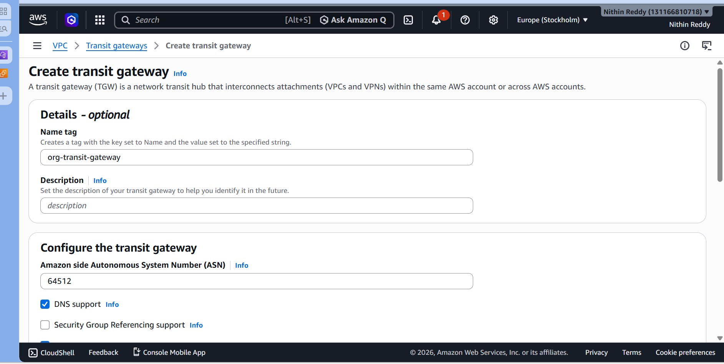
Screenshot — TGW Available

Step 6 — Create 3 TGW Attachments
Repeat for each VPC:
Attachment 1:
Field | Value
Name | attach-shared
VPC | vpc-shared-services
Subnet | shared-private-subnet
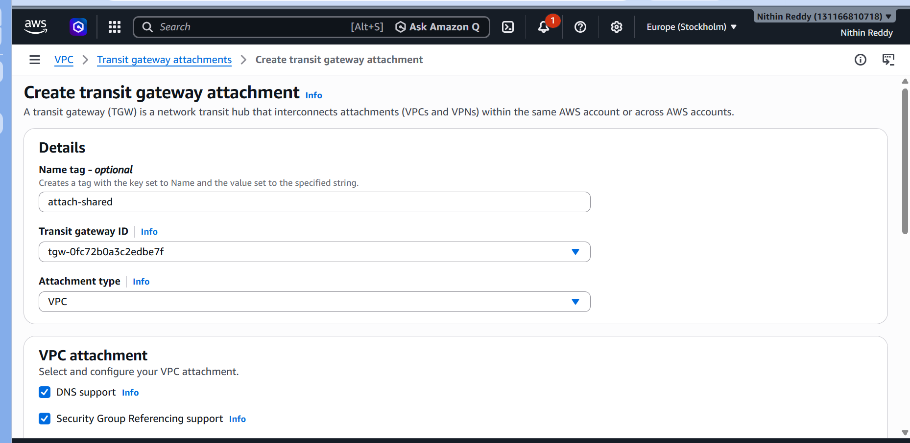
Attachment 2:
Field | Value
Name | attach-dev
VPC | vpc-dev
Subnet | dev-private-subnet
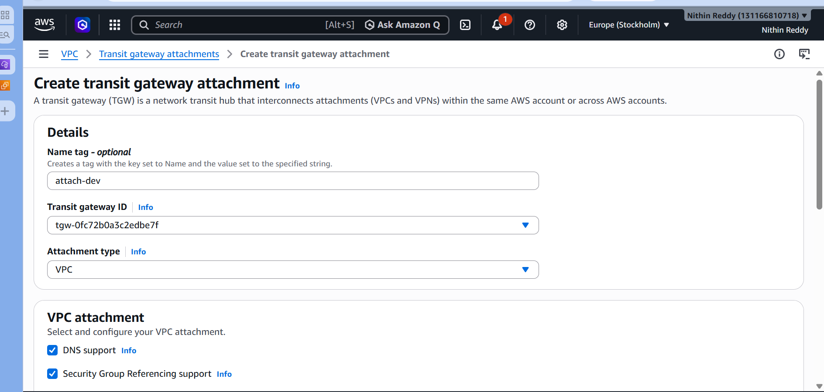
Attachment 3:
Field | Value
Name | attach-prod
VPC | vpc-prod
Subnet | prod-private-subnet
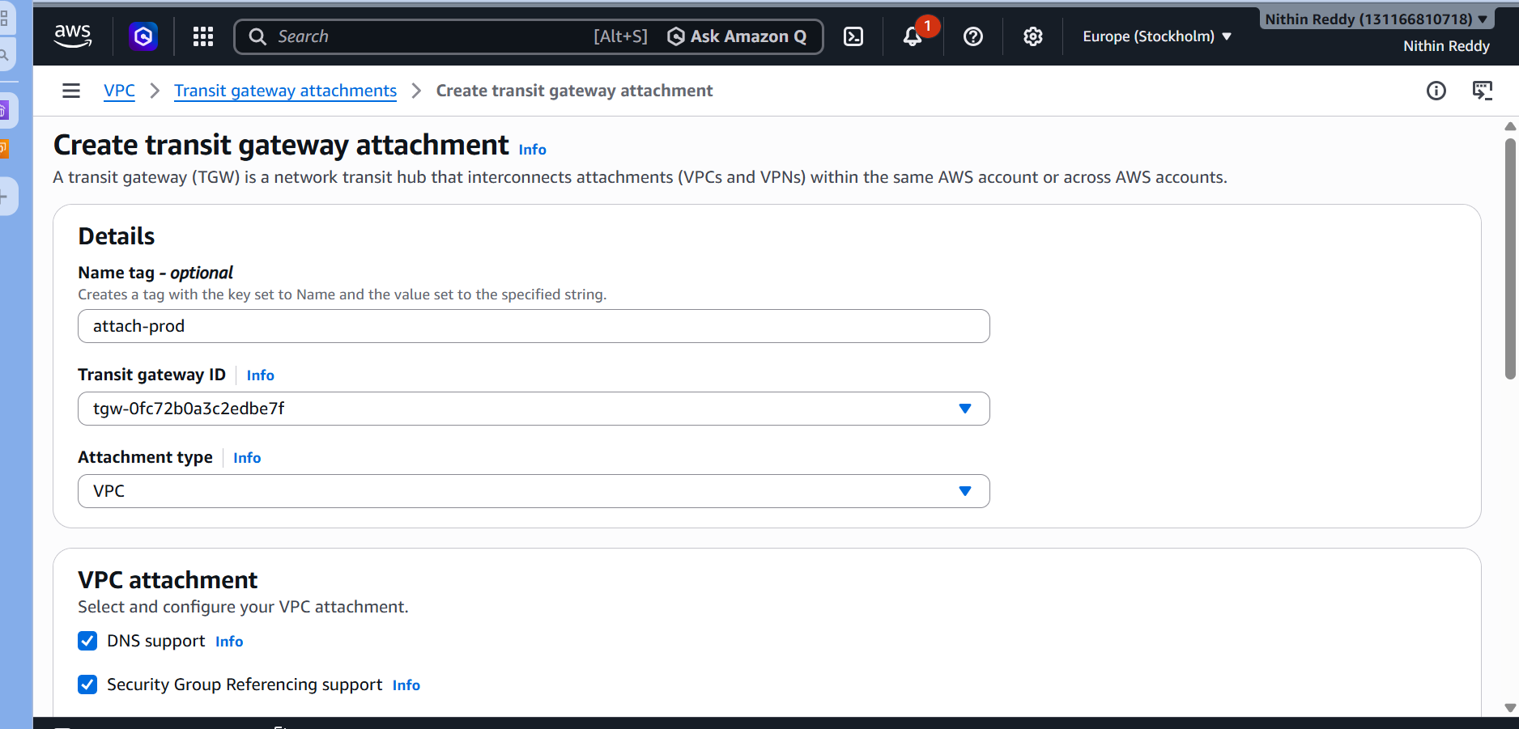
⏳ Wait until all 3 show Available

📸 Screenshot — All 3 attachments Available
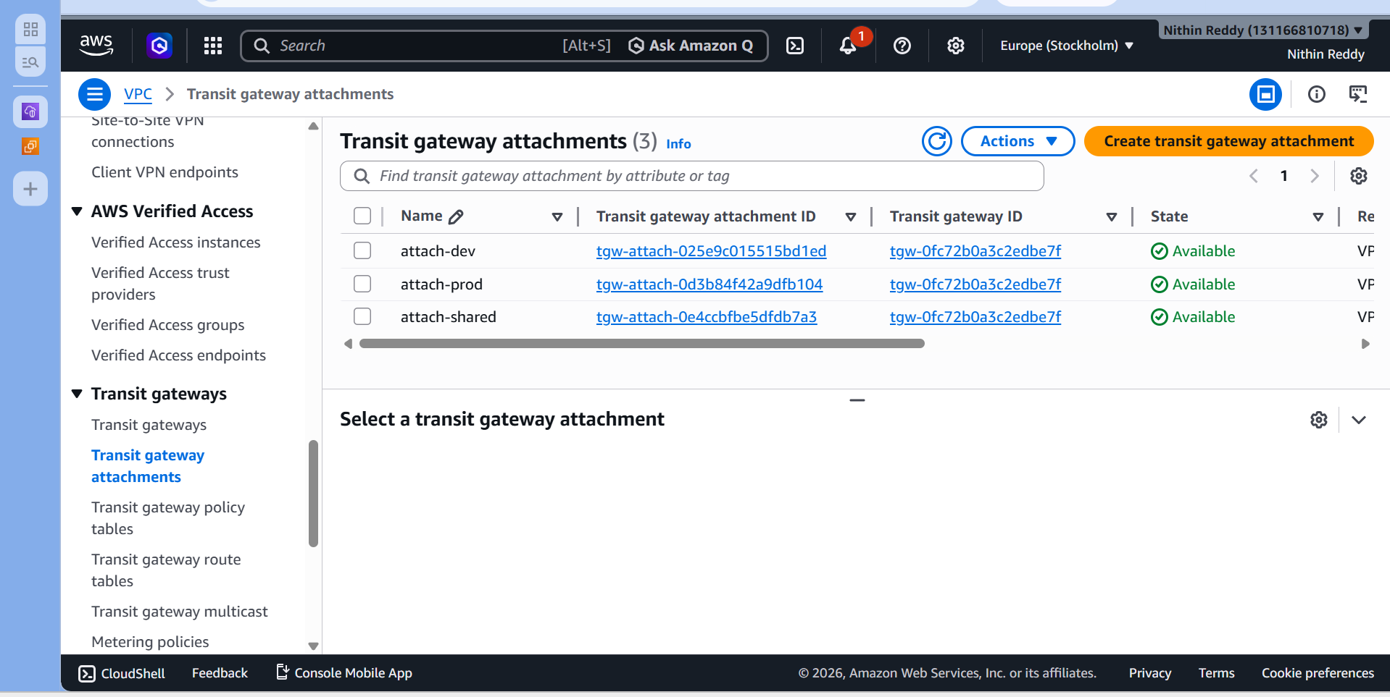

Step 7 — Verify TGW Route Table
- VPC → Transit Gateway Route Tables → default
- Routes tab — should show:
CIDR | Attachment
10.0.0.0/16 | attach-shared
10.1.0.0/16 | attach-dev
10.2.0.0/16 | attach-prod
📸 Screenshot — TGW route table with all 3 CIDRs
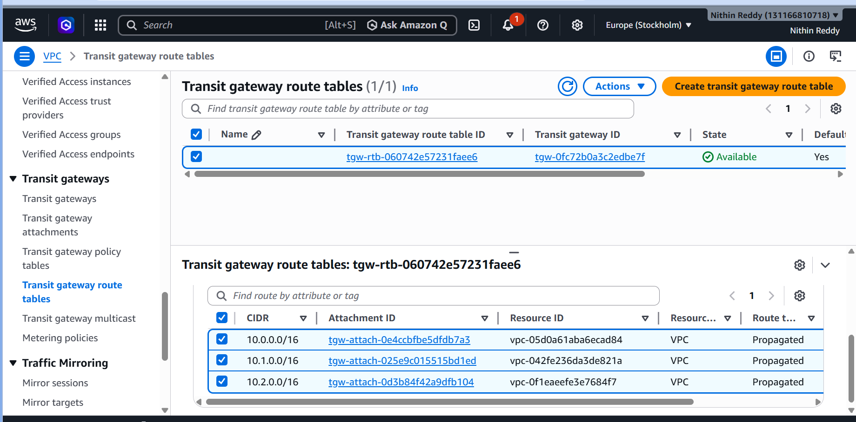
Step 8 — Update All 3 VPC Route Tables
vpc-shared route table → add:
Destination | Target
10.1.0.0/16 | Transit Gateway
10.2.0.0/16 | Transit Gateway
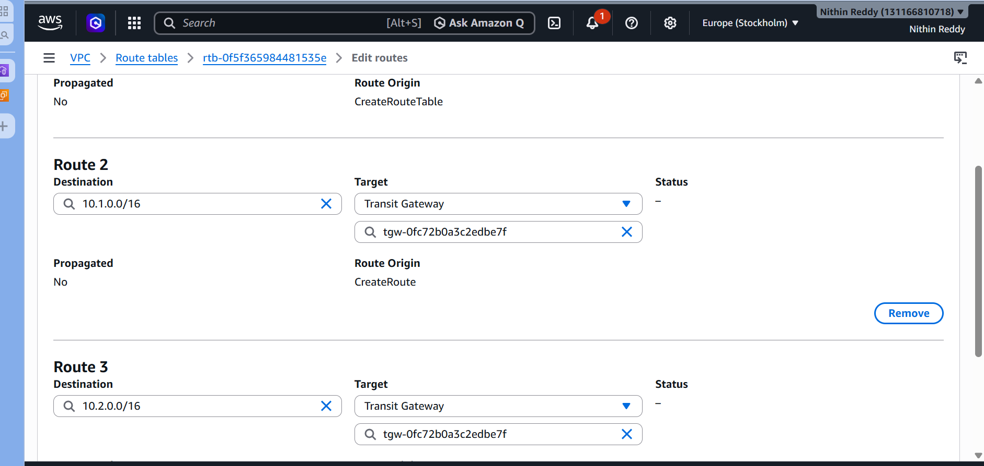

vpc-dev route table → add:
Destination | Target
10.0.0.0/16 | Transit Gateway
10.2.0.0/16 | Transit Gateway
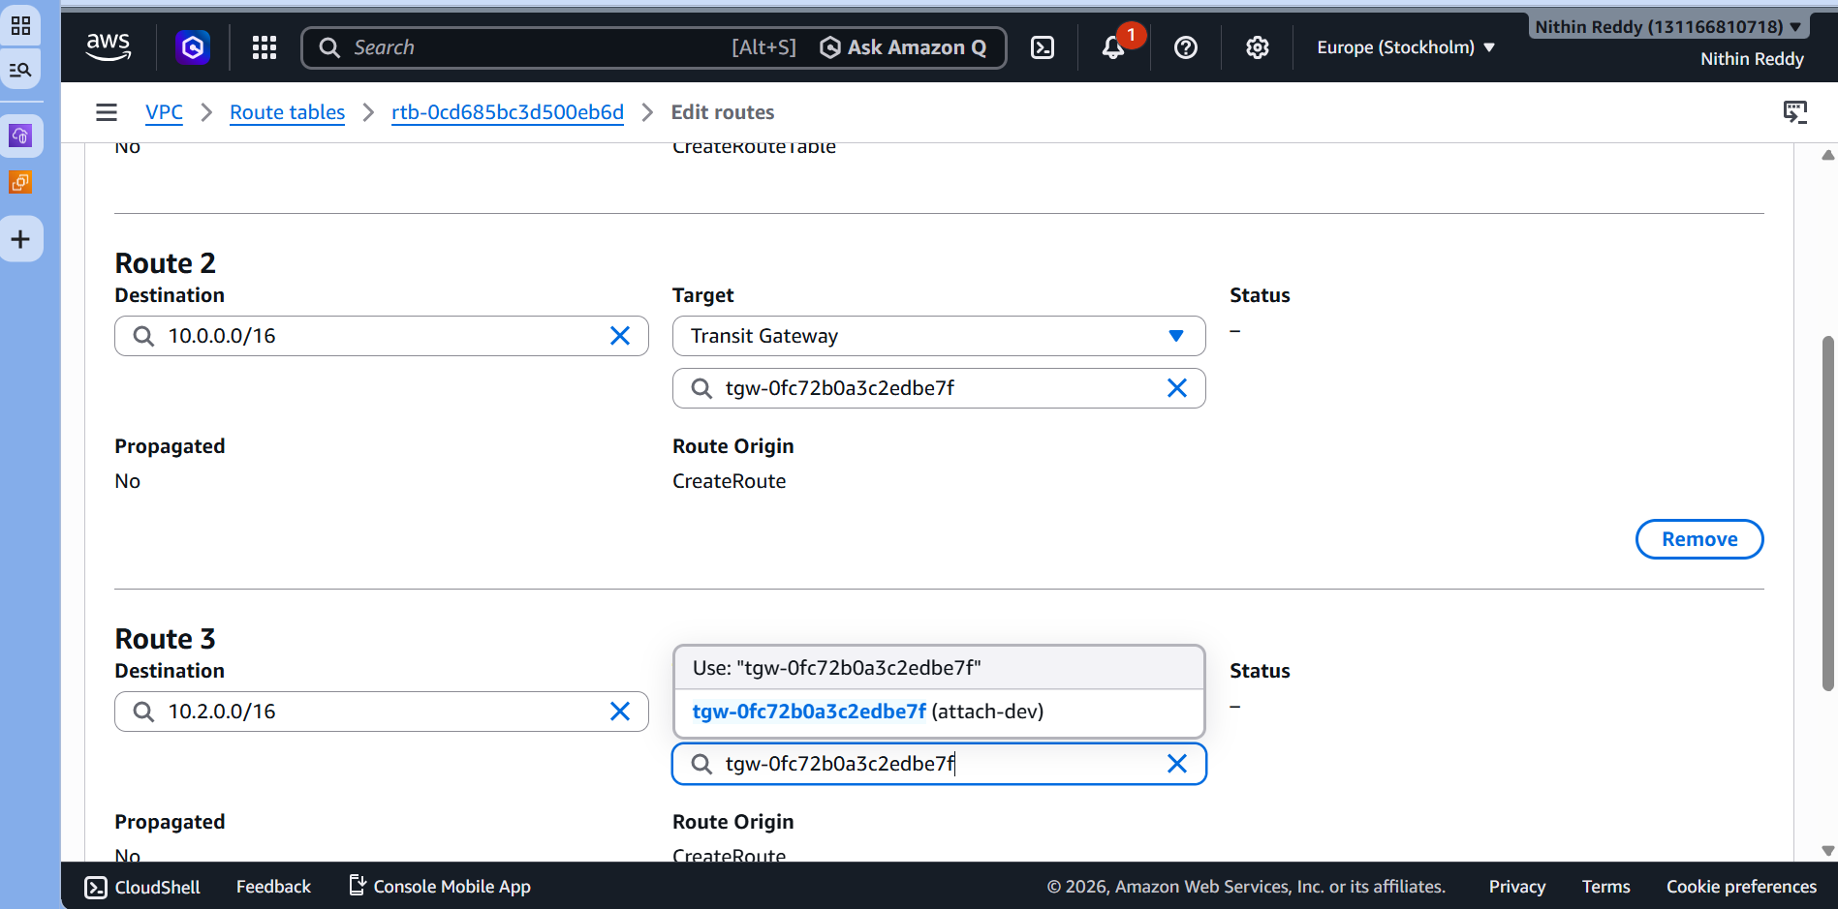
vpc-prod route table → add:
Destination | Target
10.0.0.0/16 | Transit Gateway
10.1.0.0/16 | Transit Gateway
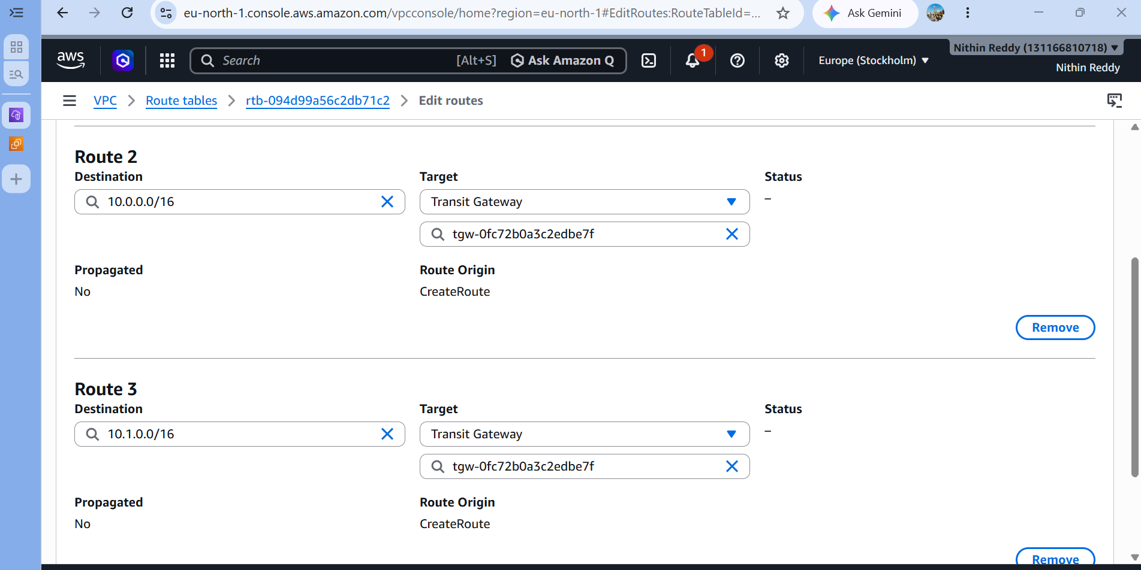
📸 Screenshot — Each VPC route table with TGW routes

Step 9 — Update Security Groups
For each EC2's security group, add inbound rule:
Type | Protocol | Port | Source
All ICMP | ICMP | All | 10.0.0.0/8
SSH | TCP | 22 | 10.0.0.0/8
10.0.0.0/8 covers all 3 VPC CIDRs at once

CHALLENGE 3 — VPC Endpoints (Multiple Services)
Objective
Configure VPC Endpoints for S3 and SSM so all VPCs access AWS services privately — no internet needed.
Steps
Step 10 — Enable DNS on All 3 VPCs
For EACH VPC (vpc-shared, vpc-dev, vpc-prod):
- Select VPC → Actions → Edit VPC Settings
- ✅ Enable DNS resolution
- ✅ Enable DNS hostnames
- Save
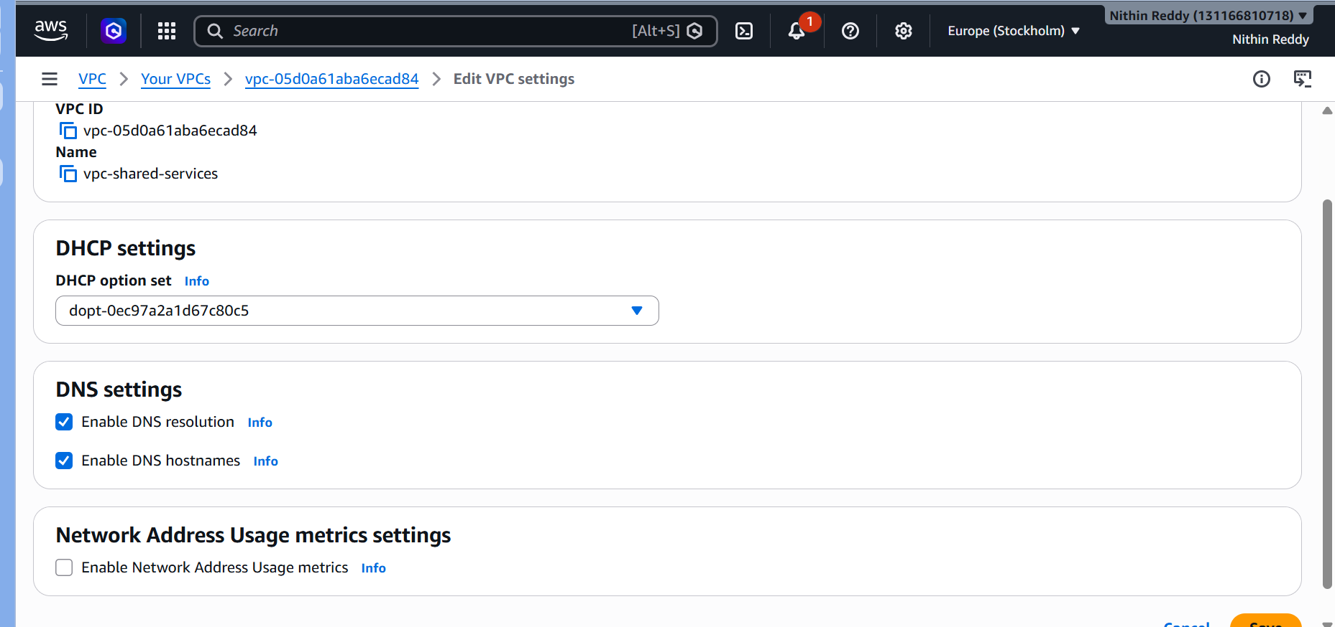

Step 11 — Create S3 Gateway Endpoint (for vpc-shared)
- VPC → Endpoints → Create Endpoint
Field | Value
Name | s3-endpoint-shared
Service | com.amazonaws.eu-north-1.s3 → Gateway
VPC | vpc-shared-services
Route Tables | ✅ Select shared route table

📸 Screenshot — S3 endpoint Available
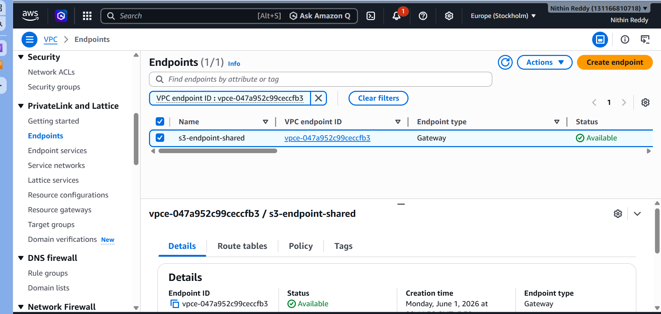
Step 12 — Create SSM Interface Endpoints (for vpc-shared)
Create 3 separate Interface endpoints for SSM:
Endpoint 1 — SSM:
Field | Value
Name | ssm-endpoint
Service | com.amazonaws.eu-north-1.ssm → Interface
VPC | vpc-shared-services
Subnet | shared-private-subnet
Security Group | Allow HTTPS 443 from 10.0.0.0/8
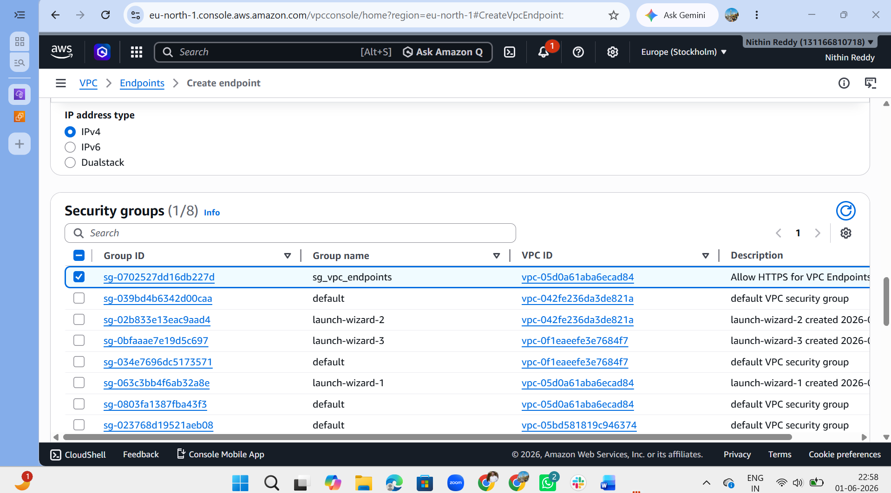
Endpoint 2 — SSM Messages:
Field | Value
Name | ssmmessages-endpoint
Service | com.amazonaws.eu-north-1.ssmmessages → Interface
VPC | vpc-shared-services
Subnet | shared-private-subnet

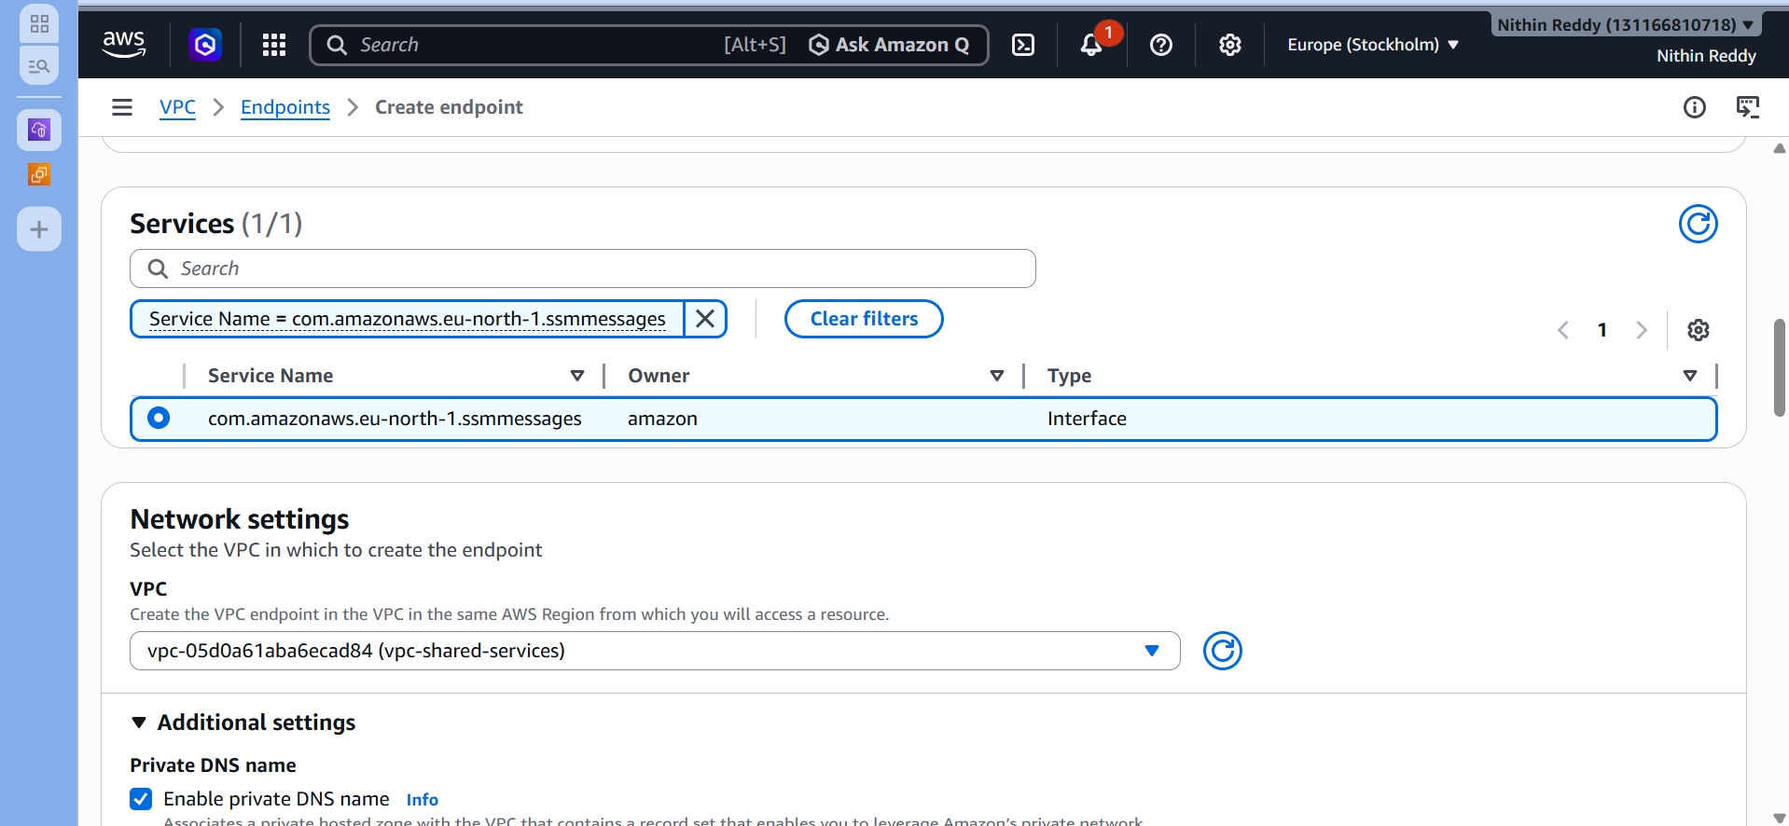
Endpoint 3 — EC2 Messages:
Field | Value
Name | ec2messages-endpoint
Service | com.amazonaws.eu-north-1.ec2messages → Interface
VPC | vpc-shared-services
Subnet | shared-private-subnet
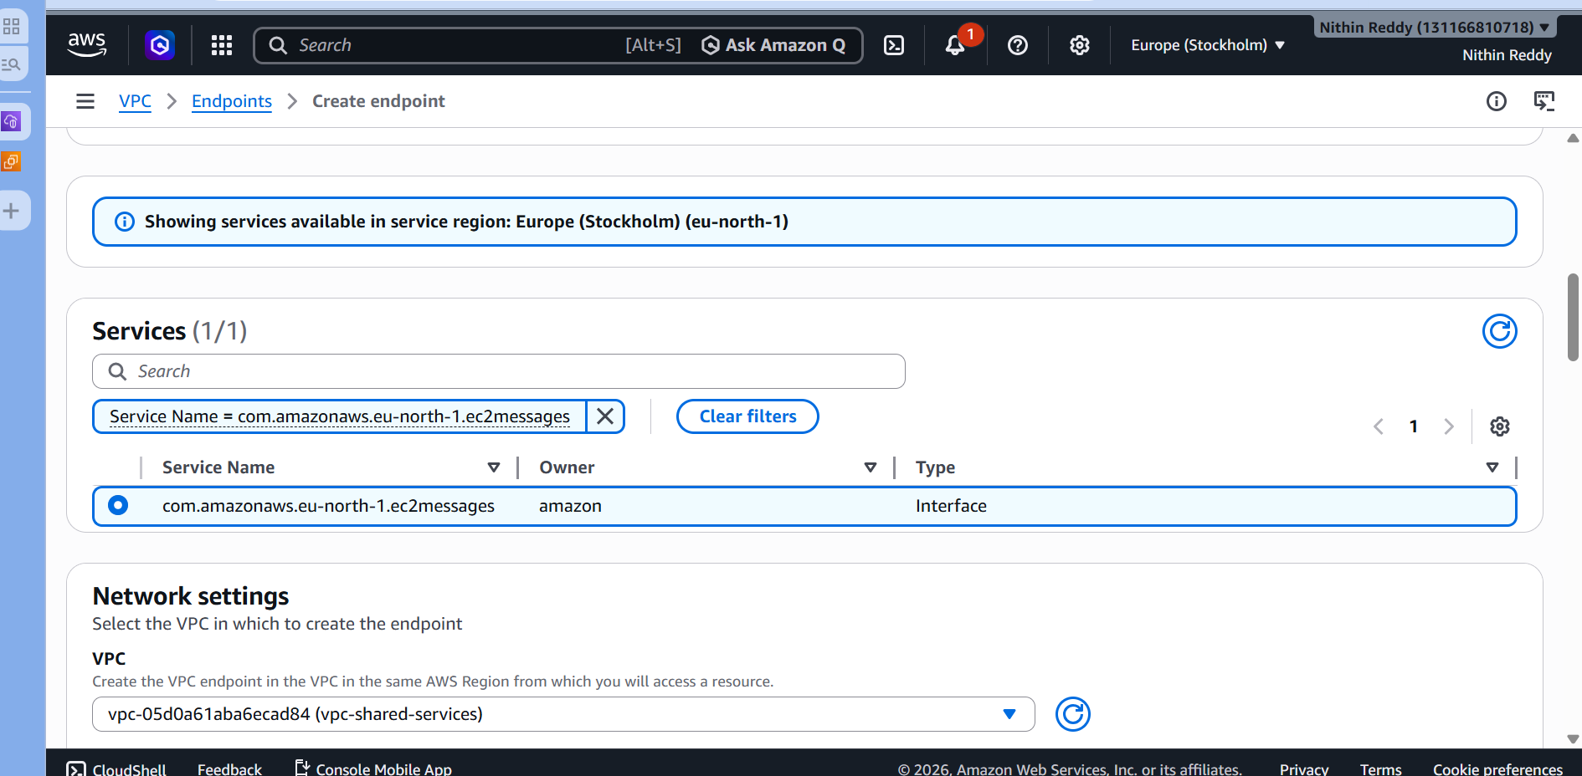
⏳ Wait until all show Available
📸 Screenshot — All endpoints Available
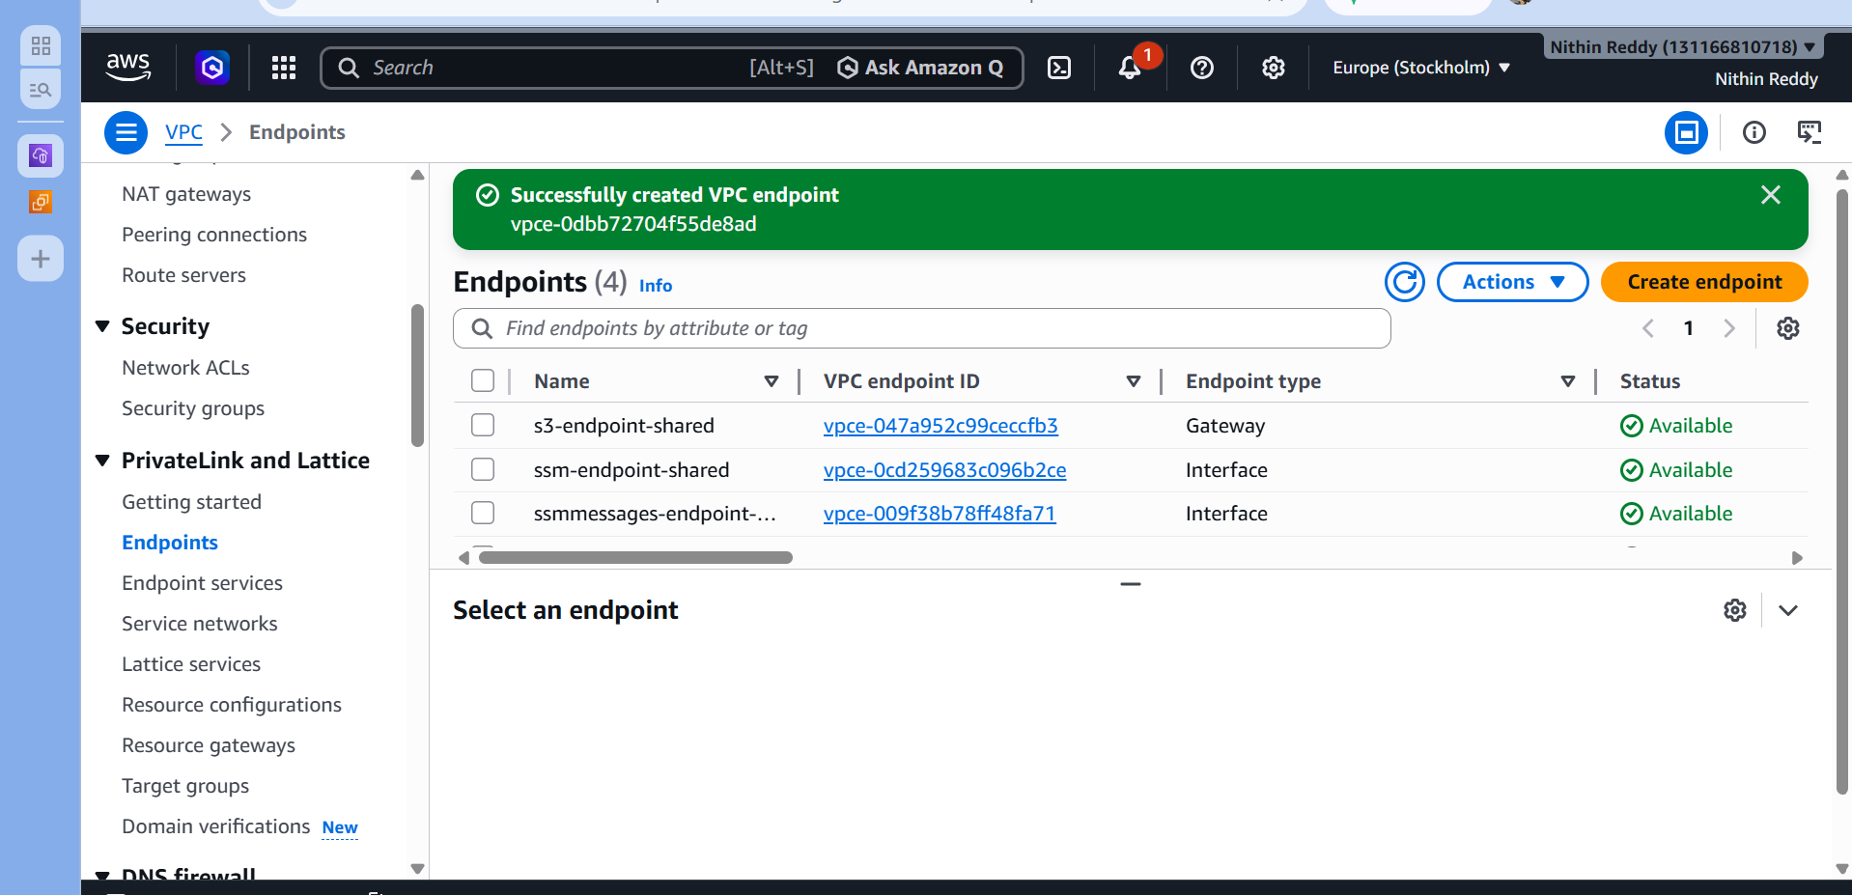
Step 13 — Validate S3 Endpoint
Final output
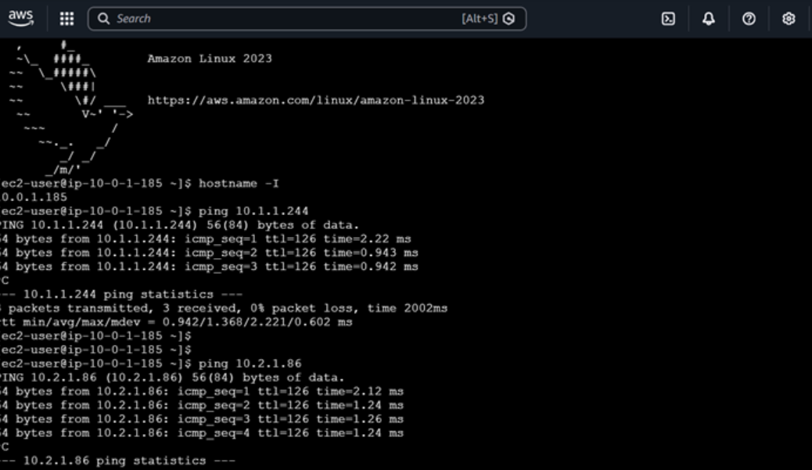

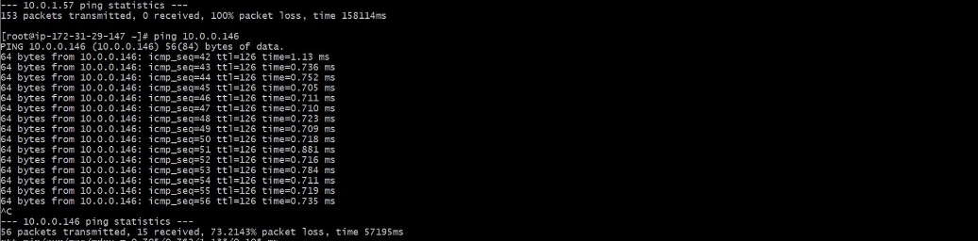
Troubleshooting Errors
Error | Cause | Fix
TGW attachment pending too long | Normal delay | Wait 5–10 mins, refresh
Routes not propagating | Propagation not set | TGW Route Table → Propagations → Create
DNS error on Interface endpoint | DNS not enabled on VPC | Edit VPC Settings → enable both DNS options
S3 endpoint already has route | Previous endpoint exists | Go to Endpoints → check existing one
SSM endpoint unreachable | SG blocking 443 | Allow HTTPS inbound from 10.0.0.0/8
CIDR overlap error | Same CIDR on 2 VPCs | Use 10.0.x, 10.1.x, 10.2.x separately
Ping fails between VPCs | Missing return route | Check BOTH VPC route tables have TGW routes

📸 Complete Evidence Checklist
□ 1. All 3 VPCs created (vpc-shared, vpc-dev, vpc-prod)
□ 2. All 3 EC2 instances running (one per VPC)
□ 3. Transit Gateway - Status = Available
□ 4. All 3 TGW Attachments - Status = Available
□ 5. TGW Route Table - all 3 CIDRs propagated
□ 6. Each VPC route table showing TGW routes
□ 7. S3 Gateway Endpoint - Status = Available
□ 8. SSM Interface Endpoints - Status = Available
□ 9. Route table with S3 prefix list (pl-xxxxx)
□ 10. aws s3 ls output showing bucket
□ 11. aws ec2 describe-vpc-endpoints output
□ 12. aws ec2 describe-transit-gateway-attachments output

📸 Final Evidence Checklist
✅ Screenshot 1 → aws s3 ls showing bucket
✅ Screenshot 2 → VPCs table (3 VPCs)
✅ Screenshot 3 → Transit Gateway available
✅ Screenshot 4 → TGW Attachments (3 available)
✅ Screenshot 5 → VPC Endpoints (4 available)
✅ Screenshot 6 → EC2 Instances (3 running)
✅ Screenshot 7 → Route Tables with TGW routes
✅ Screenshot 8 → AWS Console Endpoints list
✅ Screenshot 9 → AWS Console TGW list
✅ Screenshot 10 → AWS Console 3 VPCs

