Project Title
Serverless Secure Greeting API using AWS Lambda, API Gateway, and KMS

Architecture
User
|
v
API Gateway
|
v
AWS Lambda
|
v
AWS KMS
(Encrypt/Decrypt Message)
Flow:
- User sends request to API Gateway.
- API Gateway invokes Lambda.
- Lambda encrypts/decrypts text using KMS.
- Lambda returns response.
- User receives output.

TASK 1 – AWS KMS
Objective
Create a KMS key and use it to encrypt and decrypt data.

Expected Outcome
You should be able to:
- Create a Customer Managed Key (CMK)
- Encrypt text
- Decrypt text
- Understand key security

Prerequisites
- AWS Account
- IAM user with KMS permissions

Implementation Steps
Step 1
Open AWS Console
Search:
KMS

Step 2
Click
Customer managed keys

Step 3
Create Key
Choose:
Symmetric
Key Usage:
Encrypt and Decrypt
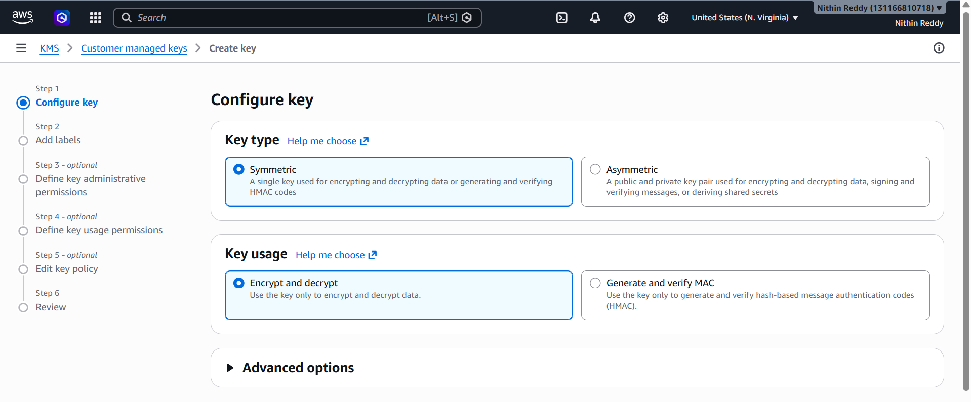
Step 4
Provide:
Alias:
demo-kms-key

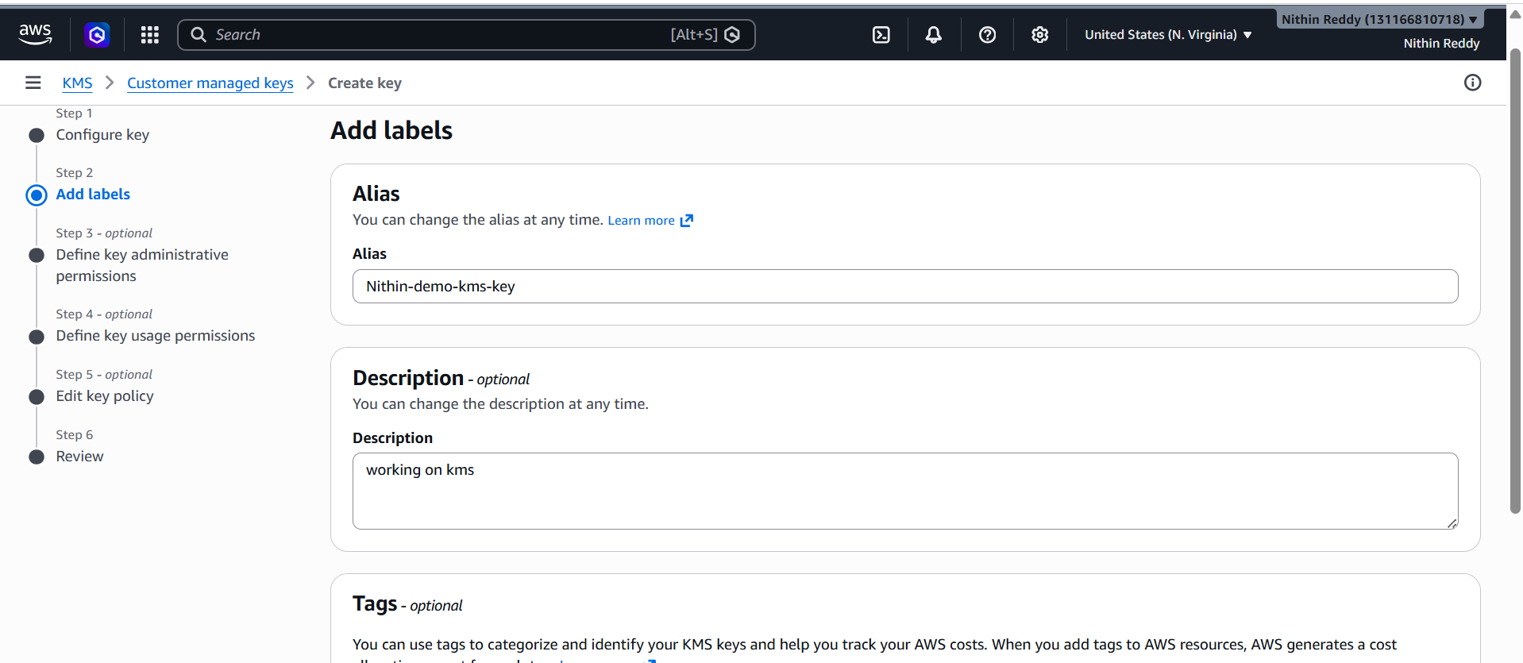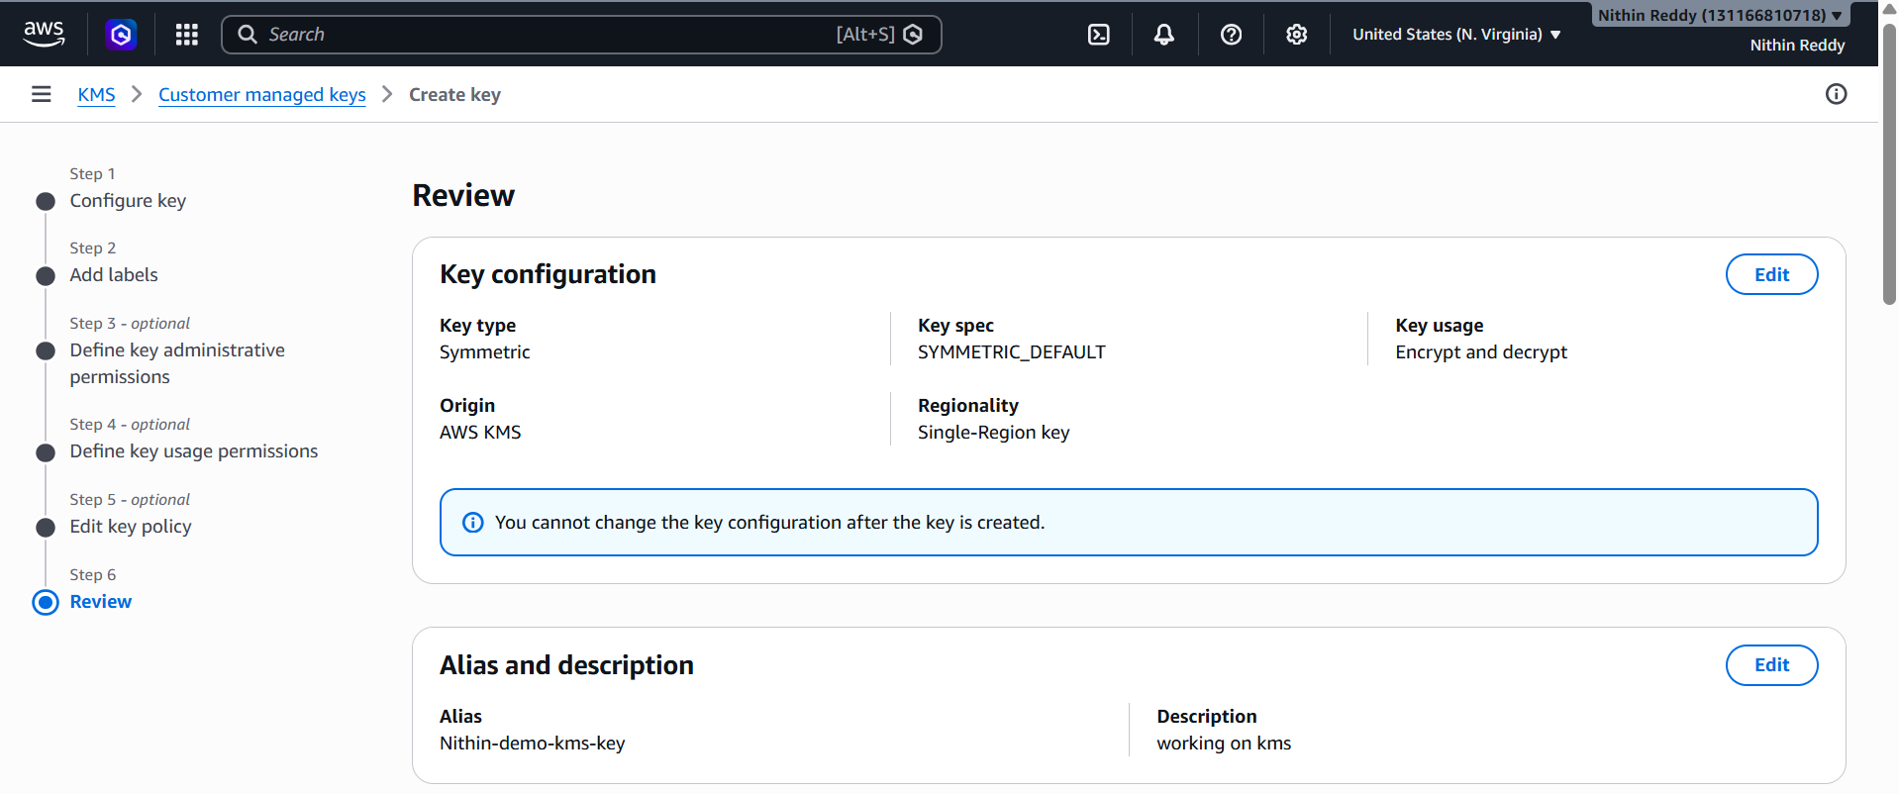
Step 5
Keep default settings
Next → Create Key
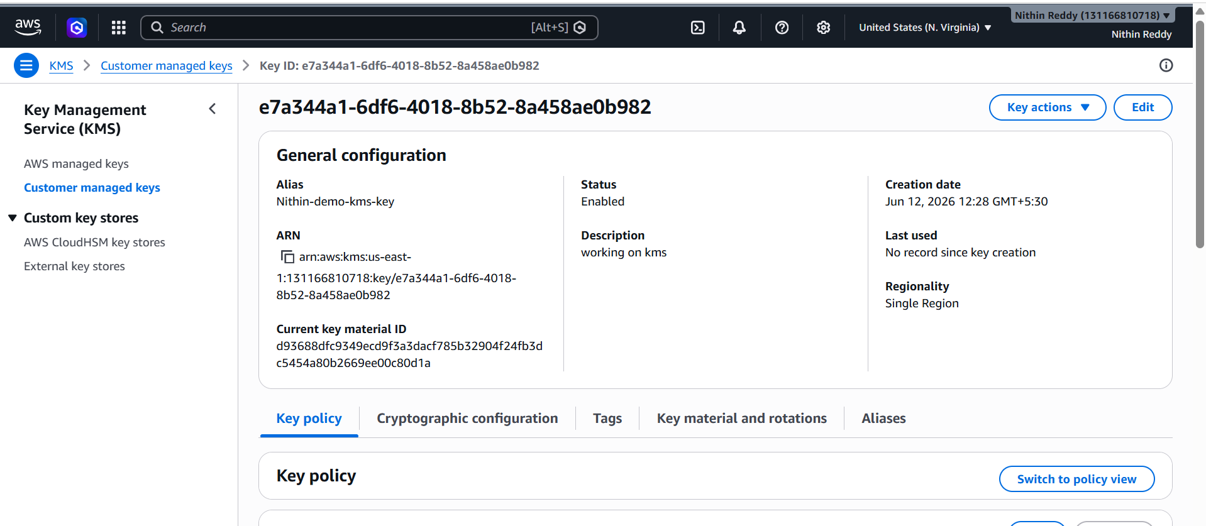
Validation
Open key
You should see:
Enabled
Status:
Enabled

Test Encryption
Go to:
AWS CloudShell
Run:
aws kms encrypt \
--key-id alias/demo-kms-key \
--plaintext "Hello AWS" \
--output text \
--query CiphertextBlob
Output:
AQICAH....
Encrypted text generated.

Common Errors
AccessDeniedException
Cause:
IAM permission missing
Fix:
Attach KMS permissions

KeyNotFoundException
Cause:
Wrong Key Alias
Fix:
Check alias name

TASK 2 – AWS Lambda
Objective
Create a Lambda function that returns a message.

Expected Outcome
Lambda executes successfully and returns response.

Prerequisites
- IAM Role
- Lambda access

Implementation Steps
Step 1
Open
Lambda

Step 2
Click
Create Function

Step 3
Choose:
Author from scratch
Name:
GreetingFunction
Runtime:
Python 3.13
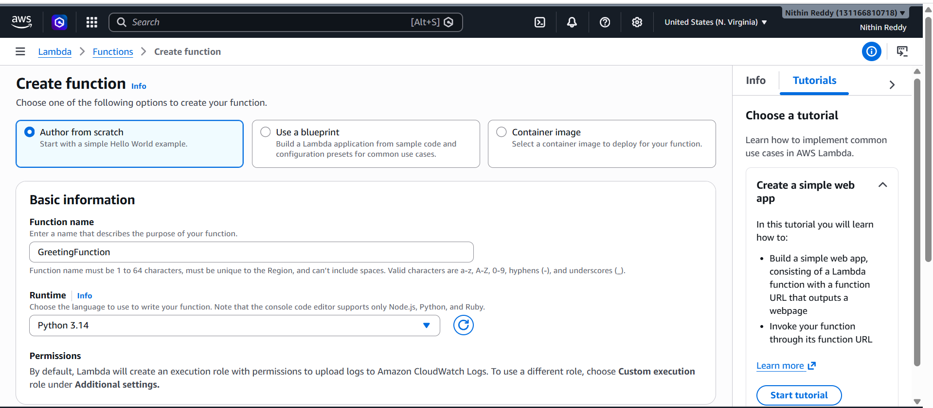
Step 4
Paste code
def lambda_handler(event, context):
return {
"statusCode": 200,
"body": "Hello from AWS Lambda"
}

Step 5
Deploy
Click:
Deploy
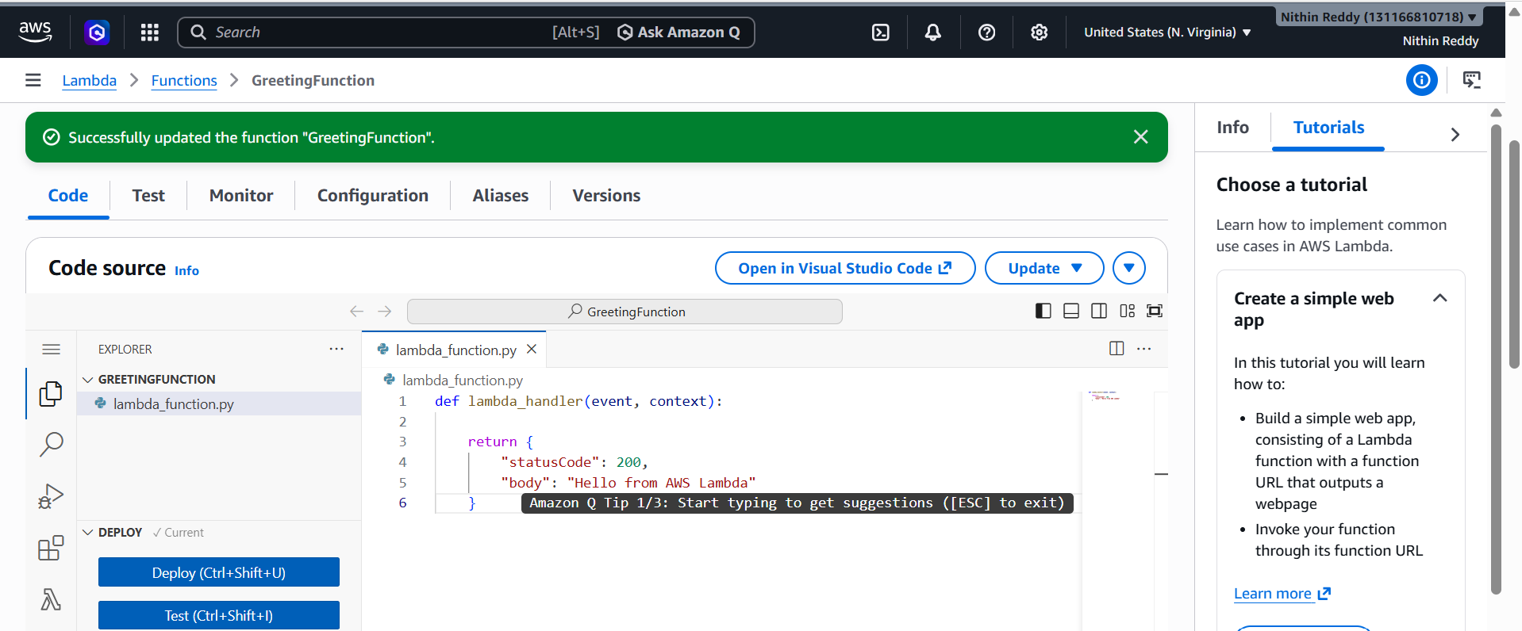
Validation
Click:
Test
Create test event
Run
Expected output:
{
"statusCode": 200,
"body": "Hello from AWS Lambda"
}
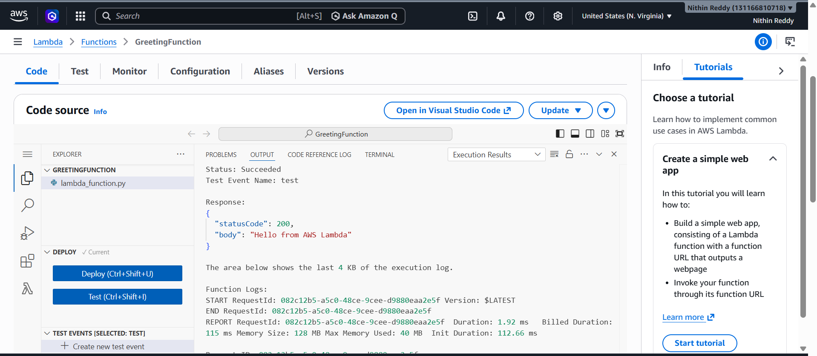
Common Errors
Timeout
Cause:
Long execution

TASK 3 – API Gateway
Objective
Expose Lambda through REST API.

Expected Outcome
Access Lambda using URL.

Prerequisites
- Lambda Function created

Implementation Steps
Step 1
Open:
API Gateway

Step 2
Create API
Choose:
HTTP API

Step 3
Integration
Select:
GreetingFunction
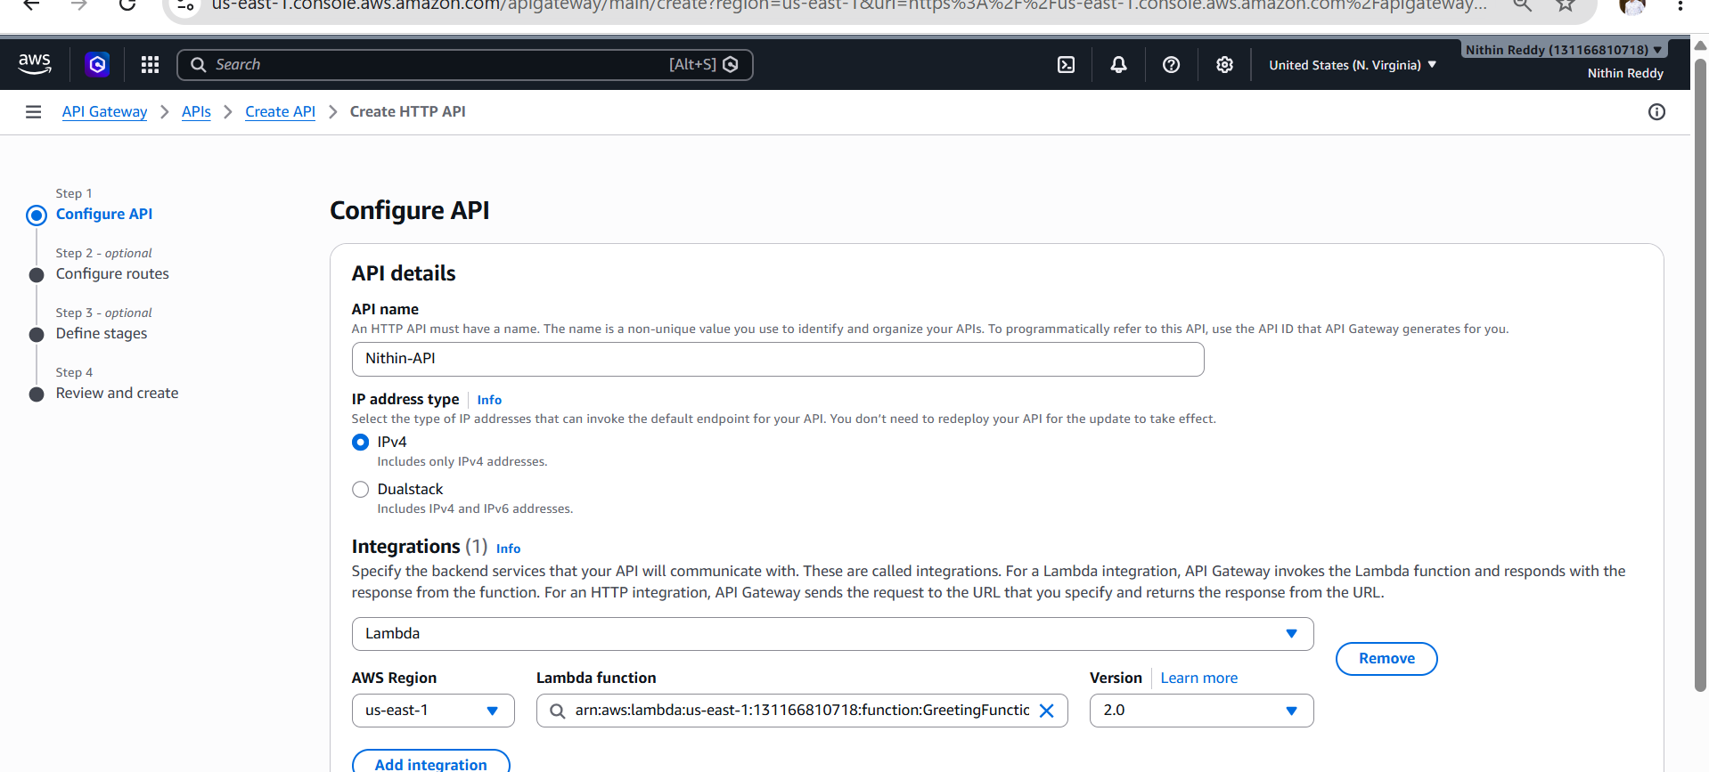
Step 4
Create Route
GET /hello
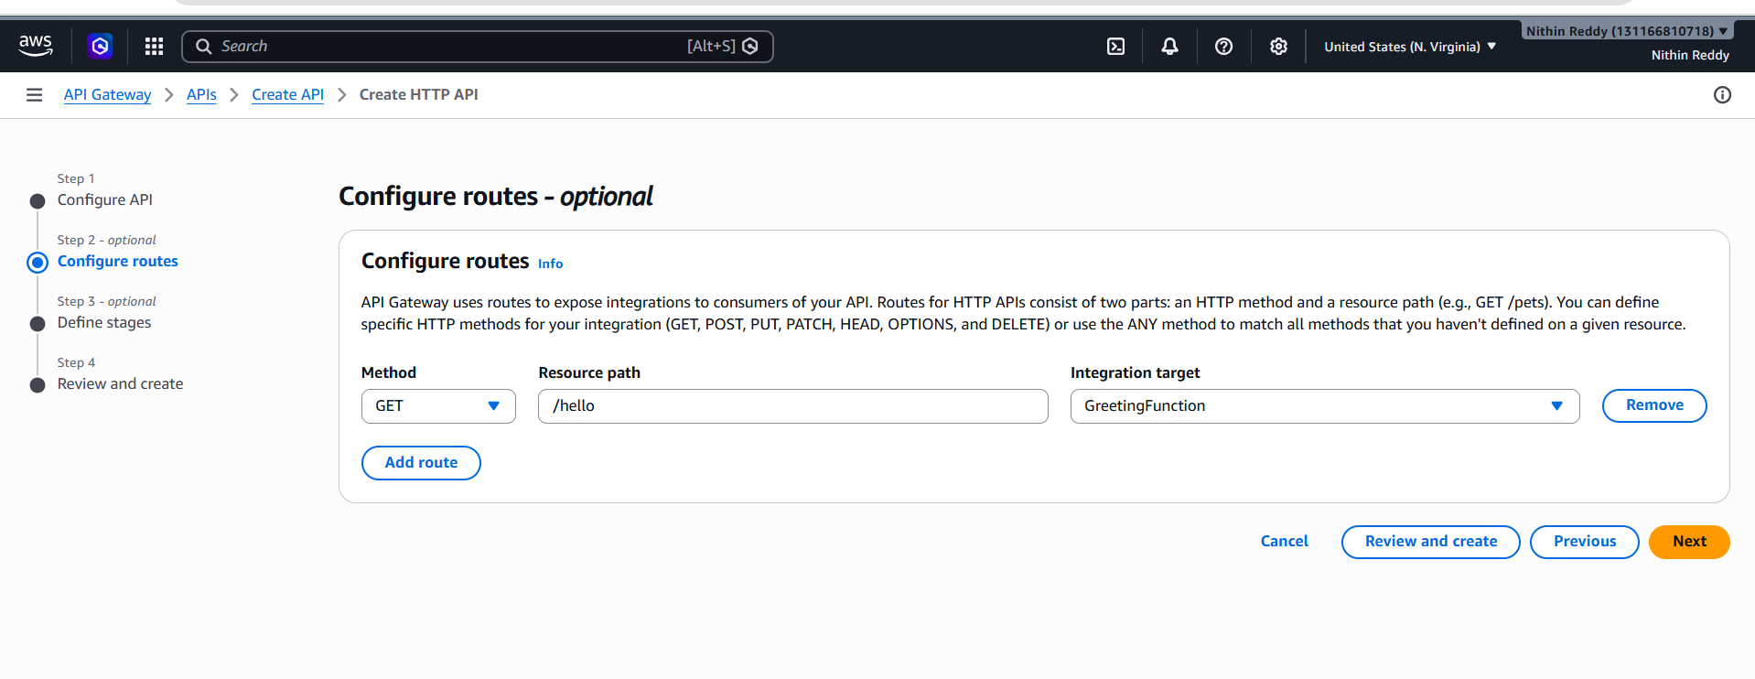
Step 5
Deploy API
Stage:
prod
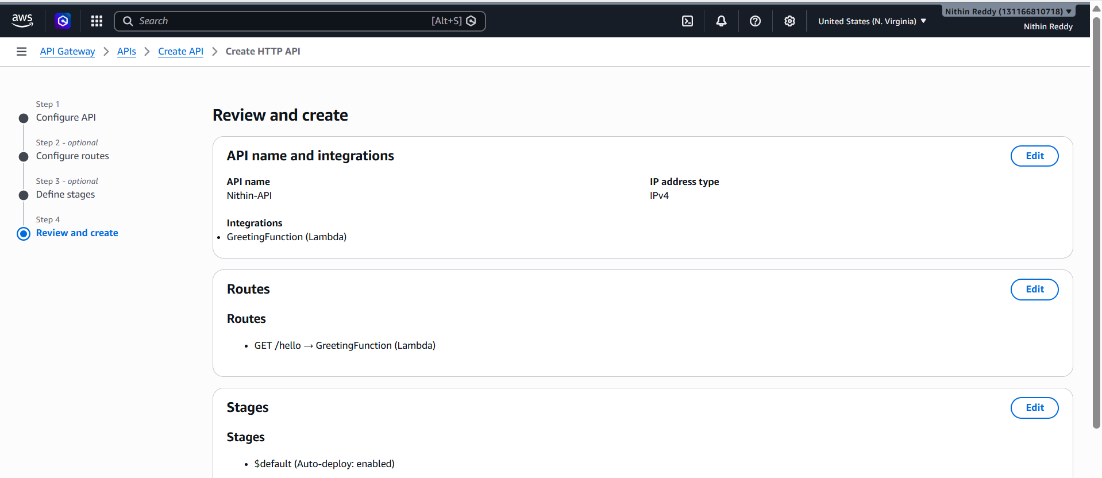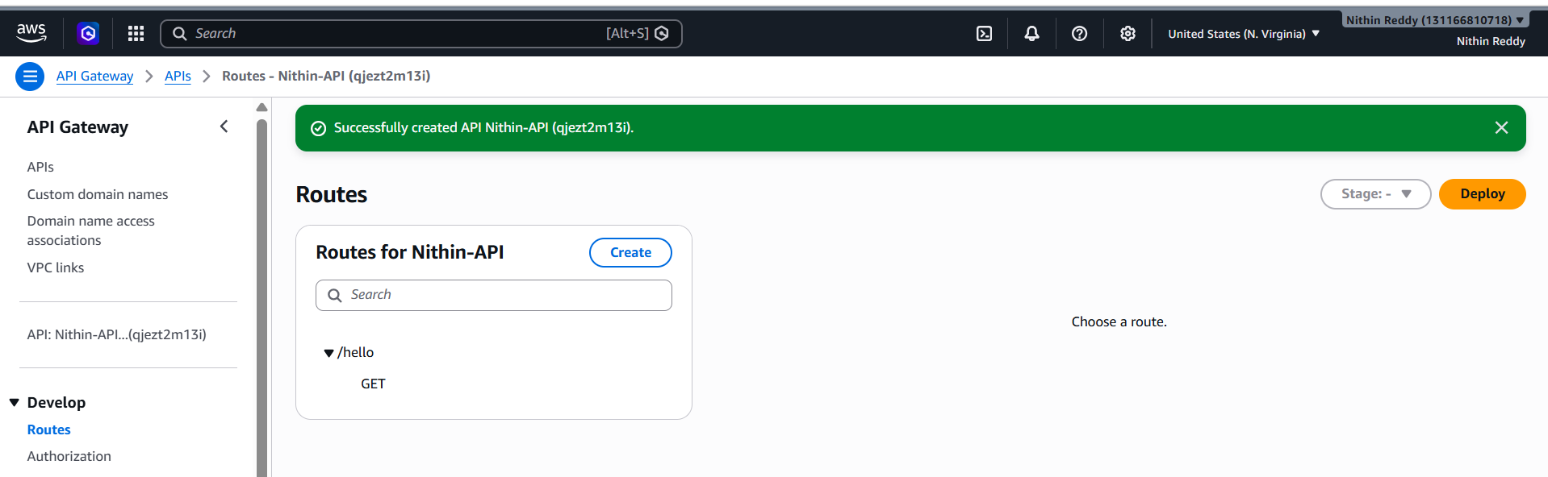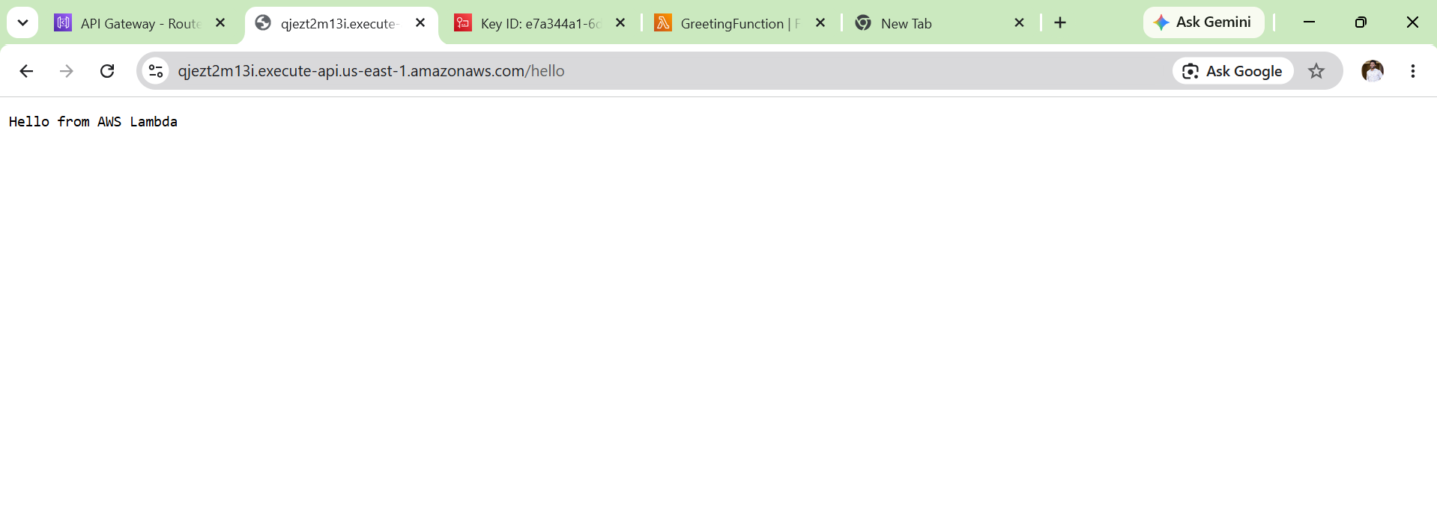
Validation
Copy Invoke URL
Example:
https://abcd123.execute-api.us-east-1.amazonaws.com/hello
Open browser.
Output:
Hello from AWS Lambda

Common Errors
Internal Server Error
Cause:
Lambda permission issue
Fix:
Reattach Lambda integration

Architecture Diagram
+-----------+
| User |
+-----------+
|
| HTTPS Request
v
+------------------+
| API Gateway |
+------------------+
|
| Invoke
v
+------------------+
| AWS Lambda |
| GreetingFunction |
+------------------+
|
| Encrypt/Decrypt
v
+------------------+
| AWS KMS |
| demo-kms-key |
+------------------+
|
| Encrypted Data
v
+------------------+
| AWS Lambda |
+------------------+
|
| Response
v
+------------------+
| API Gateway |
+------------------+
|
| HTTPS Response
v
+-----------+
| User |
+-----------+
Simple Architecture Explanation
- User sends a request to API Gateway.
- API Gateway receives the request and invokes the Lambda function.
- Lambda executes the Python code.
- Lambda uses KMS to encrypt/decrypt sensitive data.
- KMS returns the encrypted/decrypted result to Lambda.
- Lambda sends the response back to API Gateway.
- API Gateway returns the final response to the user.

AWS Services Used
Service | Purpose
AWS Lambda | Executes code without managing servers
Amazon API Gateway | Creates and manages REST/HTTP APIs
AWS Key Management Service (KMS) | Encrypts and decrypts data securely
Observation
The implementation demonstrates a serverless architecture where:
- No EC2 instance is required.
- API Gateway acts as the entry point.
- Lambda performs business logic.
- KMS provides encryption and key management.
- The solution is scalable, secure, and cost-effective for small workloads.

