Architecture
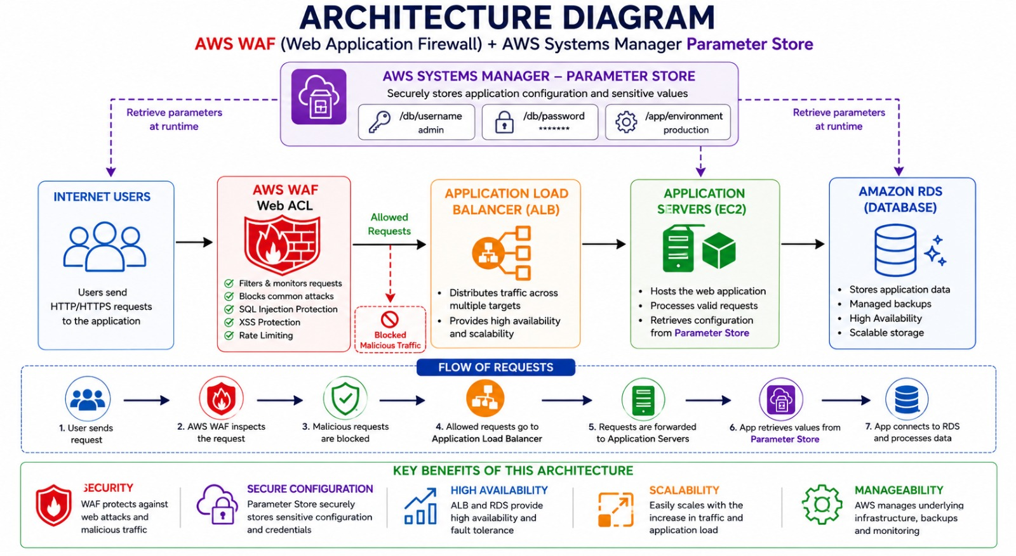
Architecture Explanation Points
- AWS WAF filters incoming HTTP/HTTPS requests before they reach the application.
- WAF protects against SQL Injection, XSS attacks, bots, and excessive requests.
- Application Load Balancer forwards valid traffic to the EC2 application.
- The application retrieves configuration values from Systems Manager Parameter Store.
- Parameter Store securely stores usernames, passwords, and application configurations.
- Sensitive information is not hardcoded inside application code.
- The architecture improves security, scalability, and maintainability.
- Only legitimate traffic reaches the application server.
- Centralized configuration management simplifies application administration.
- AWS services reduce operational overhead through managed security and configuration management.

Project Title : Secure Web Application using AWS WAF and AWS Systems Manager Parameter Store

Topic 1: AWS WAF Web Application Firewall
What is AWS WAF?
AWS WAF protects web applications from common web attacks such as:
- SQL Injection
- Cross Site Scripting (XSS)
- Bot Attacks
- IP Blocking
- Rate Limiting

Real World Example
User
|
v
AWS WAF
|
v
Application Load Balancer
|
v
EC2 Web Server
WAF checks traffic before it reaches the application.

Objective
Create a Web ACL and add a rule that blocks traffic.

Expected Outcome
- Create WAF Web ACL
- Create security rule
- Associate WAF with a resource
- Monitor blocked requests

Architecture
Internet Users
|
v
+----------------+
| AWS WAF |
+----------------+
|
v
+----------------+
| ALB / API GW |
+----------------+
|
v
+----------------+
| Web App (EC2) |
+----------------+

Simple Hands-On Task
Step 1
Open:
AWS WAF

Step 2
Create:
Web ACL
Name:
demo-waf
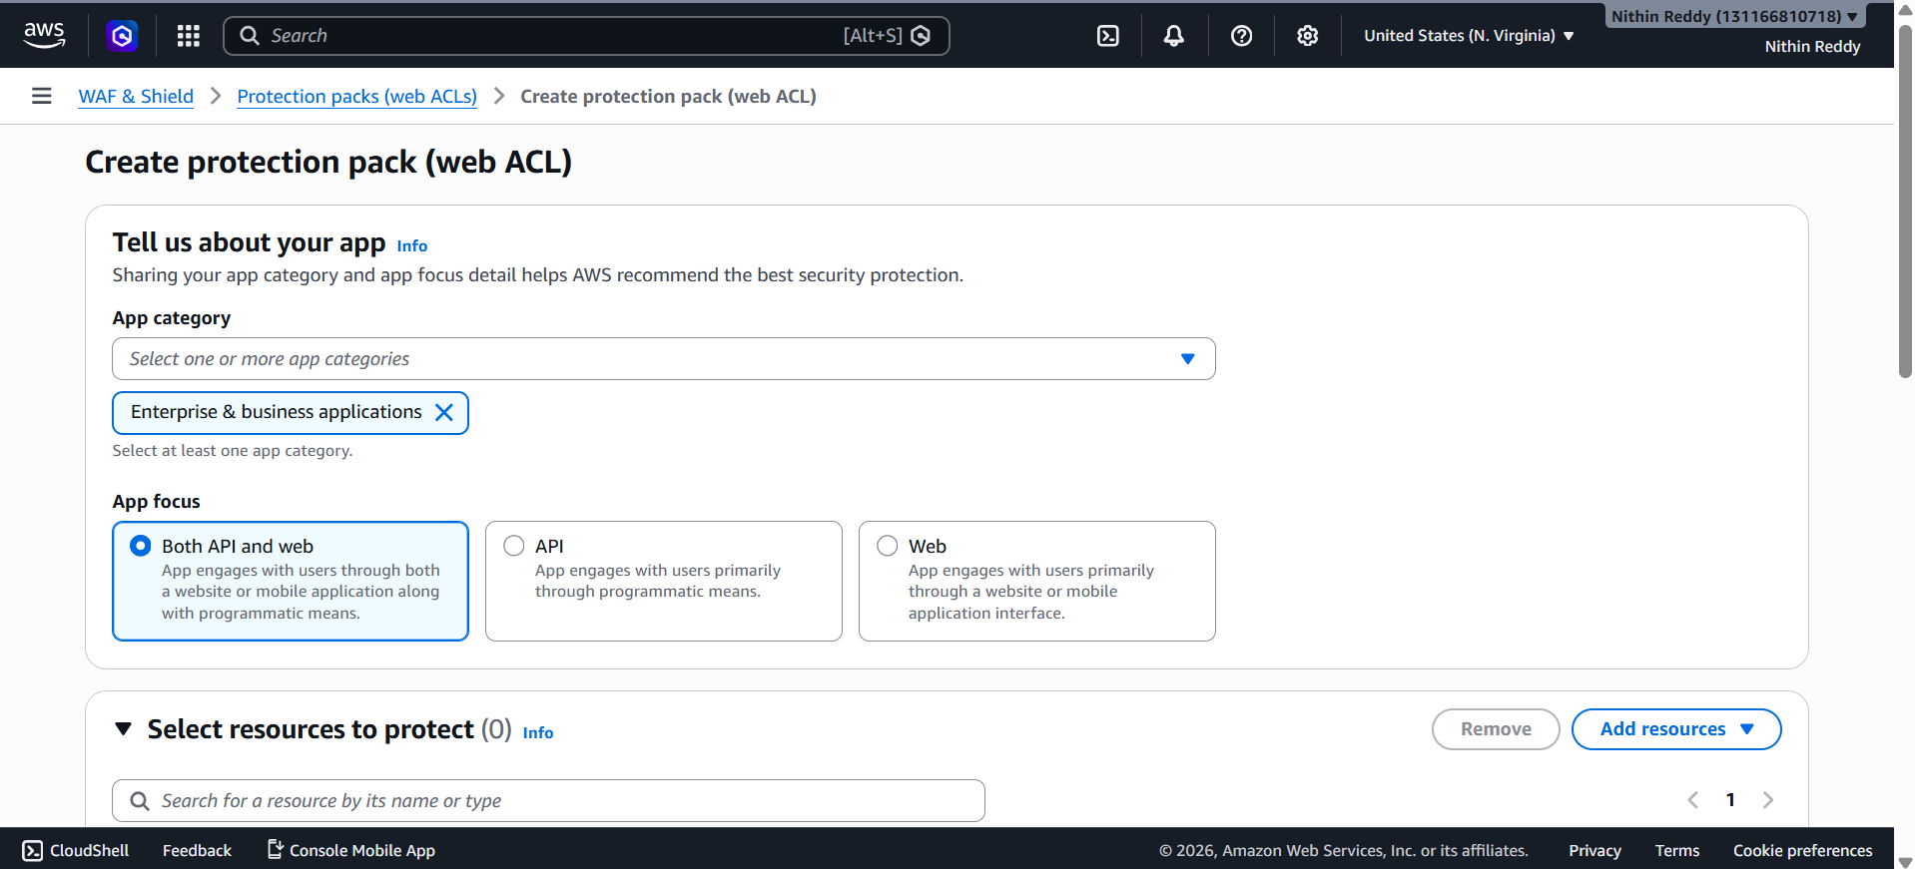
Step 3
Resource Type:
Regional Resources
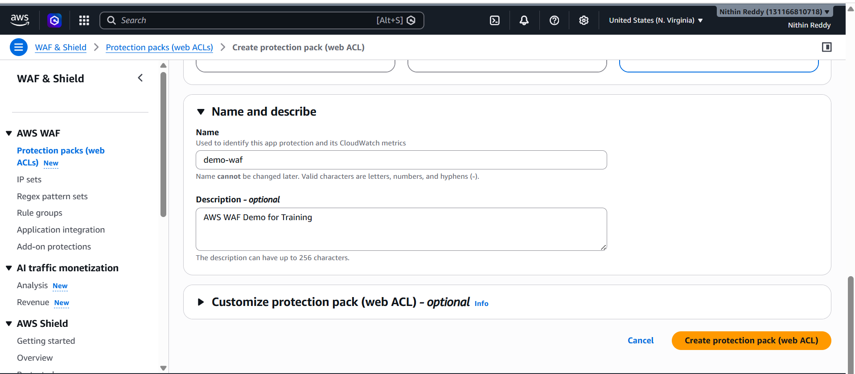
Step 4
Add Rule
Choose:
Rate-based Rule
Example:
Block IP after 100 requests in 5 minutes

Step 5
Create Web ACL
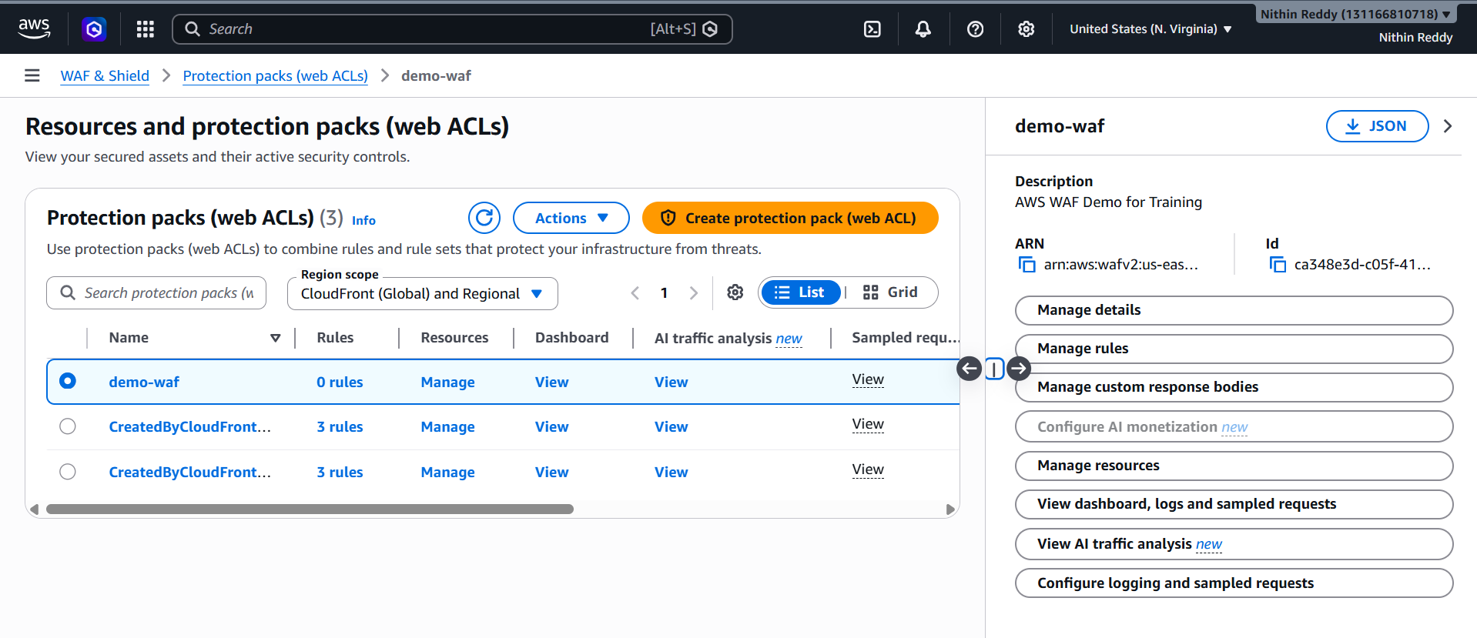
Validation
Verify:
Web ACL Status = Active
Screenshot:
- Web ACL Dashboard
- Rules Page

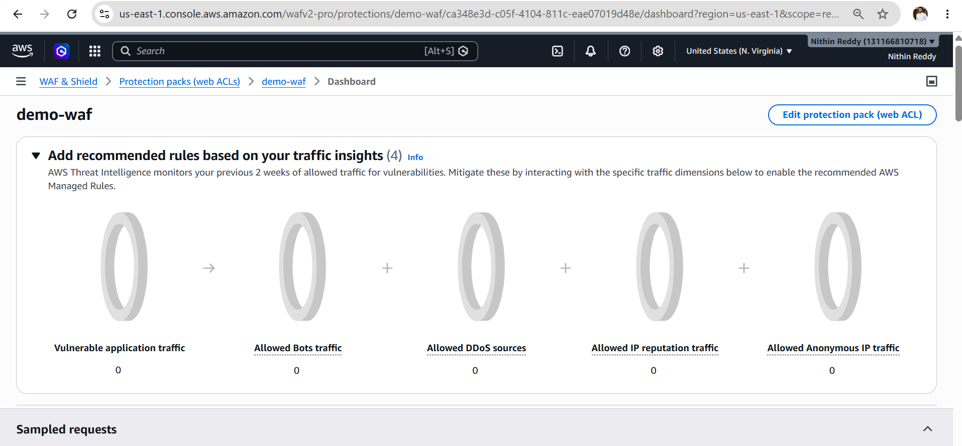
Common Errors
No Resource Found
Cause:
No ALB/API Gateway available
Fix:
Create Web ACL without association for learning purposes.

Topic 2: AWS Systems Manager Parameter Store
What is Parameter Store?
Parameter Store is used to securely store:
- Database passwords
- API keys
- Application configuration
- Environment variables
Similar to Secrets Manager but simpler and cheaper.
Objective
Store and retrieve application configuration.
Expected Outcome
- Create parameter
- Store value
- Retrieve value
Architecture
Application
|
v
Parameter Store
|
v
Configuration Data

Prerequisites
- AWS Account
- IAM User with Systems Manager permissions
No EC2 required.
No RDS required.
No Load Balancer required.

Hands-On Task
Step 1
Open:
Systems Manager
Step 2
Navigate:
Application Management
|
v
Parameter Store
Step 3
Create Parameter
Name:
/db/username
Type:
String
Value:
admin
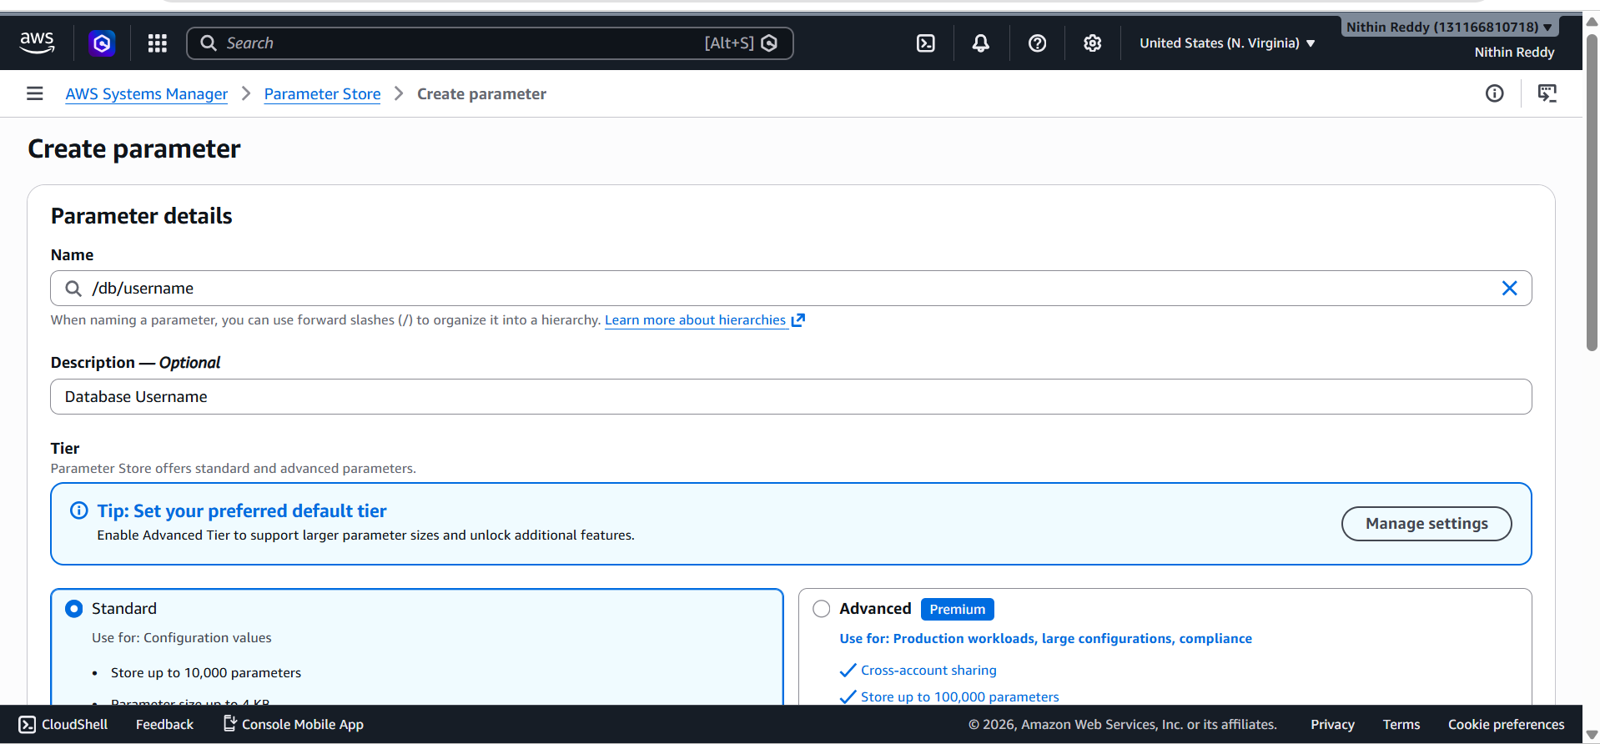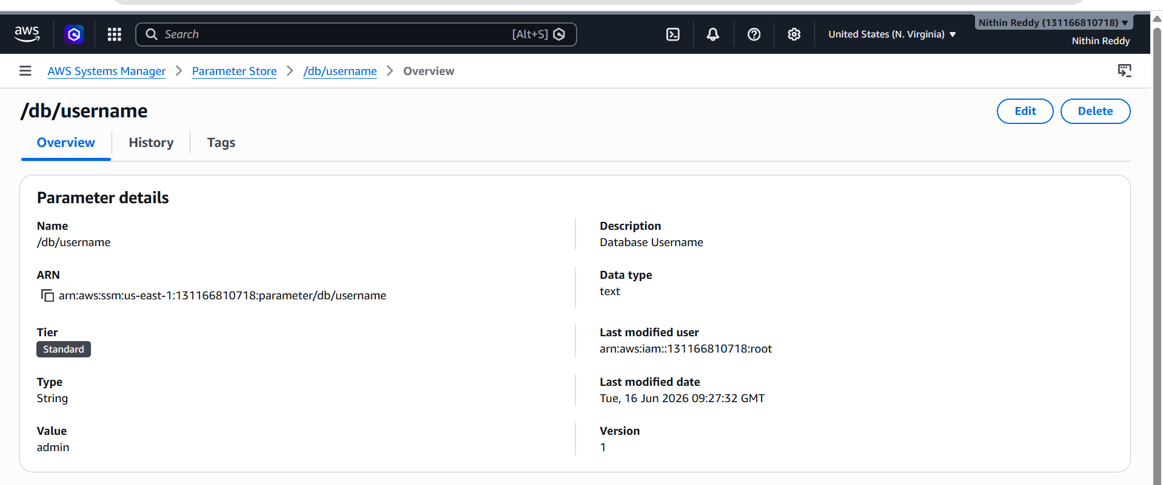
Step 4
Create Another Parameter
Name:
/db/password
Type:
SecureString
Value:
Admin@123
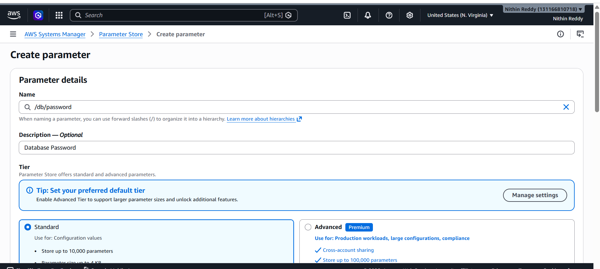
Step 5
Save
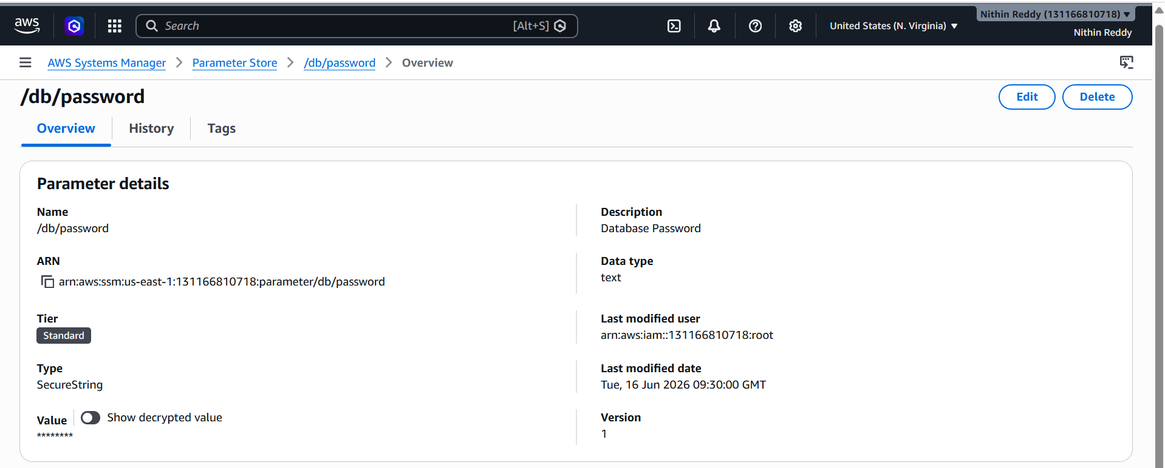
Validation
Open Parameter Store
Verify:
/db/username
/db/password
exist.
Screenshot:
- Parameter List
- Parameter Details
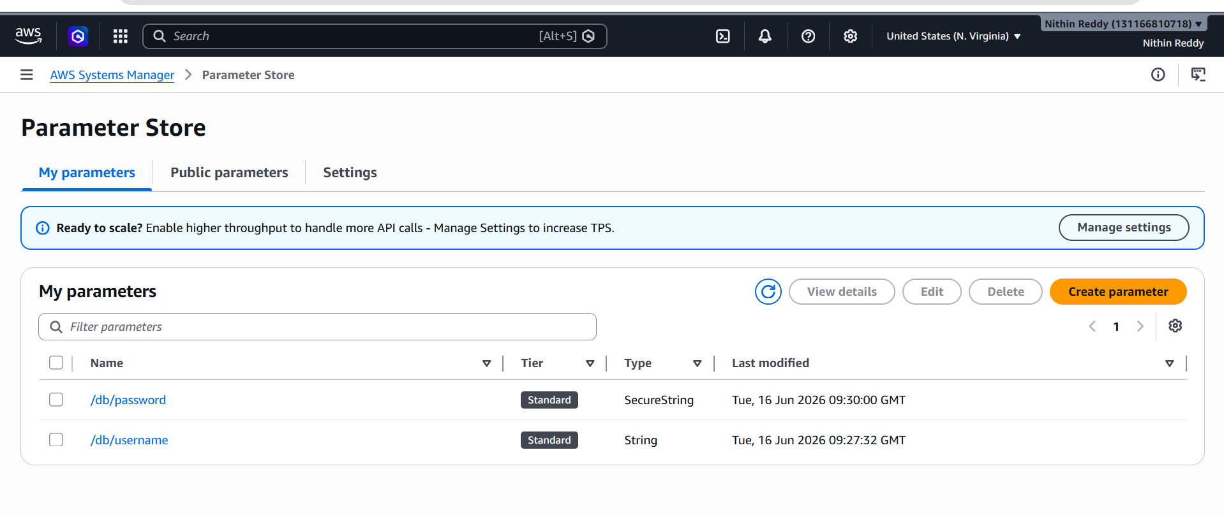
What is Application Manager?
Application Manager is a Systems Manager feature used to view and manage AWS applications and their related resources.
What is Parameter Store?
Parameter Store is used to securely store configuration values, passwords, API keys, and environment variables for applications.

