Task 1: Launch Amazon Linux 2 EC2 with Apache (User Data)
Objective Launch an EC2 instance using Amazon Linux 2 and automatically install Apache web server using User Data script at boot time
Outcome A running EC2 instance serving a webpage via Apache on port 80, fully configured without manual SSH intervention
Steps:
- Go to AWS Console → EC2 → Launch Instance
- Name: Apache-Server
- AMI: Select Amazon Linux 2 AMI (HVM)
- Instance type: t2.micro (free tier)
- Key pair: Create or select existing
- Security Group: Allow HTTP (port 80) and SSH (port 22)
- Scroll to Advanced Details → User Data, paste this script:
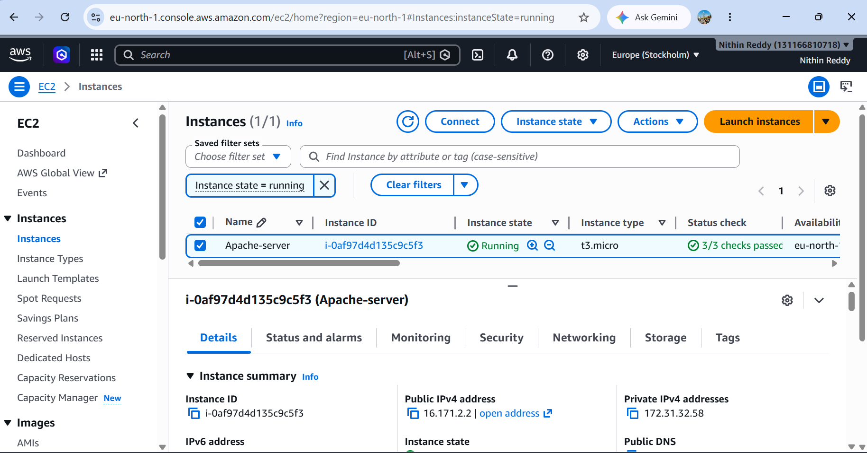
Why We Do This
In real-world DevOps, servers must be configured automatically at launch (Infrastructure as Code approach). User Data scripts eliminate manual setup, saving time and ensuring consistency across environments
Prerequisites
AWS account, IAM user with EC2 permissions, Key pair created, Security group with port 80 & 22 open
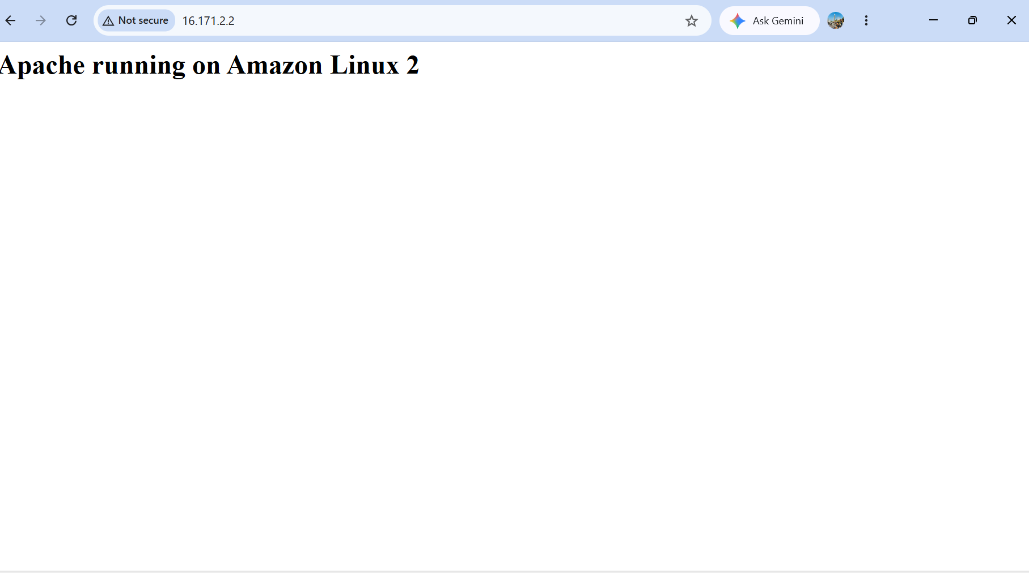
Validation
Open Public IP in browser → Apache default page or custom HTML should appear
Key ConceptUser Data
runs shell scripts automatically on first boot. systemctl enable httpd ensures Apache restarts even if instance reboots.

Task 2: Launch Ubuntu EC2 with Nginx (User Data)
Steps:
- Go to EC2 → Launch Instance
- Name: Nginx-Ubuntu-Server
- AMI: Select Ubuntu Server 22.04 LTS
- Instance type: t2.micro
- Key pair: Select the same key pair (you'll need it for Task 5)
- Security Group: Allow HTTP (port 80) and SSH (port 22)
- User Data:
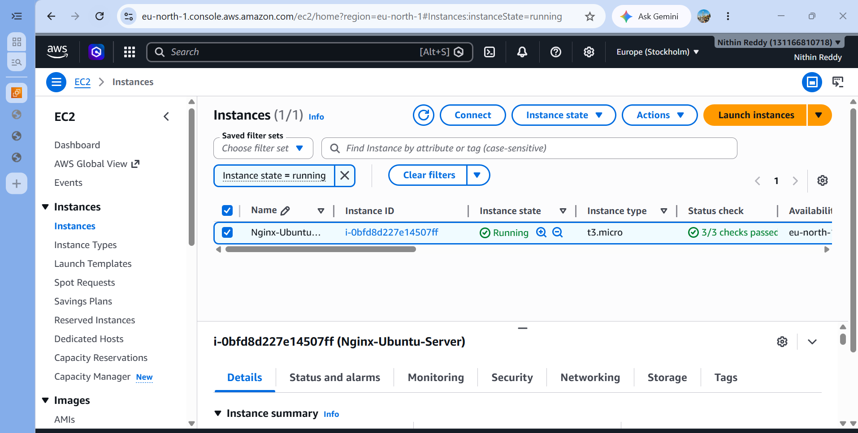

Field | Details
Objective | Launch an EC2 instance using Ubuntu AMI and automatically install Nginx web server using User Data script
Outcome | A running Ubuntu EC2 serving web traffic via Nginx on port 80, auto-configured at launch
Why We Do This | Nginx is widely used as a reverse proxy and web server in production. This task teaches how different Linux distributions (Ubuntu vs Amazon Linux) use different package managers (apt vs yum) and how to handle that in automation
Prerequisites | AWS account, Key pair, Security group with port 80 & 22, Basic Linux knowledge
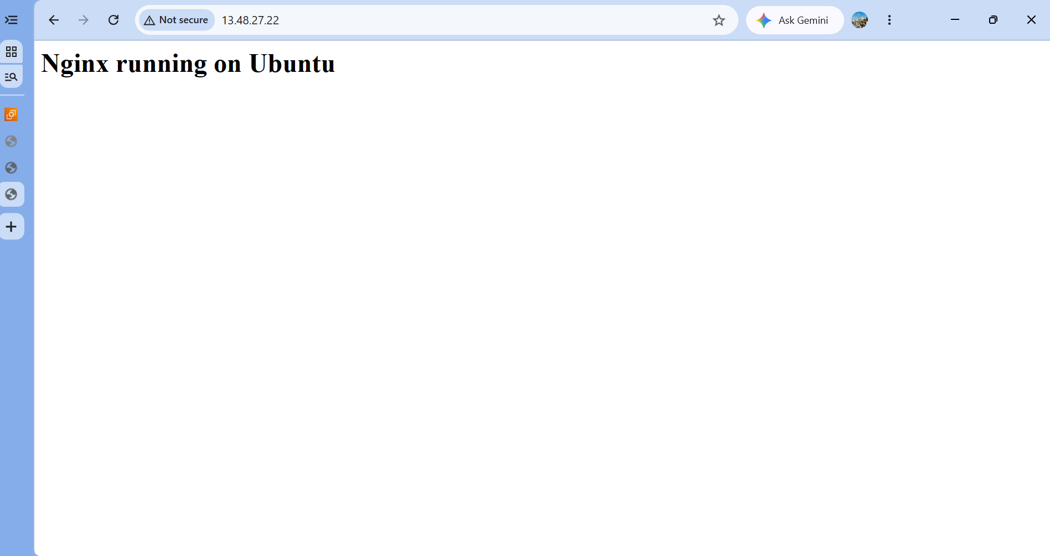
Validation
Open Public IP in browser → Nginx welcome page should appear
Key Concept
Ubuntu uses apt while Amazon Linux uses yum. Both achieve the same result but the commands differ — important for writing OS-specific automation scripts.
Task 3: Launch Windows Server & Install Tomcat
Steps:
Launch Windows EC2:
- Go to EC2 → Launch Instance
- Name: Windows-Tomcat-Server
- AMI: Windows Server 2022 Base
- Instance type: t2.medium (Windows needs more RAM)
- Security Group: Allow RDP (port 3389) and TCP port 8080
- Launch the instance
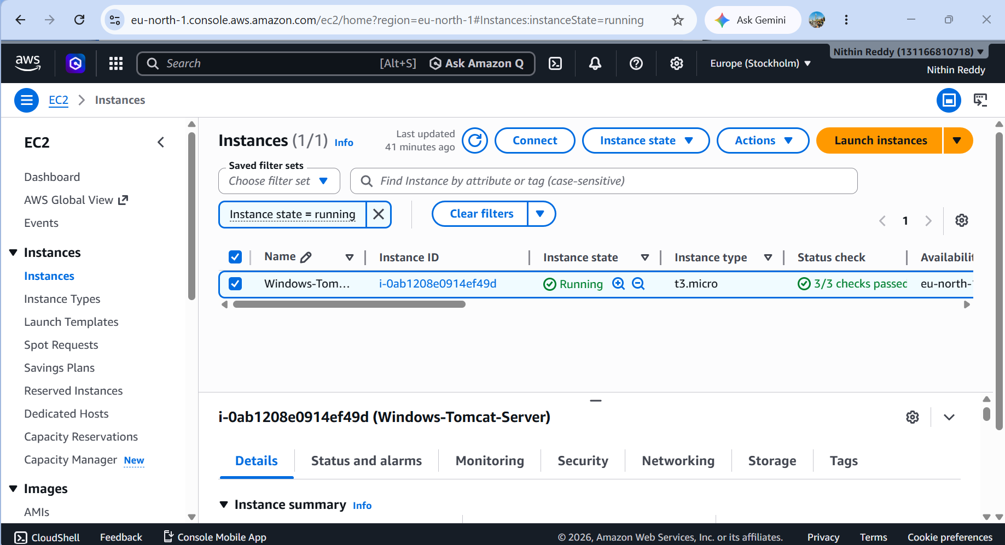
Objective
Launch a Windows Server EC2 instance, connect via RDP, and manually install Apache Tomcat as a Java application server
Outcome
A fully running Tomcat server accessible on port 8080 inside a Windows EC2 environment
Why We Do This
Many enterprise Java applications run on Tomcat on Windows servers. This task teaches how to work with Windows-based cloud infrastructure, use RDP for remote access, and set up Java environments — a common real-world scenario in enterprise DevOps
Prerequisites
AWS account, Key pair (to decrypt RDP password), Security group with port 3389 (RDP) & 8080 open, Basic Windows knowledge
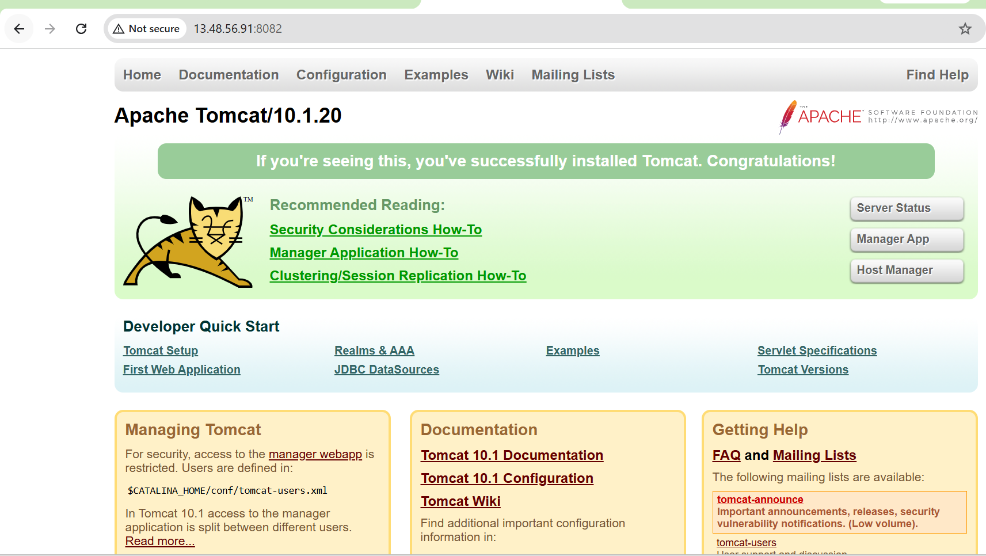
Validation
Open browser inside Windows server → http://localhost:8080 → Tomcat homepage appears
Key ConceptRDP (Remote Desktop Protocol)
is the Windows equivalent of SSH. JAVA_HOME environment variable is required for Tomcat to find the Java installation. Tomcat runs as a Windows Service for persistence.
Task 4: Take a Snapshot of Task 1 Instance (Apache Server)
Objective
Create an EBS snapshot of the Apache server (Task 1) as a point-in-time backup of its root volume
Outcome
A completed EBS snapshot stored in AWS that can be used to restore the instance or create new volumes/AMIs
Steps:
- Go to EC2 → Instances → select Apache-Server
- Scroll down → Storage tab → click the Volume ID
- Right-click the volume → Create Snapshot
- Description: Snapshot of Apache-Server Task1
- Click Create Snapshot
- Go to EC2 → Elastic Block Store → Snapshots to verify
- Evidence: Screenshot of the snapshot with status completed
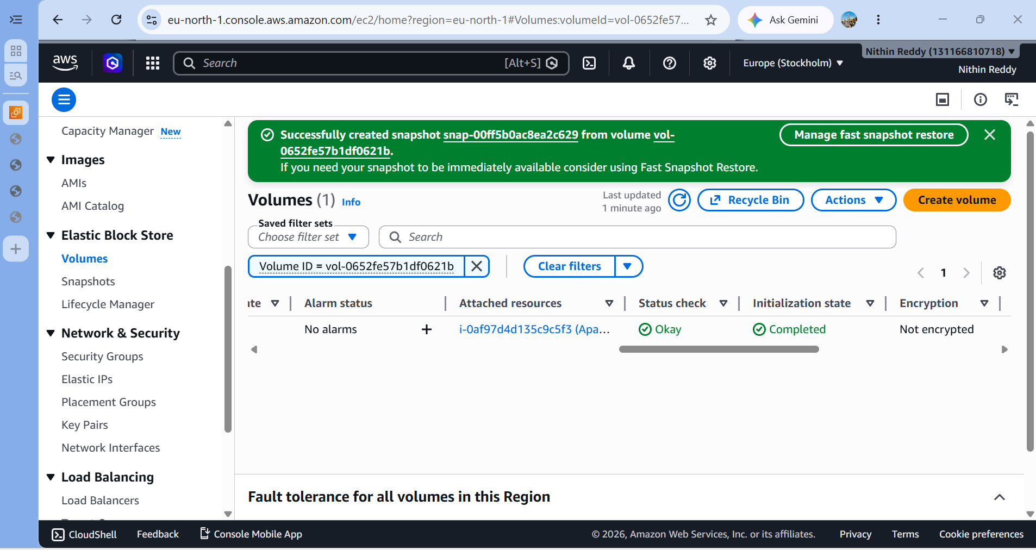
Prerequisites
Task 1 instance must be running, IAM permissions for EBS snapshot creation
Steps Go to
EC2 → Volumes → Select Task 1 root volume → Right-click → Create Snapshot → Add description → Confirm
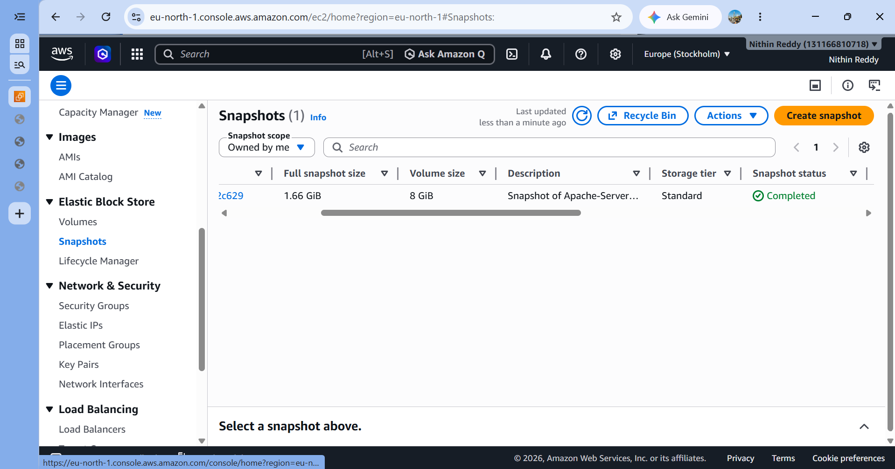
Validation
Go to EC2 → Snapshots → Status shows completed with correct volume ID
Key Concept
EBS Snapshots are incremental (only changed blocks are saved after the first snapshot), stored in S3 internally, and can be copied across regions. They are the base for creating custom AMIs
Task 5: Assign Passwordless Authentication for Task 2 Ubuntu EC2
Objective
Configure SSH key-based (passwordless) authentication on the Ubuntu EC2 so that users can log in without entering a password
Outcome
SSH login to Ubuntu EC2 works using only a private key — no password prompt appears.

Why We Do This
Passwordless SSH is a security best practice and an automation requirement. Tools like Ansible, Jenkins, and CI/CD pipelines use SSH key-based auth to connect to servers automatically. Password-based login is slower, less secure, and not suitable for automation.
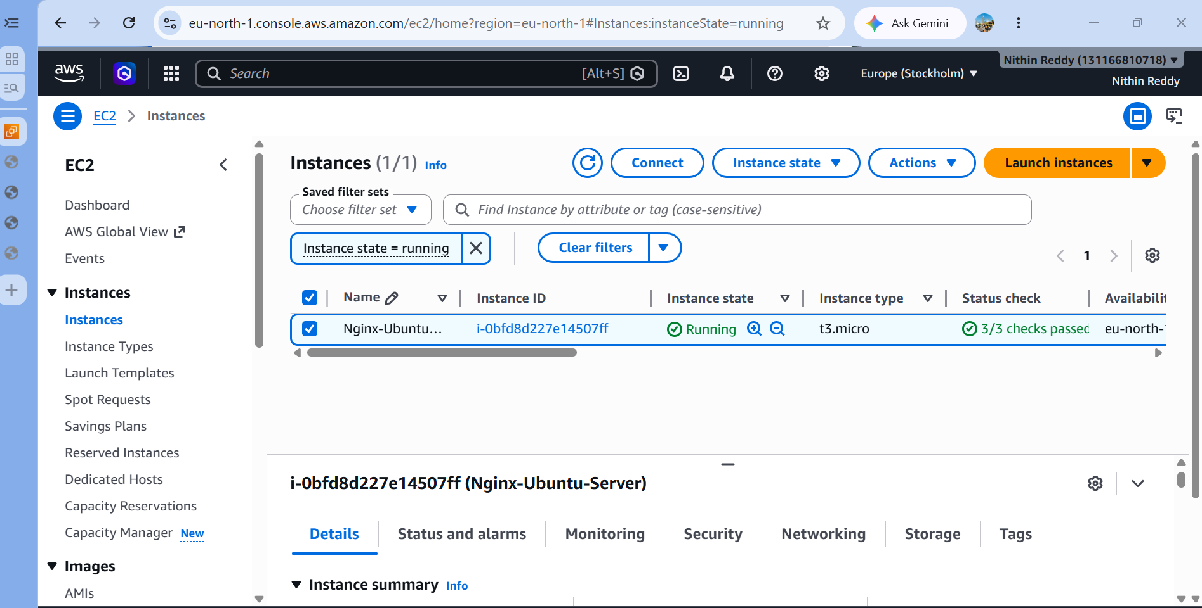
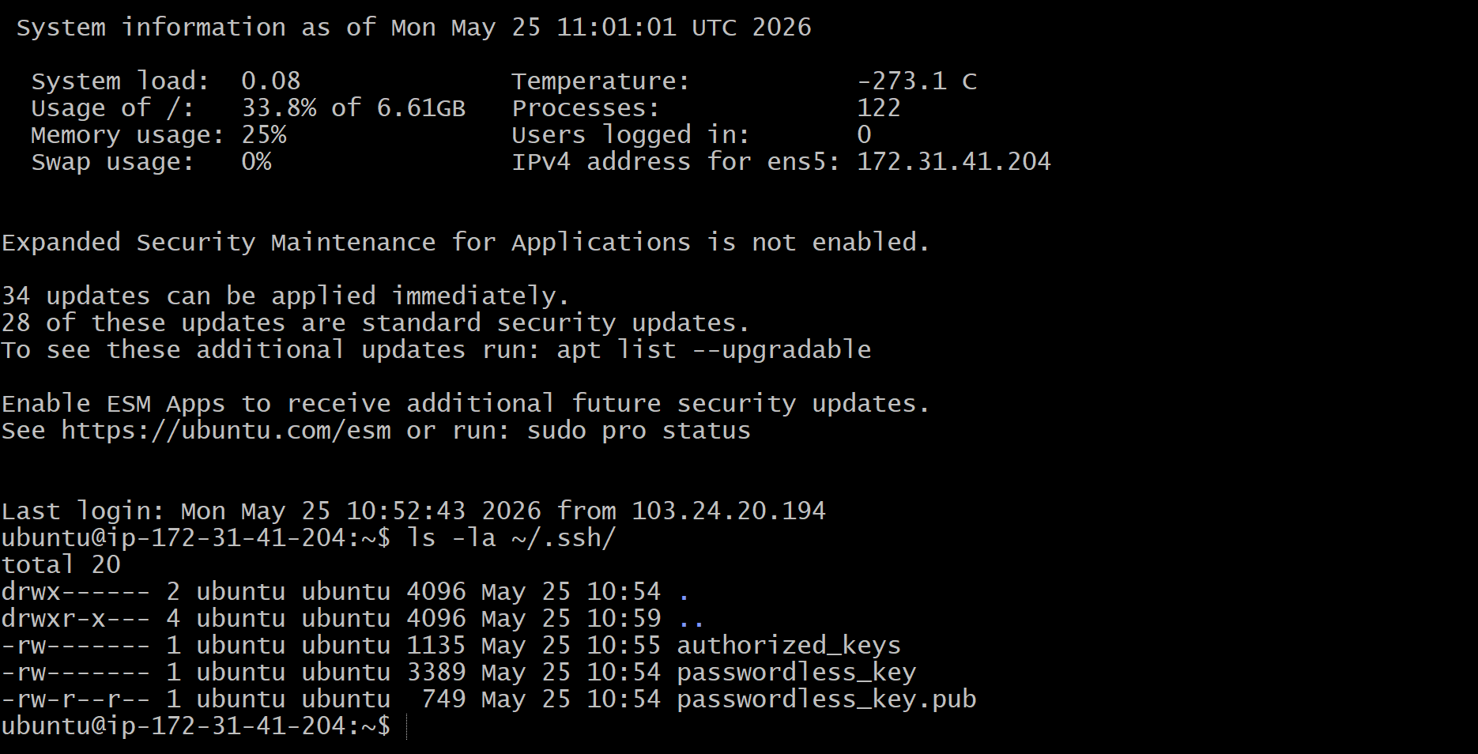
Prerequisites
Task 2 Ubuntu EC2 running, existing SSH access, SSH key pair generated locally
Steps
Generate new SSH key pair locally → SSH into Ubuntu EC2 → Add public key to ~/.ssh/authorized_keys → Set correct permissions → Test login with private key only
Validation
ssh -i passwordless_key ubuntu@<IP> logs in instantly with no password prompt
Key Concept
SSH works on asymmetric cryptography — public key is stored on server, private key stays with user. authorized_keys file tells the server which public keys are allowed. File permissions (chmod 400) are mandatory — SSH will refuse to work if permissions are too open.
Task 6: Launch EC2 Using Spot Purchasing Option
Objective
Launch an EC2 instance using the Spot pricing model instead of the default On-Demand pricing
Outcome
A running Spot Instance with lifecycle tagged as spot, at significantly reduced cost compared to On-Demand
Why We Do This
Spot Instances can save up to 90% cost compared to On-Demand. They are ideal for non-critical, flexible workloads like batch processing, data analysis, CI/CD build agents, or testing. Understanding purchasing options is key to AWS cost optimization
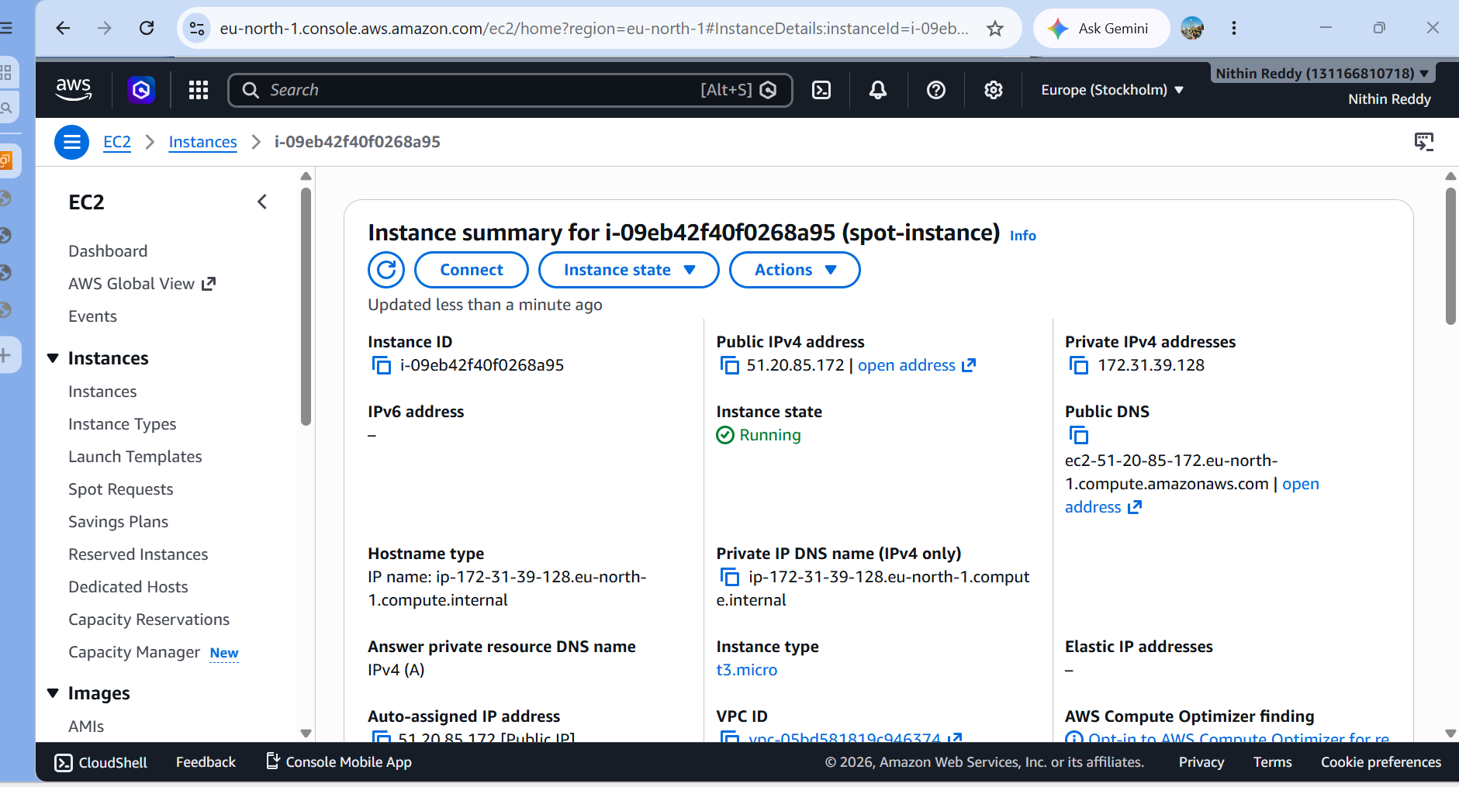
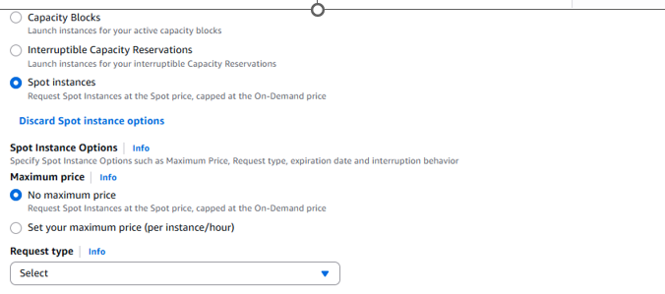
Prerequisites
AWS account, basic EC2 knowledge, understanding that Spot Instances can be interrupted by AWS with 2-minute notice
Steps
Launch EC2 → Advanced Details → Enable "Request Spot Instances" → Set max price → Complete launchValidationIn EC2 console → Instance details → Lifecycle = spot is visibleKey Concept
AWS has unused compute capacity that it offers at discounted rates as
Spot Instances.
AWS can reclaim them with a 2-minute warning. Best used for stateless, fault-tolerant applications. Spot vs On-Demand vs Reserved is a core AWS cost management concept.
Task 7: Enable Termination Protection on Task 2 Ubuntu EC2
Objective
Enable termination protection on the Ubuntu Nginx EC2 to prevent accidental deletion of the instance
Outcome
The instance cannot be terminated from the console or CLI until protection is explicitly disabled — AWS will throw an error on any termination attempt
Why We Do This
In production environments, accidental termination of critical servers can cause major outages and data loss. Termination protection is a simple safety net that prevents human error. It's a standard practice for any production EC2 instance

Prerequisites
Task 2 Ubuntu EC2 running, IAM permissions to modify instance attributes
Steps:
- Go to EC2 → Instances → select Nginx-Ubuntu-Server
- Click Actions → Instance Settings → Change Termination Protection
- Toggle to Enable → click Save
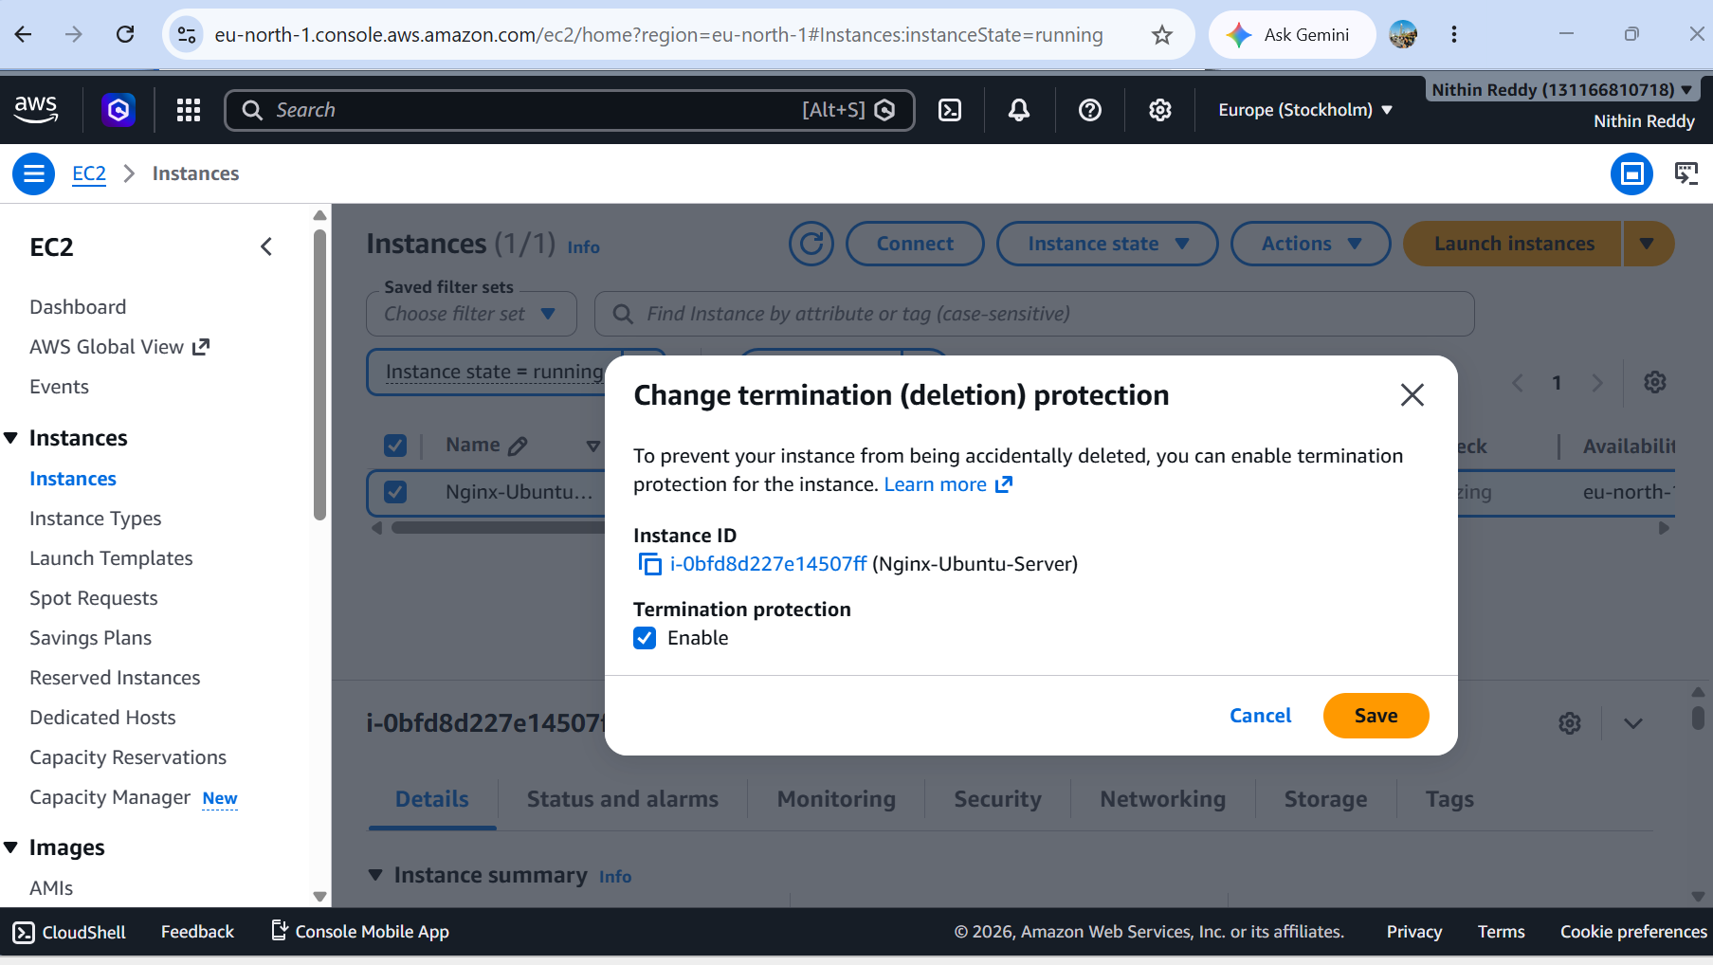
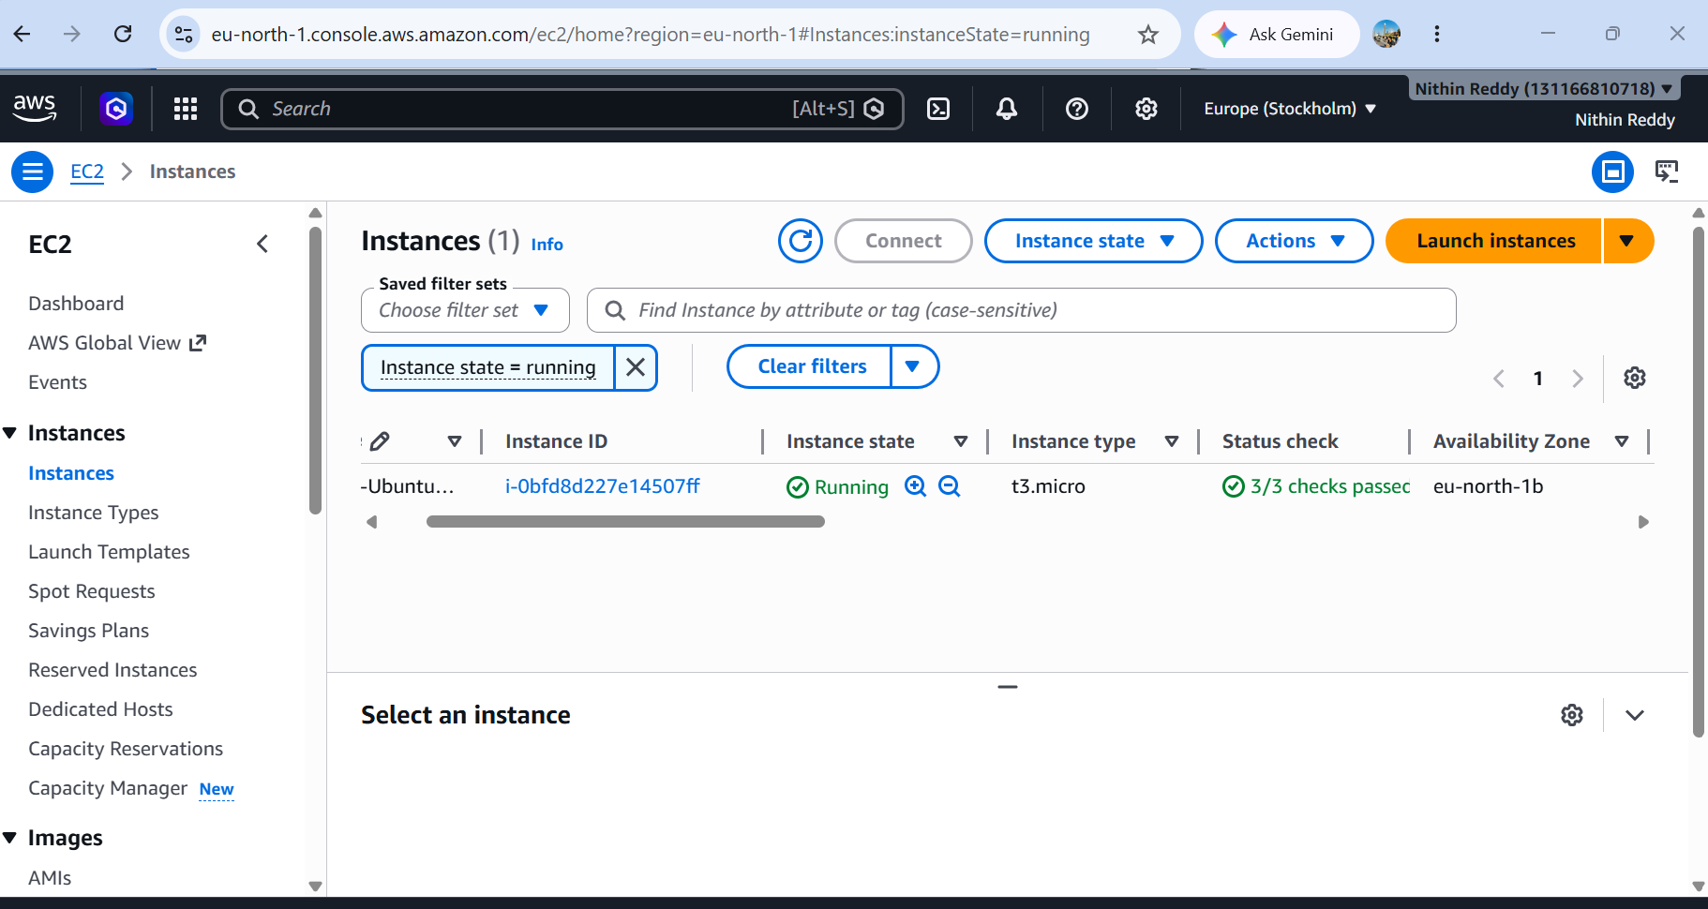
Validation
Try to terminate the instance → AWS shows error: "The instance may not be terminated. Modify its disableApiTermination attribute and try again"
Key Concept
Termination protection sets the disableApiTermination attribute to true. It doesn't prevent stopping the instance — only termination (permanent deletion). Must be manually disabled before the instance can be terminated. Can also be set via AWS CLI using --disable-api-termination.

Task 8 Launch one EC2 using AWS CLI.
Objective
Launch a new EC2 instance entirely from the command line using AWS CLI instead of the web console
Outcome
A running EC2 instance created via aws ec2 run-instances command, verified through CLI output showing Instance ID and running state
Why We Do This
Real-world DevOps and cloud engineers rarely click through the console manually. AWS CLI enables scripted, repeatable, automated infrastructure provisioning — the foundation of Infrastructure as Code (IaC). It's also faster for bulk operations and works inside CI/CD pipelines and shell scripts
Prerequisites
AWS CLI installed, aws configure done with Access Key + Secret Key + Region, existing Key pair name and Security Group ID
Steps
Run aws ec2 run-instances with AMI ID, instance type, key name, security group, subnet → Verify with aws ec2 describe-instances
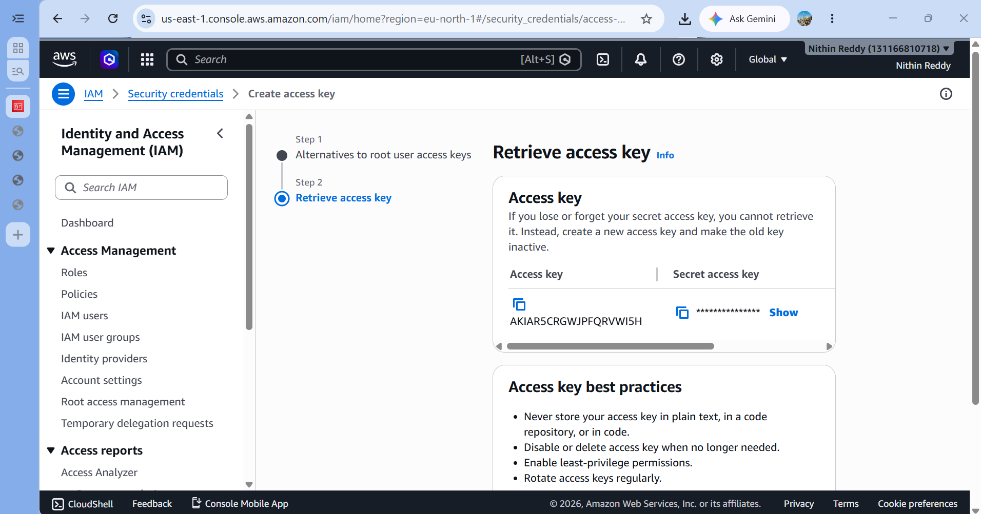
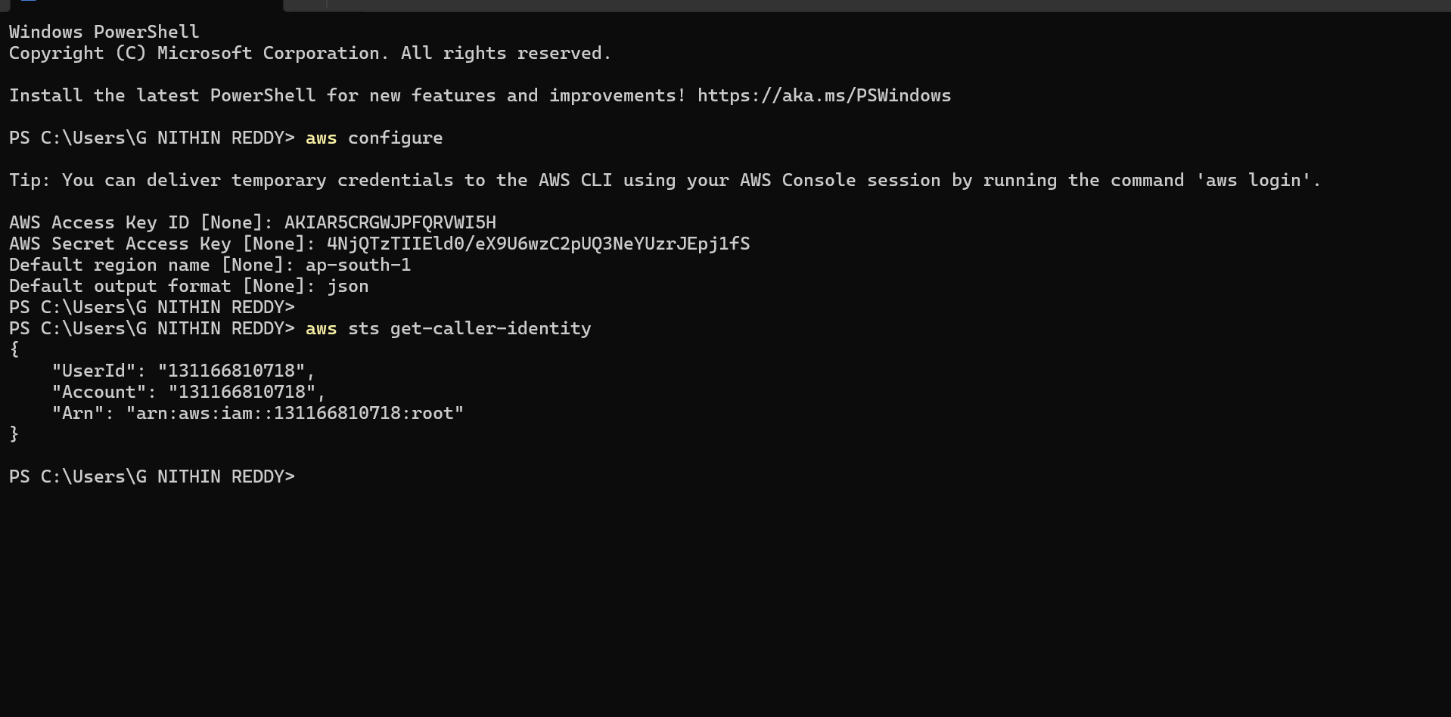
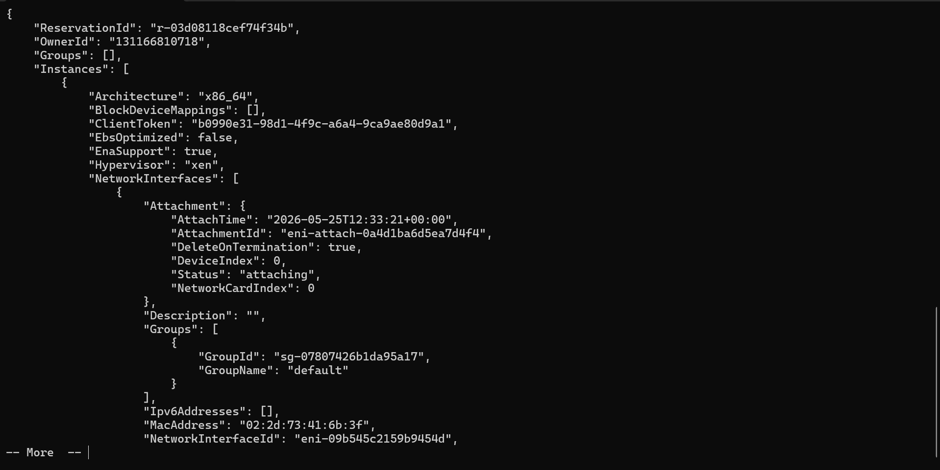
Prerequisites
AWS CLI installed, aws configure done with Access Key + Secret Key + Region, existing Key pair name and Security Group ID
Steps
Run aws ec2 run-instances with AMI ID, instance type, key name, security group, subnet → Verify with aws ec2 describe-instances
Validation
CLI output shows InstanceId and State: running; instance also visible in AWS Console
Key Concept
AWS CLI is a Python-based tool that calls the same AWS APIs the console uses — just via terminal. run-instances is the core command. --tag-specifications adds a Name tag. describe-instances with filters lets you query specific instances. This is the stepping stone toward tools like Terraform, CloudFormation, and Boto3

